2023 Water Management Plan
Seasonal Update
November 1, 2023

- Introduction
The annual Water Management Plan (WMP) is developed prior to U.S. Army Corps of Engineers (Corps), Bureau of Reclamation (Reclamation), and Bonneville Power Administration (BPA), collectively referred to as the Action Agencies (AAs), implementation of Columbia River System (CRS) operations identified in the following documents: 1) National Marine Fisheries Service (NMFS) 2020 CRS Biological Opinion (2020 NMFS BiOp); 2) U.S. Fish and Wildlife Service (USFWS) 2020 CRS BiOp (2020 USFWS BiOp); 3) AA’s 2020 CRS Biological Assessment (2020 CRS BA); 4) 2023 Fish Operations Plan (2023 FOP), and; 5) 2021 Term Sheet for Stay of Preliminary Injunction Motion and Summary Judgment Schedule, as extended, and adjusted through subsequent Motions to Extend the Litigation Stay, NWF et al. v. NMFS et al. (3:01-cv-00640-SI) (Agreement on 2022 Operations). The WMP is also developed prior to the receipt of any seasonal information that may determine how many of the operation measures are implemented. The Seasonal Update is intended to supplement the WMP with more detailed information on operations as the water year progresses. Each section of the Seasonal Update will be updated when information is available and finalized when no further information is available.

The first update for the primary elements of Fall and Winter will be posted by November 1 of each year. The first update for the primary elements of Spring and Summer will be posted by March 1 of each year. The elements and operations included in the Seasonal Update are generally the same as have been previously presented in the Fall/Winter and Spring/Summer Updates to the WMP. The change to update in this manner is intended to present better continuity for tracking operations as they change throughout and across each season. The elements and operations described in the Seasonal Update and the approximate schedule for updates and finalization are as displayed in Table 1.

Table 1. Schedule for update and finalization of Seasonal Update elements and operations.
Section | Element | Begins | Finalized | Last Updated
2.1 | Current Conditions (e.g., WSF, Streamflows) | October | July | November 1, 2023
2.2 | Seasonal Flow Objectives | April | August | November 1, 2023
2.3 | Flood Control | January | June | July 21, 2023
2.4 | Storage Project Operations | September | September | -
2.5 | Water Quality (Spill Priority Lists) | January | December | -
 | Specific Operations | Start Date | End Date | Last Updated
2.6 | Burbot spawning temperature management (Libby Dam) | November | December 30 | -
2.7 | Lake Pend Oreille Kokanee (Albeni Falls Dam) | September 1 | December 30 | -
2.8 | Upper Snake Flow Augmentation | April 1 | August 31 | -
2.9 | Chum Flows (Bonneville Dam) | November 1 | April 10 | November 1, 2022
2.10 | Hanford Reach Fall Chinook Protection | November | June | November 1, 2022
2.11 | Snake River Zero Generation | December | February | November 1, 2023
2.12 | Minimum Operating Pool | April 3 | - | November 1, 2023
2.13 | Spill Operations | April 3 | - | July 21, 2023
2.14 | Transport Operations | May 1 | - | July 21, 2023
2.15 | Fish Passage Research | March | October | July 21, 2023
- Seasonal Update Elements and Specific Operations
  - Current Conditions

Water Supply Forecasts – NWRFC
The final water supply forecast (WSF) is defined as the forecast posted on NOAA’s Northwest River Forecast Center (NWRFC) website at 5:00 pm Pacific Standard Time on the 3rd business day of the month. NWRFC water supply forecasts are available on the following website. http://www.nwrfc.noaa.gov/ws/

Table 2. The Dalles Dam Final Water Supply Forecasts.
Forecast Issue Date | January-July 2023 |  | April-August 2023
 | Volume (MAF) | % of 30-year (1991-2020) Average (103.7 MAF) | Volume (MAF) | % of 30-year (1991-2020) Average (89.2 MAF)
January 5, 2023 | 84.9 | 83% | 72.4 | 81%
February 3, 2023 | 80.2 | 77% | 72.8 | 82%
March 3, 2023 | 79.8 | 77% | 74.0 | 83%
April 5, 2023 | 81.5 | 79% | 76.8 | 86%
May 3, 2023 | 87.9 | 85% | 83.4 | 93%
June 5, 2023 | 85.4 | 82% | 79.6 | 89%
July 6, 2023 | 80.4 | 78% | 74.0 | 83%

Table 3. Grand Coulee Dam Final Water Supply Forecasts.
Forecast Issue Date | January-July 2023 |  | April-August 2023
 | Volume (MAF) | % of 30-year Average (61.7 MAF) | Volume (MAF) | % of 30-year Average (58.2 MAF)
January 5, 2022 | 48.3 | 78% | 45.8 | 79%
February 3, 2023 | 49.7 | 81% | 48.1 | 83%
March 3, 2023 | 50.3 | 81% | 49.7 | 85%
April 5, 2023 | 48.7 | 79% | 49.3 | 85%
May 3, 2023 | 51.6 | 84% | 51.6 | 89%
June 5, 2023 | 50.7 | 82% | 49.6 | 85%
July 6, 2023 | 47.3 | 77% | 45.8 | 79%

Table 4. Lower Granite Dam Final Water Supply Forecasts.
Forecast Issue Date | April-July 2023 |  | April-August 2023
 | Volume (MAF) | % of 30-year Average (1991-2020) (27.4 MAF) | Volume (MAF) | % of 30-year Average (1991-2020) 21.1 MAF)
January 5, 2023 | 18.0 | 91% | 18.0 | 90%
February 3, 2023 | 16.0 | 80% | 16.0 | 82%
March 3, 2023 | 15.9 | 80% | 17.1 | 81%
April 5, 2023 | 18.2 | 91% | 19.6 | 93%
May 3, 2023 | 20.7 | 104% | 22.0 | 104%
June 5, 2023 | 20.4 | 102% | 21.7 | 103%
July 6, 2023 | 19.4 | 97% | 20.7 | 98%

Table 5. Dworshak Dam Final Water Supply Forecasts.
Forecast Issue Date | April-July 2023
 | Volume (KAF) | % of 30-year (1991-2020) Average (2,474 KAF)
December 5, 2022 | 2296 | 93%
January 5, 2023 | 2178 | 88%
February 3, 2023 | 2117 | 86%
March 3, 2023 | 2344 | 95%
April 5, 2023 | 2521 | 102%
May 3, 2023 | 2620 | 106%
June 3, 2023 | 2229 | 90%

Water Supply Forecasts - Corps
The Corps’ Seattle District produce the following volume inflow forecast for Libby and they are available on the following website.

https://www.nwd.usace.army.mil/CRWM/Forecasts/

Table 5. Libby Dam Water Final Supply Forecasts.
Forecast Issue Date | April-August 2023
 | Volume (KAF) | % of 78-year (1991-2020) Average (6,080 KAF)
December | 5692 | 94%
January | 6061 | 100%
February | 5071 | 83%
March | 5298 | 87%
April | 4694 | 77%
May | 4408 | 73%
June | 4803 | 79%

Water Supply Forecasts – Reclamation
Water supply forecasts for Hungry Horse Dam are produced by Reclamation.

Table 7. Hungry Horse Dam Final Water Supply Forecasts.
Forecast Issue Date | April-August 2023 |  | Date-July 2023 |  | May-September 2023
 | Volume (KAF) | % of 30-year Average (2,070 KAF) | Volume (KAF) | % of Average | Volume (KAF) | % of 30-year Average (1,835 KAF)
January | 2100 | 104% | 2120 | 107% | 1950 | 110%
February | 1950 | 96% | 2050 | 98% | 1750 | 99%
March | 1960 | 96% | 1950 | 93% | 1760 | 99%
April | 1770 | 87% | 1700 | 86% | 1680 | 95%
May | 1720 | 84% | 1460 | 88% | 1550 | 88%
June | 1660 | 51% | 450 | 51% | 1475 | 83%

Weekly Weather and Precipitation Retrospectives
Week | Weekly Weather / Precipitation Retrospective
October 3, 2022 | Temperatures: For the 3rd week in a row, well above average with several records broken.  Rainfall: Mostly dry in what should normally be the start of the fall rainy season.  Streamflow: Mostly flat.
October 10, 2022 | Temperatures: For the 4th week in a row, well above average with numerous records broken. This is likely the warmest first half of October on record for much of the Columbia Basin.  Rainfall: Record dryness for early October.  Streamflow: Mostly flat.
October 17, 2022 | Temperatures: Record warm through Thu, followed by a sharp drop to near average with snow levels dropping to pass levels.  Precipitation: Record dryness flipped to well above average precipitation on Friday in US basins, with the first mountain winter storm of the season. Lagged below average in BC.  Streamflow: Mostly flat as heavy rains went into moistening soils. However, minor responses were noted in the Willamettes and lower Columbia side streams.
October 24, 2022 | Temperatures: Near average.  Precipitation: Well above average, except closer to average in SE ID.  Streamflow: Mostly flat as heavy rains went into moistening soils. However, minor responses were again noted in the Willamettes, lower Columbia, Spokane and Clearwater basins.
October 31, 2022 | Temperatures: Fell to below average.  Precipitation: Well above average basinwide, especially south half.  Streamflow: Minor rises on many low elevation streams that were typical for early November. However, flows were tempered as heavy precip continued to go into remoistening soils, or fell as snow at fairly low elevations. Minor flooding in western WA and a couple of Willamette headwaters Fri/Sat before quickly receding.
November 7, 2022 | Temperatures: Well below average, with first hard freezes west of the Cascades.  Precipitation: Above average initially over southern OR and southern ID, then dried out. Mostly dry elsewhere in what is normally a very wet time of year.  Streamflow: Flat or receding.
November 14, 2022 | Temperatures: Well below average.  Precipitation: Mostly dry in what is normally a very wet time of year, and cancelled out the very wet first half of the month.  Streamflow: Flat or receding, and well below average for this time of year.
November 21, 2022 | Temperatures: Warmed to near average.  Precipitation: Slightly above average in BC, slightly below average elsewhere and not nearly as dry as the previous two weeks.  Streamflow: Mostly flat, except for a couple of very minor rises in the Willamettes, and minor ice jams in headwater areas.
November 28, 2022 | Temperatures: Well below average.  Precipitation: Above average, with significant snow pack gains and low elevation snow.  Streamflow: Mostly flat, except for a modest rise on the Willamettes over the weekend which are already receding. Natural flows throughout the system remain well below normal due to a combination of the dry fall leaving soils moisture-depleted, followed by most November precip falling as snow.
December 5, 2022 | Temperatures: For the 6th week in a row, below average.  Precipitation: Slightly above average  Streamflow: Mostly flat, with small short-lived rises over the weekend in lowest basins receding. Natural flows remain well below normal due to a combination of the dry fall leaving soils moisture-depleted, followed by December precip continuing to fall as snow.
December 12, 2022 | Temperatures: For the 7th week in a row, below average.  Precipitation: Well below average.  Streamflow: Mostly flat, with some ice jamming in headwater areas.
December 19, 2022 | Temperatures: Brief but severe cold snap Wed-Fri, with major snow and ice storm on the valley floors. Temperatures then gradually rose sharply above average over the holiday weekend.  Precipitation: Increased to well above average late last week and over the holiday weekend.  Streamflow: Mostly flat, with some ice jamming in headwater areas.
December 26, 2022 | Temperatures: For the first time in two months, above average.  Precipitation: Well above average US Basins (150-300% of normal), but lagged below average again in BC.  Streamflow: For the first time since early November, moderate flow spikes in the Willamettes, lower Columbia, lower Snake, mid-Cs, Clearwater and Spokane basins – all of which quickly receded this weekend. Ice jams continued to be detected in ID and western MT headwaters.
January 2, 2023 | Temperatures: Started the week below average but went above average as weekend approached.  Precipitation: Below average basin wide.  Streamflow: Flows continued mostly flat and in recession. Ice jams continued to be detected in ID and western MT headwaters.
January 9, 2023 | Temperatures: Above average.  Precipitation: Above average west of the Cascades, in central WA and in southern ID; below average elsewhere.  Streamflow: Minor rises this weekend in the Willamettes, and lower Columbia, Clearwater and Spokane. Mostly flat elsewhere.
January 16, 2023 | Temperatures: Fell to below average.  Precipitation: Below average.  Streamflow: Flat or receding.
January 23, 2023 | Temperatures: Fell to well below average, but just short of cold snap criteria. Low temperatures near  -30°F this morning in central ID and near Jackson WY, with widespread below zero lows in western MT, eastern OR and SE ID.  Precipitation: Near average in BC, western MT and SE ID. Below average elsewhere.  Streamflow: Flat or receding, with some ice jams in headwater areas this weekend.
January 30, 2023 | Temperatures: Well below average through Tue, then warmed to near average.  Precipitation: Well below average, although it turned wetter over the NW half this weekend.  Streamflow: Flat or receding, with numerous, but minor ice jams in headwater areas.
February 6, 2023 | Temperatures: Slightly above average, except below average in SE ID  Precipitation: Above average in BC; below average elsewhere.  Streamflow: Mostly flat, and well below normal for early February.
February 13, 2023 | Temperatures: Below average initially with unusually low snow levels, then briefly warmed to near average.  Precipitation: Near average in BC; below average elsewhere.  Streamflow: Mostly flat, and well below normal for early February.
February 20, 2023 | Temperatures: Record cold for late February, but just above cold snap levels. Snow levels near valley floors.  Precipitation: Well above average in BC and far NW WA. Also above average in western WA and northwest OR where a major snowstorm occurred on Wednesday. Slightly below average elsewhere in US Basins.  Streamflow: Mostly flat, and well below normal for mid-February. Localized headwater ice jams.
February 27, 2023 | Temperatures: Well below average with unusually low snow levels.  Precipitation: Slightly above average.  Streamflow: Near record low flows for this time of year.
March 6, 2023 | Temperatures: Below average, with unusually low snow levels.  Precipitation: Well above average US basins (150-250% of normal in the Snakes/lower Columbia); below average in BC. Most of the precipitation fell as heavy mountain snow.  Streamflow: Very small rises on lowest elevation streams this weekend, but still near record lows for early March.
March 13, 2023 | Temperatures: For the first time in several weeks, warmed to slightly above average.  Precipitation: Well above average through Wed, then turned drier.  Streamflow: Minor flow increases in the lower Snake, lower Columbia, Clearwater, Spokane and Willamettes, but still below normal for mid March. Flat elsewhere.
March 20, 2023 | Temperatures: Slightly above average initially, then fell to below average.  Precipitation: Above average south half; below average north half.  Streamflow: Minor flow increases in the lower Snake, lower Columbia, Clearwater, and Willamettes, but still well below normal for mid-March. Flat elsewhere.
March 27, 2023 | Temperatures: Below average with unusually low snow levels.  Precipitation: Well above average south, which eventually spread north after a dry week in BC. Significant snowpack gains only in the US basins, with large deficits continuing in BC.  Streamflow: Although still well below normal, another round of slightly higher, but still minor flow increases began in the lower Snake, lower Columbia, Clearwater, Spokane and Willamettes this weekend.
April 6, 2023 | Temperatures: Well below average initially, then climbed briefly to near average this weekend.  Precipitation: Well above average US basins, which eventually spread into BC and delivered badly needed mountain snows.  Streamflow: Although still well below normal, another round of slightly higher, but still minor flow increases in the lower Snake, lower Columbia, Clearwater, Spokane and Willamettes. Still flat elsewhere.
April 13, 2023 | Temperatures: Below average.  Precipitation: Above average two-thirds; below average southeast third.  Streamflow: First notable snowmelt spike of the season in US Basins, with unregulated flows peaking near 85kcfs at Lower Granite and just over 200kcfs at The Dalles before receding somewhat this weekend.
April 20, 2023 | Temperatures: Below average.  Precipitation: Above average in US Basins; lagging below average in BC.  Streamflow: Modest recessions over the week, but somewhat elevated early snowmelt flows continued in US basins. Unregulated flows at The Dalles still below normal around 150-170kcfs and 60-70kcfs at Lower Granite. Flows still mostly flat in BC.
April 27, 2023 | Temperatures: First major spring warm spell, with widespread 80°F+ highs in the valleys and 60s in the mountains.  Precipitation: Well below average.  Streamflow: Spring freshet commenced, especially in US Basins. Unregulated flows at Lower Granite climbing over 100 kcfs, and over 300 kcfs at The Dalles as of this morning.
May 1, 2023 | Temperatures: Well above average through Thu, especially east of the Cascades, then cooled below average.  Precipitation: Well above average (150-250% of normal), with scattered thunderstorms producing heavy rain on melting snowpacks.  Streamflow: Spring snowmelt flow spikes across the basin, with spotty headwater and flash flooding. Unregulated flows at Lower Granite peaked near 210kcfs this weekend, near 450kcfs at Grand Coulee, and near 700 kcfs at The Dalles. Most streams crested on Sat and were temporarily receding, but still running high this morning.
May 8, 2023 | Temperatures: Near average through Wed, followed by record early May heat this weekend.  Precipitation: Diminished to well below average.  Streamflow: Basinwide recessions through midweek (unregulated flows at The Dalles briefly fell to around 500 kcfs) before resuming a rapid rise yesterday.
May 15, 2023 | Temperatures: Record mid-May heat continued through Fri, which then eased this weekend.  Precipitation: Slightly below average, with fairly widespread thunderstorms and locally heavy rain interspersed with areas that had little rain.  Streamflow: Peak of the spring runoff late in the week, with unusually high crests given the overall low water supply situation. Flows either leveled off or began to slowly diminish over the weekend.
May 22, 2023 | Temperatures: Slightly above average, but cooler than previous weeks.  Precipitation: Above average east with numerous thunderstorms and locally heavy rain. Below average west.  Streamflow: Peak of the spring runoff in the Lower Snake and Lower Columbia early last week, with large secondary peaks above Grand Coulee, but not quite at early May levels. Flows then fell rather quickly with cooler temperatures, despite spotty heavy rains.
May 29, 2023 | Temperatures: Near average.  Precipitation: Below average, but with scattered thunderstorms, especially in BC/MT/ID.  Streamflow: Rather rapid, basinwide recessions as we came off the spring peak and snowpacks depleted. Unregulated flows at The Dalles fell from 600 kcfs to around 400 kcfs.
June 5, 2023 | Temperatures: Well above average.  Precipitation: Well above average east, but the rains were from scattered thunderstorms with heavy rains in some spots, and little or no rain others. Below average west of the Cascades, but some badly needed rain fell Thu night-Fri.  Streamflow: A few minor flow spikes in headwater areas from thunderstorms. More broadly, flows briefly leveled off (around 100kcfs at Lower Granite, and between 350-400kcfs at The Dalles), but were well below normal for early June after being well above normal in May.
June 12, 2023 | Temperatures: Above average initially, then cooled to well below average this weekend with snow levels briefly falling to pass levels.  Precipitation: Well above average, especially in BC and central ID where widespread, badly needed 150-250% normal precipitation fell.  Streamflow: A few minor flow spikes in BC, ID and western MT headwaters. Rather steady recessions continued elsewhere with mainstem flows well below normal for mid-June. Unregulated flows at The Dalles fell to around 250 kcfs (normally, they should still be around 450 kcfs)
June 19, 2023 | Temperatures: Warmed to above average.  Precipitation: Below average, but scattered thunderstorms produced locally heavy rains, especially in BC, western MT and central ID.  Streamflow: Basinwide recessions. Unregulated flows at The Dalles fell below 200 kcfs this weekend, almost four weeks earlier than usual.
June 26, 2023 | Temperatures: Above average.  Precipitation: Near average east of the Cascades from hit-and-miss thunderstorms before drying out this weekend. Little or no precip west of the Cascades.  Streamflow: Small rises in BC due to thunderstorms and increased high elevation snowpack, with brief thunderstorm-driven flow spikes in a few ID/MT headwater areas. Gradual recessions elsewhere.
July 3, 2023 | Temperatures: Above average. Brief heat spell west of the Cascades Tue-Wed followed by modest cooling.  Precipitation: Dry initially, then scattered thunderstorms broke out this weekend east of the Cascades.  Streamflow: Somewhat elevated flows in BC due to high elevation snowmelt. Flat or receding elsewhere. Unregulated flows near record lows for early July at Grand Coulee, and lowest since 2015 in the lower Columbia.
July 10, 2023 | Temperatures: Above average east of Cascades. Warmed to well above average west of Cascades this weekend.  Precipitation: Scattered thunderstorms in BC, NE WA and Northern ID through Wed, then dried out. Seasonably dry elsewhere.  Streamflow: Flat or receding, Record low unregulated flows for this time of year above Grand Coulee, and lowest unregulated flows since 2015 in the lower Snake/lower Columbia.
July 17, 2023 | Temperatures: Above average, especially east of the Cascades.  Precipitation: Mostly dry.  Streamflow: Flat or receding. Record low unregulated flows continue for this time of year above Grand Coulee, and just below 2015 levels in the lower Columbia/lower Snake.
July 24, 2023 | Temperatures: Cooled to slightly below average west of the Cascades, while remaining above average east.  Precipitation: Scattered showers and thunderstorms north half, but rainfall was spotty and hydrologically insignificant. Mostly dry south.  Streamflow: Flat or receding. Record low unregulated flows continue for this time of year above Grand Coulee, and near 2015 levels in the lower Columbia/lower Snake.
July 31, 2023 | Temperatures: Slightly above average.  Precipitation: Scattered showers and thunderstorms in what is normally the driest time of year.  Streamflow: Mostly flat. Record low natural flows for this time of year above Grand Coulee and the Lower Columbia, and near 2015 levels in the lower Snake.
August 7, 2023 | Temperatures: Slightly below average initially, then warmed to heat wave levels on Sunday.  Precipitation: Scattered showers and thunderstorms north half through Thursday before drying out. Streamflow: Localized flow spikes in the upper Columbia, Clearwater and Salmon basins from passing thunderstorms. Otherwise record low natural flows for this time of year continued above Grand Coulee and the Lower Columbia, but climbed a little above 2015 levels in the lower Snake/lower Columbia.
August 14, 2023 | Temperatures: Heat wave conditions (2nd most intense on record) ended on Friday. Slightly above average this weekend.  Precipitation: Dry initially, followed by a gradual increase in showers and thunderstorms east of the Cascades. Streamflow: Near record low natural flows for this time of year continued above Grand Coulee and the Lower Columbia, but climbed a little above 2015 levels in the lower Snake/lower Columbia.
August 21, 2023 | Temperatures: Slightly below average initially, then rose to well above average this weekend.  Precipitation: Unusually widespread, beneficial, and in some cases record rains east of the Cascades from the remnants of Hurricane Hilary. Turned seasonably drier this weekend. Last week’s thunderstorms sparked several new wildfires that grew significantly this weekend with the hot/dry weather.  Streamflow: Unusual, albeit modest, August flow spikes scattered across several headwaters, especially in BC and the Snakes. Flows quickly receded, but mainstem baseflows are now noticeably higher than previous weeks.
August 28, 2023 | Temperatures: Coolest weather since late May across the basin.  Precipitation: Another week of unusually widespread, soaking, beneficial rain in what is normally a dry time of year. Several daily precip records broken. Significant improvement in wildfire conditions.  Streamflow: Unusual, albeit modest, flow spikes scattered across several headwaters, especially in BC and the Snakes. Flows quickly receded, but mainstem baseflows are now above average in the Snake Basin, and closer to normal on the mainstem Columbia.
September 4, 2023 | Temperatures: Gradually warmed from slightly below average to slightly above average.  Precipitation: Seasonably dry.  Streamflow: Flat, or quickly receding from last weekend’s flow spikes in ID and western MT.
September 11, 2023 | Temperatures: Above average.  Precipitation: Mostly dry.  Streamflow: Flat or receding.
September 18, 2023 | Temperatures: Cooled to slightly below average.  Precipitation: Increased to well above average, especially in the northwest half. First high mountain snows of the season in BC and western MT Thu-Fri.  Streamflow: Brief headwater increases in BC which quickly receded. Mostly flat elsewhere.
September 25, 2023 | Temperatures: Slightly below average, but with warm nights, cool days and high snow levels.  Precipitation: Well above average across the entire basin, with a few daily records broken. Most precip fell as rain in the mountains.  Streamflow: Brief and very small increases in many headwater areas, but mainstem flows remained flat as the heavy rains went into moistening soils rather than runoff.
  - Seasonal Flow Objectives
Project | Planning Dates | Seasonal Flow Objectives – (kcfs) | 2023 Season Average Flow (kcfs)
Priest Rapids | Spring 4/10–6/30 | 135 | 129
McNary | Spring 4/10–6/30 | 220 | 229
 | Summer 7/1–8/31 | 200 | 141
Lower Granite | Spring 4/3–6/20 | 93 | 95
 | Summer 6/21–8/31 | 50 | 34
- Varies according to NWRFC April forecast.
- Varies according to NWRFC June forecast.
  - Flood Control
Flood Control Elevations and April 10 objective elevations per each forecast period are listed in the table below. Forecasted flood control elevations will be calculated beginning in December after the Libby and Dworshak water supply forecasts are available. Subsequent forecasted flood controls will be updated after the final water supply forecasts are available January-April.

Grand Coulee and all Canadian projects will be operated for standard flood control. Hungry Horse and Libby will be operated for Variable Q (VARQ) Flood Control. Beginning in January, the Corps calculates Upper Rule Curve elevations based on the monthly official final forecasts. Projects are operated using these elevations as an upper limit, with the objective of reaching their spring refill elevations. Detailed flood control operations are available at the following website. http://www.nwd-wc.usace.army.mil/report/colsum.

The April 10 elevations shown in the table below are calculated by linear interpolation between the March 31 and April 15 forecasted flood control elevations.

Project | Elevation Date Objective | Dec | Jan | Feb | Mar | Apr
Libby | Dec 31 | 2419.3
 | Jan 31 | 2414.3 | 2409.5
 | Feb 28 | 2411.6 | 2404.6 | 1419.6
 | March 31 | 2408.1 | 2398.8 | 2419.4 | 3515.9
 | April 10 | 2406.9 | 2398.8 | 2419.4
 | April 15 | 2407.4 | 2398.8 | 2419.3 | 3515.4 | 2425.6
 | April 30 | 2406.7 | 2397.9 | 2419.3 | 3515.0 | 2426.2
Hungry Horse | Jan 31 | 3544.1 | 3541.7
 | Feb 28 | 3539.4 | 3534.7 | 3541.2
 | March 31 | 3534.1 | 3526.7 | 3536.9 | 3536.4
 | April 10 | 3532.3 | 3524.0 | 3535.5 | 3534.9
 | April 15 | 3531.4 | 3522.6 | 3534.8 | 3534.2 | 3538.8
 | April 30 | 3528.8 | 3518.6 | 3532.6 | 3531.9 | 3537.3
Grand Coulee | Jan 31 | 1290.0 | 1290.0
 | Feb 28 | 1290.0 | 1290.0 | 1290.0
 | March 31 | 1282.1 | 1282.5 | 1282.7 | 1281.9
 | Drum Gate April 10 | 1253.0 | 1253.0 | 1253.0 | 1253.0 | 1253.0
 | April 15 | 1279.9 | 1280.3 | 1280.6 | 1279.4 | 1278.1
 | April 30 | 1282.8 | 1283.3 | 1283.2 | 1282.6 | 1280.5
Brownlee | Jan 31 | 2077.0 | 2077.0
 | Feb 28 | 2054.4 | 2054.4 | 2060.5
 | March 31 | 2062.9 | 2062.8 | 2068.4 | 2067.6
 | April 15 | 2066.8 | 2066.7 | 2072.1 | 2071.3 | 2063.1
 | April 30 | 2073.8 | 2073.8 | 2076.3 | 2076.0 | 2069.3
Dworshak | Jan 31 | 1546.5 | 1549.5
 | Feb 28 | 1542.5 | 1547.9 | 1550.8
 | March 31 | 1553.7 | 1561.1 | 1564.3 | 1550.5
 | April 10 | 1561.0 | 1568.6 | 1571.7 | 1557.6
 | April 15 | 1564.6 | 1572.3 | 1575.4 | 1561.2 | 1548.2
 | April 30 | 1544.7 | 1556.7 | 1561.9 | 1539.6 | 1520.9
  - Storage Project Operations

Libby Dam

End of December Flood Risk Management Elevation:

As described in the 2020 CRS BA (page 2-12), Libby Dam operations follow a variable end-of-December FRM rule curve based on the water supply forecast. In most years, the target elevation is 2,411 feet, but this target may be relaxed up to 2,426 feet when the water supply forecast is below normal (5.9 MAF). The project is operated during the December-through-March period (into April if the start of refill has not been declared) in accordance with the updated VARQ FRM storage reservoir diagram, as shown in Figure 2.5. The drawdown is based on the first of month April-to-August water supply forecast, which then sets the end-of-month draft or drawdown targets. The use of the SRD and the first-of-the-month forecast results in higher water supply estimates that correspond to deeper reservoir drafts and shallower reservoir drafts for years during which water supply is forecasted to be low.

Variable Outflow (VARQ) FRM Elevation: The Corps will provide inseason updates to this section.

Follow updated VARQ FRM procedures. When not operating to minimum flows, the Corps will operate Libby Dam to achieve a 75 percent probability of reaching the elevation objective to provide spring flows (upper FRM rule curve on or about April 10; the exact date will be determined in season, based on the Corps Seattle District Libby Dam April through August forecast of water volume in the Kootenai River Basin of the CRS).

Bull Trout Flows: The Corps will provide inseason updates to this section.

From May 15 to May 31 and during the month of September, a minimum flow of 6,000 cfs will be discharged. Volume to sustain the basal bull trout minimum flow of 6,000 cfs from May 15 through May 31 will be accounted for with sturgeon volumes, and in the fall will be concurrent with the autumn FRM draft. The Action Agencies will provide minimum bull trout flows of 6,000 cfs May 15 through September, and up to 9,000 cfs after the sturgeon pulse through August 31, as determined by Table 9 below. Minimum flows of 4,000 cfs will be provided for the rest of the year.
Table 9. Minimum bull trout releases from Libby Dam after the sturgeon pulse–August 31, based on May final Libby water supply forecast for April-August period. The May 15–May 31 and all of September minimum is 6 kcfs.
Libby Forecast Runoff Volume (MAF*) | Minimum bull trout flows between sturgeon and salmon flows (kcfs)
forecast < 4.80 | 6 kcfs
4.80 ≤ forecast < 6.00 | 7 kcfs
6.00 ≤ forecast < 6.70 | 8 kcfs
6.70 ≤ forecast | 9 kcfs
*MAF = million acre-feet
(This table has been modified from BA Table 2.3 to clarify implementation details, but there are no modifications to the operation that was consulted on with the Services)
Tiered Kootenai River White Sturgeon Augmentation Volumes: The Corps will provide inseason updates to this section.

Operate to provide tiered Kootenai River white sturgeon augmentation volumes to achieve
habitat attributes for sturgeon spawning/recruitment during all or portions of in April, May,
June, and July (as determined by WSF and sturgeon behavior), shaped by the FPIP team process
in coordination with the Regional Forum including the TMT.

Summer Operations: The Corps will provide inseason updates to this section.

During the summer, the AAs draft Libby Dam within the specified draft limits in the 2020 CRS BA based on flow recommendations coordinated at TMT. The AAs consider a number of factors when developing flow recommendations for TMT to review, such as: the impact of flow fluctuations on bull trout and other resident fish below the project, the status of juvenile salmon outmigration in the lower Columbia River, attainment of flow objectives, water quality, and the effects that reservoir operations will have on other listed and resident fish populations.
Refill: The Corps will provide inseason updates to this section.

Provide for summer flow augmentation; attempt to refill within 5 feet of full (full is 2,459 feet) in July or early August while also managing total dissolved gas and meeting FRM objectives.

End of September Elevation Target: The Corps will provide inseason updates to this section.

Provide summer flow augmentation to provide flow augmentation draft limits for anadromous
fish in the Columbia River as determined by the May Libby water supply forecast. The Corps attempts to draft consistent with the values provided in Table 2.1, and drafts range from 5 to
20 feet from full depending on water supply conditions.

As described below in the 2020 CRS BA (Page 2-13, Table 2.1), the end of September draft is based on the May final Corps Libby Dam water supply forecast from April to August.

Table 9. End-of-September elevation draft limits for summer flow augmentation at Libby Dam
Local Water Supply  Forecast  (percentile)ª | Minimum | Less than or Equal to 15th  Percentile | 25th  Percentile | 75th  Percentile | Greater than or  Equal to  85th  Percentile | Maximum
End-of-September  elevation target (feet) | 2,439 | 2,439 | 2,449 | 2,449 | 2,454 | 2,454
ª Based on the May final Corps Libby Dam water supply forecast from April to August. The 15th
percentile, or 15% driest years, is currently approximately 4.66 MAF, the 85th percentile is currently approximately 7.33 MAF—both based on the current official 30-year period of 1981 to 2010. These values will be updated based on the next official 30-year period from 1991 to 2020 in early 2021.
Minimum Outflows: From October 1 through May 14, release a minimum of 4,000 cfs for resident fish.
Limit Outflow Fluctuations: Limit outflow fluctuations by operating in accordance with the ramping rates to avoid stranding bull trout.
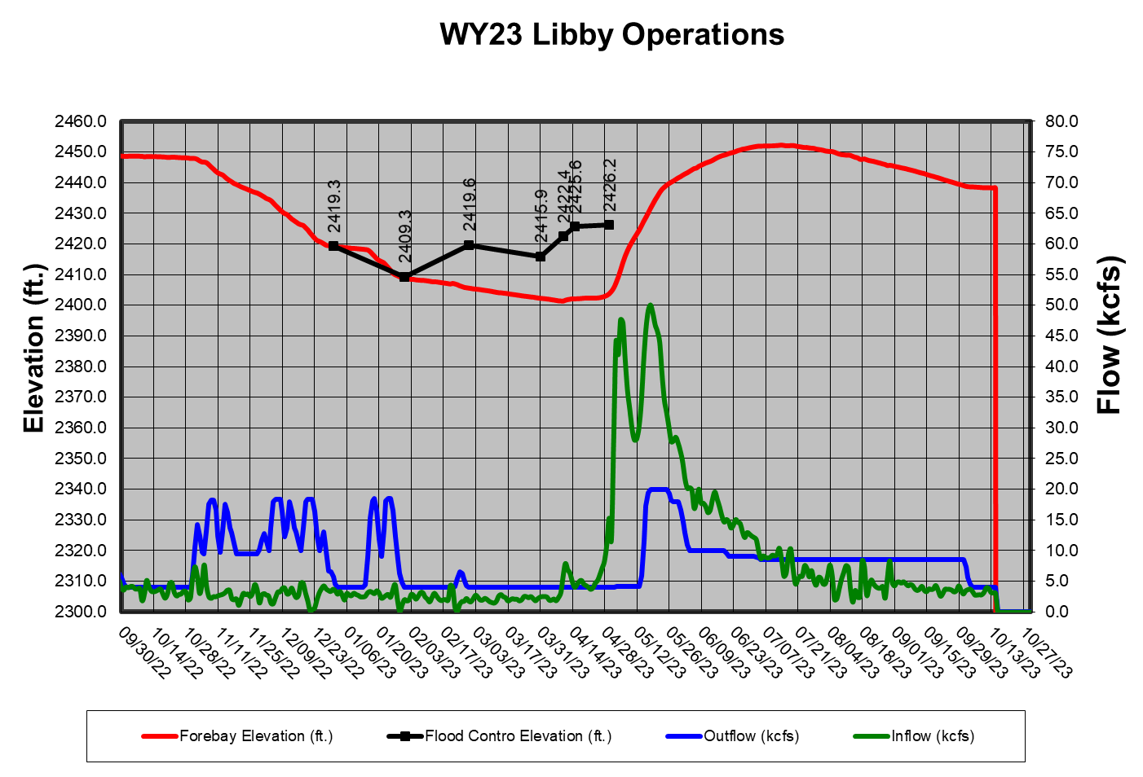
Hungry Horse Dam
Knieff Creek Culvert Repair in 2023 Reclamation will operate HGH to be below elevation 3520 feet in March and April to accommodate the repair of the culvert at Knieff Creek upstream of the Hungry Horse Dam.

Water Supply Forecast and Minimum Flows: The minimum flow requirements are measured at two locations the South Fork Flathead River below Hungry Horse Dam and the Flathead River at Columbia Falls. The minimum flows will be determined monthly, beginning in January, with the Reclamation’s WSF forecast for Hungry Horse Reservoir for the period of April 1 to August 31. The final flow levels, for the remainder of the calendar year, are based on the March Final forecast.

April 10 and June 30 Refill Objectives:

The Reclamation computes Hungry Horse’s final April 10 elevation objective by linear interpolation between the March 31 and April 15 forecasted flood control elevations based on the March Final WSF.

In 2023, Hungry Horse dam was drafted below the April 10 elevation objective to accommodated the Knieff Creek culvert repair in th forebay.

Summer Draft Limit: The Reclamation will provide inseason updates to this section.

The summer operation will target the reservoir elevation of 3540 feet to 3550 feet (20 feet to 10 feet from full) by September 30 and this will be based on the water supply forecast. The table below shows the end of September targets based of the Hungry Horse May water supply forecast. However, if the project fails to refill, especially during drought years, minimum flow requirements may draft the reservoir below the end of September target elevation.
Hungry Horse End of September Elevation Targets
Hungry Horse May-September inflow forecast (KAF) | Hungry Horse forebay target on Sept 30 (ft)
< 1410 | 3540
1410 – 1580 | Interpolate between 3540-3550
> 1580 | 3550

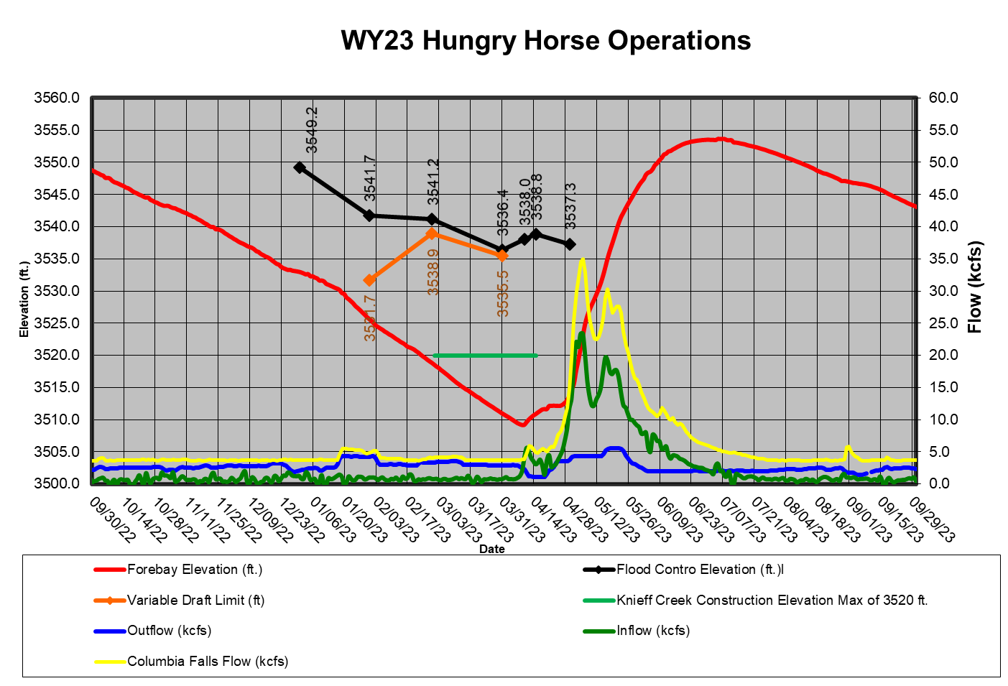

Grand Coulee Dam
April 10 and June 30 Refill Objective: The Reclamation will provide inseason updates to this section.

The April 10 elevation objective in 2023 was augmented due to the required drum gate maintenance at elevation 2053. Due to historically low inflow in March of 2023 and support for downstream flow requirements for chum and Hanford Reach fall chinook the reservoir was drafted to elevation 1240 feet.

The Lake Roosevelt Incremental Storage Release Program: The Reclamation will provide inseason updates to this section.

Table 8. Lake Roosevelt releases requested for 2023.
“Bucket” | 2023 Releases (acre-feet) | Total Lake Roosevelt Incremental Storage Releases Program (acre-feet)
Odessa
M&I
Instream Flow

Summer Draft Limit: The Reclamation will provide inseason updates to this section.

The Grand Coulee summer draft limit is set by the magnitude of the RFC's July Final April-August WSF at The Dalles Dam.

Drum Gate Maintenance: In 2023, Reclamation completed scheduled drum gate maintenance and repaired two seals were found to be leaking significantly in the summer of 2022. Drum gate maintenance began on Monday March 13, 2023 and is expected to be completed by May 5, 2023. The forebay elevation on March 12, 2023 was at elevation 1252 feet.

Banks Lake: The Reclamation will provide inseason updates to this section.

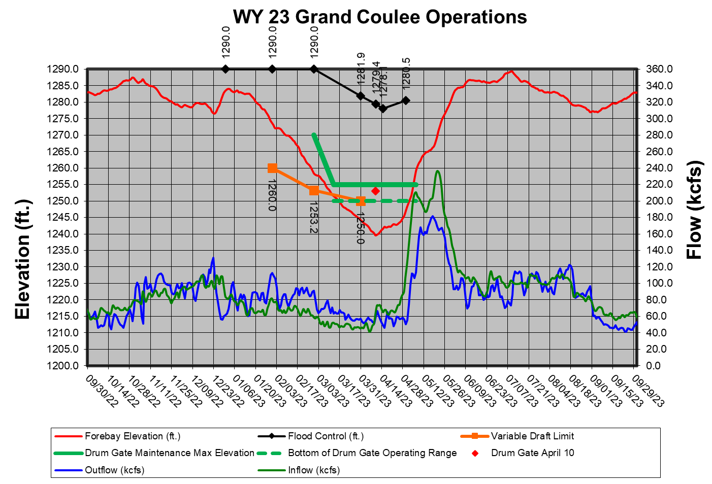

Dworshak Dam
Flood Risk Management Elevation:

Operate in accordance with standard FRM criteria; shift system FRM to Grand Coulee Dam when possible, unless modified by procedures under dry-water-year operations. The shift in system FRM space will end by April 30th, such that each project storage will satisfy their respective FRM space requirements.

Dworshak Dam was operated to meet standard FRM criteria for water year 2023. The official water supply forecast on April 5 was 2,521 KAF, which set an end of month target elevation of 1,520.9 ft. With a midnight elevation on April 1 of 1,521.23 ft, the project just remained around the FRM target for the whole month of April. The actual April 30 midnight elevation was 1,517.41 ft, which was a little more than 3 feet below the FRM target.

April 10 Elevation Objective:

When not operating to minimum flows, operate to reach the upper FRM rule curve on or about
April 10 elevation objective (the exact date to be determined during in-season management), to
increase flows for spring flow management.

Dworshak Dam remained at minimum outflow from the end of September through the end of March. Inflow remained below 5 kcfs through the beginning of April. Outflow was increased to 5.1 kcfs at the end of March, then once again increased to 10.2 kcfs around mid-April. The outflow increases were to meet the April 30th FRM elevation of 1520.9 feet. Increasing outflow at the end of March allowed the project to increase to full powerhouse capacity instead of needing to spill at the end of April.

Variable Draft Limit:

Calculate a VDL in season to increase power generation from January to March, while protecting the ability to refill with 95% confidence based on the March 31 FRM upper rule curve.

In 2023, below average water supply forecasts and low inflow precluded the availability of flexibility.

Total Dissolved Gas: The Corps will provide inseason updates to this section.

Provide augmentation flows while not exceeding the state of Idaho TDG water quality standard of 110 percent saturation.

Idaho TDG water quality standards have been surpassed two separate times this year. The first time TDG surpassed the 110% criteria, unit 2 was being used at minimum flow. The unit at this low flow began producing a lot of excess TDG. To resolve the problem, operations were switched over from unit 2 to unit 1. Unit 1 has shown to not produce excess TDG when at a low flow. The second time TDG was surpassed, unit 1 went down and the project brought unit 2 online. This only occurred over a period of a couple hours and when available they switched back over to unit 1. The highest TDG that was hit during this period was 110.2% for two hours. If unit 1 begins to creep up in TDG, the project will increase from 65 MW to 75 MW to produce more flow throught the turbine.

Refill:

At the beginning of May, outflow was decreased to 5.1 kcfs to begin refill operations at Dworshak Dam. Due to a rapid warm-up in the Clearwater basin, there was 1,231 kaf of runoff in the month of May. This required outflows to decrease to minimums to begin capturing water for refill. The mignight elevation of June 1 was 1,584.52 feet. The reservoir reached full pool by the end of June. Full pool was held through the holiday weekend and then flow augmentation releases began for the Lower Granite tailwater temperature.

End of August and September Forebay Elevations: The forebay was drafted to elevation of 1,537 feet by the end of August and to an elevation of 1,520 feet (80 feet from full) on September 23.

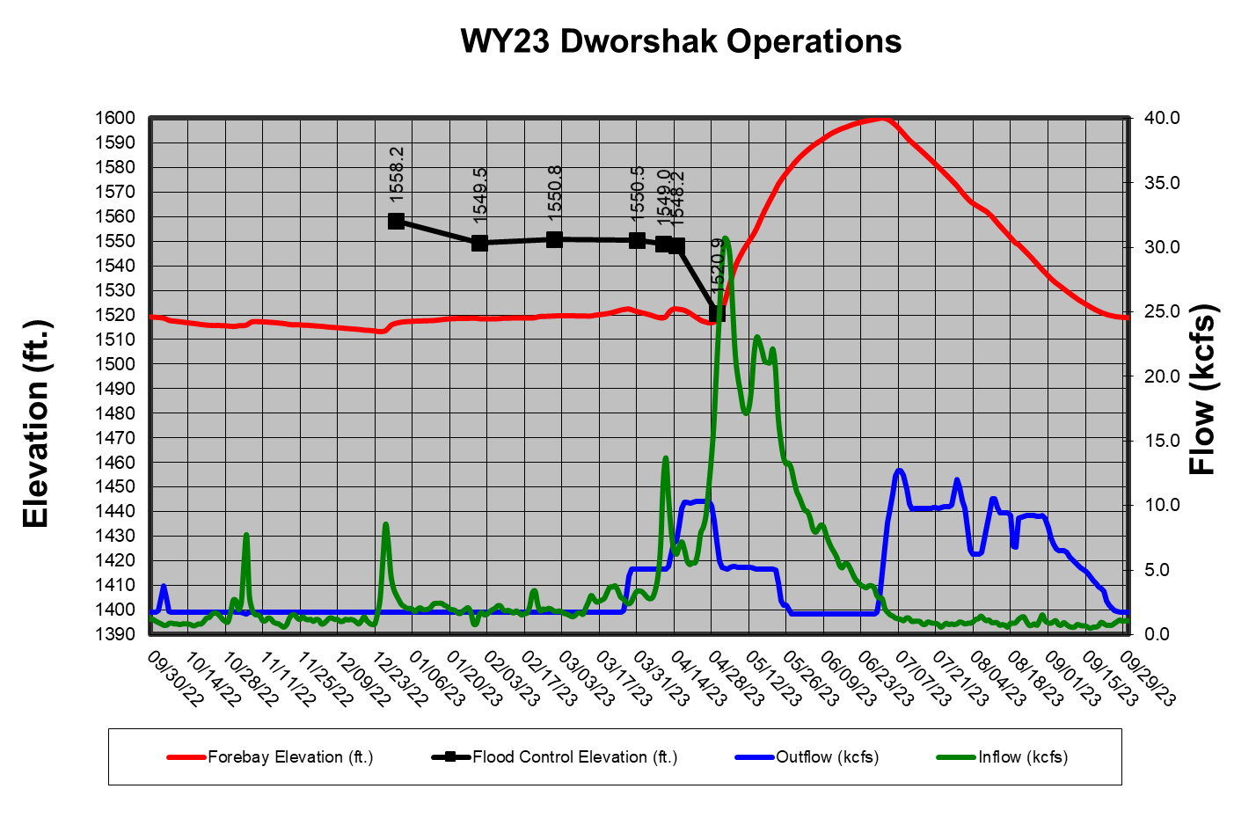

Outflows for Lower Granite Dam Tailwater Regulation: The Corps will provide inseason updates to this section.

Regulate outflow temperatures to attempt to maintain water temperatures in the Lower Granite Dam tailwater at or below 68°F, typically from July 1 through the end of September.

Water Quality
The AAs have coordinated the following spill priority lists with the TMT to date, and they may be found on the following website.

http://pweb.crohms.org/tmt/documents/spill-priority/
  - Burbot Spawning Operations
Provide the lowest discharge temperatures available in the reservoir forebay through use of Libby Dam’s selective withdrawal system to aid burbot migration and spawning in the Kootenai River in Idaho (October through February). An international interagency Memorandum of Understanding Concerning the Kootenai River/Kootenay Lake Burbot Conservation Strategy was completed in June 2005. Use of VARQ FRM procedure and implementation of the variable end-of-December FRM target elevation may increase the effectiveness of this operation in years with below average runoff forecasts (low flows / colder river temperature at Bonners Ferry).
  - Lake Pend Oreille Kokanee Elevation (Albeni Falls Dam)
Albeni Falls Dam drafted Lake Pend Oreille to within 0.5’ of its winter control minimum elevation for Kokanee spawning on 11 November. This half of foot band lasted until the end of Kokanee spawning on 31 December.

In early January of 2023 1 foot of water per the Flexible Winter Power Operation was storing in Lake Pend Oreille. The stored water was released in late January through early February.

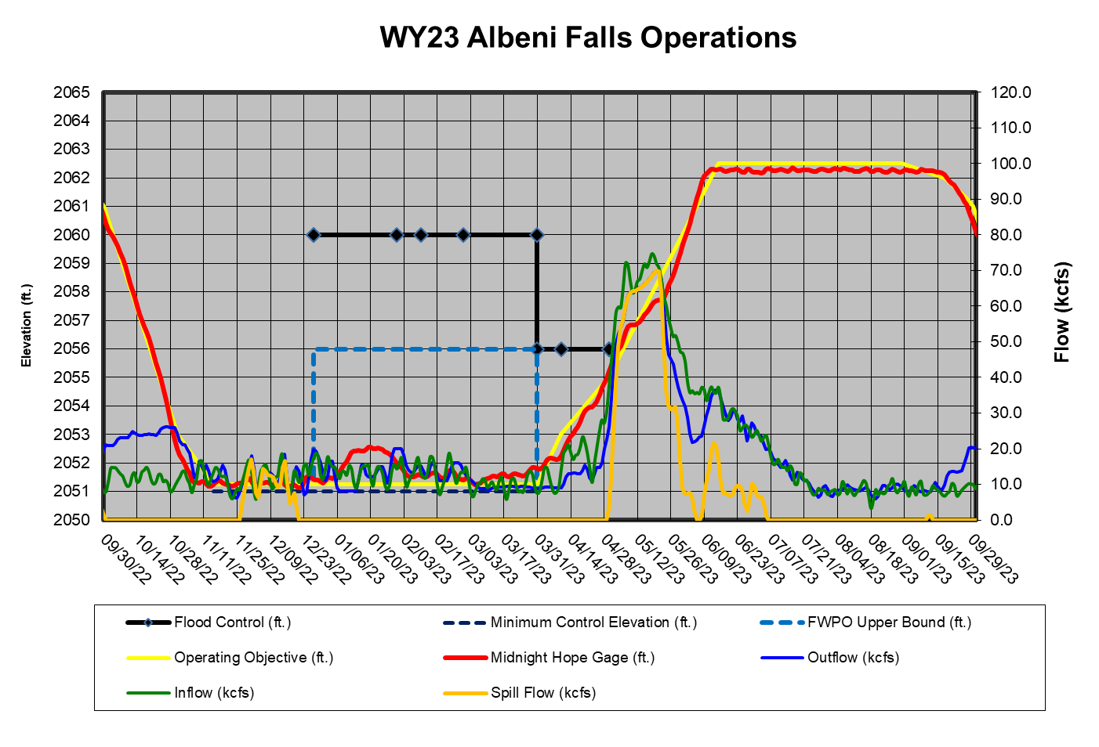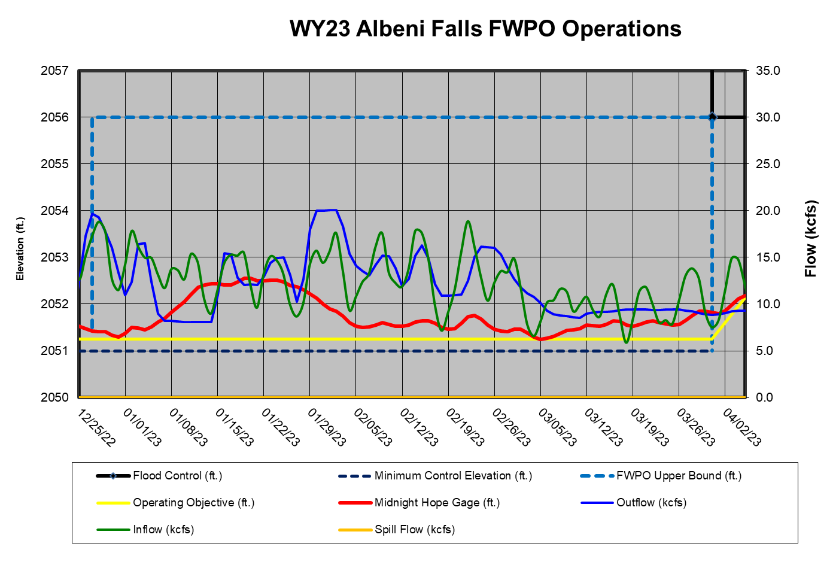
  - Upper Snake Flow Augmentation
The Reclamation will provide inseason updates to this section.
  - Chum Operation
The BPA and Corps will provide inseason updates to this section. The following summarizes the 2022/2023 TMT coordinated chum operation. Additional information on the TMT coordinated chum operation may be found in the TMT meeting minutes on the following website.
http://pweb.crohms.org/tmt/
Date | TMT Coordination Summary
October 19, 2022 | Chum Operation – The Corps, reported on current conditions and coordination for the start of chum operations. Precipitation is on the way. The NWRFC forecasts for the next 10-days start dry on days 1 and 2, then on day 3 notable precipitation starts to pick up in the entire Columbia River Basin. Precipitation will continue throughout the remainder of the 10-day period. Forecasts show Bonneville with flows around 100 kcfs by the end of the 10-day period. The Corps noted that precipitation in the lower Columbia can often play a significant role in the chum operation. The 10-day QPF shows healthy volumes of precipitation throughout the entire basin, with an excess of 100%, and up to 125-150% of average precipitation, and values ranging from ¾ inch to 5 inches (up to 4 inches in the Cascades). While the 5-day QPF is lighter, it remains noteworthy. Climate forecasts for the 6-10-day and 8-14-day outlooks both show a probability of below average temperatures throughout the Columbia basin, and a probability  of above average precipitation.  Tony Norris, BPA, reported the 10-day streamflow forecast for the Hood River shows a response to the incoming precipitation. He noted that this demonstrates a similar response should be seen in Hamilton Creek and Hamilton Springs. The forecasted 10 days of significant precipitation (especially on the west slope of the Cascades) typically produce good conditions for chum. Forecasted conditions within the immediate 14-day timeframe provide an opportunity for the chum operation to start as early as November 1, if TMT Members agree.  Kelsey Swieca, NOAA, reported 1 chum at Bonneville few weeks ago, although nothing in the past couple days and no chum yet in the below-Bonneville spawning surveys. Charles Morrill, WA, noted that the Ives area is not a good indicator of chum presence until the Bonneville tailwater is at 11.1-11.3 feet elevation. Typically, chum do not use the area at lower elevations. He noted that due to technical difficulties, an update on the Greys River is unavailable at this time. He will provide an update to the TMT when available.  Joel Fenolio, Reclamation, reported that the agency is fine to move ahead with the chum operation, despite few chum in the area currently. He noted that this year is a planned Grand Coulee drum gate maintenance year. Dave Swank, USFWS, added that releases seem to attract and stimulate chum spawning behavior, emphasizing it may not be appropriate to wait until there are large numbers present in Ives area before initiating operations.  The Corps reviewed the proposed 2022/2023 TMT coordinated chum operation (as posted to the TMT website), and TMT Members provided feedback. Generally, fish managers were supportive of the proposed operation. Kirk Truscott, Confederated Tribes of the Colville Reservation, expressed caution around Grand Coulee Dam refill, noting that with current climate predictions he is comfortable, and would like to continue to monitor conditions to avoid having to rachet back flows out of Coulee to refill in April.  Based on positive TMT input, chum operations will begin on November 1 with the same operation as coordinated last year, operating Bonneville tailwater to the 11.3 ft (11.5 ft with buffer) tailwater minimum. Action Agencies will coordinate with the project and implement the operation.  Coordination for the spawning phase will be from November through December, and will transition into the incubation phase from January through April 10, 2023 (or sooner, as coordinated by the TMT). TMT partners will continue to provide chum updates at TMT meetings throughout the operation.
November 2, 2022 | The Corps, reported on the October 19 TMT coordinated chum operation  which started on November 1 at 0600 hours. Currently, the operation is in step 2, which operates project outflow to provide a tailwater elevation in the range of 11.3-13.0 feet. The complete operational steps are the same as last year, and are posted to the TMT website.  On November 1, Bonneville Dam tailwater averaged of 11.4 feet, with average outflows of 127 kcfs. Today the project tailwater elevation ranged from 11.4 feet – 11.8 feet, with total outflow ranging from 122-133 kcfs. The Corps reminded the TMT that there are 2 project tailwater elevation columns on the Corps website: the Tanner Creek gauge is used for the chum operation and is the far-right column.  The NWRFC inflow forecasts for the next 10-days starts with a low of 114 kcfs today, and a high of 134 kcfs on November 6. The 10-day forecast period shows a trend of cooling temperatures and precipitation.  Kyle Dittmer, CRITFC noted that the significant precipitation starting on Friday is the first atmospheric river event (pineapple express) of the season. The NWRFC climate forecast for the 6–10-day outlook and the 8–14-day outlook are the same, with a probability of below average temperatures through the Columbia River basin, and a probability of above average precipitation.  Tony Norris, BPA noted the project has been hitting targets, and soon the response to precipitation should affect stream flows. Dave Swank, USFWS, noted that the Hamilton Creek gauge is not yet registering flows and Tony agreed to check on it while in the field later this week.  Kelsey Swieca, NOAA, reported a few chum per day have passed Bonneville over the past week, with 36 YTD. This is 3 times higher than last year and 233% of the 10-year average for the same date. No chum have been counted yet in the spawning surveys below-Bonneville. Charles Morrill, WA, anticipated that they will see chum this week as flows come up.
November 16, 2022 | The Corps, reported on the October 19 TMT coordinated chum operation  which started on November 1 at 0600 hours. Currently, the operation is in step 2, which operates Bonneville Dam outflow to provide a tailwater elevation in the range of 11.3-13.0 feet. The complete operational steps are posted to the TMT website.  At 0700 hours this morning, Bonneville Dam’s project outflow was 141.6 kcfs, with a tailwater elevation of 11.5 feet. NWRFC forecasted inflows range from 138 kcfs on November 17 to 125 kcfs on November 23. The 10-day meteorological forecast period shows a high-pressure system on days 1-5, resulting in little precipitation and cold temperatures, while days 6-10 show incoming precipitation and rising freezing level elevations. The climate forecast for the 6-10-day outlook shows temperatures generally above average to near normal (above average west of the Cascades, near normal east of the Cascades), and a probability of above average precipitation. The 8-14-day outlook shows a probability of above average temperatures and precipitation for the entire of the Columbia River Basin.  Trevor Conder, NOAA, reported that chum have been passing Bonneville in single digits until yesterday with 23; YTD passage is 171.
December 14, 2022 | The Corps, reported on the October 19 TMT coordinated chum operation,  noting the upcoming transition from the spawning to incubation phase of the operation (the current  spawning operation is posted to the TMT website).  The average project tailwater elevation at Bonneville Dam today is 12.7 feet. Total outflows have ranged from 138-142 kcfs, with an average of 141 kcfs. The NWRFC inflow forecasts for the next 10-days range from a high of 144 kcfs on Dec 16 to a low of 131 kcfs on December 14. The 10-day forecast period shows cool temperatures and little precipitation through this week, with incoming precipitation and lower freezing levels on Saturday throughout the Columbia River Basin for the remainder of the 10-day period, which should result in snow accumulation.  The NWRFC climate forecast for the 6-10-day outlook shows a probability of below average  temperatures throughout the basin, and near normal levels of precipitation in the Cascades and to the west, with a probability of above average precipitation east of the Cascades. The 8-14-day outlook shows a similar pattern of below average temperatures and above average precipitation throughout the basin.  Tony Norris, BPA, reported on data collected on December 2 by land surveyors, noting that Charles Morrill, WA, will accompany Tony on a December 23 land survey to help determine a desired water depth for redd protection. Based on the data collected December 2, Tony noted that an elevation of 11.8 is likely a good protection level target; this will be updated as needed based on continued weekly survey count data and pending elevation survey. Protection levels can be adjusted into the new year. Thousands of chum have been observed spawning in the Ives/Pierce area and Hamilton Creek and Springs this season.  Action Agencies offered December 23 as a tentative date to shift from the chum spawning operation to the incubation phase, pending more survey data; Tony noted pushing the date out further towards the end of the year is likely due to the number of chum present. Charles agreed and noted that with the abundance of chum this season, protection for emergence will likely be pushed out to the end of the year, if not January 1. Erick Van Dyke, OR, requested that the draft incubation operation description (on the TMT website) is edited to show a potential spawning operation end date of 12/31 instead of 12/23 to be consistent with the operating document, and that timing of the shift to the incubation phase is biologically-based.  TMT partners will continue to monitor chum spawning. Between now and the end of the month, WA, OR, NOAA, and BPA, will continue to coordinate the shift to the incubation operation (via calls and email). Charles noted that, should significant numbers of chum still be observed at the end of the year, a discussion would occur on when to transition the operation.
January 4, 2023 | The Corps, reported on the December 14 TMT coordinated chum operation, noting that the incubation phase of the operation began on December 31, 2022, and will end on April 10, 2023, with the start of spring spill at Bonneville Dam (current incubation operation is posted to the TMT website). Any changes to the end date would be coordinated through the TMT. The incubation operation maintains a Bonneville Dam minimum tailwater elevation of 11.8 feet at all hours.  Today at 0700 hours, project tailwater elevation was 12.6 feet, with a total outflow of 134 kcfs. The Corps noted that the project has maintained the minimum tailwater elevation since start of the incubation phase of the operation on December 31, 2022. The NWRFC inflow forecast and for the next 10-days range from a low of 120 kcfs to a high of 150 kcfs. The 10-day forecasted period shows a steady influx in precipitation in western Washington and Oregon, although still below average for this time of year. Similarly, the 10-day QPF shows localized areas of above average precipitation in eastern Oregon and Idaho, however, many areas are still below average.  The NWRFC climate forecasts for both the 6-10 and 8-14-day outlooks show a probability of above average temperatures and precipitation.  The Corps noted that the annual NWRFC Water Supply Briefing will occur tomorrow and can be accessed via their homepage. The Briefing will be recorded for those who cannot attend live.  Tony Norris, BPA, noted a significant precipitation event at the end of December 2022, with Willamette River flows peaking at the same time and unregulated river inflow. This resulted in the daytime tailrace elevation rising above 13 feet.  Charles Morrill, WA, reported that field crews were able to get out at the end of December and beginning of January; crews did not observe new redds during the high-water period. A few live chum were in the Hamilton Creek area, however, WDFW believes spawning is wrapped up and that the incubation operation should go forward as planned.
January 25, 2023 | The Corps reported that Bonneville today at 0700 hours had a total outflow of 134 kcfs,  with a project tailwater elevation of 12.2 feet. The NWRFC inflow forecast for the next 10-days ranges from a low of 124 kcfs on February 3 to a high of 130 kcfs on January 30; it is a relatively constant and stable inflow forecast. The 10-day forecasted period shows localized areas of above average precipitation in central and eastern Idaho and northwestern Montana, but below average precipitation throughout the majority of the Columbia River Basin. Similarly, the 5-day QPF shows areas in central and eastern Idaho and northwestern Montana with above average precipitation, while the remainder of the Columbia River Basin shows predominantly below average precipitation.  The NWRFC climate forecast for the next 10-days shows generally below average precipitation as well as cooler temperatures; precipitation will come in Thursday through Saturday. Values are below average for this time of year, with forecasted snow levels dropping. Cooling through the 10-day period will start on Sunday with the freezing level down to sea level (0.0 feet).  In response to a query from Charles Morrill, WA, Tony noted that Bonneville is drafting towards the drum gate maintenance elevation and is operating with the draft for Grand Coulee. BPA fully expects to be able to support the chum minimum tailwater elevation through April 10; Reclamation confirmed this.
February 8, 2023 | The Corps reported that Bonneville Dam today at 0700 hours had a total outflow of 133.8 kcfs, with a project tailwater elevation of 12.1 feet. The NWRFC inflow forecast for the next 10-days ranges from a high of 148 kcfs on February 9, to a low of 127 kcfs on February 17. The 10-day forecasted period shows below average precipitation throughout most of the entire Columbia River Basin, with some near average conditions in the upper Columbia basin and NW Washington. The 5-day QPF shows a similar story of well below average precipitation; overall dry conditions are expected throughout the basin for the next 10-days. The NWRFC climate forecast for the 8-14-day outlook shows a probability of below average temperatures and some variability with above average precipitation in Washington, Idaho, and NW Montana, with near normal conditions in Oregon.  Tony Norris, BPA, presented collected GPS data (since 2016) that show locations and elevations of redds below Bonneville Dam; these data help inform accurate protection tailwater levels at Bonneville. Monitored areas where redds generally spawn include the Ives channel and pockets, Woodard Creek, the Breaks, Strawberry; McCord Creek and the boat ramp saw some spawners this year.  BPA expects to be able to continue to support the chum tailwater minimum while continuing to draft Grand Coulee for drum gate maintenance; they continue to monitor water supply conditions and will report to TMT if any issues arise in the coming weeks.
February 22, 2023 | The Corps, reported that Bonneville Dam today at 0700 hours had a total outflow of 134 kcfs, with a project tailwater elevation of 12.1 feet. The NWRFC inflow forecast for Bonneville Dam over the next 10-days ranges from a high of 130 kcfs on February 22 to a low of 119 kcfs on February 28. The 10-day weather forecast period shows quite a bit of variability for precipitation; somewhat average conditions in western Washington, Oregon, and central Idaho, followed by far below average conditions. The 5-day QPF shows well below average precipitation throughout the Columbia River basin. In comparison to the Water Year (October 1, 2022-February 21, 2023), the Snake River above Ice Harbor dam is 80% of normal, the upper Columbia River basin above Arrow Dam is 73% of normal, and the Columbia River mainstem above the Dalles is 72% of normal. The NWRFC climate forecast for the 6-10-day outlook, as well as the 8-14 and 30-day outlooks, show a probability of below average temperatures and above average precipitation.  Tony Norris, BPA, noted that BPA still expects to continue to support the Bonneville Dam 11.8 feet minimum tailwater for chum while drafting towards Grand Coulee drum gate maintenance elevation. He added that with the forecasted dry conditions and low inflows into Grand Coulee, there is potential that additional draft out of Grand Coulee may be needed to support chum through March. Joel Fenolio, Reclamation, noted that with the dry conditions, there may come a point to consider tradeoffs between spring flows and chum operations over the next 6 weeks.  In response to a query from Kirk Truscott, Confederated Tribes of the Colville Reservation, Tony noted that regarding additional draft at Grand Coulee, there is potential to draft Grand Coulee below the drum gate operating range (5 feet) before chum emergence is complete. An additional TMT meeting was scheduled for March 1 to coordinate on the chum operation.
March 1, 2023 | The Corps, reported that Bonneville Dam today at 0600 hours had a total outflow of 136.6 kcfs, with a project tailwater elevation of 11.9 feet. The current Bonneville tailwater minimum for chum protection is 11.8 feet.  The NWRFC inflow forecast for Bonneville Dam shows continued low inflows into the project, in the 125 kcfs range over the next 10-days. The Corps noted that current water supply volumes forecasts show below average volumes:  • The Dalles: NWRFC April to August volume forecast is 73 maf, or 83% of average, and  • Lower Granite: NWRFC April to July volume forecast is 16 maf, or 81% of average.  Looking at observed precipitation so far this Water Year (October 1, 2022 – February 28, 2023); the Snake River above Ice Harbor Dam is 81% of normal, the upper Columbia River above Arrow Dam is 75% of normal, the middle Columbia River is below normal, and the Columbia River mainstem above The Dalles Dam is 73% of normal. The Corps noted that the Willamette River above Portland shows similar trends, at 64% of normal observed precipitation; this affects the chum operation by requiring more outflow from Bonneville to meet tailwater elevations.  The NWRFC extended forecast for Bonneville Dam at 50% climatology in April at the start of spring spill shows average conditions starting at 210-220 kcfs, while the current forecast is very low, in the 120 kcfs range. On the Snake River, Lower Granite at 50% climatology would put Lower Granite inflows around high 35-40 kcfs, while current forecasts are about 20 kcfs.  Jonathan Ebel, IDFG, noted that the NWRFC 30-year period of record for the percent normal values on the precipitation table is 1981-2010, and wondered if that is accurate or needs to be updated. Eric Chow, Corps, noted that the NWRFC is working on updating their datasets to the most recent 30-year period. In response to a query, Aaron Marshall, Corps, noted that the NWRFC inflow forecasts are updated daily, typically twice a day. The Corps provides reservoir regulation updates Mondays and Thursdays generally, unless there is an unusual situation that would require more frequent updates. Also, current snow pack is taken into consideration for short term and seasonal runoff forecasts in the basin, and is updated twice daily.  The Corps reported that from a water management standpoint, current low water supply conditions don’t allow for meeting both objectives of an 11.8 ft minimum tailwater elevation for chum protection and ensuring adequate flows for spring migration, leading to tough conversations on competing priorities (see Water Management Plan for description of priorities; posted to the TMT website). Per the 2020 BiOp and associated documentation, Grand Coulee refill for spring flows takes priority over the chum protection level. Outflows from Bonneville Dam will need to be reduced to support Grand Coulee refill, which supports spring flows for a wider range of ESUs.  Moving forward, the AAs will reduce outflows and lower the Bonneville tailwater elevation. Tony Norris, BPA, added that conditions (below average streamflow, precipitation, air temperatures) have reached the point where the availability of water remains insufficient to support the minimum tailwater elevation below Bonneville. In addition, due to low inflow into Grand Coulee Dam this month, the project is unable to release enough water daily within the draft rate limits for dam safety to augment the flow rate at Bonneville to meet the minimum tailwater elevation, and forecasted flows in the Snake River remain low.  While still balancing for spring refill, conditions are expected to persist until natural stream flows in the river increase sufficiently to alleviate the need for Grand Coulee Dam to augment flow to Bonneville. The resulting tailwater below Bonneville will vary and depend on the available water in the river, and wind and tide conditions. The AAs will attempt to maintain a stable Bonneville tailwater, likely around 10.2 feet, but if unable to given the water available, they will try to maintain as high as possible tailwater with a flat discharge across all hours. Tony noted that maintaining the hydro connection between the Columbia mainstem and Hamilton Springs will depend on the flows in Hamilton Creek (currently 1.5 feet over the gauge). Historically, the minimum elevation of 10.5 feet has been coordinated, but site visit observations prior to the start of chum at much lower tailwater still appeared to provide an egress path (March is historically peak migration out of Hamilton Creek). WDFW and BPA will continue to monitor the situation. Tony noted a plan visit the area with surveyors to take adjacent water surface elevations for redds previously identified. He hopes to report back in a couple weeks on the impact of the lower tailwater elevation on those redds.  Chris Runyan, Reclamation, added that inflows above Grand Coulee Dam have been below average since November 2022, around 85% of average. Tributaries are even lower for base flow, and forecasted inflows remain low. The project has operational draft rate limits, which are being met, and the project is currently directed to not exceed the draft rate limits this year due to landslide concerns on the Spokane Arm. Even with current projections, if conditions continue to be cold and dry, there could be even less local inflow. Reclamation is concerned with the impact to spring flows, as every additional foot drafted out of the project would need to be filled. Chris also noted concerns for local cultural resources while balancing delivering water to Columbia River basin projects to meet base demands.  Kirk Truscott, Confederated Tribes of the Colville Reservation, noted the Tribes’ disappointment in the current water situation, and concerns on the risks from low spring flows when upper Columbia River fish are moving, including ESA-listed spring Chinook. Chris noted that drum gate maintenance will start in mid-march and typically takes 6-8 weeks. Reclamation will update the TMT as the operation progresses and noted the desire from Fish Managers to expedite the work as  possible. Joel Fenolio, Reclamation offered that drum gate maintenance is only one of many impacts on the current situation, and that draft rate limits are irrespective of drum gate. Stream flows remain another significant contributor.  Action Agency Plan Moving Forward: Effective Thursday, March 2, Bonneville Dam minimum tailwater elevation will drop down to 10.2 feet. Due to physical limitations of draft rate limits, the project may not be able to sustain this elevation at all hours, while it does remain the objective. Tony reiterated that if BPA is unable to maintain a minimum of 10.2 feet at all hours, they will attempt to flatten the discharge across the remaining hours to maximize the tailwater during those hours with the available water. There could be variable outcomes downstream of Bonneville if outflows are insufficient to meet 10.2 feet.  WDFW, NOAA, and USFWS Fish Managers noted that they appreciated the discussion, efforts, and coordination to balance chum elevations and spring flows, and acknowledged that this tradeoff is difficult.
March 8, 2023 | The Corps, reported that, as of last Thursday, the Corps began operating the Bonneville Dam minimum tailwater elevation to 10.2 feet on all hours. The Corps noted that this operation change had an impact in both total outflow and project tailwater elevation. Total outflow for March 8, hour 0600, was 115.8 kcfs and the project tailwater elevation was 10.4 feet. Prior to the change, the minimum tailwater elevation was 11.8 feet.  Looking ahead, the NWRFC inflow forecast for Bonneville Dam shows inflows into the project ranging from 105 kcfs to 120 kcfs over the next 10-days. The NWRFC extended forecast for Bonneville Dam 120-day outlook is well below 50% climatology. The current forecast for March shows low precipitation and water supply forecasts are showing low project inflows. According to the 10-day QPF, some areas are forecast to get above average amounts of precipitation, however, when quantified into inches, it will be relatively low and not enough to relieve the water year deficit.  The Corps reviewed the Water Year Precipitation Summary Table and noted that, while precipitation in the 10-day forecast period is occurring in the region, the observed precipitation across the Water Year (October 1, 2022 to current) is below normal conditions. Specifically,  • In the Snake River above Ice Harbor Dam, the observed precipitation is 81% of normal.  • The Upper Columbia River is experiencing below average conditions.  • In the Columbia River Main Stem above the Dalles, the observed precipitation is 73% of normal.  • Low precipitation values in Western Oregon are another variable as the Willamette can help bolster the Bonneville Dam tailwater. For the Willamette River Basin above Portland, precipitation values are 65% of normal.  Tony Norris, BPA, noted that Bonneville Dam currently needs inflows of 110 to 115 kcfs to produce tailwater elevations of 10.2 feet, or slightly above. BPA continues to draft Grand Coulee to support the 10.2 feet. elevation; however, inflow to Grand Coulee is still insufficient to support a higher tailwater of 11.8 feet. He noted that an atmospheric river is in the forecast for next week, with below average temperatures that will be closer to average temperatures for this time. This weather event is forecasted to produce some increases in stream flows, which may result in slightly better conditions for chum for a period of time. He noted that the 10-day forecasts for the Willamette River at Salem, the Snake River at Lower Granite and the Hood River near Tucker Bridge all show an increase in stream flows which indicates there could be an increased flow into the Bonneville pool. The increase in the flow in the Willamette will decrease the flow rate needed to produce a specific tailwater at Bonneville Dam.  The 10-day weather forecast also shows the forecasted maximum temperatures will be a bit warmer while the nighttime minimums will not be as cold as they have been.  The AAs will continue to operate to preserve water in the system and at Grand Coulee and to operate the Bonneville Dam tailwater between 10.3 and 11.8 feet, when possible, to take advantage of this natural increase in flow to provide better conditions for migrating chum. He cautioned that there is a lot of uncertainty as to what actual flow response will occur and what the conditions will be like after this weather event. Tony will be visiting the area with WDFW on Thursday to take water surface elevations adjacent to redd locations previously identified in 2022.  In response to an inquiry from Jay Hesse, Nez Perce, Tony noted that the chum spawned in areas of upwelling and consequently, it is not certain that the redds have been completely desiccated; BPA is operating on the assumption that some fish have yet to emerge from the redds and would benefit from having a better egress path to the river. Charles Morrill, WA, added that other factors at play are the location of the redds and whether there is inter-gravel flow to support those fish; any additional flow will enhance the opportunity for fry to emerge out and move downstream. He noted that emergence is ongoing, and fry have been observed coming out of Duncan and Hamilton Creeks. Tony noted that any tailwater above 10.2 – 10.5 feet would allow flow to pass over the upstream bar and to pass between Ives Island and Hamilton Island. Charles noted that there is a lot of low elevation snow in the lower Gorge, and if there is additional wet, warm weather, the area will see a lot of runoff. Charles will attempt to get data from the crews that are running the traps and share the data with TMT.  Erick Van Dyke, OR, noted that peak flow/flash flood events have been known to impact redds negatively. He added that the operations being discussed are water management operations and not natural flow dynamics. Tony noted the relative change in the Ives Complex would be incremental, not flooding, however, conditions could be turbulent for fish in Hamilton Creek due to the elevation changes. Hamilton springs is not expected to fluctuate.  Jonathan Ebel, ID inquired whether the survey might provide some quantification of potential desiccation. Tony noted that while it is not possible to quantify the level of desiccation, the survey will provide water surface elevations and photos of the locations. Charles noted that in areas where it appears redds are below the current water levels, it might be possible to check for inter-gravel flow.  An additional TMT meeting has been scheduled for March 15 to provide an update to TMT members on field  conditions.
March 15, 2023 | The Corps, reported on current hourly data at Bonneville Dam. Total outflow at 0700 hours was 120 kcfs, with a project tailwater elevation of 11.5 feet.  The NWRCF inflow forecasts for Bonneville Dam over the next 10-day period are relatively low, ranging from a low of 103 kcfs on March 15, to a high of 109 on March 20. Looking ahead, the 120-day forecast shows low inflows. Starting in April, 50% climatology is 181 kcfs at Bonneville Dam, and April 1 is currently forecasted to be 112 kcfs (below the 90% climatology value of 134 kcfs). While the forecasted precipitation in the region shows some variability, in the Columbia River basin, the 10-day and 5-day QPF both show well below average precipitation.  The Corps reviewed the monthly precipitation table for March, noting that this month has seen above average precipitation values. The Snake River above Ice Harbor Dam (observed month to date) is 180% of normal, and the Columbia River mainstem above The Dalles is 137% of normal. This monthly precipitation is not enough to get out of the current Water Year deficit, as the observed precipitation across the Water Year (October 1, 2022 to current) is still below normal conditions. The Snake River above Ice Harbor Dam is 89% of normal, and the Columbia River mainstem above The Dalles is 78% of normal. The 6-10-day temperature outlook shows a probability of below average temperatures and variability in precipitation: a probability of near normal in northern Washington, Idaho, and northwestern Montana, and a probability of above average precipitation in the southern Columbia River basin.  The Corps reiterated that the current tailwater minimum at Bonneville Dam is 10.2 feet for the chum operation, and, unless otherwise coordinated at TMT, this will continue through April 9 at midnight. Spring spill will begin on April 10.  Tony Norris, BPA, reported results from the March 9 water surface survey data (“2022 Chum Redds and March Water Elevation,” posted on the TMT website). The survey gave a snapshot of downstream water surface elevations during an average tailwater of 10.5 feet at Bonneville, to help identify which redds are above or below surface water. The location of redds were marked on December 2, 2022, at McCord Creek, Breaks, Ives Pocket and Channel, Woodard Creek, and the Hamilton Creek area. Tony noted that many redds are still under the water, and some are not. Charles Morrill, WDFW, noted that updates on emergence out of Hamilton Springs are still coming and he will update the TMT when it becomes available. Tony reported that the WDFW staff member on the survey trip noted that they generally count about 10,000 fry coming out of Hamilton Springs per day. At a 10.5-foot elevation, there are good egress conditions from Hamilton Creek to the river; egress is expected to be good if there is 1-1.5 feet of water above the gauge. Tony clarified that in terms of water elevation, each data point location has a timestamp and corresponding instantaneous average Bonneville tailwater hourly reading, and that data are looking at relative submergence. Additionally, the aerial photos used in the presentation are not reflective of the day data were taken.  See TMT minutes for questions/answers/comments
March 22, 2023 | The Corps, reported on the chum operation. Bonneville Dam project outflow was 123 kcfs at 0700 hours this morning, with a tailwater elevation of 11.5 feet. The NWRFC inflow forecast for the next 10-days shows a general decline in inflows, ranging from 118 kcfs to 103 kcfs by the end of 10-day period. Long term forecasts show a similar and continued trend of below average water supply conditions; current inflow forecasts are quite low, below 90% climatology at Bonneville. Forecasted precipitation is below average over the next 10-day period.  Observed precipitation across the current Water Year (October 1, 2022 to current) is still below normal. The Snake River is 88% of normal, the Columbia River mainstem above The Dalles is 76% of normal, and the Willamette River is 67% of normal for the WY.  The Corps reminded the group that the current TMT coordinated Bonneville Dam tailwater operation for chum is a 10.2 feet tailwater minimum at all hours, which will continue to be implemented through April 9 at midnight. April 10 is the transition to spring spill operations at the project. Tony Norris, BPA, reiterated that forecasts are consistently low. He noted that Priest Rapids will transition to running to the minimum to provide the minimum flows at Hanford Reach for fall Chinook, and Tony expects the Bonneville tailwater in the 10.2-10.5 feet range in coming days and weeks.  Kirk Truscott, Confederated Tribes of the Colville Reservation, expressed continued and elevated concern that maintaining chum and Vernita Bar flows results in getting further behind the FRM at Grand Coulee, and may seriously affect late April and early May flows in the Columbia River extant anadromous zone for juvenile migration. Jonathan Ebel, IDFG, shared Kirk’s concern and added that the current operations do not seem to be a “fish operation” at this point. Tony noted that AAs have been operating to take advantage of variable input into the system and precipitation events. He said that the AAs will manage closely to Vernita Bar minimums in the coming days, which can result in a more variable tailwater. Regarding Vernita Bar minimums, Kirk suggested looking at where fish spawned and to verify what flow is needed to support the redds this year, rather than assuming the standardized 60 kcfs flow minimum at Priest Rapids. This conversation was tabled for a later time.  Charles Morrill, WDFW, reported that crews have not been able to provide chum emergence data yet, and that he will provide information as it is available.
April 5, 2023 | The Corps, reported on the chum operation at Bonneville Dam. Total outflow at 0600  hours was 112 kcfs, with a project tailwater elevation of 10.6 feet. The NWRFC inflow forecasts for Bonneville Dam over the next 10-day period range from a low of 108 kcfs on April 7, to a high of 143 kcfs on April 12. As previously coordinated at TMT, Action Agencies will end the chum  operation at 0001 hours on April 10, concurrent with the commencement of spring spill. The Corps noted that spring spill on the Snake River started on April 3. Tony Norris, BPA, added that with Grand Coulee running close to Vernita Bar, Bonneville’s tailwater is expected to be variable but remain above 10.2 feet, even after April 10.  Charles Morrill, WDFW, noted that he has not yet been able to access spring trap and emergence data; once available, he will add a cumulative graph to the table presented previously at TMT.

Dates | Chum Water Management Summary
October | Grand Coulee filled to elevation ~1288 by the end of the month. Record dry fall flipped to above average precip in the last half of October providing sufficient rainfall on the west slope of the cascades to get Hamilton Creek and Spings flowing. By the end of October Hamilton Creek was flowing at ~1 foot over the gauge.
Nov 1-11 | A streamflow response from the late October precipitation was experienced during this period reducing the augmentation required from Grand Coulee and about 1 week where the BON TW was up to closer to 12.5 feet during the day. During this period Grand Coulee filled back to elevation 1287 feet before resuming the draft to support the BON TW once the streamflow recession took hold. By Nov 11, The BON TW was back to a range from 11.3 to 12.0 with augmentation draft from Grand Coulee.
Nov 12 – 30 | During this period the Snake and Willamette Rivers were both flowing <20 kcfs and Grand Coulee was augmenting the flow to meet the BON TW. The BON TW during this period ran very close to the bottom of the range, rarely exceeding 12.0 feet averaging ~11.6 feet. Grand Coulee drafted to elevation 1279 feet. This normally would draw significant concern except that this was a required drum gate maintenance year and we typically see more precipin December to recover the Grand Coulee forebay.
Dec 1-20 | During this period Grand Coulee generally passed inflow with some shape around a significant cold snap. The forebay began and ended this period at elevation ~1279 feet. The BON TW ranged from 11.3 to 13.0 feet.
Dec 21-24 | During this period, the region experienced a brief but severy cold snap. Grand Coulee drafted approximately 3’ to help meet load with Columbia River System hydrogeneration. The BON TW during this period was close to 13.0 feet during the day with TW exceeding 14 feet at night per the operational instructions.
Dec 25 - Jan 3 | Following the previous week’s colds snap was a period of significant precipation at warmer temperatures. The Willamette River peaked at ~75 kcfs at Salem with the Snake River peaking at ~45 kcfs. This increase in streamflow at the tail end of the spawning phase of the chum operation resulted in the BON TW significantly exceeding the daytime TW operating range. The increase in natural streamflows allowed for a decrease in outflow from Grand Coulee resulting in refill during this period to elevation ~1284 feet.
Jan 4 – 17 | During this period Tehie Willamette River receded to ~36 kcfs and the Snake River back to ~18-25 kcfs. Grand Coulee drafted approximately 2 feet ending this period at elevation ~1282 feet. The BON TW during this period averaged 12.6 feet.
Jan 18 – Feb 6 | During this period Grand Coulee’s forbay was being managed to achieve the drum gate maintenance elevation by March 12 while keeping an eye on the ability to meet the chum minimum tailwater. Grand Coulee ended this period at elevation 1272 feet.
Feb 6 –  Mar 1 | Dry and cold conditions persisted throughout this period. Grand Coulee was drafted across this period to support chum and achieve the drum gate maintenance elevation. The BON TW averaged ~12.2 feet reflecting the need to minimize the draft of Grand Coulee but still targeting the drum gate maintenance elevation. The Snake and Willamette Rivers remained well below average across this period and inflow to Grand Coulee average ~66 kcfs. The outflow from BON required to maintain the chum protection TW ranged from 125 to 140 kcfs. Grand Coulee forebay on March 1 was at elevation 1258 feet.
Mar 1 -12 | Inflow to Grand Coulee during this period (and through March) was insufficient to support the chum minimum TW of 11.8 at BON without exceeding the draft rate limit at Grand Coulee and drafting Grand Coulee excessively. This condition was not related to the required drum gate maintenance and would have occurred regardless of the forebay elevation at Grand Coulee. As a result the chum protection level was reduced to elevation 10.2 feet. Grand Coulee outflow was reduced by ~17 kcfs resulting in flow at BON of ~110-115 kcfs to minimize the impact on chum redds. On March 12 the GCL forebay elevation was at elevation 1252 feet. The maximum allowable forebay for the 3/13 start of drum gate maintenance was elevation 1255 feet.
Mar 13-21 | During this period above average precipitation produced a streaflow response in the Willamette and Snake rivers which resulted in some improvement in the BON TW which averaged ~11.1 feet. During this period the outflow from Grand Coulee was reduced by an average 5 kcfs but was offset with an average reduction in inflowof ~3 kcfs resulting in continued draft of ~0.4 feet/day. Grand Coulee ended this period at elevation at 1248 feet.
Mar 22-Apr 10 | During this period Grand Coulee was operated to meet the minimum flow in the Hanford Reach of 63 kcfs. This resulted in an additional reduction in outflow from Grand Coulee of 5-7 kcfs to ~58 kcfs. Inflow during this period continued to drop to below 50 kcfs resulting in continued draft of ~0.4 feet per day and a forebay elevation of 1240 feet on April 10. During the period the above average precipitation produced streamflow responses in the Snake and Willamette Rivers. The increased streamflow from the Snake and Willamette Rivers produced a BON TW average of ~11 feet.

Additional chum water management notes:
- February through March streamflows into Grand Coulee, Snake River and Willamette River were consistently below the 10th percentile of historial flows.
- The inflow to Grand Coulee in March average ~48 kcfs which was in the 0.6 percentile of inflow since 1977. Since 1977, inflow to Grand Coulee has been at 50 kcfs or lower 102 days. Of those days over half occurred in 2023.
- The inflow to Grand Coulee on April 8 was 39.7 kcfs which was in the 0.02 percentile of inflow since 1977. Since 1977 only 4 days was inflow to Grand Coulee lower than 39.7 kcfs.
- On March 12 the day before the start of drum gate maintenance the elevation of the forebay at Grand Coulee could have been only a maximum of 3 feet higher.
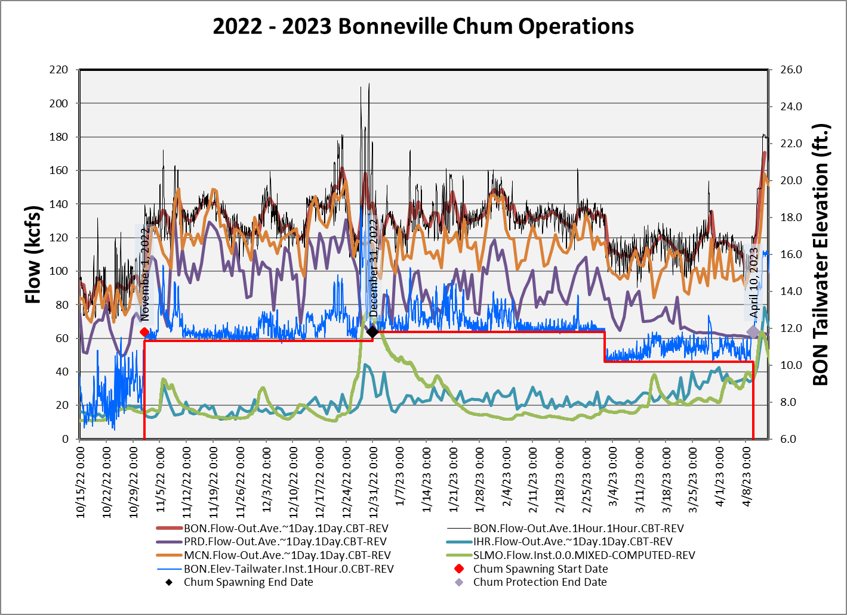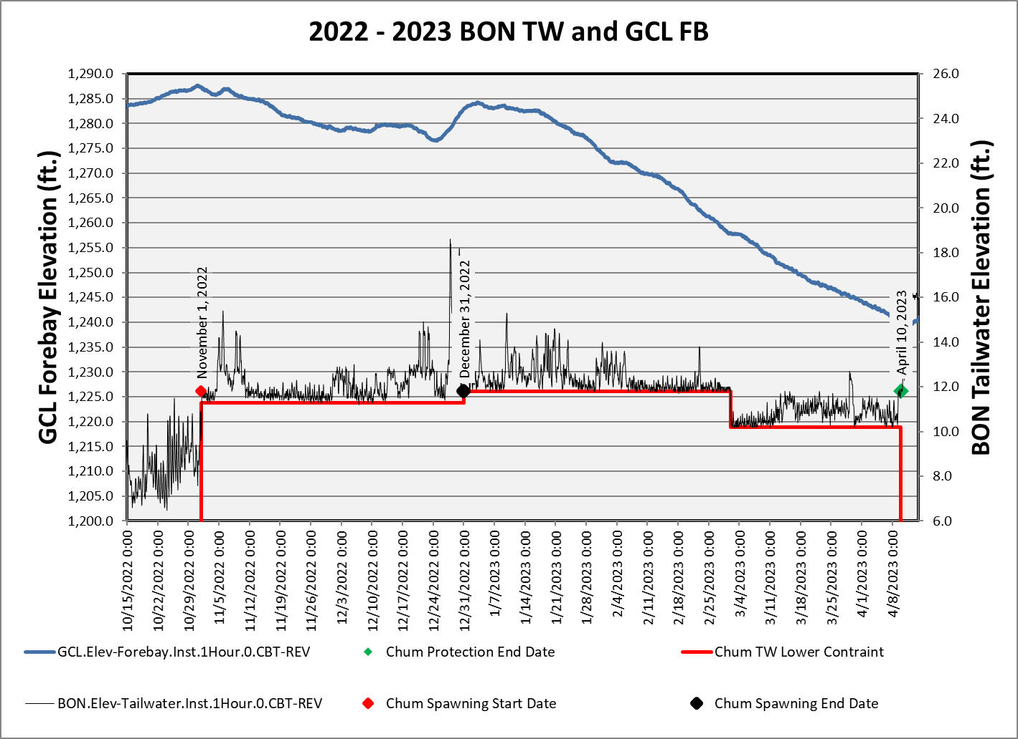
Chum survey data gathered at the Ives/Pierce Island Complex will be summarized in the table below. Data from all Chum survey areas, including the Ives/Pierce Island Complex, are provided by the Fish Passage Center and available on the following website.

https://www.fpc.org/spawning/spawning_surveys/ODFW_reports/2022spawning.htm

Table 9. Chum Salmon Spawning Ground Surveys Below Bonneville Dam, 2022-2023.

Survey Area
Ives/Pierce Island Complex

Date | Lives | Dead^{i} | Redds^{ii} | Visibility (feet)
12-Sep-22 | 0 | 0 | 0 | 12 ft.
19-Sep-22 | 0 | 0 | 0 | 10 ft.
26-Sep-22 | 0 | 0 | 0 | 12 ft.
3-Oct-22 | 0 | 0 | 0 | 12 ft.
11-Oct-22 | 0 | 0 | 0 | 12 ft.
13-Oct-22 | 0 | 0 | 0 | 7 ft.
17-Oct-22 | 0 | 0 | 0 | 15 ft.
20-Oct-22 | 0 | 0 | 0 | 8 ft.
24-Oct-22 | 0 | 0 | 0 | 8.5 ft.
27-Oct-22 | 0 | 0 | 0 | 15 ft.
31-Oct-22 | 0 | 0 | 0 | 4.5 ft.
8-Nov-22 | 31 | 1 | 4 | 3 ft.
16-Nov-22 | - | - | - | -
21-Nov-22 | 452 | 18 | 129 | 3.5 ft.
29-Nov-22 | 808 | 161 | 170 | 5 ft.
6-Dec-22 | 668 | 223 | 147 | 5.5 ft.
13-Dec-22 | 230 | 187 | 73 | 6 ft.
19-Dec-22 | 19 | 77 | 7 | 5 ft.
29-Dec-23 | 0 | 0 | 0 | 3.5 ft.
- Dead are newly samply fish only.
- Redds are an instantaneous count for the day, not cumulative.
NC = No Count

Chum redd locations and water surface at a BON TW of 10.5 feet.

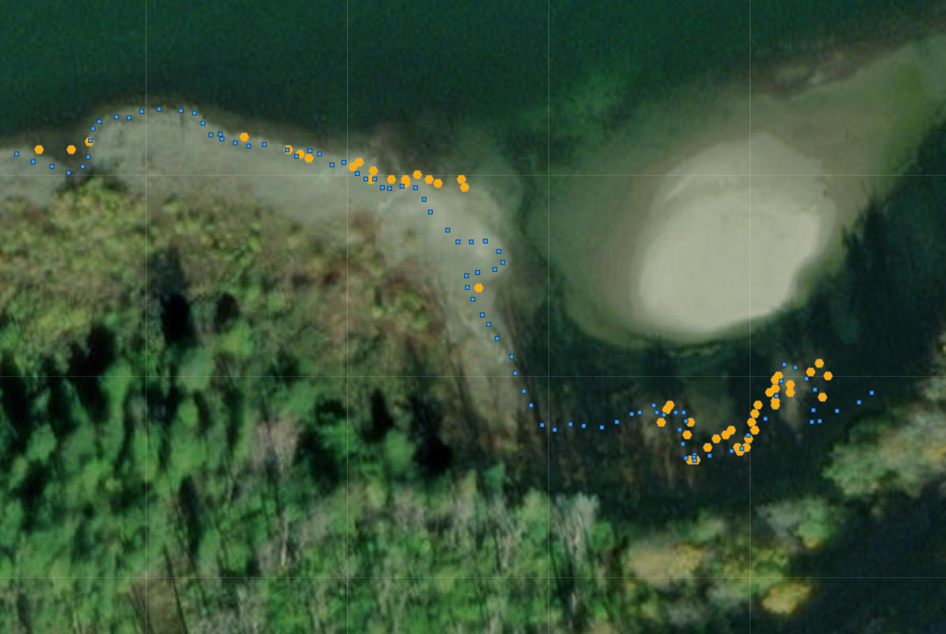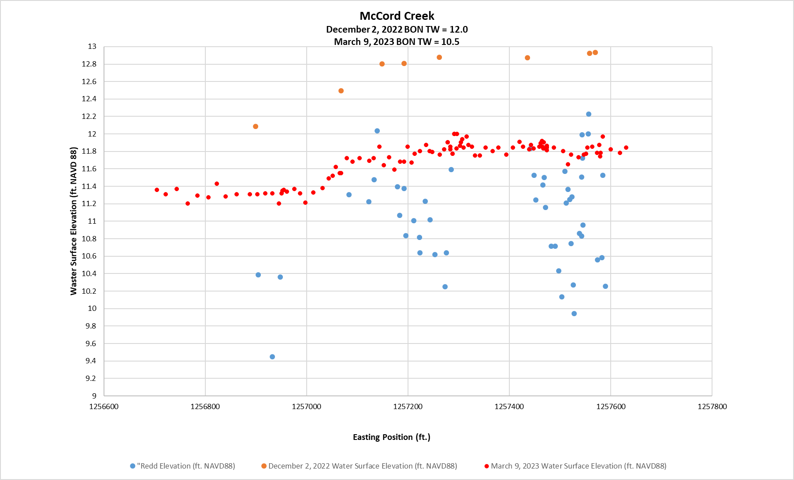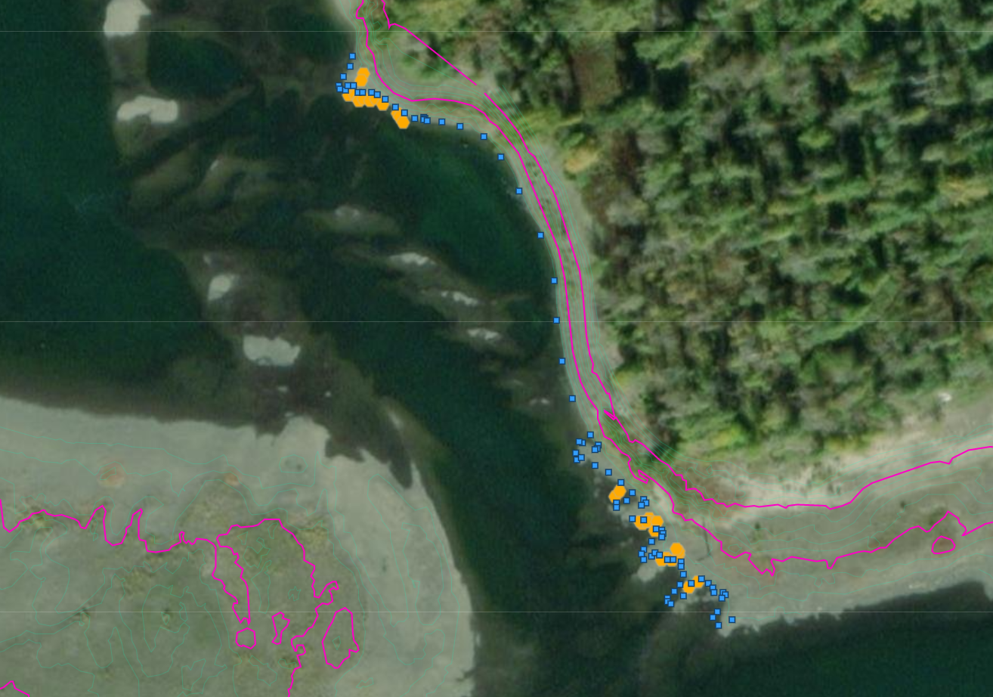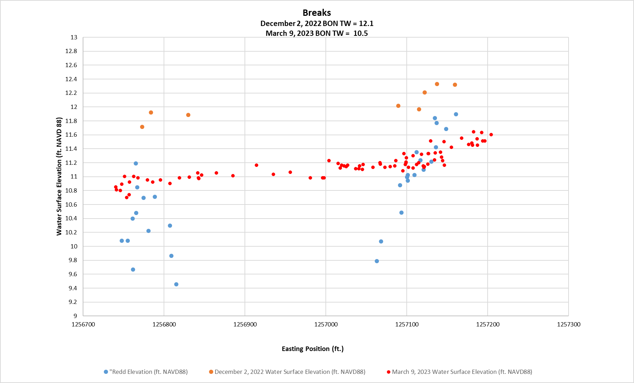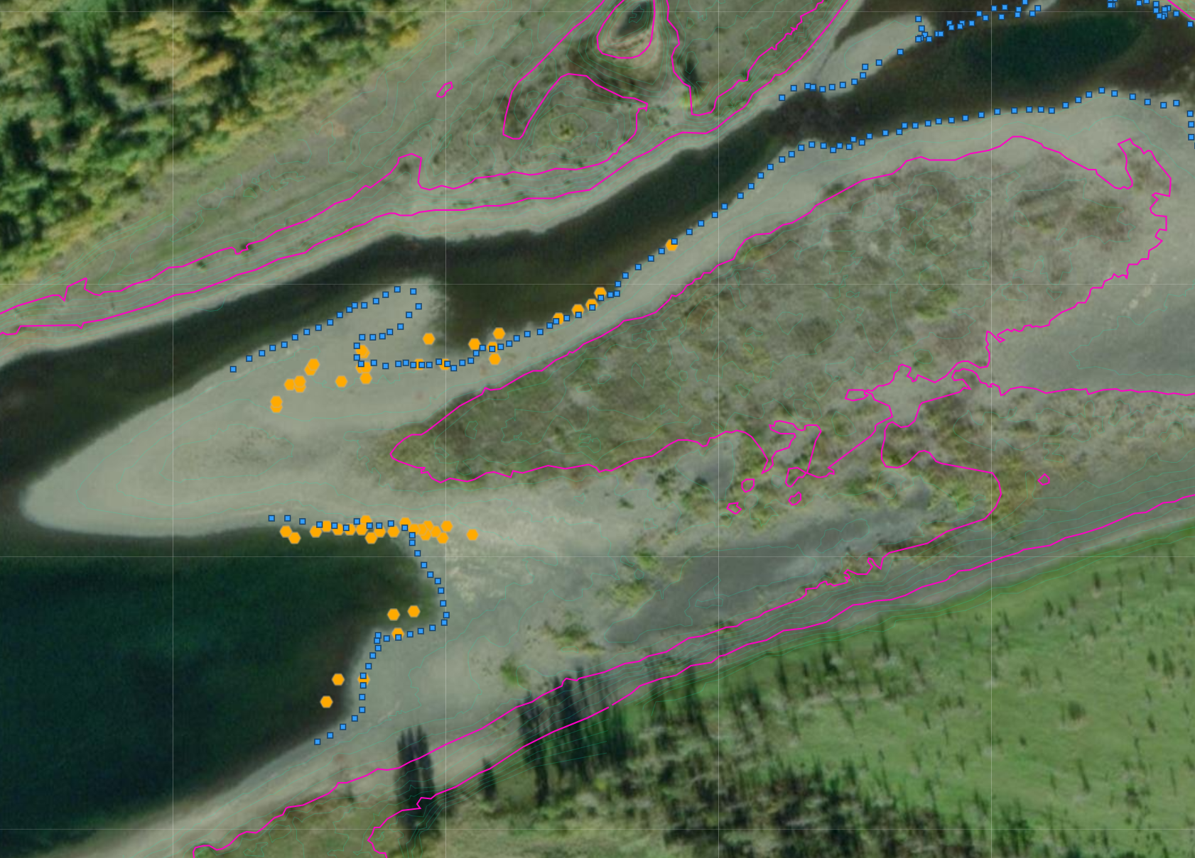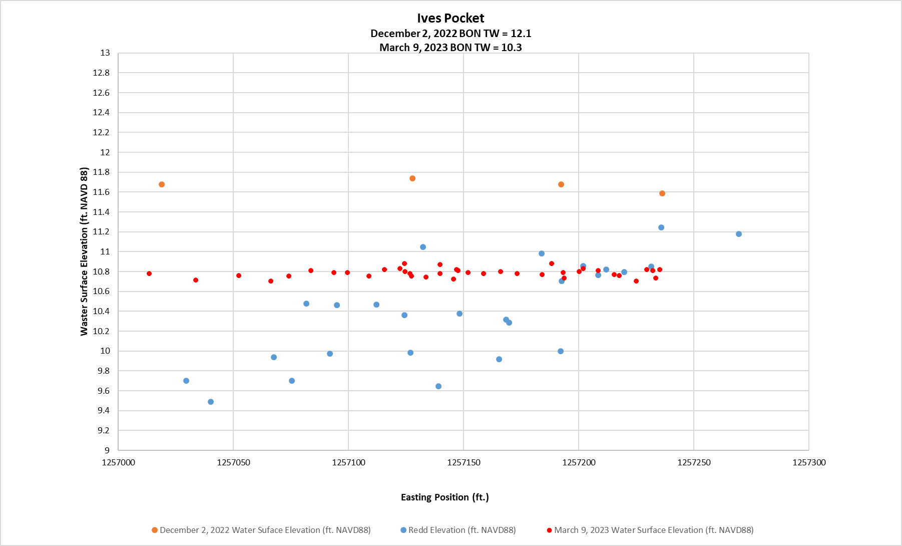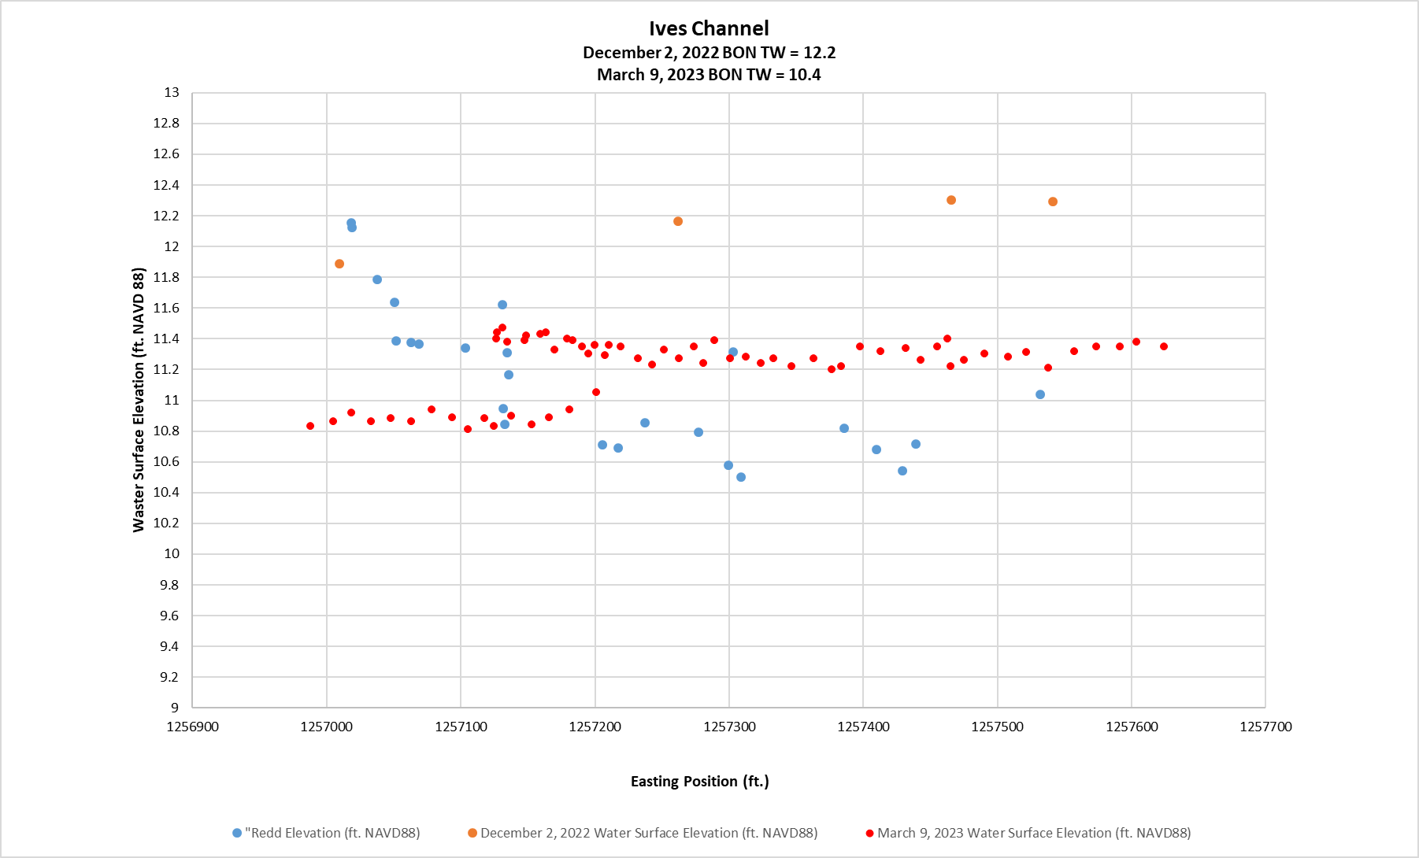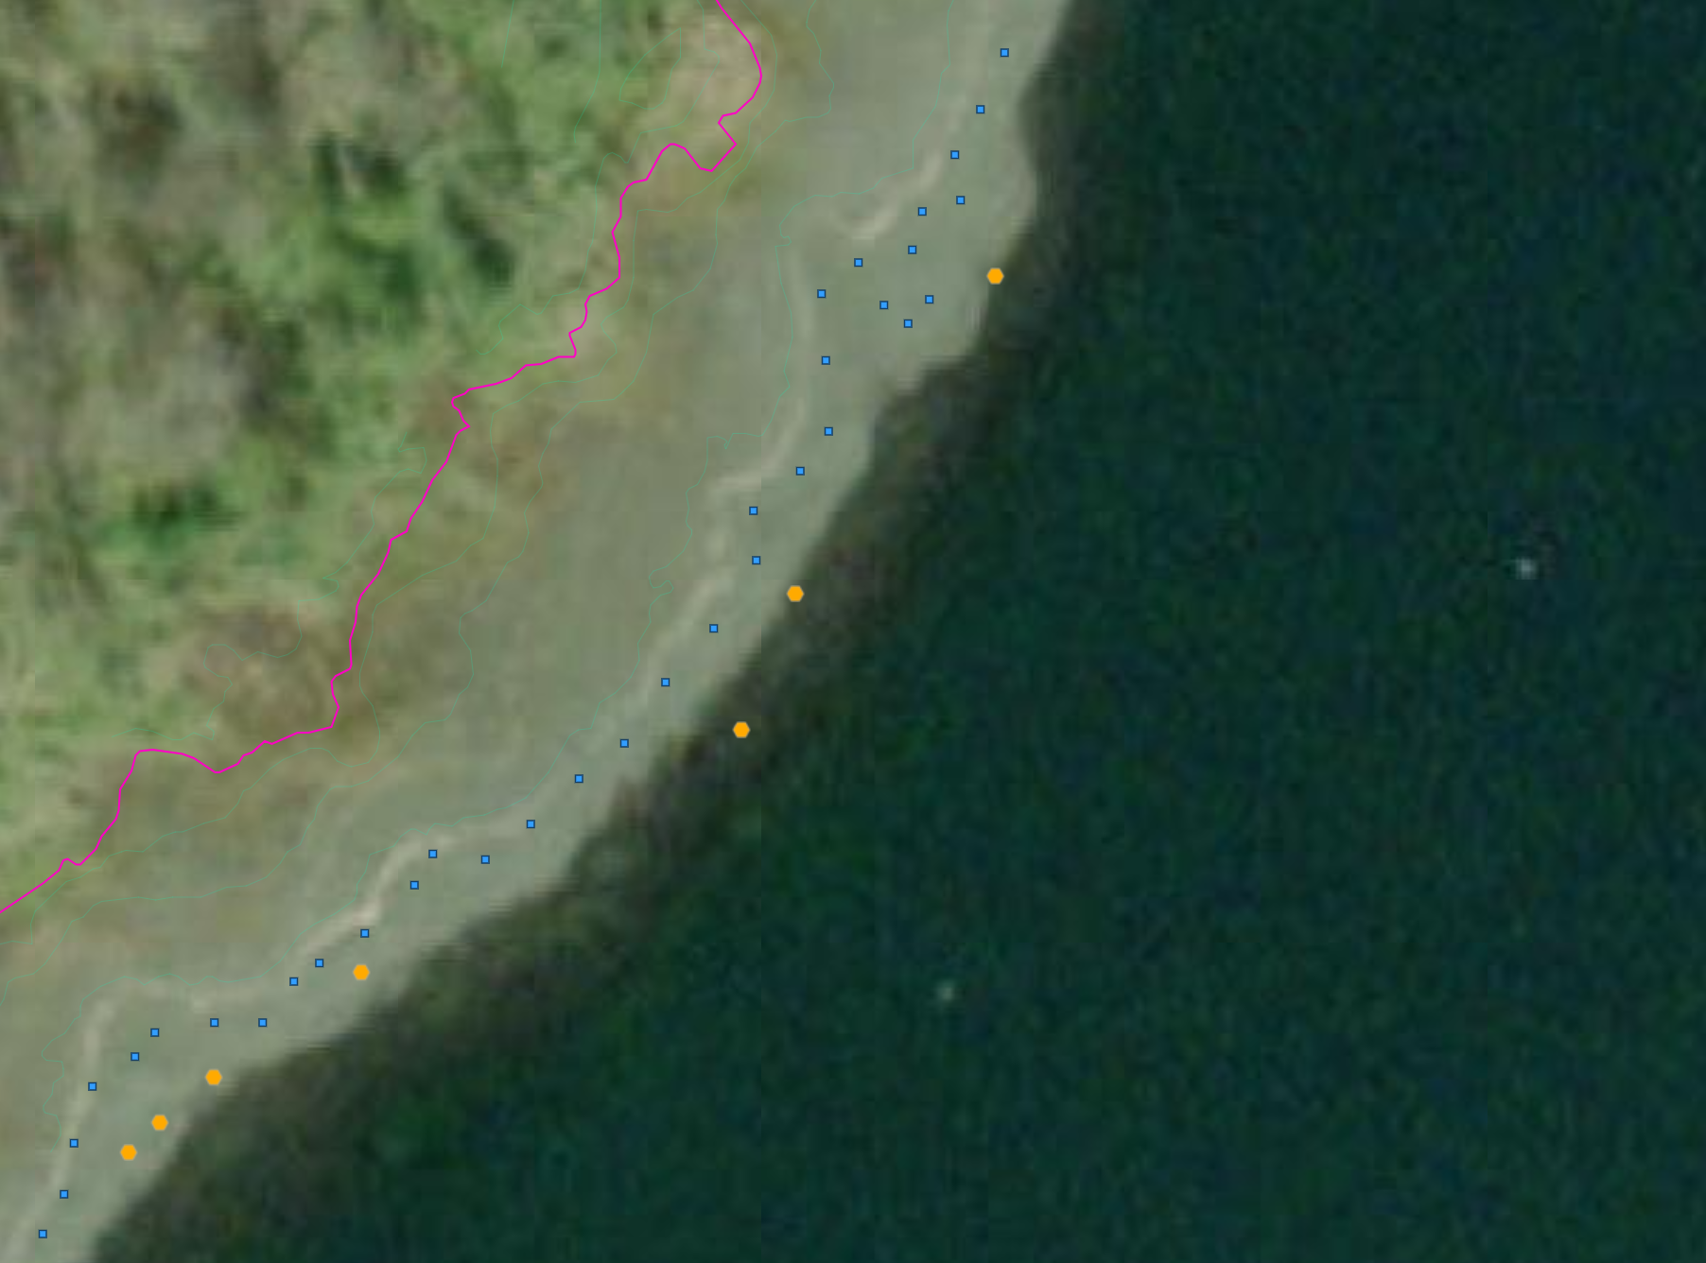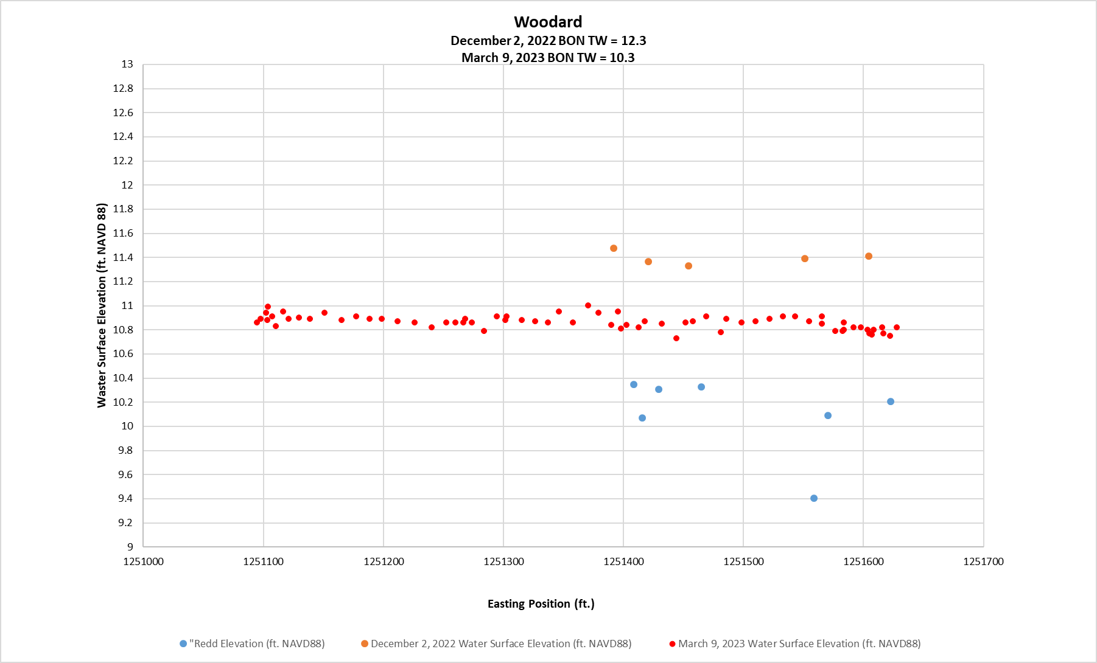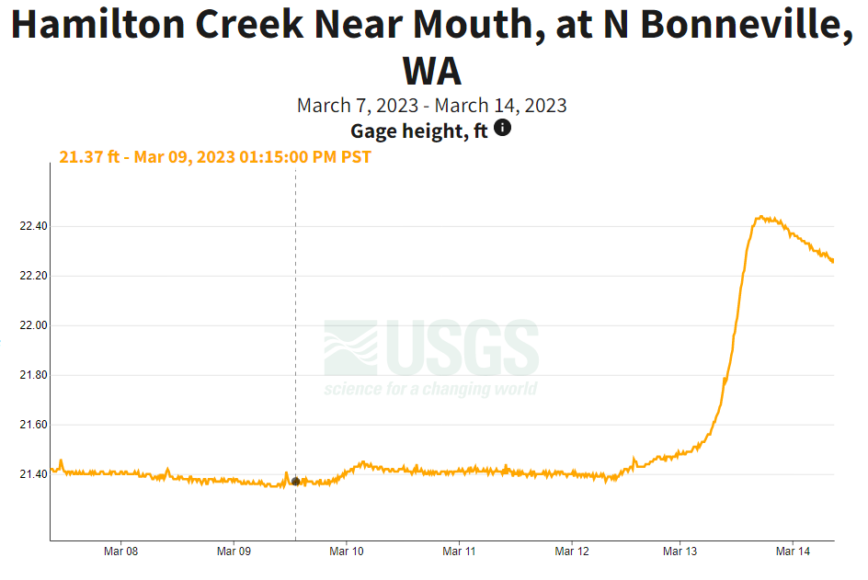

  - Vernita Bar/Hanford Reach Fall Chinook Protection Program Operations (Non-BiOp Action)

The Corps will provide inseason updates to this section.

The Hanford Reach Fall Cinook Protection Agreement (Agreement) ebstablishes the obligations of the Parties with respect to the protection of fall Chinook in the Hanford Reach of the Columbia River. The Parties agree that during the term of the Agreement these flow regimes address all issues in the Hanford Reacth with respect to fall Chinoook protection and the impact of operation of the seven dams operatin under Mid’Columbia Hourly Coordination, including the obligations of Grant, Chelan, and Douglas under any new licenses issued by the Federal Energy Regulatory Commission (FERC).

Beginning in mid-October, under the terms of the Hanford Reach Fall Chinook Protection Program Agreement, river flows are reduced every Sunday morning (day of lowest power demand) to the Priest Rapids Dam minimum operating discharge of 36,000 cubic feet per second (ft³/s) [1000 cubic meters per second (m³/s)]. This allows the Agency and Utility Party Monitoring Team to manually survey for redd distribution at Vernita Bar just downstream of Priest Rapids Dam. These drawdowns occur every Sunday morning until the initiation of fall Chinook spawning has been set both above and below the 50,000 ft³/s (1,416 m³/s) flow elevations. A final drawdown is conducted on the Sunday prior to Thanksgiving to establish the minimum critical flow needed to protect pre-emergent fall Chinook. Given the previously described limitations, this weekly reduction in river flow affords the best viewing conditions for aerial flights. Aerial flights are therefore scheduled to be conducted concurrent with the Sunday morning drawdowns, when possible.
Date | Summary
October 23, 2022 | On Sunday, October 23, 2022 representatives from Grant PUD and the Washington Department of Fish & Wildlife conducted the first 2022 Vernita Bar spawning ground survey. No completed redds were observed on Vernita Bar. A second spawning ground survey will be conducted next Sunday, October 30 to count redds above and below the 50 kcfs elevation.  For October 30, please schedule Priest Rapids Dam discharge to be less than 40 kcfs from 0700 to 1500 hours. The redd count will begin at 0900 hours. This will be the second redd survey this year as required by the 2004 Hanford Reach Fall Chinook Protection Program Agreement. Accompanying Grant PUD staff will be a Washington Department of Fish & Wildlife representative.
October 30, 2022 | On Sunday, October 30, 2022 representatives from Grant PUD and the Washington Department of Fish & Wildlife conducted the second 2022 Vernita Bar spawning ground survey. Twelve completed redds were observed on Vernita Bar, all of which were below the 50 kcfs elevation. Five redds are required for the Initiation of Spawning above and below the 50 kcfs elevation. Therefore, the date for the Initiation of Spawning below 50 kcfs has been set as October 27, 2022. A third spawning ground survey will be conducted next Sunday, November 6 to count redds above the 50 kcfs elevation.  For November 6, please schedule Priest Rapids Dam discharge to be less than 50 kcfs from 0700 to 1500 hours. The redd count will begin at 0900 hours. This will be the third redd survey this year as required by the 2004 Hanford Reach Fall Chinook Protection Program Agreement. Accompanying Grant PUD staff will be a Washington Department of Fish & Wildlife representative.
November 6, 2022 | On Sunday, November 6, 2022 representatives from Grant PUD and the Washington Department of Fish & Wildlife conducted the third 2022 Vernita Bar spawning ground survey. Fourteen completed redds were observed on Vernita Bar above the 50 kcfs elevation. Five redds are required for the Initiation of Spawning above the 50 kcfs elevation. Therefore, the date for the Initiation of Spawning above 50 kcfs has been set as November 3, 2022. A fourth spawning ground survey will be conducted Sunday, November 20 to determine if spawning has ended and establish the Critical Elevation for the 2022-2023 season.  For November 20, please schedule Priest Rapids Dam discharge to be less than 50 kcfs from 0700 to 1500 hours. The redd count will begin at 0900 hours. This will be the fourth redd survey this year as required by the 2004 Hanford Reach Fall Chinook Protection Program Agreement. This survey will be to determine if spawning has ended and the Critical Elevation for the 2022-2023 season. Accompanying Grant PUD staff will be a Washington Department of Fish & Wildlife
November 20, 2022 | On Sunday, November 20, 2022 representatives from Grant PUD and the Washington Department of Fish & Wildlife conducted the fourth 2022 Vernita Bar spawning ground survey. The intent of this week’s survey was to determine the Critical Elevation for the 2022-2023 protection season and to determine if spawning has ended. A determination was made that spawning is ongoing and another survey will be necessary to determine the Critical Elevation for the 2022-2023 protection season. The next survey will be Sunday November 27.  For November 27, Priest Rapids Dam will be scheduled to be less than 50 kcfs from 0700 to 1500 hours. The redd count will begin at 0900 hours. This will be the fifth redd survey this year as required by the 2004 Hanford Reach Fall Chinook Protection Program Agreement. Accompanying Grant PUD staff will be a Washington Department of Fish & Wildlife representative.
November 27, 2022 | On Sunday, November 27, 2022 representatives from Grant PUD and the Washington Department of Fish & Wildlife conducted the fifth 2022 Vernita Bar spawning ground survey. The intent of this week’s survey was to determine the Critical Elevation for the 2022-2023 protection season and to determine if spawning has ended.  As described in the Hanford Reach Fall Chinook Protection Program Agreement, if there are fewer than 15 redds above the 65k elevation, then the Critical Elevation will be the first 5 kcfs elevation above the elevation containing the 16th highest redd. Therefore, using today’s data, the Critical Elevation for the 2022-2023 Protection Season is 60 kcfs. Additionally, based on observations during the survey it was determined that Spawning Period has ended today, November 27 (average end date = Nov. 22).  Starting on Monday, November 28, we will be in the Pre-Hatch Period. During the Pre-Hatch Period Priest Rapids Outflow may be reduced below the Critical Elevation for up to 8 hours on weekdays and 12 hours on weekends with no two consecutive periods below 60 kcfs. We are projecting that the Post-Hatch Period for the below 50 kcfs elevation will occur on December 9. During this period, flows must remain no less than 15 cm below the 50 kcfs elevation at all times. We are projecting that Post-Hatch for the above 50 kcfs elevation will occur on December 24. During this period, flows must remain no less than 15 cm below the 60 kcfs elevation at all times. I will continue to provide email updates as the season progresses.
November 29, 2022 | Yesterday, 11/28, Post-Hatch below the 50k elevation began. At this time flows at Vernita Bar must remain no less than 15 cm below the 50 kcfs elevation at all times.  Above the 50 kcfs elevation, we remain in the Pre-Hatch Period which allows for flows to be reduced below the Critical Elevation (65 kcfs) for up to 8 hours on weekdays and 12 hours on weekends with no two consecutive periods below 65 kcfs. We are projecting that Post-Hatch for the above 50 kcfs elevation will occur on December 9. When the Post-Hatch period begins, flows must remain no less than 15 cm below the 65 kcfs elevation at all times. I will continue to provide email updates as the season progresses.
December 5, 2022 | We are projecting that on Friday 12/9, Post-Hatch below the 50k elevation will begin. At that time flows at Vernita Bar must remain no less than 15 cm below the 50 kcfs elevation at all times.  Above the 50 kcfs elevation, we remain in the Pre-Hatch Period which allows for flows to be reduced below the Critical Elevation (60 kcfs) for up to 8 hours on weekdays and 12 hours on weekends with no two consecutive periods below 60 kcfs. We are projecting that Post-Hatch for the above 50 kcfs elevation will occur on December 23. When the Post-Hatch period begins, flows must remain no less than 15 cm below the 60 kcfs elevation at all times. I will continue to provide email updates as the season progresses.
April 4, 2023 | We are projecting that the Emergence and Rearing periods will begin on Tuesday, April 11 (average start date = 3/17). During these periods, daily flow fluctuation below Priest Rapids Dam will be limited and the water level at Vernita Bar must be no less than the Critical Elevation (60 kcfs) at all times.
  - Snake River Zero Generation
Zero Generation Operations as described in the 2020 CRSO EIS ROD will no longer commence as early as October 15, and will instead commence once the previously defined implementation trigger of “few, if any” actively migrating anadromous fish (as described in SOR 2005-22) has been met. This trigger will be implemented in relation to both date (implementation will be limited to periods between December 1 and through February 28) and abundance.
Salmon Managers submitted System Operations Request (SOR) 2005-22 Snake River Zero Nighttime and Weekend Flow, to the Action Agencies (AA) on December 6, 2005. The SOR may be found on the following website:
http://pweb.crohms.org/tmt/sor/2005/2005-22.pdf
In the SOR, the Salmon Managers provided the AAs with the following table to define the criteria of “… few, if any …” prior to the implementation of the Zero Generation Operation. The few migrating adult criterion trigger will be defined on a sliding scale outlined in the following table. The table applies to both “wild” and “total” categories of returning adult steelhead.
Table 12: The Few Migrating Adult Criterion Trigger (SOR 2005-22)
Run to date># | Run to date< # | Few criteria< #
0 | 30,000 | 10
30,000 | 60,000 | 20
60,000 | 100,000 | 35
100,000 | 150,000 | 50
150,000 | 200,000 | 65
200,000 | 250,000 | 80
250,000 |  | 100

System Operations Request 2005-22 defined “few” migrating adults; this SOR has guided operations through 2019. Over time, these criteria have been slightly modified to include:

- The number of adults migrating per day is defined as the number of upstream counts minus the number of downstream counts, as reported on the Fish Passage Center’s website (https://www.fpc.org/currentdaily/HistFishTwo_7day-ytd_Adults.htm).
- A three-day moving average will be used to determine if the few migrating adult criterion has been met.
- The criteria apply to both “Unclipped” and “total” categories of returning adult steelhead. “Unclipped” and “total” returns will be calculated separately. Only one of the categories is necessary to show that more than a few adults are migrating.
- The run to date is defined as the cumulative number of adult steelhead in the “Unclipped” and “total” categories passing Lower Granite Dam since July 1st of the return year.

The timing of “nighttime” and “dawn” changes throughout the year. Based on the hours of actual Civil Twilight at Lower Granite Dam, the following hour ranges were coordinated during the October 21, 2020, TMT meeting to be consistent with the criteria identified in the 2020 CRS BA:

DATES “NIGHTTIME” HOURS FOR ZERO GEN

December 1-14 1800-0600

December 15 - January 31 1800-0600 + up to 3 daytime hours

February 1-28 1900-0600 + up to 3 daytime hours

Sources for definitions and computation of nighttime hours: https://www.esrl.noaa.gov/gmd/grad/solcalc/glossary.html
https://www.esrl.noaa.gov/gmd/grad/solcalc/calcdetails.html
2022-2023 Zero Gen Operations
Forebay restrictions due the 3-foot raised pool elevation at LWG limited the usability of the zero generation operation this water year. Zero generation was utilized at LWG on only 2 instances. Zero generation was utilized at LGS, LMN an IHR an averge of 14-15% of available days. Across all 4 projects zero generation was used 3.8% of all available hours. The majority of the days used occurred in early December during a period of cold temperatures in the region where power prices and available generation produced conditions where the flexibility was helpful to maintain a reliable and cost effective power system.
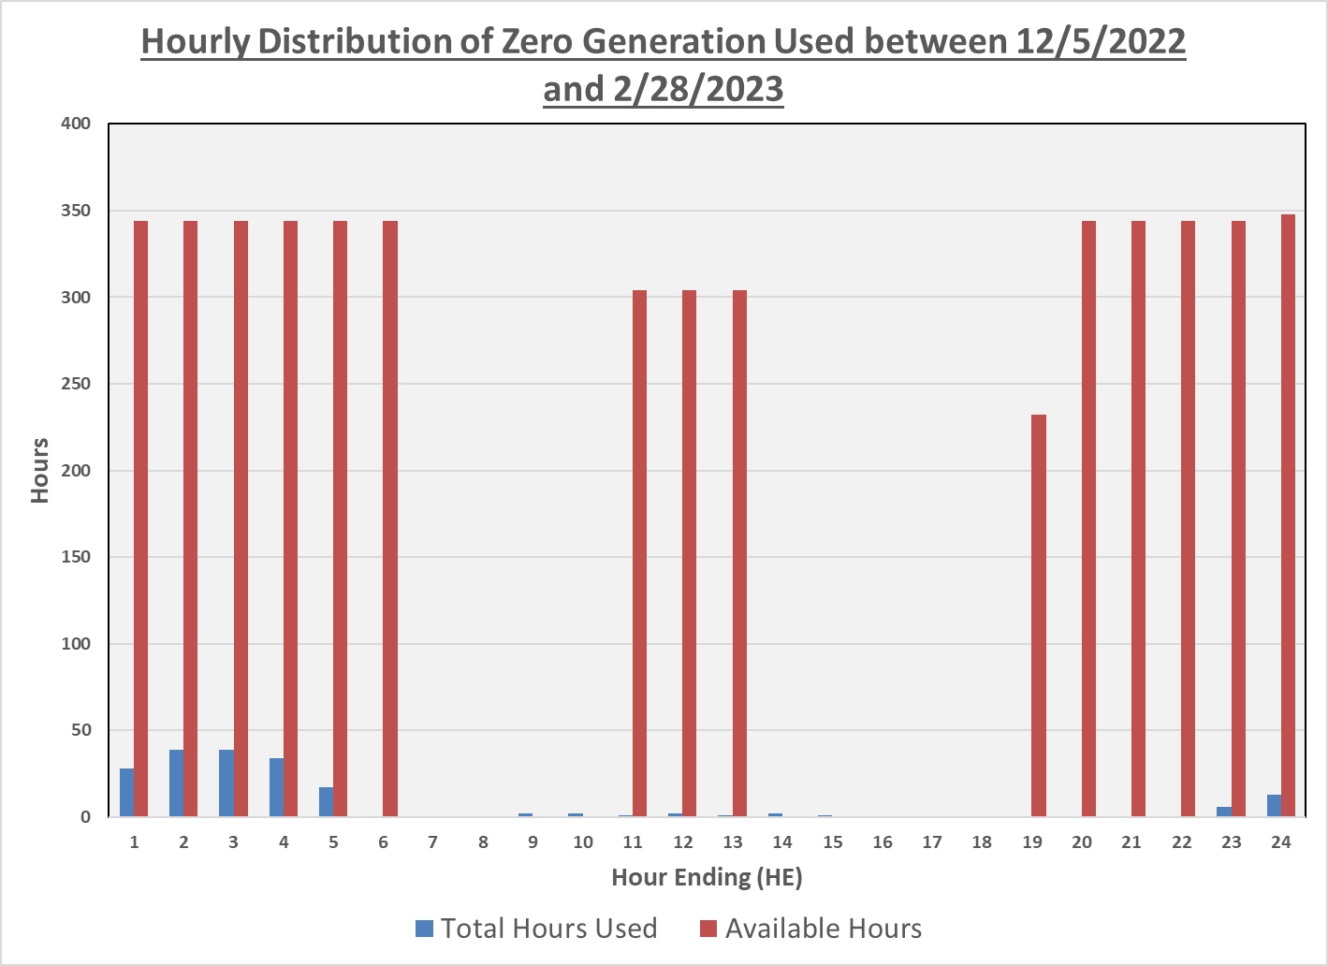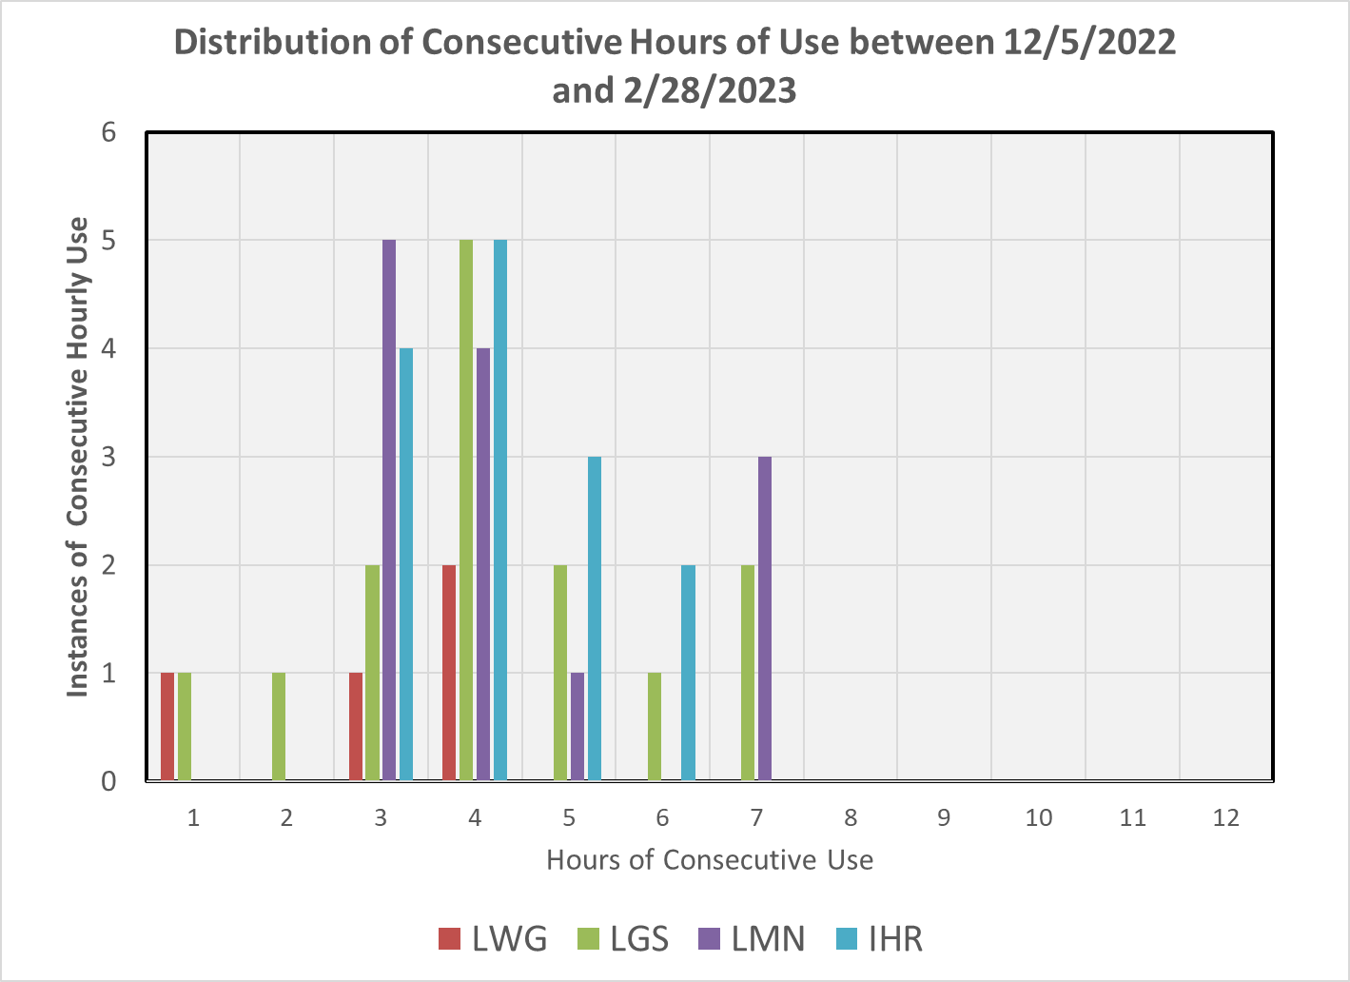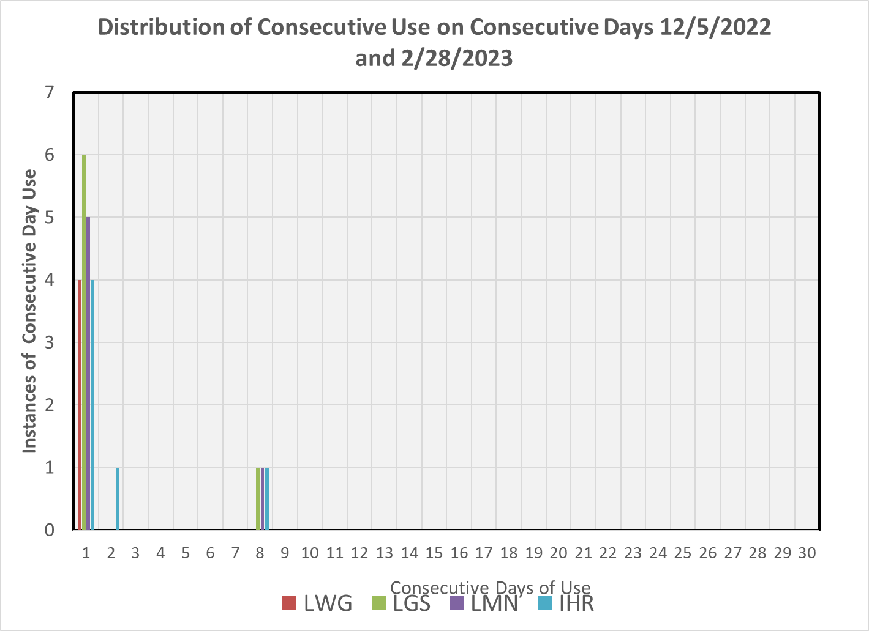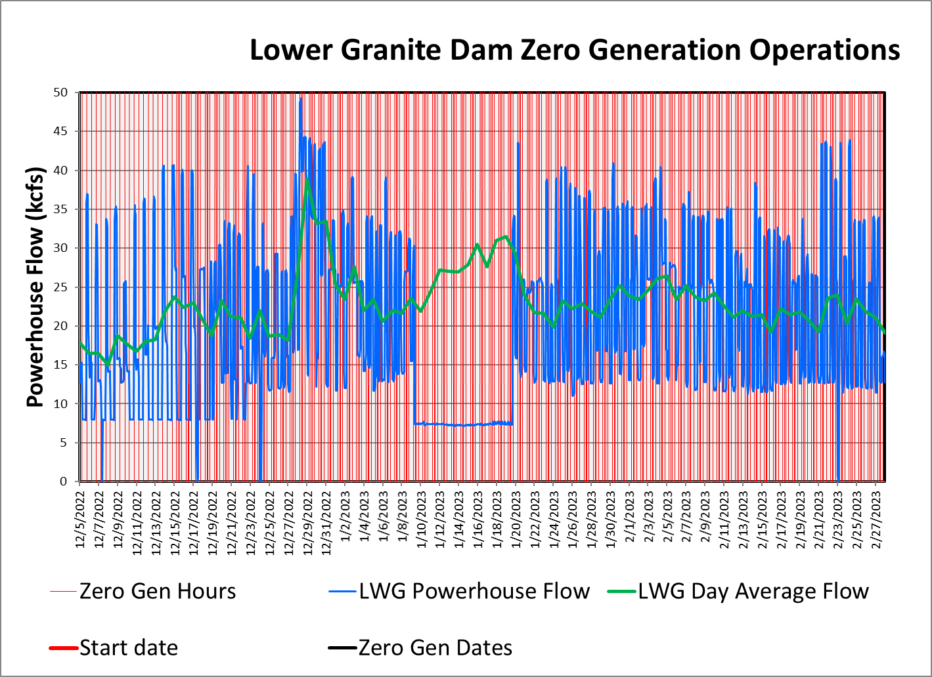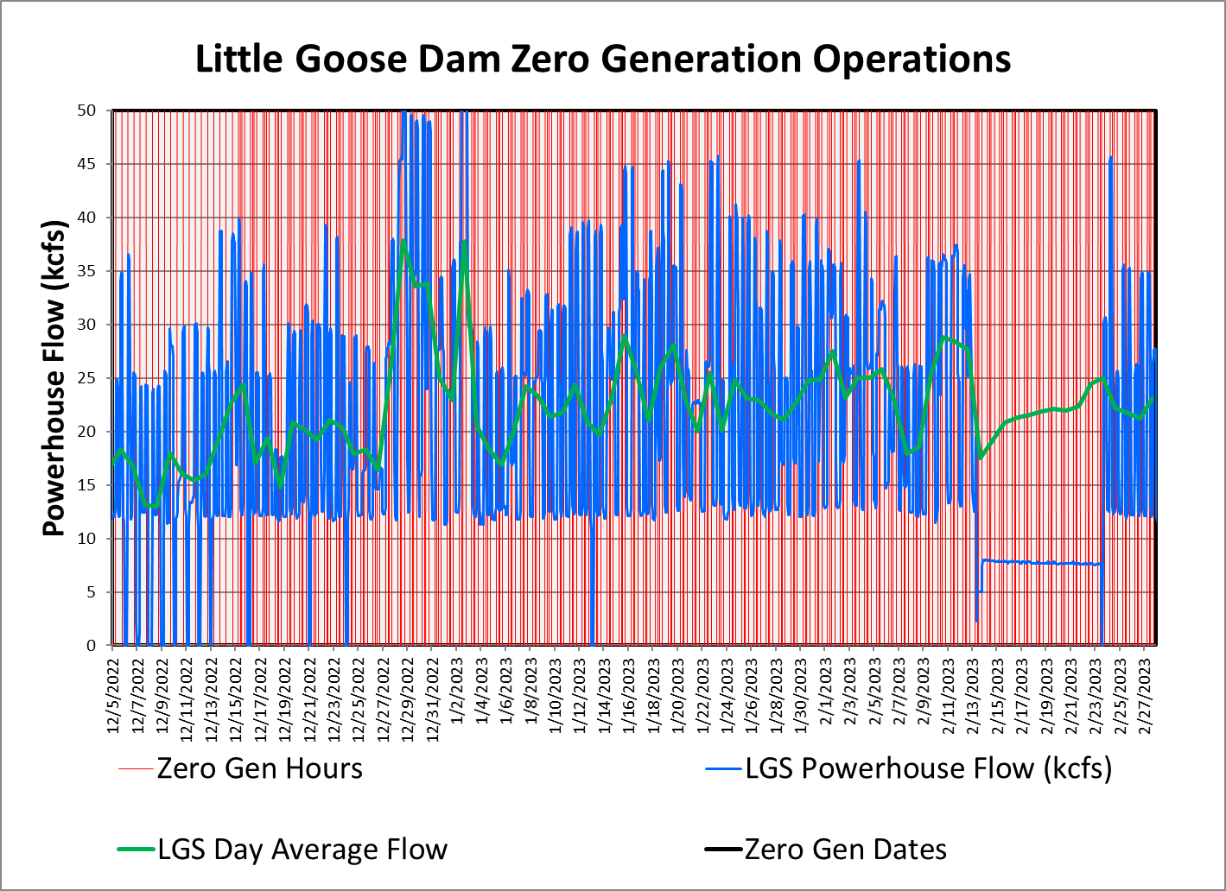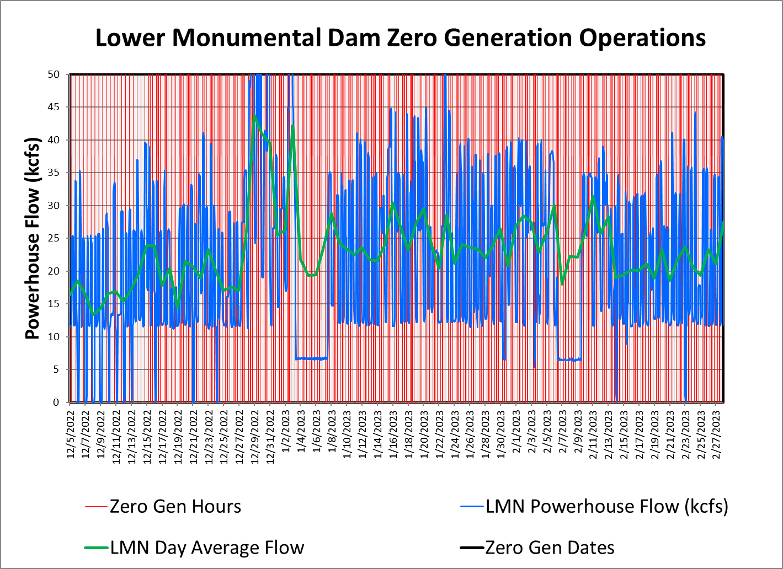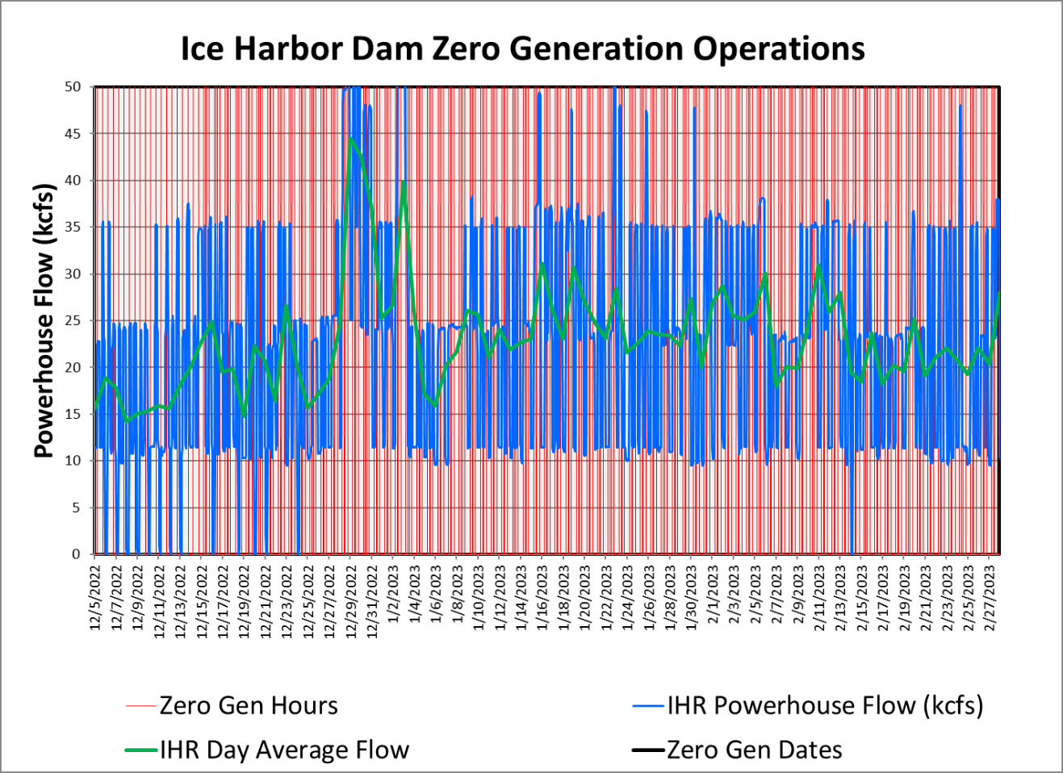
  - Minimum Operating Pool (MOP)
Short-term adjustments in spill or minimum operating pool (MOP) elevations may be required at any of the fish passage projects to address navigation safety concerns. This may include changes in spill patterns, reductions in spill, short-term spill curtailment, or operating above MOP. Adjustments to MOP may also be required to meet minimum tailwater elevations (Table 2). Current spill operations for juvenile fish passage result in complex downstream hydraulics that cause large fluctuations in tailwater elevations. The 2020 BiOps describe MOP at the lower Snake River projects as a 1.5-foot range above the minimum forebay elevation (Table 2). To clearly communicate the implementation of this operation, the term “MOP” will refer to the 1.5-foot operating range above the minimum forebay elevation at the lower Snake River projects (i.e., “MOP” is a 1.5-foot operating range).
As described in the 2022 Agreement, the Corps will operate Lower Granite, Little Goose, Lower Monumental, and Ice Harbor dams at MOP with a 1.5 foot forebay operating range and a 1.0 foot range to the extent possible (referred to operationally as a “soft constraint”) from April 3 until August 14, 2023, unless adjusted on occasion to meet authorized project purposes, primarily navigation, except as noted below:
- The following modification will be made to the 2023 operations stemming from the Administration's Commitments in Exhibit 2 of the Joint Motion to Extend the Litigation Stay. During 2023 summer spill operations, Lower Granite Dam will be held within MOP through August 31, 2023, unless adjusted on occasion to meet authorized project purposes.
The Corps conducts a bathymetric survey of the federal navigation channel annually to assure a 14-foot depth is maintained in the federal navigation channel. The Corps completed dredging of the federal navigation channel in the Lower Granite pool during winter 2022/2023. This dredging action was done to reestablish the full depth needed for safe navigation and will allow Lower Granite to operate throughout its full normal operating range. With the dredging completed, in 2023 Lower Granite will operate in the normal MOP range (733.0-734.5 feet) from 3 April until 31 August (and within a 1.0 foot soft constraint range to the extent possible).

Table 2.─ Normal and minimum operating pool (MOP) elevation ranges and minimum tailwater elevations for lower Snake River projects. ^{A}
Project | Normal Operating  Elevation Range (ft)^{B} |  | MOP Elevation Range (ft)^{C} |  | Project Tailwater (ft)
 | Minimum | Maximum | Minimum | Maximum | Minimum
Lower Granite | 733.0 | 738.0 | 733.0 | 734.5 | 633.0
Little Goose | 633.0 | 638.0 | 633.0 | 634.5 | 537.0
Lower Monumental | 537.0 | 540.0 | 537.0 | 538.5 | 437.0
Ice Harbor | 437.0 | 440.0 | 437.0 | 438.5 | 337.0
A. Elevations provided in feet above mean sea level (NGVD29).
B. August 15 – April 2, except at Lower Granite (September 1-April 2).
C. April 3 – August 14, except at Lower Granite (April 3 – August 31). Projects will be operated within a 1.0-foot range to the extent possible (referred to operationally as a “soft constraint”).
Lower Snake River MOP operations are discussed in greater detail in the 2023 Fish Operations Plan on the following website on page FOP-14.

https://pweb.crohms.org/tmt/documents/fpp/2023/

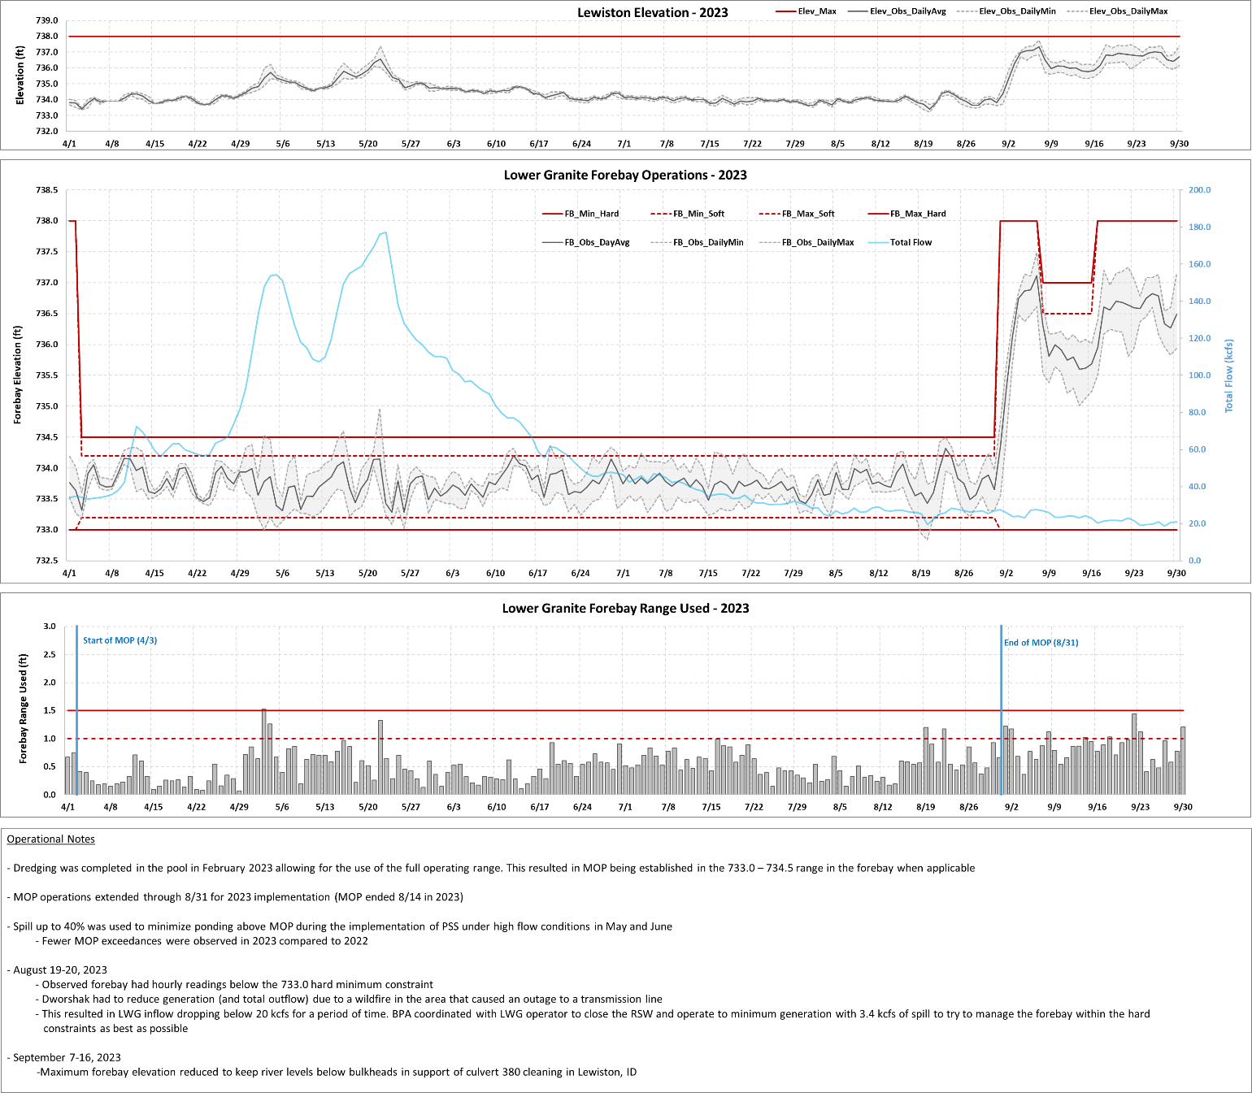

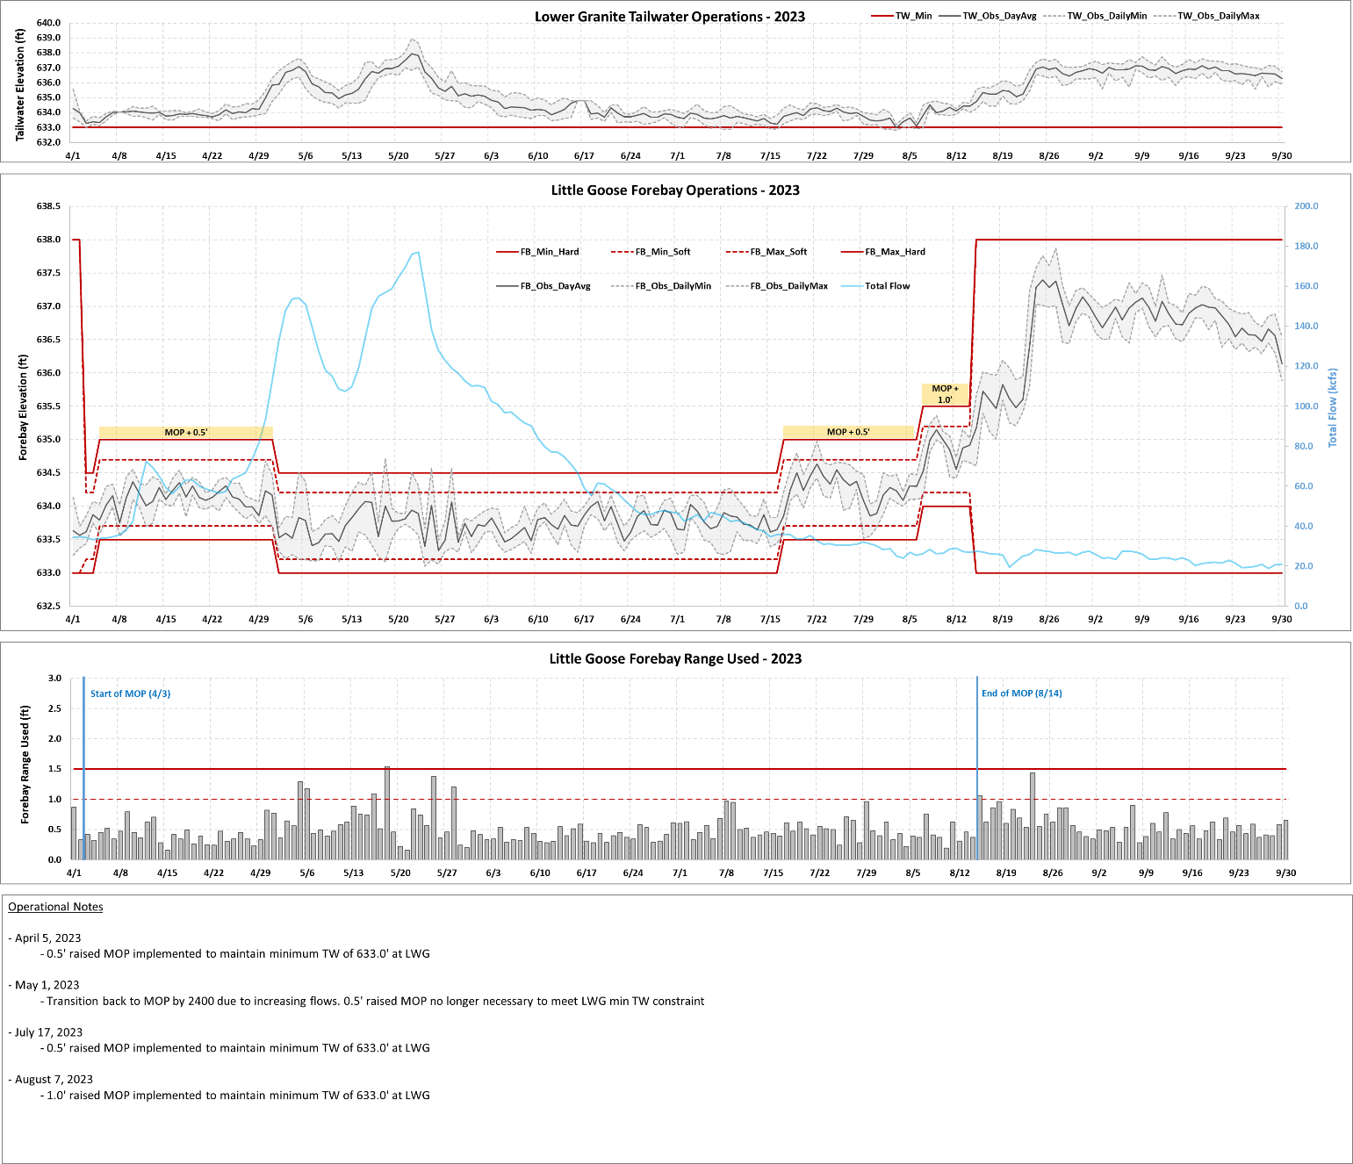

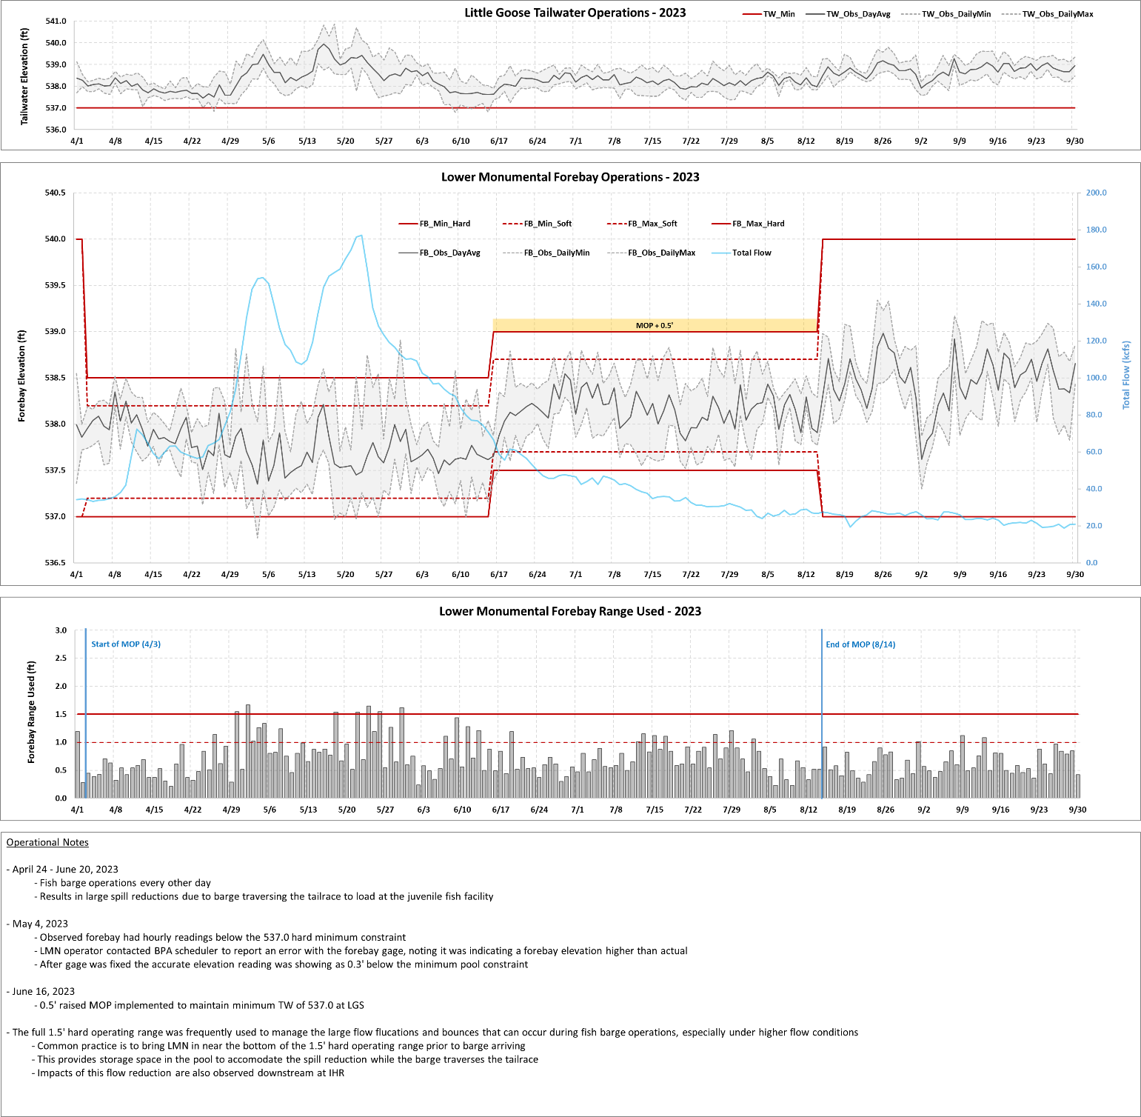

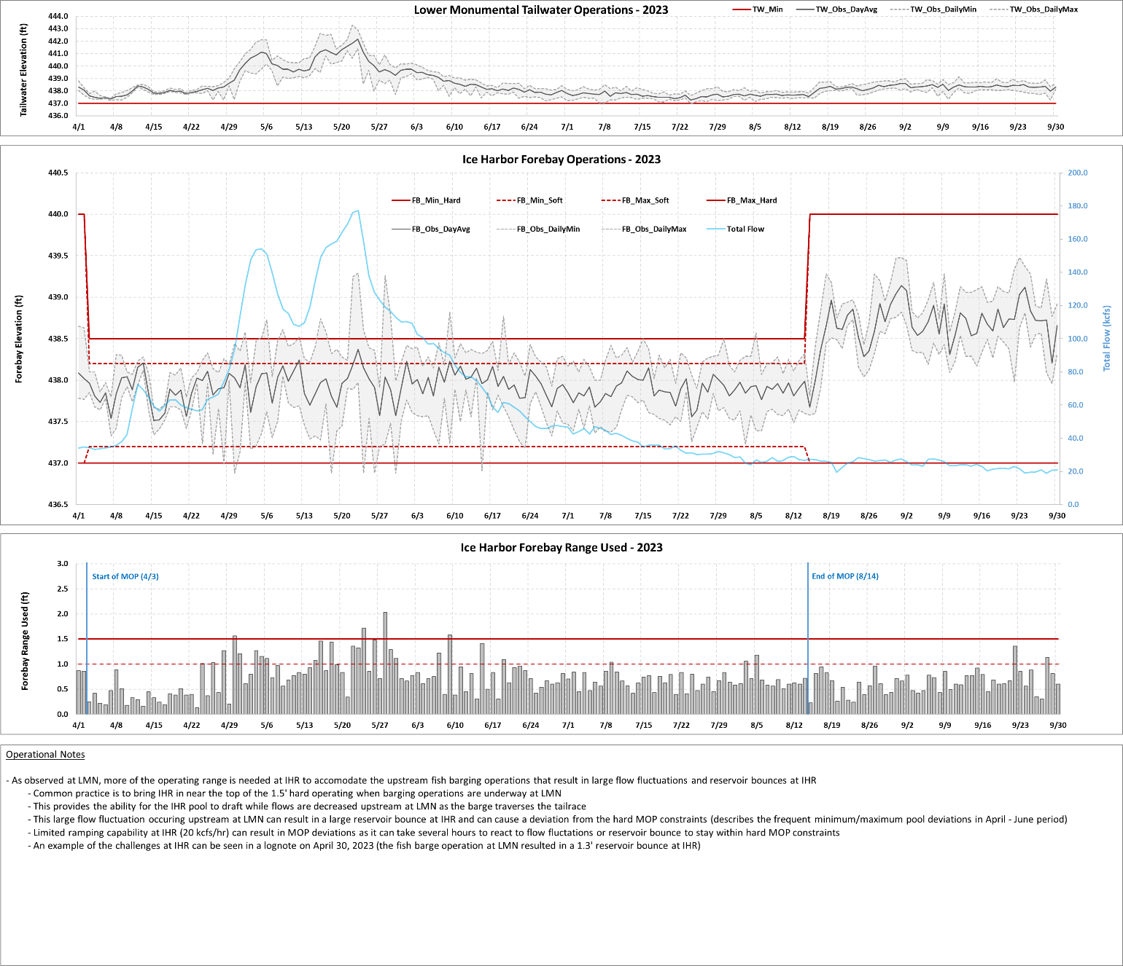

  - Minimum Irrigation Pool (MIP)
As described in the 2020 CRS BA (page 2-57), from April 10 – June 1 (or as feasible based on river flows), the John Day reservoir elevation will be held between 264.5 feet and 266.5 feet (an average of 265.5 feet) to deter Caspian terns from nesting in the Blalock Islands Complex. The Action Agencies intend to begin increasing the forebay elevation prior to initiation of nesting by Caspian terns to avoid take of tern eggs; operations may begin earlier than April 10 (when the reservoir is typically operated between 262.0 to 266.5 feet). The operation may be adaptively managed due to changing run timing; however, the intent of the operation is to begin returning to reservoir elevations of 262.5–264.5 feet on June 1, but no later than June 15, which generally captures 95% of the annual juvenile steelhead migration. The results of this action would be monitored and communicated with USFWS and NMFS. During the operation, safety-related restrictions would continue, including but not be limited to maintaining ramp rates for minimizing project erosion and maintaining power grid reliability. Following this operation, the John Day reservoir elevation would return to MIP + 2 ft operation through August 31.

From June 1 through August 31, John Day Dam will be operated to minimize water travel time for downstream-migrating juvenile salmon by operating the forebay within the minimum irrigation pool (MIP) range of 262.5 to 264.5 feet, which is the lowest pool elevation that allows irrigation withdrawals.

This section will be updated throughout the season as new information becomes available.
  - Spill for Juvenile Fish Passage
Table 3 below is a summary of the 2023 spring target spill levels at lower Snake River and lower Columbia River projects, as described in the 2023 Fish Operations Plan (2023 FOP). Additional information on spring spill operations may be found in the 2023 FOP (page FOP-18) on the following website.

https://pweb.crohms.org/tmt/documents/fpp/2023/

Table 3.─ Summary of 2023 spring target spill levels at lower Snake River (April 3 – June 20) and lower Columbia River (April 10 – June 15) projects.
PROJECT | SPRING SPILL  DATES | SPRING SPILL  OPERATION
Lower Granite ^{A, C} | April 3 until adult criteria met  (no later than April 24) | 24 hours/day: 125% Gas Cap
 | Adult criteria met  (no later than April 24) – June 20 | 16 hours/day: 125% Gas Cap  8 hours/day: 20 kcfs Performance Standard
Little Goose ^{B, C} | April 3 – June 20 | 16 hours/day: 125% Gas Cap  8 hours/day: 30% Performance Standard
Lower  Monumental ^{A, C} | April 3 until adult criteria met  (no later than April 24) | 24 hours/day: 125% Gas Cap
 | Adult criteria met  (no later than April 24) – June 20 | 16 hours/day: 125% Gas Cap  8 hours/day: 40%
Ice Harbor | April 3 – June 20 | 24 hours/day: 125% Gas Cap
McNary | April 10 – June 15 | 24 hours/day: 125% Gas Cap
John Day ^{D} | April 10 – June 15 | 16 hours/day: 125% Gas Cap  8 hours/day: 32% Performance Standard
The Dalles ^{E} | April 10 – June 15 | 24 hours/day: 40% Performance Standard
Bonneville ^{F} | April 10 – June 15 | 24 hours/day: 125% Gas Cap
- Lower Granite and Lower Monumental Adult Criteria – Within 1 business day of when the earliest of the following conditions occurs: (1) a cumulative total of 25 adult spring Chinook salmon (not including jacks) pass Lower Monumental Dam; or (2) a cumulative total of 50 adult spring Chinook salmon (not including jacks) pass Ice Harbor Dam; or (3) April 24, 2023, the Corps will implement 20 kcfs performance standard spill, up to 40% spill to manage high flows, at Lower Granite and 40% spill at Lower Monumental for 8 consecutive AM hours, 0400–1200, to target hours of peak adult passage. If lack of load conditions precludes the implementation of 20 kcfs performance standard spill at Lower Granite and 40% spill at Lower Monumental during the targeted AM period, those blocks will begin as soon as practicable during AM hours and continue for up to 8 consecutive hours. If a second block is needed, it will start as soon as load conditions allow, continue for at least two consecutive hours, and conclude no later than 2000. During periods of high river flow, the 8-hour Lower Granite performance standard spill may increase from 20 kcfs up to 40% of total river outflow if needed to improve conditions to meet performance standard blocks.
- Little Goose – The 8 hours of performance standard spill will occur between the hours of 0300 and 2200 in one or two blocks per calendar day. Within 1 business day of a cumulative total of 25 adult spring Chinook salmon (not including jacks) passing Lower Monumental Dam, the Corps will implement performance standard spill at Little Goose Dam for 8 consecutive AM hours (April 3–15 starting at 0500 hours; April 16–June 20 starting at 0400 hours) to target hours of peak adult passage. If lack of load conditions preclude the implementation of performance standard spill during the targeted periods, performance standard spill will begin as soon as practicable during AM hours and continue for up to 8 consecutive hours. If a second block is needed, it will start as soon as load conditions allow, continue for at least two consecutive hours, and conclude no later than 2000.
- During periods of high river flow that exceeds powerhouse hydraulic capacity, implementing 8 consecutive hours of spill as described in Footnotes A and B may result in storing additional inflow in the forebay above MOP. If it is necessary to pond water to achieve the 8-hour block of spill during high inflow, water stored above MOP should be drafted out over the remaining hours by increasing spill to pass inflow from 1200-1600 hours, then increasing spill as necessary from 1600-0400 to draft the pool back to MOP. If it is forecasted that the drafting spill will result in exceeding 130% TDG in the tailrace, all 16 hours will be used to return the pool to MOP. In lack of load conditions performance standard spill blocks will be prioritized at Little Goose, Lower Monumental, and Lower Granite dams, in that order.
- John Day Dam – The 8 hours/day of performance standard spill may occur with some flexibility, in either a single 8-hour block or two separate blocks per calendar day. Performance standard spill will not be implemented between 2200-0300 hours.
- The Dalles Dam –TDG in The Dalles tailrace may fluctuate up to 125% prior to reducing spill at upstream projects or reducing spill at The Dalles below 40%. Maintain 40% spill for 24 hours at The Dalles and reduce John Day spill below the 125% TDG spill cap as needed for TDG management. Spill above 40%, up to 125% TDG, may occur for TDG management or for carrying reserves.
- Bonneville Dam – Spill for fish passage should not exceed 150 kcfs due to erosion concerns.

Table 4 below is a summary of the 2023 summer target spill levels at lower Snake River and lower Columbia River projects, as described in the 2023 FOP.

Additional information on summer spill operations may be found in the 2023 FOP (page FOP-19) on the following website.

https://pweb.crohms.org/tmt/documents/fpp/2023/

Summer spill operations occur June 21–August 31 at the four lower Snake River projects, and June 16–August 31 at the four lower Columbia River projects. The Corps initiates spill at 0001 hours, or shortly after midnight, at each of the projects on the start date. Target spill levels for summer 2023 at each project are defined in Table 4. At the Snake River Projects spill may range up to ±1 kcfs during the summer spill operation from August 15 – August 31.
Table 4.─ Summary of 2023 summer target spill levels at lower Snake River and lower Columbia River projects.
PROJECT | SUMMER SPILL^{A}  (June 21/16 – August 14)  (24 hrs/day) | SUMMER SPILL^{A}  (August 15 – August 31)  (24 hrs/day)
Lower Granite ^{B} | 18 kcfs | SW flow  (as river flow allows)
Little Goose ^{B, C} | 30% | SW flow or 7 kcfs spill
Lower Monumental ^{B, D} | 17 kcfs | SW flow or 8 kcfs spill
Ice Harbor ^{B, E} | 30% | SW flow or 9 kcfs spill
McNary ^{F} | 57% | 20 kcfs
John Day | 35% | 20 kcfs
The Dalles | 40% | 30%
Bonneville | 95 kcfs | 50 kcfs
A. Spill may be temporarily reduced below the FOP target summer spill level at any project if necessary to ensure navigation safety or transmission reliability, or to avoid exceeding State TDG standards.
B. Late summer spill August 15-August 31 will be through the SW or a constant spill rate through conventional spillbays using the appropriate FPP spill pattern. The SW spill rate is a function of forebay elevation (as pool elevation increases, more water is spilled over the SW), as defined in the FPP. The SWs will be operated per FPP criteria and closed when low flow criteria are met. When the SW is closed, the spill target will transition to a constant spill rate through conventional spillbays and will not vary with a fluctuating forebay elevation.
C. Flow corresponds to the SW high crest elevation as adjusted relative to the forebay operating range (see FPP Chapter 8, section 2.3.2.7).
D. Flow corresponds to a forebay elevation of 538.5 feet, the mid-point of the forebay range from 537-540 feet.
E. Flow corresponds to a forebay elevation of 438.5 feet, the mid-point of the forebay range from 437-440 feet.
F. From June 16-August 14, McNary will adjust spill once a day to 57% of the previous day’s average project outflow. The intent is to reduce the frequency of spillgate changes while implementing a more uniform pattern to the extent it can be done safely (see FPP Chapter 5, section 2.2.2.1)
  - Juvenile Trasportation
As described in the 2023 FOP, transportation will be initiated at Lower Granite, Little Goose and Lower Monumental dams on April 24 (collection starting on April 23) or as coordinated through the TMT and the RIOG but begin no later than May 1. Transport begins the following day after fish collection and collected juvenile fish will be transported from each facility on a daily or every-other-day basis (depending on the number of fish) throughout the migration season. Transportation of spring migrants ends on June 20. Truck transportation of summer migrants at Lower Granite and Little Goose resumes on August 1 with allowance for TMT adaptive management adjustments and continues through October 31.
  - Fish Passage Research in 2023
    - Bonneville Dam
There are no studies planned at Bonneville Dam in 2023.
    - The Dalles Dam
There are no studies planned at The Dalles Dam in 2023.
    - John Day Dam
There are no studies planned at John Day Dam in 2023.
    - McNary Dam
There are no studies planned at McNary Dam in 2023.
    - Ice Harbor Dam
IHR Unit 3 Direct Injury and Sensor Fish Characterization.
a) Dates: September–October 2023
b) Description: Juvenile spring Chinook and Sensor Fish will be directly released into unit 3 to evaluate the new Kaplan runner. The study is expected to require approximately four weeks of total study time. Direct release pipes will be installed in all three intakes of Unit 3 for direct fish and Sensor Fish releases. Release pipes will be installed on the STS frames. Three specific turbine operations will be tested. Project support will be provided for equipment install, removal, and turbine operations. A one-day Unit 3 outage is expected for release pipe install and removal. Another consideration will be river flow and unit priority during the study period. Specific dates for Project support, outages, and operations will be scheduled appropriately with the Project and through FPOM closer to study implementation.
c) Impacts to FPP Criteria: Any modification to unit priority order or other FPP criteria will be coordinated through FPOM.
    - Lower Monumental Dam
Lower Monumental Dam Juvenile Lamprey Survival
a) Dates: March through Sept 2023
b) Description: From March through September 2023, juvenile lamprey will be tagged and released upstream of the Lower Monumental Dam. The removable spillway weir (RSW) may need be taken out of service for a few hours for one day in March or April to test the acoustic arrays in the forebay with a remote operated boat. This study will help inform juvenile Pacific Lamprey passage conditions, migration behavior, and fate. The objectives of this are to:
• Determine distribution and approach routes (including vertical, horizontal, and temporal) of juvenile lamprey in the forebay of Lower Monumental Dam.
• Determine passage and proportions through all fish passage routes to include the RSW, conventional spill bays, juvenile bypass systems (JBS), and turbines by juvenile lamprey throughout fish passage season.
• Calculate whole project survival of juvenile lamprey (from forebay to tailrace)
• Relate project operations (including hydrograph) to passage and route selection
• Determine reach survival of juvenile lamprey and reservoir residence time through the lower Snake River.
c) Impacts to FPP Criteria: To be determined. Any modification to or deviation from FPP criteria will be coordinated with FPOM.
    - Little Goose Dam
Kelt Collection & Reconditioning
a) Dates: April to July
b) Description: The Nez Perce Tribe (NPT) Department of Fisheries Resources Management will collect wild/natural post-spawned, emigrating steelhead from the separator at Little Goose Juvenile Fish Facility. These fish will be transported to the Nez Perce Tribal Hatchery (NPTH) or Dworshak National Fish Hatchery (DNFH) to be utilized in the kelt reconditioning program.
c) Impacts to FPP Criteria: None.
    - Lower Granite Dam
This section will be updated following the issuance of the 2023 Fish Passage Plan that will include fish passage research in 2023.
      - Genetic Stock Identification (Idaho Department of Fish & Game)
a) Dates: March 1 – June 28
b) Description: Fish collected as part of the Lower Granite juvenile condition sample are used to enumerate and characterize age composition and genetic stock profiles of naturally producing yearling Chinook and juvenile steelhead. IDFG will sample Monday through Friday through mid-June with a goal of collecting 2,000-5,000 yearling Chinook and juvenile steelhead genetic samples.
c) Impacts to FPP Criteria: None.
      - Kelt Study (Nez Perce Tribe, University of of Idaho, CRITFC)
a) Dates: March 1 – June 29
b) Description: This research investigates steelhead kelt physiology and endocrinology to evaluate the feasibility and success of rehabilitating strategies. Selected kelts collected at Lower Granite are transported by NPT to Dworshak National Fish Hatchery for reconditioning and later release as part of this study.
c) Impacts to FPP Criteria: None.
      - PIT-Tag Adult Wild Chinook and Adult Steelhead for ISEMP-Related Dispersal Monitoring (NOAA Fisheries)
a) Dates: TBD
b) Description: The goal of this project is to PIT-tag up to 4,000 unclipped adult Chinook and 4,000 unclipped adult steelhead collected in the adult trap daily sample for dispersal monitoring.
c) Impacts to FPP Criteria: None.
      - Lower Granite Dam Juvenile Lamprey Survival
a) Dates: March through Sept 2023
b) Description: From March through September of 2023, juvenile lamprey will be tagged and released upstream of the Lower Granite Dam. The removable spillway weir (RSW) may need be taken out of service for a few hours for one day in March or April to test the acoustic arrays in the forebay, with a remote operated boat. This study will help inform juvenile Pacific Lamprey passage conditions, migration behavior, and fate. The objectives of this Juvenile Lamprey passage and survival study at Lower Granite are to:
• Determine distribution and approach routes (including vertical, horizontal, and temporal) of juvenile lamprey in the forebay of Lower Granite Dam.
• Determine passage and proportions through all fish passage routes to include the RSW, conventional spill bays, juvenile bypass systems (JBS), and turbines by juvenile lamprey throughout fish passage season.
• Calculate whole project survival of juvenile lamprey (from forebay to tailrace)
• Relate project operations (including hydrograph) to passage and route selection
• Determine reach survival of juvenile lamprey and reservoir residence time through the lower Snake River.
c) Impacts to FPP Criteria: To be determined. Any modification to or deviation from FPP criteria will be coordinated with FPOM.
      - Sampling of Adult Steelhead, Chinook, and Sockeye for Biological Data Collection (IDFG and NOAA Fisheries)
9.2.5. Sampling of Adult Steelhead, Chinook, and Sockeye for Biological Data Collection (IDFG and NOAA Fisheries)
a) Dates: April 4 – December 15
b) Description: Upriver migrating adult steelhead, spring/summer Chinook salmon, and sockeye salmon are collected from the adult trap from April 4 through December 15. The goal is to collect 5–20% of adult steelhead, spring/summer Chinook salmon, and sockeye salmon ascending the ladder. Data collection includes fish scales, genetics tissue, sex and length, wild/hatchery composition, and non-adipose clipped hatchery fish assessment. All natural-origin adult steelhead and spring/summer Chinook salmon trapped will be PIT-tagged to estimate headwater tributary escapement. Sockeye salmon may be PIT-tagged in the future to estimate metrics regarding conversion rates. Some steelhead and spring/summer Chinook salmon may be radio-tagged or spaghetti-tagged. This information on adult fish forms the basis for status information used in several forums including BiOp-RPA identified needs.
c) Impacts to FPP Criteria: None.
      - Bull Trout PIT-Tagging and Genetic Sample Collection for USFWS
a) Dates: April 4 – December 15
b) Description: Bull trout will be collected as part of the normal adult trap daily sample and using the adult sort-by-code (SbyC) system to recapture previously PIT-tagged fish. Untagged bull trout will be PIT-tagged, fin clipped for genetic analysis, and have morphometric data collected including weight and length, etc. Fin clips will be sent to USFWS to determine the fish’s origin. Previously PIT-tagged bull trout will only have morphometric data collected. All fish will be released back into the adult fish ladder.
c) Impacts to FPP Criteria: None.
      - Subyearling Chinook Parentage-Based Tagging (USGS)
a) Dates: June 1–15 and July 1–15
b) Description: The goal of this project is to determine the abundance of unmarked, untagged, natural- and hatchery-origin subyearling Chinook salmon in Lower Granite sample collection. Fin clips will be taken from 30 unclipped, untagged subyearling Chinook each day from June 1-15 and for another two weeks in July depending in fish passage numbers.
c) Impacts to FPP Criteria: None.
      - Collection of Adult Fall Chinook and Coho for Hatchery Broodstock – (WDFW and Nez Perce Tribe)
a) Dates: August 18 until broodstock requirements are met
b) Description: Adult fish are collected in the adult trap. Fall Chinook are transported by WDFW employees to Lyons Ferry hatchery and by NPT employees to Dworshak hatchery. Coho are transported by NPT and transported to Dworshak hatchery.
c) Impacts to FPP Criteria: None.

The Corps conducts annual surveys to assess sedimentation in the reservoirs and under certain conditions. To ensure safe navigation, there may be a need to operate the pools above the MOP range.

