**2022 Water Management Plan**

**Seasonal Update**

**October 28, 2022**

1. **Introduction**

The annual Water Management Plan (WMP) is developed prior to U.S. Army Corps of Engineers (Corps), Bureau of Reclamation (Reclamation), and Bonneville Power Administration (BPA), collectively referred to as the Action Agencies (AAs), implementation of Columbia River System (CRS) operations identified in the following documents: 1) National Marine Fisheries Service (NMFS) 2020 CRS Biological Opinion (2020 NMFS BiOp); 2) U.S. Fish and Wildlife Service (USFWS) 2020 CRS BiOp (2020 USFWS BiOp); 3) AA’s 2020 CRS Biological Assessment (2020 CRS BA); 4) 2022 Fish Operations Plan (2022 FOP), and; 5) The October 2021 Term Sheet for Stay of Preliminary Injunction Motion and Summary Judgment Schedule, as extended as part of the August 2022 Joint Motion to Extend the Litigation Stay, *NWF et al. v. NMFS et al.* (3:01-cv-00640-SI) (Agreement on 2022 Operations). The WMP is also developed prior to the receipt of any seasonal information that may determine how many of the operation measures are implemented. The Seasonal Update is intended to supplement the WMP with more detailed information on operations as the water year progresses. Each section of the Seasonal Update will be updated when information is available and finalized when no further information is available.

The first update for the primary elements of Fall and Winter will be posted by November 1 of each year. The first update for the primary elements of Spring and Summer will be posted by March 1 of each year. The elements and operations included in the Seasonal Update are generally the same as have been previously presented in the Fall/Winter and Spring/Summer Updates to the WMP. The change to update in this manner is intended to present better continuity for tracking operations as they change throughout and across each season. The elements and operations described in the Seasonal Update and the approximate schedule for updates and finalization are as displayed in Table 1.

**Table 1. Schedule for update and finalization of Seasonal Update elements and operations.**

|  |  |  |  |  |
| --- | --- | --- | --- | --- |
| **Section** | **Element** | **Begins** | **Finalized** | **Last Updated** |
| 2.1 | Current Conditions (e.g., WSF, Streamflows) | October | July | March 30, 2022 |
| 2.2 | Seasonal Flow Objectives | April | August | - |
| 2.3 | Flood Control | January | June | March 30, 2022 |
| 2.4 | Storage Project Operations | September | September | February 16, 2022 |
| 2.5 | Water Quality (Spill Priority Lists) | January | December | - |
|  | **Specific Operations** | **Start Date** | **End Date** | **Last Updated** |
| 2.6 | Burbot spawning temperature management (Libby Dam) | November | December 30 | February 8, 2022 |
| 2.7 | Lake Pend Oreille Kokanee (Albeni Falls Dam) | September 1 | December 30 | - |
| 2.8 | Upper Snake Flow Augmentation | April 1 | August 31 | - |
| 2.9 | Chum Flows (Bonneville Dam) | November 1 | April 10 | March 30, 2022 |
| 2.10 | Hanford Reach Fall Chinook Protection | November | June | - |
| 2.11 | Snake River Zero Generation | December | February | February 16, 2022 |
| 2.12 | Minimum Operating Pool | April 3 | September 1 | November 24, 2021 |
| 2.13 | Spill Operations | April 3 | September 1 | March 30, 2022 |
| 2.14 | Transport Operations | May 1 | - | March 30, 2022 |
| 2.15 | Fish Passage Research | March | October | March 30, 2022 |

1. **Seasonal Update Elements and Specific Operations**
   1. ***Current Conditions***

**Water Supply Forecasts – NWRFC**

The final water supply forecast (WSF) is defined as the forecast posted on NOAA’s Northwest River Forecast Center (NWRFC) website at 5:00 pm Pacific Standard Time on the 3rd business day of the month. NWRFC water supply forecasts are available on the following website. <http://www.nwrfc.noaa.gov/ws/>

**Table 2. The Dalles Dam Final Water Supply Forecasts.**

|  |  |  |  |  |
| --- | --- | --- | --- | --- |
| **Forecast Issue Date** | **January-July 2022** | | **April-August 2022** | |
| **Volume (MAF)** | **% of 30-year Average (103.7 MAF)** | **Volume (MAF)** | **% of 30-year Average (89.2 MAF)** |
| January 5, 2022 | 106.8 | 103% | 91.3 | 102% |
| February 3, 2022 | 99.4 | 96% | 88.8 | 99.6% |
| March 3, 2022 | 97.5 | 94% | 86.4 | 97% |
| April 5, 2022 | 96.8 | 83% | 86.0 | 96% |
| May 4, 2022 | 93.4 | 90% | 83.3 | 93% |
| June 3, 2022 | 97.9 | 94% | 88.1 | 99% |
| July 6, 2022 | 106.0 | 102% | 97.2 | 109% |

**Table 3. Grand Coulee Dam Final Water Supply Forecasts.**

|  |  |  |  |  |
| --- | --- | --- | --- | --- |
| **Forecast Issue Date** | **January-July 2022** | | **April-August 2022** | |
| **Volume (MAF)** | **% of 30-year Average (61.7 MAF)** | **Volume (MAF)** | **% of 30-year Average (58.1 MAF)** |
| January 5, 2022 | 63.9 | 103% | 60.0 | 103% |
| February 3, 2022 | 65.3 | 106% | 61.6 | 106% |
| March 3, 2022 | 65.6 | 106% | 61.4 | 106% |
| April 5, 2022 | 65.1 | 105% | 61.9 | 106% |
| May 4, 2022 | 60.2 | 98% | 51.2 | 98% |
| June 3, 2022 | 61.9 | 100% | 59.4 | 102% |
| July 6, 2022 | 67.7 | 110% | 65.7 | 113% |

**Table 4. Lower Granite Dam Final Water Supply Forecasts.**

|  |  |  |  |  |
| --- | --- | --- | --- | --- |
| **Forecast Issue Date** | **January-July 2022** | | **April-August 2022** | |
| **Volume (MAF)** | **% of 30-year Average (27.5 MAF)** | **Volume (MAF)** | **% of 30-year Average (21.1 MAF)** |
| January 5, 2022 | 27.0 | 100% | 22.1 | 104% |
| February 3, 2022 | 23.4 | 85% | 18.7 | 88% |
| March 3, 2022 | 20.9 | 76% | 16.5 | 78% |
| April 5, 2022 | 19.9 | 73% | 15.5 | 74% |
| May 4, 2022 | 21.2 | 77% | 16.9 | 80% |
| June 3, 2022 | 23.2 | 85% | 18.9 | 90% |
| July 6, 2022 | 25.1 | 91% | 20.9 | 99% |

**Water Supply Forecasts - Corps**

The Corps’ Seattle and Walla Walla Districts produce the following volume inflow forecasts for Libby and Dworshak Dams and they are available on the following website.

https://www.nwd.usace.army.mil/CRWM/Forecasts/

**Table 5. Libby Dam Water Final Supply Forecasts.**

|  |  |  |
| --- | --- | --- |
| **Forecast Issue Date** | **April-August 2022** | |
| **Volume (KAF)** | **% of 91-year (1929-2020) Average (6,259 KAF)** |
| December | 7123 | 114% |
| January | 7273 | 116% |
| February | 7249 | 116% |
| March | 6972 | 111% |
| April | 6992 | 112% |
| May | 6740 | 108% |
| June | 6276 | 100% |

**Table 6. Dworshak Dam Final Water Supply Forecasts.**

|  |  |  |
| --- | --- | --- |
| **Forecast Issue Date** | **April-July 2022** | |
| **Volume (KAF)** | **% of 30-year (1991-2020) Average (2,474 KAF)** |
| December | 3104 | 125% |
| January | 3090 | 125% |
| February | 2805 | 113% |
| March | 2669 | 108% |
| April | 2367 | 96% |
| May | 2399 | 97% |
| June | 2397 | 97% |

**Water Supply Forecasts – Reclamation**

Water supply forecasts for Hungry Horse Dam are produced by Reclamation.

**Table 7. Hungry Horse Dam Final Water Supply Forecasts.**

|  |  |  |  |  |  |  |
| --- | --- | --- | --- | --- | --- | --- |
| **Forecast Issue Date** | **April-August 2022** | | **Date-July 2022** | | **May-September 2022** | |
| **Volume (KAF)** | **% of 30-year Average (2,070 KAF)** | **Volume (KAF)** | **% of 30-year Average (2,224 KAF)** | **Volume (KAF)** | **% of 30-year Average (1,835 KAF)** |
| January | 2200 | 108% | 2375 | 113% | 1990 | 112% |
| February | 2060 | 101% | 2170 | 103% | 1700 | 102% |
| March | 1960 | 96% | 2140 | 102% | 1700 | 102% |
| April | 2000 | 99% | 1950 | 98% | 1600 | 91% |
| May | 2100 | 103% | 1780 | 106% | 1910 | 108% |
| June | 2100 | 103% | 1120 | 127% | 1900 | 107% |

**Weekly Weather and Precipitation Retrospectives**

| **Week** | **Weekly Weather / Precipitation Retrospective** |
| --- | --- |
| August 30, 2021 | Temperatures: Warmed to slightly above average.  Rainfall: Seasonably dry.  Streamflow: Flat or receding. |
| September 6, 2021 | Temperatures: Well above average initially, then cooled to near average. Brief heat wave in central California also ended.  Rainfall: Below average, but with scattered showers across the basin.  Streamflow: Flat or receding. |
| September 13, 2021 | Temperatures: Below average with much below average during the weekend rainfall.  Rainfall: Below average, during the week with some daily record rainfall on the west side and to the north. Even so, weekend rain does NOT change the seasonal precipitation numbers substantially.  Streamflow: Flat or receding with very small localized responses to weekend rainfall. |
| September 20, 2021 | Temperatures: Warmed to above average.  Rainfall: Turned dry for much of the week, but another round of significant rain arrived in western WA and BC this weekend.  Streamflow: Flat or receding. Recent rains have boosted some unregulated flows back to near September normals; however, we typically have the lowest flows of the year in mid-August through September. |
| September 27, 2021 | Temperatures: Fell to near average.  Rainfall: Above average in BC and western WA. Below average elsewhere.  Streamflow: Mostly flat, except for very minor, brief rises in BC, mid-Cs and Willamettes. Most rains went into moistening soils. |
| October 4, 2021 | Temperatures: Fell to below average west; but remained above average east.  Precipitation: Above average Southern ID, BC, and extreme NW WA. Below average elsewhere.  Streamflow: Mostly flat, except for minor, brief rises in BC, mid-Cs and Bonneville side streams. Heavy rains in SE ID went into remoistening soils, and Reclamation projects are nearly empty after this year’s drought. |
| October 11, 2021 | Temperatures: Below average.  Precipitation: Below average.  Streamflow: Flat or receding. |
| October 18. 2021 | Temperatures: Above average.  Precipitation: Increased to well above average, especially in US Basins (200-400% of normal).  Streamflow: Very minor rises have begun on the mid-Cs, Clearwater, Spokane, lower Columbia, lower Snake and Willamettes. Despite heavy rains, soils in many areas were very dry going into this wet period, so flow responses are more muted than usual. |
| October 25, 2021 | Temperatures: Slightly above average.  Precipitation: Well above average (150-250% of normal), then dried out this weekend.  Streamflow: Minor but rather sharp rises peaked on most US basins and in the Kootenay, but quickly receded back to slightly higher baseflows as soils gradually moisten. |
| November 1, 2021 | Temperatures: Slightly above average, then cooled to below average this weekend.  Precipitation: Above average. First significant snow at pass levels this past weekend in US Basins.  Streamflow: Minor re-rises on the Willamettes, lower Columbia, Clearwater and mid-Cs. Mostly flat elsewhere as some precip fell as mountain snow. |
| November 8, 2021 | Temperatures: Warmed to well above average, with snow levels well above pass levels.  Precipitation: Well above average, especially northwest half where much of the precipitation fell as rain on modest snowpacks.  Streamflow: Rather sharp rises on the Willamettes, lower Columbia, and mid-Cs. More modest rises in the Snakes, Spokane, Pend Oreille and Kootenay basins. Mid-C streams are still rising and central Idaho streams are staying elevated this morning. |
| November 15, 2021 | Temperatures: Fell to slightly below average.  Precipitation: Very heavy precip northwest two-thirds on Monday before gradually drying out.  Streamflow: Sharp rises on the entire system gradually receded. Unregulated flows peaked near 250kcfs (over 250% of normal) on Thursday before dropping to around 125kcfs this weekend. |
| November 22, 2021 | Temperatures: Climbed back well above average with a few record highs this weekend. Snow levels well above pass levels.  Precipitation: Well above average northwest third (200-400% of normal), with some mountains in BC and extreme northwest WA receiving 5-9” of mostly rain. Below average elsewhere, especially SE 1/3 where little precipitation was noted.  Streamflow: Slow, basinwide recessions until yesterday when rises resumed in BC, the mid-Cs, Clearwater and Spokane basins. Significant flooding over far northwest Washington eased, only to redevelop this weekend. |
| November 29, 2021 | Temperatures: Record warmth through Wed, then cooled sharply to near average.  Precipitation: Well above average for the third straight week in BC and extreme NW WA. Below average elsewhere.  Streamflow: Another flow spike in the Upper Columbia, Kootenay and mid-Cs which worked its way to the lower Columbia. Much smaller rises in the Pend Oreille, Spokane and Clearwater Basins. Flows dropped sharply with colder weather this weekend, although baseflows are well above normal across most of the basin. |
| December 6, 2021 | Temperatures: Near average.  Precipitation: Above average, with significant snowpack gains in US basins.  Streamflow: Flat or receding, except for typical, minor flow increases in the Willamettes, lower Columbia, and Clearwater from passing storms this weekend. |
| December 13, 2021 | Temperatures: Near average initially, then fell to below average with some low elevation snow this weekend.  Precipitation: Above average US basins with a second week of significant snowpack gains. Slightly below average in BC.  Streamflow: Flat or receding, except for a significant flow increase in the Willamettes where some minor tributary flooding is underway this morning. |
| December 20, 2021 | Temperatures: Fell to below average, with snow levels falling to valley floors.  Precipitation: Above average US basins with significant snowpack gains. Slightly below average in BC.  Streamflow: Flat or receding, except for a large, bankfull crest on the Willamette on Tuesday, which quickly receded this weekend with colder weather. Some gage icing noted east of the Cascades as Arctic air arrived. |
| December 27, 2021 | Temperatures: Cold snap conditions, and coldest 3-day stretch since January, 2017. Snow levels at valley floors.  Precipitation: Below average, but with low elevation snow most US basins.  Streamflow: Flat or receding, except on the Willamettes as a rapid rain-on-snowmelt rise commenced overnight. Some river icing and gage freezing east of the Cascades. |
| January 3, 2022 | Temperatures: Warmed to above average, with snow level briefly lifting above pass levels.  Precipitation: Well above average US basins (200-300% of normal), and increased to near average in BC. Most of it fell as heavy mountain snow, but some fell as rain-on-snow west of the Cascades.  Streamflow: Significant rises on the Willamettes, with a couple of tributaries exceeding flood stages before receding. Major flooding on several coastal rivers, with several landslides west of the Cascades. Minor rises in the lower Columbia, Spokane and Clearwater. All flows receded over the weekend. |
| January 10, 2022 | Temperatures: Above average west; near average east.  Precipitation: Above average in BC and NW WA before drying out. Below average elsewhere.  Streamflow: Very minor rises in the Spokane, Clearwater and lower Columbia, which have since receded. Flat or receding elsewhere. |
| January 17, 2022 | Temperatures: Above average.  Precipitation: Below average.  Streamflow: Another round of very minor rises in the Spokane, Clearwater and lower Columbia, which have since receded. Flat or receding elsewhere. |
| January 24, 2022 | Temperatures: Below average valleys and major load centers; slightly above average in mountains.  Precipitation: Mostly dry in what is normally a wet time of year. Some precip returned on Sunday.  Streamflow: Flat or receding. |
| January 31, 2022 | Temperatures: Below average.  Precipitation: Near average in BC, slightly below average elsewhere.  Streamflow: Flat or receding. Some ice jamming and river freezing has resumed in headwater areas. |
| February 7, 2022 | Temperatures: Warm days, with a few record highs west of the Cascades this weekend. However, the warm days were offset by cold nights, especially in valleys  Precipitation: Well below average in what is normally a wet time of year.  Streamflow: Mostly flat. |
| February 14, 2022 | Temperatures: Slightly above average, then dropped sharply to well below average this weekend with snow levels dropping near valley floors.  Precipitation: Mostly dry initially, then increased to above average northwest half.  Streamflow: Mostly flat. Some river icing has resumed in western MI and northern ID |
| February 21, 2022 | Temperatures: Record cold for late Feb (just short of cold snap levels), then recovered to above average by Sunday.  Precipitation: Mostly dry through Fri, then turned much wetter this weekend.  Streamflow: Mostly flat. Some river icing in western MT and northern ID. |
| February 28, 2022 | Temperatures: Near record warmth through Thu with unusually high snow levels, then fell sharply to below average.  Precipitation: Well above average northwest half, with several daily rainfall records in WA, OR and northern ID. Lagged below average above Revelstoke and southeast.  Streamflow: Sharp rises crested on most low elevation streams Thu/Fri, especially the Clearwater, Spokane and lower Snake. Unregulated flows crested near 180kcfs at The Dalles on Fri before receding this weekend. |
| March 7, 2022 | Temperatures: Well below average initially, then moderated to near average.  Precipitation: Increased to near average.  Streamflow: Flat or receding. |
| March 14, 2022 | Temperatures: Slightly above average.  Precipitation: Slightly above average, but not as wet as initially expected.  Streamflow: Moderate rises on the Clearwater, Spokane and lower Snake. Mostly flat elsewhere. |
| March 21, 2022 | Temperatures: Rollercoaster of temps, starting below average, rising to above average early in the week then returning to near average then rising again for the weekend.  Precipitation: Average to above average in BC and NW WA; below average elsewhere.  Streamflow: Mostly flat to start the week then minor rises on the Clearwater, Spokane, lower Snake and lower tributaries. |
| March 28, 2022 | Temperatures: Week started much above average before dropping to near average this past weekend.  Precipitation: Above average in BC and NW WA; below average elsewhere.  Streamflow: Gradual but notable rises on the Clearwater, Spokane, lower Snake and lower tributaries as the lower elevation snow begins to melt. |
| April 4, 2022 | Temperatures: Brief warm spell Thu-Fri, otherwise below average with unusually low snow levels.  Precipitation: Above average mountains with notable snowpack gains; below average valleys.  Streamflow: Minor flow increases in many low elevation streams due to the briefly warmer weather. Unregulated flows at Lower Granite remained between 45-55kcfs, and between 150-200kcfs at The Dalles. |
| April 11, 2022 | Temperatures: Near record cold, with unusually low snow levels and frequent valley freezes.  Precipitation: Above average south half with considerable and unusual late season snowpack gains. Below average in BC and western MT.  Streamflow: Fell to well below average for this time of year. Unregulated flows at The Dalles fell to around 120kcfs. Normally they should have climbed to over 200 kcfs. |
| April 18, 2022 | Temperatures: Below average.  Precipitation: Above average, but it was somewhat hit-and-miss and mostly fell as snow in the mountains.  Streamflow: Well below average for this time of year. Unregulated flows at The Dalles fell to around 120kcfs before increasing slightly this weekend. |
| April 25, 2022 | Temperatures: Below average.  Precipitation: Above average. Portland recorded its wettest April on record. However, April precip was very uneven across the basin. See map on previous page.  Streamflow: Well below average for this time of year. Unregulated flows at The Dalles climbed to near 180kcfs this weekend, but they should be near 300 kcfs by now. |
| May 2, 2022 | Temperatures: Well below average, with record cold this weekend and unusually low snow levels.  Precipitation: Well above average, with a few daily precip records Thursday-Saturday.  Streamflow: Significant, basinwide increases as the spring runoff commenced. Unregulated flows at The Dalles reached Initial Control Flow (300kcfs) Friday, and peaked near 450 kcfs yesterday. Unregulated flows at Lower Granite finally rose to 120 kcfs Saturday before receding back below 100 kcfs this morning. Most of the rain above Brownlee either disappeared into parched soils, or was captured by half-empty reservoirs. |
| May 9, 2022 | Temperatures: For the 6th week in a row, well below average, but with a brief warm spell on Sunday.  Precipitation: Above average, but not as wet as last week.  Streamflow: Brief basinwide recessions due to colder weather, but re-rises commenced this weekend as temperatures warmed. Unregulated flows at The Dalles dropping to around 300 kcfs before rising again. |
| May 16, 2022 | Temperatures: For the 6th week in a row, well below average with unusually low snow levels.  Precipitation: Above average northwest 2/3rd, especially in BC where much of it fell as snow; slightly below average southeast.  Streamflow: Elevated flows due to low-mid elevation snowmelt, but still running below average due to ongoing cold weather. Unregulated flows at The Dalles hovered between 280-360 kcfs, while peaking around 110 kcfs at Lower Granite before briefly receding this weekend. |
| May 23, 2022 | Temperatures: Above average through Thu, then fell sharply back below average this weekend.  Precipitation: Increased to well above average this weekend, especially in US basins.  Streamflow: Gradual snowmelt rises accelerated this weekend as locally heavy rain fell on the melting packs. Unregulated flows at The Dalles rose back above 450 kcfs, and back to 140 kcfs at Lower Granite. |
| May 30, 2022 | Temperatures: Slightly above average overall, but turned cooler this weekend.  Precipitation: Below average initially, followed by well above average and heavy rains this past weekend, with several daily rainfall records broken yesterday.  Streamflow: Gradual snowmelt rises accelerated as heavy rain fell on the melting packs. Unregulated flows at The Dalles rose toward 600 kcfs, and toward 170 kcfs at Lower Granite. Localized flash flooding in eastern WA, northern ID and Southern ID yesterday and last night. |
| June 6, 2022 | Temperatures: Slightly above average, mostly driven by warm nights.  Precipitation: Record June rainfall Thu-Sun, especially US basins.  Streamflow: Peak of spring runoff commenced as record rains combined with melting snow. Minor headwater flooding in the Clark Fork, Flathead, Yakima and Clearwater basins continuing this morning. Columbia River at Vancouver near its 16ft flood stage this morning. Unusually high flows for June also noted on the Willamettes, but well below flood stages. |
| June 13, 2022 | Temperatures: Below average, except for a brief warm spell in ID and western MT Thu-Fri.  Precipitation: Well above average (150-250% of normal), but not as wet as the previous week.  Streamflow: Peak of spring runoff. Columbia River held near its 16ft flood stage Mon-Thu before receding. Several headwaters in the Clark Fork, Flathead, Yakima, Clearwater, and Blue Mountains also went into minor flood stages before receding. Flathead Lake rose above flood stage this weekend, and began to back up into the Flathead River. Even some unusual June refill was noted on the drought-depleted upper Snake projects. |
| June 20, 2022 | Temperatures: Slightly below average through Thu, then warmed to well above average this weekend but well below heat wave criteria.  Rainfall: Slightly above average in BC, but mostly dry elsewhere for the first time in several weeks.  Streamflow: Gradual basinwide recessions. However, flows were very high for late June, especially in BC where rain fell on near record late June snowpacks. Unregulated flows at The Dalles fell to only around 600 kcfs before leveling off, and to 95 kcfs at Lower Granite. |
| June 27, 2022 | Temperatures: Cooled sharply to slightly below average.  Rainfall: Mostly dry initially, then increased to well above average this weekend with more widespread rains in BC and scattered thunderstorms in US basins.  Streamflow: Nearly steady, very high snowmelt slows continued in BC. Scattered streamflow spikes and isolated flash flooding above Grand Coulee this weekend from passing thunderstorms, which slowed recessions in western MT and Grand Coulee side streams. Gradual basinwide recessions elsewhere, but still unusually high for early July, |
| July 4, 2022 | Temperatures: Gradually warming to near average BC/WA/OR; above average ID/western MT.  Rainfall: Well above average northwest two-thirds, with numerous thunderstorms over BC, western MT and northern ID before drying out. Seasonably dry southeast third.  Streamflow: Canadian flows remained elevated as sustained snowmelt continues. Gradual recessions elsewhere. |
| July 11, 2022 | Temperatures: Slightly below average west; above average east.  Rainfall: Below average, but with scattered showers and thunderstorms east of the Cascades.  Streamflow: Canadian flows remained much higher than usual as sustained snowmelt continues. Gradual recessions elsewhere. |
| July 18, 2022 | Temperatures: Above average, especially east of the Cascades.  Rainfall: Seasonably dry.  Streamflow: Canadian flows remained much higher than usual as sustained snowmelt continues. Gradual recessions elsewhere, but still above average for mid July. |
| July 25, 2025 | Temperatures: Unusually long duration heat wave, with numerous record highs across the region. Peak of the heat was Saturday, with a load center average temperature of 83.0°F.  Rainfall: Seasonably dry. Scattered thunderstorms occurred over southern Oregon this weekend, some of which produced dry lightning and gusty winds.  Streamflow: Canadian flows remained much higher than usual as sustained snowmelt continues. Gradual recessions elsewhere, but still well above average for late July. |
| August 1, 2022 | Temperatures: Cooled to near average, then warmed well above average again this weekend.  Rainfall: Above average southern OR, southern ID, and northern of Revelstoke BC, but it was rather spotty and hydrologically insignificant. Seasonably dry elsewhere.  Streamflow: Basinwide recessions. |
| August 8, 2022 | Temperatures: Above average.  Rainfall: Scattered showers and thunderstorms throughout the basin. While a few thunderstorms were severe east of the Cascades, heavy rainfall was spotty and hydrologically insignificant.  Streamflow: Basinwide recessions. |
| August 15, 2022 | Temperatures: Well above average with several record high and lows, but just short of three-day heat wave criteria.  Rainfall: Scattered showers and thunderstorms east of the Cascades, but isolated heavy rains were spotty and hydrologically insignificant.  Streamflow: Basinwide recessions. |
| August 22, 2022 | Temperatures: Record heat for late August, but just below three-day heat wave criteria. Then cooled to near average this weekend.  Rainfall: Above average in BC, NE WA, northern ID and western MT from scattered thunderstorms and locally heavy rain. Below average elsewhere, but with isolated showers and thunderstorms.  Streamflow: Basinwide recessions, except for very minor headwater flow spikes in western MT. |
| August 29, 2022 | Temperatures: Nearly identical to the previous week, with record heat for late August on Tue-Thu gradually cooling closer to average over the weekend. Prolonged heat wave conditions also got underway in California.  Rainfall: Seasonably dry.  Streamflow: Flat or receding. |
| September 5, 2022 | Temperatures: Well above average, which combined with gusty east winds Fri-Sat drove dangerous wildfire conditions along and west of the Cascades. Heat wave conditions in California gradually ended Thu-Fri.  Rainfall: Seasonably dry.  Streamflow: Flat or receding |
| September 12, 2022 | Temperatures: Fell to slightly below average, and was the coolest week since mid-June.  Rainfall: Pockets of unseasonably heavy rain east half. Below average west.  Streamflow: Flat or receding. The locally heavy rains mostly went into remoistening soils. |
| September 19, 2022 | Temperatures: Fell to slightly below average, and was the coolest week since mid-June.  Rainfall: Well above average across southern and eastern OR, ID, and western MT. Below average elsewhere.  Streamflow: Mostly flat. The locally heavy rains mostly went into remoistening soils and greatly reducing regional fire danger. |
| September 26, 2022 | Temperatures: Well above average with several records broken, except for a brief cool-down Thu-Fri.  Rainfall: Below average, but scattered showers occurred across the basin.  Streamflow: Mostly flat. |

* 1. ***Seasonal Flow Objectives***

|  |  |  |  |
| --- | --- | --- | --- |
| **Project** | **Planning Dates** | **Seasonal Flow Objectives – (kcfs)** | **2022 Season Average Flow (kcfs)** |
| Priest Rapids | Spring 4/10–6/30 | 135 | 173 |
| McNary | Spring 4/10–6/30 | 240 | 268 |
| Summer 7/1–8/31 | 200 | 207 |
| Lower Granite | Spring 4/3–6/20 | 85 | 87 |
| Summer 6/21–8/31 | 50 | 45 |

1. Varies according to NWRFC April forecast.
2. Varies according to NWRFC June forecast.
   1. ***Flood Control***

Flood control elevations and April 10 objective elevations per each forecast period are listed in the table below. Forecasted flood control elevations will be calculated beginning in December after the Libby and Dworshak water supply forecasts are available. Subsequent forecasted flood controls will be updated after the final water supply forecasts are available January-April.

Grand Coulee and all Canadian projects will be operated for standard flood control. Hungry Horse and Libby will be operated for Variable Q (VARQ) Flood Control. Beginning in January, the Corps calculates Upper Rule Curve elevations based on the monthly official final forecasts. Projects are operated using these elevations as an upper limit, with the objective of reaching their spring refill elevations. Detailed flood control operations are available at the following website. <http://www.nwd-wc.usace.army.mil/report/colsum>.

*The April 10 elevations shown in the table below are calculated by linear interpolation between the March 31 and April 15 forecasted flood control elevations.*

| **Project** | **Elevation Date Objective** | **Dec** | **Jan** | **Feb** | **Mar** | **Apr** |
| --- | --- | --- | --- | --- | --- | --- |
| **Libby** | **Jan 31** | 2388.9 | 2384.6 |  |  |  |
| **Feb 28** | 2370.5 | 2362.6 | 2363.9 |  |  |
| **March 31** | 2363.2 | 2354.2 | 2355.6 | 2371.8 |  |
| **April 10** | 2363.2 | 2354.2 | 2355.6 | 2371.8 |  |
|  | **April 15** | 2363.2 | 2354.2 | 2355.6 | 2371.8 |  |
|  | **April 30** | 2363.2 | 2354.2 | 2355.6 | 2371.8 | 2370.7 |
| **Hungry Horse** | **Jan 31** | 3544.1 | 3542.2 |  |  |  |
| **Feb 28** | 3539.4 | 3535.7 | 3539.3 |  |  |
| **March 31** | 3534.1 | 3528.2 | 3533.9 | 3539.3 |  |
| **April 10** | 3532.3 | 3525.7 | 3532.1 | 3538.2 |  |
| **April 15** | 3531.4 | 3524.5 | 3531.2 | 3537.7 |  |
| **April 30** | 3528.8 | 3520.7 | 3528.5 | 3536.0 | 3542.5 |
| **Grand Coulee** | **Jan 31** | 1290.0 | 1290.0 |  |  |  |
| **Feb 28** | 1290.0 | 1288.3 | 1290.0 |  |  |
| **March 31** | 1281.8 | 1263.7 | 1265.3 | 1271.5 |  |
| **April 10** | 1273.9 | 1255.7 | 1253.0 | 1253.0 |  |
| **April 15** | 1269.9 | 1251.7 | 1248.7 | 1255.4 | 1258.2 |
| **April 30** | 1257.9 | 1239.7 | 1244.5 | 1249.9 | 1250.7 |
| **Brownlee** | **Jan 31** | 2077.0 | 2077.0 |  |  |  |
| **Feb 28** | 2056.1 | 2048.1 | 2053.7 |  |  |
| **March 31** | 2057.8 | 2042.8 | 2053.7 | 2059.1 |  |
| **April 15** | 2061.9 | 2040.5 | 2056.4 | 2062.8 |  |
| **April 30** | 2062.8 | 2038.6 | 2056.4 | 2064.1 | 2077.0 |
| **Dworshak** | **Jan 31** | 1527.6 | 1527.6 |  |  |  |
| **Feb 28** | 1500.1 | 1501.3 | 1518.6 |  |  |
| **March 31** | 1459.9 | 1462.0 | 1519.5 | 1528.6 |  |
| **April 10** | 1453.3 | 1454.9 | 1524.6 | 1534.3 |  |
| **April 15** | 1450.0 | 1451.3 | 1527.2 | 1537.2 | 1559.5 |
| **April 30** | 1490.4 | 1491.4 | 1509.8 | 1517.8 | 1540.0 |

* 1. ***Storage Project Operations***

**Libby Dam**

**End of December Flood Risk Management Elevation:** The December 2021 WSF for the April-August 2022 runoff period was estimated at 7.1 Maf, or 117 percent of the 30-year normal (1991-2020), setting end-of-December 2021 FRM elevation to 2,411.0 ft. Releases were at maximum powerhouse capacity in December to reach an end of December 2021 elevation of 2,414.4 ft. Outflow for December 2021 averaged 26.3 kcfs. FRM elevation of 2,411.0 ft was reached on January 3rd.

**Variable Outflow (VARQ) FRM Elevation**: Libby began refill on 27 April 2022 and the calculated VARQ flow was 16.1 kcfs which was greater than inflow. Therefore, that last few days of outflow were set to match inflow that increased to 6.2 kcfs on 30 April 2022. The end of April lake elevation was 2,369.0 ft. On 6 May, the new WSF forecast resulted in an updated VarQ flow of 12.3 kcfs and inflows increased enough to match to the VarQ flow.

**Tiered Kootenai River White Sturgeon Augmentation Volumes:** The pulse started on 16 May 2022 with a ramp up on 17 May to powerhouse capacity of 24.3 kcfs and remained at peak powerhouse capacity until 7 June for 22 days. On 12 June a system flood emergency was declared by the Corps of Engineers Columbia basin water management division office and was rescinded on 19 June. On 13 June, the pulse flow of 20 kcfs was reduced more steeply than originally planned to the pulse flow of 13 kcfs due to concerns of approaching flood stage in the Bonners Ferry area. On 16 June, flows were reduced to 12 kcfs at which time the Sturgeon volume Tier 4 target of 1.15 Maf had been met.

**Bull Trout Flows and Summer Operations:** Bull trout minimum flows are shown in Table 8. The post sturgeon pulse though August period minimum flow was 9 kcfs. The project generally exceeded minimum flows over most of the summer.

**Table 8.**  Minimum bull trout releases from Libby Dam after the sturgeon pulse–August 31, based on May final Libby water supply forecast for April-August period. The May 15–May 31 and all of September minimum is 6 kcfs.

|  |  |
| --- | --- |
| **Libby Forecast Runoff Volume (MAF*)** | **Minimum bull trout flows between sturgeon and salmon flows (kcfs)** |
| forecast < 4.80 | 6 kcfs |
| 4.80 ≤ forecast < 6.00 | 7 kcfs |
| 6.00 ≤ forecast < 6.70 | 8 kcfs |
| 6.70 ≤ forecast | 9 kcfs |

*\*MAF = million acre-feet*

*(This table has been modified from BA Table 2.3 to clarify implementation details, but there are no modifications to the operation that was consulted on with the Services)*

**Refill:** The Corps provided for summer flow augmentation and on 5 August refilled to 2,454.4 ft, which was 4.6 ft below full pool.

**End of September Elevation Target:** The Corps, Libby Dam, May Final Water Supply Forecast, from April to August, that was 6.74 Maf. As described below in the 2020 CRS BA (Page 2-13, Table 2.1), the resultant target elevation was 2449 feet. Generating unit rough zone limitations at the end of September prevented a minimum outflow of 6.0 kcfs therefore, the resulting end of September lake elevation was 2448.8 ft which was 0.2’ feet below the target.

**Table 9. End-of-September elevation draft limits for summer flow augmentation at Libby Dam**

|  |  |  |  |  |  |  |
| --- | --- | --- | --- | --- | --- | --- |
| **Local Water Supply**  **Forecast**  **(percentile)a** | **Minimum** | **Less than or Equal to 15th**  **Percentile** | **25th**  **Percentile** | **75th**  **Percentile** | **Greater than or**  **Equal to**  **85th**  **Percentile** | **Maximum** |
| End-of-September  elevation target (feet) | 2,439 | 2,439 | 2,449 | 2,449 | 2,454 | 2,454 |
| a Based on the May final Corps Libby Dam water supply forecast from April to August. The 15th  percentile, or 15% driest years, is currently approximately 4.66 MAF, the 85th percentile is currently approximately 7.33 MAF—both based on the current official 30-year period of 1981 to 2010. These values will be updated based on the next official 30-year period from 1991 to 2020 in early 2021. | | | | | | |

**Minimum Outflows:** From October 1 through May 14, release a minimum of 4,000 cfs for resident fish.

**Limit Outflow Fluctuations:** The Corps limited outflow fluctuations by operating in accordance with the ramping rates to avoid stranding bull trout.

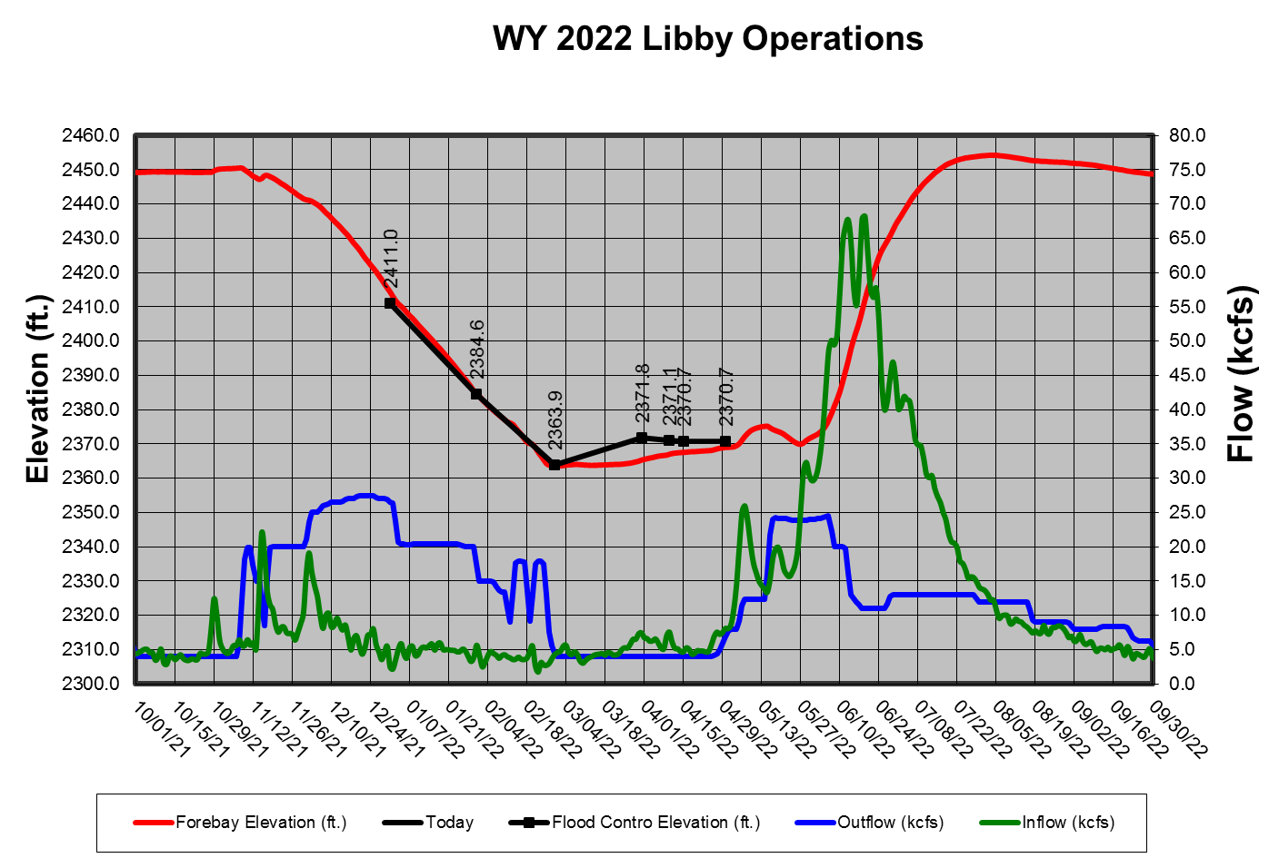

**Hungry Horse Dam**

**Water Supply Forecast and Minimum Flows:** The minimum flow requirements are measured at two locations the South Fork Flathead River below Hungry Horse Dam and the Flathead River at Columbia Falls. The minimum flows will be determined monthly, beginning in January, with the Reclamation’s WSF forecast for Hungry Horse Reservoir for the period of April 1 to August 31. The final flow levels, for the remainder of the calendar year, are based on the March Final forecast.

**April 10 and June 30 Refill Objectives**: The Reclamation will provide inseason updates to this section.

The Reclamation computes Hungry Horse’s final April 10 elevation objective by linear interpolation between the March 31 and April 15 forecasted flood control elevations based on the March Final WSF.

**Summer Draft Limit:** The Reclamation will provide inseason updates to this section.

The summer operation will target the reservoir elevation of 3540 feet to 3550 feet (20 feet to 10 feet from full) by September 30 and this will be based on the water supply forecast. The table below shows the end of September targets based of the Hungry Horse May water supply forecast. However, if the project fails to refill, especially during drought years, minimum flow requirements may draft the reservoir below the end of September target elevation.

Hungry Horse End of September Elevation Targets

|  |  |
| --- | --- |
| **Hungry Horse May-September inflow forecast (KAF)** | **Hungry Horse forebay target on Sept 30 (feet)** |
| < 1,410 | 3,540 |
| 1,410 – 1,580 | Interpolate between 3,540-3,550 |
| > 1,580 | 3,550 |

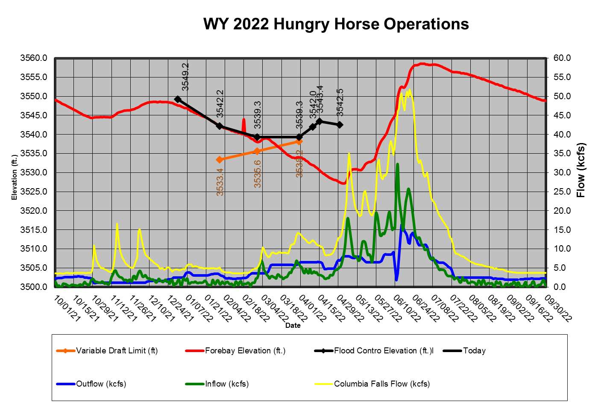

**Grand Coulee Dam**

**April 10 and June 30 Refill Objective:** The Reclamation will provide inseason updates to this section.

The Reclamation computes Grand Coulee’s final April 10 elevation objective by linear interpolation between the March 31 and April 15 forecasted flood control elevations based on the March Final WSF for The Dalles.

**The Lake Roosevelt Incremental Storage Release Program:** The Reclamation will provide inseason updates to this section.

**Table 8. Lake Roosevelt releases requested for 2022.**

|  |  |  |
| --- | --- | --- |
| **“Bucket”** | **2022 Releases (acre-feet)** | **Total Lake Roosevelt Incremental Storage Releases Program (acre-feet)** |
| Odessa |  |  |
| M&I |  |  |
| Instream Flow |  |  |

**Summer Draft Limit:** The Reclamation will provide inseason updates to this section.

The Grand Coulee summer draft limit is set by the magnitude of the RFC's July Final April-August WSF at The Dalles Dam.

**Drum Gate Maintenance:** The Reclamation will provide inseason updates to this section.

**Banks Lake:** The Reclamation will provide inseason updates to this section.

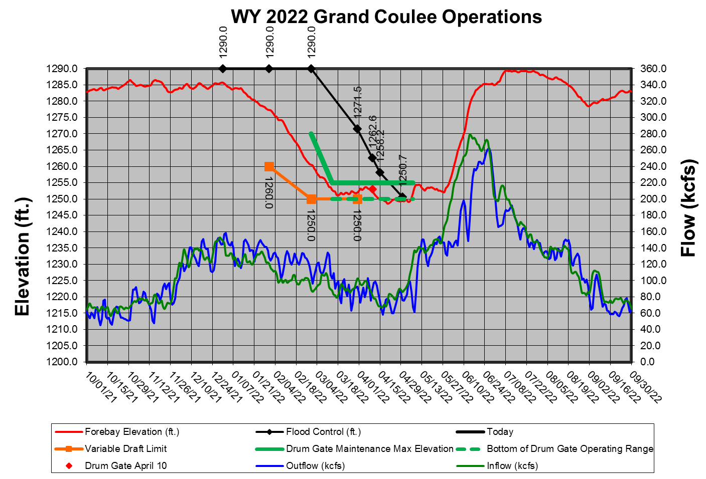

***Dworshak Dam***

**Flood Risk Management Elevation:** Operate in accordance with standard FRM criteria; shift system FRM to Grand Coulee Dam when possible, unless modified by procedures under dry-water-year operations. The shift in system FRM space will end by April 30, such that each project storage will satisfy their respective FRM space requirements.

Opportunities to shift system FRM requirements from Dworshak to Grand Coulee will be considered periodically from January through April. Shift of system space will not occur in high water years (with a Dworshak water supply forecast of 3.0 MAF or greater April to July runoff).

Dworshak Dam was operated to meet standard FRM criteria for water year 2022. The official water supply forecast on April 1 was 2,367 KAF, which would have set an end of month target elevation of 1,537.2 ft. With a midnight elevation on April 1 of 1,530.93 ft, the project was allowed to fill an additional 6 ft. The actual April 30 midnight elevation was 1,529.02 ft, meaning the project drafted 1 ft over the month of April due to hatchery releases that occured.

Discharges from Dworshak Dam were managed during this time to meet the obectives described above, and to support hatchery releases which occurred between March 31 and April 19. The magnitude of the hatchery supporting discharge ranged, on average, between 9.6 kcfs and 7.1 kcfs. After hatchery releases concluded, discharge tapered to the minimum flow of 1.6 kcfs.

Refill continued for the months of May and June. Please see the refill section below for more details.

**Variable Draft Limit:** Calculate a VDL in season to increase power generation from January to March, while protecting the ability to refill with 95% confidence based on the March 31 FRM upper rule curve.

No VDL operation occurred in WY 2022 because the WSFs were below VDL limits.

**Total Dissolved Gas:** Provide augmentation flows while not exceeding the state of Idaho TDG water quality standard of 110 percent saturation.

Two operations at Dworshak Dam in WY 2022 caused a TDG exceedance. During an atmospheric river that hit the region in mid June, Dworshak increased outflow to 25 kcfs, due to the elevation of the forebay being 8 ft from full at 1,592.3 ft. The TDG was recorded at the USGS NF Clearwater River at Ahsahka, ID (gage #13341000) to reach a maximum level of 122%. There was an additional exceedance of the 110% TDG on July 25-26 when outflows were at 12.7 kcfs for the summer flow augmentation for Lower Granite. The TDG during this time frame reached 111% at USGS NF Clearwater River at Ahsahka, ID.

**Refill:** Refill by about June 30 or earlier in dry years (exact date to be determined during in-season management).

The midnight elevation on June 1 was 1,581.9 ft. at Dworshak Reservoir. The reservoir was able to refill by June 30. The April 1 forecast for Dworshak was 2,367 KAF, but the actual volume received from April 1 to July 31 was 2,826 KAF. The reservoir reached elevation 1,590 ft on June 7 and reached elevation 1,599 ft on June 18. The reservoir was held at 1,599 ft from June 18 to July 8, when summer flow augmentation began.

**End of August and September Forebay Elevations:** Draft no lower than an elevation of 1,535 feet by the end of August and to an elevation of 1,520 feet (80 feet from full) by the end of September, unless modified per the agreement between the United States and the Nez Perce Tribe for water use in the Dworshak Reservoir.

The end of August and September forebay elevation targets were met. The midnight elevation on August 31 was 1,536.8 ft.

200 KAF was drafted from Dworshak between September 1 and September 29. The change in water temperature as measured at USGS Clearwater River at Spalding, ID (gage #13342500) did not exceed more than 1 degree F per day on average. After the 200 KAF was released, the outflow from Dworshak was reduced to the standard fall flow of 1.6 kcfs. The midnight elevation on September 30 was 1,519.09 ft.

**Outflows for Lower Granite Dam Tailwater Regulation:** Regulate outflow temperatures to attempt to maintain water temperatures in the Lower Granite Dam tailwater at or below 68°F, typically from July 1 through the end of September.

Flow augmentation for Lower Granite started on July 8 and continued until the end of September for WY 22. Outflows from Dworshak ranged from 7.1 kcfs to 12.8 kcfs during this time frame. There was one exceedance of the 110% TDG on July 25-26 when outflows were at 12.7 kcfs. The exceedance based on the 12 hour averages lasted for 15 hours. Lower Granites tailwater had two 12 hour average temperature exceedances of 68 degrees on August 8 and 9. Respectively, the water temperatures were 68.34 degrees and 68.17 degrees on those two days.

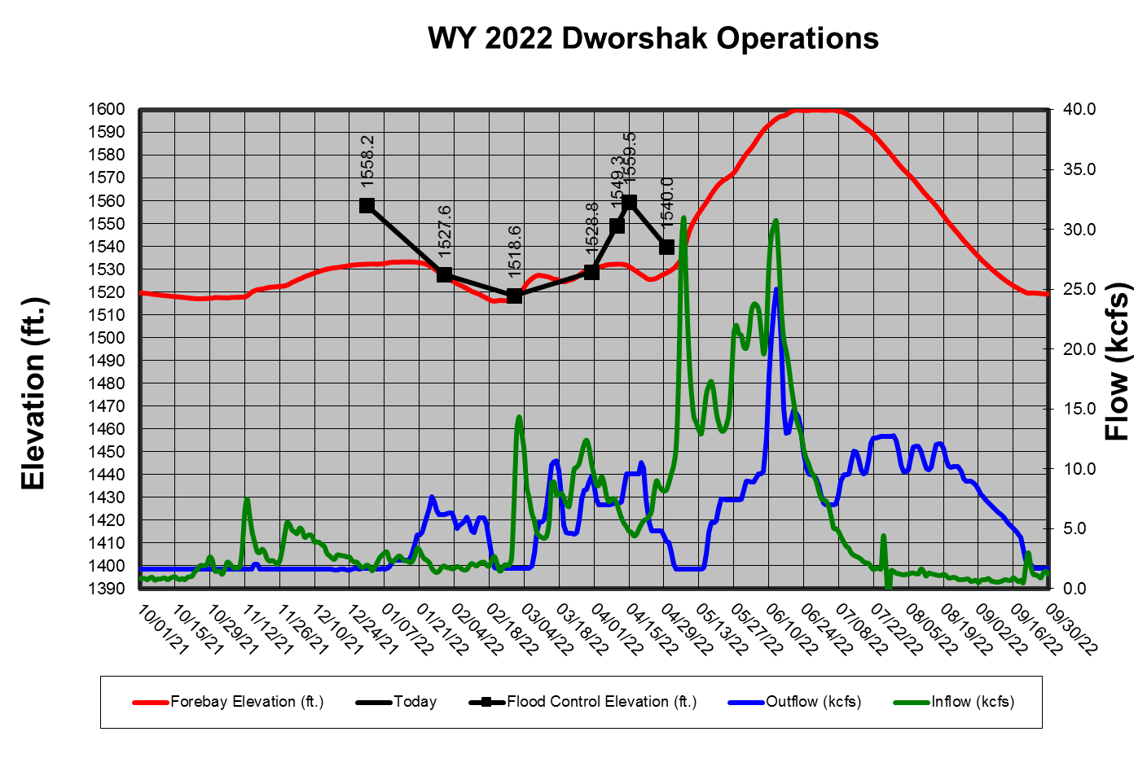

***Water Quality***

The AAs have coordinated the following spill priority lists with the TMT to date, and they may be found on the following website.

<http://pweb.crohms.org/tmt/documents/spill-priority/>

* 1. ***Burbot Spawning Operations***

Providing low temperatures, if possible, from Libby Dam to aid upstream migration of burbot to spawning areas in the Kootenai River in Idaho occur each winter. These low temperatures may be called for over an extended period from October through February. The Corps operates the selective withdrawal system at Libby Dam to provide the coldest discharge temperature available in the forebay for the purposes of minimizing river temperature to benefit burbot migration and spawning during the winter.

* 1. ***Lake Pend Oreille Kokanee Elevation (Albeni Falls Dam)***

Albeni Falls Dam drafted Lake Pend Oreille to within 0.5’ of its winter control minimum elevation for Kokanee spawning on 9 November. This half of foot band lasted until the end of Kokanee spawning in shallow water on 20 December.  
  
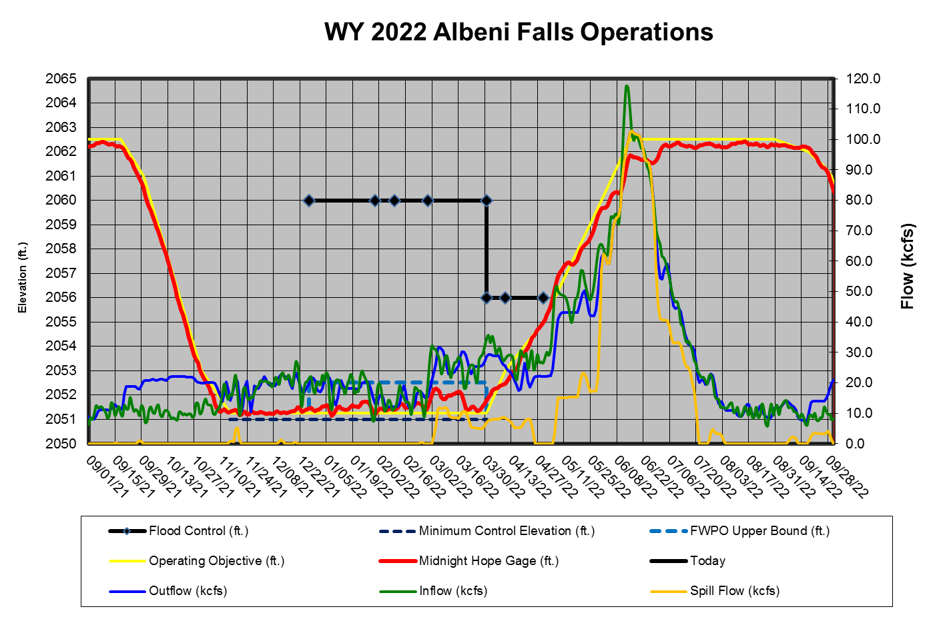

* 1. ***Upper Snake Flow Augmentation***

The Reclamation will provide inseason updates to this section.

* 1. ***Chum Operation***

The BPA and Corps will provide inseason updates to this section. The following summarizes the 2021/2022 TMT coordinated chum operation. Additional information on the TMT coordinated chum operation may be found in the TMT meeting minutes on the following website.

<http://pweb.crohms.org/tmt/>

| **Date** | **TMT Coordination Summary** |
| --- | --- |
| October 20, 2021 | The Corps, reported on coordination for the first phase of chum operations. Operations begin (as described in the BA) the first week of November, or when chum arrive. Coordination for the spawning phase will be from November through December, and will transition into the incubation phase from January through April, 2022.  Average outflow at Bonneville Dam for the month of October has been 89.8 kcfs, with an associated project tailwater average of 8.5 feet. Current forecasts show precipitation on the horizon, and the RFC inflow forecast for the next 10-days is between 80 kcfs and 121 kcfs. Snake River inflows have been relatively low; the forecast for Lower Granite is between 15 kcfs and 19 kcfs. The Corps noted that for chum operations, if flows from the Snake and Willamette rivers are low, the balance must be made from the upper Columbia River, although as other TMT members noted, the Snake River input is typically relatively small. Also of note is the Willamette River at Salem, where forecasts for the next 10-days show a discharge range of 6 kcfs to 30 kcfs. Additionally, with dry soil conditions, there is a lot of uncertainty surrounding the effect of precipitation on these initial stream flow rises. The BOR, noted that relative to WY 1991, Grand Coulee inflows are in the bottom 20th percentile, while flows into Ice Harbor are in 15th percentile. The BPA, reported Hamilton Creek is flowing, and more so with forecasted precipitation, which will help contribute to hyporheic flow in that area.  RFC forecasts for the next 10-days show significant and well above average precipitation in the Columbia River basin and west of the Cascades. Climate forecasts for both the 6-10-day and 8–14-day outlooks show a probability of below average temperatures and above average precipitation. The 3–4-week outlook is consistent with these forecasts as well.  WA, noted that FPAC is aware of the current situation and advocates for patience to see how forecasts develop. Charles reported a few chum have been counted passing over Bonneville, with some chum in the lower river. Chum have not been seen in the Ives Pierce area; they typically show when there is enough water, in early November. Except for Oregon, those present at yesterday’s FPAC discussion (Colville Tribes were not present at FPAC) did not object to starting chum spawning operations on November 1, assuming that flows increase, and operating to the 11.3 foot (11.5 foot with buffer) tailwater minimum. Action Agencies noted they prefer a start date of November 2 or 3 with the operating range of 11.3-13.0 feet. However, due to the inflow uncertainties, Salmon Managers think it is prudent to not make any decisions on chum operations until next week; Action Agencies agreed.  The Colville Tribes, raised concerns on behalf of the Tribes regarding the risks to Grand Coulee refill, power production, and effects on resident fish rearing and spawning. Claire McGrath, NOAA, noted that NOAA does not support “hardwiring” a start date, emphasizing the need to consider each year’s water and fish conditions. OR, also raised concerns about the intent to protect riverine species and restore riverine requirements, noting that when fish are present and water is low, they are not able to access the habitat, and monitored areas. WA added that it takes 2-3 days after the habitat is wetted for the chum to move into the area, but that they will start spawning as soon as they arrive onsite. TMT Members decided to schedule a meeting next Wednesday to finalize the start of chum operations. This will allow more time to see how the precipitation plays out.  ACTION: TMT will meet next Wednesday, October 27 at 9:00AM to continue the conversation and decide a start date for chum operations. The Corps TMT Chair will facilitate this meeting. |
| October 27, 2021 | The Corps, reminded the group that this unscheduled meeting was to continue the conversation on chum and consider updated forecasts and survey data to inform and confirm a start date of operations. Based on water supply conditions, Action Agencies preferred a start date of November 2 or 3, while Salmon Managers requested a start date of November 1.  The Corps confirmed that chum spawning operation parameters include project outflow at all hours to provide a tailwater elevation range of 11.3 – 13 feet. Average outflow at Bonneville Dam for the month of October has been 92 kcfs, with an associated project tailwater elevation average of 8.8 feet. Current forecasts show continued precipitation, and the RFC inflow forecast for the next 10-days is between 82 kcfs and 125 kcfs. At Lower Granite, the inflow forecast is between 17 kcfs and 20 kcfs, and the Willamette as measured at Salem has forecasted discharge between 10 kcfs and 15 kcfs. The most recent gauge height elevation at Hamilton Creek was 22.568 feet on October 27.  RFC weather forecasts for the next 10-days show lots of precipitation in the Portland area and west of the Cascades. Dry weather on day 4 is expected to be followed by more precipitation for the remainder of the 10-day period in Oregon and Washington. Climate forecasts for the 6–10-day outlook show a probability of above average temperatures in the SW Columbia Basin, near normal in the central Columbia basin and below average in the east basin and northwestern Montana. There is a probability of above average precipitation west of the Cascades and near normal east of the Cascades. The 8-14-day outlook shows a probability of above average temperatures and precipitation. Finally, the 30-day outlook shows an equal chance of above or below average temperaturesin the northern Columbia basin, a probability of above average temperatures in the southern basin, and a probability of above average precipitation throughout the whole Columbia basin.  The Colville Tribes, requested clarification on the chum operating tailwater range, and expressed continued concerns on elevations at Grand Coulee and risk to refill. The BPA, noted that the intent is to minimize the water management impact of the operation while working within a complex set of variables. In regard to a question on how the water management impact of chum operations could affect Lake Roosevelt’s elevation, BPA noted that the single trace stream flow showed that the project could potentially be drafting as low as 1,268 feet by the end of December to support chum spawning operation. The Reclamation, reported that flow augmentation out of Grand Coulee does have a potential to impact spring refill objectives, although at this point longer-term forecasts look good; however, he noted that things can change quickly. Drum gate maintenance at the project will occur in 2022 if the February water supply forecast shows an FRM elevation of 1,265 feet or less on April 30, which would bring the elevation down to 1,255 feet for the work. Otherwise, maintenance would be delayed until next year when it would be a forced year. The Colville Tribes and BPA will follow up offline to share information on the chum operations and Grand Coulee considerations.  ACTION: BPA will confirm how the trace data are distributed and how TMT members can access results.  BPA reported that recent precipitation occurred further north than forecasted, and that stream flows came in lower than expected due to dry soil conditions. The lack of water contributions from the Snake and Willamette rivers increases the amount of water needed from Grand Coulee to support chum operations. Action Agencies noted that water supply forecasts are still early, and many variables can change; at this point they do not expect chum operations to risk Grand Coulee refill. WA, reiterated that conditions suggest that chum operations would not put Grand Coulee more at risk than any other year. NOAA, acknowledged the uncertainties, noting that operation parameters are not set in stone and can be adjusted and adaptively managed depending on real time conditions.  NOAA reported that as of yesterday there were 8 chum counted over Bonneville, which is a good number for this time of year. Chum are expected in the Ives/Pierce area next week at the latest, and NOAA supports an operation start date range between November 1-4. After the meeting, WA later confirmed via email to the TMT that chum are clearly present below Bonneville, and that WA believes the decision to operate at a tailwater elevation of 11.3 - 13 feet on November 1 will benefit chum spawning in the Ives/Pierce complex sooner rather than later.  The Corps summarized that the chum operation (as posted on the TMT website) will begin on November 1 at 0600 hours, operating to a 11.3-13 tailwater elevation at all hours. The remaining steps are the same as last year’s operation.  ACTION: The AAs will coordinate to start chum spawning operations on November 1 at 0600 hours. |
| November 3, 2021 | The Corps, reported on the chum operation (as coordinated by the TMT on October 27) to operate Bonneville Dam outflow at all hours to provide a tailwater elevation range between 11.3 – 13 feet; complete operational steps are posted to the TMT website. The chum spawning operation will continue until the transition into the incubation phase (end of December). The Corps will continue to provide updates at TMT meetings in coordination with WA. The Corps noted that project tailwater elevation on November 3 was 11.8 feet.  At Bonneville, the RFC inflow forecast for the next 10-days is between 125-140 kcfs, with similar conditions in the tailwater. RFC weather forecastsfor the next 10-days show lots of variability: there is a probability of average to above average precipitation in western and northeastern Washington, with average to above average precipitation in Oregon and west of the Cascades. There is some variability in southeastern Washington and eastern Oregon, with below average precipitation. The 5-day QPF shows areas with above average precipitation in Oregon and Washington, but below average precipitation is forecasted in the upper Columbia and into Canada, and eastern Oregon.  The Corps noted that above average precipitation has been rare recently, so the percentages for the month of October are significant. The Snake River basin above Ice Harbor Dam observed 163% of normal precipitation; Columbia River above Arrow only 80% of normal; Columbia River above The Dalles was 119% of normal; and the Willamette River basin above Portland was 107% of normal.  BPA, reported that prior to the start of augmenting for chum, Grand Coulee’s peak forebay elevation was 1,286.5 feet, and the project is providing about 0.4 feet per day on average to support chum operations; it could potentially be drafting below 1,283 feet early next week. Hamilton Creek is flowing strong, based on a site visit. BPA noted that after the augmentation draft in July/August for Grand Coulee, which drafted Lake Roosevelt to 1,277 feet, additional augmentation volumes required to support the Bonneville minimum flows beyond the end of August drafted the project to 1,274.7 feet. Overall, the project filled just shy of 12 feet in September/October prior to the chum operation.  WA, reported that weather conditions for collecting survey data haven’t been great, although the crew visited the Ives/Pierce area on Monday and spotted 2 live chum, which indicate chum are in the area. WA will provide a summary of chum survey data next week so that TMT members can stay up to date on chum action between sessions. |
| November 17, 2021 | The Corps, reported on the chum operations; complete operational steps are posted to the TMT website. On November 17, project tailwater elevation has been within the range of 11.3 – 13.0 feet at all hours. On Monday, tailwater elevation at 1900 hours was up to 13.5 feet, peaked at 14.3 feet and was back down to 13.3 feet at midnight. Project outflows were lower on Tuesday. At Bonneville, the RFC inflow forecast for the next 10-days is between 125-140 kcfs; current precipitation is expected to bring inflows up, followed by a recession back down to 125 kcfs. RFC weather forecasts for the next 10-days show things drying up through the entire Columbia River Basin. The 10-day and 5-day QPF shows well below average precipitation throughout the basin. Monthly precipitation for October, however, was above average: the Snake River Basin above Ice Harbor Dam had 122% of normal precipitation; the Upper Columbia River Basin above Arrow observed 111% of normal; the Columbia River mainstem above The Dalles observed 117% or normal; and the Willamette River Basin above Portland observed 115% of normal precipitation.  However, even with all the precipitation, Oregon is still experiencing drought conditions. BPA, noted there may be a day or so where the project exceeds 16.5-foot tailwater at night as water is moved through system. BPA reported that Grand Coulee has been filling because the flows required from Bonneville were less than normal, as the Willamette River hit almost 50 kcfs due to heavy precipitation. BPA is not seeing any issues in continuing to meet the chum operation flows. BPA also noted that Hamilton Creek received precipitation; during the peak of the rainy period, the water surface reached 7 feet over the gauge. Water levels are currently back down to what is expected with normal precipitation and should recede to somewhere under 22 feet.  WA, reported that chum are present, although poor conditions in the Ives/Pierce area prevented surveying there this week. Weekly surveys will continue as conditions allow. In the Duncan Creek Seeps there were 30 lives and 11 redds; Multnomah had 96 lives and 17 redds; St. Cloud had 18 lives and 4 redds; Horsetail had 1 live; and Marker 85 had 3 lives and 1 redd. Last Wednesday there were 43 chum observed above the weir at Hamilton Creek and 22 below.  NOAA, noted that historically this is the week when chum ramp up at Ives; hopefully the next surveys will reflect increasing numbers. At Bonneville, chum YTD is 150, or 113% of the 10-year average. The Corps added that TMT will need to coordinate the transition from the chum spawning phase to chum incubation at the next TMT business meeting on December 15. |
| December 15, 2021 | The Corps, reported on chum operations; complete operational steps are posted to the TMT website. Project tailwater elevations have been high; total outflow at 0600 hours today was 177 kcfs with a project tailwater elevation of 15.9 feet. Yesterday, average tailwater elevation was 16.9 feet, with a total outflow of 192 kcfs. At Bonneville, the RFC inflow forecast for the next 10-days is between 172 kcfs-181 kcfs. The 4-day trend shows a drop in current levels, although a lot of water (180+ kcfs) is expected the rest of this month.  BPA, reported that average flow on December 6 was 170 kcfs, and on Dec 7, the project was no longer able to remain below 13-foot tailwater during the day. Willamette flow came up during this time period (around 50 kcfs at Salem) contributing to the 16-foot daytime tailwaters. To manage Bonneville’s forebay, BPA was spilling as much as 40 kcfs with a 19.5-foot tailwater. Operators have been passing inflows at Grand Coulee and incremental outflows between Grand Coulee and Bonneville were around 55 kcfs. These flows are expected to hold through the end of the month. Chum survey conditions have been poor due to high flows, a recent survey trip was cancelled due to visibility issues. BPA noted that later in the season, the survey crews will be able to confirm if there are redds needing protection above 11.5 feet.  WA, reported that the latest survey data are from December 8. To date, there have been no signs of any activity along the edges of the 13 foot elevation habitat. Survey data do suggest active spawning is nearing completion, although there could be a few late arrivals. The most recent Hamilton Creek counts were 87 live, 51 dead, and 34 redds. At Horsetail on December 8, it was very windy and only 2 live chum were counted. At Ives/Pierce counts on December 6 were 37 live, 4 dead, and 22 redds. At Multnomah on December 8 there were 63 live and 23 redds.  WA is comfortable with shifting to the incubation phase of the chum operations on December 24, as proposed by the Action Agencies. During the incubation phase, Bonneville will operate to a 13 foot tailwater at all hours. NOAA also supported pre-coordinating to start incubation operations on December 24, noting that the start date is aligned with past year’s operations and fish will still be able tospawn during the incubation operations if needed.  → ACTION: On December 24, chum operations will transition from the spawning to incubation phase, with a 13-foot minimum tailwater at all hours. |
| January 5, 2022 | The Corps, reported on the chum operation. The spawning phase of the operation is complete and as of December 24, 2021, the incubation phase is being implemented. During the incubation phase the Bonneville Dam will have a minimum tailwater of 13 feet. This operation will continue until the beginning of spring spill (April 10) unless otherwise coordinated at TMT.  The Corps reviewed Bonneville project data: Tailwater elevation is 18.3 feet; elevations have been relatively high due to increased flows. Yesterday’s average elevation was 17.3 feet, with total outflow averaging 192 kcfs. It is expected that high inflows will continue over the next 10-day period, the inflow forecast ranges from 172-207 kcfs. The Corps noted that the official water supply forecasts will be posted by close of business today and will be linked to the January 19 TMT meeting agenda. Current (un-official) water supply forecasts from the Northwest River Forecast Center are as follows:  • The Dalles (April to August) 92 maf or 103% of average  • Lower Granite (April-July) 21 maf or 103% of average  The Corps pointed out that although we are experiencing significant precipitation, the snowfall and rain are not creating a significant increase in the water supply above average. BPA, added that snowpack is increasing nicely. Due to poor weather conditions, chum survey crews were unable to get out for a 2nd redd survey. Additionally, when tailwater levels did rise, they went from 13 feet to 16 feet quickly and crews were unable to see redds at any higher elevations if they did occur. Despite this, the crews did not think that redds were placed above the 13 foot elevation. BPA will present data on redd elevations at the January 19 TMT meeting. WA, noted that surveys last occurred in Hamilton Creek on December 30 and 1 redd was observed. WA agrees that Chum spawning activity has concluded. |
| January 19, 2022 | The Corps reported on the incubation phase of the chum operation, during which Bonneville Dam will be operated to a minimum tailwater of 13 feet. This operation will continue until the beginning of spring spill (April 10) unless otherwise coordinated at TMT.  On January 19 at 0800 hours, Bonneville tailwater elevation was 17.5 feet, with a total outflow of 211 kcfs. The RFC inflow forecast at Bonneville ranges from 172 kcfs to 193 kcfs over the next 10-day period. BPA, added that the current WSF projects plenty of water to support chum minimum tailwater. |
| February 2, 2022 | The Corps, reported on the chum operation. As coordinated through TMT, the incubation phase is being implemented (since December 24, 2021). During the incubation phase the Bonneville Dam will operate to a minimum tailwater elevation of 13 feet all hours. This operation will continue through April 9, until the beginning of spring spill on April 10, unless otherwise coordinated at TMT. Bonneville tailwater elevation was 17.10 feet, with a total outflow of 206.40 kcfs this morning.  Official Water Supply Forecasts (WSF) will be posted on the TMT website by close of business on February 3 and will be reviewed at the next TMT meeting on February 16. BPA, noted that information on redd elevations will also be presented at the February 16 TMT meeting. |
| February 16, 2022 | The Corps reported that there has been no change to the chum operation since the last TMT meeting. The incubation phase, during which Bonneville Dam will be operated to a minimum tailwater of 13 feet, will continue through April 9 (spill season starts on April 10) unless otherwise coordinated at TMT. On February 16 at 0800 hours, Bonneville tailwater elevation was 15.3 feet, with a total outflow of 181.1 kcfs.  BPA, reported on observed and measured chum redds from 2021 (posted to the TMT website), noting that redd distribution was not as common in the typical locations. Redds were observed in Woodard Creek and McCord Creek areas, with only a few in the Breaks, one in Ives Pocket, and none in the Ives Channel. Reports from the field noted that sea lion predation has kept spawning in the Ives Pocket and Ives channel area. The Strawberry area had more redds than typical. All redds had significant submergence. Only the redds that were observed by WDFW field crews were marked, however, there may have been more redds that were not visible due to high water and low visibility. BPA does not see any issue maintaining tailwater of 13’ through April 10.  BPA noted that he visited the area prior to the start of operations and there was significant upwelling flow through the gravel in the Ives Pocket area at a BON TW of 8.5’. That, in conjunction with decent precipitation prior to the start of chum, and with Hamilton Creek flowing, contributed to good access to spawning areas prior to the start of the chum operation.  In response to a query from the Colville Tribe, BPA noted that no augmentation flow has been required from Grand Coulee this winter to support the chum minimum TW, drafting at Coulee has been for management of the forebay, flood control and the draft for drum gate maintenance.  WA, added that the timing of the elevated tailwater elevation had occurred after most of the observed spawning had been completed. Given the shared concern on increased predation activity, he also noted that WA has not incorporated incidental observation of sea lion predation, however, is considering doing so and WA will keep the TMT updated. |
| March 2, 2022 | The Corps, reported on the chum operation, noting no change from the last update. As coordinated through TMT, the incubation phase is being implemented (since December 24, 2021). During the incubation phase, Bonneville Dam will operate to a minimum tailwater elevation of 13 feet all hours. This operation will continue through April 9, until the beginning of spring spill on April 10, unless otherwise coordinated at TMT. On March 2 at 0700 hours, Bonneville tailwater elevation was 18.1 feet, with a total outflow of 209 kcfs.  Looking at the RFC inflow forecast for Bonneville, heavy precipitation and snow melt will increase flows significantly. Today the low is forecast to be 163 kcfs, with flows anticipated to peak around 250 kcfs and taper off to 220 kcfs by the end of the 10-day period. |
| March 16, 2022 | The Corps reported that there has been no change to the chum operation since the last TMT meeting. The incubation phase, during which Bonneville Dam will be operated to a minimum tailwater of 13 feet, will continue through April 9 (spill season starts on April 10) unless otherwise coordinated at TMT. On March 16  at 0800 hours, Bonneville tailwater elevation was 16.3 feet, with a total outflow of 196.8 kcfs. |
| April 6, 2022 | The Corps updated the TMT on chum operations coordinated at TMT and available on the TMT website. As coordinated, the chum operation transitioned from spawning to incubation on December 24, at 0001 hours with a Bonneville Dam minimum tailwater elevation of 13 feet all hours. Incubation will continue until the start of spring spill on April 10, unless coordinated otherwise at TMT.  There have been no changes to the operation since the last update. The Bonneville Dam tailwater elevation at 0700 was 15.5 ft. Outflow was 188 kcfs. |

| **Date** | **Chum Water Management Summary** |
| --- | --- |
| October 15-31, 2021 | The last half of October 150-400% precip fell across the basin building snow pack and providing significant increases in streamflows. During this period Grand Coulee was filled to 1286.5 feet prior to the start of the chum operation. Augmentation for the start on the chum spawning operation on November 1 began on October 31. Outflow from Grand Coulee from October 15-30 averaged ~55 kcfs but the start of the chum operation required outflow of ~90 kcfs for the first three days of the operation to get started.  It is notable that in late October with the significant precipation especially on the west slope the Cascades that Hamilton Creek and Hamilton Springs had robust flows prior to the arrival of chum or chinook in the Ives area. Also, significant flow through the gravel in the Ives Pocket area was observed with at BON TW elevation of 8.5 feet in an area that is typically indundated with a BON TW elevation of 11.3 feet. This is notable that the seeps in the are are likely more dependent on the amount of water held in the water table above this area than the BON TW. During this period the pool between the mouth of Hamilton Creek and the last bar separating the flow through the Ives Island area as full and flowing due to significant ground water upwelling. With Hamilton Creek flowing at ~2’ above the invert of the gauge there was 6-10” of depth flowing from Hamilton Creek over the last break in slope immediately downstream of the mouth of Hamitlon Creek. |
| October 31- Novermber 9, 2021 | During this period outflow from Grand Coulee averaged ~83 kcfs to support the chum TW below Bonneville. During this period inflow to Grand Coulee steadily increases generally halting additional draft of the Lake Roosevelt and passing inflow. During this period outflow from Bonneville average ~123 kcfs with an average TW of 11.6 feet. |
| November 10-18, 2021 | Increase in local streamflows including the Willamette (~50 kcfs) and Hamilton Creek which spiked to 7 feet over the gauge invert. During the period the outflow from Bonneville remained stable at ~123 kcfs similar to the previous week the TW increased in response the increase in streamflows downstream. The Bonneville TW during this period was closer to 13 feet during the daytime with the start of the need to move water above a 13 foot tailwater at night and Grand Coulee filled ~2 feet to contribute to maintaining the daytime TW at Bonneville at or below 13.0 feet. |
| November 19-25, 2021 | The daytime TW at Bonneville remaind at or below 13.0 feet during this period however, significant inflow into system above Bonneville require moving water up to as high as an 18.5 foot TW at night. During this period Grand Couleee was drafted to 1282.6 feet in anticipation of the forecasted increases in inflow into Grand Coulee in the coming weeks. |
| November 26-December 6, 2021 | During this period inflow into Grand Coulee increased by ~40 kcfs and filled ~2.5 feet in an effort to maintain the daytime 13.0 TW maximum at Bonneville. Outflow from Grand Coulee increased from ~80 kcfs in the first half of this period to ~110 kcfs in the second half in order to manage the elevation of Lake Roosevelt. |
| December 7 – February 4, 2022 | On December 7 it was no longer possible to maintain a daytime maximum TW elevation of 13.0 feet. During this period inflow to Grand Coulee increased to an average of 135 kcfs with peaks up to 160 kcfs. The Willamette River had 3 distinct rises during this period of 50, 90 and 100 kcfs. Since the last peak of ~100 kcfs in early January the Willamette River flow has receded to 15 kcfs. During this period the Bonneville TW has ranged from 14 to 20 feet with outflow averaging ~190 kcfs. The February WSF at The Dalles was ~100% with a computed April 30 FRM elevation of 1244.5 feet which is well below the 2022 trigger for planning drum gate maintenance. This will require the draft of Lake Roosevelt to elevation 1255 by March 13. This draft will ensure that the flows at Bonneville will remain well in excess of that needed to support the minimum TW of 13.0 feet below Bonneville. |
| February 5 – March 10, 2022 | February was mostly dry until the end of the month when the high pressure systems finally move offshore allowing some atmospheric rivers to hit the basin into March. The Willamette and Snake Rivers came up to ~50 kcfs. Inflow into Grand Coulee also increased to over 100 kcfs during the draft the drum gate maintenance elvation of 1255 by mid March. |
| March 11 – April 10, 2022 | During this period Grand Coulee was passing inflow and operated within 5’ of the maximum drum gate elevationof 1255 feet. Average outflow at Bonneville ranged from 160-200 kcfs resulting a BON TW > 13 feet. |

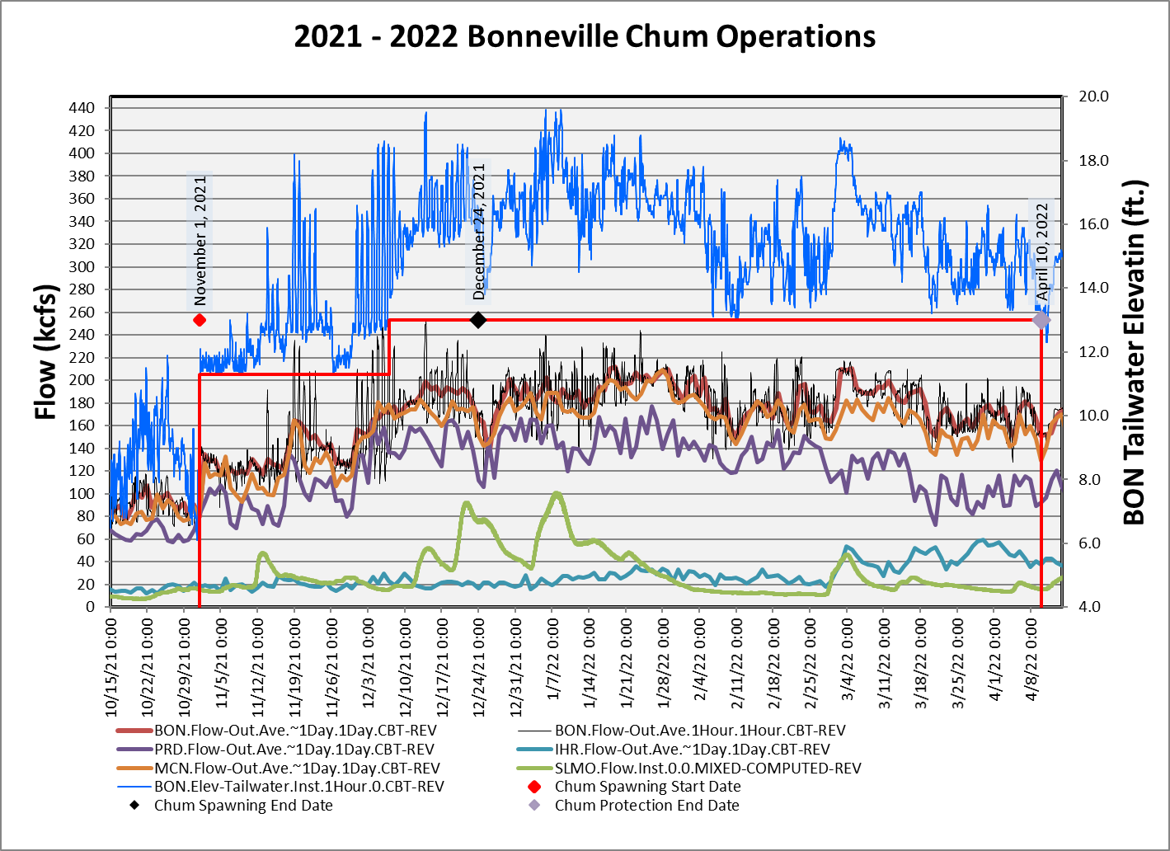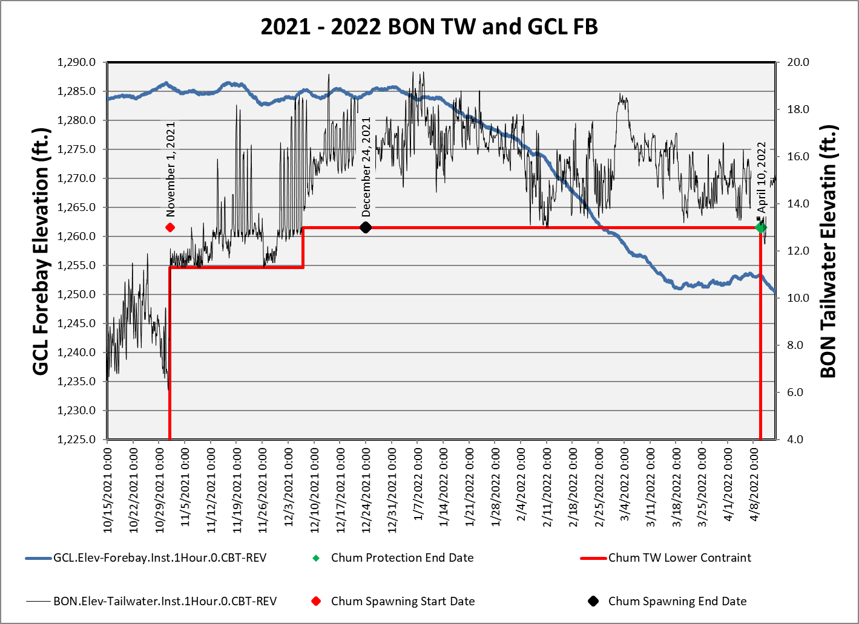

Chum survey data gathered at the Ives/Pierce Island Complex will be summarized in the table below. Data from all Chum survey areas, including the Ives/Pierce Island Complex, are provided by the Fish Passage Center and available on the following website.

https://www.fpc.org/spawning/spawning_surveys/ODFW_reports/2021spawning.htm

**Table 9. Chum Salmon Spawning Ground Surveys Below Bonneville Dam, 2021-22.**

**Survey Area**

**Ives/Pierce Island Complex**

| **Date** | **Lives** | **Deadi** | **Reddsii** | **Visibility (feet)** |
| --- | --- | --- | --- | --- |
| 13-Sep-21 | 0 | 0 | 0 | 6.5 |
| 20-Sep-21 | 0 | 0 | 0 | 8.0 |
| 27-Sep-21 | 0 | 0 | 0 | 5.0 |
| 4-Oct-21 | 0 | 0 | 0 | 10.0 |
| 12-Oct-21 | 0 | 0 | 0 | 8.5 |
| 15-Oct-21 | 0 | 0 | 0 | 8.5 |
| 18-Oct-21 | 0 | 0 | 0 | 3.0 - Bad wind chop |
| 21-Oct-21 | 0 | 0 | 0 | 5.0 - Hard east wind |
| 28-Oct-21 | 1 | 0 | 0 | 5.5 |
| 2-Nov-21 | 2 | 0 | 0 | 4.0 - Gusty east wind |
| 8-Nov-21 | 27 | 0 | 0 | 8 |
| 15-Nov-21 | - | - | - | No Survey - No Visibility |
| 18-Nov-21 | 284 | 3 | 77 | 4.0 - Heavy East Wind |
| 23-Nov-21 | 421 | 4 | 133 | 3.5 – Heavy East Wind |
| 30-Nov-21 | 338 | 116 | 151 | 8 |
| 6-Dec-21 | 37 | 22 | 8 | 4.5 |
| 13-Dec-21 | 2 | 11 | 0 | 0 – No Visibility still surveyed |
| 20-Dec-21 | 0 | 0 | 0 | 4.5 - High Water – Good Visibility |

1. Dead are newly samply fish only.
2. Redds are an instantaneous count for the day, not cumulative.
3. https://www.fpc.org/spawning/spawning_surveys/ODFW_reports/2021spawning.htm
   1. ***Vernita Bar/Hanford Reach Fall Chinook Protection Program Operations (Non-BiOp Action)***

The Hanford Reach Fall Cinook Protection Agreement (Agreement) ebstablishes the obligations of the Parties with respect to the protection of fall Chinook in the Hanford Reach of the Columbia River. The Parties agree that during the term of the Agreement these flow regimes address all issues in the Hanford Reacth with respect to fall Chinoook protection and the impact of operation of the seven dams operatin under Mid’Columbia Hourly Coordination, including the obligations of Grant, Chelan, and Douglas under any new licenses issued by the Federal Energy Regulatory Commission (FERC).

Beginning in mid-October, under the terms of the Hanford Reach Fall Chinook Protection Program Agreement, river flows are reduced every Sunday morning (day of lowest power demand) to the Priest Rapids Dam minimum operating discharge of 36,000 cubic feet per second (ft3/s) [1000 cubic meters per second (m3/s)]. This allows the Agency and Utility Party Monitoring Team to manually survey for redd distribution at Vernita Bar just downstream of Priest Rapids Dam. These drawdowns occur every Sunday morning until the initiation of fall Chinook spawning has been set both above and below the 50,000 ft3/s (1,416 m3/s) flow elevations. A final drawdown is conducted on the Sunday prior to Thanksgiving to establish the minimum critical flow needed to protect pre-emergent fall Chinook. Given the previously described limitations, this weekly reduction in river flow affords the best viewing conditions for aerial flights. Aerial flights are therefore scheduled to be conducted concurrent with the Sunday morning drawdowns, when possible.

| **Date** | **Grant County Public Utility District –**  **Hanford Reach –**  **Fall Chinook Protection Updates** |
| --- | --- |
| October 14, 2021 | Operations to support the Hanford Reach Fall Chinook Protection Program will begin on October 15, 2021. Reverse Load Factoring will begin at 000 hours on Friday the 15th and continue through the end of the Spawning Period. The Spawning Period is scheduled to end at 24:00 on November 21, 2021 (last Sunday prior to Thanksgiving) but may be extended if spawning activity is observed during the redd survey on that day.  During Reverse Load Factoring, discharge from Priest Rapids Dam (as measured at the USGS gage) must target between 55 and 70 kcfs during daylight hours. The goal during the Spawning Period is to limit spawning to the area below the 70 kcfs elevation on Vernita Bar.  Reduced daytime flows (38 kcfs) below Priest Rapids Dam on Sundays during the Spawning Period will be required to support redd counts on Vernita Bar. The first redd count will be conducted on Sunday, October 24. Specific details for operational support during Vernita Bar redd counts will be updated throughout the season and will be provided in individual flow requests. |
| November 21, 2021 | On Sunday, November 21, 2021 representatives from Grant PUD and the Washington Department of Fish & Wildlife conducted the third 2021 Vernita Bar spawning ground survey. The intent of this week’s survey was to determine the Critical Elevation for the 2021-2022 protection season and to determine if spawning has ended.  As described in the Hanford Reach Fall Chinook Protection Program Agreement, if there are fewer than 15 redds above the 65k elevation, then the Critical Elevation will be the first 5 kcfs elevation above the elevation containing the 16th highest redd. Therefore, using today’s data, the Critical Elevation for the 2021-2022 Protection Season is 65 kcfs. Additionally, based on observations during the survey it was determined that Spawning Period has ended today, November 21 (average end date = Nov. 22).  Starting on Monday, November 22, we will be in the Pre-Hatch Period. During the Pre-Hatch Period Priest Rapids Outflow may be reduced below the Critical Elevation for up to 8 hours on weekdays and 12 hours on weekends with no two consecutive periods below 65 kcfs. We are projecting that the Post-Hatch Period for the below 50 kcfs elevation will occur on November 28. During this period, flows must remain no less than 15 cm below the 50 kcfs elevation at all times. We are projecting that Post-Hatch for the above 50 kcfs elevation will occur on December 9. During this period, flows must remain no less than 15 cm below the 65 kcfs elevation at all times. |
| November 29, 2021 | Yesterday, 11/28, Post-Hatch below the 50k elevation began. At this time flows at Vernita Bar must remain no less than 15 cm below the 50 kcfs elevation at all times.  Above the 50 kcfs elevation, we remain in the Pre-Hatch Period which allows for flows to be reduced below the Critical Elevation (65 kcfs) for up to 8 hours on weekdays and 12 hours on weekends with no two consecutive periods below 65 kcfs. We are projecting that Post-Hatch for the above 50 kcfs elevation will occur on December 9. When the Post-Hatch period begins, flows must remain no less than 15 cm below the 65 kcfs elevation at all times. |
| December 6, 2021 | We are projecting that Post-Hatch for the above 50 kcfs elevation will occur on December 9. When the Post-Hatch period begins, flows must remain no less than 15 cm below the 65 kcfs elevation at all times. |
| December 9, 2021 | Today, 12/9, began that Post-Hatch Period above the 50k elevation. During this period flows must remain no less than 15 cm below the 65 kcfs elevation at all times. |
| March 10, 2022 | We are projecting that on March 16, 2022 (average start date March 17) the Emergence and Rearing Periods will begin. During these periods, daily flow fluctuation below Priest Rapids Dam will be limited and the water level at Vernita Bar must be no less than the Critical Elevation (65 kcfs) at all times. |
| March 15, 2022 | We have an updated projection date of 3/17 for the beginning of the Emergence and Rearing period. |
| April 14, 2022 | We continue to be in the Emergence and Rearing Periods. This Period requires no less than the Critical Elevation (65 kcfs) at all times and flow fluctuation constraints from Priest Rapids Dam.  We are projecting that the enhanced weekend minimum flow constraints (CJAD II) will begin on Saturday, April 23. The enhanced weekend constraints will continue for four consecutive weekends ending on Sunday, May 15. During the CJAD II weekends, the minimum flow below Priest Rapids Dam must be no less than the average of the daily hourly minimum from Monday through Thursday of the current week. |
| April 20, 2022 | Due to persisting cold temperatures we have updated our projection date for enhanced weekend minimum flow constraints (CJAD II) to Saturday April 30. The enhanced weekend constraints will continue for four consecutive weekends ending on Sunday, May 22. During the CJAD II weekends, the minimum flow below Priest Rapids Dam must be no less than the average of the daily hourly minimum from Monday through Thursday of the current week. |
| May 12, 2022 | We are projecting the end of the Emergence Period on Monday 5/16. This will end the requirement for flows to be no less than the Critical Elevation (65 kcfs) at all times. Flow fluctuation constraints from Priest Rapids Dam will continue through mid-June and enhanced weekend minimum flow constraints (CJAD II) remain for this weekend (May 14-15) and next (May 21-22). |
| May 19, 2022 | This Sunday, May 22 will be the final weekend of the enhanced weekend minimum flows (CJAD II). We continue to be in the Rearing Period which limits flow fluctuations below Priest Rapids Dam. We are projecting that the Rearing Period will end on June 18 (average date = June 13). Projected dates may change based on river temperatures. I will provide updates as the season progresses. |
| June 28, 2022 | The Rearing Period ended on Tuesday, June 21. This ended the flow fluctuation constraints from Priest Rapids Dam. |

* 1. ***Snake River Zero Generation***

Zero Generation Operations as described in the 2020 CRSO EIS ROD will no longer commence as early as October 15, and will instead commence once the previously defined implementation trigger of “few, if any” actively migrating anadromous fish (as described in SOR 2005-22) has been met. This trigger will be implemented in relation to both date (implementation will be limited to periods between December 1 and through February 28) and abundance.

Salmon Managers submitted System Operations Request (SOR) 2005-22 Snake River Zero Nighttime and Weekend Flow, to the Action Agencies (AA) on December 6, 2005. The SOR may be found on the following website:

<http://pweb.crohms.org/tmt/sor/2005/2005-22.pdf>

In the SOR, the Salmon Managers provided the AAs with the following table to define the criteria of “… few, if any …” prior to the implementation of the Zero Generation Operation. The few migrating adult criterion trigger will be defined on a sliding scale outlined in the following table. The table applies to both “wild” and “total” categories of returning adult steelhead.

Table 12: The Few Migrating Adult Criterion Trigger (SOR 2005-22)

|  |  |  |
| --- | --- | --- |
| **Run to date>#** | **Run to date< #** | **Few criteria< #** |
| 0 | 30,000 | 10 |
| 30,000 | 60,000 | 20 |
| 60,000 | 100,000 | 35 |
| 100,000 | 150,000 | 50 |
| 150,000 | 200,000 | 65 |
| 200,000 | 250,000 | 80 |
| 250,000 |  | 100 |

System Operations Request 2005-22 defined “few” migrating adults; this SOR has guided operations through 2019. Over time, these criteria have been slightly modified to include:

1. The number of adults migrating per day is defined as the number of upstream counts minus the number of downstream counts, as reported on the Fish Passage Center’s website (<https://www.fpc.org/currentdaily/HistFishTwo_7day-ytd_Adults.htm>).
2. A three-day moving average will be used to determine if the few migrating adult criterion has been met.
3. The criteria apply to both “Unclipped” and “total” categories of returning adult steelhead. “Unclipped” and “total” returns will be calculated separately. Only one of the categories is necessary to show that more than a few adults are migrating.
4. The run to date is defined as the cumulative number of adult steelhead in the “Unclipped” and “total” categories passing Lower Granite Dam since July 1st of the return year.

The timing of “*nighttime*” and “*dawn*” changes throughout the year. Based on the hours of actual Civil Twilight at Lower Granite Dam, the following hour ranges were coordinated during the October 21, 2020, TMT meeting to be consistent with the criteria identified in the 2020 CRS BA:

DATES “NIGHTTIME” HOURS FOR ZERO GEN

December 1-14 1800-0600

December 15 - January 31 1800-0600 + up to 3 daytime hours

February 1-28 1900-0600 + up to 3 daytime hours

Sources for definitions and computation of nighttime hours: <https://www.esrl.noaa.gov/gmd/grad/solcalc/glossary.html>

<https://www.esrl.noaa.gov/gmd/grad/solcalc/calcdetails.html>

The abundance criterion to begin zero generation operations was met as of December 17, 2021. This was communicate to the action Agencies via email and NMFS Morandum dated December, 20, 2022.

Zero Generation flexibility was used extensively coincident with a regional cold snap that began in late December and extended through January 8th. Subsequent moderate regional temperatures produced power market conditions the resulted in no use since early January.

From December 17th through February 28th usage was 5.9% of the available hours of zero generation on 17.9% of the available days. A small number of the daytime hours have been used during this period. At total of 16 daytime hours were used over 4 instances at LWG and 1 instance each at LGS and LMN.

Summary graphs below:

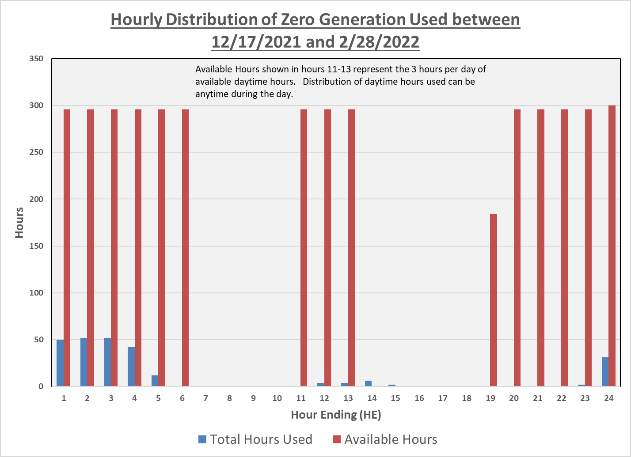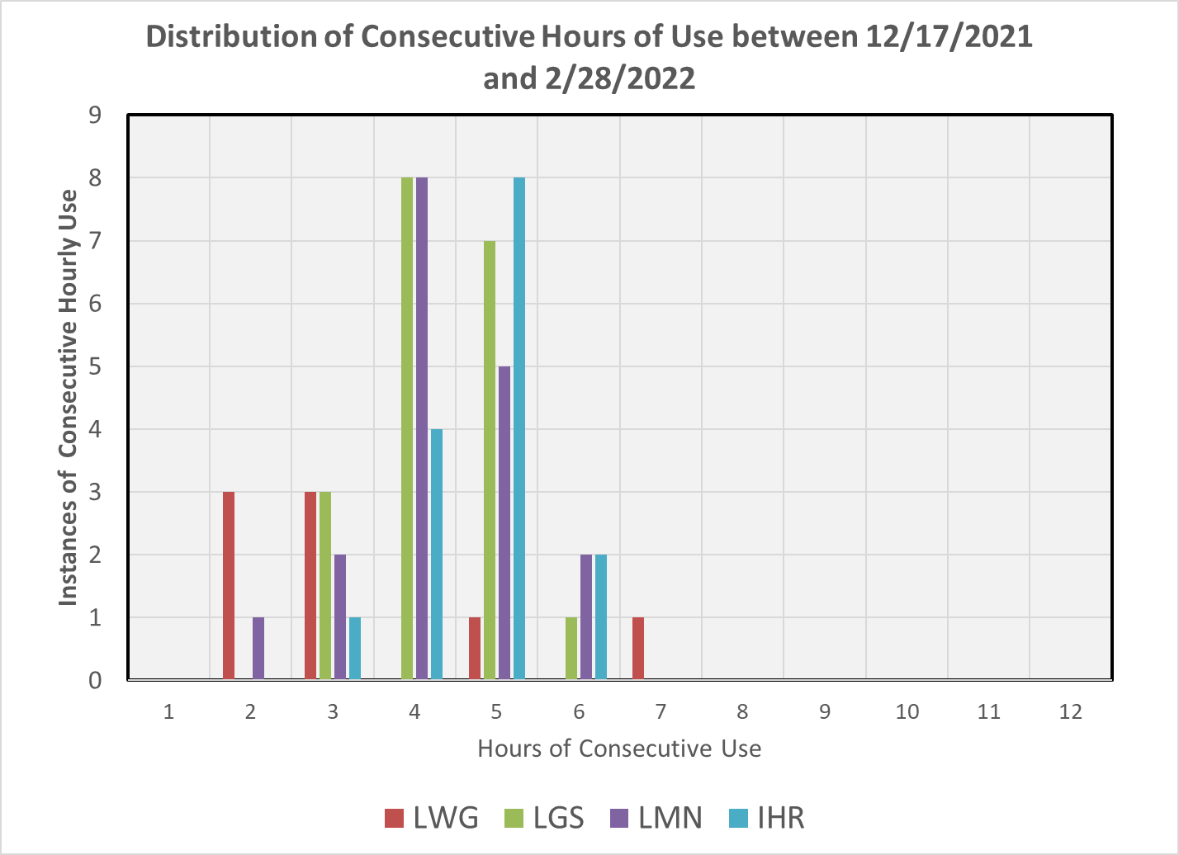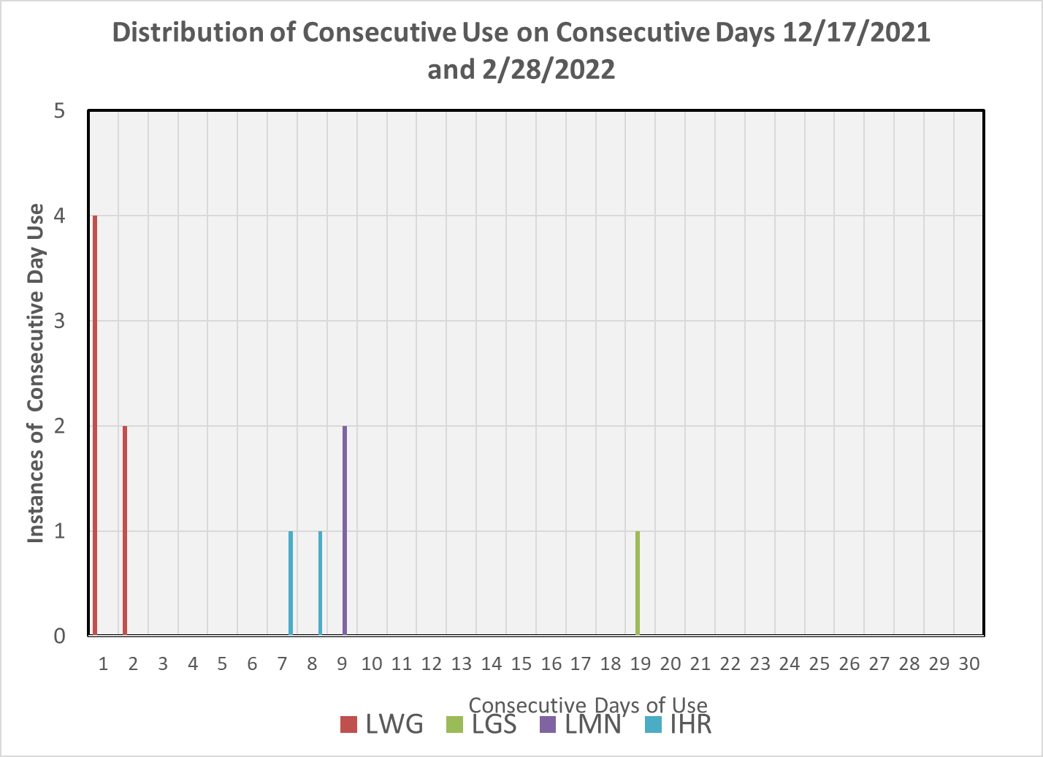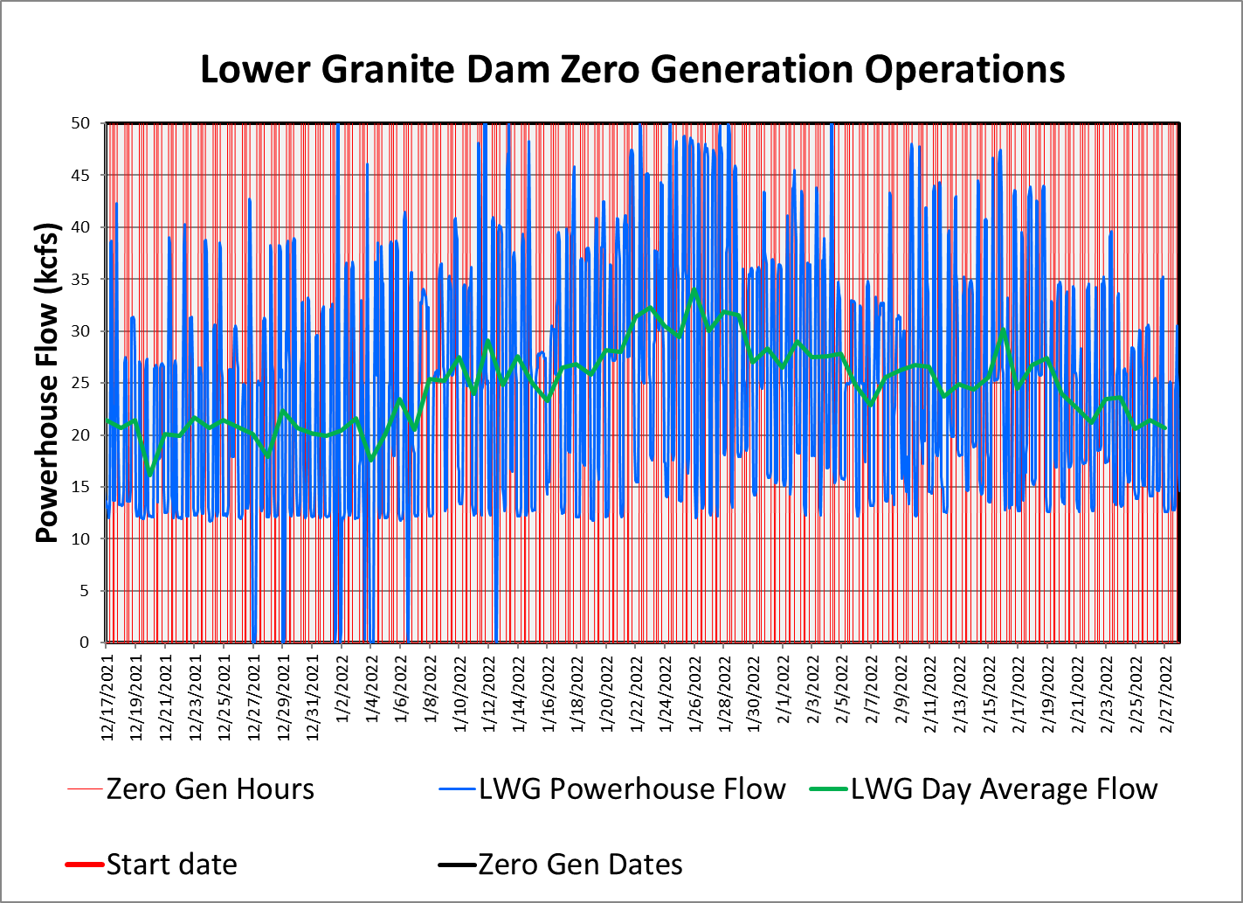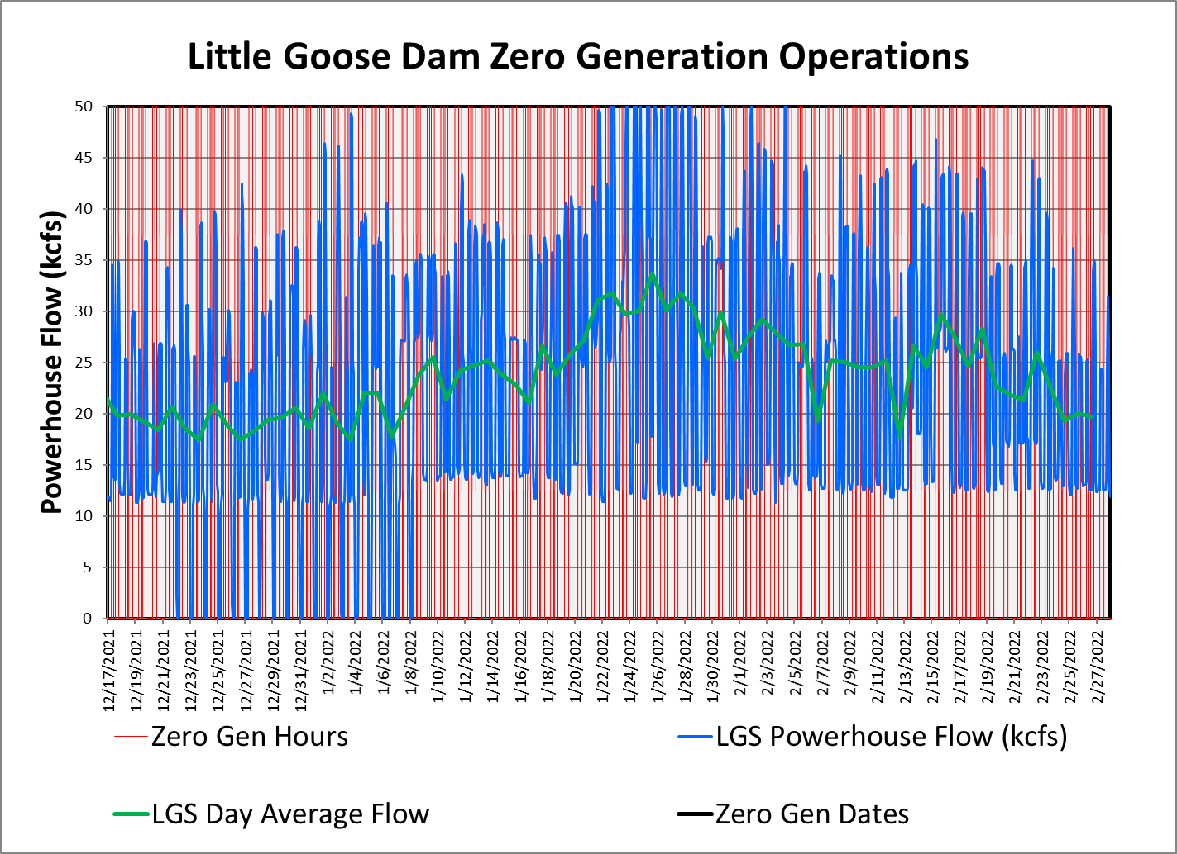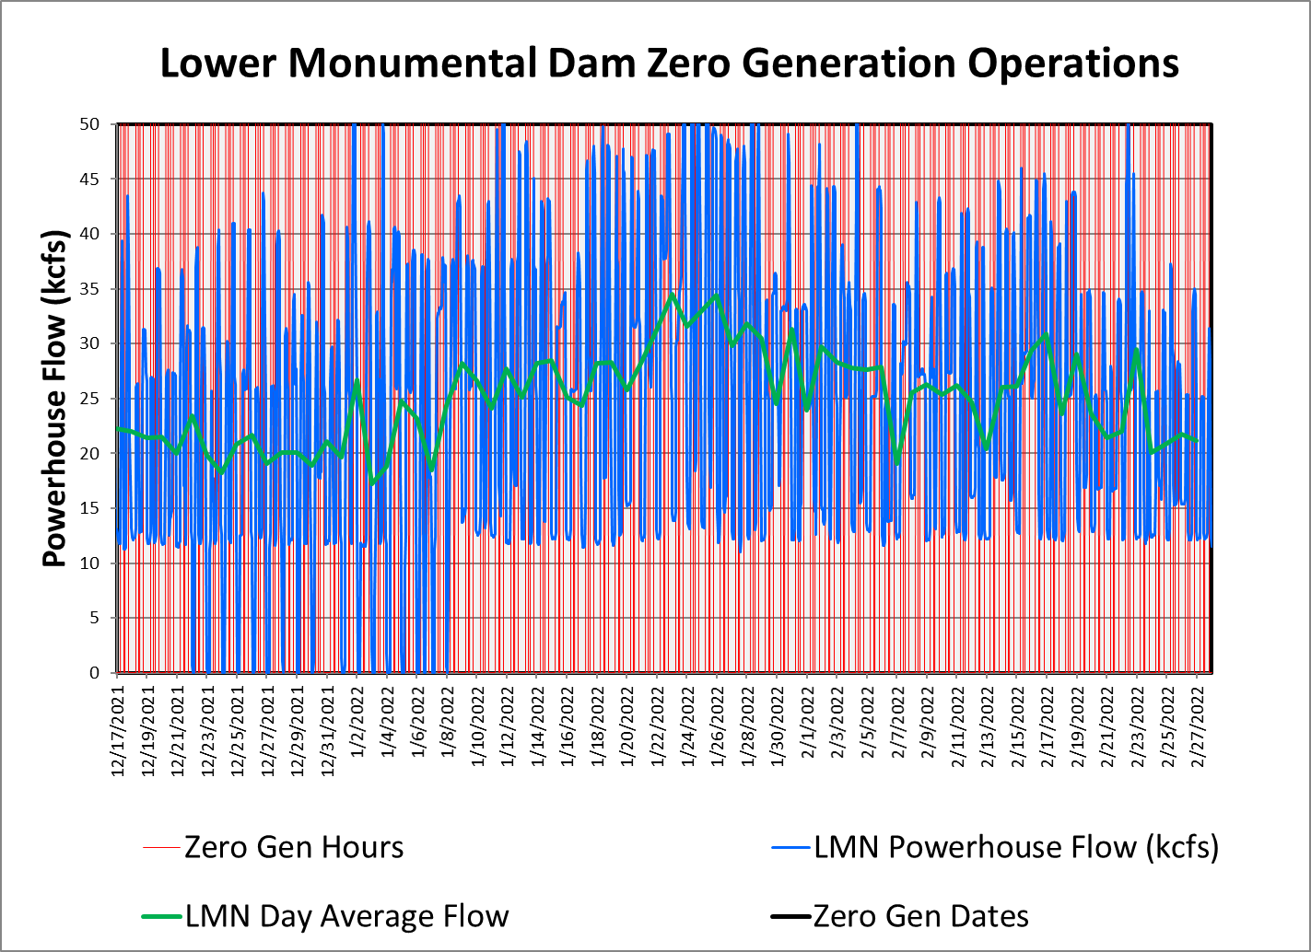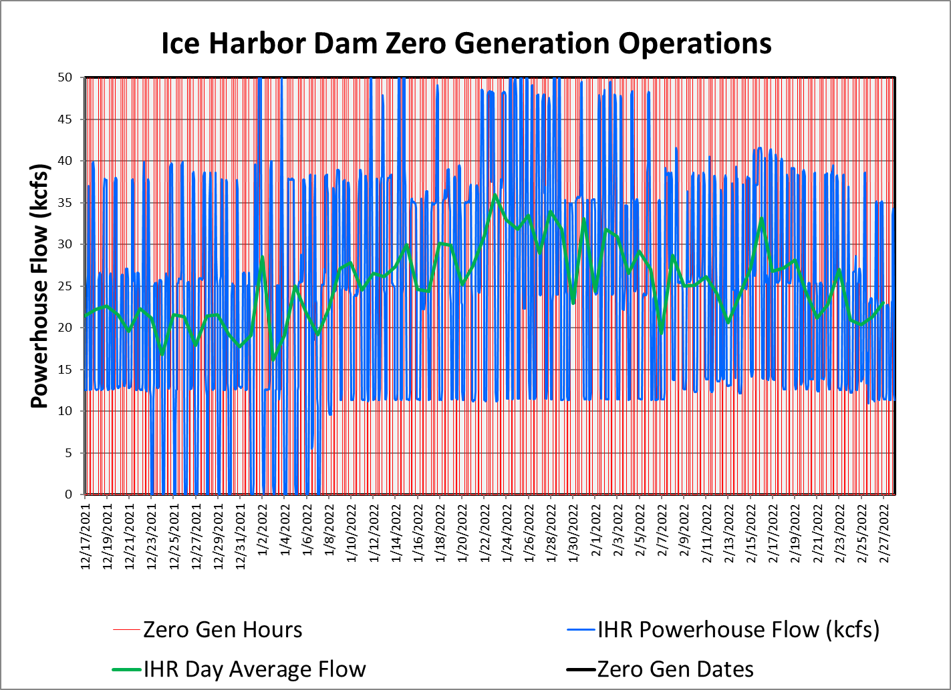

* 1. ***Minimum Operating Pool (MOP)***

The four lower Snake River CRS projects (Lower Granite, Little Goose, Lower Monumental, and Ice Harbor) are operated for multiple purposes including fish and wildlife conservation, irrigation, navigation, hydropower generation, recreation, and limited FRM. As described in the Agreement on 2022 Operations, the Corps shall operate Lower Granite, Little Goose, Lower Monumental, and Ice Harbor Dams at minimum operating pool (MOP) with a 1.5 foot forebay operating range and a 1.0 foot range to the extent possible (referred to operationally as a “soft constraint”) from April 3 until August 14, 2022, unless adjusted on occasion to meet authorized project purposes, primarily Navigation, as specified in the FOP (e.g., 2022 FOP Section 4.6).

The 1.0 ft soft/1.5 ft hard operating range allows BPA schedulers and Corps operators to use a 1.0 ft operating range after applying operational buffers (~0.5 ft of buffers) that are necessary to avoid real time deviations from the hard operating limits.

The 1.0 ft soft/1.5 ft hard operating range is necessary for successful implementation of the fish passage spill requirements. Transitions between 125% and PSS spill blocks require large flow changes that can result in significant reservoir bounces at the projects, making reservoir storage vital for successful implementation. The Lower Snake projects have several fixed blade generating units which create dead bands and restricted operating ranges for turbine operations. This results in minimum turbine flow changes of 20-25 kcfs when turning units on or off to meet power demand, causing large flow changes and bounces in the reservoir.

The AAs will coordinate this operation and any other changes in MOP operations with TMT. Additional information regarding MOP operations are described in the 2022 FOP on the following website.

http://pweb.crohms.org/tmt/documents/fpp/2022/final/FPP22_AppE.pdf

Observed data from 2022, show the 1.0 ft soft/1.5 ft hard operating range resulted in the reservoirs being operated within a 1 ft range over 95% of the time at Lower Granite, Little Goose and Ice Harbor and over 90% of the time at Lower Monumental.

* All deviations above the 1.0 ft soft range that were caused by ponding water to achieve PSS hours during high flows (per FOP guidelines) were removed from these statistics
* The fish barging operation at Lower Monumental appears to be the main cause for the additional deviations above the 1.0 ft soft range (compared to the other 3 Lower Snake projects)
* The 5% - 10% of the time projects exceeded the 1.0 ft soft operating range were mostly caused by reservoir bounces and other complexities that are a part of the real time operations of the Lower Snake projects. In other words, the projects were planned and scheduled to stay within the 1.0 ft soft range, but factors experienced during real time operations occasionally caused a deviation above the 1.0 ft soft range.

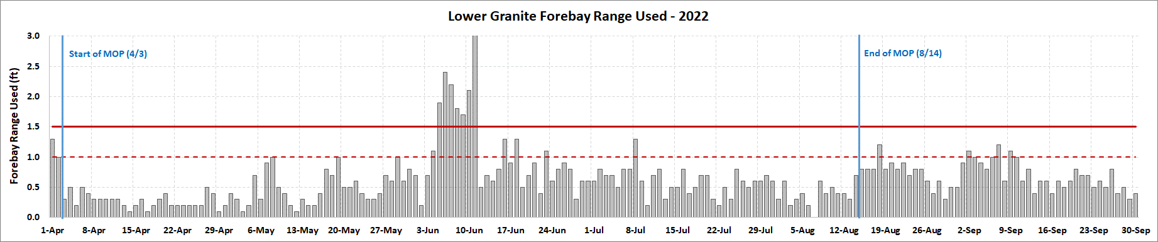

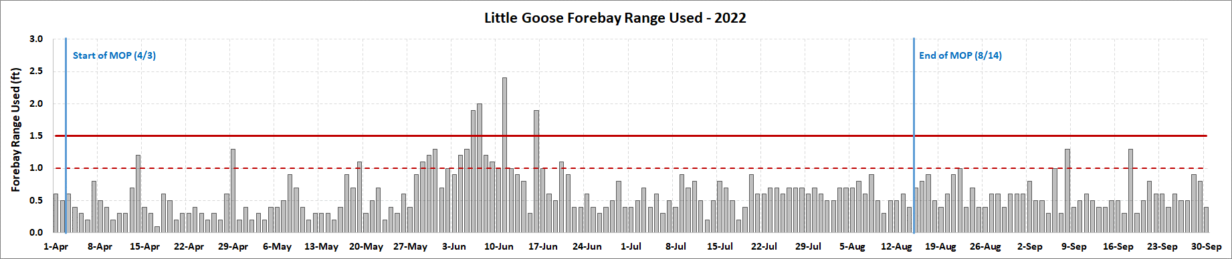

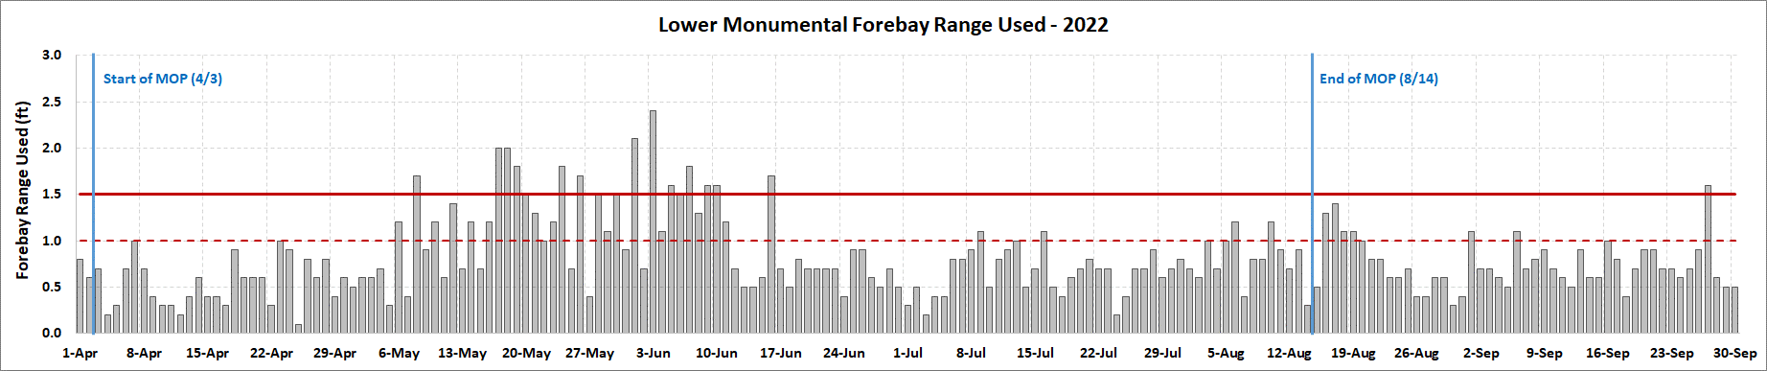

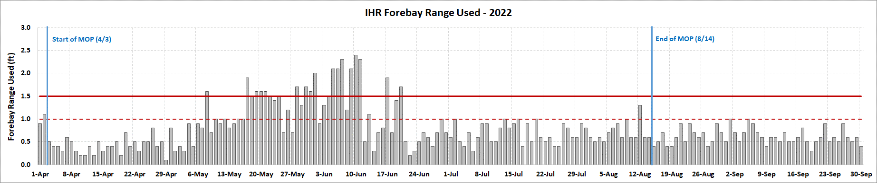

**Observed reservoir operations for April – September 2022 at Lower Granite.**

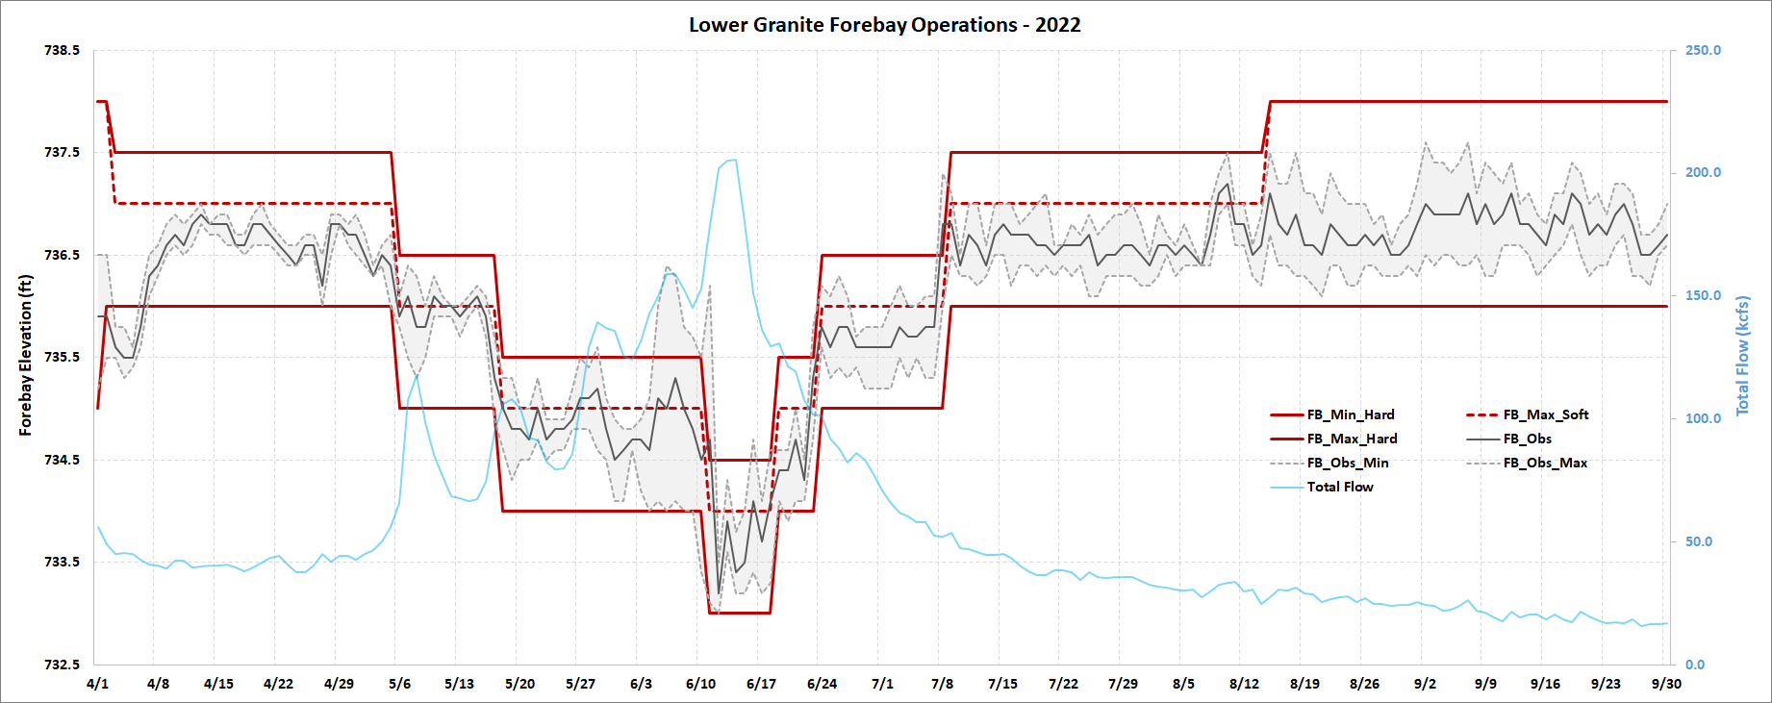

The reservoir requirements for MOP, when considering navigational safety, are a function of total flow into Lower Granite. For navigation safety, lower flows produce higher elevation requirements and higher flows produce lower elevation requirements. This plot shows the various adjustments made to the 1.0 soft/1.5ft hard MOP range throughout the operating season. The deviations outside of MOP late-May through late-June were caused by ponding water above MOP to implement the PSS hours as prescribed in the FOP.

**Observed reservoir operations for April – September 2022 at Little Goose.**

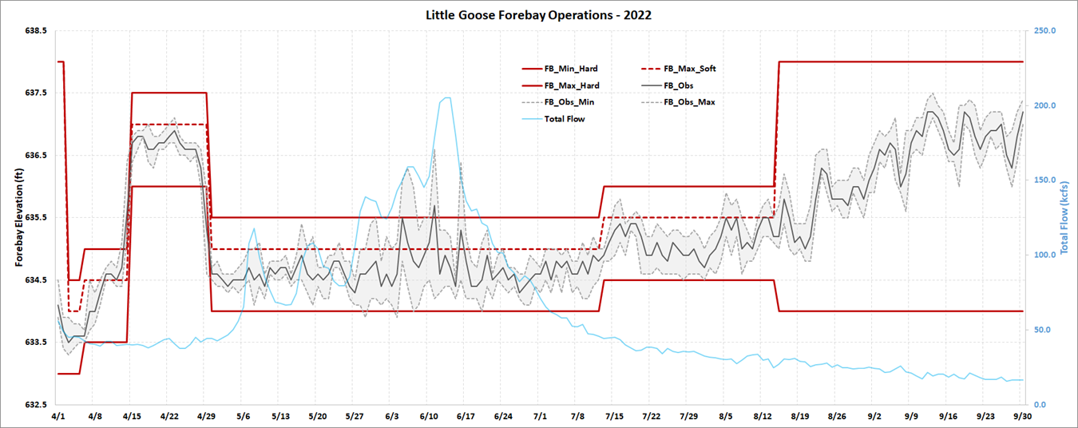

This plot shows the various adjustments made to the 1.0 soft/1.5ft hard MOP range throughout the operating season as needed for navigation safety requirements. In mid-April the MOP range was raised significantly higher in the pool to provide adequate depth until a navigation hazard could be removed.

The deviations outside of MOP late-May through late-June were caused by ponding water above MOP to implement the PSS hours as prescribed in the FOP.

**Observed reservoir operations for April – September 2022 at Lower Monumental.**

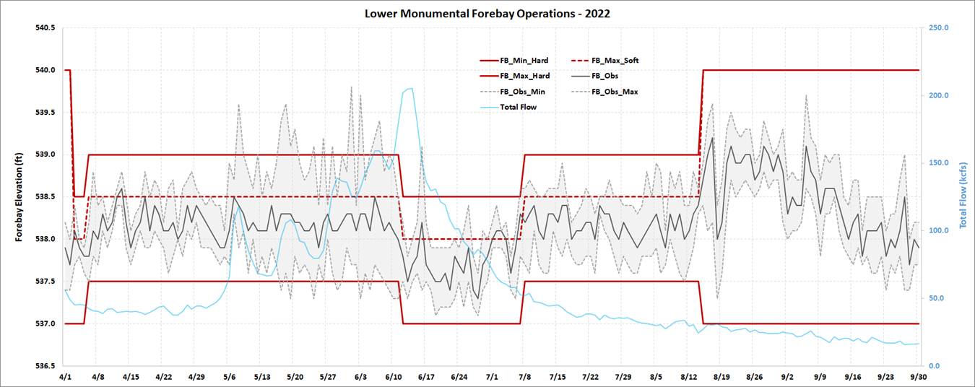

This plot shows the various adjustments made to the 1.0 soft/1.5ft hard MOP range throughout the operating season as needed for navigation safety requirements.

The deviations outside of MOP late-May through late-June were caused by ponding water above MOP to implement the PSS hours as prescribed in the FOP. Additional deviations outside MOP (relative to the other 3 Lower Snake projects) were observed at Lower Monumental due to the fish barge operation.

Elevation requirements for a cruise ship (maximum 539.0 ft) and to reduce TDG during the adult steelhead spill operation (537.0 – 538.0 ft range) caused the project to draft the pool to an elevation similar to where the pool was located at the conclusion of MOP.

**Observed reservoir operations for April – September 2022 at Ice Harbor.**

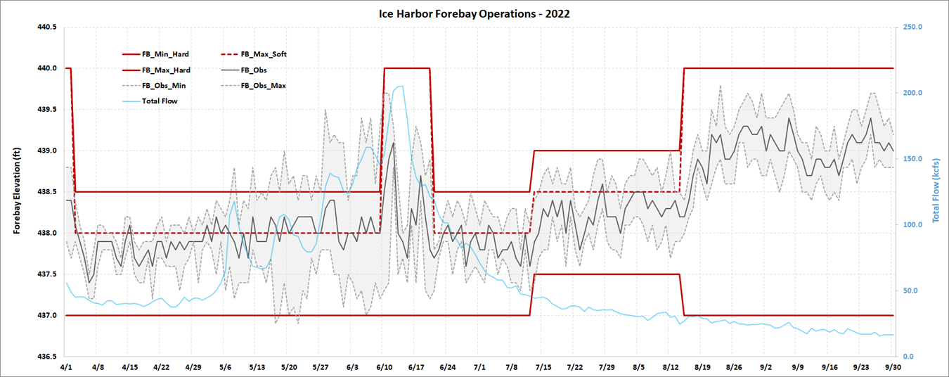

This plot shows the various adjustments made to the 1.0 soft/1.5ft hard MOP range throughout the operating season as needed for navigation safety requirements. From June 10 – June 20 the full operating range (437.0 – 440.0 ft) was available to help reduce flow fluctuations being observed at Ice Harbor due to the implementation of the PSS hours at the upstream projects under high flow conditions.

The deviations outside of MOP late-May through late-June were caused by large flow fluctuations due to upstream projects ponding of water to achieve the PSS hours during the high flow period as prescribed in the FOP.

* 1. ***Minimum Irrigation Pool (MIP)***

As described in the 2020 CRS BA (page 2-57), from April 10 – June 1 (or as feasible based on river flows), the John Day reservoir elevation will be held between 264.5 feet and 266.5 feet (an average of 265.5 feet) to deter Caspian terns from nesting in the Blalock Islands Complex. The Action Agencies intend to begin increasing the forebay elevation prior to initiation of nesting by Caspian terns to avoid take of tern eggs; operations may begin earlier than April 10 (when the reservoir is typically operated between 262.0 to 266.5 feet). The operation may be adaptively managed due to changing run timing; however, the intent of the operation is to begin returning to reservoir elevations of 262.5–264.5 feet on June 1, but no later than June 15, which generally captures 95% of the annual juvenile steelhead migration. The results of this action would be monitored and communicated with USFWS and NMFS. During the operation, safety-related restrictions would continue, including but not be limited to maintaining ramp rates for minimizing project erosion and maintaining power grid reliability. Following this operation, the John Day reservoir elevation would return to MIP + 2 ft operation through August 31.

From June 1 through August 31, John Day Dam will be operated to minimize water travel time for downstream-migrating juvenile salmon by operating the forebay within the minimum irrigation pool (MIP) range of 262.5 to 264.5 feet, which is the lowest pool elevation that allows irrigation withdrawals.

This section will be updated throughout the season as new information becomes available.

* 1. ***Spill for Juvenile Fish Passage***

Table 3 below is a summary of the 2022 spring target spill levels at lower Snake River and lower Columbia River projects, as described in the 2021 Fish Operations Plan (2020 FOP). Additional information on spring spill operations may be found in the 2021 FOP (page FOP-18) on the following website.

http://pweb.crohms.org/tmt/documents/fpp/2022/final/FPP22_AppE.pdf

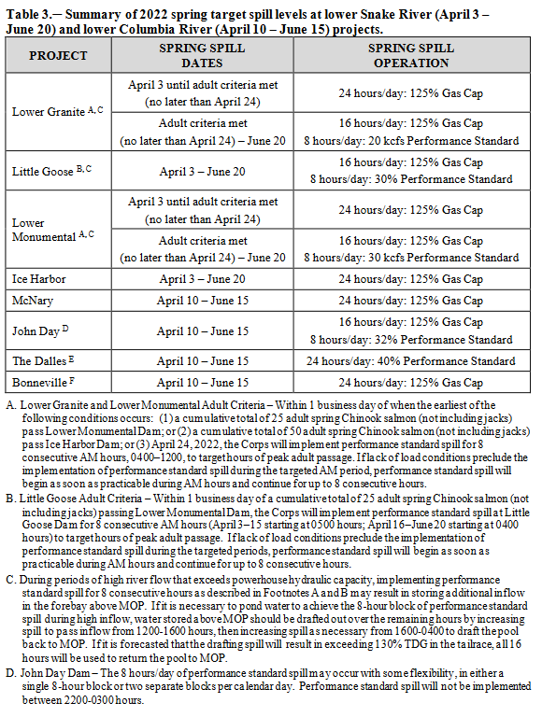

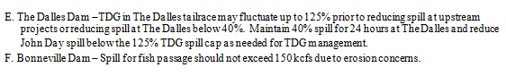

Table 4 below is a summary of the 2022 summer target spill levels at lower Snake River and lower Columbia River projects, as described in the 2022 FOP.

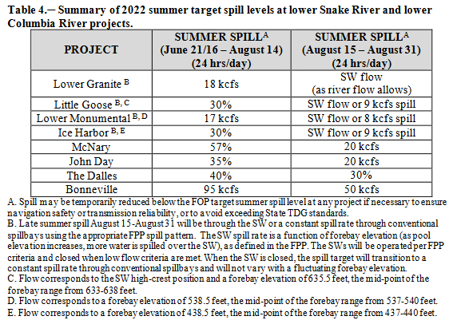

* 1. ***Juvenile Trasportation***

As described in the 2022 FOP, transportation will be initiated at Lower Granite, Little Goose, and Lower Monumental dams on April 24 (collection starting on April 23) or as coordinated through the TMT and the RIOG, but begin no later than May 1. Barging of fish begins the following day after fish collection and collected juvenile fish will be transported from each facility on a daily or every-other-day basis (depending on the number of fish) throughout the migration season. Transportation of spring migrants ends on June 20. Truck transportation of summer migrants resumes on August 15 with allowance for TMT adaptive management adjustments and continues through September 30 at Lower Monumental and October 31 at Little Goose and Lower Granite.

The start date for the 2022 juvenile transportation operation was coordinated during the March 16, 2022, TMT Meeting. During this meeting the Corps noted juvenile collection will begin on April 23 at Lower Granite, Little Goose and Lower Monumental with the first barge departing on April 24. NOAA suggested that TMT Members bookmark January 2024 to begin discussions for the 2023 Juvenile Transportation Program. Additional information regarding this TMT coordination may be found in the March 16, 2022, TMT meeting minutes on the following website.

https://pweb.crohms.org/tmt/agendas/2022/

* 1. ***Fish Passage Research in 2022***

The following project specific sections provide a brief summary of fish passage research in 2022.  
More information on this research may be found in the 2022 Fish Passage Plan in Appendix A  
on the following website.

<http://pweb.crohms.org/tmt/documents/fpp/2022/final/FPP22_AppA.pdf>

* + 1. ***Bonneville Dam***

**Powerhouse 2 Fish Guidance Efficiency (FGE) Program – Unit 15 Gatewell Hydraulic Velocity Measurements.** The B2FGE Program PDT has contracted work to install concrete gatewell flow modification devices in place of the metal plates that were installed and then removed due to structural failure. Installation has been complete in hydraulic test Unit 15 during 2021. In spring 2022, hydraulic measurements will be taken in the gatewell and behind the VBS,  
expected to occur sometime in May–June. The gatewell measurements will be similar to  
what was done in 2014 and 2015. VBS screens in test gatewells will be raised, seals  
inspected, and cleaned at least once per week, or as coordinated with the project to account  
for environmental conditions. Hydraulic measurement equipment and framework will be in  
the Unit 15 gatewells during test periods. Unit 15 will be tested during operation in the  
middle 1% range and the upper 1% range, one day per gatewell for each treatment, during  
daylight hours (0600–1700). Adjacent Units 14 and 16 operations will be requested during  
the test periods to provide stable operations to minimize hydraulic changes in the gatewell. All unit operations will be within the existing 1% range (see FPP Table BON-15), with unit  
availability contingent on total river flow, spill, and unit priority. A daily schedule will be  
provided to Bonneville Dam Operations.

* + 1. ***The Dalles Dam***

There are no studies planned at The Dalles Dam in 2022.

* + 1. ***John Day***

There are no studies planned at John Day Dam in 2022.

* + 1. ***McNary Dam***

There are no studies planned at McNary Dam in 2022.

* + 1. ***Ice Harbor Dam***

**Ice Harbor Dam - Unit 3 - Direct Injury and Sensor Fish Characterization.** Juvenile spring Chinook salmon and Sensor Fish will be directly released into turbine unit 3 to evaluate the new Kaplan runner. The study is expected to require approximately four weeks of total study time. Direct release pipes will be installed in all three intakes of Unit 3 for direct fish and Sensor Fish releases. Release pipes will be installed on the STS frames. Three specific turbine operations will be tested. Project support will be provided for equipment install, removal, and turbine operations. A one-day Unit 3 outage is expected for release pipe install and removal. Another consideration will be river flow and unit priority during the study period. Specific dates for Project support, outages, and operations will be scheduled appropriately with the Project and through FPOM closer to study implementation.

* + 1. ***Lower Monumental Dam***

There are no studies planned for Lower Monumental Dam in 2022

* + 1. ***Little Goose Dam***

**Kelt Collection & Reconditioning.** The Nez Perce Tribe (NPT) Department of Fisheries Resources Management will collect wild/natural post-spawned, emigrating steelhead from the separator at Little Goose Juvenile Fish Facility. These fish will be transported to the Nez Perce Tribal Hatchery (NPTH) or Dworshak National Fish Hatchery (DNFH) to be utilized in the kelt  
reconditioning program

* + 1. ***Lower Granite Dam***

**Genetic Stock Identification (Idaho Department of Fish & Game).** Fish collected as part of the Lower Granite juvenile condition sample are used to enumerate and characterize age composition and genetic stock profiles of naturally producing yearling Chinook and juvenile steelhead. IDFG will sample Monday through Friday through mid-June with a goal of collecting 2,000-5,000 yearling Chinook and juvenile steelhead genetic samples.

**Kelt Study (Nez Perce Tribe, University of of Idaho, CRITFC)**. This research investigates steelhead kelt physiology and endocrinology to evaluate the feasibility and success of rehabilitating strategies. Selected kelts collected at Lower Granite are transported by NPT to Dworshak National Fish Hatchery for reconditioning and later release as part of this study.

**PIT-Tag Adult Wild Chinook and Adult Steelhead for ISEMP-Related Dispersal  
Monitoring (NOAA Fisheries).** The goal of this project is to PIT-tag up to 4,000 unclipped adult Chinook and 4,000 unclipped adult steelhead collected in the adult trap daily sample for dispersal monitoring.

**Lower Granite Dam Juvenile Lamprey Survival.**  In Spring 2022, from Mid-March till late-May, juvenile lamprey will be tagged and released twice a month. The RSW might be taken out of service for a few hours for one day in early March to test the acoustic arrays in the forebay. This study will help inform Pacific Lamprey passage conditions, migration behavior, and fate.

**Post-Construction Assessment of PIT Detection Efficiencies in Spill Bay 1.** The goal of this evaluation is to assess post-construction conditions of Lower Granite Dam’s spillbay 1 and PIT-tag detection efficiencies. Release PIT-tagged hatchery yearling Chinook salmon (O. tshawytscha) into the entrance of Bay 1 at three locations horizontally across the spillbay and at low and high elevations within the water column for each to evaluate single fish detection efficiencies at the recently installed ogee PIT detection system. Sample sizes will be sufficient to determine single fish detection efficiencies with a precision of ±5% @ 90% CI. This study addresses Reasonable and Prudent Alternatives (RPA) 54 and 55 in the 2008 BiOp. This study also addresses Question 3 of the Ten Key Questions for Salmon Recovery in the NMFS-NWFSC Salmon Research Plan (NWFSC 2002). Releases would require additional spill (4 more hours) for 1 day if the study is done before spring spill, preferably 0900 to 1700.

**Sampling of Adult Steelhead, Chinook, and Sockeye for Biological Data Collection  
(IDFG and NOAA Fisheries).** Upriver migrating adult steelhead, spring/summer Chinook salmon, and sockeye salmon are collected from the adult trap from April 4 through December 15. The goal is to collect 5–20% of adult steelhead, spring/summer Chinook salmon, and sockeye salmon ascending the ladder. Data collection includes fish scales, genetics tissue, sex and length, wild/hatchery composition, and non-adipose clipped hatchery fish assessment. All natural-origin adult steelhead and spring/summer Chinook salmon trapped will be PIT-tagged to estimate headwater tributary escapement. Sockeye salmon may be PIT-tagged in the future to estimate metrics regarding conversion rates. Some steelhead and spring/summer Chinook salmon may be radio-tagged or spaghetti-tagged. This information on adult fish forms the basis for status information used in several forums including BiOp-RPA identified needs.

**Bull Trout PIT-Tagging and Genetic Sample Collection for USFWS.** Bull trout will be collected as part of the normal adult trap daily sample and using the adult sort-by-code (SbyC) system to recapture previously PIT-tagged fish. Untagged bull trout will be PIT-tagged, fin clipped for genetic analysis, and have morphometric data collected including weight and length, etc. Fin clips will be sent to USFWS to determine the fish’s origin. Previously PIT-tagged bull trout will only have morphometric data collected. All fish will be released back into the adult fish ladder.

**Subyearling Chinook Parentage-Based Tagging (USGS).** The goal of this project is to determine the abundance of unmarked, untagged, natural- and hatchery-origin subyearling Chinook salmon in Lower Granite sample collection. Fin clips will be taken from 30 unclipped, untagged subyearling Chinook each day from June 1-15 and for another two weeks in July depending in fish passage numbers.

**Collection of Adult Fall Chinook and Coho for Hatchery Broodstock – (WDFW and  
Nez Perce Tribe).** Adult fish are collected in the adult trap. Fall Chinook are transported by  
WDFW employees to Lyons Ferry hatchery and by NPT employees to Dworshak hatchery.  
Coho are transported by NPT and transported to Dworshak hatchery.