2021 Water Management Plan
Seasonal Update
November 22, 2021

- Introduction
The annual Water Management Plan (WMP) is developed prior to U.S. Army Corps of Engineers (Corps), Bureau of Reclamation (Reclamation), and Bonneville Power Administration (BPA), collectively referred to as the Action Agencies (AAs), implementation of Columbia River System (CRS) operations identified in the following documents: 1) NMFS 2020 CRS Biological Opinion (2020 NMFS BiOp); 2) U.S. Fish and Wildlife Service (USFWS) 2020 CRS BiOp (2020 USFWS BiOp); 3) AA’s 2020 CRS Biological Assessment (2020 CRS BA), and; 4) 2021 Fish Operations Plan (2021 FOP). The WMP is also developed prior to the receipt of any seasonal information that may determine how many of the operation measures are implemented. The Seasonal Update is intended to supplement the WMP with more detailed information on operations as the water year progresses. Each section of the Seasonal Update will be updated when information is available and finalized when no further information is available.

The first update for the primary elements of Fall and Winter will be posted by November 1 of each year. The first update for the primary elements of Spring and Summer will be posted by March 1 of each year. The elements and operations included in the Seasonal Update are generally the same as have been previously presented in the Fall/Winter and Spring/Summer Updates to the WMP. The change to update in this manner is intended to present better continuity for tracking operations as they change throughout and across each season. The elements and operations described in the Seasonal Update and the approximate schedule for updates and finalization are as displayed in Table 1.

Table 1. Schedule for update and finalization of Seasonal Update elements and operations.
Section | Element | Begins | Finalized | Last Updated
2.1 | Current Conditions (e.g., WSF, Streamflows) | October | July | October 8, 2021
2.2 | Seasonal Flow Objectives | April | August | October 8, 2021
2.3 | Flood Control | January | June | October 8, 2021
2.4 | Storage Project Operations | September | September | October 8, 2021
2.5 | Water Quality (Spill Priority Lists) | January | December | June 4, 2021
 | Specific Operations | Start Date | End Date | Last Updated
2.6 | Burbot spawning temperature management (Libby Dam) | November | December 30 | October 25, 2019
2.7 | Lake Pend Oreille Kokanee (Albeni Falls Dam) | September 1 | December 30 | -
2.8 | Upper Snake Flow Augmentation | April 1 | August 31 | -
2.9 | Chum Flows (Bonneville Dam) | November 1 | April 10 | June 4, 2021
2.10 | Hanford Reach Fall Chinook Protection | November | June | June 4, 2021
2.11 | Snake River Zero Generation | December | February | June 4, 2021
2.12 | Minimum Operating Pool | April 3 | September 1 | -
2.13 | Spill Operations | April 3 | September 1 | June 4, 2021
2.14 | Transport Operations | May 1 | - | June 4, 2021
2.15 | Fish Passage Research | March | October | June 4, 2021
- Seasonal Update Elements and Specific Operations
  - Current Conditions

Water Supply Forecasts – NWRFC
The final water supply forecast (WSF) is defined as the forecast posted on NOAA’s Northwest River Forecast Center (NWRFC) website at 5:00 pm Pacific Standard Time on the 3rd business day of the month. NWRFC water supply forecasts are available on the following website. http://www.nwrfc.noaa.gov/ws/

Table 2. The Dalles Dam Final Water Supply Forecasts.
Forecast Issue Date | January-July 2021 |  | April-August 2021
 | Volume (MAF) | % of 30-year Average (101.4 MAF) | Volume (MAF) | % of 30-year Average (87.5 MAF)
January 6, 2021 | 96.4 | 95 | 82.4 | 94
February 3, 2021 | 93.2 | 92 | 83.3 | 95
March 3, 2021 | 92.1 | 91 | 82.2 | 94
April 5, 2021 | 87.3 | 86 | 78.7 | 90
May 5, 2021 | 83.3 | 82 | 74.5 | 85
June 3, 2021 | 82.0 | 81 | 72.6 | 83
July 6, 2021 | 83.4 | 82 | 73.3 | 84

Table 3. Grand Coulee Dam Final Water Supply Forecasts.
Forecast Issue Date | January-July 2021 |  | April-August 2021
 | Volume (MAF) | % of 30-year Average (59.6 MAF) | Volume (MAF) | % of 30-year Average (56.8 MAF)
January 6, 2021 | 59.5 | 100 | 55.5 | 98
February 3, 2021 | 60.7 | 102 | 57.3 | 101
March 3, 2021 | 57.7 | 97 | 55.4 | 98
April 5, 2021 | 54.9 | 92 | 53.9 | 95
May 5, 2021 | 52.2 | 88 | 50.4 | 89
June 3, 2021 | 52.3 | 88 | 50.3 | 89
July 6, 2021 | 54.0 | 91 | 51.3 | 90

Table 4. Lower Granite Dam Final Water Supply Forecasts.
Forecast Issue Date | January-July 2021 |  | April-August 2021
 | Volume (MAF) | % of 30-year Average (27.4 MAF) | Volume (MAF) | % of 30-year Average (21.1 MAF)
January 6, 2021 | 22.8 | 83 | 17.8 | 84
February 3, 2021 | 21.7 | 79 | 17.1 | 81
March 3, 2021 | 21.9 | 80 | 17.8 | 84
April 5, 2021 | 20.1 | 73 | 16.0 | 76
May 5, 2021 | 18.9 | 69 | 14.8 | 70
June 3, 2021 | 18.6 | 68 | 13.4 | 67
July 6, 2021 | 18.5 | 68 | 13.3 | 67

Water Supply Forecasts - Corps
Water supply forecasts for Libby and Dworshak dams are produced by the Corps’ Seattle and Walla Walla Districts, respectively. Corps’ forecasts are available on the following website.

https://www.nwd.usace.army.mil/CRWM/Forecasts/

Table 5. Libby Dam Water Final Supply Forecasts.
Forecast Issue Date | April-August 2021
 | Volume (KAF) | % of 78-year (1929-2008) Average (6,282 KAF)
December | 6336 | 101
January | 6215 | 99
February | 5979 | 95
March | 5980 | 95
April | 5549 | 88
May | 5191 | 83
June | 5006 | 80

Table 6. Dworshak Dam Final Water Supply Forecasts.
Forecast Issue Date | April-July 2021
 | Volume (KAF) | % of 81-year (1929-2010) Average (2,663 KAF)
December | 3063 | 115
January | 2843 | 107
February | 2432 | 92
March | 2855 | 108
April | 2716 | 102
May | 2149 | 81
June | 1875 | 77

Water Supply Forecasts – Bureau of Reclamation
Water supply forecasts for Hungry Horse Dam are produced by the Bureau of Reclamation.

Table 7. Hungry Horse Dam Final Water Supply Forecasts.
Forecast Issue Date | April-August 2021 |  | Date-July 2021 |  | May-September 2021
 | Volume (KAF) | % of 30-year Average (2,070 KAF) | Volume (KAF) | % of 30-year Average (2,224 KAF) | Volume (KAF) | % of 30-year Average (1,835 KAF)
January | 2035 | 105 | 2200 | 105 | 1820 | 107
February | 1925 | 99 | 2050 | 99 | 1670 | 99
March | 2055 | 106 | 2075 | 105 | 1805 | 107
April | 1844 | 96 | 1780 | 95 | 1626 | 96
May | 1800 | 93 | 1500 | 90 | 1600 | 95
June | 1820 | 94 | 820 | 91 | 1640 | 97

Weekly Weather and Precipitation Retrospectives
Week | Weekly Weather / Precipitation Retrospective
October 5, 2020 | Temperatures: Well above average initially, then cooled to near average.  Precipitation: Dry initially, then turned much wetter this weekend with some precipitation falling as snow above 6000ft.  Streamflow: Flat until this weekend, when basinwide but minor rises began on most low elevation streams.
October 12, 2020 | Temperatures: Near average.  Precipitation: Well above average, especially north, with high elevation snow.  Streamflow: Receded after early week flow spikes. Localized re-rises underway this morning in the Clearwater, Spokane and mid-Cs with the latest batch of rain across.
October 19, 2020 | Temperatures: Fell to well below average. Near record cold and first widespread, hard freeze this weekend.  Precipitation: Above average north with significant mountain snow; below average south.  Streamflow: Receded after last weekend’s minor flow peaks.
October 26, 2020 | Temperatures: Record low temperatures at beginning of the week moderating to just above average as week progressed.  Precipitation: Above average north with significant mountain snow; below average south.  Streamflow: Mostly flat and receding.
November 2, 2020 | Temperatures: Unseasonably warm temperatures to start the week moderating to just below average as weekend approached.  Precipitation: A band of above average precipitation across eastern Oregon, Idaho panhandle and western MT with below average precipitation most everywhere else. Kootenay also saw above average precipitation.  Streamflow: Minor to modest rises as week progressed with lower basins seeing some rain.
November 9, 2020 | Temperatures: Near average.  Precipitation: Well above average US basins (200-300% of normal). Slightly below average in BC.  Streamflow: Mostly flat east of Cascades as snow levels remained low. Minor rises in the Willamettes.
November 16, 2020 | Temperatures: Slightly above average, with a brief warm spell on Mon/Tue.  Precipitation: Well above average initially, then turned drier.  Streamflow: Moderate, but rather typical rises on the Willamettes. Minor rises on the lower Columbia, lower Snake, Clearwater, Spokane, and mid-Cs before receding this weekend.
November 23, 2020 | Temperatures: Near average.  Precipitation: Below average, except closer to average in BC.  Streamflow: Flat or receding.
November 30, 2020 | Temperatures: Temperature inversions, with above average temps in the mountains and near or slightly below average in valleys.  Precipitation: Mostly dry in which is normally a wet time of year.  Streamflow: Flat or receding.
December 7, 2020 | Temperatures: Slightly above average.  Precipitation: Dry initially. Then gradually increased to above average north; lagged below average south.  Streamflow: Very minor rises in the lower Snake, Clearwater and Spokane, partially from isolated ice jams. Flat elsewhere.
December 14, 2020 | Temperatures: Above average, with unusually high snow levels US basins this weekend  Precipitation: Well above average (200-400% of normal). Over 5 feet of snow in BC mountains this weekend, with a few daily precip records broken.  Streamflow: Mostly flat initially, followed by significant rises in the Willamettes and lower Columbia. Minor rises in the Lower Snake, Clearwater, Spokane and mid-Cs.
December 21, 2020 | Temperatures: Cooled to near average.  Precipitation: Diminished to below average.  Streamflow: Flows peaked on Mon/Tue after previous week’s heavy rains, followed by steady recessions.
December 28, 2020 | Temperatures: Slightly below average initially, then warmed to above average.  Precipitation: Above average, especially in NW WA, BC and western MT where most precip fell as snow, even at low elevations.  Streamflow: After slow recessions for much of the week, moderate flow rises resumed on the lower Columbia and Willamettes this weekend. Minor rises on the Clearwater/Spokane have also begun as rain falls on low elevation snowpack. Mostly flat elsewhere.
January 4, 2021 | Temperatures: Above average.  Precipitation: Above average initially, then diminished to below average.  Streamflow: Minor flow peaks early in the week receded in the Willamettes, Lower Columbia, Clearwater and Spokane basins. Mostly flat elsewhere.
January 11, 2021 | Temperatures: Well above average initially, then cooled to near average this weekend.  Precipitation: Well above average, especially OR/WA/northern ID and Western MT, then dried out this weekend.  Streamflow: High flows and minor flooding west of Cascades early in the week, with moderate rises on the Clearwater, Spokane, mid-Cs, and lower Snake before receding this past weekend. Unregulated flows at Lower Granite peaked just over 40kcfs, and around 130kcfs at The Dalles.
January 18, 2021 | Temperatures: Fell to below average.  Precipitation: Well below average, especially in BC and western MT where virtually no precip fell.  Streamflow: Flat or receding.
January 25, 2021 | Temperatures: Gradually rose to near average.  Precipitation: Increased to above average south; remained below average north.  Streamflow: Flat or receding.
February 1, 2021 | Temperatures: Slightly above average.  Precipitation: Increased to above average, although remained below average I central WA and eastern OR.  Streamflow: Flat or receding.
February 8, 2021 | Temperatures: Coldest period of the year Fri-Sun, especially east of Cascades, but short of 1-in-2 year cold snap criteria. Snow levels dropped to sea level before recovering.  Precipitation: Increased to above average south; below average north. Sizable snowpack gains US basins from two major winter storms, with two devastating ice storms in Oregon on Friday and Sunday.  Streamflow: Mostly flat, but some ice jams noted.
February 16, 2021 | Temperatures: Gradually moderated to near average.  Precipitation: Above average south, which then shifted north this weekend.  Streamflow: Very minor rises on the Willamettes and lower Columbia. Mostly flat elsewhere as most precip fell as snow.
February 22, 2021 | Temperatures: Near average west; below average east  Precipitation: Above average north two-thirds with significant snowpack gains. Below average southern OR/ID.  Streamflow: Very minor rises in the lower Columbia/Snake, Clearwater and Spokane which have since receded back to near baseflows. Flat elsewhere as most precip fell as snow.
March 1, 2021 | Temperatures: Slightly above average.  Precipitation: Well below average, although precip increased this weekend.  Streamflow: Very minor snowmelt rises in the lower Columbia/Snake, Clearwater and Spokane. Flat elsewhere.
March 8,2021 | Temperatures: Near average, with mild days offset by notably cold nights.  Precipitation: Well below average.  Streamflow: Flat or receding due to cold, dry weather.
March 15, 2021 | Temperatures: Slightly above average through Fri, then fell to below average.  Precipitation: Increased to slightly above average in western OR/WA, western MT and SE ID. Remained below average elsewhere, although it was not as dry as the first half of the month.  Streamflow: Minor snowmelt cycling/rises in the Clearwater, Spokane, lower Snake and lower Columbia, then receded a bit over the weekend with cooler temperatures. Flat elsewhere.
March 22, 2021 | Temperatures: Below average.  Precipitation: Slightly above average. Widespread wind storm east of Cascades Sunday evening, with gusts 50-70mph, and isolated mountaintop gusts 90-100mph in the WA Cascades and mountains of NW MT.  Streamflow: Minor snowmelt cycling/rises in the Clearwater, Spokane, lower Snake and lower Columbia. Flat elsewhere.
March 29, 2021 | Temperatures: Warmed to slightly above average, but with chilly nights.  Precipitation: Mostly dry, then turned somewhat wetter in BC this weekend.  Streamflow: Minor snowmelt cycling in the Clark Fork, Clearwater, Spokane, lower Snake and lower Columbia. Flat elsewhere.
April 5, 2021 | Temperatures: Below average.  Precipitation: Above average in BC; well below average elsewhere.  Streamflow: Typical, early spring snowmelt cycling in the Clark Fork, mid-Cs, Clearwater, Spokane, lower Snake and lower Columbia, which diminished through the week due to colder temps. Flat in BC.
April 12, 2021 | Temperatures: Above average initially, then gradually fell to near average.  Precipitation: Well below average, but not as dry as previous weeks.  Streamflow: Modest, basinwide, low elevation snowmelt rises, which leveled off somewhat this weekend as temperatures cooled. Unregulated flows increased to 65kcfs at Lower Granite and 220kcfs at The Dalles – both below average for late April.
April 19, 2021 | Temperatures: Above average initially, then gradually fell to near average.  Precipitation: Well below average, the increased to near average this weekend.  Streamflow: Modest, basinwide, low elevation snowmelt rises, which leveled off somewhat this weekend as temperatures cooled. Unregulated flows increased to 65kcfs at Lower Granite and 220kcfs at The Dalles – both below average for late April.
April 26, 2021 | Temperatures: A brief warm spell Wed-Fri, otherwise slightly above average.  Precipitation: Below average, but with some precip north half this weekend.  Streamflow: Basinwide snowmelt rises resumed with warmer weather, peaking over the weekend before falling slightly as temperatures cooled. Unregulated flows at Lower Granite peaked near 85kcfs this weekend, and rose to 250kcfs at The Dalles.
May 3, 2021 | Temperatures: Slightly below average, except for a brief warm spell Wed-Thu.  Precipitation: Slightly above average in BC and western MT; below average elsewhere.  Streamflow: Moderate freshet flows in US basins and some lower elevation streams in BC. Unregulated flows at Lower Granite hovered near 80-90kcfs, and rose to around 350kcfs at The Dalles.
May 10, 2021 | Temperatures: Rose to above average.  Precipitation: Well below average basin wide. Drought conditions intensified across US basins.  Streamflow: Flows mostly dropped during the week, with re-rises beginning this weekend. Natural flows approached 100 kcfs at Lower Granite and 350 kcfs at The Dalles
May 17, 2021 | Temperatures: Cooled to below average.  Precipitation: For the first time since late February, above average, especially in BC, western MT and central ID.  Streamflow: Basinwide flow increases from rain and snowmelt, although they were tempered by cooler temps. Unregulated flows peaked near 114kcfs at Lower Granite (which is likely the peak of the season) and 480 kcfs at The Dalles (with a similar peak possible late this week).
May 24, 2021 | Temperatures: Below average through Fri, then warmed to above average this weekend.  Precipitation: Well above average, especially in western MT, BC and far SE ID, then dried out.  Streamflow: Another streamflow peak on most basins Fri/Sat, followed by fairly rapid recessions, especially in the Snake Basin where snowpacks have depleted.
June 1, 2021 | Temperatures: Near record warmth Tue-Thu, then cooled sharply to below average.  Precipitation: Below average, but with scattered thunderstorms Wed-Fri and more showers this weekend concentrated in BC and western WA.  Streamflow: Peak of spring runoff at Grand Coulee and The Dalles this past weekend, driven mostly by mostly snowmelt in BC, western MT, northern ID. One last, minor snowmelt peak in the Snake basin (peaking near 90kcfs), but below the mid-May peak.
June 7, 2021 | Temperatures: Below average, then warmed to average this weekend.  Precipitation: Near average, but with some areas receiving nothing, and others receiving heavy rain from scattered thunderstorms.  Streamflow: Rapid recessions, especially US Basins. Unregulated flows at The Dalles fell below 400kcfs, and below 60kcfs at Lower Granite.
June 14, 2021 | Temperatures: Near average early, then warmed to above average Thursday through the weekend.  Precipitation: Above average Canada and Western Washington, below average elsewhere.  Streamflow: Moderate rain and snowmelt rises in Canada early followed by recessions. Small rainfall rises also draining from the Northern Cascades. Recessions across the remainder of the US basins.
June 21, 2021 | Temperatures: Climbed to all time record highs, especially in WA, OR and BC.  Rainfall: Well below average. Isolated severe thunderstorms triggered PSPS event in central OR on 6/21, and a damaging wind/dust storm in Boise on 6/22.  Streamflow: Significant rises above Arrow due to record heat on snowpack, which propped up unregulated flows at The Dalles above 350 kcfs. Recessions elsewhere.
June 28, 2021 | Temperatures: Most intense heat wave ever recorded in BPA Service Territory ended on Wed, but temperatures remained well above average, especially east.  Rainfall: Below average, but with isolated strong thunderstorms along and east of the Cascades.  Streamflow: Very high snowmelt and glacier runoff flows in the upper Columbia eased as temperatures fell late in the week, which propped unregulated flows at The Dalles above 400kcfs. Steady recessions elsewhere.
July 5, 2021 | Temperatures: Above average, especially east of Cascades.  Rainfall: Well below average, but with isolated thunderstorms in BC, southern ID and western MT.  Streamflow: Basinwide recessions. Most US basins have fallen to 50-80% of climatological median flows.
July 12, 2021 | Temperatures: Above average east of Cascades. Cooled to near average west of Cascades.  Rainfall: Mostly dry.  Streamflow: Basinwide recessions.
July 19, 2021 | Temperatures: Well above average; probably just touching 1-in-2 year heat wave criteria Thu-Sat. This is also the climatological, warmest week of the year in the Columbia Basin.  Rainfall: Above average SE half, but rains will be from scattered thunderstorms.  Streamflow: Basinwide recessions as any rains disappear into very dry soils.
July 26,2021 | Temperatures: Well above average, and just touching 1-in-2 year heat wave criteria Thu-Sat.  Rainfall: Above average SE half, but the rains were spotty in what is normally the driest time of year in the Columbia Basin. Mostly dry northwest half.  Streamflow: Very minor rises in BC as heat wave induced some high elevation snow and glacier melt. Gradual recessions in US basins, with unregulated flows approaching record lows in a few locations.
August 2, 2021 | Temperatures: Well above average, then dropped below average.  Rainfall: Well above average in what is normally a dry time of year, especially east. However, the locally heavy rain was spotty.  Streamflow: Small rises in the Snake basin due to isolated heavy rains. Snowmelt rises in Canadian portions of the basin. Flat elsewhere.
August 9, 2021 | Temperatures: 3rd heat wave of the summer Wed-Sat (four-day event). Load center average temps peaked at 84.2F on Thu, 14°F above normal. Comparable to heat waves in 2009 and 2015, more intense than the July heat wave, but not nearly as intense as the June event.  Rainfall: Seasonably dry.  Streamflow: Flat or receding, except for slight snowmelt rises in BC.
August 16, 2021 | Temperatures: Fell to slightly below average.  Rainfall: Well above average BC, ID and western MT in what is normally our driest time of year. Below average elsewhere.  Streamflow: Slight rain-driven headwater rises in BC, MT and ID which quickly receded. Otherwise flat flows as most rains disappeared into very dry soils and vegetation.
August 23, 2021 | Temperatures: Near average west; below average east.  Rainfall: Near average in BC and western MT; below average elsewhere. Fire weather conditions have notably improved due to recent rains and cooler temps in western MT, northern ID, and extreme eastern ID.  Streamflow: Flat or receding.
August 30, 2021 | Temperatures: Warmed to slightly above average.  Rainfall: Seasonably dry.  Streamflow: Flat or receding.
September 6, 2021 | Temperatures: Well above average initially, then cooled to near average. Brief heat wave in central California also ended.  Rainfall: Below average, but with scattered showers across the basin.  Streamflow: Flat or receding.
September 13, 2021 | Temperatures: Below average with much below average during the weekend rainfall.  Rainfall: Below average, during the week with some daily record rainfall on the west side and to the north. Even so, weekend rain does NOT change the seasonal precipitation numbers substantially.  Streamflow: Flat or receding with very small localized responses to weekend rainfall.
September 20, 2021 | Temperatures: Warmed to above average.  Rainfall: Turned dry for much of the week, but another round of significant rain arrived in western WA and BC this weekend.  Streamflow: Flat or receding. Recent rains have boosted some unregulated flows back to near September normals; however, we typically have the lowest flows of the year in mid-August through September.
September 27, 2021 | Temperatures: Fell to near average.  Rainfall: Above average in BC and western WA. Below average elsewhere.  Streamflow: Mostly flat, except for very minor, brief rises in BC, mid-Cs and Willamettes. Most rains went into moistening soils.
  - Seasonal Flow Objectives
Project | Planning Dates | Seasonal Flow Objectives – (kcfs) | 2021 Season Average Flow (kcfs)
Priest Rapids | Spring 4/10–6/30 | 135 | 133
McNary | Spring 4/10–6/30 | 220^{i} | 203
 | Summer 7/1–8/31 | 200 | 146
Lower Granite | Spring 4/3–6/20 | 85^{i} | 61
 | Summer 6/21–8/31 | 50^{ii} | 26
- Varies according to NWRFC April forecast.
- Varies according to NWRFC June forecast.
  - Flood Control
Flood Control Elevations and April 10 objective elevations per each forecast period are listed in the table below. Forecasted flood control elevations will be calculated beginning in December after the Libby and Dworshak water supply forecasts are available. Subsequent forecasted flood controls will be updated after the final water supply forecasts are available January-April.

Grand Coulee and all Canadian projects will be operated for standard flood control. Hungry Horse and Libby will be operated for Variable Q (VARQ) Flood Control. Beginning in January, the Corps calculates Upper Rule Curve elevations based on the monthly official final forecasts. Projects are operated using these elevations as an upper limit, with the objective of reaching their spring refill elevations. Detailed flood control operations are available at the following website. https://www.nwd-wc.usace.army.mil/report/colsum.

The April 10 elevations shown in the table below are calculated by linear interpolation between the March 31 and April 15 forecasted flood control elevations.

Project | Elevation Date Objective | Dec | Jan | Feb | Mar | Apr
Libby | Jan 31 | 2407.0 | 2408.1
 | Feb 28 | 2399.1 | 2401.5 | 2406.2
 | March 31 | 2391.2 | 2394.6 | 2401.0 | 2401.0
 | April 10 | 2391.1 | 2394.4 | 2400.7 | 2400.6
 | April 15 | 2391.0 | 2394.3 | 2400.5 | 2400.5
 | April 30 | 2390.8 | 2394.0 | 2399.9 | 2399.9 | 2409.9
Hungry Horse | Jan 31 | 3544.1 | 3543.9
 | Feb 28 | 3539.4 | 3539.0 | 3543.8
 | March 31 | 3534.1 | 3533.4 | 3540.8 | 3534.1
 | April 10 | 3532.3 | 3531.5 | 3539.9 | 3532.4
 | April 15 | 3531.4 | 3530.6 | 3539.4 | 3531.5
 | April 30 | 3528.8 | 3527.8 | 3538.0 | 3528.8 | 3540.9
Grand Coulee | Jan 31 | 1290.0 | 1290.0
 | Feb 28 | 1290.0 | 1290.0 | 1290.0
 | March 31 | 1283.3 | 1280.2 | 1279.8 | 1280.1
 | April 10 | 1281.6 | 1269.5 | 1269.8 | 1270.0
 | April 15 | 1280.7 | 1264.2 | 1264.8 | 1264.9
 | April 30 | 1271.9 | 1259.9 | 1257.6 | 1275.9 | 1272.8
Brownlee | Jan 31 | 2077.0 | 2077.0
 | Feb 28 | 2058.4 | 2054.8 | 2055.7
 | March 31 | 2063.3 | 2056.4 | 2057.3 | 2056.7
 | April 15 | 2067.1 | 2060.0 | 2061.4 | 2060.3
 | April 30 | 2069.5 | 2061.3 | 2062.3 | 2061.7 | 2074.1
Dworshak | Jan 31 | 1528.2 | 1533.0
 | Feb 28 | 1503.6 | 1516.8 | 1536.2
 | March 31 | 1466.1 | 1516.8 | 1544.6 | 1516.0
 | April 10 | 1458.0 | 1521.9 | 1551.4 | 1521.0
 | April 15 | 1453.9 | 1524.4 | 1554.8 | 1523.5
 | April 30 | 1493.3 | 1507.5 | 1531.0 | 1506.8 | 1533.0
  - Storage Project Operations

Libby Dam
Bull Trout Flows: Bull trout minimum flows are specified in the 2020 CRS BA on page 2-39.

April 10 and Refill Objectives: From September 2020 through April 2021, the project was operated to meet minimum bull trout flows and FRM requirements. For most of February, March and April the project operated at minimum flows and, on 6-7 April, reached its minimum elevation of 731.83 m (2401.02 ft). The project then operated the remainder of April at minimum flows until the onset of refill on 1 May 2021, when operations went to the updated Variable Flow (VarQ) FRM rules to set minimum flows until the start of the sturgeon pulse.

Sturgeon Pulse: The sturgeon pulse began on 6 May, with a steady flow of 9,000 cfs until the main pulse began on 13 May. This was a Tier 2 year with an associated sturgeon volume of 0.8 MAF. The outflows for the main pulse were ramped up to 25,000 cfs following BiOp ramping rates. This largest discharge of the pulse lasted for 11 days before outflows needed to be reduced to 20,000 cfs for emergency transmission repair. That discharge was held for 6 days and then reduced following BiOp ramping rates.
End of September Elevation Target:
As described below in the 2020 CRS BA (Page 2-13, Table 2.1), the AA drafted Libby Dam to a midnight reservoir elevation of 2449 feet on September 30, 2021. The elevation of 2449 feet was based on the Corps, Libby Dam, May Final Water Supply Forecast, from April to Augst, that was 5,191 KAF. This local water supply forecast volume was within the 25th and 75th percentile of water years (30 year period from 1991 to 2020) therefore the end of September elevation target was 2449 feet. This Libby Dam end of September elevation target was coordinated with the TMT during the September 15 meeting.
Table 2.1. End-of-September elevation draft limits for summer flow augmentation at Libby Dam
Local Water Supply  Forecast  (percentile)ª | Minimum | Less than or Equal to 15th  Percentile | 25th  Percentile | 75th  Percentile | Greater than or  Equal to  85th  Percentile | Maximum
End-of-September  elevation target (feet) | 2,439 | 2,439 | 2,449 | 2,449 | 2,454 | 2,454
ª Based on the May final Corps Libby Dam water supply forecast from April to August. The 15th
percentile, or 15% driest years, is currently approximately 4.66 MAF, the 85th percentile is currently approximately 7.33 MAF—both based on the current official 30-year period of 1981 to 2010. These values will be updated based on the next official 30-year period from 1991 to 2020 in early 2021.

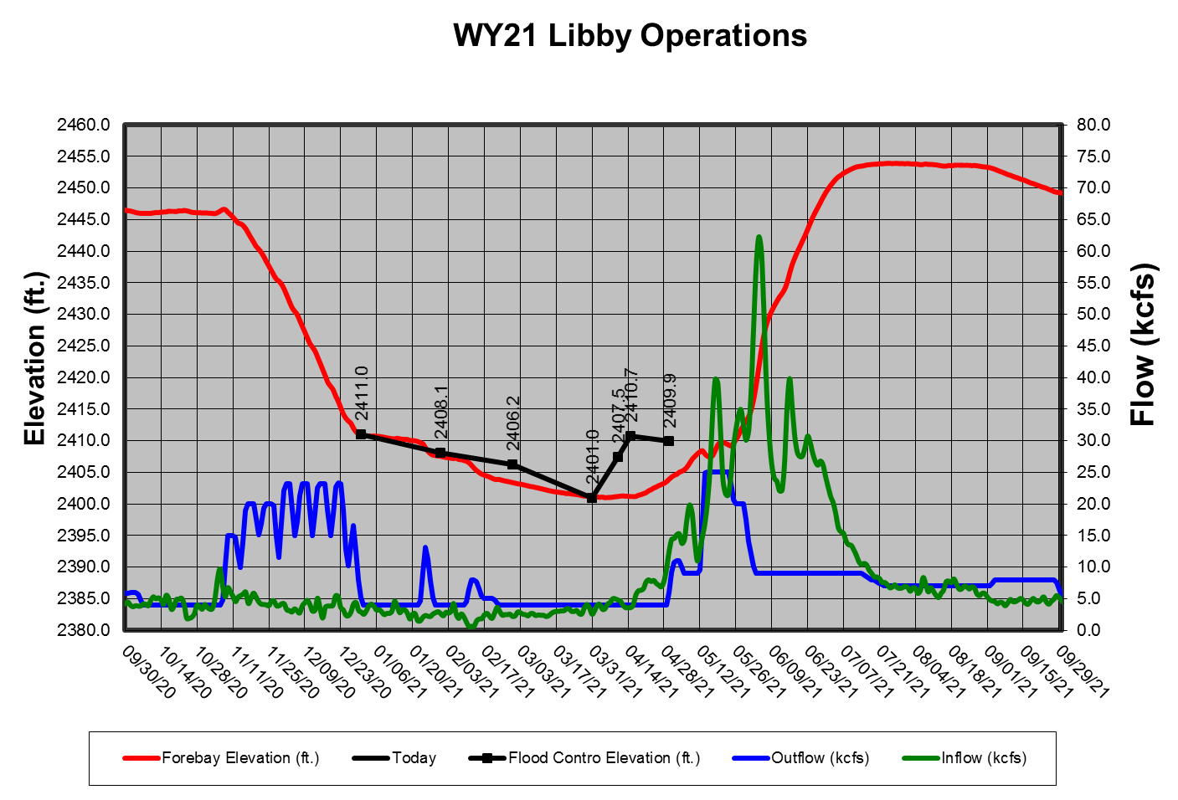

Hungry Horse Dam
Water Supply Forecast and Minimum Flows: The minimum flow requirements are measured at two locations the South Fork Flathead River below Hungry Horse Dam and the Flathead River at Columbia Falls. The minimum flows will be determined monthly, beginning in January, with the Bureau of Reclamation’s WSF forecast for Hungry Horse Reservoir for the period of April 1 to August 31. The final flow levels, for the remainder of the calendar year, are based on the March Final forecast.

April 10 and June 30 Refill Objectives: The Bureau of Reclamation computes Hungry Horse’s final April 10 elevation objective by linear interpolation between the March 31 and April 15 forecasted flood control elevations based on the March Final WSF.

Summer Draft Limit: The summer operation will target the reservoir elevation of 3540 feet to 3550 feet (20 feet to 10 feet from full) by September 30 and this will be based on the water supply forecast. The table below shows the end of September targets based of the Hungry Horse May water supply forecast. However, if the project fails to refill, especially during drought years, minimum flow requirements may draft the reservoir below the end of September target elevation.
Hungry Horse End of September Elevation Targets
Hungry Horse May-September inflow forecast (KAF) | Hungry Horse forebay target on Sept 30 (ft)
< 1410 | 3540
1410 – 1580 | Interpolate between 3540-3550
> 1580 | 3550

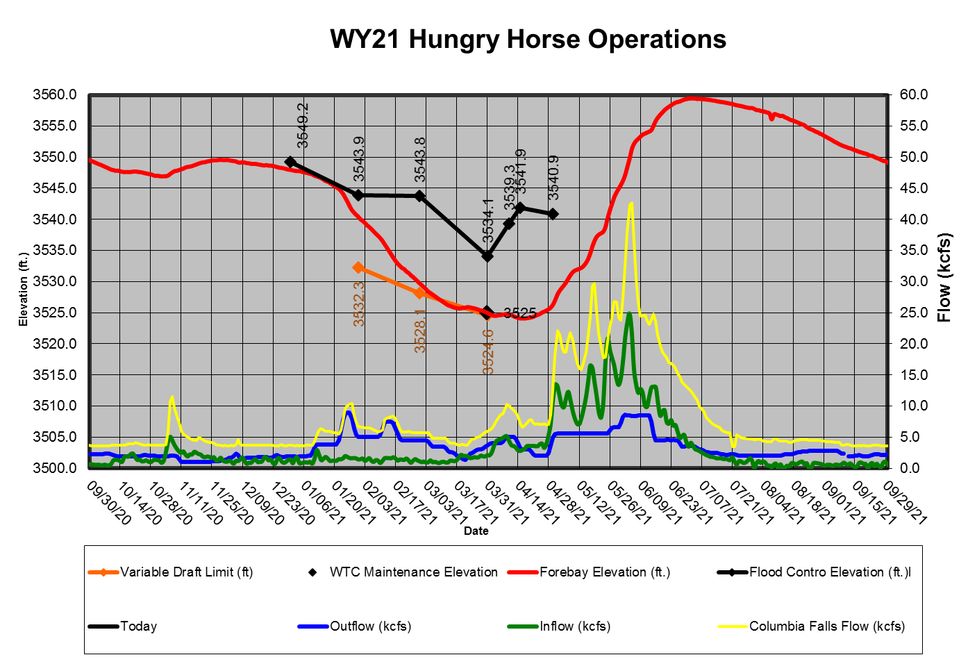

Grand Coulee Dam
April 10 and June 30 refill Objective: The Bureau of Reclamation computes Grand Coulee’s final April 10 elevation objective by linear interpolation between the March 31 and April 15 forecasted flood control elevations based on the March Final WSF for The Dalles.

The official April 10 refill objective for Grand Coulee was elevation 1270.0 feet. Grand Coulee’s forebay was at elevation 1270.2 feet at 1700 on April 10, 2021.

The Lake Roosevelt Incremental Storage Release Program: This section will be updated throughout the season as new information becomes available.

Table 8. Lake Roosevelt releases requested for 2021.
“Bucket” | 2021 Releases (acre-feet) | Total Lake Roosevelt Incremental Storage Releases Program (acre-feet)
Odessa
M&I
Instream Flow

Summer Draft Limit: The Grand Coulee summer draft limit is set by the magnitude of the RFC's July Final April-August WSF at The Dalles Dam.

This section will be updated as information becomes available.

Drum Gate Maintenance: Drum Gate Maintenance was not triggered in 2021.

Banks Lake: This section will be updated as information becomes available.

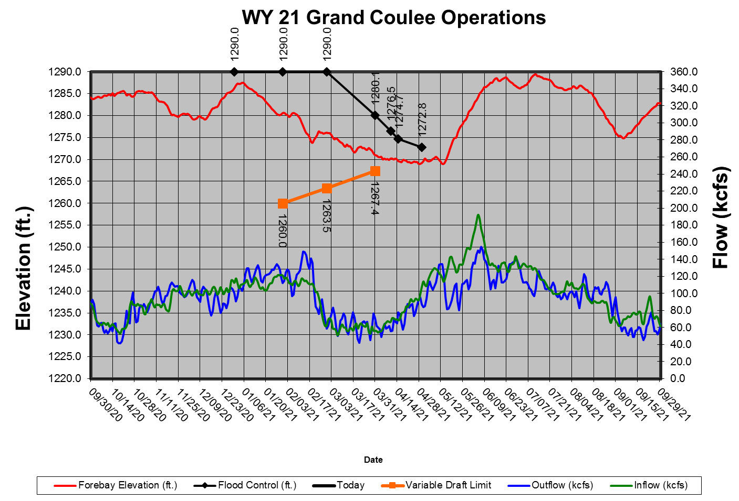

Dworshak Dam
Flood Risk Management Elevation: Operate in accordance with standard FRM criteria; shift system FRM to Grand Coulee Dam when possible, unless modified by procedures under dry-water-year operations. The shift in system FRM space will end by April 30, such that each project storage will satisfy their respective FRM space requirements.

Dworshak Dam was operated to meet standard FRM criteria for water year 2021. The official water supply forecast on April 1 was 2,716 KAF, which would have set an end of month target elevation of 1,495.5 feet. With a midnight elevation on April 1 of 1,506.8 feet, a draft of 11.3 feet draft would have occurred over the month of April if no deviation had been filed and/or if the project had not been released to begin refill on the FCRC. However, a deviation request was approved on April 20, setting the maximum allowable April 30 elevation to 1,533.8 feet. The deviation was approved based on the improved likelihood of refilling Dworshak Reservoir before the start of flow augmentation, and because no significant increase to flood risk due to the desired operations was anticipated. The actual April 30 midnight elevation was 1,522.8 feet, meaning the project filled 16 feet over the month of April rather than drafting.

Discharges from Dworshak Dam were managed during this time to meet the obectives described above, and to support hatchery releases which occurred between March 30 and April 15. The magnitude of the hatchery supporting discharge ranged, on average, between 9.8 kcfs and 7.8 kcfs. After hatchery releases concluded, discharge tapered to the minimum flow of 1.6 kcfs.

Refill continued for the months of May and June. Please see the refill section below for more details.

Variable Draft Limit: Calculate a VDL in season to increase power generation from January to March, while protecting the ability to refill with 95% confidence based on the March 31 FRM upper rule curve.

No VDL operation occurred in WY 2021 because the WSFs were below VDL limits.

Total Dissolved Gas: Provide augmentation flows while not exceeding the state of Idaho TDG water quality standard of 110 percent saturation.

No operations of Dworshak Dam in WY 2021 caused TDG exceedance. TDG did not exceed 110% as recorded at the USGS NF Clearwater River at Ahsahka, ID (gage #13341000).

Refill: Refill by about June 30 or earlier in dry years (exact date to be determined during in-season management).

The midnight elevation on June 1 was 1,575.6 feet. Dworshak Reservoir was on-track to refill by July 3. However, an unprecedented heatwave hit the region in late June. The heatwave forced flow augmentation to begin June 22, thus drafting the reservoir before it filled. Typically, flow augmentation is not expected to commence until the first week of July. Please see the Lower Granite tailwater regulation section for further details.

End of August and September Forebay Elevations: Draft no lower than an elevation of 1,535 feet by the end of August and to an elevation of 1,520 feet (80 feet from full) by the end of September, unless modified per the agreement between the United States and the Nez Perce Tribe for water use in the Dworshak Reservoir.

The end of August and September forebay elevation targets were met. The midnight elevation on August 31 was 1,535.1 feet.

200 KAF was drafted from Dworshak between September 1 and September 29. The change in water temperature as measured at USGS NF Clearwater River at Spalding, ID (gage #13342500) did not exceed more than 1 degree F per day on average. The average change was 0.4 degrees F per day. After the 200 KAF was released, the outflow from Dworshak was reduced to the standard fall flow of 1.6 kcfs. The midnight elevation on September 30 was 1,519.7 feet.

Outflows for Lower Granite Dam Tailwater Regulation: Regulate outflow temperatures to attempt to maintain water temperatures in the Lower Granite Dam tailwater at or below 68°F, typically from July 1 through the end of September.

Summer began with an extreme regional heatwave during which the air temperature recorded at Silcott Island was at or above 100 degrees F for 12 consecutive days, from June 26 to July 7. The maximum air temperature reached during the initial heatwave was 114.5 degrees F on June 29. A second, less intense heatwave immediately followed the first, so the air temperature at Silcott Island was at or above 95 degrees F for 26 consecutive days, from June 21 to July 16. Three additional heatwaves with temperatures at or above 100 degrees F occurred before the end of summer.

The decision to begin flow augmentation on June 22 was made on June 20, when the hottest temperature in the forecast was 105 degrees F, and the intense portion of heatwave was forecasted to last 3 days. The observed heatwave was approximately 10 degrees hotter at its peak, and lasted 4 times as long as the initial forecast. Had flow augmentation been delayed until closer July 1, a more typical start to augmentation, the 68.0 degree F tailwater limit would likely have been violated.

The maximum temperature of Lower Granite’s tailwater at the start of augmentation was 65.6 degrees F. Dworshak releases were increased to the maximum allowable threshold without violating TDG standards, 12.5 kcfs, in order to keep the tailwater temperature below 68.0 degrees F. The tailwater did reach 68, but it was not exceeded. The reservoir was drafting approximately 1 foot per day during that time. NWW water management determined that drafting at that rate 9 days earlier than normal with more heatwaves likely to occur in the summer would mean that there was not enough water in the reservoir to continue augmentation through the end of August. With that in mind, SORs were presented to TMT for in-season adaptive management to combat the high temperatures.

The SORs described in the following paragraph are only discussed in relation to direct impact on Dworshak operations. For additional SORs and details, please refer to the TMT website.

SOR 2021-3 was implemented beginning July 2. The SOR decreased the required releases from Dworshak because it reduced the total volume of spill at Lower Granite for specified periods. A higher proportion of outflow traveled through turbines than spillways, and spill outlets draw from warmer water, comparitively. Dworshak releases were able to be reduced from 12.5 to 9.7 kcfs in response to this SOR while keeping the tailwater temperature below 68 degrees F.

SOR 2021-5 with components of 2021-4 also aimed to conserve water in Dworshak Reservoir in order to extend flow augmentation later into August. A flexible time window lasting approximately from July 23 to August 17 raised the maximum tailwater temperature criteria from 68.0 to 69.5 degrees F. The justification for raising the criteria included the fact that the proportion of adult sockeye, adult summer stealhead, and juvenille and adult fall chinook migrating during this period was relatively low. Conversely, steelhead and fall Chinook migration and fall Chinook broodstock collection depend on flow augmentation being available in late August.

The tailwater temperature can vary for short durations within a half of a degree of the criteria during standard operations. However, during the elevated 69.5 degree F criteria window, the tailwater temperature did drift over 70 degrees on a 12-hour moving average from August 3 to 5 due to an additional heatwave that was longer and more intense than initially forecasted. Daily average releases during the entire time period SOR 2021-5 was implemented were 7.1 kcfs, and the average daily maximum tailwater temperature was 68.9 degrees F.

Lower Granite’s tailwater temperature transitioned back below 68 degrees F on August 16 and and was in compliance for the opening of the adult fish trap on August 18 (as scheduled in the FPP). Both the trap and the tailwater temperature remained in compliance through the end of the season.

The coordination that occurred between regional co-managers and Walla Walla water management allowed for the quick analysis of suggested alternative operations and timely implementation of those operations. Regional co-managers had to make numerous considerations and concessions to minimize negative impacts to fish, which occured due to unfavorable natural conditions. Though impacts were minimized, they were not completely negated and fish conditions were not ideal. As a result of the adaptive management endeavors, increased real-time temperature analysis, and advanced coordination and communication efforts, flow augmentation did last through August 31 with a midnight elevation of 1,535.1 feet.

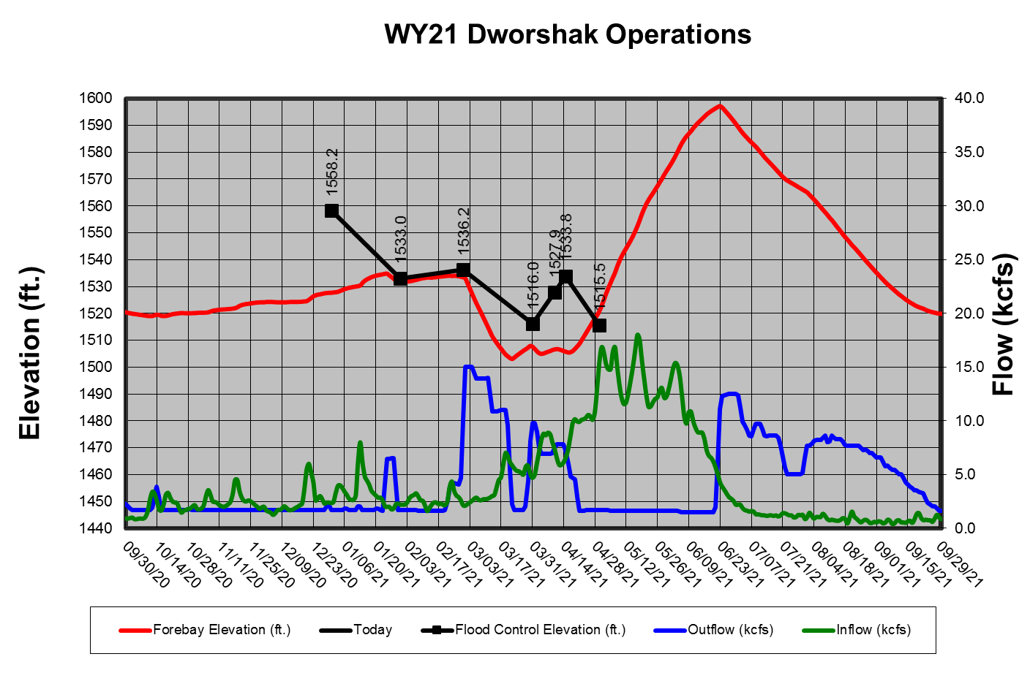
  - Water Quality
The AAs have coordinated the following spill priority lists with the TMT to date, and they may be found on the following website.

http://pweb.crohms.org/tmt/documents/spill-priority/
  - Burbot Spawning Flows (Libby Dam)
Providing low temperatures, if possible, from Libby Dam to aid upstream migration of burbot to spawning areas in the Kootenai River in Idaho will occur each winter. These low temperatures may be called for over an extended period from October through February. Specific details of this operation for the current year will be developed and will be included in the fall/winter update. An interagency Memorandum of Agreement for this species was completed in June 2005. Use of VARQ FRM procedure and implementation of the variable end-of-December FRM target elevation may aid this operation in years with below average runoff forecasts.
  - Lake Pend Oreille Kokanee Elevation (Albeni Falls Dam)
Albeni Falls Dam drafted Lake Pend Oreille to within 0.5’ of its winter control minimum elevation for Kokanee spawning on 11 November. This half of foot band lasted until the end of Kokanee spawning on 31 December.
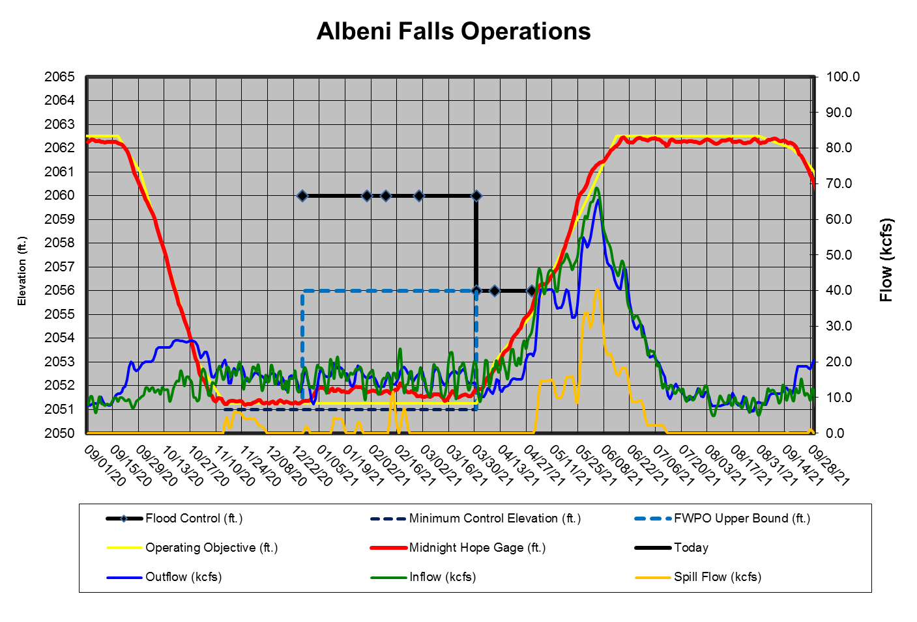
  - Upper Snake Flow Augmentation

This section will be updated throughout the season as new information becomes available.
  - Chum Operation
The following is a summary the 2020/2021 TMT coordinated chum operation. Additional information on the TMT coordinated chum operation may be found in the TMT meeting minutes on the following website.
http://pweb.crohms.org/tmt/
Date | TMT Coordination Summary
October 21, 2020 | The AA’s will begin coordination to start chum operations on Sunday, November 1 at 0600 hours, as coordinated today by the TMT. The operating tailwater elevation range for step 1 will be 11.5-13 feet. The remaining steps (as posted in the 2019 chum operation) will not change.
November 18, 2020 | The Corps, reported on chum operations, as coordinated on October 21 (posted on the TMT website). Current hourly data puts operations at step #2 ( tailwater range of 11.5-13 feet during daytime hours) and step #3 (up to 16.5 feet during nighttime hours) with a project tailwater elevation of 14.7 feet at 0500 hours, and outflow of 158.4 kcfs. The Corps noted that the Tanner Creek gauge, reported in the hourly data as “Project Tailwater Elevation” in the far right column, is the gauge used to measure the tailwater elevation for the chum operation. The RFC inflow forecast for Bonneville over the next 10-day period shows flows ranging from 125-155 kcfs; with a low of 125 kcfs today, November 18, and a high of 155 kcfs on November 20.  NOAA, reported on adult counts and chum surveys. Chum passage has picked up at Bonneville, with 6-20 per day, and 134 YTD (as of yesterday), which is 153% of the 10-year average. WDFW survey data from the Ives/Pierce area on November 10 counted 37 live chum, 1 dead, and 14 redds; this is not far off from last year’s counts at this time. Chinook are showing in stronger numbers. WA noted that field crews continue to monitor fish access to spawning channels. WA, presented Columbia River chum survey summary data (posted on the TMT website) that will be updated every other week. Surveys show a substantial amount of redds in the tributaries below I-5, with nearly 3,000 live chum, and very few dead fish; WA noted that some lives could have been double counted. Most of the tributaries below Bonneville also show chum distribution, and WA noted a sea lion presence outside of the Ives/Pierce area.
December 16, 2020 | The Corps, reported on chum operations, as coordinated on October 21 (posted on the TMT website). At 0700 hours this morning, Bonneville outflows were 125.4 kcfs, with a project tailwater elevation of 12.2 feet. The RFC inflow forecast shows outflows ranging from 129-157 kcfs over the next 10-day period, with a low of 129 kcfs on December 20, and a high of 157 kcfs on December 22. NOAA, reported that chum passage has dropped off significantly, with YTD passage at 190, or 150% of the 10-year average. WA, reviewed chum salmon spawning ground survey data below Bonneville (posted on the TMT website) and noted diminishing numbers with yesterday’s Ives/Pierce Island complex counts at 27 live, 3 dead, and 43 redds. Other notable counts are from Woods, with 94 live chum and 52 redds. The most recent tributary update is from December 9 & 10 and WA expects to have more recent data from the lower portion of Hamilton Creek soon. The ground surveys are from a WDFW internal database, and WA will ensure they are posted to the TMT website. The current chum spawning operation is underway and will soon transition to the chum incubation operation. Action Agencies requested coordination from the TMT to prepare for operational logistics, and to identify a start date, time, and elevation for the Bonneville Dam minimum tailwater during all hours.  ACTION: WA will gather December 22 survey results and coordinate on Tuesday afternoon with NOAA and OR regarding the results. WA will update the Corps and BPA via email regarding the survey results by COB on December 22.
January 6, 2021 | The Corps, reported on chum operations, as coordinated on December 29 (posted on the TMT website). At 0700 hours this morning, Bonneville total outflow was 194 kcfs, with a project tailwater elevation of 17 feet. The RFC inflow forecast shows a high of 171 kcfs on January 8, and a low of 155 kcfs at the end of the 10-day period on January 16. Posted on the TMT website is an email sent from the Corps to highlight the initiation of the chum incubation operation, which was coordinated at end of December with Salmon Managers. NOAA, reported that 193 chum passed Bonneville Dam from October 17 through December 27, with peak daily passage of 20 fish on November 6 and 16. It is estimated that 97% of the run was complete by December 1; there were 5 days in December where a single chum was counted in the Bonneville ladder. Bonneville YTD chum count is 193 fish, or 152% of the 10-year average.  WA, updated the TMT on chum operation discussions between NOAA, WA and OR on December 22 and December 29. On December 22, they reviewed survey data, which reported that of the 7 live chum observed on December 22, 6 were nearly dead, one was expected to die soon, and no active spawning was observed. This discussion did not lead to a consensus recommendation to transition from the spawning to incubation phase, and thus the decision was deferred to December 29. According to the December 29th survey, one chum was observed.  After more discussion with NOAA, WA, and OR, there was still differing thought on when to shift to the incubation operation. WDFW survey crews had reported that from their observations, they believed that spawning was complete. NOAA added that based on the assessment from field survey crews that active spawning was complete, NOAA recommended transitioning into the incubation phase, while acknowledging that NOAA did not think that maintaining the spawning operation would cause any harm to chum and thus, were also okay if the decision were to continue the spawning operation through the end of the month.  OR, clarified that OR supported continuing the spawning operation while chum were still present to support spawning. OR pointed to periods when tailwater elevations were high enough to impact chum behavior in Ives Island area, and that OR did not want to push chum off redds with high flows from Bonneville. OR noted that given the high flows, it was plausible that this was occurring during last few weeks of December, which makes a day’s observation alone somewhat less definitive. OR supported waiting until the end of the designated operation plan on December 31, as specified in the Water Management Plan.  WA shared that the January 5 survey reported no live chum; survey conditions were excellent and allowed for all site visits. BPA, noted that the WA field experts provided a recommendation to shift into incubation operations, and while there was a lot of precipitation that affected the operation at Bonneville, the continued spawning operation was not doing fish any favors during the daytime. There were periods when Bonneville outflow was as low as 85 kcfs, running to almost a 13-foot tailwater, which resulted in the need to increase discharge at night to 18 feet, which according to studies will move the fish off the redds.  BPA believed that the decision to transition to incubation operations should have been made sooner. As requested by Salmon Managers, BPA will provide data on this year’s redd elevations later this month, and in the future will provide it to FPAC as soon as possible (ideally before the spawning elevation is set) in an effort to help better inform chum operation decisions in the future. BPA also noted that temperature data are no longer collected for the incubation phase, as the years of data have provided sufficient understanding of the temperature characteristics in the area. Thus, future water management decisions will rely on survey information and previous temperature findings; it will continue to be a balancing act moving forward.
January 20, 2021 | BPA, presented data on observed redd locations for 2020 (posted on the TMT website). Survey locations included Strawberry, McCord Creek, Breaks, Ives pockets, Ives channel (Woodard area redds were deep and not surveyed). BPA noted that there were not many redds upstream at the entrance to the off-channel area, as seen in other years. NOAA, requested available data to compare tailwater elevations in the chum spawning phase to redd elevation numbers, as it could be useful in future spawning discussions. Operational data for Bonneville outflows is available on the Corps’ website. →ACTION: WA will follow up with BPA to clarify specific requested data; BPA will provide CSV files with redd elevations and water surface elevations. This data will be shared with other interested TMT members. BPA reminded the TMT that temperature data is no longer collected. In the future, BPA will have a historical record of all temperature data collected over the years in one location, to assist in building data correlations.  WA, requested access to past PowerPoint presentations with chum spawning data, which should still be available on the TMT website. →ACTION: WA and BPA will follow up on the Power Point access.
February 3, 2021 | The Corps, reported on chum operations, as coordinated on December 29 (posted on the TMT website). At 0800 hours this morning, Bonneville total outflow was 200 kcfs, with a project tailwater elevation of 16.5 feet. The chum incubation operation will continue through April 9 at 2400 hours, whenspring spill operations commence at the project on April 10.
February 17, 2021 | The Corps, reported on chum operations. The current chum incubation operation (beginning on January 1, 2021) sets Bonneville Dam with a minimum tailwater elevation of 11.8 feet. Incubation will continue through April 9, 2021, unless otherwise coordinated at TMT.
March 3, 2021 | The Corps, reported on chum operations. The chum incubation operation (coordinated on December 9, 2020) sets a Bonneville Dam minimum tailwater elevation of 11.8 feet and is set to continuethrough April 9; spring spill operations will begin on April 10.
March 17, 2021 | The Corps reported the continuation of the chum incubation operation, which sets Bonneville Dam with a minimum tailwater elevation of 11.8 feet. The operation will end on April 10 with the start of spring spill.

Dates | Chum Water Management Summary
Late October, 2020 | Above average precipitation preceded the chum operation in late October. Hamilton Creek and Springs responded well to the precipitation both were flowing sufficiently prior by the end of the month. Grand Coulee filled to 1285.5 feet prior to the start of the chum operation.
November 1, 2020 -November 10, 2020 | Grand Coulee generally passed inflow (85 kcfs average). The flow at Bonneville Dam average ~135 kcfs with resulting daytime TW elevations generally below 12.0 feet.
November 11, 2020 -November 22, 2020 | With the potential for higher inflow and basin wide precipitation across Nov-Dec Grand Coulee began drafting to ensure that any increases in streamflows can be managed throughout the spawning phase of the chum operation. Outflow at Bonneville Dam during this period averaged ~140 kcfs. During this period precipation produce a significant streamflow responses above and below Bonneville Dam. Some days during this period a flow of 115 kcfs was producing TW elevations at Tanner Creek of just under 13.0 feet. Nighttime TW elevations at Bonneville dam ranged from 14-18 feet across this period. Daytime TW elevations stayed closed to 12.8 feet across this period. Grand Coulee drafted to 1280 feet across this period.
November 23, 2020 - December 14, 2020 | Precipation during this period was generally below average. During this period Grand Coulee was managed +/- 1 foot of elevation 1280 feet. TW elevations on all hours below Bonneville Dam generally stabilized closer to 12.0 feet across this period. Inflow to Grand Coulee during this period increased to ~100 kcfs. Outflow at Bonneville Dam across this period averaged ~140 kcfs. Strong east winds during this period increased the flow required to produce an 11.5 TW to as high as 135 kcfs on some days.
December 15, 2020 – January 1, 2021 | 2000-400% above average precipation started this period off producing a peak in the Willamette close to 100 kcfs. During this period the earlier draft of Grand Coulee paid off as daytime tailwater operating range was maintained throughout this period in spite of the streamflow conditions. On some days and hours a flows from Bonneville Dam less than 90 kcfs produced TW elevations at 13.0 feet. The daytime TW operating range would not have been maintained if Grand Coulee had not had the space to store during this period. Grand Coulee filled to elevation 1287 feet across this period. Daytime TW elevations were close to 13 with nighttime TW elevations at or above 18 feet were required to move the water past Bonneville Dam to prevent setting a higher protection level.
January 1 – March 12, 2021 | Grand Coulee’s forebay started the year within 2.5 feet of full and then drafted across this period toward the April 10 refill objective. This draft provided sufficient flow in the river to protect chum. During this period the Willamette provided a few modest rises: one in early January (~90 kcfs) and another in February (~60 kcfs) but was generally well below average across the winter. Snake River flows were particularly low across the winter with flow from 20-35 kcfs until mid March where flow increase to ~50 kcfs.
March 13-April 10, 2021 | From early March through April 10 Grand Coulee was operating to the minimum at PRD for Hanford Reach flows. During this period the Willamette dropped down to ~15 kcfs and the Snake ranged from 35-60 kcfs. This provided just enough flow to manage the TW below BON to be 11.8-12.0 on most hours. In the first week of April the Snake flow came up to 60 kcfs which increase the coverage below BON just as the start of spill on the Columbia began.
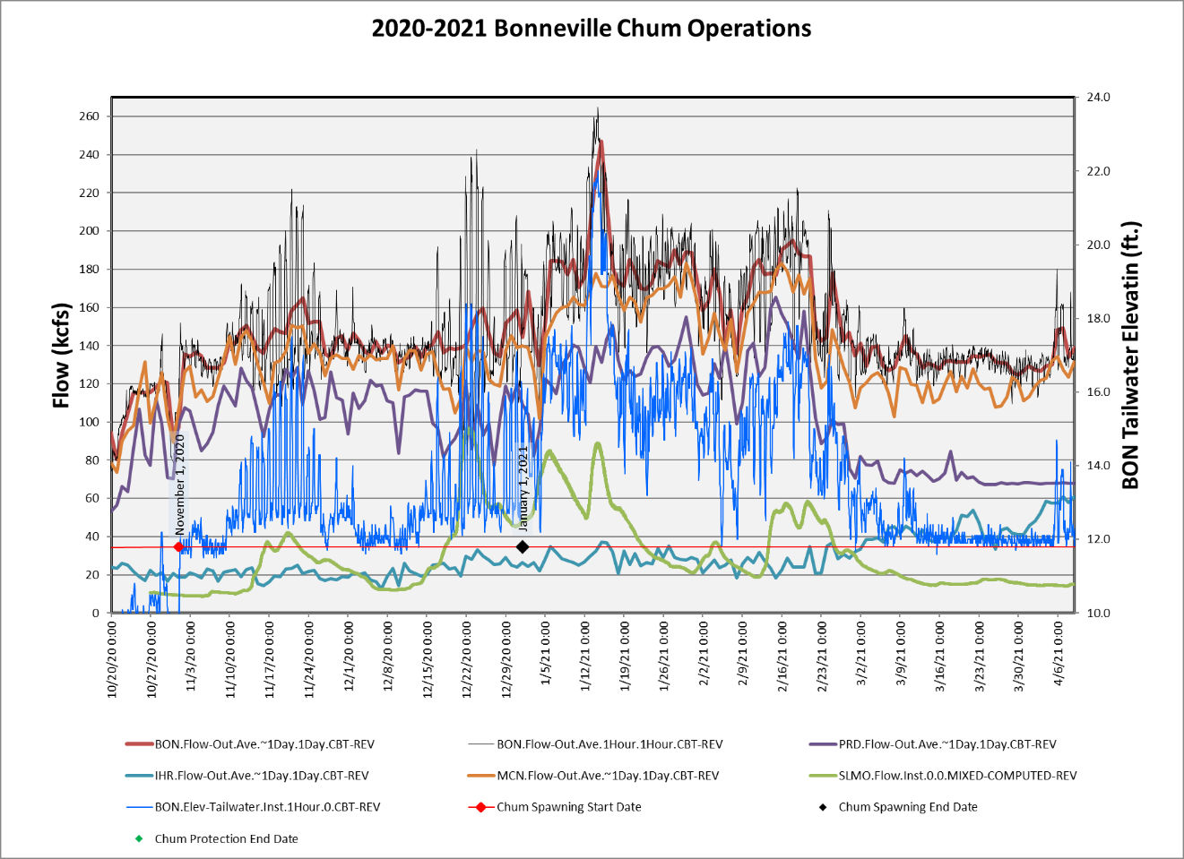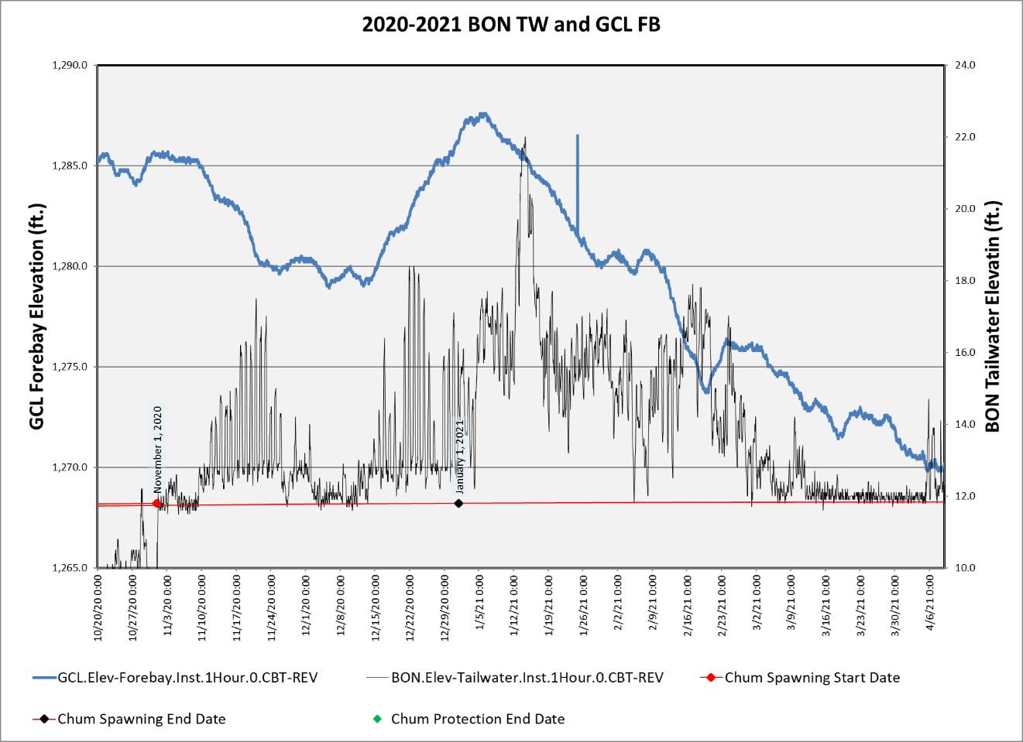
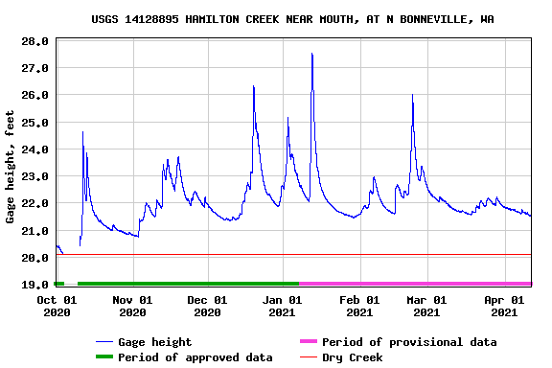

Chum survey data gathered at the Ives/Pierce Island Complex will be summarized in the table below. Data from all Chum survey areas, including the Ives/Pierce Island Complex, are provided by the Fish Passage Center and available on the following website.

https://www.fpc.org/spawning/spawning_surveys/ODFW_reports/2020spawning.htm

Table 9. Chum Data from Surveys of the Ives/Pierce Island Complex
Date | Lives | Dead^{i} | Redds^{ii} | Visibility (feet)
September 25, 2020 | 5 | 0 | 0 | 6
September 28, 2020 | 1 | 0 | 0 | 3
October 5, 2020 | 0 | 0 | 0 | 7
October 13, 2020 | NC | NC | NC
October 16, 2020 | 1 | 0 | 0 | 3
October 19, 2020 | 2 | 0 | 0 | 6
October 22, 2020 | 35 | 1 | 0 | 7
October 26, 2020 | 98 | 0 | 1 | 6
October 29, 2020 | 55 | 0 | 4 | 6
November 3, 2020 | 252 | 0 | 62 | 6
November 10, 2020 | 1124 | 12 | 311 | 6
November 17, 2020 | 1249 | 32 | 277 | 4.5
November 24, 2020 | 1426 | 37 | 471 | 6
December 1, 2020 | 598 | 23 | 199 | 5
December 8, 2020 | 145 | 27 | 48 | 6
December 15, 2020 | 107 | 9 | 75 | 4
- Dead are newly samply fish only.
- Redds are an instantaneous count for the day, not cumulative.
  - Vernita Bar/Hanford Reach Fall Chinook Protection Program Operations (Non-BiOp Action)

The Hanford Reach Fall Cinook Protection Agreement (Agreement) ebstablishes the obligations of the Parties with respect to the protection of fall Chinook in the Hanford Reach of the Columbia River. The Parties agree that during the term of the Agreement these flow regimes address all issues in the Hanford Reacth with respect to fall Chinoook protection and the impact of operation of the seven dams operatin under Mid’Columbia Hourly Coordination, including the obligations of Grant, Chelan, and Douglas under any new licenses issued by the Federal Energy Regulatory Commission (FERC).

Beginning in mid-October, under the terms of the Hanford Reach Fall Chinook Protection Program Agreement, river flows are reduced every Sunday morning (day of lowest power demand) to the Priest Rapids Dam minimum operating discharge of 36,000 cubic feet per second (ft³/s) [1000 cubic meters per second (m³/s)]. This allows the Agency and Utility Party Monitoring Team to manually survey for redd distribution at Vernita Bar just downstream of Priest Rapids Dam. These drawdowns occur every Sunday morning until the initiation of fall Chinook spawning has been set both above and below the 50,000 ft³/s (1,416 m³/s) flow elevations. A final drawdown is conducted on the Sunday prior to Thanksgiving to establish the minimum critical flow needed to protect pre-emergent fall Chinook. Given the previously described limitations, this weekly reduction in river flow affords the best viewing conditions for aerial flights. Aerial flights are therefore scheduled to be conducted concurrent with the Sunday morning drawdowns, when possible.
Date | Summary
November 22, 2020 | This morning representatives from Grant PUD and the Washington Department of Fish & Wildlife conducted the fourth 2020 Vernita Bar spawning ground survey. The intent of this week’s survey was to determine the Critical Elevation for the 2020-2021 protection season and to determine if spawning had ended. Based on the results of the survey the Critical Elevation for the 2020-2021 Protection Season is 65 kcfs (see the attached memo for redd count details). Additionally, based on observations during the survey it was determined that Spawning Period has ended.  Today will be the final day of the Spawning Period and reverse load factoring. Beginning tomorrow we will be in the Pre-Hatch Period. During the Pre-Hatch Period the Priest Rapids Outflow may be reduced below the Critical Elevation (65 kcfs) for up to 8 hours on weekdays and 12 hours on weekends with no two consecutive periods below the Critical Elevation.  Based on temperature units, we are projecting that we will transition to the Post-Hatch Protection Period for the below 50 kcfs zone on November 30. When that occurs, Priest Rapids Outflow must be maintained so that the intergravel water level is no less than 15 cm below 50 kcfs at all times and may be reduced below the Critical Elevation (65 kcfs) for up to 8 hours on weekdays and 12 hours on weekends with no two consecutive periods below the Critical Elevation. We are projecting that the Post-Hatch Protection Period for the above 50 kcfs zone will begin on December 12. When that occurs Priest Rapids Outflow must be maintained so that the intergravel water level is no less than 15 cm below the Critical Elevation at all times.
November 30, 2020 | Today, November 30, 2020 the Post-Hatch Protection Period for the below 50 kcfs zone will begin. During this period, the water level at Vernita Bar must be no less than 15 cm below the 50 kcfs elevation at all times and may be reduced below the Critical Elevation (65 kcfs) for up to 8 hours on weekdays and 12 hours on weekends with no two consecutive periods below the Critical Elevation.  We are projecting that the Post-Hatch Protection Period for the above 50 kcfs zone will begin on December 11. When this occurs the water level at Vernita Bar must be no less than 15 cm below the Critical Elevation at all times.
December 9, 2020 | On December 11th we will begin the Post-Hatch Period for the above 50 kcfs zone. During this period the water level at Vernita Bar must be no less than 15 cm below the Critical Elevation (65 kcfs) at all times.  The next protection period will be Emergence and Rearing and is projected to occur in early March.
February 3, 2021 | GCPUD is projecting that March 1 will be the start of the Emergence and Rearing Periods. During these periods daily flow fluctuation below Priest Rapids Dam will be limited based on inflow from Rock Island Dam and the water level at Vernita Bar must be maintained above the Critical Elevation (65 kcfs). The protection dates may change based on river temperature. GCPUD will provide updates as the season progresses.  The Hanford Reach Fall Chinook Protection Program Agreement (HRFCPPA) periods are determined by the accumulation of temperature units (ATUs) from the Initiation of Spawning date. The projected dates are predicted based on historical temperature trends. The projected dates may change throughout the 2020-2021 season. An updated table will be distributed as the season progresses.  On March 1, 2021 the Emergence and Rearing Periods will begin. During this period, daily flow fluctuation below Priest Rapids Dam will be limited and the water level at Vernita Bar must be no less than the Critical Elevation (65 kcfs) at all times.
February 17, 2021 | GCPUD is projecting that on February 26, 2021 the Emergence and Rearing Periods will begin. During these periods, daily flow fluctuation below Priest Rapids Dam will be limited and the water level at Vernita Bar must be no less than the Critical Elevation (65 kcfs) at all times.
February 25, 2021 | GCPUD is projecting that the Emergence and Rearing periods will begin on Saturday, February 27 (average start date = 3/17). During these periods, daily flow fluctuation below Priest Rapids Dam will be limited and the water level at Vernita Bar must be no less than the Critical Elevation (65 kcfs) at all times.
March 31, 2021 | GCPUD is projecting that the enhanced weekend minimum flow constraints (CJAD II) will begin on Saturday, April 10. The enhanced weekend constraints will continue for four consecutive weekends ending on Sunday, May 2. During the CJAD II weekends, the minimum flow below Priest Rapids Dam must be no less than the average of the daily hourly minimum from Monday through Thursday of the current week.
April 5, 2021 | The enhanced weekend minimum flow constraints (CJAD II) will begin on Saturday, April 10. The enhanced weekend constraints will continue for four consecutive weekends ending on Sunday, May 2. During the CJAD II weekends, the minimum flow below Priest Rapids Dam must be no less than the average of the daily hourly minimum from Monday through Thursday of the current week.  Additionally, GCPUD continue to be in the Emergence and Rearing Periods. These periods requires no less than the Critical Elevation (65 kcfs) at all times and flow fluctuation constraints from Priest Rapids Dam.
April 27, 2021 | This Sunday, May 2 will be the final weekend of the enhanced weekend minimum flows (CJAD II). Additionally, we are projecting that the Emergence Period, which requires no less than 65k below Priest Rapids Dam, will end on Saturday, May 1 (average date = May 12). After the Emergence we will continue to be in the Rearing Periods which limits flow fluctuations below Priest Rapids Dam. GCPUD is projecting that the Rearing Period will end on June 5 (average date = June 13). Projected dates may change based on river temperatures.
  - Snake River Zero Generation
The four lower Snake River projects may cease hydropower generation during the dates and times defined below when power market conditions warrant and when river conditions make it feasible to store water during low demand periods for use during higher demand periods:

October 15 – November 30 Nighttime hours, end no later than 2 hours before dawn

December 1-14 Nighttime hours

December 15 – February 28 Nighttime hours + up to 3 daytime hours

This operation is pursuant to the AAs’ Proposed Action in the 2020 CRS BA, page 2-64, and analyzed in the 2020 NMFS BiOp, page 944, and the 2020 USFWS BiOp, page 212. Based on previous operations between December 15 and February 28 and during nighttime hours only, BPA estimates that the use of this operation may occur 1 out of every 3 to 5 days at each project (2020 NMFS BiOp, page 64).

The timing of “nighttime” and “dawn” changes throughout the year. Based on the hours of actual Civil Twilight at Lower Granite Dam, the following hour ranges were coordinated during the October 21, 2020, TMT meeting to be consistent with the criteria identified in the 2020 CRS BA:

DATES “NIGHTTIME” HOURS FOR ZERO GEN

October 15-31 1900-0400 (ending 2 hours < dawn)

November 1-30 1800-0400 (ending 2 hours < dawn)

December 1-14 1800-0600

December 15 - January 31 1800-0600 + up to 3 daytime hours

February 1-28 1900-0600 + up to 3 daytime hours

Sources for definitions and computation of nighttime hours: https://www.esrl.noaa.gov/gmd/grad/solcalc/glossary.html
https://www.esrl.noaa.gov/gmd/grad/solcalc/calcdetails.html

The AAs will implement the Snake River Zero Nightime Generation Operation on the Lower
Snake River during winter of 2020/2021 in coordination with the TMT.

Operations from October 15, 2020 to December 15, 2020
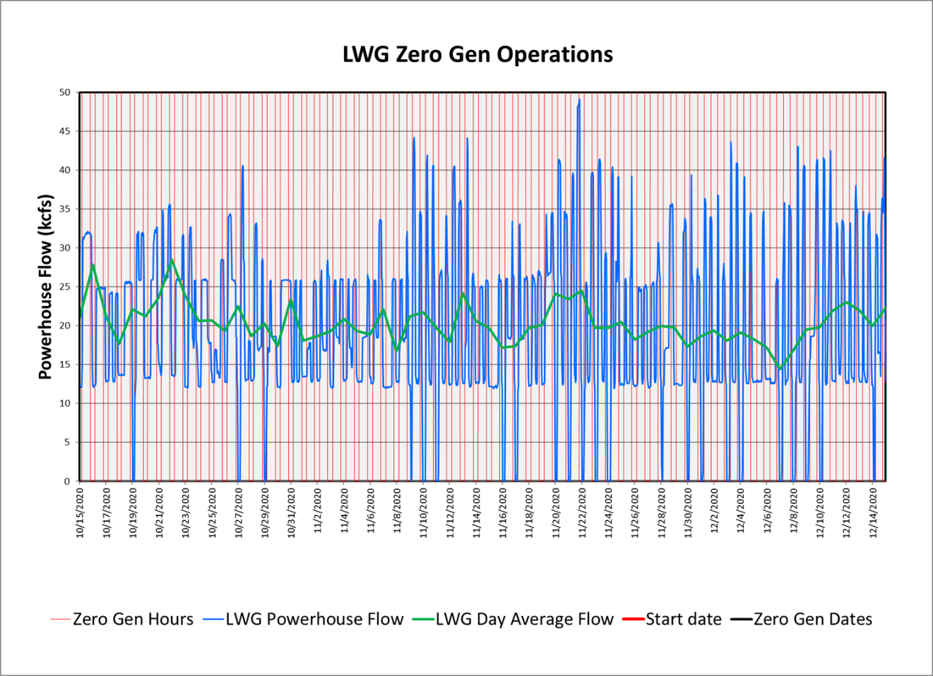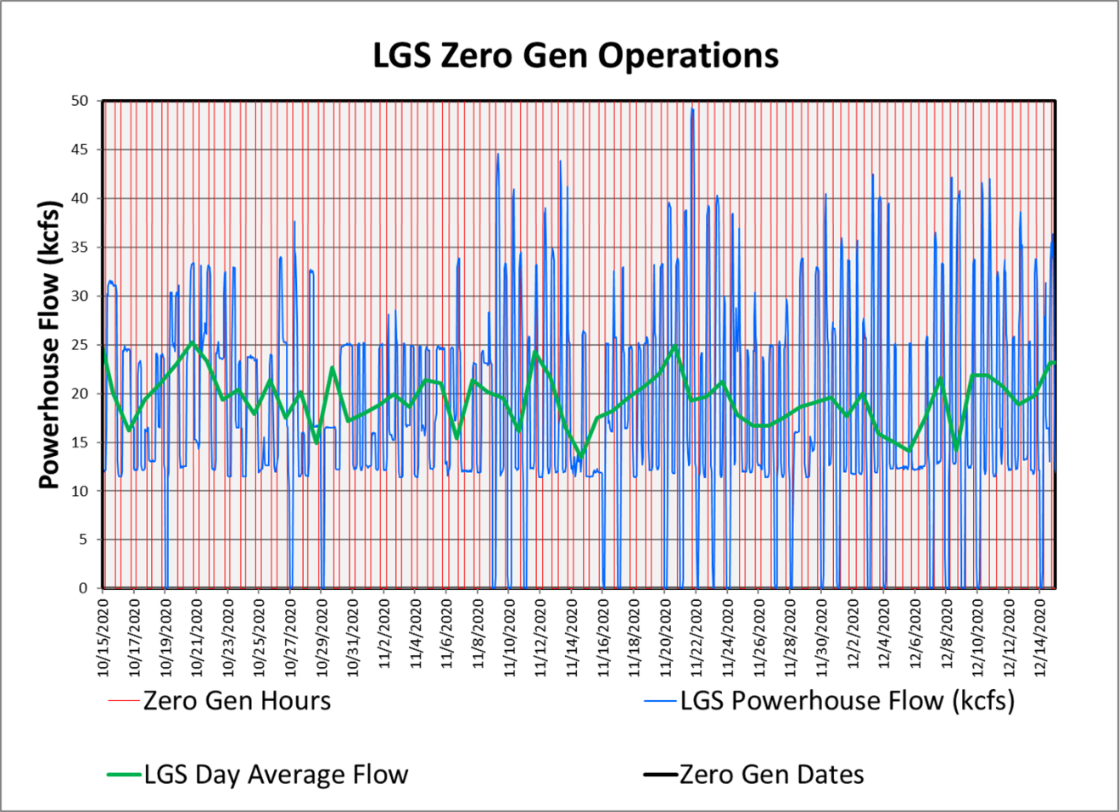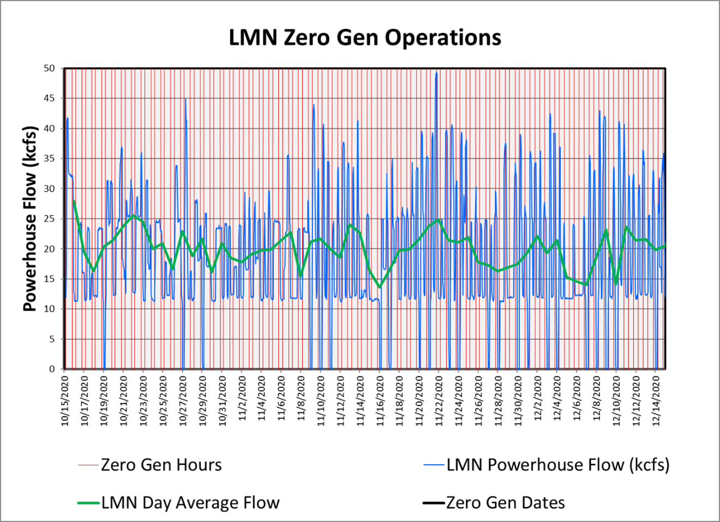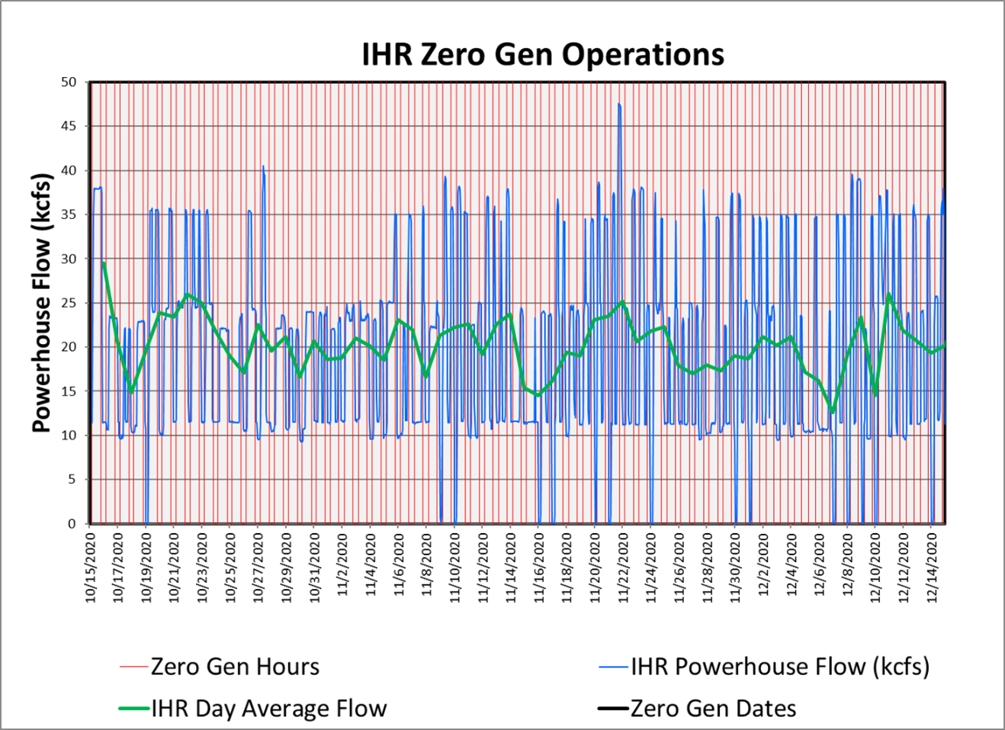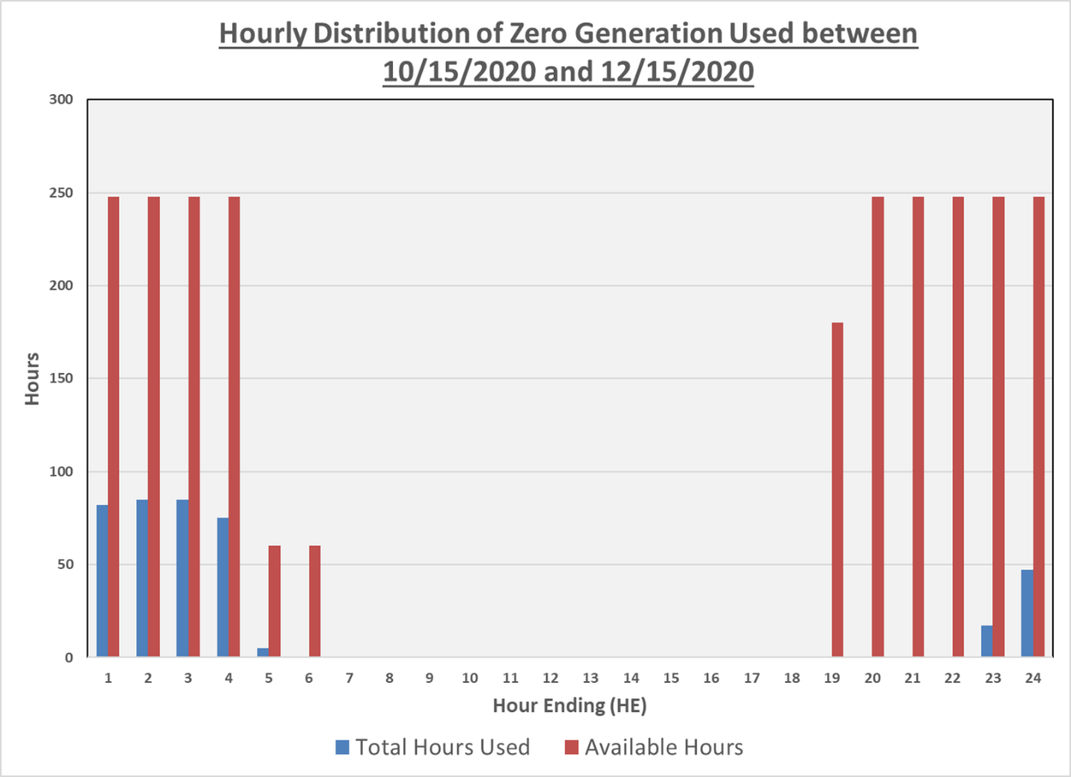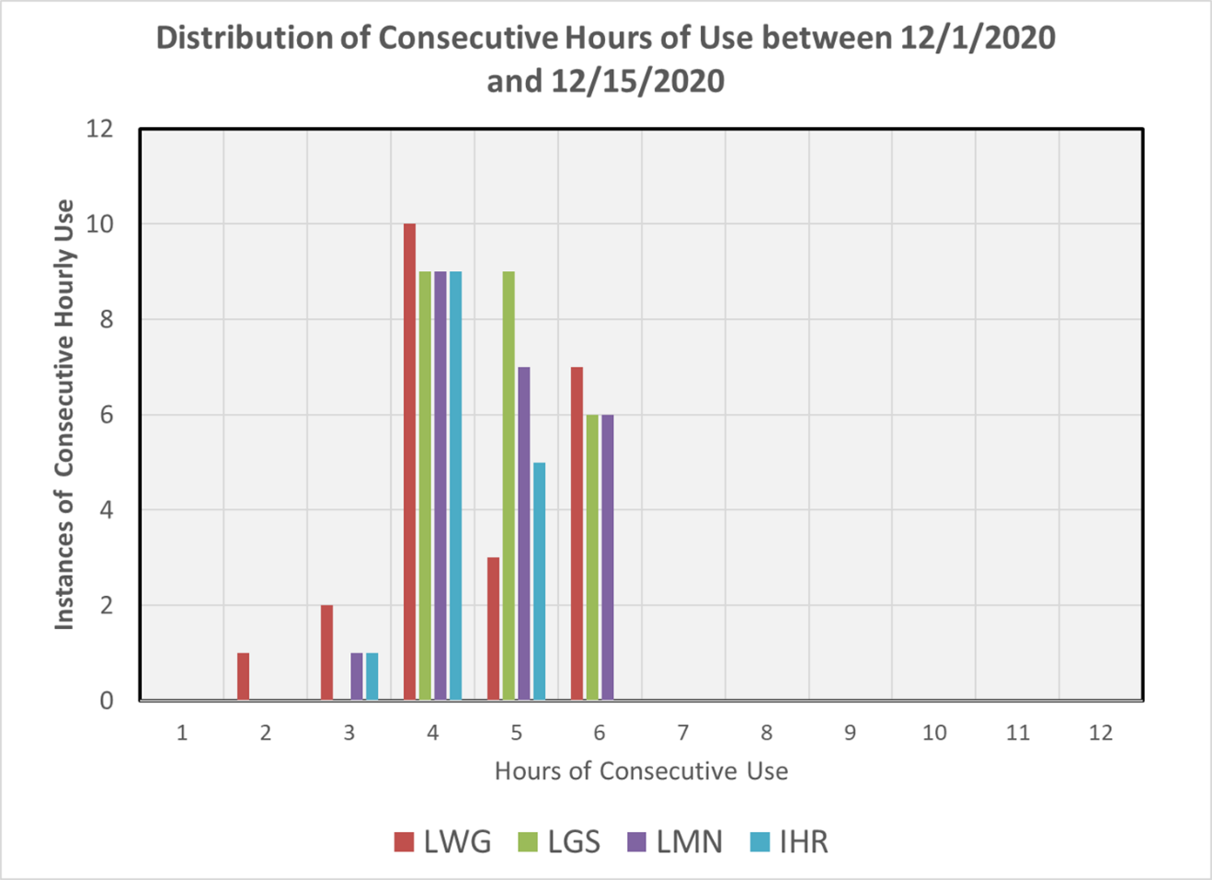
From October 15 to December 15
- Percentage of available hours used = 15.6%
- Percentage of all hours (24 per day) used = 6.7%
- Average Percentage of days used 34%

Operations from October 15, 2020 to December 15, 2020
- Percentage of available hours used = 15.6%
- Percentage of all hours (24 per day) used = 7.6%
- Average Percentage of days used 41%

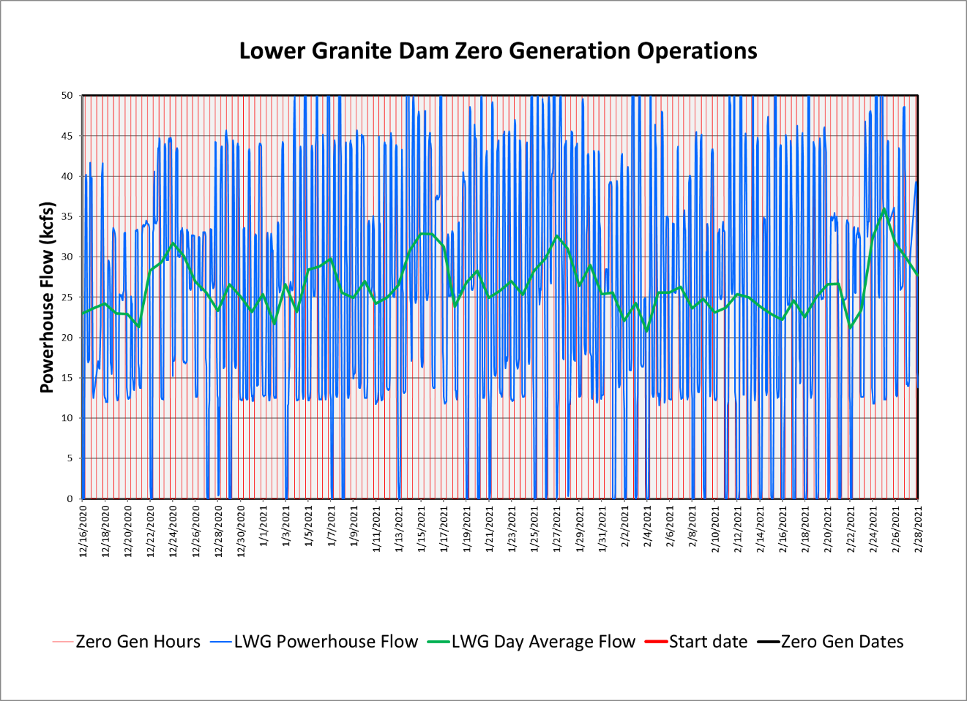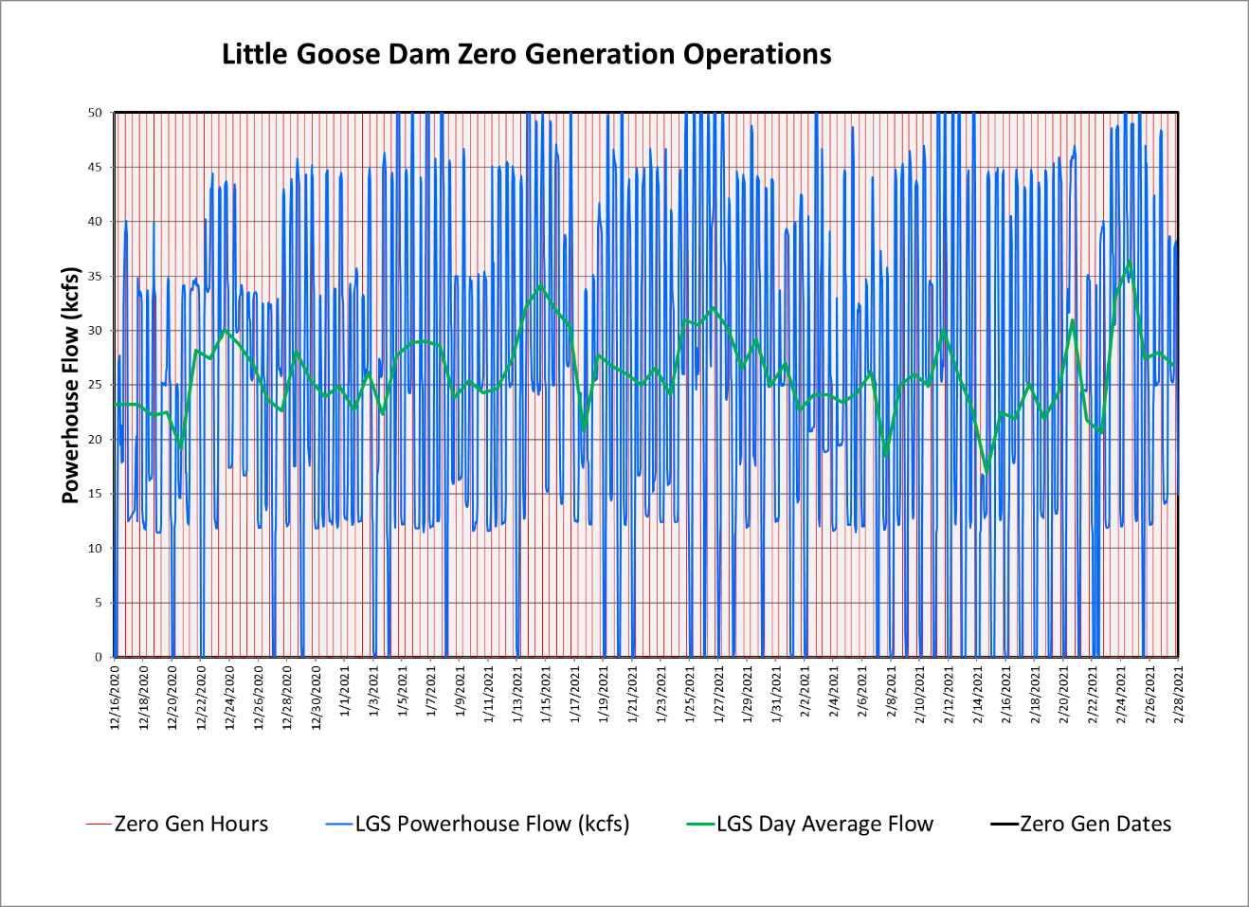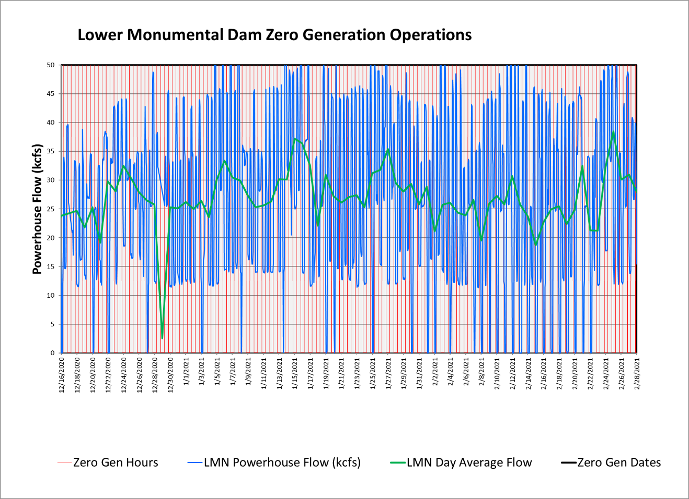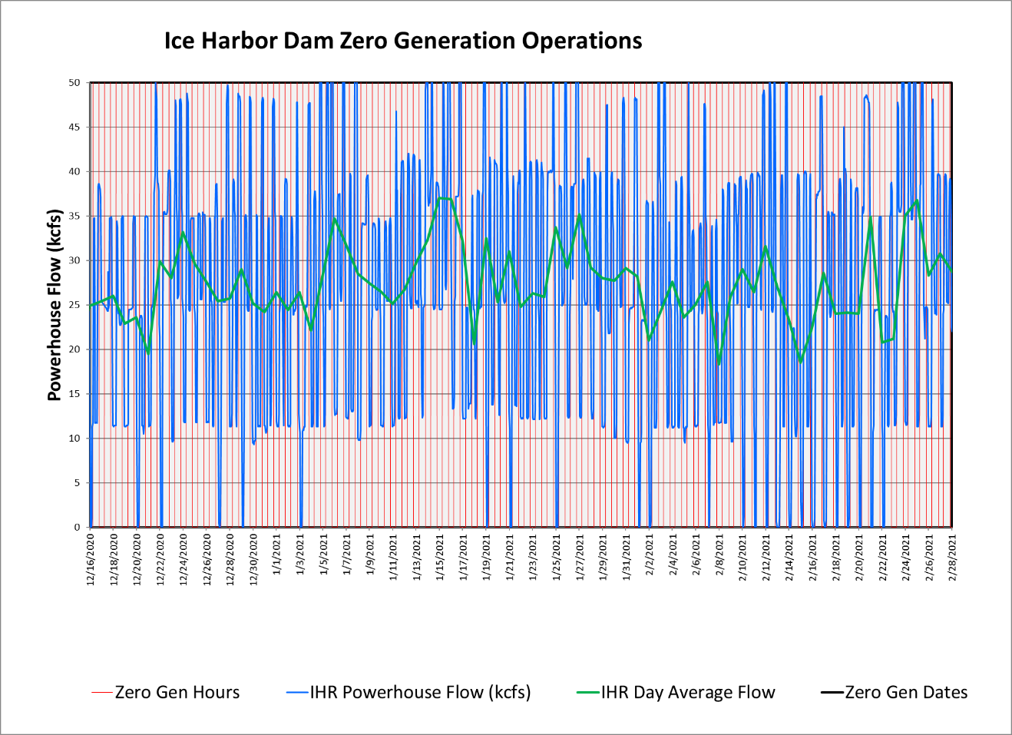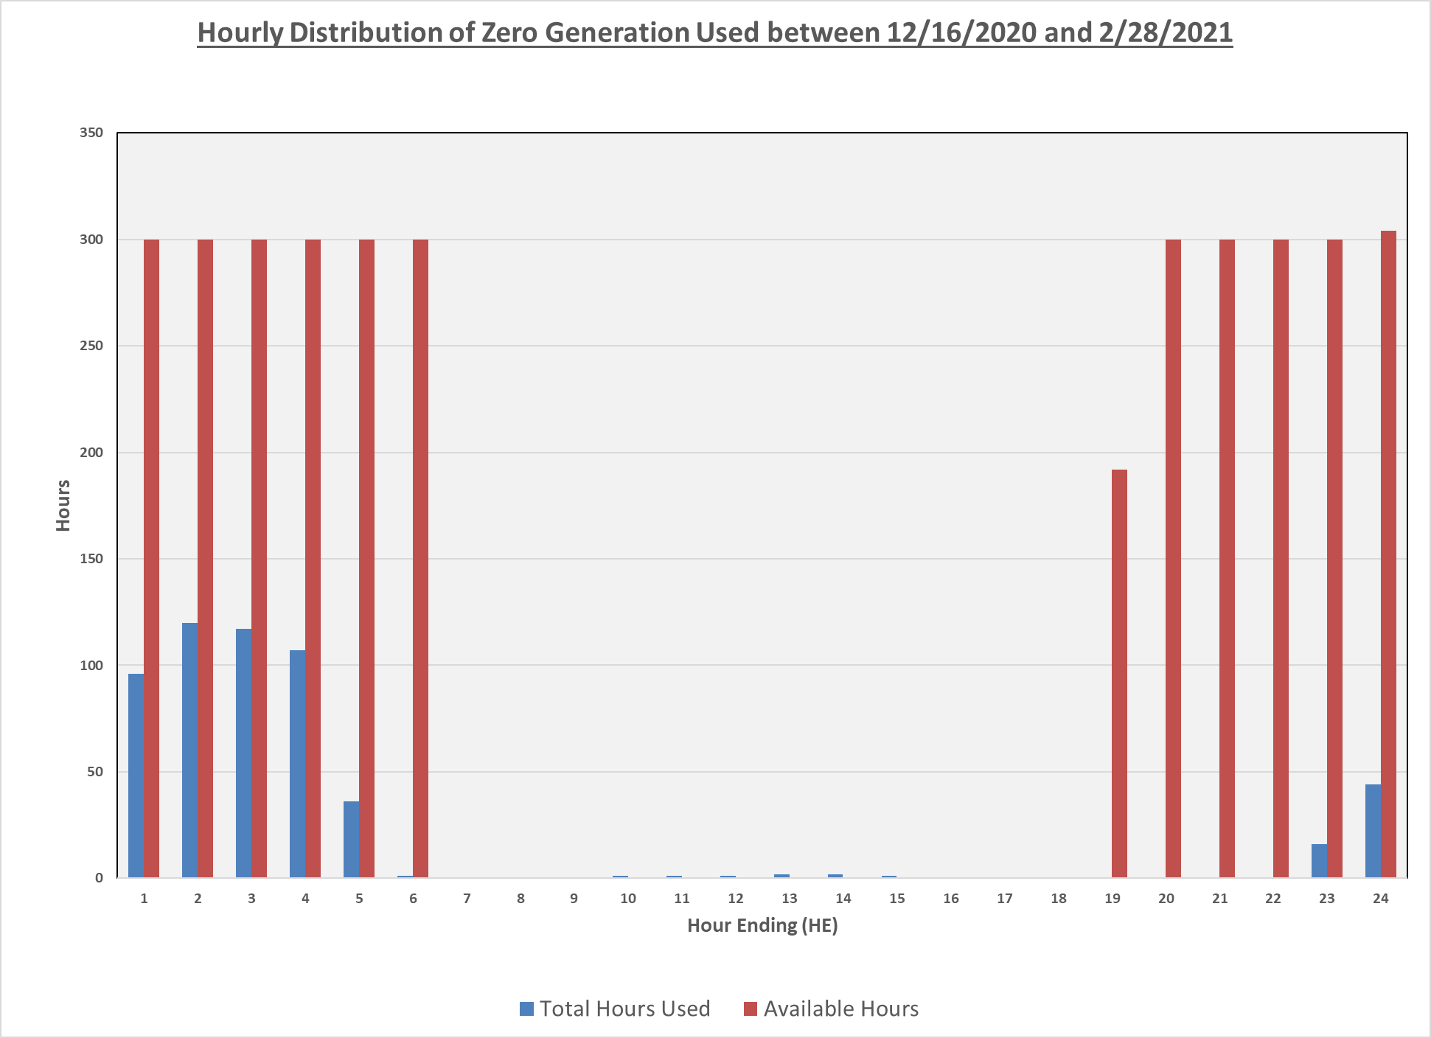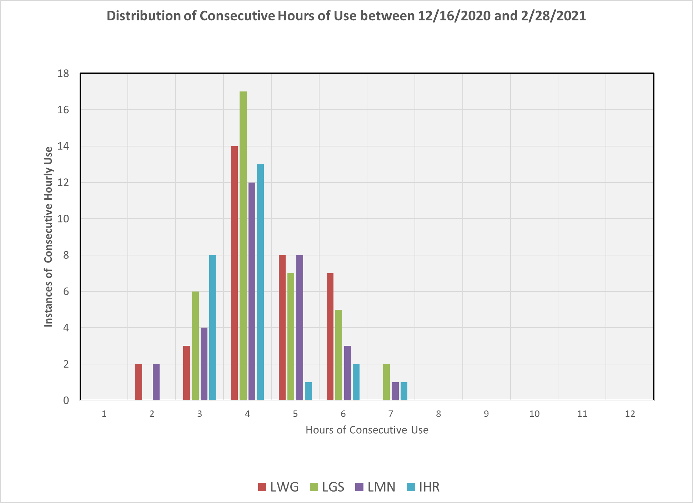

  - Minimum Operating Pool (MOP)
The four lower Snake River CRS projects (Lower Granite, Little Goose, Lower Monumental, and Ice Harbor) are operated for multiple purposes including fish and wildlife conservation, irrigation, navigation, hydropower generation, recreation, and limited FRM. The AAs will operate Lower Granite, Little Goose, Lower Monumental, and Ice Harbor Dams at minimum operating pool (MOP) with a 1.5-foot operating range from April 3 until August 14, unless adjusted due to (rare) low flow occurrences in the Snake River to meet authorized project purposes (2020 CRS BA, page 2-51; 2020 NMFS BiOp, page 58, and; 2020 USFWS BiOp, page 18).

The Corps conducts a bathymetric survey of the federal navigation channel annually to assure a 14 foot depth is maintained in the federal navigation channel. The survey conducted in the fall of 2017 demonstrated impairment of the federal navigation channel in the Lower Granite pool. In accordance with the 2020 CRS BA, until sediment accumulation is addressed to provide required channel depths for safe navigation, the Corps will continue use of the variable MOP operation implemented during the 2020 fish passage season to maintain a safe navigation channel. The AAs will coordinate this operation and any other changes in MOP operations with TMT. Additional information regarding turbine operations (±1% from peak efficiency), spill operations, and juvenile transportation may be found in the most current Fish Operations Plan and Fish Passage Plan.

The AAs will coordinate this operation and any other changes in MOP operations with TMT. Additional information regarding MOP operations are described in the 2021 FOP on the following website.

http://pweb.crohms.org/tmt/documents/fpp/2021/final/FPP21_AppE_03-31-21.pdf
  - Minimum Irrigation Pool (MIP)
As described in the 2020 CRS BA (page 2-57), from April 10 – June 1 (or as feasible based on river flows), the John Day reservoir elevation will be held between 264.5 feet and 266.5 feet (an average of 265.5 feet) to deter Caspian terns from nesting in the Blalock Islands Complex. The Action Agencies intend to begin increasing the forebay elevation prior to initiation of nesting by Caspian terns to avoid take of tern eggs; operations may begin earlier than April 10 (when the reservoir is typically operated between 262.0 to 266.5 feet). The operation may be adaptively managed due to changing run timing; however, the intent of the operation is to begin returning to reservoir elevations of 262.5–264.5 feet on June 1, but no later than June 15, which generally captures 95% of the annual juvenile steelhead migration. The results of this action would be monitored and communicated with USFWS and NMFS. During the operation, safety-related restrictions would continue, including but not be limited to maintaining ramp rates for minimizing project erosion and maintaining power grid reliability. Following this operation, the John Day reservoir elevation would return to MIP + 2 ft operation through August 31.

From June 1 through August 31, John Day Dam will be operated to minimize water travel time for downstream-migrating juvenile salmon by operating the forebay within the minimum irrigation pool (MIP) range of 262.5 to 264.5 feet, which is the lowest pool elevation that allows irrigation withdrawals.

For the 2021 season, the John Day reservoir level was raised to the 264.5-266.5 foot range to submerge low-lying nesting habitat in the Blalock Island Complex as set forth in the 2020 CRSO EIS, the 2020 CRS BA and the 2020 CRS NMFS BiOp. The operation officially began on April 10 and ended on June 5. The coordinated transition period from the high pool operation to Minimum Irrigation Pool (MIP) (262.5-264.5 ft) was June 2-5. The reservoir reached MIP on June 5 and remained within the MIP range through August 31.

Aerial surveys conducted during the nesting season show that the John Day high pool operation was successful in that no Caspian terns successfully nested within the Blalock Island complex during the spring 2021 operation.

  - Spill for Juvenile Fish Passage
Table 3 below is a summary of the 2021 spring target spill levels at lower Snake River and lower Columbia River projects, as described in the 2021 Fish Operations Plan (2020 FOP). Additional information on spring spill operations may be found in the 2021 FOP (page FOP-18) on the following website.

http://pweb.crohms.org/tmt/documents/fpp/2021/final/FPP21_AppE_03-31-21.pdf

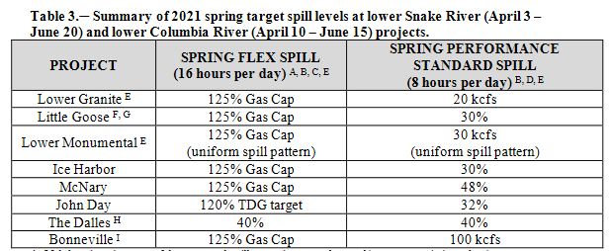

Table 4 below is a summary of the 2021 summer target spill levels at lower Snake River and lower Columbia River projects, as described in the 2021 FOP.

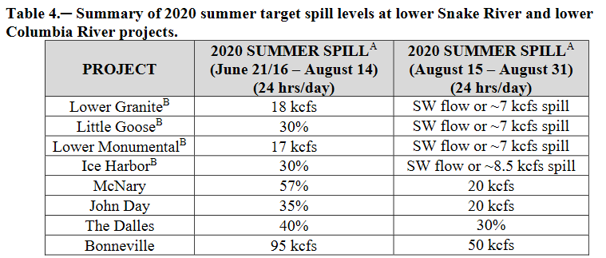

  - Juvenile Trasportation
As described in the 2021 FOP, transportation will be initiated at Lower Granite, Little Goose, and Lower Monumental dams on April 24 (collection starting on April 23) or as coordinated through the TMT and the RIOG, but begin no later than May 1. Barging of fish begins the following day after fish collection and collected juvenile fish will be transported from each facility on a daily or every-other-day basis (depending on the number of fish) throughout the migration season. Transportation of spring migrants ends on June 20. Truck transportation of summer migrants resumes on August 15 with allowance for TMT adaptive management adjustments and continues through September 30 at Lower Monumental and October 31 at Little Goose and Lower Granite.
  - Fish Passage Research in 2021
The following project specific sections provide a brief summary of fish passage research in 2021. More information on this research may be found in the 2021 Fish Passage Plan in Appendix A on the following website.
http://pweb.crohms.org/tmt/documents/fpp/2021/final/FPP21_AppA.pdf
    - Bonneville Dam
The B2FGE Program PDT has awarded a contract to install a concrete gatewell flow modification device in place of the metal plates that were installed and then removed due to structural failure. Installation is planned in Unit 15, currently scheduled for March 1 through April 20. Following installation, hydraulic measurements will be taken in the gatewell and behind the VBS, expected to occur sometime in May–June. The gatewell measurements will be similar to what was done in 2014 and 2015. VBS screens in test gatewells will be raised, seals inspected, and cleaned at least once per week, or as coordinated with the project to account for environmental conditions. Hydraulic measurement equipment and framework will be in the Unit 15 gatewells during test periods. Unit 15 will be tested during operation in the middle 1% range and the upper 1% range, one day per gatewell for each treatment, during daylight hours (0600–1700). Adjacent Units 14 and 16 operations will be requested during the test periods to provide stable operations to minimize hydraulic changes in the gatewell. All unit operations will be within the existing 1% range (see FPP Table BON-15), with unit availability contingent on total river flow, spill, and unit priority. A daily schedule will be provided to Bonneville Dam Operations.
    - The Dalles Dam
There are no studies planned at The Dalles Dam in 2021.
    - John Day Dam
There are no studies planned at John Day Dam in 2021.
    - McNary Dam
The 2020 NOAA CRS BiOp calls for off-season surface spill for adult steelhead overshoots at McNary and the four lower Snake River projects from March 1 through March 30 and October 1 through November 15, three times each week on non-consecutive days for four hours in the morning (generally between 05:00 and 11:00). In spring 2021, a study will be implemented at McNary Dam to evaluate surface spill for adult steelhead overshoots from February 15 through April 9 (spring spill for juvenile fish passage begins April 10). Units 1 and 10 will need to be taken out of service for the installation of transducers on fish screens during the second week of February. Screens for these units will be deployed into operating position following equipment installation. Units 1, 2, 9, 10, and 11 might need to be taken out of service during the second week of February if diving is needed for replacement of trash rack transducers. The TSW and spillway bays (12-22) might be taken out of service for replacement of transducers during the second week of February.
    - Ice Harbor Dam
There are no studies planned for Ice Harbor Dam in 2021.
    - Lower Monumental Dam
There are no studies planned for Lower Monumental Dam in 2021.
    - Little Goose Dam
The Nez Perce Tribe (NPT) Department of Fisheries Resources Management will collect wild/natural post-spawned, emigrating steelhead from the separator at Little Goose Juvenile Fish Facility. These fish will be transported to the Nez Perce Tribal Hatchery (NPTH) or Dworshak National Fish Hatchery (DNFH) to be utilized in the kelt reconditioning program.
    - Lower Granite Dam
      - Genetic Stock Identification (Idaho Department of Fish & Game)
Fish collected as part of the Lower Granite juvenile condition sample are used to enumerate and characterize age composition and genetic stock profiles of naturally producing yearling Chinook and juvenile steelhead. IDFG will sample Monday through Friday through mid-June with a goal of collecting 2,000-5,000 yearling Chinook and juvenile steelhead genetic samples.
      - Kelt Study (Nez Perce Tribe, University of of Idaho, CRITFC)
This research investigates steelhead kelt physiology and endocrinology to evaluate the feasibility and success of rehabilitating strategies. Selected kelts collected at Lower Granite are transported by NPT to Dworshak National Fish Hatchery for reconditioning and later release as part of this study.
      - PIT-tagging of Adult Wild Chinook and Adult Steelhead for ISEMP-Related Dispersal Monitoring (NOAA Fisheries)
The goal of this project is to PIT-tag up to 4,000 unclipped adult Chinook and 4,000 unclipped adult steelhead collected in the adult trap daily sample for dispersal monitoring.
      - Post-Construction Assessment of PIT Detection Efficiencies in Spill Bay 1
The goal of this evaluation is to assess post-construction conditions of Lower Granite Dam’s spill bay 1 and the passive integrated transponder (PIT-tag) detection efficiencies following installation of a new detection system. Release PIT-tagged hatchery yearling Chinook salmon (O. tshawytscha) into the entrance of Spill Bay 1 at three locations horizontally across the spill bay and at low and high elevations within the water column for each to evaluate single fish detection efficiencies at the recently installed ogee PIT detection system at Lower Granite Dam. Sample sizes will be sufficient to determine single fish detection efficiencies with a precision of ±5% @ 90% CI. This study addresses Reasonable and Prudent Alternatives (RPA) 54 and 55 in the 2008 BiOp. This study also addresses Question 3 of the Ten Key Questions for Salmon Recovery in the NMFS-NWFSC Salmon Research Plan (NWFSC 2002). Releases would require additional spilling (4 more hours) for 1 day if the study is done before spring spill.
      - Sampling of Adult Steelhead, Chinook, and Sockeye for Biological Data Collection (IDFG and NOAA Fisheries)
Upriver migrating adult steelhead, spring/summer Chinook salmon, and sockeye salmon are collected from the adult trap from April 4 through December 15. The goal is to collect 5–20% of adult steelhead, spring/summer Chinook salmon, and sockeye salmon ascending the ladder. Data collection includes fish scales, genetics tissue, sex and length, wild/hatchery composition, and non-adipose clipped hatchery fish assessment. All natural-origin adult steelhead and spring/summer Chinook salmon trapped will be PIT-tagged to estimate headwater tributary escapement. Sockeye salmon may be PIT-tagged in the future to estimate metrics regarding conversion rates. Some steelhead and spring/summer Chinook salmon may be radio-tagged or spaghetti-tagged. This information on adult fish forms the basis for status information used in several forums including BiOp-RPA identified needs.
      - Bull Trout PIT-Tagging and Genetic Sample Collection for USFWS
Bull trout will be collected as part of the normal adult trap daily sample and using the adult sort-by-code (SbyC) system to recapture previously PIT-tagged fish. Untagged bull trout will be PIT-tagged, fin clipped for genetic analysis, and have morphometric data collected including weight and length, etc. Fin clips will be sent to USFWS to determine the fish’s origin. Previously PIT-tagged bull trout will only have morphometric data collected. All fish will be released back into the adult fish ladder.
      - Subyearling Chinook Parentage-Based Tagging (USGS)
The goal of this project is to determine the abundance of unmarked, untagged, natural- and hatchery-origin subyearling Chinook salmon in Lower Granite sample collection. Fin clips will be taken from 30 unclipped, untagged subyearling Chinook each day from June 1-15 and for another two weeks in July depending in fish passage numbers.
      - Collection of Adult Fall Chinook and Coho for Hatchery Broodstock – (WDFW and Nez Perce Tribe)
Adult fish are collected in the adult trap. Fall Chinook are transported by WDFW employees to Lyons Ferry hatchery and by NPT employees to Dworshak hatchery. Coho are transported by NPT and transported to Dworshak hatchery.

