2023 Fish Passage Plan
Chapter 1 – Overview
Table of Contents
1. Fish Passage Plan (FPP) OVERVIEW 5
1.1. Introduction 5
1.2. ESA Consultations (Biological Opinions) 5
1.3. Fish Facilities Inspection & Reporting 6
1.4. Deviations from FPP Criteria 6
1.5. Spill for Juvenile Fish Passage 6
1.6. Total Dissolved Gas (TDG) Monitoring 7
1.7. Juvenile Fish Transportation Plan 7
1.8. System Load Shaping 7
1.9. Lamprey Passage 8
1.10. Chief Joseph & Dworshak Turbine Dewatering Protocols 8
2. Implementation & Coordination 8
2.1. Implementation 8
2.2. Agency Responsibilities 8
2.3. FPOM Coordination 10
2.4. TMT Coordination 12
2.5. Day-to-Day Coordination 13

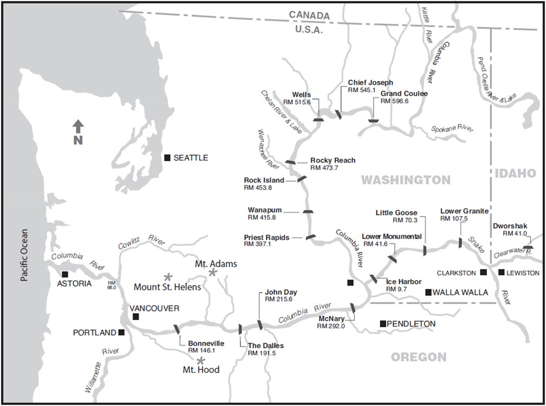
Figure OVE-1. Map of 11 of the 14 Federal hydropower projects in the Columbia River System (CRS), not including Hungry Horse, Albeni Falls, and Libby, and the 4 Mid-Columbia PUD projects.
Table OVE-1. Project Information and Operating Criteria for CRS Projects on the Lower Columbia and Lower Snake Rivers. ª
Lower Columbia River
PROJECT | Bonneville | The Dalles | John Day | McNary
Project Acronym ^{b} | BON | TDA | JDA | MCN
River Mile (RM) | Columbia River – RM 146.1 | Columbia River – RM 191.5 | Columbia River – RM 215.6 | Columbia River – RM 292
Reservoir | Lake Bonneville | Lake Celilo | Lake Umatilla | Lake Wallula
Minimum Instantaneous Flow (kcfs) | 80 kcfs | Dec–Feb: 12.5 kcfs  Mar–Nov: 50 kcfs | Dec–Feb: 12.5 kcfs  Mar–Nov: 50 kcfs | Dec–Feb: 12.5 kcfs  Mar–Nov: 50 kcfs
Forebay Normal Operating Range (ft) | 71.5’ – 76.5’ | 155.0’ – 160.0’ | Nov–Jun: 260 – 265’  Jul–Oct: 265 – 268’ | 337’ – 340’
Tailrace Rate of Change Limit (ft) | Apr–Sep: 1.5’/hr, 4’/day  Oct–Mar: 3’/hr, 7’/day | 3’/hr | 3’/hr | 1.5’/hr
POWERHOUSE
Powerhouse Length (ft) | PH1: 1,027’  PH2: 986’ | 2,089’ | 1,975’ | 1,422’
Turbine Units (#) | PH1: 10  PH2: 8 + 2 Fish Units | 22 + 2 Fish Units | 16 | 14
Turbine Generating Capacity (MW) | PH1: 535 MW  PH2: 558 MW | 1,808 MW | 2,160 MW | 980 MW
Powerhouse Hydraulic Capacity (kcfs) | PH1: 136 kcfs  PH2: 152 kcfs | 375 kcfs | 322 kcfs | 232 kcfs
SPILLWAY
Spillway Length (ft) | 1,450’ | 1,447’ | 1,228’ | 1,310’
Spillbays (#) | 18 | 23 | 20 | 22
Spillway Weirs (#) | 0 | 0 | 2 (Bays 18-19) | 2 (Bays 19-20)
Spillway Hydraulic Capacity (kcfs) | 1,600 kcfs | 2,290 kcfs | 2,250 kcfs | 2,200 kcfs
NAVIGATION LOCK
Nav. Lock Length x Width (ft) | 675’ x 86’ | 650’ x 86’ | 650’ x 86’ | 683’ x 86’
Nav. Lock Maximum Lift (ft) | 70’ | 90’ | 113’ | 75’
Lower Snake River
PROJECT | Ice Harbor | Lower Monumental | Little Goose | Lower Granite
Project Acronym ^{b} | IHR | LMN | LGS | LWG
River Mile (RM) | Snake River – RM 9.7 | Snake River – RM 41.6 | Snake River – RM 70.3 | Snake River – RM 107.5
Reservoir | Lake Sacajawea | Lake Herbert G. West | Lake Bryan | Lake Lower Granite
Minimum Instantaneous Flow (kcfs) | Dec–Feb: 0 kcfs  Mar–Jul: 9.5 kcfs / Aug–Nov: 7.5 kcfs | Dec–Feb: 0 kcfs  Mar–Nov: 11.5 kcfs | Dec–Feb: 0 kcfs  Mar–Nov: 11.5 kcfs | Dec–Feb: 0 kcfs  Mar–Nov: 11.5 kcfs
Forebay Normal Operating Range (ft) | 437’ – 440’ | 537’ – 540’ | 633’ – 638’ | 733’ – 738’
Tailrace Rate of Change Limit (ft) | 1.5’/hr | 1.5’/hr | 1.5’/hr | 1.5’/hr
POWERHOUSE
Powerhouse Length (ft) | 671’ | 656’ | 656’ | 656’
Turbine Units (#) | 6 | 6 | 6 | 6
Turbine Generating Capacity (MW) | 603 MW | 810 MW | 810 MW | 810 MW
Powerhouse Hydraulic Capacity (kcfs) | 106 kcfs | 130 kcfs | 130 kcfs | 130 kcfs
SPILLWAY
Spillway Length (ft) | 590’ | 498’ | 512’ | 512’
Spillbays (#) | 10 | 8 | 8 | 8
Spillway Weirs (#) | 1 (Bay 2) | 1 (Bay 8) | 1 (Bay 1) | 1 (Bay 1)
Spillway Hydraulic Capacity (kcfs) | 850 kcfs | 850 kcfs | 850 kcfs | 850 kcfs
NAVIGATION LOCK
Nav. Lock Length x Width (ft) | 675’ x 86’ | 666’ x 86’ | 668’ x 86’ | 674’ x 86’
Nav. Lock Maximum Lift (ft) | 100’ | 100’ | 101’ | 105’
- Project operating limits and constraints are based on physical plant limitations, legal limits of authorized purposes, and/or to maximize efficiency and benefit of CRS reservoir operations. Flexibility of these limits is pursuant to general provisions of the applicable law and any other agreements or contracts. More information is available in the project-specific FPP Chapters 2-9, or on the Corps District websites: www.nwp.usace.army.mil/Locations/ColumbiaRiver.aspx (BON, TDA, JDA); www.nww.usace.army.mil/Locations.aspx (MCN, IHR, LMN, LGS, LWG).
- Project acronym as designated by U.S. Army Corps of Engineers Northwestern Division (NWD), Columbia Basin Water Management. Due to the large number of hydropower projects managed by NWD, this acronym may differ from other common regional acronyms. For example, Lower Granite Dam is commonly abbreviated LGR in the region; however, this acronym is already assigned to another NWD project, so the official Corps NWD acronym is LWG.
- Fish Passage Plan (FPP) OVERVIEW
  - Introduction
The annual Fish Passage Plan (FPP) is developed by the U.S. Army Corps of Engineers (Corps) in coordination with the Bonneville Power Administration (BPA), regional Federal, State, and Tribal fish agencies, and other partners through the Fish Passage Operations & Maintenance (FPOM) coordination team.
The FPP describes year-round operations and maintenance (O&M) actions scheduled to occur each year from March 1 through the end of February to provide fish passage and protection at the eight Corps hydropower projects on the lower Columbia and lower Snake rivers (Figure OVE-1; Table OVE-1). The FPP includes appendices for fish protection procedures during turbine maintenance at Chief Joseph Dam on the Columbia River (Appendix H) and at Dworshak Dam on the North Fork Clearwater River (Appendix I). Other Corps documents and agreements related to fish passage at these projects are consistent with the FPP.
The FPP is revised as necessary to incorporate changes due to new or modified facilities and operational procedures. Revisions will be coordinated with the region as described below in section 2.3, and with NOAA Fisheries and USFWS as part of ESA Section 7 consultation, Recovery Plan, or Incidental Take permit processes, and through consideration of other regional input, agreements, and plans. When revising the FPP, the Corps also considers the Northwest Power and Conservation Council’s Columbia River Basin Fish & Wildlife Program practicable.
Comments on the FPP are welcome and may be sent to FPOM and/or the Corps’ Northwestern Division, Reservoir Control Center (RCC) Fisheries Section, in Portland, Oregon.
  - ESA Consultations (Biological Opinions)
The Fish Passage Plan is developed as part of the ongoing O&M strategy to improve fish survival in the Columbia River System (CRS), in accordance with all current and applicable ESA Section 7 Biological Opinions. Actions in the FPP shall comply with all other regulatory requirements (e.g., NEPA, CWA) and regional agreements that are in effect at the time (e.g., Fish Accords, Agreement for short-term operations of the CRS).
  - Fish Facilities Inspection & Reporting
An illustration of a typical fish passage system is in Figure OVE-2. Inspection and reporting criteria for fish passage facilities at Corps projects are defined in the FPP project-specific Chapters 2–9. The Corps provides weekly inspection reports to NOAA Fisheries Hydropower Program in Portland, OR, describing out-of-criteria situations, adjustments made to resolve problems, and a detailed account of impacts on project fish passage and survival. The weekly inspection reports also include summaries of equipment calibrations and monitoring of water temperature and adult fish collection channel velocity. Equipment that does not require calibration will not be routinely included in the weekly report. The Corps also provides an annual report to NOAA summarizing project O&M, fish passage facility inspections and monitoring, severity of out-of-criteria conditions, and avian predation abatement actions. In addition, the Corps reports hourly individual spillbay and turbine unit operations at mainstem projects.
  - Deviations from FPP Criteria
The phrase "when practicable" is used in the FPP to describe actions for fish that may vary on a case-by-case basis and thus require the exercise of professional judgment by Project staff. These situations may be due to real-time biological and/or other environmental conditions, availability of staff and/or equipment, or integrity of fish facility or other dam structures. In these cases, the Project biologist and other Project personnel will consider all relevant factors to determine the best way to proceed and implement appropriate action. These actions will be coordinated with fish agencies and tribes when they deviate from the FPP.
River operational emergencies may occur that require projects to temporarily deviate from the FPP. These operations will be coordinated with fish agencies and tribes and conducted in a manner to avoid or minimize fish impacts to the extent practicable. Normally, coordination occurs prior to an action; however, if an emergency requires immediate attention, coordination will be completed as soon as practicable afterwards, as described in section 2.
In-season decisions on river operations to achieve BiOp biological performance standards for spring and summer out-migrants will be made in coordination with the regional forum Technical Management Team (TMT). Special operations identified in the FPP will be coordinated through TMT and included in the annual Water Management Plan (WMP), such as maintenance or research activities requiring unit outages that affect other river operations, operation of turbines outside of the ±1% of peak efficiency range, Snake River zero nighttime generation, and implementation of the Juvenile Fish Transportation Plan (Appendix B).
  - Spill for Juvenile Fish Passage
Planned spring and summer spill operations for juvenile fish passage at the eight lower Snake and lower Columbia River projects are defined in the Fish Operations Plan (FOP), which is included in the FPP as Appendix E. Spill operations to improve juvenile fish passage are developed in accordance with the current NOAA Fisheries Biological Opinion. During spring and summer spill for fish passage, spill at each project will be distributed across the spillway as defined in patterns in the project-specific Chapters 2-9, unless otherwise coordinated with FPOM or TMT. If spill occurs outside of spring and summer spill season, projects will typically use the FPP patterns but may modify patterns as necessary to accommodate maintenance, research, navigation, or other constraints.
  - Total Dissolved Gas (TDG) Monitoring
The Federal Clean Water Act (CWA) establishes a total dissolved gas (TDG) aquatic life standard of 110% that has been adopted by the states of Washington, Oregon, Idaho, and Montana, and regional tribes. During spill operations for fish passage, the states of Oregon and Washington have authorized exceptions (standard modification and criteria adjustment, respectively) for the four lower Snake River and four lower Columbia River projects. The Corps monitors TDG levels at fixed monitoring stations in the forebay and tailrace of each project to ensure that spill for fish passage is consistent with all applicable State and Tribal standards. For more information, see the FOP (Appendix E).
The most current information on State water quality standards is included in the Corps’ annual TDG Management Plan (Appendix 4 of the WMP), which also provides definitions of spill types (e.g., fish passage spill, lack of load spill), the process for coordinating and implementing the Spill Priority List to manage systemwide TDG, the process for setting spill caps, and TDG management policies and monitoring programs. The Corps will coordinate with TMT to develop the Spill Priority List and to provide ongoing TDG information and reports as necessary.
  - Juvenile Fish Transportation Plan
Juvenile salmonids will be transported in accordance with the FOP, FPP, and ESA Section 10 permit. Protocols and criteria for collection, holding, and transport of juvenile fish are defined in the Juvenile Fish Transportation Plan, included in the FPP as Appendix B. Other operating criteria for juvenile fish bypass facilities are contained in the project-specific FPP Chapters 2–9. Additional criteria may be developed as part of the ESA Section 10 permit process and/or in coordination with the TMT. Implementation of the transportation plan, including deviations, will be coordinated through TMT and NOAA Fisheries.
  - System Load Shaping
To avoid or minimize impacts of hydropower operations on fish, BPA coordinated the System Load Shaping Guidelines, included in the FPP as Appendix C. The Guidelines define how BPA requests load so that the Corps can operate turbine units at fish passage projects within ±1% of peak turbine efficiency (1% range) in-season, or as otherwise coordinated through FPOM and/or TMT to enhance fish passage (e.g., Bonneville Dam PH1 BOP and PH2 mid-range operations).
Excursions outside of the 1% range are tracked and reported as described in Appendix C. The intent of reporting excursions is to provide a means for quality assurance for project operations.
For reporting of excursions not covered by Appendix C, the Corps and BPA will take all reasonable and practicable steps to provide advance notification through the existing interagency coordinating mechanisms prior to departure from the fish-protection measures set out in the current CRS BiOp. If unforeseen circumstances arise that preclude BPA or the Corps from notifying TMT prior to a variation from required operating criteria and those circumstances are not covered by Appendix C, those variations will be reported to TMT as soon as practicable.
  - Lamprey Passage
The Fish Accords⁴ were originally signed in May 2008 and include actions to protect Pacific lamprey and improve juvenile and adult lamprey passage through the CRS. Project operations to improve passage for adult and juvenile lamprey are addressed in FPOM. Specific operations for juvenile and adult lamprey are defined in Appendix D and in the project-specific Chapters 2-9. In-season conflicts between operations for ESA-listed species and Pacific lamprey that are not addressed in the FPP may be reviewed by FPOM and/or TMT.
  - Chief Joseph & Dworshak Turbine Dewatering Protocols
The Corps has coordinated and adopted fish protection procedures during turbine dewatering for maintenance at Chief Joseph Dam (Appendix H) and Dworshak Dam (Appendix I). While these projects do not have fish passage capabilities, ESA-listed salmon and steelhead are present in the tailrace and may become trapped in the turbine unit draft tube during dewatering. The procedures and criteria defined in these Appendices provide fish-protection measures to avoid or minimize impacts on ESA-listed salmonids during turbine dewaterings at these projects.
- Implementation & Coordination
  - Implementation
Implementation of the FPP requires information exchange and coordination between the Corps, NOAA Fisheries, BPA, other Federal and State fish agencies, and Tribes. Corps District biologists coordinate through FPOM on spill patterns, unit priority, adult and juvenile fish facilities, and other project-specific operations that do not have system-wide impacts (see FPOM Coordination section 2.3). Corps District and RCC biologists attend monthly FPOM meetings dealing with project-specific issues to consider recommendations from affected interests; provide updates on construction, O&M, research, and other topics; develop criteria for the annual FPP; and coordinate fish passage issues that may require deviation from FPP criteria. For Corps operations that have system-wide effects, such as water management, spill, and unit availability, the Corps RCC coordinates through TMT (see TMT Coordination section 2.4).
  - Agency Responsibilities
    - U.S. Army Corps of Engineers
            - Coordinate with NOAA Fisheries and USFWS on operations that may impact ESA-listed threatened, endangered, or candidate species.
            - Prepare annual Water Management Plan and Seasonal Updates in coordination with TMT.
            - Collaborate with fish agencies and tribes to provide fish passage monitoring, surveillance, and reporting at Corps projects throughout the migration period.
            - Provide timely information on all proposed and/or scheduled studies or special operations that may negatively impact or otherwise constrain fish passage or energy production. Discuss unforeseen changes in fish passage operations with fish agencies and tribes.
            - Carry out routine and emergency fish passage operations and maintenance procedures in accordance with criteria in FPP Chapters 2-9 and Appendix A.
            - Conduct the TDG Monitoring Program.
    - Federal, State and Tribal Fishery Agencies
            - Request spill for fish through TMT to protect ESA-listed species or other species in accordance with the TMT Guidelines.
            - Via TMT, provide RCC with a recommended order for the spill priority list and any modifications.
            - Provide biological monitoring and surveillance reports throughout the migration period from predetermined locations, such as Smolt Monitoring Program sample sites.
            - Provide status reports on the timing of the downstream migration, including pertinent marked fish release and recovery data, with weekly written reports estimating percentage of runs past key projects.
            - Where biologically and logistically feasible, coordinate hatchery releases to ensure they are protected by regulated fish flows and spill while minimizing impacts on ESA-listed species. Provide updated hatchery release schedules weekly.
            - Provide recommendations to the operating agencies for maintaining acceptable fish passage conditions. This information can be used to maximize other project uses, including power generation.
            - Provide information on all proposed and scheduled studies or special operations designed to improve fish passage operations that may affect energy production or project operation. Discuss unforeseen changes with the Corps.
            - Recommend viable methods and procedures to reduce migratory and resident fish mortality (e.g., collection and transport of migrants, use of alternate bypass strategies, or other methods to minimize fish mortality).
    - Bonneville Power Administration
            - Report to RCC on updated load-resource studies during the April–September period to supplement the Northwest River Forecast Center's runoff volume forecast for fish passage planning assistance.
            - Provide the BPA estimate of power market impacts of requested spill operations to RCC, NOAA Fisheries, other fish agencies, and tribes,
            - Utilize available flexibility of the FCRPS to shape flow requirements, spill priorities, and plant generation consistent with BPA policies and statutory requirements related to fish protection.
            - Adjust system generation to provide adequate water for fish operation requirements in accordance with the FOP and relevant CRS BiOps.
            - Provide project load requests on a real-time/hourly basis that enable the Corps to implement spill priorities.
            - Provide information on unit operations outside the ±1% range per Appendix C.
    - Mid-Columbia Public Utility Districts
            - Operate projects for spill transfer in accordance with provisions of the FPP with at least 1.5 hours notification to start or stop spill.
  - FPOM Coordination
Project O&M activities in the annual FPP are regionally coordinated through FPOM, which includes representatives from the Corps, BPA, NOAA Fisheries, USFWS, State fish agencies, regional Tribes, and other interested parties (see current list in section 2.3.3).
The annual FPP goes into effect each year starting March 1 and is effective year-round, though revisions may be approved through FPOM at any time. Proposed revisions are presented in an FPP Change Form with a description and justification for the change that is submitted to the relevant District Operations biologist for consideration by the Corps. The Corps will submit Change Forms to FPOM for a minimum of two weeks to review and provide feedback to the Corps POC. Approved Change Forms will be finalized with comments received and a record of final action, then incorporated into the current year’s online FPP. The Corps will provide FPP changes to TMT as necessary for use as part of the overall river operation plan. Special operational requirements will also be included in the annual Water Management Plan.
    - FPOM Memorandum of Coordination (MOC)
Project activities under the purview of FPOM that may require deviations from FPP criteria will be fully coordinated in a timely manner pursuant to the coordination procedures below.
For O&M activities within the District’s Operations Division, Project personnel will compile relevant information into a Memorandum of Coordination (MOC; see template at the end of this Chapter) that includes a summary of the activity, location, date and time, analyses of potential impacts to ESA-listed species, and potential alternative actions, then forward to the District Biologist or other appropriate personnel for routing to FPOM. The District biologist will submit the MOC to FPOM at the next monthly meeting and/or via email, and if necessary, follow up with appropriate FPOM members via phone or email. For planned O&M, the MOC should be provided to FPOM for review at least two weeks in advance. For unplanned, non-emergency O&M (e.g., equipment failure), the MOC should be provided to FPOM at least three workdays in advance. Emergency O&M may be performed immediately, and a Memo for the Record (MFR) submitted to FPOM as soon as possible, either before or after the activity (see section 2.3.2).
For each MOC, the analysis of potential impacts will include the following information (links to data are included in the MOC template):
            - 10-year average passage of adults and juveniles of each affected listed species during dates of impact.
            - Statement about the current year’s run compared to the 10-year average.
            - Estimated exposure to impact of adults and/or juveniles, as appropriate, by species (number or percent of 10-year average that occurs during dates of impact).
            - Type of impact to adults and/or juveniles, as appropriate, by species (e.g., increased delay, exposure to predation, exposure to a route of higher injury/mortality rate, exposure to higher TDG, etc.).
            - Final judgement on scale of potential impact (negligible, minor, significant) on adult and juvenile salmonids (including bull trout) and lamprey (e.g., “As a result of this analysis, we anticipate that the proposed action will result in negligible impact to listed species.”).
FPOM members may submit responses to MOCs by the requested due date via email, phone, or in person. All responses will be documented in the final MOC and distributed to FPOM and posted to the FPOM website. The District biologist will forward the final coordinated operation to project personnel, and if necessary, RCC will issue a teletype to the project(s).
For research and construction activities involving the Planning Division, the Planning Division biologists will coordinate the effort with Operations Division biologists to develop an MOC. Research development is largely carried out and documented through the Corps’ Anadromous Fish Evaluation Program (AFEP) in the regional forum Studies Review Work Group (SRWG). New construction or modification of fish facilities is typically carried out and documented through the Fish Facility Design Review Work Group (FFDRWG).
If implementation requires assistance from Project staff, temporary equipment installation, facility modification, and/or operational changes, then both Planning and Operations biologists will work closely with Project personnel and any others necessary to ensure all personnel are continually informed and updated throughout the process.
    - FPOM Memorandum for the Record (MFR)
Incidents that result in adverse or negative impacts to fish or fishways shall be documented by Project biologists in a Memorandum for the Record (MFR – see template at end of this Chapter). The MFR will be sent to FPOM by the next working day and added to the next FPOM meeting agenda for review. FPOM members may submit responses to an MFR by the requested due date via email, phone, or in person, and all responses will be documented in the final MFR for posting to the FPOM website.
    - FPOM Representatives & Participants (*Co-Chairs)
FPOM membership is comprised of federal, state, and tribal representatives, as established in the FPOM Guidelines.⁷ As of March 2022, the list of FPOM members and participants is as follows:
        - Corps Walla Walla District – Operations: Chris Peery*, Scott St. John
        - Corps Walla Walla District – Planning, Programs, & Project Mgmt: Steve Juhnke
        - Corps Portland District – Operations: Tammy Mackey*
        - Corps Portland District – Planning, Programs, & Project Mgmt: Brad Eppard
        - Corps Seattle District: Katherine Cousins, Fred Goetz
        - Corps Northwestern Division, Reservoir Control Center: Doug Baus, Lisa Wright
        - Bonneville Power Administration: Scott Bettin, Ben Hausmann, Christine Peterson, Leah Sullivan
        - Bureau of Reclamation: Jarod Blades
        - NOAA Fisheries: Trevor Conder, Blane Bellerud, Kelsey Swieca
        - US Fish & Wildlife Service: David Swank, Erin Britton Kuttel
        - Confederated Tribes of the Umatilla: Tom Lorz (CRITFC)
        - Colville Confederated Tribes: Kirk Truscott
        - Nez Perce Tribe: Jay Hesse
        - Confederated Tribes of Warm Springs: Jennifer Graham
        - Yakama Nation: Tom Iverson
        - Oregon Dept. of Fish & Wildlife: Erick Van Dyke
        - Washington Dept. of Fish & Wildlife: Charles Morrill
        - Idaho Dept. of Fish & Game: Jonathan Ebel
  - TMT Coordination
Actions that may impact fish system-wide are coordinated and documented through TMT. Actions that may impact fish at a specific project that result from actual operations, implementation of FOP/BiOp actions, incidental take, BiOp terms and conditions, or research will be coordinated through the process outlined in section 2.5. TMT Guidelines are posted as an Appendix to the annual Water Management Plan.
The Corps RCC hosts TMT meetings throughout the year to consider recommendations for river operations and to implement the FOP, BiOps, and other recommendations from fish interests. As part of this process, TMT may evaluate research data, current conditions and forecasts, and advice on whether existing operations are consistent with current study results. TMT meeting agendas are posted online, and meetings are open to the public. Action Agency representatives provide the latest weather and runoff forecasts, and information on fish, hydrology, water quality, and power generation to assist in planning operations for fish passage. The Corps evaluates fish operation recommendations to determine impacts on overall system operations.
  - Day-to-Day Coordination
Procedures described in the annual Water Management Plan will be used for fish operations. Coordination of system and project operations for flow augmentation and recommended reservoir operations will occur through TMT. This includes operation of turbine units outside of the 1% range, Snake River zero nighttime generation, reservoir operation at minimum operating pool (MOP) or some other specific elevation, and special operations for implementation of approved research projects in Appendix A. When reservoirs are not being operated to provide special protection for fish passage, projects may be operated within the full normal operating range.
Recommendations for special fish operations outside the Water Management Plan may be made to RCC and coordinated through TMT. Recommendations related to project O&M activities requiring special operations will be evaluated for fish impacts. Sufficient lead time will be allowed for a planned operation, whenever practical, to allow ESA coordination with TMT, NOAA Fisheries, and USFWS. Preferably, as much lead time as possible will be provided for activities requiring immediate action. After-action coordination will occur when advance notice is not possible, such as in an emergency. All other special operations will be evaluated for fish impacts and effects on other project O&M requirements and coordinated through TMT. Except as necessary for emergency actions, adequate time will be allowed for evaluation of all project and fish impacts prior to implementation. Coordination of emergencies will occur as identified in the Emergency Protocols adopted by TMT (Water Management Plan, Appendix 2).
The Corps will implement fish spill provisions as described in the FOP (Appendix E), including special TDG conditions for juvenile fish passage. During spill for fish passage, TDG levels will be monitored and fish will be evaluated for signs of gas bubble trauma by the Corps, NOAA Fisheries, other fish agencies, Tribes, and/or State water quality agencies. Project spill levels will be adjusted as needed based on daily physical and biological monitoring results and coordinated with TMT and other relevant agencies and tribes.
All non-Corps personnel intending to conduct activity at a Corps facility (e.g., fish handling; minor facility modifications) must have prior written approval from the Corps. This approval must be requested in writing to the Chief, Operations Division, at the appropriate Corps District office. If the activity may affect ESA-listed fish, proof of consultation with NOAA Fisheries or USFWS (Section 10 permit) must be provided. Appropriate State permits must be provided as well for activities that may impact ESA-listed or non-listed fish.

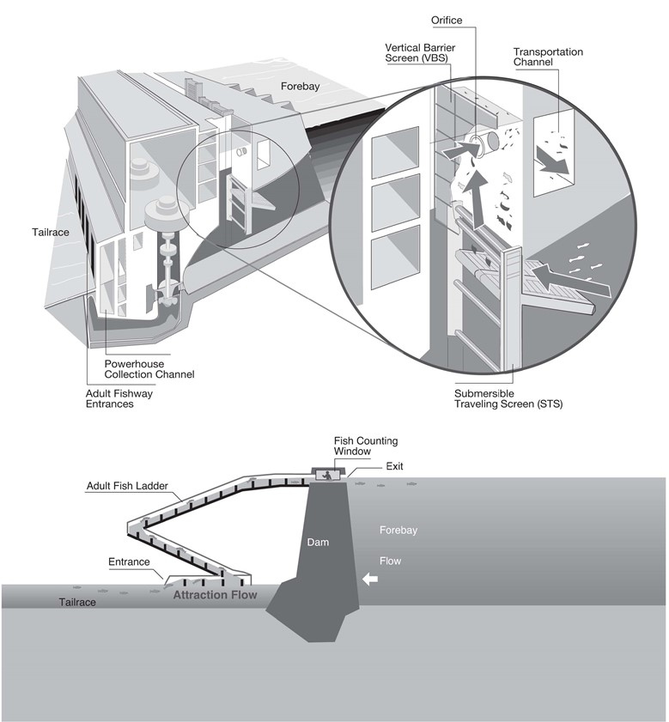
Figure OVE-2. Example Design of Fish Passage Structures at CRS Corps Hydropower Projects.

OFFICIAL MEMO of COORDINATION (MOC) FOR
NON-ROUTINE OPERATIONS & MAINTENANCE
COORDINATION TITLE- (filled in by District OD Biologist)
COORDINATION DATE-
PROJECT-
RESPONSE DATE-
- Description of problem.
- Type of outage required (relate to deviation from FPP).
- Dates of impacts/repairs.
- Length of time for repairs.
- Impact on fish facility operation (fishway, JFF, etc.).
- Impact on project operations (unit priority, forebay/tailwater operation and/or spill).
- Analysis of potential impacts to fish. Include:
  - 10-year average passage of adults and juveniles of each affected listed species during dates of impact.
    - Adult counts: www.cbr.washington.edu/dart/query/adult_graph_text.
    - Adult counts by ladder: www.cbr.washington.edu/dart/query/adult_ladder_sum. To calculate 10-year average, download each of the most recent 10 years and copy into a spreadsheet for averaging.
    - Smolt index: www.cbr.washington.edu/dart/query/smolt_graph_text. To calculate 10-year average, select the most recent 10 years (hold “ctrl” and select each year) and select download to .CSV spreadsheet.
  - Statement about the current year’s run (e.g., higher or lower than 10-year average).
    - Pre-season – NOAA adult returns forecast: www.nwfsc.noaa.gov/research/divisions/fe/estuarine/oeip/g-forecast.cfm. Or contact the District adult fish passage coordinator.
    - Mid-season - current counts to-date vs. 10-year average (see links in section a.).
  - Estimated exposure to impact of adults and/or juveniles, as appropriate, by species (number or percentage of 10-year average that occurs during dates of impact).
  - Type of impact to adults and/or juveniles, as appropriate, by species (e.g., increased delay, exposure to predation, exposure to a route of higher injury/mortality rate, exposure to higher TDG, etc.).
  - Final judgement on scale of expected impacts (negligible, minor, significant) on:
    - Downstream migrants.
    - Upstream migrants (including Bull Trout).
    - Lamprey.
- Comments from agencies.
- Final coordination results.
- After Action update.

Please email or call with questions or concerns.
Thank you,

Name
Project
Title of person writing MOC
E-mail address of person writing MOC

CENWP-OD-Project code Date of report

MEMORANDUM FOR THE RECORD (include title i.e. 12BON01)

SUBJECT: Include species and location.

Insert explanatory verbiage in this section.

- Species –
- Origin –
- Length –
- Marks and tags –
- Marks and injuries found on carcass –
- Cause and time of death –
- Future and preventative measures –
- Regional coordination and responses/comments –
- Next FPOM meeting (add to agenda for review) –

Include photos if available.
Sincerely,
Project Fisheries

FPP website: pweb.crohms.org/tmt/documents/fpp/
Biological Opinions, decision documents, and other related documents are available online at: www.salmonrecovery.gov/BiologicalOpinions/FCRPSBiOp.aspx
In past ESA consultations, the Action Agencies used the term Federal Columbia River Power System (FCRPS). The FCRPS in its entirety includes 31 multi-purpose dam and reservoir projects operated by the Corps and Reclamation, and a transmission system operated by BPA. The Columbia River System (CRS) is a subset of 14 of the FCRPS projects that are operated as a coordinated water management system and the subject of current consultations.
Fish Accords: www.salmonrecovery.gov/Partners/FishAccords.aspx
Term Sheet Stay Agreement (see PDF pages 6-8), as extended through August 31, 2023: https://pweb.crohms.org/tmt/JointMotion_TermSheet_CourtOrder_and_Extension_AUG2022.pdf
Water Management Plan website: pweb.crohms.org/tmt/documents/wmp/
FPOM website: http://pweb.crohms.org/tmt/documents/FPOM/2010/
TMT website: http://pweb.crohms.org/tmt/

