# Fish Passage Plan (FPP) Change Form

**Change Form # & Title**: 23AppA001 – Doble Test Schedule for 2023

**Date Submitted**: 17-January-2023; REVISED 8-FEB-2023

**Project**: Lower Snake Projects and DWR

**Requester Name, Agency**: Chris Peery and Lisa Wright, Corps

**Final Action: APPROVED 16-FEB-2023**

**FPP Section**:

Appendix A, section 1.5

**Justification for Change**:

Add the 2023 Doble test schedule for the lower Snake projects and Dworshak Dam.

**Proposed Change**:

See following pages for edits to existing FPP text in track changes.

**Proposed Change**: *edits to existing FPP text in track changes*

1.5. Doble Testing[1]

The current year’s transformer outage schedule for Doble testing at lower Snake projects and Dworshak Dam is in **Table A-1**.

1.5.1. Lower Snake River Projects:

At the Lower Snake projects, Doble testing of transformers is required every three years to ensure they are functioning correctly and to identify issues that need repair. The testing must be conducted during warm, dry conditions (July–August) and requires an outage of the transformer and associated units. Testing is performed during already scheduled outages to the extent possible and timed to avoid or minimize impacts to fish. In years that Doble testing isn’t required, the project may still require an outage during the same timeframe to perform necessary transformer maintenance and repairs that were identified in previous Doble tests and inspections. For more information, see project-specific **sections 6-9** below.

1.5.2. Dworshak Dam:

At Dworshak Dam, required transformer maintenance and Doble testing occurs every two out of three years starting September 21. For more information on Dworshak maintenance and testing, see **Appendix I**.

Table A-1. Doble Testing Schedule in 2023.a

|  |  |  |  |
| --- | --- | --- | --- |
| **Project** | **Dates** | **Outage**  **(Transformer & Units)** | **Notes b** |
| **IHR** | July  18–22 | TW3 & TW4 (Units 3, 4) all hours | Remaining available units (2, 5, 6) operated per FPP priority order. |
| **LMN** | July 24 –  August 3 | T1 (Units 1–4) all hours  T2 (Units 5, 6) first/last day | On first and last day, all units OOS 0530–1800 with Unit 5 at speed no load (8 kcfs) for station service. During all other hours, T2 (Units 5 & 6) available and operated per FPP priority order. |
| **LGS** | July 31 –  August 12 | T1 (Units 1–4) all hours  T2 (Units 5, 6) 0500-1700 | During the daily T2 outage, Unit 6 or 5 (if available) will be operated at Speed-no-Load for station service. T2 RTS nightly and Unit 6 and Unit 5 (if available) operated per FPP priority order. |
| **LWG** | N/A | N/A | No Doble testing in 2023 |
| **DWR** | Sep 25-28 | T2 (Unit 1) all hours |  |

**a**. The lower Columbia projects (BON, TDA, JDA, MCN) perform Doble testing concurrent with outages for maintenance and do not have specific outages for Doble tests.

**b.** OOS = Out of Service (unavailable to operate); RTS = Return to Service (available to operate).

1. ICE HARBOR DAM

**6.1.3. Doble Testing (see section 1.5 above for more information)**

1. Dates: Summer (annually). In 2023, the outage is scheduled for July 17-21.
2. Description: The outage in 2023 is required to perform Doble testing of TW3 and TW4, which will take Units 3 and 4 out of service continuously during testing. Doble testing conducted in conjunction with the scheduled 6-year overhaul on Unit 4. Remaining available units (2, 5, 6) will be operated per FPP priority order.
3. Impacts to FPP Criteria: None. Since Ice Harbor has multiple transformer banks and transmission lines and redundant switching capability, remaining available units will be available and operated pursuant to FPP priority order.
4. Lower monumental DAM

**7.1.3. Doble Testing (see section 1.5 above for more information)**

1. Dates: Summer (annually). In 2023, the outage is scheduled for July 24–August 3.
2. Description: During the 2023 outage, the project will upgrade the T1 iso-phase bus, which will consist of replacing the doghouse covers, replacing gaskets with upgraded materials, cleaning, and inspections. The outage will require T1 and T2 (all units) out of service for up to 11.5 hours (0530-1800) on the first and last day of the outage to hang clearances. During these hours, all project outflow will be spilled except 8 kcfs through Unit 5 for station service power. During all other hours, T2 (Units 5 and 6) will be available and operated per FPP priority order.
3. Impacts to FPP Criteria: All units will be out of service for up to 11.5 hours (0530-1800) and all project outflow will be spilled except approximately 8 kcfs through Unit 5 for station service.

8. little goose DAM

**8.1.1. Doble Testing & T1 Isophase Bus Upgrades (see section 1.5 above for more information)**

1. Dates: Summer (annually). In 2023, the outage is scheduled for July 31–August 12.
2. Description: During the 2023 outage, the project will upgrade T1 iso-phase bus, which will consist of replacing doghouse covers and replace thru-bushing bus ducting. The upgrades will reduce risk of water intrusion and increase efficiency in future outages. While some of the Doble and maintenance are conducted concurrently, portions of both will need to be conducted at the beginning and end of the required outage. Access to these areas requires significant transformer outages, thus combining maintenance and Doble efforts reduces future impacts. T1 will be Doble tested and Units 1-4 will be out of service continuously from July 31 through August 12. T2 (Units 5, 6) will also be out of service daily from 0500-1700, with Unit 5 (or Unit 6 if Unit 5 is unavailable) at 8 kcfs for station service power. T2 will return to service nightly from 1700-0500 and Units 5, 6 operated as available per FPP priority order.
3. Impacts to FPP Criteria: Daily from 0500-1700, all units will be out of service and all project outflow spilled except 8 kcfs for station service through Unit 5 (or Unit 6 if Unit 5 is unavailable).

9. LOWER GRANITE DAM

**9.1.1.** Doble Testing (see section 1.5 above for more information)

1. Dates: N/A (no Doble testing scheduled in 2023).
2. Description: N/A
3. Impacts to FPP Criteria: N/A

**Comments**:

3-FEB-2023 FPOM FPP Meeting:

Conder – LMN July 24-Aug 3. Concerned with outage of priority units last week of July. Prefer in the future to avoid that if possible.

Peery – will talk to project to see if there’s flexibility to move that later this year.

Ebel – appreciate the order and doing the downstream projects first toward the end of July.

Van Dyke – LGS is longer than a week. Why?

Peery – likely to perform maintenance on issues discovered during last year’s testing.

Hesse – would like Doble separated from other maintenance.

Peery – can look into how best to communicate that.

Conder – concerned that outages for maintenance could be done at a different time.

Ebel – request NWW put out a press release for DWR ops that change flow.

Need to add more info on maintenance vs Doble, esp for LGS.

PENDING

8-FEB-2023 email from Scott St. John:

Updated version with edits to section 8 (LGS).

14-FEB-2023 email from Scott St. John to FPOM:

FPOM,

During the FPOM meeting last week, concerns were raised regarding the extended Doble schedule to include some non-routine transformer maintenance.  We worked with numerous individuals to address these concerns, as outlined below.

Please review and provide feedback by COB 16 February 2023.

* Background: The extended outage request is to support non-routine iso-phase bus upgrades.  These upgrades include “doghouse covers”, upgraded thru-bushing ducting and installing new gaskets with upgraded materials.  Portions of these upgrades, such as removing the doghouse covers, need to be done to conduct Doble testing, thus replacing with new components would be an efficient use of the outage.  The upgraded components will increase efficiency and may reduce future planned and unplanned transformer outages.
* Temperature Impact: Our temperature modeling simulations showed negligible differences in tailwater temperatures below Little Goose and Lower Monumental dams when comparing a normal (5-day total outage) vs the extended Doble outage (as proposed).
* Fish Impact: The tables below compare the proportion of the 10-yr average number of adults and juveniles that may be impacted by a normal (gray) vs the proposed Doble and transformer maintenance schedule.

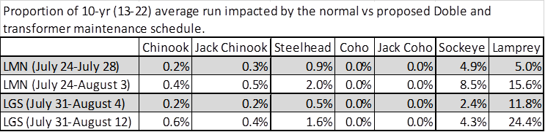

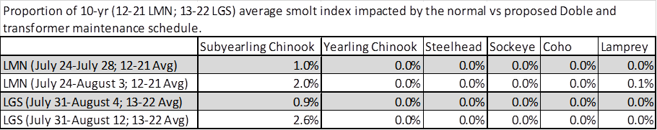

* Risks: If the work is not conducted, we increase the potential for water intrusion and future forced transformer outages.  Water intrusion can lead to thru-bushing failure and require a forced/unplanned outage depending on severity, as observed recently at Little Goose Dam (20 LGS 17).
* Schedule: Powerhouse staff is extremely limited with maintenance schedules planned in advance.  The proposed schedule includes overtime, with crews working straight through the entire outage (IE- Fri-Sun included).  Staff have procured materials, plan to rent additional manlifts to conduct work and will assign as many electrical and mechanical staff as possible, as room allows.
  + Moving this outage to a cooler time (IE- Nov-Feb) will impact other scheduled work.  Planned maintenance includes unit annuals, fish passage maintenance, fish screen maintenance, navigation lock, etc.  Additionally, gasket material and other sealants become less pliable and potentially not as effective if installed in cold and potentially wet conditions.
    - Both Lower Monumental and Little Goose dams have committed to reduced winter maintenance periods to support earlier fish screen installs in current and future years.  Additionally, Lower Monumental Dam is conducting a March 1 early start, requiring STS screen maintenance and install to occur in a condensed timeframe.

No comments received.

**Record of Final Action**:

Approved Feb 16, 2023. Any in-season modifications to the schedule will be coordinated with FPOM via MOC.

1. “Doble test” is a common term referring to a power factor test of transformers to measure performance of electrical insulation. Doble is the name of a manufacturer of the test equipment.