Fish Passage Plan (FPP) Change Form
Change Form # & Title: 22JDA007 – STS Schedule
Date Submitted: 2/1/22
Project: John Day Dam
Requester Name, Agency: Scott Fielding and Eric Grosvenor CENWP-ODJ
Final Action: APPROVED 2/10/22
FPP Section: Table JDA-1 John Day Dam Schedule of Operations and Actions Defined in the 2021 Fish Passage Plan, 2.3.1
Justification for Change: This Fish Passage Plan (FPP) change is to request STS removal to start on the Monday of the third week of December, to include the first partial week when applicable. The current start date for removal of STSs of December 16th changes from year to year in an 8-day cycle. Some cycles fall Friday-Sunday which is outside the normal work week or fall toward the end of the work week resulting in a narrow window of complete STS removal. This results in overtime labor costs and negative impacts to work-life balance of personnel.
In 2022, December 16th falls on a Friday which means the mechanical crew would require overtime to pull STSs without impacting other maintenance that must be completed during the winter maintenance period. The proposed change would allow the crew to start pulling screens Monday December 12-15. This will reduce cost in the overall Fish labor budget and support employees that would like to schedule leave for the holidays.
Proposed Change: Edits to existing FPP text in “track changes”.

Table JDA-1. John Day Dam Schedule of Operations and Actions Defined in the 2021 Fish Passage Plan.
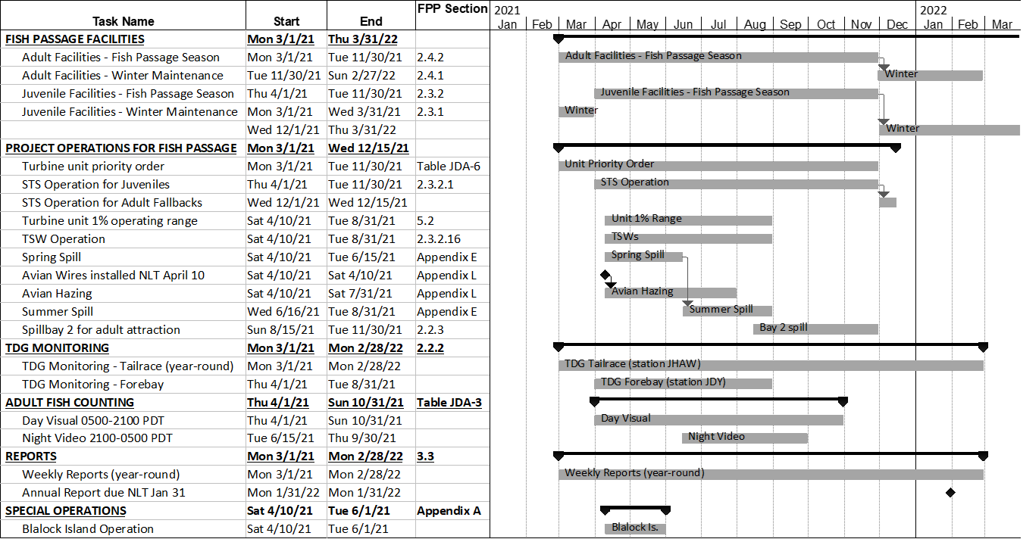
First Monday of the 3rd week of December

2.3.1. Juvenile Fish Facilities - Winter Maintenance Period (December 1 – March 31)
2.3.1.1. From December 1 through Sunday of the second week of December, submersible traveling screens (STS) will remain in place and the juvenile bypass system (JBS) channel will operate for adult fallbacks, thereby shortening some aspects of the winter maintenance period by two weeks. During this period, priority units will be screened to the extent practicable (barring operational failure). STSs will only be removed from non-priority units when necessary to begin maintenance. Starting Monday of the third week of December, all STSs may be removed.

2.3.2. Juvenile Fish Facilities – Fish Passage Season (April 1 – November 30)
2.3.2.1. STSs and VBSs.
            - Operate STSs from April 1 through November 30 for juvenile fish passage, and from December 1 through Sunday of the second week of December for adult fallbacks. Do not operate units without a full complement of rotating STSs except to comply with other coordinated fish measures.
2.3.2.2. Gatewells and Orifices.
            - Open all gatewell orifices April 1 through Sunday of the second week of December.

Comments:

Record of Final Action: Approved at FPOM 2/10/22

