Fish Passage Plan (FPP) Change Form
Change Form # & Title: 22BON003 - Reduce frequency of velocity readings
Date Submitted: 11-MAY-2022
Project: Bonneville Dam
Requester Name, Agency: Andrew Derugin, Tucker Gossett, Rebecca Cates, Jeanette Wendler -
USACE
Final Action: APPROVED 11-AUG-2022
FPP Section: BON section 2.4.2.7 Adult Fish Facilities / Adult Fish Passage Season
Justification for Change:
BON Fisheries measures water velocities daily during fishway inspections to ensure velocities are between FPP criteria of 1.5 – 4 feet per second. We would like to reduce the frequency of readings to once per week. This frequency reflects the protocols of other dams in the district. For example, The Dalles Dam – FPP section 2.4.2.6. only requires water velocity readings once per week during the adult fish passage season. BON Fisheries believes this request is justified because water velocities are rarely out of criteria (out of criteria velocity occurred zero times so far in 2022, twice in 2021, and once in 2020). If the velocity reading is out of criteria, we will increase the weekly readings to three times a week until proper channel conditions are met.
BON Fisheries is implementing the use of small portable flow meters to measure water velocities. The portable flow meters will replace the old stationary flow meter in Photo 1. Stationary flow meters are very large and in the center of the collection channel where fish must navigate around to pass. The stationary flow meters require constant positioning with changing channel elevations and collect vegetation/debris that comes down the fishway. This requires personnel to frequently raise the flow meter to clean or reposition to match elevations. The small, portable flow meters (Photo 2) will reduce time and effort spent to clean the equipment and reposition with changing elevations. They will also give the advantage of being deployed anywhere in the channel which will give a better overall representative reading of channel velocity. BON fisheries suggest removing all stationary flow meters from the fishways.
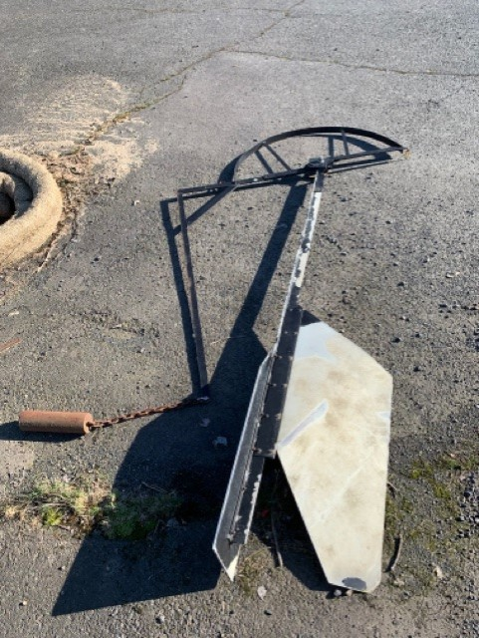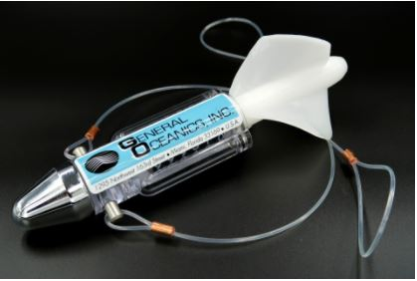
Photo 1. Old stationary flow meter Photo 2. New mechanical flow meter
Proposed Change: [see below with edits to existing FPP in track changes]
2.4.2. Adult Fish Facilities – Adult Fish Passage Season (March 1 – November 30).
      - Maintain water velocity between 1.5 feet per second (fps) and 4 fps (2 fps preferred) for the full length of the powerhouse collection channel and the lower ends of the fish ladders that are below tailwater. Measure water velocities once per week during fishway inspections to verify channels are operating between 1.5 and 4 fps. If the velocity reading is out of criteria, weekly readings will increase to three times a week until proper conditions are met.
Comments:
May 12, 2022 - FPOM: Conder wants to think about this. PH1 does not cause as many issues as PH2. Mackey asked if they could just crank the flow meter out of the ladder when it’s not in use. Derugin said that’s a possibility, but he still has concerns with maintenance of the clunky old meters that tend to catch debris. PENDING more review and discussion at the June FPOM.
June 9, 2022 - email from Trevor Conder, NOAA: “I am fine if they change their frequency, but I still need some way of verifying that the channels are in criteria when I am at the project for monthly inspections. The flow meters allow me that opportunity, but if removed, how will I know? I do not think the PH1 flow meter causes a problem.”
August 11, 2022, FPOM: Conder would like to leave the existing flow meter in PH2 to have the capability to verify. Derugin confirmed they can leave PH2 as is and only replace the meter at PH1. They will continue to look for better options for PH2.
Record of Final Action: Approved at FPOM on August 11, 2022.

