Fish Passage Plan (FPP) Change Form
Change Form # & Title: 22AppL003 – LMN Bird Monitoring Plan
Date Submitted: February 23, 2022
Project: Lower Monumental Dam
Requester Name, Agency: Denise Griffith, Corps LMN
Final Action: APPROVED – March 10, 2022
FPP Section: Appendix L – Predator Management Plans, LMN sections – 8.1. Monitoring, 8.3. Incident Response and 8.4. Reporting.
Justification for Change:
The piscivorous bird monitoring program at Lower Monumental Dam has not been updated in numerous years and consists of various inspections to collect a singular dataset. The proposed changes utilize more recent data to determine suggested action thresholds and also incorporates an increase in daily bird monitoring that is more consistent. Additionally, the update to the monitoring program better aligns with other Projects within Walla Walla District and more clearly defines the monitoring plan, incident response and reporting.
Currently, the incident response action point numbers are based off of hazing effectiveness inspections which are conducted once daily between 1100 and 1300 hours from April 1 through June 30. Data is limited to flying gull and tern counts and floating cormorant counts in the tailrace and near the juvenile fish bypass outfall.
Bird behavior and location may change during a single monitoring event and may add a layer of subjectivity to data collection. Therefore, the proposed action point numbers are based on overall maximum daily abundance observed for all locations and behaviors.
The last 5-years (2016-2021) of bird monitoring data from standard fish ladder inspections has been compiled to determine the maximum daily bird counts as well as daily and monthly averages for all behaviors and zones combined. The maximum daily gull count ranged from 138 to 213 individuals and occurred between May 4 and May 20, except in 2018 when the maximum gull count occurred in August. The maximum daily cormorant count ranged from 20 to 54 individuals and occurred between September 11 and September 21, except in 2017 and 2021 when the maximum count occurred in May and April, respectively. The maximum daily Caspian tern count ranged from 0 to 4 individuals and occurred in April or May in all years. The maximum daily grebe count ranged from 0 to 16 individuals and occurred in April, May, or June, except for in 2016 when the maximum grebe count occurred in September. The maximum daily pelican count ranged from 12 to 45 individuals and occurred in April during 2016 and 2017, July in 2018 and 2019 and in May 2020 and 2021. The maximum daily total bird count ranged from 141 to 230 individuals and occurred in May during all years except 2018 when the maximum total bird count occurred in August. Daily average bird counts, all zones and behaviors combined, for days counts were conducted by species and month are in Figure 1.
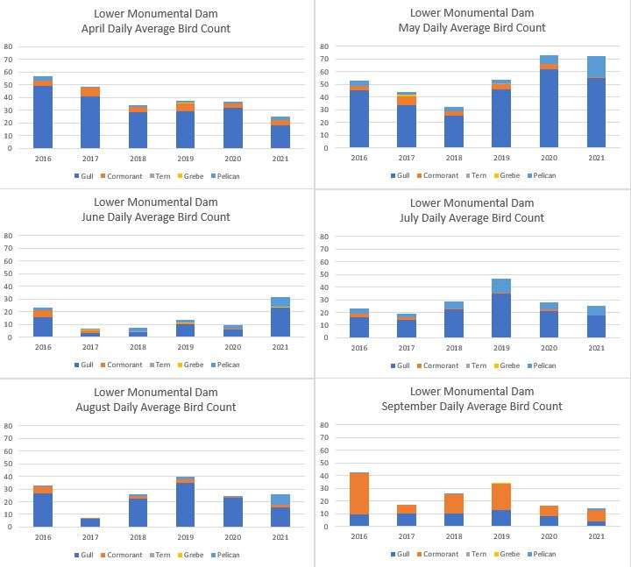
Figure 1. Daily average bird counts at Lower Monumental Dam, 2016 through 2021.

Proposed Change:

8.1. Monitoring. Bird monitoring by Juvenile Fish Facility staff will occur at least once daily from April 1 to September 30, but more frequently if deemed necessary by the Project Biologist. The primary species for monitoring actives include gulls, grebes, Caspian terns, white pelicans, and double-crested cormorants. Data collection will include the number of individuals present in each of five zones as well as bird behavior: foraging (flying, diving or feeding) and non-foraging (resting in/on water, on debris, structures or land, or while scavenging). Zone monitoring will include the forebay (FB1), spillway (SWT1), powerhouse outflow under the bird wires (PH1), powerhouse outflow downstream of the bird wires (PH2) and the juvenile bypass outfall (JFOF).
Additional bird monitoring, as part of standard fish ladder inspections, will occur from October 1 through December 30. During those inspections, basic bird abundance observations will be recorded.

8.3. Incident Response. The following toolbox items will be utilized based on the trigger criteria of birds present and the availability of trained staff.
(a) Focus hazing efforts in areas with the greater abundance.
(b) Propane cannon placement.
(c) COE employee (added) hazing with screamers and poppers fired from shore.

The following action point number is based on the most recent 5-year (2016-2021) dataset and is proposed as a starting point for the toolbox items.
(a) Action point for total number of birds including gulls, cormorants, terns, grebes, and pelicans = 90 birds

8.4. Reporting. Bird monitoring data collected from April 1 through September 30 is maintained in an excel spreadsheet. Piscivorous bird abundance along with a summary of hazing effectiveness and deterrent program will be provided on the fish facility weekly report. A summary of seasonal bird abundance and overall effectiveness of the bird deterrent program will be provided in the annual report.

Comments:

Record of Final Action: Approved at FPOM March 10, 2022

