# Fish Passage Plan (FPP) Change Form

**Change Form # & Title**: 22AppG001 – Lamprey Trapping Temperature

**Date Submitted**: 30-November-2021

**Project**: BON

**Requester Name, Agency**: Greg Silver, CRITFC

**Final Action: APPROVED 27-January-2022**

**FPP Section**:

Appendix G – Adult Fish Facility Operating Protocols - Bonneville Dam, section 1.4.5.

**Justification for Change**:

Pacific lamprey are collected at Bonneville Dam (BON) for translocation to upper tributaries as part of the CRITFC-Tribal translocation program in support of Pacific lamprey restoration efforts (CTUIR, YN, NPT, CTWSO). Tube traps are deployed during the annual adult lamprey migration (~June through early September) above picket leads in the Bradford Island, Cascades Island, and Washington Shore AWS channels. Additional trapping locations include the Powerhouse Two Lamprey Flume System (LFS), a flume-style trap in the Cascades Island AWS, and a flume-style trap in the Adult Fish Facility exit ladder. Traps are deployed 24 hours per day, and fish are removed daily between 0700 and 1000 hours (or earlier in higher temperatures). Appendix G, Section 1.4.5 of the Fish Passage Plan states daytime lamprey trapping at BON must cease when water temperature exceeds 72°F, and all lamprey trapping must cease when water temperature exceeds 74°F.

We are requesting revision of the FPP to remove temperature criteria pertaining to lamprey trapping at Bonneville Dam. Data from CRITFC lamprey trapping activities from 2019-2021 (CRITFC, unpublished data) indicate no increase in lamprey trapping and/or holding mortality in water temperature above 72°F. Annual trap mortality during these years was low (range 0.2% to 0.4%; Table 1) across water temperatures (maximum daily forebay temperature) that ranged from 58.7°F to 74.2°F; source: http://pweb.crohms.org/tmt/documents/ops/temp/; Table 1). Similarly, holding tank mortality in Bonneville Dam Adult Fish Facility tanks was also low (annual range 1.1%-1.8%) and not related to high water temperature.

Table . CRITFC Pacific lamprey collection totals, trap mortality, and AFF holding tank mortality at Bonneville Dam in 2019-2021 (CRITFC, unpublished data) binned according to lamprey specific temperature criteria in the FPP for BON (Bonneville Dam maximum daily forebay water temperature, source: <http://pweb.crohms.org/tmt/documents/ops/temp/>).



*Traps were operated at BON one of four days in 2021 (8/13) where maximum daily forebay temperature exceeded 74°F. Tube traps were removed from service the following three days (8/14-8/16) where water temperature exceeded 74°F.

Revising the BON lamprey trapping temperature criteria as suggested by this change form would also provide continuity of lamprey collection actions with The Dalles and John Day dams. At these projects, no temperature related lamprey trapping criteria are published in the FPP. Section 4.2.9 in ‘Appendix D Ops for Lamprey, Etc.’ at JDA states:

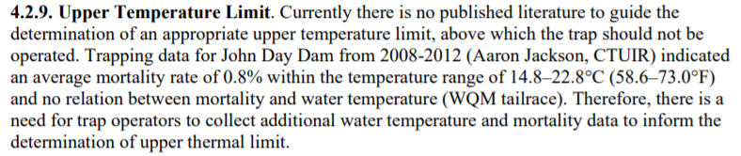

**Proposed Change**: *Edits to existing FPP text in “track changes”.*

1. BONNEVILLE DAM ADULT FISH FACILITY

1.4. Trapping Protocols – Ladder Water Temperatures >= 70°F.

**1.4.5.** At water temperatures of 70–72°F, sampling will be permitted as defined below for up to four days per week from 0600-1030 hours to allow for *U.S. v Oregon* requirements. This operation will remain in effect until daily average water temperature drops to ≤ 69.9°F. All samplings will cease when temperature reaches 72°F. No sampling may resume until daily average water temperature drops to ≤ 71.9°F. An exception is that lamprey trapping will be permitted above 72°F for tagging and transport purposes.

**Comments**:

1/27/22 FPOM FPP Meeting:

**Record of Final Action**: Approved as revised at the FPOM FPP meeting 1/27/22.