# Fish Passage Plan (FPP) Change Form

**Change Form # & Title**: 21BON003 – PH2 Mid-Range Criteria

**Date Submitted**: March 11, 2020

**Project**: Bonneville Dam

**Requester Name, Agency**: Scott Bettin, BPA

**Final Action: WITHDRAWN – April 20, 2021**

**FPP Section**: BON Section 4.2. “Turbine Operating Range”

**Justification for Change**: This change form proposes increasing the spill threshold before returning PH2 units to the mid-range. Last year, 180 kcfs was too low and it took us over 150 kcfs spill for a few days, which likely required us to do the rock removal contract.

Going back to the mid-range shifts approximately 24 kcfs from PH2 to the spillway (assuming all eight units available at ~3 kcfs/unit). Pushing that water through PH2 rather than the spillway at higher flows could reduce the chance for moving rocks into the spillway.

**Proposed Change**: See following pages for edits to existing FPP in “track changes”.

**Comments**:

April 8, 2021 FPOM: Bettin provided a graphic to illustrate the impact last year (~June 10th).

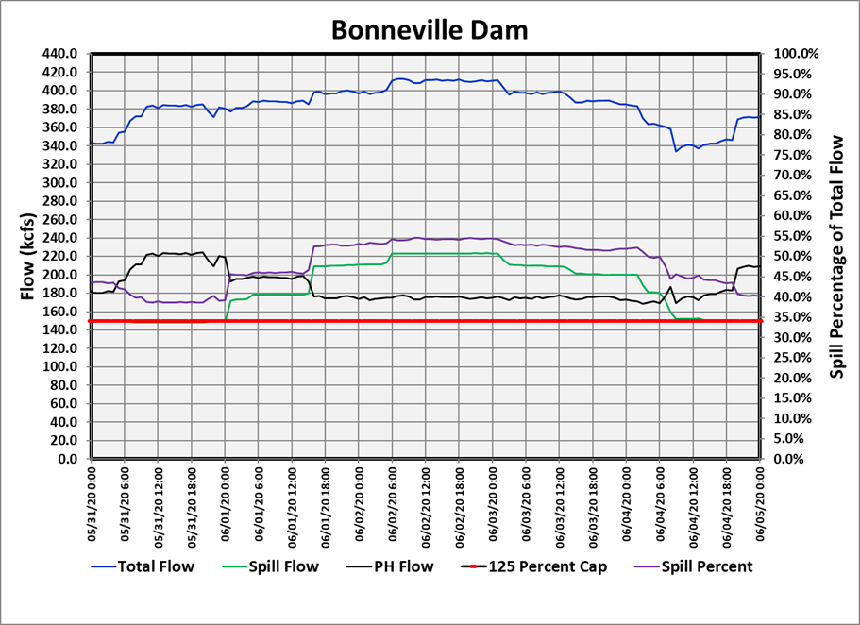

Conder was not in attendance and Bellerud requested waiting to hear from him.

Bettin noted this has been on the agenda for over a month and would like a response before the next FPOM.

Lorz will bring this to FPAC then provide a response by the end of next week (4/16).

April 19, 2021 – communication from Trevor Conder, NOAA: Conder might be ok with increasing the threshold to 200 kcfs, but any higher than that and we are pulling rocks into the spillway stilling basin as well as exposing fish to poor gatewell hydraulics at PH2.

April 20, 2021 – email from Trevor Conder, NOAA: After further consideration, NOAA doesn’t feel like there’s adequate biological justification for this change.

**Record of Final Action**: WITHDRAWN

4.2. Turbine Unit Operating Range

**4.2.2.2.** Until gatewell structural modifications are completed, PH2 units will be operated within the 1% mid-range (13–15 kcfs) from April 1 through July 31 to minimize turbulence for bypassed fish. *RCC will issue a teletype with any in-season modifications as construction and testing is completed*.

During this time, additional flow above project hydraulic capacity (PH2 in mid-range + PH1 at BOP + FOP spill + corner collector, ladders, etc.) will be passed in the following sequential order with increasing flow, or as otherwise determined by Project Fisheries based on observed conditions. This sequence of operations is also summarized in **Table BON-14**:

April 1–9 Pre-Spring Spill and June 16 – July 31 Summer Spill:

1. Increase PH2 units up to the 1% upper limit.
2. Then, increase spill.

April 10 – June 15 Spring Spill w/ Juvenile Trigger: when juvenile spring Chinook collection counts[1] exceed adult spring Chinook total passage counts[2] (excluding jacks) for at least three consecutive days, Project Fisheries will notify the control room to pass additional flow as follows:

1. Maintain PH2 units within mid-range and increase spill up to a maximum of 150 kcfs to avoid causing erosion in the spillway stilling basin. *This applies during Performance Standard spill and Gas Cap spill. DO NOT SHAPE TO ONLY APPLY TO HOURS OF GAS CAP SPILL*.
2. Then, increase PH2 units above the mid-range to the 1% upper limit in order from south to north (Unit 11 to Unit 18). *NOTIFY* *FPOM ASAP (no later than 3 workdays) and include in the Weekly Report*.
3. Then, increase spill above 150 kcfs, up to 210 kcfs.
4. Then, increase spill above 210 kcfs and resume operating PH2 units within the mid-range. *PH2 UNITS MAY ONLY BE OPERATED ABOVE THE MID-RANGE WHEN SPILL IS BETWEEN 150 KCFS AND 210 KCFS.*

April 10 – June 15 (Spring Spill) w/ Adult Trigger: when adult spring Chinook total passage counts5 (excluding jacks) exceed juvenile spring Chinook collection counts4 for two consecutive days, Project Fisheries will notify the control room to pass additional flow as follows:

1. Increase PH2 units up to the 1% upper limit in order from north to south (Unit 18 to Unit 11).
2. Then, increase spill.

Table BON-. Sequential Steps to Pass Increasing Levels of Flow, per Modified PH2 Operating Range Guidelines in section 4.2.2.2.

|  |  |
| --- | --- |
| **April 1 – 9** | 1. PH2 in mid-range and PH1 up to BOP. |
| **Pre-FOP Spill** | 1. Then, increase PH2 > mid-range up to 1% upper limit. |
|  | 1. Then, spill (start with B2CC if not already open). |
| **April 10 – June 15** | **JUVENILE TRIGGER** |
| **FOP Spring Spill** | 1. FOP Spring Spill, PH2 in mid-range, and PH1 up to BOP. |
|  | 1. Then, increase spill > FOP up to 150 kcfs. *This applies during all hours. DO NOT SHAPE TO ONLY APPLY TO HOURS OF GAS CAP SPILL.* |
|  | 1. Then, increase PH2 > mid-range up to 1% upper limit (south to north) and *NOTIFY FPOM as soon as possible.* |
|  | 1. Then, increase spill > 150 kcfs up to 210 kcfs. |
|  | 1. Then, increase spill > 210 kcfs and resume PH2 in mid-range. |
|  |  |
|  | **ADULT TRIGGER** |
|  | 1. FOP Spring Spill, PH2 in mid-range, and PH1 up to BOP. |
|  | 1. Then, increase PH2 > mid-range up to 1% upper limit (north to south). |
|  | 1. Then, increase spill > FOP. |
| **June 16 – July 31** | 1. FOP Summer Spill, PH2 in mid-range, and PH1 up to BOP. |
| **FOP Summer Spill** | 1. Then, increase PH2 > mid-range up to 1% upper limit. |
|  | 1. Then, increase spill > FOP. |
| **August 1 – 31\***  **FOP Summer Spill** | 1. FOP Summer Spill, PH2 in full 1% (*see footnote), and PH1 up to BOP. 2. Then, increase spill > FOP. |

*Starting August 1, PH2 units may be operated within the full 1% range for flexibility during low flows. During this period, PH2 units will typically be maintained within the mid-range but may be adjusted through the full 1% range as necessary to avoid dead-bands during low flows. PH2 operations above the mid-range will be infrequent, consistent with previous years.

1. **Juvenile Spring Chinook** reported as “*CollCount*” in the SMP Smolt Data. Query current year, “*BO2*”, “*Combined Chinook Yearling*”: <https://www.fpc.org/smolt/smpsubmitdataquery_2014v7.html>
2. **Adult Spring Chinook** reported as “*Spring Chinook Adult*” for Bonneville Dam: <https://www.fpc.org/currentdaily/HistFishTwo_7day-ytd_Adults.htm>