Fish Passage Plan (FPP) Change Request Form
Change Form # & Title: 21BON001 – Update Temperature Monitor Locations
Date Submitted: 2 February 2021
Project: Bonneville Dam
Requester Name, Agency: Andrew Derugin, COE BON
Final Action:
FPP Section:
Figures BON-1 through BON-5
Justification for Change:
Updates the location of the temperature monitors for 2021.
Proposed Change:
See updated figures below with updated temperature monitor locations noted by a gold star.
Comments:

Record of Final Action:

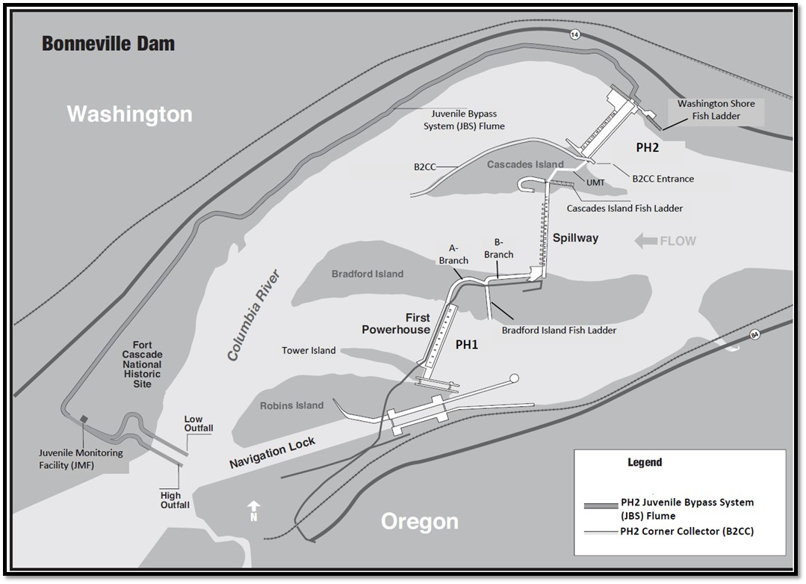
Ladder Temperature Monitors

Figure BON-1. Bonneville Dam Overview, including Powerhouse 1 (PH1), Powerhouse 2 (PH2), Spillway, Adult Fish Ladders, PH2 Juvenile Bypass System (JBS), Corner Collector (B2CC), Juvenile Monitoring Facility (JMF) and JBS Outfall.
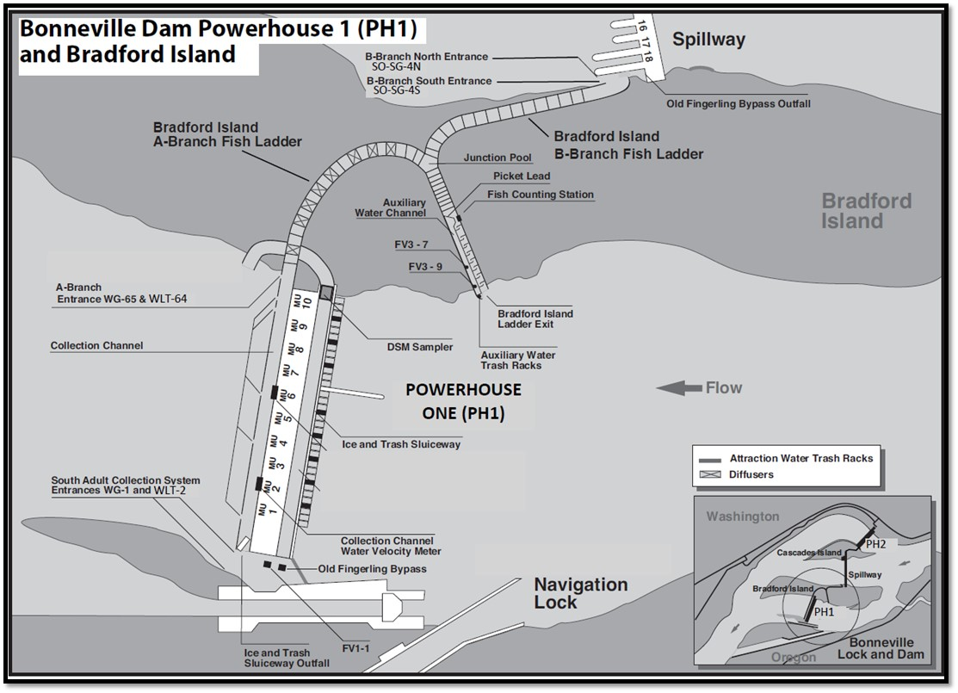
South Adult Collection System
Entrances WG-1 and WG-2
A-Branch
Entrances WG-65 and WG-64

Ladder Temperature Monitors (4)

Figure BON-2. Bonneville Dam Powerhouse 1 (PH1) and Bradford Island Adult Fish Ladder A-Branch and B-Branch.
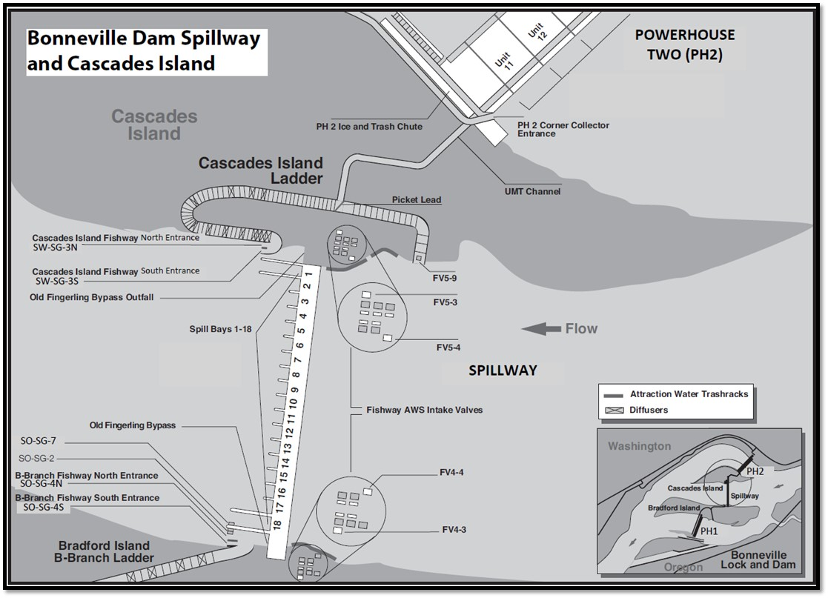
Ladder Temperature Monitors (3)

Figure BON-3. Bonneville Dam Spillway, Cascades Island Fish Ladder and Upstream Migrant Transportation (UMT) Channel.
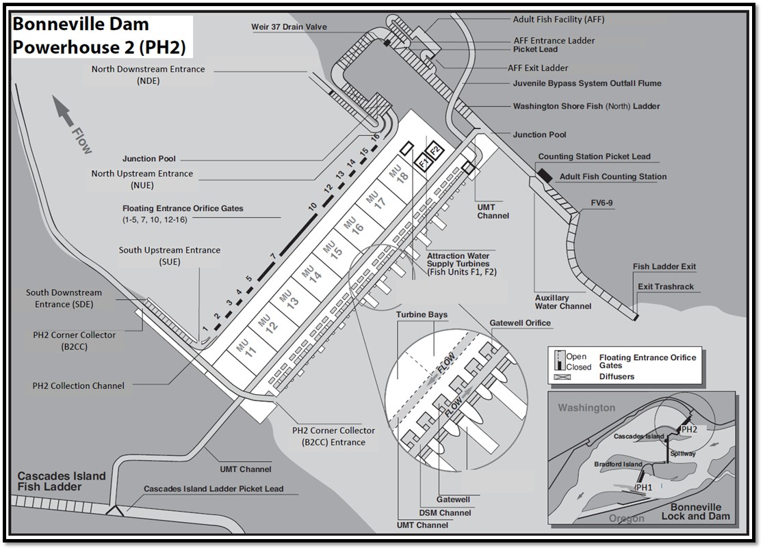
Ladder Temperature Monitors (5)

Figure BON-4. Bonneville Dam Powerhouse 2 (PH2) and Washington Shore (WS) North Fish Ladder.
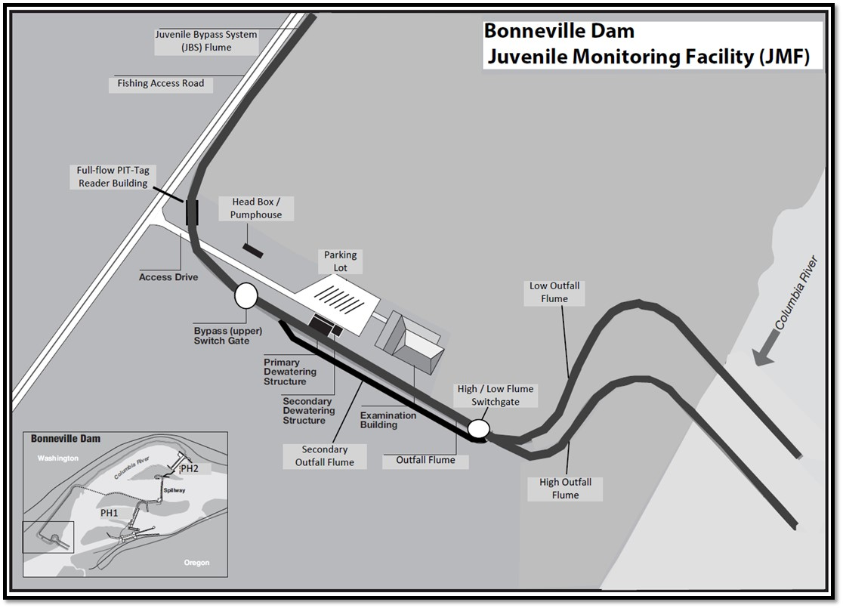
Ladder Temperature Monitors (1)

Figure BON-5. Bonneville Dam Juvenile (Smolt) Monitoring Facility (JMF) and Outfall Flumes.

