2018 Fish Passage Plan
Chapter 1 – Overview
Table of Contents
1. IntroductioN 5
1.1. Fish Passage Plan (FPP) 5
1.2. ESA Consultations (Biological Opinions) 5
1.3. Deviations from FPP Criteria 6
1.4. Spill for Juvenile Fish Passage 7
1.5. Total Dissolved Gas (TDG) Monitoring 7
1.6. System Load Shaping 8
1.7. Juvenile Fish Transportation Plan (JFTP) 8
1.8. Turbine Dewatering Fish Protection Protocols at Chief Joseph & Dworshak Dams 8
1.9. Lamprey Passage 8
2. Fish Passage Facilities – Inspection & Reporting Criteria 8
2.2. Annual Reporting 9
2.3. Reporting of Excursions Not Covered by Appendix C 9
3. FPP Implementation & Coordination 9
3.1. FPP Implementation 9
3.2. Agency Responsibilities 10
3.3. FPOM Coordination 11
3.4. TMT Coordination 14
3.5. Day-to-Day Coordination of FCRPS 14

Figure OVE-1. Map of the Federal Columbia River Power System (FCRPS).
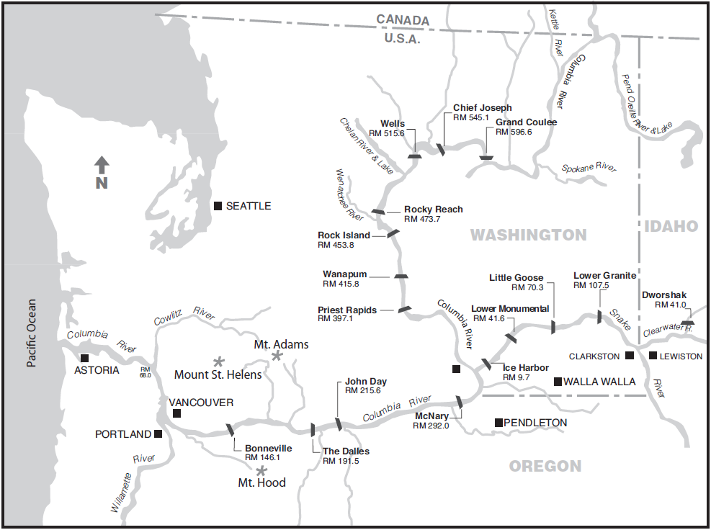
Table OVE-1. Project Information and Operating Criteria for FCRPS Projects on the Lower Columbia and Lower Snake Rivers. ª
Lower Columbia River
PROJECT | Bonneville | The Dalles | John Day | McNary
Project Acronym ^{b} | BON | TDA | JDA | MCN
River Mile (RM) | Columbia River – RM 146.1 | Columbia River – RM 191.5 | Columbia River – RM 215.6 | Columbia River – RM 292
Reservoir | Lake Bonneville | Lake Celilo | Lake Umatilla | Lake Wallula
Minimum Instantaneous Flow (kcfs) | 80 kcfs | Dec–Feb: 12.5 kcfs  Mar–Nov: 50 kcfs | Dec–Feb: 12.5 kcfs  Mar–Nov: 50 kcfs | Dec–Feb: 12.5 kcfs  Mar–Nov: 50 kcfs
Forebay Normal Operating Range (ft) | 71.5’ – 76.5’ | 155.0’ – 160.0’ | Nov–Jun: 260 – 265’  Jul–Oct: 265 – 268’ | 337’ – 340’
Tailrace Rate of Change Limit (ft) | Apr–Sep: 1.5’/hr, 4’/day  Oct–Mar: 3’/hr, 7’/day | 3’/hr | 3’/hr | 1.5’/hr
POWERHOUSE
Powerhouse Length (ft) | PH1: 1,027’  PH2: 986’ | 2,089’ | 1,975’ | 1,422’
Turbine Units (#) | PH1: 10  PH2: 8 + 2 Fish Units | 22 + 2 Fish Units | 16 | 14
Turbine Generating Capacity (MW) | PH1: 535 MW  PH2: 558 MW | 1,808 MW | 2,160 MW | 980 MW
Powerhouse Hydraulic Capacity (kcfs) | PH1: 136 kcfs  PH2: 152 kcfs | 375 kcfs | 322 kcfs | 232 kcfs
SPILLWAY
Spillway Length (ft) | 1,450’ | 1,447’ | 1,228’ | 1,310’
Spillbays (#) | 18 | 23 | 20 | 22
Spillway Weirs (#) | 0 | 0 | 2 (Bays 18-19) | 2 (Bays 19-20)
Spillway Hydraulic Capacity (kcfs) | 1,600 kcfs | 2,290 kcfs | 2,250 kcfs | 2,200 kcfs
NAVIGATION LOCK
Nav. Lock Length x Width (ft) | 675’ x 86’ | 650’ x 86’ | 650’ x 86’ | 683’ x 86’
Nav. Lock Maximum Lift (ft) | 70’ | 90’ | 113’ | 75’
Lower Snake River
PROJECT | Ice Harbor | Lower Monumental | Little Goose | Lower Granite
Project Acronym ^{b} | IHR | LMN | LGS | LWG
River Mile (RM) | Snake River – RM 9.7 | Snake River – RM 41.6 | Snake River – RM 70.3 | Snake River – RM 107.5
Reservoir | Lake Sacajawea | Lake Herbert G. West | Lake Bryan | Lake Lower Granite
Minimum Instantaneous Flow (kcfs) | Dec–Feb: 0 kcfs  Mar–Jul: 9.5 kcfs / Aug–Nov: 7.5 kcfs | Dec–Feb: 0 kcfs  Mar–Nov: 11.5 kcfs | Dec–Feb: 0 kcfs  Mar–Nov: 11.5 kcfs | Dec–Feb: 0 kcfs  Mar–Nov: 11.5 kcfs
Forebay Normal Operating Range (ft) | 437’ – 440’ | 537’ – 540’ | 633’ – 638’ | 733’ – 738’
Tailrace Rate of Change Limit (ft) | 1.5’/hr | 1.5’/hr | 1.5’/hr | 1.5’/hr
POWERHOUSE
Powerhouse Length (ft) | 671’ | 656’ | 656’ | 656’
Turbine Units (#) | 6 | 6 | 6 | 6
Turbine Generating Capacity (MW) | 603 MW | 810 MW | 810 MW | 810 MW
Powerhouse Hydraulic Capacity (kcfs) | 106 kcfs | 130 kcfs | 130 kcfs | 130 kcfs
SPILLWAY
Spillway Length (ft) | 590’ | 498’ | 512’ | 512’
Spillbays (#) | 10 | 8 | 8 | 8
Spillway Weirs (#) | 1 (Bay 2) | 1 (Bay 8) | 1 (Bay 1) | 1 (Bay 1)
Spillway Hydraulic Capacity (kcfs) | 850 kcfs | 850 kcfs | 850 kcfs | 850 kcfs
NAVIGATION LOCK
Nav. Lock Length x Width (ft) | 675’ x 86’ | 666’ x 86’ | 668’ x 86’ | 674’ x 86’
Nav. Lock Maximum Lift (ft) | 100’ | 100’ | 101’ | 105’
a. Project operating limits and constraints are based on physical plant limitations, legal limits of authorized purposes, and/or to maximize efficiency and benefit of FCRPS reservoir operations. Flexibility of these limits is pursuant to general provisions of the applicable law and any other agreements or contracts. More information is available in the project-specific FPP Chapters 2-9, or on the Corps District websites: www.nwp.usace.army.mil/Locations/ColumbiaRiver.aspx (BON, TDA, JDA); www.nww.usace.army.mil/Locations.aspx (MCN, IHR, LMN, LGS, LWG).
b. Project acronym designated by U.S. Army Corps of Engineers Northwestern Division (NWD), Columbia Basin Water Management. Due to the large number of hydropower projects managed by NWD, this acronym may differ from other common regional acronyms. For example, Lower Granite Dam is commonly abbreviated LGR; however, this acronym is assigned to another NWD project, so the official Corps NWD acronym is LWG.
- IntroductioN
  - Fish Passage Plan (FPP)
    - The annual Fish Passage Plan (FPP) is developed by the U.S. Army Corps of Engineers (Corps) in coordination with the Bonneville Power Administration (BPA), regional Federal, State, and Tribal fish agencies, and other partners through the Fish Passage Operations & Maintenance (FPOM) workgroup.
    - The FPP describes year-round (March-February) operations and maintenance (O&M) actions to provide fish passage and protection at the eight Corps projects on the lower Columbia and lower Snake rivers (Figure OVE-1; Table OVE-1). The FPP includes appendices for fish protection procedures during turbine maintenance at Chief Joseph Dam on the upper Columbia River and at Dworshak Dam on the North Fork Clearwater River. Other Corps documents and agreements related to fish passage at these projects are consistent with the FPP.
    - The FPP will be revised as necessary to incorporate changes due to new facilities or modified operational procedures. Revisions will be coordinated with the region as described below in section 3.3 and with NOAA Fisheries and USFWS as part of ESA Section 7 consultation, Recovery Plan, or Incidental Take permit processes, and through consideration of other regional input and plans. When revising the FPP, the Corps also considers the Northwest Power and Conservation Council’s Columbia River Basin Fish & Wildlife Program to the fullest extent practicable.
    - Comments on the FPP are welcome and may be sent to FPOM and/or the Corps’ Northwestern Division, Reservoir Control Center (RCC) Fisheries Section, in Portland, Oregon.
  - ESA Consultations (Biological Opinions)
    - NOAA Fisheries issued a Biological Opinion (BiOp) in May 2008 on the effects of operating the Federal Columbia River Power System (FCRPS) on ESA-listed anadromous fish species. The BiOp included a Reasonable & Prudent Alternative (RPA) table of recommended actions and strategies to avoid jeopardizing ESA-listed fish species. The 2008 BiOp was supplemented in 2010 with new information and an Adaptive Management Integration Plan (AMIP), and again in 2014 with a review of new and updated scientific reports, data, and analyses, additional project definitions, and amended RPA actions.
    - The FPP is developed pursuant to RPA 32 (Figure OVE-2) as part of the hydropower strategy to operate and maintain fish passage facilities for biological performance.
Figure OVE- 2. Fish Passage Plan (FPP), as defined in RPA Action 32 of the 2008 NOAA Fisheries FCRPS Biological Opinion (BiOp) and modified in the 2014 Supplemental BiOp.
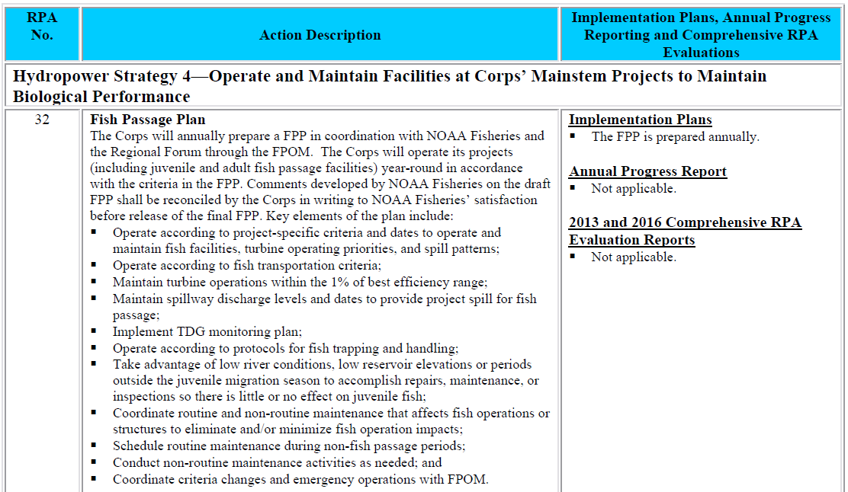

  - Deviations from FPP Criteria
    - The phrase "when practicable" is used in the FPP to describe Project actions for fish that may vary on a case-by-case basis and thus require the exercise of professional judgment by Project staff. These situations may be due to real-time biological and/or other environmental conditions, availability of Project staff and/or equipment, or integrity of fish facility or other dam structures. In these cases, the Project biologist and other Project personnel will consider all relevant factors to determine the best way to proceed and implement appropriate action. These actions will be coordinated with fish agencies and tribes when they deviate from the FPP.
    - River operational emergencies may occur that require projects to temporarily deviate from the FPP. To the extent practicable, these operations will be coordinated with fish agencies and tribes, and conducted in a manner to avoid or minimize fish impacts. Normally, coordination occurs prior to an action; however, if an emergency situation requires immediate attention, coordination will be completed as soon as practicable afterwards, as described in section 3.
    - In-season decisions on river operations to achieve BiOp biological performance standards for spring and summer out-migrants will be made in coordination with the regional forum Technical Management Team (TMT). Special operations identified in the FPP will be coordinated through TMT and included in the annual Water Management Plan (WMP) , such as maintenance or research activities requiring unit outages that affect other river operations, operation of turbines outside of the ±1% of peak efficiency range, Snake River zero nighttime generation, and implementation of the Juvenile Fish Transportation Plan (Appendix B).
  - Spill for Juvenile Fish Passage
    - Planned yearly spring and summer spill operations for juvenile fish passage at the eight lower Snake and lower Columbia River projects are defined in the Fish Operations Plan (FOP), included in the FPP as Appendix E. Spill operations to improve juvenile fish passage are defined in the 2014 NOAA Fisheries Supplemental FCRPS BiOp RPA Action 29 and Table 2.
    - During spring and summer spill for fish passage, spill at each project will be distributed across the spillway as defined in patterns in the project-specific FPP Chapters 2-9, unless otherwise coordinated with FPOM or TMT. If spill occurs outside of spring and summer spill season, projects will typically use the FPP patterns but may modify patterns as necessary to accommodate maintenance, research, navigation, or other constraints.
  - Total Dissolved Gas (TDG) Monitoring
    - The Federal Clean Water Act establishes a total dissolved gas (TDG) aquatic life standard of 110% that has been adopted by the states of Washington, Oregon, Idaho, and Montana, and regional tribes.
    - During spill operations for fish passage, the states of Oregon and Washington have authorized exceptions (standard modification and criteria adjustment, respectively) for the four lower Snake River and four lower Columbia River projects of 120% in the project tailrace (OR and WA) and 115% in the next downstream forebay (WA). The Oregon standard modification applies to spill for fish passage April 1–August 31. The Washington criteria adjustment applies to spill for fish passage year-round. As such, the Corps monitors TDG levels at fixed monitoring stations in the forebay and tailrace of each project to ensure that spill for fish passage is consistent with all applicable State and Tribal standards. For more information, see the FOP (Appendix E).
    - The Corps’ annual TDG Management Plan (included as Appendix 4 to the WMP³) provides the most current information on State water quality standards and includes definitions of spill types (e.g., fish passage, lack of turbine), the process for coordinating and implementing a spill priority list to manage system-wide TDG, the process for setting spill caps, and TDG management policies and monitoring programs. The Corps will coordinate with TMT to develop the spill priority list and to provide ongoing TDG information and reports as necessary.
  - System Load Shaping
    - To avoid or minimize impacts of hydropower operations on fish, BPA coordinated the System Load Shaping Guidelines Regarding Turbine Operation & Peak Efficiency, included in the FPP as Appendix C. The Guidelines define how BPA requests load April 1–October 31 so that the Corps can operate turbine units at fish passage projects within ±1% of peak efficiency (1% range), or as otherwise coordinated through FPOM and/or TMT to enhance fish passage (e.g., Bonneville Dam PH2 mid-range operations).
  - Juvenile Fish Transportation Plan (JFTP)
    - Juvenile fish will be transported in accordance with the FOP, FPP, and ESA Section 10 permit. Protocols and criteria for collection, holding, and transport of juvenile fish are defined in the Juvenile Fish Transportation Plan (JFTP), included in the FPP as Appendix B. Other operating criteria for juvenile fish bypass facilities are contained in the project-specific FPP Chapters 2–9. Additional criteria may be developed as part of the ESA Section 10 permit process and/or in coordination with the TMT. Implementation of the JFTP, including deviation from the plan described in Appendix B, will be coordinated through TMT and NOAA Fisheries.
  - Turbine Dewatering Fish Protection Protocols at Chief Joseph & Dworshak Dams
    - The Corps has coordinated and adopted fish protection procedures during turbine dewatering for maintenance at Chief Joseph (Appendix H) and Dworshak (Appendix I). While these projects do not have fish passage capabilities, ESA-listed salmon and steelhead are present in the tailrace and may become trapped in the turbine unit draft tube during dewatering. The procedures and criteria defined in the Appendices provide fish-protection measures to avoid or minimize impacts on ESA-listed salmonids during turbine dewaterings at these projects.
  - Lamprey Passage
    - The Fish Accords were signed in May 2008 and include actions to protect Pacific lamprey and improve juvenile and adult lamprey passage through the FCRPS. Project operations to improve passage for adult and juvenile lamprey are addressed in FPOM; specific operations for juvenile and adult lamprey are defined in Appendix D and in the appropriate project-specific FPP Chapters 2-9. In-season conflicts between operations for ESA-listed species and Pacific lamprey that are not addressed in the FPP may be reviewed by FPOM and/or TMT.
- Fish Passage Facilities – Inspection & Reporting Criteria
    - The project-specific FPP Chapters 2–9 include detailed inspection and reporting criteria for fish passage facilities at Corps projects. An example of a typical fish passage system is illustrated in Figure OVE-3. The Corps provides weekly written inspection reports to NOAA Fisheries Hydropower Program in Portland, Oregon, describing out-of-criteria situations, adjustments made to resolve problems, and a detailed account of impacts on project fish passage and survival. The weekly inspection reports also include summaries of equipment calibrations and monitoring of water temperature and adult fish collection channel velocity. Equipment that does not require calibration will not be routinely included in the weekly report. The Corps also provides an annual report to NOAA Fisheries summarizing project O&M, fish passage facility inspections and monitoring, severity of out-of-criteria conditions, and avian predation abatement actions. In addition, the Corps is developing methods to report hourly individual spillbay and turbine unit operations at mainstem projects as called for in the UPA. An acceptable procedure will be coordinated with NOAA Fisheries and other FPOM participants.
  - Annual Reporting
    - Excursions outside of ±1% peak turbine efficiency range are tracked by BPA for each project during the fish passage season. The Corps determines the cause of each excursion and compiles this information approximately bi-weekly. After the fish passage season, the Corps submits an annual report to NOAA Fisheries that describes instances where turbines at lower Columbia and lower Snake River projects operated outside of ±1% peak efficiency range for significant periods, as defined under the guidelines in Appendix C. The intent of excursion reporting is to provide a means for quality assurance for project operations.
  - Reporting of Excursions Not Covered by Appendix C
    - The Corps and BPA will take all reasonable and practicable steps to provide advance notification through the existing interagency coordinating mechanisms prior to departure from the fish-protection measures set out in the 2008 BiOp. If unforeseen circumstances arise that preclude BPA or the Corps from notifying the TMT prior to a variation from required 1% operating criteria and those circumstances are not covered by Appendix C, those variations will be reported to the TMT as soon as practicable.
- FPP Implementation & Coordination
  - FPP Implementation
    - FPP implementation requires information exchange and coordination with NOAA Fisheries, BPA, other Federal and state fish agencies, and tribes. The Corps RCC coordinates through TMT for Corps operations that have system-wide effects, such as water management, spill volume, and unit availability. Corps District biologists coordinate through FPOM on spill patterns, unit priority, adult and juvenile fish facilities, and other project-specific operations that do not have system-wide impacts.
    - The Corps RCC participates in TMT meetings throughout the year to consider recommendations for river operations to implement the FOP, BiOps, and other recommendations from fish interests. As part of this process, TMT may evaluate research data and advice on whether existing operations are consistent with current study results. These meetings are held in the Corps’ Northwestern Division office in Portland, Oregon, and are open to the public. Corps representatives are available at these meetings to discuss the latest weather and runoff forecasts, as well as fish, hydrologic, water quality, and power generation information to assist in planning upcoming operations for fish passage. The Corps evaluates fish operation recommendations to determine impact on overall system operations. See section below regarding TMT coordination.
    - Corps District and RCC biologists attend monthly FPOM meetings dealing with project-specific issues below (see section 3.3. FPOM Coordination):
            - Consider recommendations from affected interests;
            - Provide updates on construction, O&M, research, and other topics;
            - Develop criteria for the annual FPP;
            - Coordinate fish passage issues that may require deviation from FPP criteria.
  - Agency Responsibilities
    - U.S. Army Corps of Engineers
            - Coordinate with NOAA Fisheries and USFWS on operations that may impact ESA-listed threatened, endangered, or candidate species;
            - Prepare annual Water Management Plan and seasonal updates in coordination with TMT.
            - In cooperation with fish agencies and tribes, provide fish passage monitoring, surveillance, and reporting at Corps projects throughout the migration period;
            - Provide timely information on all proposed and/or scheduled studies or special operations that may negatively impact or otherwise constrain fish passage or energy production. Discuss unforeseen changes in fish passage operations with fish agencies and tribes;
            - Carry out routine and emergency fish passage operations and maintenance procedures in accordance with criteria in FPP Chapters 2-9 and Appendix A;
            - Conduct the TDG Monitoring Program.
    - Federal, State and Tribal Fishery Agencies
            - Request spill for fish through TMT to protect ESA-listed species or other species in accordance with the TMT Guidelines;
            - Via TMT, provide RCC with a spill priority list and recommended modifications;
            - Provide biological monitoring and surveillance reports throughout the migration period from predetermined locations, such as Smolt Monitoring Program sample sites;
            - Provide status reports on the timing of the downstream migration, including pertinent marked fish release and recovery data, with weekly written reports estimating percentage of runs past key projects;
            - Where biologically and logistically feasible, coordinate hatchery releases to ensure they are protected by regulated fish flows and spill while minimizing impacts on ESA-listed species. Provide updated hatchery release schedules weekly;
            - Provide recommendations to the operating agencies for maintaining acceptable fish passage conditions. This information can be used to maximize other project uses, including power generation;
            - Provide information on all proposed and scheduled studies or special operations designed to improve fish passage operations that may affect energy production or project operation. Discuss unforeseen changes with the Corps;
            - Recommend viable methods and procedures to reduce migratory and resident fish mortality (e.g., collection and transport of migrants, use of alternate bypass strategies, or other methods to minimize fish mortality).
    - Bonneville Power Administration
            - Report to RCC on updated load-resource studies during the April-to-September period to supplement the National Weather Service River Forecast Center's runoff volume forecast for fish passage planning assistance.
            - Provide to RCC, NOAA Fisheries, other fish agencies, and tribes, the BPA estimate of power market impacts of requested spill operations.
            - Utilize available flexibility of the Federal Columbia River Power System to shape flow requirements, spill priorities, and plant generation consistent with BPA policies and statutory requirements related to fish protection.
            - Adjust system generation to provide adequate water for fish operation requirements in accordance with the FOP and relevant FCRPS BiOps.
            - Provide project load requests on a real-time/hourly basis that enable the Corps to implement spill priorities.
            - Provide information on unit operations outside ±1% peak efficiency, as defined in Appendix C.
    - Mid-Columbia Public Utility Districts
            - Operate projects for spill transfer in accordance with provisions of the FPP with at least 1.5 hours notification to start or stop spill.
  - FPOM Coordination
    - Pursuant to RPA Action 32 (Figure OVE-2), project O&M activities in the annual FPP are regionally coordinated through FPOM, which includes representatives from the Corps, BPA, NOAA Fisheries, USFWS, state fish agencies (OR, WA, ID), tribes, and other interested parties. The printed FPP is published annually on or about March 1 and is effective year-round, though revisions may be approved through FPOM at any time. Proposed revisions are presented to the relevant project’s District Operations biologist for consideration by the Corps in an FPP “Change Form” that includes a description and justification for the change. The Corps will submit Change Forms to FPOM for a minimum of two weeks to review and provide feedback to the Corps POC. Approved Change Forms will be finalized with comments received and a record of final action, then amended to the current year’s online FPP (if finalized after mid-February) or published in the next printed FPP (if finalized before mid-February). The Corps will provide FPP changes to TMT as necessary for use as part of the overall river operation plan. Sections dealing with special operational requirements will also be included in the annual Water Management Plan.
    - Project activities under the purview of FPOM that may require deviations from FPP criteria will be fully coordinated in a timely manner. All coordination procedures below shall be followed.
    - Memorandum of Coordination (MOC). For O&M activities within the District’s Operations Division, project personnel will compile relevant information into a Memorandum of Coordination (MOC) that includes a summary of the activity, location, date, time, analyses of potential impacts to ESA-listed species, and potential alternative actions (see MOC template at the end of this Chapter) and forward to the District Biologist (or other appropriate personnel) for routing to FPOM. The District biologist will submit the MOC to FPOM at the next monthly meeting and/or via email, and if necessary, follow up with appropriate FPOM members via phone or email.
      - For each proposed action requiring an MOC, the analysis of potential impacts will include the following (see MOC template at end of this Chapter for links to data):
            - 10-year average passage of adults and juveniles of each affected listed species during dates of impact.
            - Statement about the current year’s run compared to the 10-year average.
            - Estimated exposure to impact of adults and/or juveniles, as appropriate, by species (number or percent of 10-year average that occurs during dates of impact).
            - Type of impact to adults and/or juveniles, as appropriate, by species (e.g., increased delay, exposure to predation, exposure to a route of higher injury/mortality rate, exposure to higher TDG, etc.).
            - Final judgement on scale of potential impact (negligible, minor, significant) on adult and juvenile salmonids (including bull trout) and lamprey (e.g. “As a result of this analysis, we anticipate that the proposed action will result in negligible impact to listed species.”).
      - For planned O&M, the MOC should be provided to FPOM for review at least two weeks in advance.
      - For unplanned, non-emergency O&M (e.g., equipment failure), the MOC should be provided to FPOM at least three workdays in advance.
      - Emergency O&M may be performed immediately and an MOC submitted to FPOM as soon as possible, either before or after the activity (see section 1.3).
      - FPOM members may submit responses to MOCs by the requested due date via email, phone, or in person; all responses will be documented in the final MOC and distributed to FPOM and posted to the FPOM website. The District biologist will forward the final coordinated operation to project personnel, and if necessary, RCC will issue a teletype.
      - For research and construction activities involving the Planning Division, the Planning Division biologists will coordinate the effort with Operations Division biologists to develop an MOC. Research development is largely carried out and documented through the Corps’ Anadromous Fish Evaluation Program (AFEP) in the regional forum Studies Review Work Group (SRWG). New construction or modification of fish facilities is typically carried out and documented through the Fish Facility Design Review Work Group (FFDRWG).
      - If implementation requires assistance from Project staff, temporary equipment installation or facility modification, and/or operational changes, then both Planning and Operations biologists will work closely with Project personnel and any others necessary to ensure all personnel are continually informed and updated throughout the process.
    - Memorandum for the Record (MFR). Incidents that result in adverse or negative impacts to fish or fishways shall be documented by Project biologists in a Memorandum for the Record (MFR; see template at end of this Chapter). The MFR will be sent to FPOM by the next working day and added to the next FPOM meeting agenda for review. FPOM members may submit responses to an MFR by the requested due date via email, phone or in person, and all responses will be documented in the final MFR for posting to the FPOM website.
    - FPOM Representatives & Participants (*Chair, **Co-chair):
        - Corps Portland District, Operations – Tammy Mackey**
        - Corps Portland District, Planning, Programs & Project Mgmt – Brad Eppard
        - Corps Walla Walla District, Operations – Ann Setter*, Chris Peery, Eric Hockersmith
        - Corps Walla Walla District, Planning, Programs & Project Mgmt – Marvin Shutters
        - Corps Northwestern Division, Reservoir Control Center – Doug Baus, Lisa Wright
        - Bonneville Power Administration (BPA) – Scott Bettin, Christine Peterson
        - NOAA Fisheries – Trevor Conder, Blane Bellerud, Ed Meyer
        - US Fish & Wildlife Service (USFWS) – David Swank
        - Columbia River Inter-Tribal Fish Commission (CRITFC) – Tom Lorz
        - Colville Confederated Tribes (CCT) – Sheri Sears
        - Nez Perce Tribe – Dave Statler
        - Confederated Tribes of Warm Springs – Jennifer Graham
        - Yakama Nation – Tom Iverson
        - Oregon Dept. of Fish & Wildlife (ODFW) – Erick Van Dyke
        - Washington Dept. of Fish & Wildlife (WDFW) – Charles Morrill
        - Idaho Dept. of Fish & Game (IDFG) – Russ Kiefer
        - Fish Passage Center (FPC) – Dave Benner
  - TMT Coordination
    - Actions that may impact fish system-wide will be coordinated and documented through TMT. Actions that may impact fish at a specific project which are a result of actual operations, implementation of FOP/BiOp actions, incidental take, terms and conditions contained in the BiOps, or research projects will be coordinated through the process outlined below. TMT Guidelines are posted as an Appendix to the annual Water Management Plan.
  - Day-to-Day Coordination of FCRPS
    - Procedures described in the annual Water Management Plan will be used for fish operations. Coordination of system and project operations for flow augmentation and recommended reservoir operations will occur through TMT. This will include operation of turbine units outside of the ±1% peak efficiency range, zero nighttime flow in the Snake River, reservoir operation at minimum operating pool (MOP) or some other specific elevation, and special operations for implementation of approved research projects (see Appendix A – Special Project Operations & Studies). When reservoirs are not being operated to provide special protection for fish passage, projects may be operated within the full normal operating range.
    - Fish Spill Management. The Corps will implement fish spill provisions as described in the FOP (Appendix E), including special TDG conditions for juvenile fish passage. During spill for fish passage season, TDG levels will be monitored and fish will be evaluated for signs of gas bubble trauma by the Corps, NOAA Fisheries, other fish agencies, Tribes, and/or State water quality agencies. Project spill levels will be adjusted as needed based on daily physical and biological monitoring results, and coordinated with TMT and other relevant agencies and tribes.
    - Special Operations. Recommendations for special fish operations outside the Water Management Plan may be made to RCC and coordinated through TMT. Recommendations related to project O&M activities requiring special operations will be evaluated for fish impacts. Sufficient lead time will be allowed for a planned operation, whenever practical, to allow ESA coordination with TMT, NOAA Fisheries, and USFWS. Preferably, as much lead time as possible will be provided for activities requiring immediate action. After-action coordination will occur when advance notice is not possible, such as in emergency actions. All other special operations will be evaluated for fish impacts and effects on other project O&M requirements, and coordination with NOAA Fisheries, USFWS, fish agencies, and tribes, through TMT. Except as necessary for emergency actions, adequate time will be allowed for evaluation of all project and fish impacts prior to implementation. Coordination of emergencies will occur as identified in the Emergency Protocols adopted by TMT (Water Management Plan, Appendix 2).
    - Non-Corps Activities. All non-Corps personnel intending to conduct activity at a Corps facility (e.g., fish handling; minor facility modifications) must have prior written approval from the Corps. This approval must be requested in writing to the Chief, Operations Division, at the appropriate Corps District office. If the activity may affect ESA-listed fish, proof of consultation with NOAA Fisheries or USFWS (Section 10 permit) must be provided. Appropriate State permits must be provided as well for activities that may impact ESA-listed or non-listed fish.

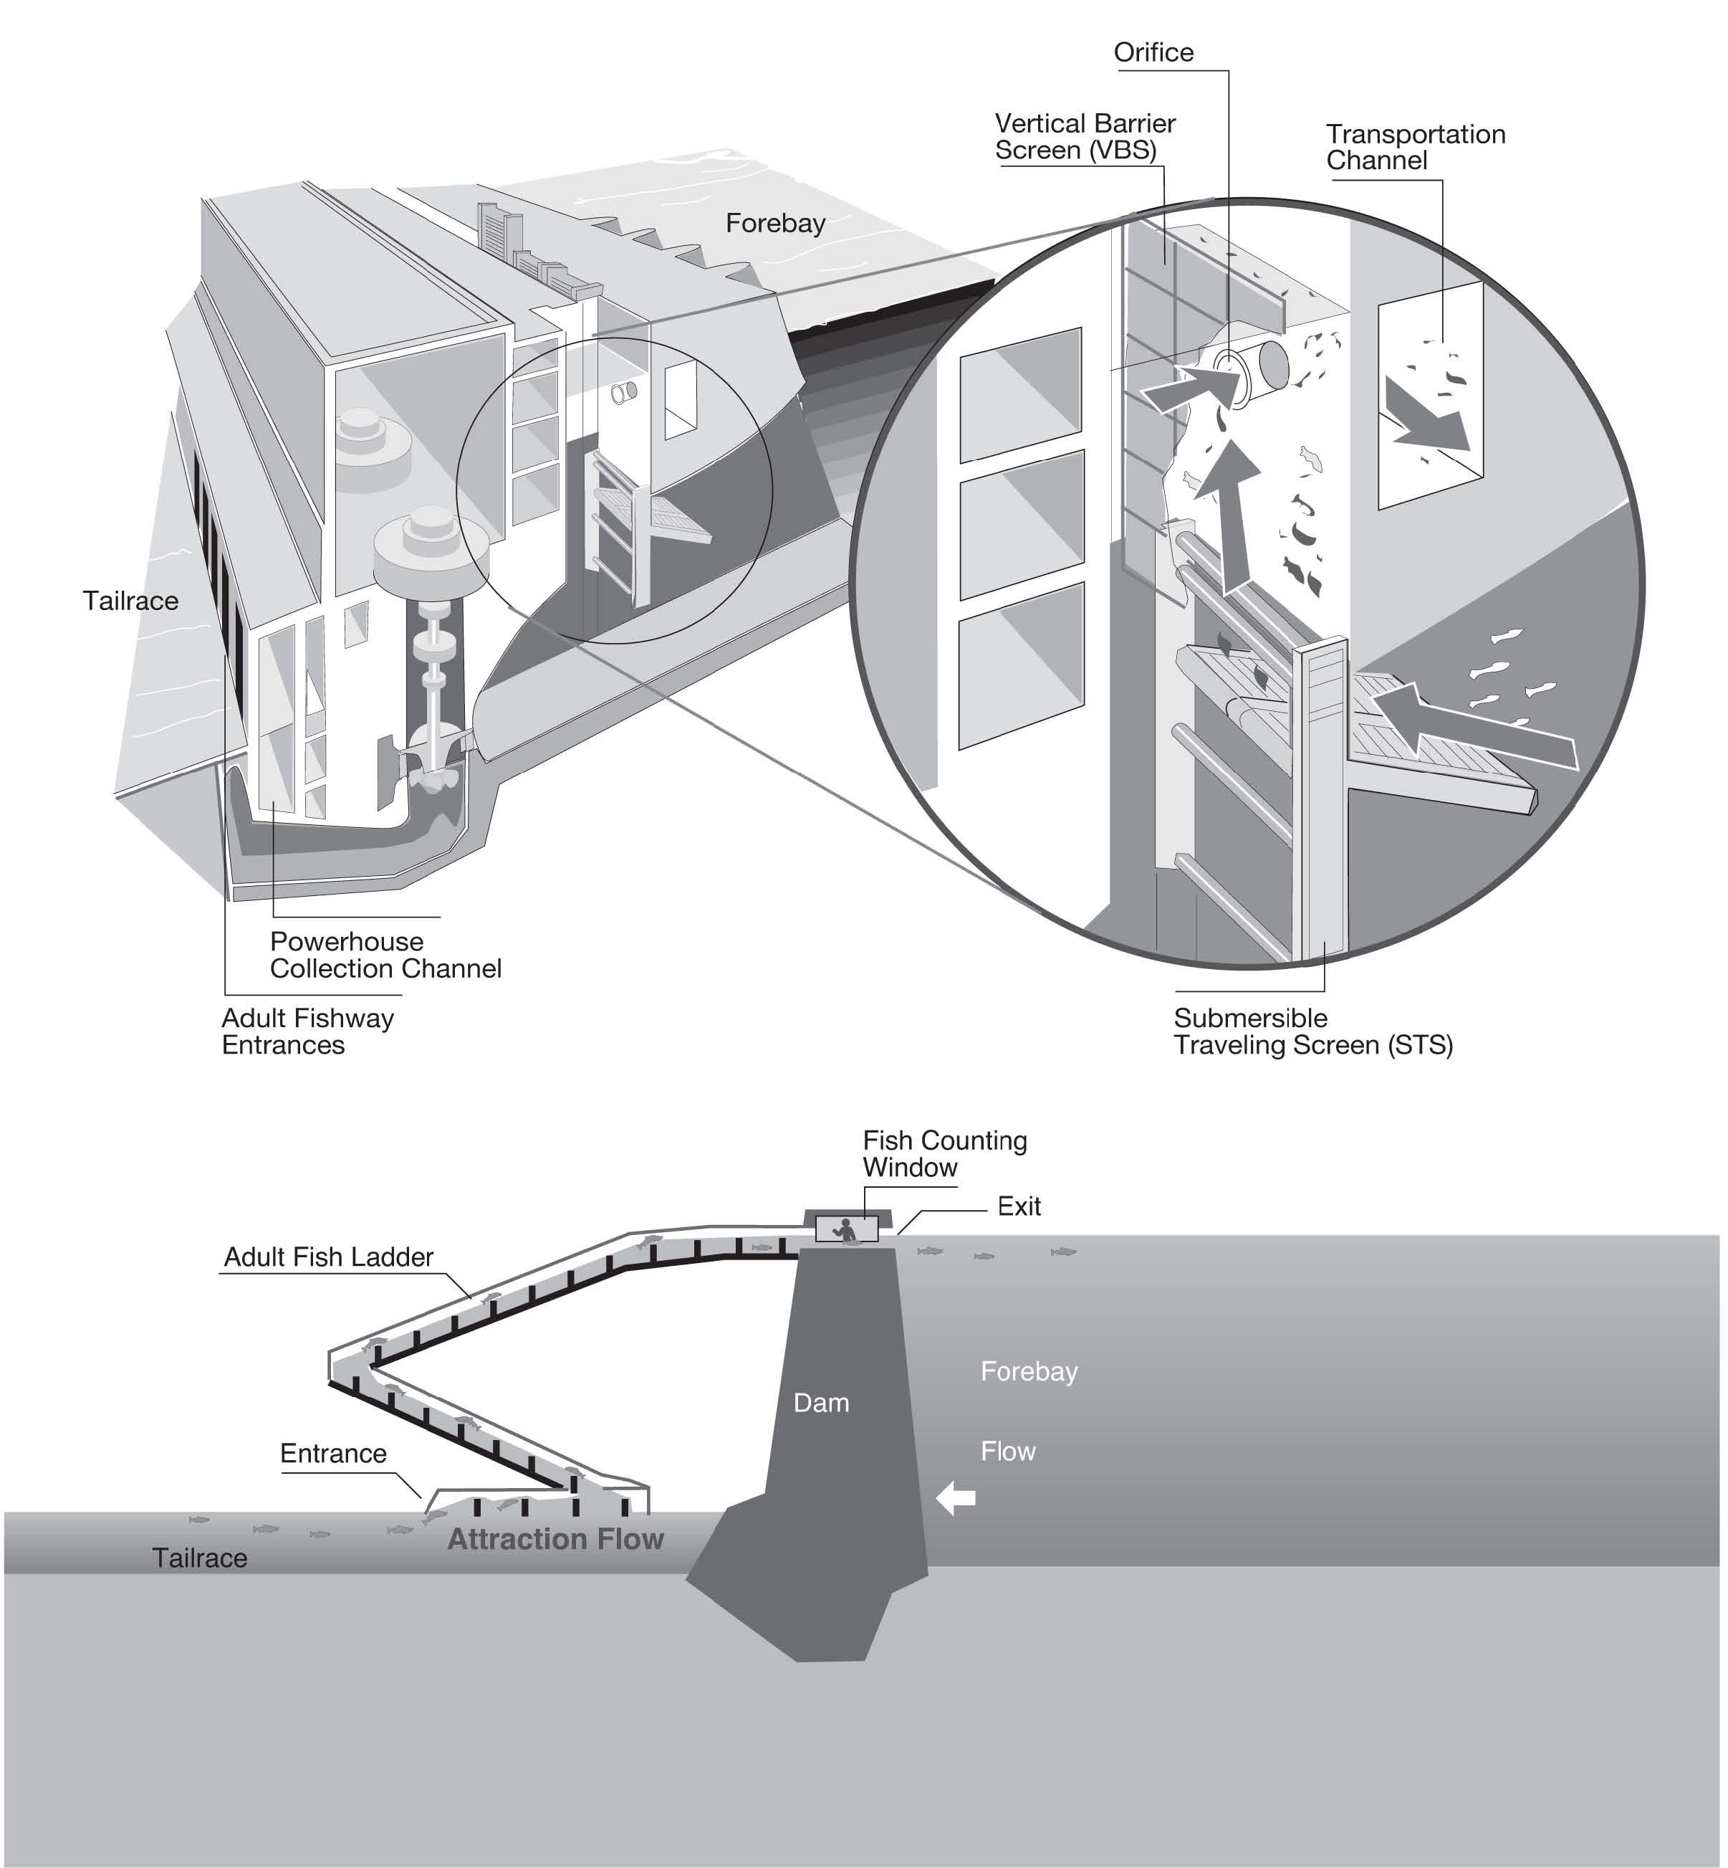
Figure OVE-3. Example Design of Fish Passage Structures at FCRPS Corps Hydropower Projects.

OFFICIAL MEMO of COORDINATION (MOC) FOR
NON-ROUTINE OPERATIONS & MAINTENANCE
COORDINATION TITLE- (filled in by District OD Biologist)
COORDINATION DATE-
PROJECT-
RESPONSE DATE-
- Description of problem.
- Type of outage required (relate to deviation from FPP).
- Dates of impacts/repairs.
- Length of time for repairs.
- Impact on fish facility operation (fishway, JFF, etc.).
- Impact on project operations (unit priority, forebay/tailwater operation and/or spill).
- Analysis of potential impacts to fish. Include:
  - 10-year average passage of adults and juveniles of each affected listed species during dates of impact.
    - Adult counts: www.cbr.washington.edu/dart/query/adult_graph_text.
    - Adult counts by ladder: www.cbr.washington.edu/dart/query/adult_ladder_sum. To calculate 10-year average, download each of the most recent 10 years and copy into a spreadsheet for averaging.
    - Smolt index: www.cbr.washington.edu/dart/query/smolt_graph_text. To calculate 10-year average, select the most recent 10 years (hold “ctrl” and select each year) and select download to .CSV spreadsheet.
  - Statement about the current year’s run (e.g., higher or lower than 10-year average).
    - Pre-season – NOAA adult returns forecast: www.nwfsc.noaa.gov/research/divisions/fe/estuarine/oeip/g-forecast.cfm. Or contact the District adult fish passage coordinator.
    - Mid-season - current counts to-date vs. 10-year average (see links in section a.).
  - Estimated exposure to impact of adults and/or juveniles, as appropriate, by species (number or percentage of 10-year average that occurs during dates of impact).
  - Type of impact to adults and/or juveniles, as appropriate, by species (e.g., increased delay, exposure to predation, exposure to a route of higher injury/mortality rate, exposure to higher TDG, etc.).
  - Final judgement on scale of expected impacts (negligible, minor, significant) on:
    - Downstream migrants.
    - Upstream migrants (including Bull Trout).
    - Lamprey.
- Comments from agencies.
- Final coordination results.
- After Action update.

Please email or call with questions or concerns.
Thank you,

Name
Project
Title of person writing MOC
E-mail address of person writing MOC

CENWP-OD-Project code Date of report

MEMORANDUM FOR THE RECORD (include title i.e. 12BON01)

SUBJECT: Include species and location.

Insert explanatory verbiage in this section.

- Species –
- Origin –
- Length –
- Marks and tags –
- Marks and injuries found on carcass –
- Cause and time of death –
- Future and preventative measures –
- Regional coordination and responses/comments –
- Next FPOM meeting (add to agenda for review) –

Include photos if available.
Sincerely,
Project Fisheries

FPPs from 2000 through present (including all Change Forms) are available on the FPP website at: pweb.crohms.org/tmt/documents/fpp/
FCRPS BiOps, associated decision documents, and other related information are available online at: www.salmonrecovery.gov/BiologicalOpinions/FCRPSBiOp.aspx
WMPs from 2001 through present are available online at: pweb.crohms.org/tmt/documents/wmp/

