Fish Passage Plan (FPP) Change Request Form
Change Form # & Title: 17TDA002 – Ladder Temperature Monitoring & Locations
Date Submitted: September 8, 2016
REVISED 12/31/16 (added monitor location maps)
Project: TDA
Requester Name, Agency: Tom Lorz, CRITFC; Trevor Conder and Gary Fredricks, NOAA
Final Action: APPROVED 1/26/17
FPP Section: TDA 2.4.2. Adult Facilities – Fish Passage Season; Figures TDA-2, -3, -4
Justification for Change: Adds language to standardize temperature monitoring at the mainstem ladders to record entrance and exit temperatures and differentials. Adds monitor locations to the FPP figures.

Proposed Change: (see following pages)

Comments: (listed oldest to newest)
9/12/2016 email from Trevor Conder, NOAA Fisheries: We are only really concerned with ladder temps from around June 1 until September 30. We can use TDG or strings during the other periods to see how things are tracking. Bill had a good thought to have them start in May so that if things get screwed up, we can get it fixed by June.
10/13/16 FPOM: Cordie will drop a hobo to confirm that the existing monitor at the count station is adequate.
1/26/2017 FPOM FPP Meeting: FPOM revised the language to clarify where the monitors should be located.
Cordie clarified that the figures show the current locations. Fredricks, Conder, and Lorz noted these need to be reviewed and moved if necessary to meet the objectives. FPOM requested spot checks throughout the season to QA/QC the locations, then revisit if necessary to move them.

Record of Final Action: Section 2.4.2.2 approved at FPOM 10/13/16, then revised at FPOM FPP Meeting 1/26/17. Figures approved at FPOM FPP Meeting 1/26/17, with caveat that monitors will be moved if necessary to meet objectives.

Proposed Change:
2.4.2.2. Temperature Monitoring.
- Water temperatures will be measured in count station of each adult fishway and will be recorded in the fishway status report. When water temperature reaches 70°F, all fish handling activities will be coordinated through FPOM prior to any action to verify protocols that will be followed.
- From June 1 through September 30, water temperature will be monitored at adult fishway entrances and exits.
  - Temperature monitors shall be placed within 10 meters of all shore-oriented entrances and exits.
  - If possible, the entrance monitor shall be within 1 meter above the ladder floor and at least 10 meters downstream of ladder diffusers to allow for sufficient mixing with surface water.
  - The exit monitor shall be within 1 meter above the ladder floor and above all diffusers to allow for sufficient mixing with surface water.
  - If an existing temperature monitoring location is proposed for either the exit or entrance, it shall be verified that the site accurately reflects water temperature within 10 meters of the entrance or exit.
  - Project Fisheries will submit temperature data to the Fish Passage Center (FPC) on a weekly basis for posting online at: http://www.fpc.org/river/Q_ladderwatertempgraph.php.

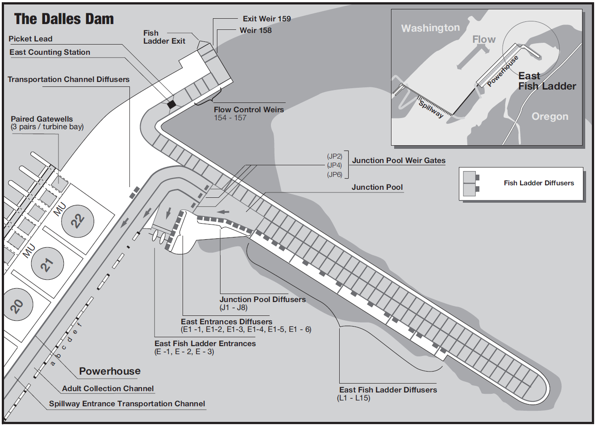

Ladder Temperature Monitors

Figure TDA-2. The Dalles Dam East Fish Ladder.
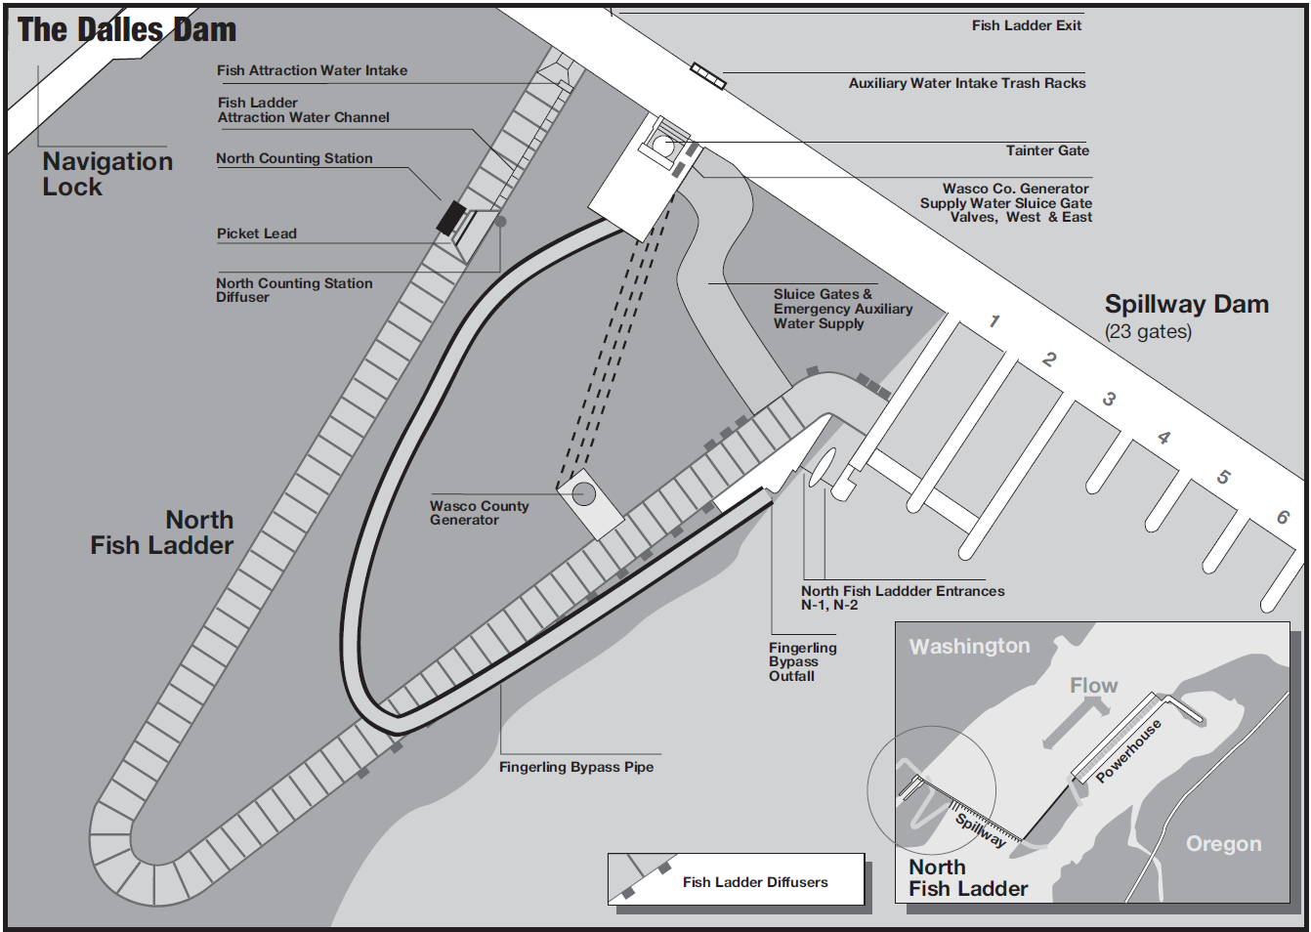

Ladder Temperature Monitors

Figure TDA-4. The Dalles Dam North Fish Ladder and Spillway.

