Fish Passage Plan (FPP) Change Request Form
Change Form # & Title: 17LGS001 – SW Close Criteria (revised/resubmitted 16LGS003)
Date Submitted: April 14, 2016
Project: LGS
Requester Name, Agency: Corps NWW
Final Action: WITHDRAWN – May 25, 2016
FPP SECTION: LGS 2.3.3.7. Juvenile Facilities - Fish Passage Season – Spillway Weir (SW).
JUSTIFICATION: Change Form 16LGS003 proposed to change criteria for closing the SW from 35 kcfs on or after August 1 to 50 kcfs on or after June 21 (summer spill), based performance test and modeling data that indicated lower juvenile survival at low flow with the SW operating. At the Feb 2016 FPOM, IDFG did not support this proposal (see Comments section below), and Change Form 16LGS003 was withdrawn for the 2016 FPP.
This Change Form is the revised and resubmitted proposal for further FPOM coordination and inclusion in the 2017 FPP.
At the April 2016 FPOM, IDFG proposed revising the criteria to a later date (mid-July) and adding a threshold for subyearling passage in order to avoid closing the SW during periods of higher subyearling outmigration. In a follow-up email (see Comments section below), IDFG proposed the following: 50 kcfs on or after July 14 (or possibly earlier) based on the RFC forecast for at least 10 days AND a rolling 3-day average subyearling Chinook passage index below 4,000. The 4,000 smolt index is a straw-man for FPOM consideration and to compare to the figures below (pages 5-9) in order to define a Regionally agreed upon passage number.
PROPOSED CHANGES:
(edits to existing FPP text shown in track changes)
2.3.3.7. Spillway Weir (SW).
c. Close SW: On or after July 14, when daily average discharge drops below 50 kcfs and the RFC forecast indicates flow will remain below 50 kcfs for at least 10 days, AND the subyearling Chinook rolling 3-day average passage index at Little Goose Dam is less than 4,000, the SW will be closed for the remainder of the spill season. The SW will be closed within 3 normal work days after RCC issues the teletype and coordinated through CENWW-OD-T. During work to close the SW, spill will be distributed in “Alternate Uniform" patterns (Table LGS-11) and Bay 2 will be closed to ensure worker safety in adjacent Bay 1. After the SW is closed, spill will be distributed in “Uniform” patterns with No SW (Table LGS-10).
c.1. The SW will not be closed prior to July 14 in order to enhance subyearling migration even if flow drops below 50 kcfs, unless an adult passage delay is observed or if necessary due to turbine unit operational constraints at low flow. Closing the SW prior to July 14 will be coordinated through FPOM by CENWW-OD-T.
COMMENTS (listed oldest to newest):
February 03, 2016 10:36
From: Milligan, Sean C NWW
Here are my comments on this change form:
1) The ERDC model trip for LGo low-flow operations was Sept 2014...
2) In the justification paragraph, I think we should mention that the initial impetus to look at this was poor survival in the performance study, which identified lower survival at the lower flows with the TSW operating. So then we looked at the model and confirmed acceptable operating conditions with TSW above 50 kcfs and better operating conditions with uniform spill (TSW out) below 50 kcfs. So I suggest a statement like this: "Changes criteria to close the spillway weir (SW) from the previous 35 kcfs trigger to 50 kcfs, based on juvenile fish survival data from performance tests indicating lower survival at lower river discharges with the TSW operating, with follow-up modeling results at ERDC in September 2014."
3) I believe the agreement was that the TSW would be removed when river discharge falls below 50 kcfs, regardless of the date. So Paragraph 2.3.3.7.c.1 needs to be removed entirely, and the first phrase in Paragraph 2.3.3.7.c referring to the date should be removed.
February 04, 2016 12:59
From: Trevor Conder - NOAA
I agree Aug 1 is probably too late of a trigger date, we should have a trigger date so we don't remove the SW in the spring where we made the standard for spring migrants under the normal SW operation. I suggest using the SW for the bulk of the spring migration, but allow it to come out during the summer migration. Looking at the data in 2015 it appears if we had used June 1 and below 50K we would have captured that idea best.
February 05, 2016 10:09
From: Tom Lorz
close but needs some work. This was suppose to be for the summer period or at lease that was my way of thinking, the way it is written would affect anytime of year. I would add some language anytime after July 1st? pick your favorite day. Otherwise will need to have some re-install language and then we could be taking the [SW] in and out repeatedly across the season as flows change in a 3 day window, not sure if this is what people wanted. If we do add this to spring part of the run, people could easily ask, since this has not been tested how do we know that it is good idea, especially given the high usage of the TSW by steelhead.
February 08, 2016 10:25
From: Tom Lorz
I was leaning more towards [June] 20th to keep the spring/summer switch consistent.
February 08, 2016 10:47
From: Trevor Conder - NOAA
I just spoke with Bill on this, and we support CRITFC in using the spring/summer transition date for the first step on the LGO SW removal trigger.
February 08, 2016 12:42
From: Milligan, Sean C NWW
Ok with me, although at some point we may have to acknowledge that the tailwater doesn't care what the date is -- it will react to whatever the discharge and our operating configuration is, and if the discharge is less than 50 kcfs with the TSW operating, resulting in poor passage conditions for both adults and juveniles, what is the appropriate response? But this is still an improvement over the current plan, and Q<50 kcfs is a relatively rare event in the spring, so let's move forward.
February 11, 2016 - FPOM:
- Kiefer said this action is based upon not meeting subyearling performance standards at LGS and is an issue at low flow across the basin. He questioned whether this action will improve survival and is concerned there aren’t any tests planned to evaluate impacts.
- Setter said this proposal stemmed from the ERDC modeling trip in October, so it’s based on an evaluation of hydraulics, not fish data.
- Condor said it’s also based upon performance test results.
- Kiefer asked how we got into a bulk spill pattern, now you’re going to change one mortality problem for another. He wants to see a study of survival at flows below 50 kcfs with the SW open versus closed. He does not support this change form.
- Condor asked where we should discuss these issues then. There is a chance that the performance standard won’t be met at this level and they’ll evaluate it during the next performance test.
- Bettin said they already took a risk defining the trigger at 35 kcfs, which appears to be too low.
- Setter said the NWW hydraulic engineer, Sean Mulligan, feels strongly that this is the best way to improve project survival. Bill Hevlin also strongly supports. She said closing the SW at 50 kcfs might also improve tailrace hydraulics for adult passage.
- Kiefer doesn’t support this change without evaluation and doesn’t want to wait for performance testing.
- Lorz said this is a COP discussion.
February 22, 2016 13:34
From: Kiefer, Russell
I'm sending this email because IDFG wanted to make sure that folks understood why we did not support this change form. The stated justification was that summer dam passage performance was not met in a low flow year with the SW in operation, and a modeling trip that indicated tailrace eddies would be greatly reduced at these flows with the proposed change.
IDFG's concerns are as follows:
1) There has been a fairly consistent pattern of not meeting dam passage performance survival at lower flows at multiple projects, including those without significant eddy issues.
2) We moved away from flat spill patterns at lower flows at Snake River Projects because of documented increased injury and mortality resulting from smaller gate openings.
3) As proposed, this change would reduce SPE when the most recent results (T:C0 and increased transport stray rates) indicate this may be a net overall negative for the Region.
4) There is disagreement in the Region as to whether reducing eddies (as proposed in the change form) or increasing spill and SPE is the most effective way to improve dam passage performance and resulting adult returns during low flows.
5) This significant change in operation and configuration is being proposed without an evaluation to determine effect.
IDFG recommends that a special SRWG be convened to select an alternative operation and develop a test to compare the two operations.
February 22, 2016 14:17
From: Setter, Ann L NWW
Russ: Thanks for writing out your concerns. As a reminder, the timeframe when this type of operation would have been implemented is July - August. Once we are past Independence day weekend, it is presumed that 95% of the subyearling run is out of the Snake River, generally speaking. You also need to be weighing reducing impact to adults, and the flat pattern makes the entrance signatures more identifiable during low flows. This change was proposed without a study to determine if the necessary consensus could be reached to allow for an adaptive management change. SRWG studies are facilitated by our Planning group using CRFM funds so I am including them on this response.
April 14, 2016 – FPOM:
- Kiefer prefers to pass subyearlings via spill as much as possible in June/July. Closing the SW reduces spill efficiency (SPE) and puts more fish through bypass and transport. After August 1, data are sparse and the benefit to transport may be higher, so reduced SPE is less of a concern. He recommends revising the date to July 14 (or possibly earlier) and adding criteria for subyearling passage index (i.e., rolling 3-day average <4,000). Tammy will forward an email to FPOM with Russ’ proposed criteria.
April 14, 2016
From: Kiefer, Russell
This was a straw-man to implement Hevlin's idea of spilling 40% at night to compensate for removing the SW (maintain SPE) when significant numbers of subyearlings are still passing LGO. It could be modified to remove the SW a little earlier if significant numbers of subyearlings are no longer passing LGO and flows are below 50 Kcfs. This straw-man proposal would now read:
1) Starting 7/14 or possibly earlier , if flows are below 50 Kcfs at Little Goose Dam and the NW River Forecast Center 10 day forecast indicates flow will remain below 50 Kcfs, and the 3 day moving average of smolt index passage at Little Goose is < 4,000, the surface weir would be removed.
The notes under each figure [below] indicate the date range the SW would be maintained as compared to the original change form, and estimated % of smolt index during that date range. The date range would likely be shorter (end sooner) in some years because flows reach the current 35 Kcfs trigger. The % of smolt index affected would also be a little lower in these years as well.
Please note that the 4,000 smolt index is a straw-man number to compare to the attached figures and we likely should use a Regionally agreed upon passage estimate number instead. Also note that IDFG would prefer to use the 10 day flow forecast instead of the 3 day.
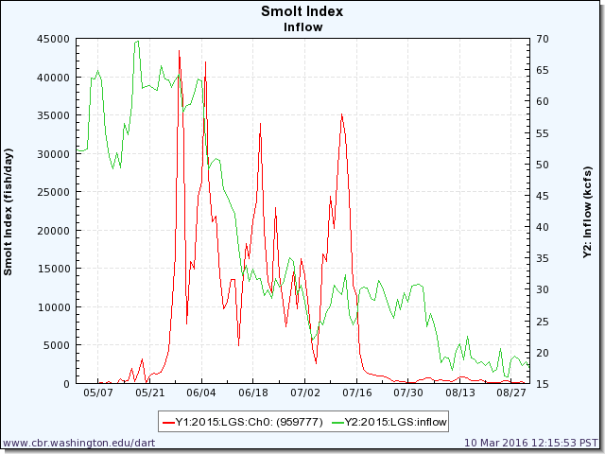
SW maintained: 6/19 – 7/17; 49% of smolt index affected.

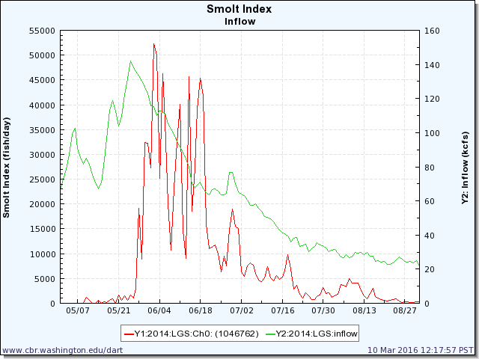
SW maintained: 7/13 – 7/24; 5% of smolt index affected.
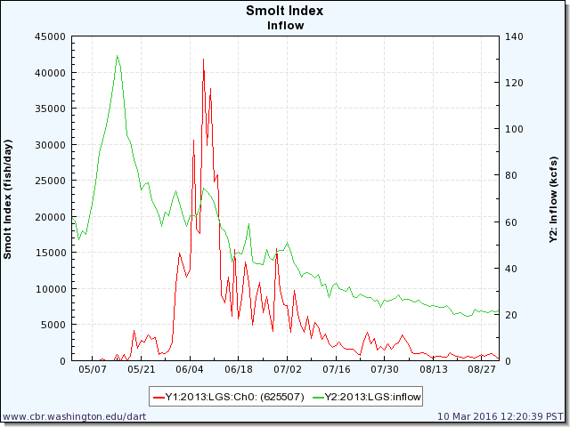
SW maintained: 6/22 – 7/17; 25% of smolt index affected.

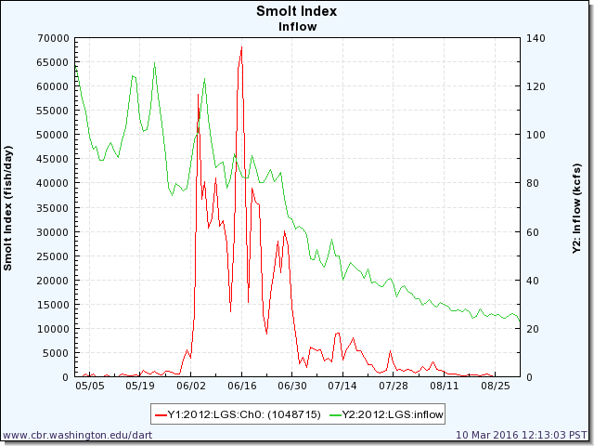
SW maintained: 7/13 – 7/22; 5% of smolt index affected.

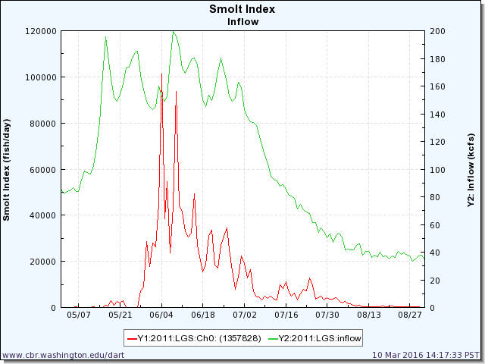
Criteria not met.

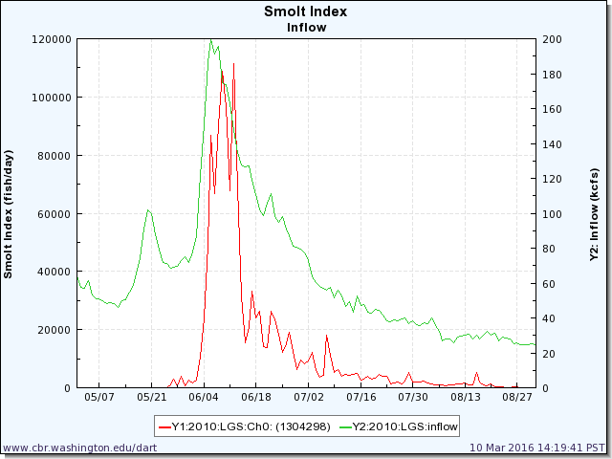
SW maintained: 7/12 – 7/18; 2% of smolt index affected.

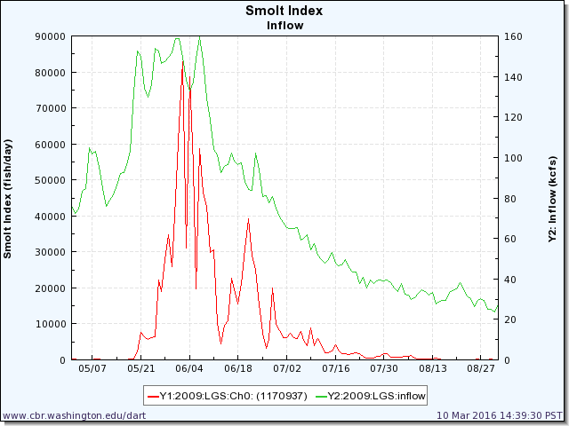
Criteria not met.

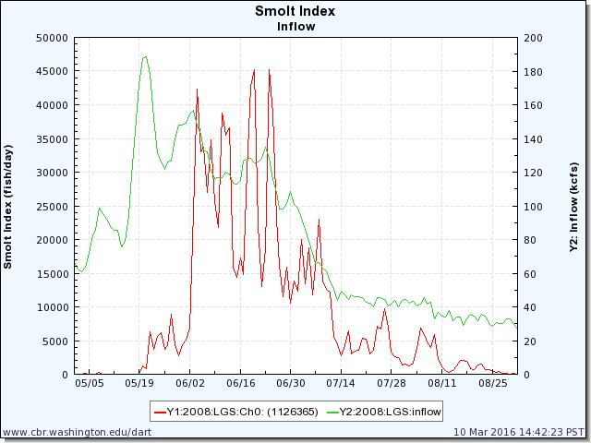
SW maintained: 7/13– 7/16; 1% of smolt index affected.

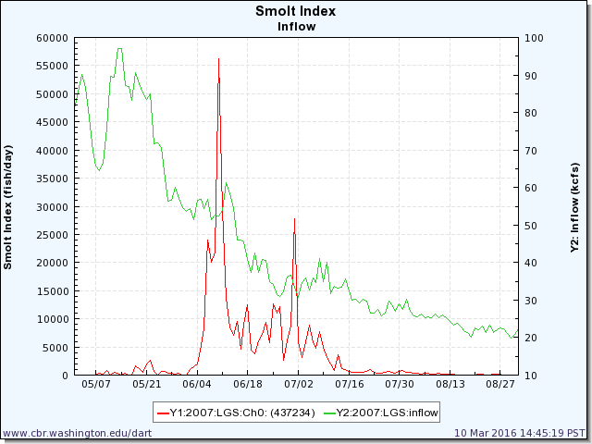
SW maintained: 6/19 – 7/14; 40% of smolt index affected

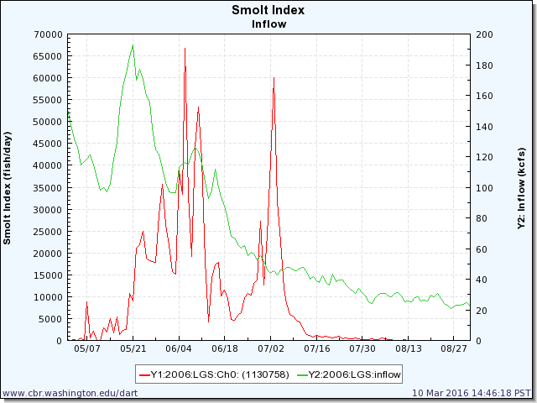
SW maintained: 7/1 – 7/14; 20% of smolt index affected

Wednesday, May 11, 2016 9:44
From: Bill Hevlin - NOAA Federal
I wanted to add a tailrace temperature criteria to the discussion for tomorrow for (1) when to take the spillway weir out of service and use the uniform pattern, and (2) when to close all spill gates.
For discussion:
(1) When Little Goose tailrace temperature exceeds 68 degrees take the spillway weir out of service and use uniform deep spill.
(2) When Little Goose tailrace temperature exceeds 70 degrees, shut all spill gates, operate the powerhouse only.
Wednesday, May 11, 2016 15:20
From: Pinney, Chris A NWW
FPOM,
I have compiled some research and operational data graphics for informing the discussion of TSW closure criteria/triggers for Little Goose summer low flow/heated water regime operation. They take into account both SMP index CH0 and summerCh1 passage distributions as well as adult Chinook and sockeye passage distribution.
If an implementation consideration date is required the MOCs versions suggest either the 21 June as per the FOP switch to summer operations vs a 17 July date. Data from the Performance Standard Evaluations along with a couple Radio-tag route survival studies ended sampling for summer-run fall chinook subyearling migrants by 1-4 July. This cut-off was due to the amount of juveniles that were estimated for several years to not actively migrate (reservoir-type) and their increased variance introduced to not being able to confirm non-detection as mortality or non-migration behavior.
So, maybe a logical compromise if a date is required to balance effects across juvenile and adult passage would far around 1 July when the survival studies releases ended?
This is too much to go over and discuss at any one FPOM meeting, but it does illustrate measured SPE and other parameters for which TSW removal may degrade- as brought up as ripe questions towards a decision to change FPP language. I put into a pdf converted from the ppt, so it should transmit through our email systems. [note: pdf included as Change Form “Attachment 1”]
May 12, 2016 – FPOM:
- Hevlin proposed adding temperature criteria to close the SW when tailrace temp exceeds 68°F and go to deep spill only in order to keep downstream cooler for adults. If tailrace temp exceeds 70°F, shut off spill entirely and pass all flow through deeper turbines to maximize cool water downstream.
- Pinney suggests July 1 is the best balance for juv vs adult impacts, according to survival data.
- Kiefer, Conder and others recommended taking this discussion to a Task Group or FFDRWG so salmon managers could get into the weeds before landing on an operation. Next NWW FFDRWG is May 25.
May 25, 2016 – FFDRWG:
No consensus reached. The FPP will not be changed and the operation will be coordinated in season via FPOM, consistent with last year.

RECORD OF FINAL ACTION: WITHDRAWN – May 25, 2016

