Fish Passage Plan (FPP) Change Request Form
Change Form # & Title: 17JDA002 – Ladder Temperature Monitoring & Locations
Date Submitted: September 8, 2016
REVISED 12/31/16 (added monitor location maps)
Project: JDA
Requester Name, Agency: Corps RCC
Final Action: APPROVED 1/26/2017
FPP Section: JDA section 2.4.2. Adult Facilities – Fish Passage Season; Figures JDA-1, -2

Justification for Change: Adds language to standardize temperature monitoring at the mainstem ladders to record entrance and exit temperatures and differentials. Adds monitor locations to the FPP figures.

Proposed Change: (see following pages)

Comments: (listed oldest to newest)
1/6/2017 email from Eric Grosvenor, JDA Fisheries: Our temp probe locations are attached. The locations are in the exit control sections of both ladders and entrance transition areas for the entrances. I gave this a lot of thought 6 years ago when I deployed them to give an accurate entrance/ exit temperature differential. Since we've already been taking these measurements for so long, I'd rather not move them.
1/26/2017 FPOM FPP Meeting: FPOM revised the language to clarify where the monitors should be located.
Zyndol clarified that the figures show the current locations. Fredricks, Conder, and Lorz noted the monitor locations need to be reviewed and moved if necessary to meet the objectives. JDA will drop a probe in the north ladder locations to QA/QC the monitor locations, then move if necessary to meet the objectives.

Record of Final Action: Section 2.4.2.2 approved at FPOM 10/13/16, then revised at FPOM FPP Meeting 1/26/17. Figures approved at FPOM FPP Meeting 1/26/17, with caveat that monitors will be moved if necessary to meet objectives.

Proposed Change:
2.4.2.2. Temperature Monitoring.

- Measure water temperatures at the count stations of each ladder and include the weekly means in the status report. When water temperature reaches 70°F all fish handling activities will be coordinated with the Regional fish agencies through FPOM prior to any action to verify protocols that will be followed.
- From June 1 through September 30, water temperature will be monitored at adult fishway entrances and exits.
  - Temperature monitors shall be placed within 10 meters of all shore-oriented entrances and exits.
  - If possible, the entrance monitor shall be within 1 meter above the ladder floor and at least 10 meters downstream of ladder diffusers to allow for sufficient mixing with surface water.
  - The exit monitor shall be within 1 meter above the ladder floor and above all diffusers to allow for sufficient mixing with surface water.
  - If an existing temperature monitoring location is proposed to be used for either the exit or entrance, it shall be verified that the site accurately reflects water temperature within 10 meters of the entrance or exit.
  - Project Fisheries will submit temperature data to the Fish Passage Center (FPC) on a weekly basis for posting online at: http://www.fpc.org/river/Q_ladderwatertempgraph.php.

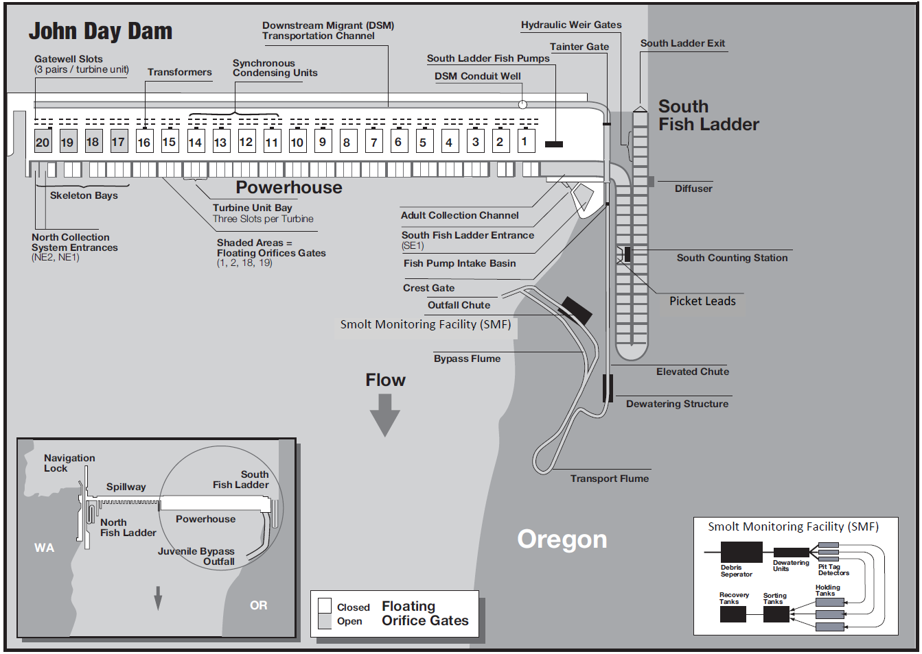

Ladder Temperature Monitors

Figure JDA-1. John Day Dam South Fish Ladder, Powerhouse Collection System, and Juvenile Bypass System.
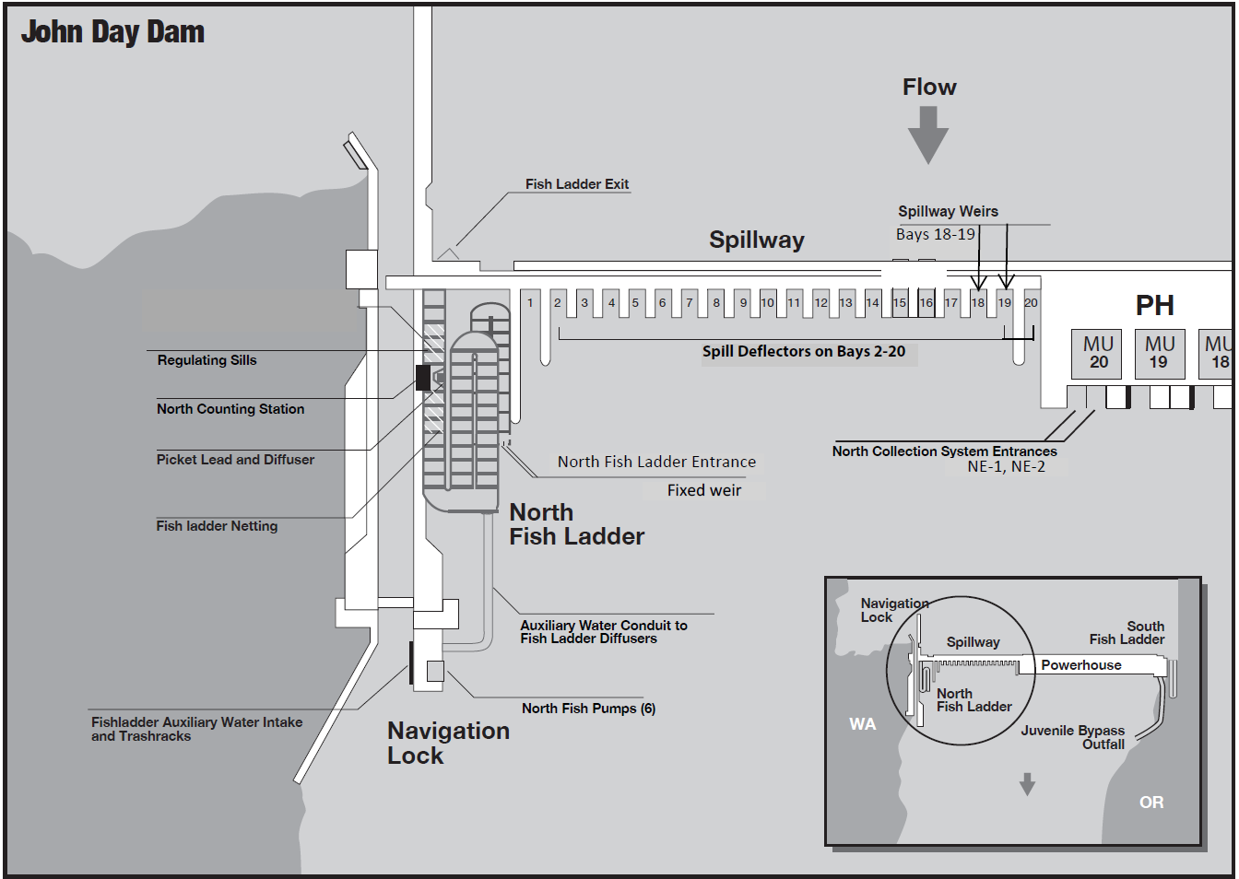

Ladder Temperature Monitors

Figure JDA-2. John Day Dam Spillway and North Fish Ladder.

