Fish Passage Plan (FPP) Change Request Form
Change Form # & Title: 17BON003 – Nighttime Lamprey Operations
Date Submitted: 8/14/2016
Project: BON
Requester Name, Agency: BON Fisheries
Final Action: WITHDRAWN 12/7/2016
FPP Section: BON 2.4.2.12.c. – Adult Facilities Operating Criteria – Fish Passage Season (Mar 1-Nov 30) – PH2
Justification for Change: Lamprey currently benefit from “nighttime lamprey operations” at PH2 entrances but not at the fishway entrances at the spillway or PH1. We would like to extend nighttime operations to these places. Entrance efficiency and passage times have been shown to benefit from reduced velocities at entrance gates (Clabough, Johnson, Keefer, Caudill, Moser, 2011). More recently, Project and Field Unit Biologists have, on separate occasions, observed and photographed lamprey attempting to enter at B-Branch and repeatedly thwarted by the high current velocity.
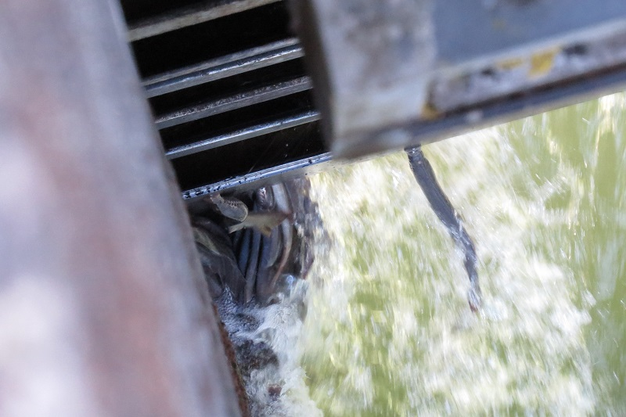 Photo courtesy of Bjorn Van der Leeuw

Proposed Change: (edits to existing FPP text shown in track changes)
2.4.2.12.c. Lamprey Operations June 1–August 31: During night spill hours (Table BON-5), reduce fish unit output to operate all north (NUE, NDE) and south (SUE, SDE) entrances at 0.5’ of entrance head. To ensure proper function of fish units, B2 fish unit output can be further reduced or placed on standby to float debris as necessary from 2200-0400 hours. Fishway entrance differentials at Cascade Island, B-Branch, and PH1 will be reduced to 0.5’ by reprogramming of existing PLC Fish Valve control systems.

Comments: (listed oldest to newest)
8/11/16 FPOM: Fredricks and Lorz agreed this would be good for lamprey. Fredricks concerned it could potentially slow adult salmon passage and increase risk of sea lion predation. Conder wondered how much of an issue the entrances really are for lamprey. Fredricks wants to look at PIT-tag sockeye passage data—one side vs the other—and see if there is a difference between daytime vs nighttime passage. Mackey reminded there is a report from the early 2000s with this info. Fredricks and Conder want to look into this more. PENDING more time for review.
9/8/16 FPOM: Since this is the same operation as the one that already occurs at PH2, Fredricks and Lorz are fine with this change. Conder would like to look at sockeye data to see if there might be a delay impact due to this operation. If there is an impact, then should we be doing it at all? Since the impact is uncertain, Conder thinks that keeping it only at PH2 spreads the risk, just in case. PENDING more time for review.
10/6/16 email to FPOM:
From: Tackley, Sean C NWP
Subject: RE: 17BON033 FPP change form (nighttime lamprey operations at B1)
All,
My apologies for not seeing the 17BON003 FPP change form (nighttime lamprey operations) earlier. Jen Graham brought it to my attention at this week's quarterly Corps-Tribal Lamprey Workgroup meeting in Walla Walla. The proposal is to go to reduced nighttime flows at BON Bradford Island in an effort to improve entrance conditions for lamprey. My understanding from the FPOM notes is that Gary and others may have concerns regarding sockeye attraction.
From a lamprey standpoint...this is a laudable goal and worth continuing to revisit, but I'd caution against it without a robust RT evaluation (as was done at B2). Caudill or Keefer can probably speak to the particulars better than me, but while reduced nighttime flows at B2 provided an apparent overall net benefit in entrance efficiency, there were some apparent tradeoffs in attraction (see attached final report). [Hyperlink in footnote ]
In the wake of moving to this permanent operation at B2, the Corps-Tribal Lamprey Workgroup discussed the possibility of expanding the operation and testing beyond BON and MCN. After considering the potential tradeoffs between attraction and entrance efficiency and with the knowledge that each fishway is different, we decided to shelve any plans to do costly RT studies at B1, TDA, JDA, etc, favoring higher priority actions. This is definitely NOT to say that we shouldn't in the future or that objectives couldn't be added to the upcoming post-construction lamprey RT study at BON (2018, 2019).
The sockeye concerns are also worth consideration. My memory may be hazy, but don't think this was a major part of the discussion when operations were changed at B2. I'm sure we didn't run concurrent sockeye RT studies in the years we evaluated B2.
I'd like to thank BON Fisheries for putting this idea forward and for getting the discussion going. The initiative is much appreciated.
10/6/16 email to FPOM:
From: Caudill, Christopher (caudill@uidaho.edu)
Subject: Re: 17BON033 FPP change form (nighttime lamprey operations at B1)
Hello all, I’ve attached the publication that resulted from the report Sean sent—it may be a bit more digestible. [Hyperlink in footnote ] The punchline was that lowered velocities improved entrance efficiency, but that improved movement into the lower ladder from the entrance was inconsistent, i.e., the bottleneck moved from the entrance to the transition pool/lower ladder. We should have some data on day vs. night sockeye entrance times from 2013-2014 that could speak to the issue, though I don’t recall if operations included lowered nighttime velocities in those years.
10/13/16 FPOM: Swank supports removing the bottleneck at the entrance; then other bottlenecks can be addressed later. Conder reviewed diel sockeye passage and is comfortable with this operation since sockeye aren’t passing from 2300-0400. Lorz thinks starting at 2200 would be fine. FPOM was generally supportive of this operation but wants more discussion with Tackley, Caudill at FFDRWG next week. PENDING discussion at FFDRWG 10/20/16.
11/10/16 FPOM: This issue was discussed at FFDRWG. NOAA is ok with impacts to sockeye and Chinook, but Tackley has concerns for lamprey. Studies show half flow was good, but no flow was bad. Tackley will coordinate with CRITFC (McIlraith). PENDING further coordination/discussion – will be revisited at December FPOM.
12/7/16 email to FPOM:
From: Tackley, Sean C CIV USARMY CENWP (US)
Subject: Re: 17BON033 FPP change form (nighttime lamprey operations at B1)
Hi all,
First, I'd like to thank Bonneville Fisheries for preparing change form 17BON033 and for continuing to look for ways to improve lamprey passage at Bonneville Dam. Your efforts are much appreciated!

Ricardo noticed that a decision on this change form had been deferred, pending discussion between me and Brian McIlraith. With FPOM coming tomorrow, he asked if I could close the loop on the topic.

Brian McIlraith, Ricardo and I discussed this today and agreed that it is risky to implement the proposed operation without a study. As many of you know, evaluation of reduced nighttime entrance flows was a particular action item in the Columbia Basin Fish Accords. U of I completed studies at Bonneville WA Shore Ladder (B2) in 2007-2009 and at McNary South Ladder in 2009-2010. There was a minor net benefit at Bonneville and a neutral effect at McNary. We collectively decided to go ahead and implement the nighttime operations of reduced AWS flows at Bonneville WA Shore and lowered entrance weirs (lower velocities) at McNary.

As we discussed with our tribal partners several years ago and as noted in the 2014 revision to the Corps' 10 Year Plan, generalizing (mixed) results from the WA Shore/B2 study to other fishway systems is not recommended, given the potential negative impacts on lamprey attraction and the inherent differences between each fishway system.

We are currently planning a 2018-2019 lamprey RT study to evaluate performance of the new LPS(s). It is worth considering whether we could/should add an evaluation of reduced nighttime flows at B1 to the scope of this study. Good topic of discussion for SRWG, BON Fisheries, U of I, and the Corps-Tribal Lamprey Workgroup. More to come!

I request that change form 17BON033 be withdrawn by the Corps at this time and that we instead have an SRWG discussion about adding this to the 2018-19 lamprey telemetry study.

Best Regards,
Sean
Record of Final Action: WITHDRAWN 12/7/16

Johnson et al, 2010. “Effects of Lowered Fishway Water Velocity on Fishway Entrance Success by Adult Pacific Lamprey at Bonneville Dam, 2007-2009”. Available online at: http://www.webpages.uidaho.edu/uiferl/pdf%20reports/Johnson_etal_Lamprey_Velocity_Test_07_09_Draft_Final.pdf
Johnson et al, 2012. “Movement of Radio-Tagged Adult Pacific Lampreys during a Large-Scale Fishway Velocity Experiment”. Available online at: http://www.tandfonline.com/doi/abs/10.1080/00028487.2012.683468

