2013 Fish Passage Plan
Section 5 – McNary Dam
Table of Contents
1. Fish Passage Information.......... MCN-01
1.1. Juvenile Fish Passage MCN-01
1.2. Adult Fish Passage MCN-05
2. Project Operation MCN-06
2.1. Spill Management MCN-06
2.2. Dissolved Gas Management and Control MCN-06
2.3. Operating Criteria MCN-06
3. Project Maintenance MCN-17
3.1. Juvenile Fish Passage Facilities MCN-17
3.2. Adult Fish Passage Facilities MCN-20
4. Turbine Unit Operation and Maintenance MCN-22
4.1. Turbine Unit Operation MCN-22
4.2. Turbine Unit Maintenance MCN-24
5. Forebay Debris Removal MCN-25
5.1. Special Spills MCN-26
Section 5 McNary Dam

Fish Passage Information

The locations of fish passage facilities at McNary Lock and Dam are shown in Figure MCN-1. Dates of project operations for fish purposes and special operations are listed in Table MCN-2.

Juvenile Fish Passage.

Facilities Description. The juvenile facilities at McNary Dam consist of extended-length submersible bar screens (ESBSs) with flow vanes, vertical barrier screens (VBSs), gatewell orifices, a concrete collection channel with emergency bypass outlets, primary and secondary dewatering structures, a pipeline/corrugated metal flume for transporting juvenile fish to the transportation facilities or bypassing them back to the river, and a full-flow PIT tag detection system. Juvenile transportation facilities at McNary include: a separator to sort juvenile fish by size and to separate them from adult fish; a flume system for distributing fish among the raceways; covered raceways for holding fish; sampling facilities; an office and sampling building with fish marking facilities; barge and truck loading facilities; and PIT tag detection and deflection systems.

Juvenile Migration Timing. Juvenile migration timing at McNary Dam is indicated in Table MCN-1. The dates in the table are based on juvenile fish collection numbers and do not reflect FGE or spill passage. Salmon, steelhead, bull trout, lamprey, and other species are routinely counted. Maintenance of juvenile fish passage facilities that may impact juvenile fish passage or facility operations should be conducted during the winter maintenance season.
Table MCN-. Juvenile Migration Timing at McNary Dam, 2003–2012.1
Yearling Chinook |  |  |  |  |  |  | Subyearling Chinook
 | 10 % |  | 50% | 90 % | # of Days |  |  | 10 % | 50% | 90 % | # of Days
2003 | 29-Apr |  | 13-May | 29-May | 30 |  | 2003 | 20-Jun | 2-Jul | 31-Jul | 41
2004 | 27-Apr |  | 11-May | 31-May | 34 |  | 2004 | 22-Jun | 30-Jun | 18-Jul | 26
2005 | 3-May |  | 15-May | 29-May | 26 |  | 2005 | 16-Jun | 25-Jun | 3-Jul | 17
2006 | 21-Apr |  | 9-May | 19-May | 28 |  | 2006 | 14-Jun | 6-Jul | 19-Jul | 35
2007 | 1-May |  | 11-May | 25-May | 24 |  | 2007 | 22-Jun | 6-Jul | 28-Jul | 36
2008 | 9-Apr |  | 15-May | 27-May | 48 |  | 2008 | 22-Jun | 8-Jul | 9-Aug | 48
2009 | 2-May |  | 15-May | 25-May | 23 |  | 2009 | 18-Jun | 4-Jul | 22-Jul | 34
2010 | 3-May |  | 17-May | 27-May | 24 |  | 2010 | 18-Jun | 4-Jul | 4-Aug | 47
2011 | 29-Apr |  | 8-May | 23-May | 24 |  | 2011 | 24-Jun | 24-Jul | 19-Aug | 56
2012 | 29-Apr |  | 11-May | 25-May | 26 |  | 2012 | 22-Jun | 18-Jul | 22-Aug | 61
MEDIAN | 29-Apr |  | 12-May | 26-May | 26 |  | MEDIAN | 21-Jun | 5-Jul | 29-Jul | 39
MIN | 9-Apr |  | 8-May | 19-May | 23 |  | MIN | 14-Jun | 25-Jun | 3-Jul | 17
MAX | 3-May |  | 17-May | 31-May | 48 |  | MAX | 24-Jun | 24-Jul | 22-Aug | 61
Unclipped Steelhead |  |  |  |  |  |  | Clipped Steelhead
 |  | 10 % | 50% | 90 % | # of Days |  |  | 10 % | 50% | 90 % | # of Days
2003 |  | 19-Apr | 25-May | 4-Jun | 46 |  | 2003 | 1-May | 25-May | 2-Jun | 32
2004 |  | 23-Apr | 13-May | 4-Jun | 42 |  | 2004 | 23-Apr | 10-May | 31-May | 38
2005 |  | 1-May | 17-May | 27-May | 26 |  | 2005 | 19-Apr | 15-May | 29-May | 40
2006 |  | 19-Apr | 7-May | 27-May | 38 |  | 2006 | 23-Apr | 1-May | 23-May | 30
2007 |  | 27-Apr | 11-May | 25-May | 28 |  | 2007 | 29-Apr | 9-May | 23-May | 24
2008 |  | 1-May | 15-May | 29-May | 28 |  | 2008 | 3-May | 11-May | 23-May | 20
2009 |  | 25-Apr | 7-May | 23-May | 28 |  | 2009 | 27-Apr | 7-May | 23-May | 26
2010 |  | 1-May | 13-May | 2-Jun | 32 |  | 2010 | 1-May | 9-May | 29-May | 28
2011 |  | 19-Apr | 7-May | 27-May | 38 |  | 2011 | 19-Apr | 1-May | 17-May | 28
2012 |  | 24-Apr | 5-May | 25-May | 31 |  | 2012 | 23-Apr | 1-May | 17-May | 24
MEDIAN |  | 24-Apr | 12-May | 27-May | 32 |  | MEDIAN | 25-Apr | 9-May | 23-May | 28
MIN |  | 19-Apr | 5-May | 23-May | 26 |  | MIN | 19-Apr | 1-May | 17-May | 20
MAX |  | 1-May | 25-May | 4-Jun | 46 |  | MAX | 3-May | 25-May | 2-Jun | 40
Coho |  |  |  |  |  |  | Sockeye (Wild & Hatchery)
 |  | 10 % | 50% | 90 % | # of Days |  |  | 10 % | 50% | 90 % | # of Days
2003 |  | 25-May | 4-Jun | 29-Jun | 35 |  | 2003 | 3-May | 15-May | 27-May | 24
2004 |  | 15-May | 31-May | 18-Jun | 34 |  | 2004 | 15-May | 31-May | 14-Jun | 30
2005 |  | 5-May | 21-May | 6-Jun | 32 |  | 2005 | 11-May | 19-May | 31-May | 20
2006 |  | 9-May | 27-May | 2-Jun | 24 |  | 2006 | 3-May | 17-May | 29-May | 26
2007 |  | 3-May | 21-May | 8-Jun | 36 |  | 2007 | 11-May | 21-May | 31-May | 20
2008 |  | 13-May | 25-May | 6-Jun | 24 |  | 2008 | 15-May | 25-May | 6-Jun | 22
2009 |  | 13-May | 23-May | 12-Jun | 30 |  | 2009 | 5-May | 21-May | 2-Jun | 28
2010 |  | 9-May | 31-May | 12-Jun | 34 |  | 2010 | 11-May | 29-May | 2-Jun | 22
2011 |  | 24-Apr | 19-May | 8-Jun | 45 |  | 2011 | 4-May | 13-May | 31-May | 27
2012 |  | 7-May | 23-May | 4-Jun | 28 |  | 2012 | 1-May | 11-May | 21-May | 20
MEDIAN |  | 9-May | 24-May | 8-Jun | 33 |  | MEDIAN | 8-May | 20-May | 31-May | 23
MIN |  | 24-Apr | 19-May | 2-Jun | 24 |  | MIN | 1-May | 11-May | 21-May | 20
MAX |  | 25-May | 4-Jun | 29-Jun | 45 |  | MAX | 15-May | 31-May | 14-Jun | 30
- Dates are derived from daily and yearly facility collection numbers.
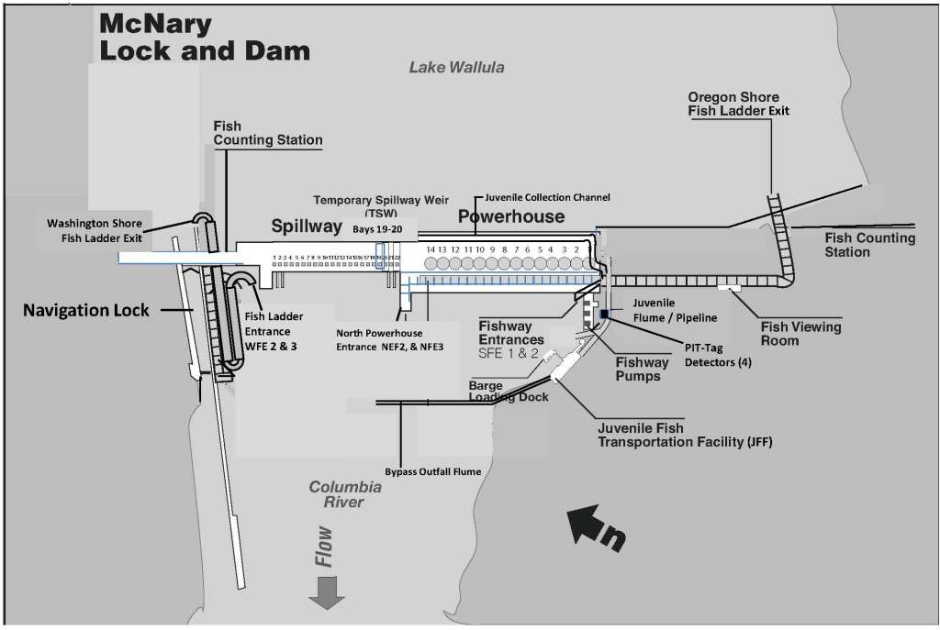
Figure 1. McNary Lock and Dam General Site Plan.
Table MCN-. McNary Dam Dates of Fish-Related Operations during the 2013 Fish Passage Season and 2013/14 Winter Maintenance Period.
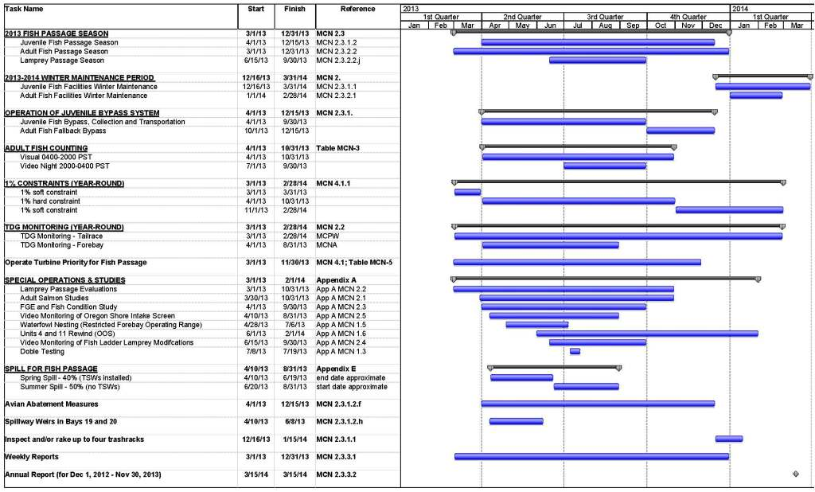

Adult Fish Passage.

Facilities Description. The adult fish passage facilities at McNary consist of separate north and south shore facilities.

North Shore Adult Fish Passage Facility. The north shore facilities are made up of a fish ladder with counting station, submerged orifice PIT tag antennas in the ladder, a small collection system, and a gravity-flow auxiliary water supply system. The gravity-flow auxiliary water supply system has a turbine unit installed on it, operated by North Wasco County PUD. The gravity-flow auxiliary water supply system takes water from the forebay through two conduits, passes the water through a turbine unit or through a bypass/energy dissipater when the turbine unit is not in operation, and distributes the water through a diffuser system at the bottom of the ladder and in the transportation channel. The north shore collection system has three downstream entrances and a side entrance into the spillway basin. Two of the downstream entrances are used during normal operation.

South Shore Adult Fish Passage Facility. The south shore facilities are comprised of a fish ladder with counting station, submerged orifice PIT tag antennas in the ladder and antennas at the counting station, two south shore entrances, a powerhouse collection system, and gravity and pumped auxiliary water supply systems.

Powerhouse Collection System. The powerhouse collection system contains three downstream entrances and one side entrance into the spillway basin at the north end of the powerhouse, twelve operating floating orifices, and a common transportation channel. At the north end of the powerhouse, two of the downstream entrances are used during normal operation with the other downstream and side entrances closed. The gravity-flow auxiliary water is provided by one conduit from the forebay and supplies the diffusers at the bottom of the ladder at tailwater level. The pumped auxiliary water is supplied by three electric pumps with variable-pitched blades. Two pumps are capable of providing the required flow when the third pump is bulkheaded to prevent water from flowing back through the pump to the river. The electric pumps supply the auxiliary water for the diffusers at the entrances and in the transportation channel. Excess water from the primary dewatering structure in the juvenile fish collection channel is routed to the adult collection system at the north end of the powerhouse.

Adult Migration Timing. Upstream migrants are present at McNary Dam throughout the year and adult passage facilities are operated year round. Maintenance of adult fish facilities is scheduled for January and February to minimize impacts on upstream migrants. Facilities are usually shut down one shore at a time for maintenance. Adult fish (salmon, steelhead, shad, and lamprey) are counted as per Table MCN-3; these data appear daily on the Corps adult fish count website at: http://www.nwp.usace.army.mil/Missions/Environment/Fishdata.aspx. Salmon migration timing data appear in Table MCN-4. Sturgeon and bull trout are also counted and recorded on the fish counters’ daily summary sheet comments section, but do not appear on the Corps daily website total due to relative infrequency of passage. These data are posted periodically during the passage season in the Miscellaneous Fish Counts report on the Corps’ website, and summarized in the Annual Fish Passage Report.
Table MCN-. Adult Fish Counting Schedule at McNary Dam.
Count Period | Counting Method and Hours ¹
April 01 – October 31 | Visual 0400–2000 hours (PST)
July 01 – September 30 | Night Video 2000–0400 hours (PST)
1. All count hours are shown in Pacific Standard Time (PST). Note that during daylight saving time (DST) from March 10–November 3, 2013, count hours will be adjusted forward one hour (DST = PST+1).

Table MCN-. Adult Fish Count Period and Peak Migration Timing at McNary Dam (based on fish count data for 1954-2012).
Species | Count Period | Earliest Peak | Latest Peak
Spring Chinook | 4/1 – 6/8 | 4/20 | 5/26
Summer Chinook | 6/9 – 8/8 | 6/17 | 7/26
Fall Chinook | 8/9 – 10/31 | 9/10 | 9/28
Steelhead | 4/1 – 10/31 | 7/9 | 10/13
Sockeye | 4/1 – 10/31 | 9/5 | 10/11
Coho | 4/1 – 10/31 | 7/23 | 7/16
Lamprey | 4/1 – 10/31 | 7/21 | 8/12

Project Operation

Spill Management. See the Fish Operations Plan (Appendix E) for more information.

Involuntary Spill. Involuntary spill at McNary Dam is the result of river flow exceeding powerhouse capacity, insufficient generation loads to pass the river flow, turbine unit outages (forced or scheduled), or the failure of a key component of the juvenile fish passage facility which forces the project to spill to provide juvenile fish passage. Spill at McNary Dam shall be distributed in accordance with the spill pattern for fish passage (Table MCN-7) or the appropriate spill pattern during TSW removal (Table MCN-10) and after TSW removal (Table MCN-9).

Total Dissolved Gas Management and Control. Total dissolved gas (TDG) levels at all projects are monitored in accordance with the TDG Monitoring Plan, included in the Water Management Plan as Appendix 4, and available online at: http://www.nwd-wc.usace.army.mil/tmt/documents/wmp/2013/.

Operating Criteria

Juvenile Fish Passage Facilities. Operate from April 1 through September 30 for juvenile fish bypass, collection, and transportation and from October 1 through December 15 for bypassing adult fallbacks. Operate according to the criteria listed below and in Appendix B (Corps' of Engineers Juvenile Fish Transportation Program) for the bypassing, collection, and transportation of juvenile salmonids. The transportation program may be revised in accordance with the ESA Section 10 permit and the NOAA Fisheries biological opinion.

Winter Maintenance Period (December 16 through March 31). Check and perform maintenance as required on the items listed below. Prior to the end of January 15, inspect or rake up to four trashracks to determine if debris is present. Prioritize raking trashracks at units with known debris issues and longer run times, and insure to the extent practicable that raked units are distributed evenly across the powerhouse.
- Forebay Area and Intakes
  - Remove debris from forebay and trashracks.
  - Rake trashracks.
  - Remove debris from gatewell slots.
  - Measure and log drawdown in gatewell slots.
  - Inspect and repair gatewell dip net as needed.
- Extended-Length Submersible Bar Screens (ESBSs), Flow Vanes, and Vertical Barrier Screens (VBSs)
  - Maintenance completed on all ESBSs.
  - Inspect ESBSs for good running order and operate debris cleaner one trial run (dogged off at deck level).
  - Inspect flow vanes to make sure they are in good condition and all surfaces are smooth. Repair as needed.
  - Inspect all VBSs at least once per year by either raising the VBS and visually inspecting or inspecting with an underwater video camera.
- Collection Channel.
  - Orifice lights are operational.
  - Orifices clean and valves operating correctly.
  - Orifice air backflush system works correctly.
  - Netting over handrails and orifice chutes maintained and in good condition.
  - Plastic covers over orifice chutes maintained and in good condition and clean so orifice flow is visible.
- Dewatering Structure and Flume.
  - Inclined and side dewatering screens are clean and in good condition with no gaps between screen panels, no damaged panels, and no missing silicone.
  - Cleaning brush systems are maintained and operating correctly.
  - All valves in good condition and operating correctly.
  - Stilling well water level sensing device inspected and operable.
  - Flume and pipe interiors smooth with no rough edges.
  - Maintain full-flow PIT tag system as required. Coordinate with PSMFC.
- Transportation Facilities.
  - Flume switch gate is maintained and operational.
  - Flume is smooth with no rough edges.
  - Perforated plate and bar screen edges are smooth with no rough edges.
  - Wet separator and fish distribution system maintained and operating as designed.
  - Brushes on all crowders in good condition or new.
  - Crowders maintained and operating properly.
  - All valves, slide gates, and switch gates maintained and operating correctly.
  - Raceway and tank retainer screens set in place with no holes or sharp wires protruding.
  - Barge and truck loading pipes are free of debris, cracks, or blockages.
  - Barge loading boom maintained and tested.
  - All sampling equipment should be maintained and operating correctly.
  - Maintain juvenile PIT tag system as required (see “Columbia Basin PIT Tag Information System, General Gate Maintenance and Inspection, Walla Walla District”, February 2003). Coordinate with PSMFC.
- Avian Predation Areas (Forebay and Tailrace). Inspect bird wires, water cannon, and other deterrent devices and repair or replace as needed. Where possible, install additional bird wires or other deterrent devices to cover areas of known avian predation activity. Prepare avian abatement contract as needed.
- Fish Transport Trailers.
  - All systems are maintained, including refrigeration system, and operating properly.
  - No leaks around air stone fittings; repair where necessary.
  - Plugs should be placed in end of air stones.
  - Turn air stones on lathe if necessary to allow free air passage through stones.
  - Each trailer should carry two hoses of the right size with necessary cam lock caps.
  - All air and water valves should operate correctly.
  - Overall condition of trailer should be maintained and in good condition including hatch covers, release gates, and oxygen manifold system.
- Maintenance Records.
  - Record all maintenance and inspections.

Juvenile Fish Passage Period (April 1 through December 15)
- Forebay Area and Intakes
  - Remove debris from forebay.
  - Inspect gatewell slots daily for debris, fish buildup, and contaminating substances (particularly oil). Clean gatewells before they become 50% covered with debris. If due to the volume of the debris, it is not possible to keep the gatewell at least 50% clear, clean gatewells at least once daily. If flows through an orifice or fish sampling results indicate that an orifice may be partially obstructed with debris, close the orifice(s) and backflush to remove the obstruction. If the obstruction cannot be removed, the orifice shall be closed and the alternate orifice for that gatewell slot shall be operated. If both orifices become obstructed or plugged with debris, the turbine unit will not be operated until the gatewell and orifices are cleared of debris.
  - If a visible accumulation of contaminating substances (such as oil) is detected in a gatewell and it cannot be removed within 24 hours, the gatewell orifices shall be closed immediately and the turbine unit shut down within one hour until the material has been removed and any problems corrected. A preferred method for removing oil from the water surface is to install absorbent socks, booms, or pads capable of encapsulating the material, tied off with a rope for later disposal. Action should be taken as soon as possible to remove the oil from the gatewell so the orifice can be reopened to allow the fish to exit the gatewell. Orifices shall not be closed for longer than 48 hours.
  - Remove debris from forebay and trashracks as required to minimize fish impacts. Generally this will result in removing debris from trashracks at least four times per year - just prior to the fish passage season and, monthly for the first three months Raking may be required when heavy debris loads are present in the river. Fish quality and trash rack differential may also be an indicator of debris buildup on the trashracks. Project biologist shall determine when trash raking is required.
  - Coordinate cleaning efforts with personnel operating juvenile collection facilities.
  - Dip bulkhead gatewell slots to remove fish prior to installing bulkhead for dewatering bulkhead slot.
- Extended-Length Submersible Bar Screens (ESBSs) and Vertical Barrier Screens (VBSs).
  - Operate ESBSs with flow vanes attached to the screen. Installation of the ESBSs will not start before April 5 and will be completed no later than April 15.
  - Operate ESBSs with debris cleaners in automatic mode. Set cleaning frequency as required to maintain good fish condition, with initial settings of every 15 minutes. Increase or decrease cleaning frequency if needed to maintain clean screens.
  - Inspect ESBSs in at least 3 operating turbine units per week by means of underwater video. Spot-check VBSs at the same time.
  - Conduct additional ESBS inspections if fish condition warrants it.
  - If an ESBS is damaged or fails during the juvenile fish passage season, follow procedures detailed under unscheduled maintenance of ESBSs (section 3.1.2.1). In no case should a turbine unit be operated with a missing or known non-operating or damaged ESBS or VBS. Turbine units shall not operate for more than 10 hours, and preferably less than 3 hours, with ESBSs in place and orifices closed. Orifice closure should be minimized by efficient planning and completion of the work to be done (e.g., having equipment, materials and personnel ready before orifices are closed).
  - Make formal determination at end of season as to adequacy of bar screen panels and debris cleaner brushes and replace components as necessary.
  - Measure head differentials across VBSs daily during times of debris. Clean and inspect VBS when head differentials reach 1.5'. When a head differential of 1.5' is reached, the respective turbine unit should be operated at a reduced generation loading if the VBSs cannot be cleaned within 8 hours, to minimize loading on the VBS and potential fish impingement.
  - Between the spring and summer periods, inspect at least four VBSs in two different turbine units that were operated frequently during the spring. If debris accumulation is noted, inspect other VBSs and clean debris as necessary.
  - Inspect all VBSs at least once per year and when pulled for cleaning. Since VBSs in the northern turbine units (generally units 9-14) rarely need cleaning, they should be pulled and inspected at least twice per year. Repair as needed.
- Collection Channel.
  - Orifices clean and operating. Operate at least one orifice per gatewell slot (preferably the south orifice). If orifices must be closed to repair any part of the facility, do not close orifices in operating turbine units with ESBSs in place for longer than 10 hours, and preferably less than 3 hours. During periods of high fish numbers or high debris, this time period may be less. Reduce turbine unit loading to the lower end of the 1% efficiency range if deemed necessary by the project biologist. Monitor fish conditions in gatewells hourly or more frequently during orifice closure periods.
  - Orifice lights operational and operating on open orifices. Orifice lights and area lights may be turned off the evening before the channel is dewatered at the end of the season (dewatering occurs on December 16 or later) to encourage fish to exit the channel volitionally. Area lights can be turned on briefly for personnel access if necessary.
  - Replace all burned out orifice lights within 24 hours of notification. Orifice lights shall remain lighted 24 hours/day.
  - Orifice jets hitting no closer than 3’ from back wall, collection channel full.
  - Orifice valves are either fully open or closed.
  - Backflush orifices at least once per day and more frequently if required. During periods of high fish and debris passage, April 1 through August 15, orifices should be inspected and backflushed twice daily or more frequently as determined by the project biologist, to keep orifices clean. If debris is causing continual orifice plugging problems in a particular turbine unit gatewell, the respective turbine unit generation may be restricted to the lower end of the 1% turbine efficiency range to minimize orifice plugging problems.
  - The netting along handrails should be maintained in good condition with no holes or gaps in the netting.
  - Plastic covers over orifice chutes in good condition.
- Dewatering Structure.
  - No gaps between panels or missing silicone in side and inclined screens.
  - Trash sweeps operating correctly.
  - The project biologist shall determine the frequency of operation of the trash sweeps. The sweeps should operate at a frequency to maintain a clean screen given present debris loads. Frequency of operation may vary from as low as once every 15 minutes to once every 2 or more hours. This frequency should coincide with the ESBS cycle time.
  - If automated cleaning system problems occur, project personnel shall operate cleaners at least once per shift unless determined differently by the project biologist.
  - The dewatering structure may be dewatered twice during the season, during low fish passage periods in June and September, for inspection and cleaning of the dewatering screens. Before dewatering occurs, the project biologist must notify CENWW-OD-T who in turn will coordinate the proposed action with NOAA Fisheries and other FPOM participants.
  - Lights at the dewatering structure should be turned off at night, unless needed for personnel access, to encourage fish to move downstream volitionally.
- Transportation Facilities. Note: Normal operations when not transporting fish in the spring is to operate the juvenile bypass facilities in full flow bypass to the river. During this operation, fish may be periodically routed through the transportation facilities to sample fish for the Smolt Monitoring Program or for routine sampling to monitor facility descaling and fish condition. Sampling during full flow bypass operations will be coordinated on an as needed basis. Sampling during the spring is normally done every other day per Appendix B.
  - There should be no holes or gaps between screen panels. All silicone sealer should be in good condition.
  - Crowder screen brushes should be in good operating condition.
  - Assure that retainer screens in raceways and tanks are clean with no holes or protruding wires.
  - Operate wet separator and fish distribution system as designed.
  - Project personnel shall release ice blocks through each 10-inch bypass line, one to three times per day as warranted by woody debris loads, during the spring as a preventative measure for debris plugging. Additional ice blocks shall be passed down the pipelines during high debris periods as needed to keep the pipes debris free. Releasing ice blocks through the pipes should continue during the summer when transporting fish, as determined by the project biologist to keep the pipelines debris free.
  - Truck and barge loading facilities should be kept in good operating condition.
  - Inform PSMFC, in advance if possible, of situations that cause the PIT tag system to become inoperable (e.g. power outages) or that could result in confounding the interpretation of PIT tag data (e.g. bypassing fish from raceways to the river, operating in primary bypass mode without an operational full-flow detector, emergency dewatering).
- Avian Predation Areas (Forebay, Tailrace, and Collection Channel)
  - Bird wires and other avian deterrent devices should be monitored to assure they are in good condition. Any broken wires or devices should be replaced as soon as possible.
  - Harassment program in place to deter avian predation in areas actively used by birds and not covered by bird wires or other devices.
  - Project biologists shall routinely monitor project areas to determine areas of active avian predation and, if possible, adjust harassment program to cover these areas or install bird wires or other deterrent devices to discourage avian predation activities. Grebes should be routinely captured in the juvenile fish channel and released below the dam, in coordination with USDA/Wildlife Services.
- Inspection and Record Keeping. Inspect all facilities according to fish facilities monitoring plan. Record all inspections.
- TSW Operation. A temporary spillway weir (TSW) will be installed in spillbays 19 and 20, available for the start of the spring spill operations. During spring spill operations when TSWs are in service, implement the “Spill Pattern for Fish Passage” (Table MCN-7). Both TSWs will be removed from service on June 8 or the next available work day. To allow crews to safely remove the TSWs from service, temporarily implement the “Spill Pattern During TSW Removal” (Table MCN-10) throughout the TSW removal process. Upon completion of the TSW removal process when both TSWs have been removed from service, implement the “Spill Pattern After Both TSWs Removed” (Table MCN-9) for the remainder of the fish passage spill season.
- Emergency Bypass During Freezing Conditions
  - When cold weather is forecasted for Umatilla, Oregon, between November 1 and December 15, the McNary Fisheries staff may place the McNary Juvenile Fish Facility (JFF) channel in emergency bypass mode until the beginning of the winter maintenance season when the juvenile channel is fully dewatered.
  - “Cold weather” is defined as: forecasted daily high temperature below 32°F or daily low temperature below 20°F. Staff shall use the forecast for Umatilla, Oregon, provided by NOAA’s National Weather Service at www.weather.gov.
  - If the projects installs a proposed “X” or “Y” valve in the south trash sluiceway that eliminates the need for emergency bypass, then the fisheries staff may shut down the water supply to the JFF after November 1 until the JFF is re-watered the following March, unless earlier re-watering is required for testing or maintenance.
- Emergency Bypass During Late Season Mechanical Failure. After November 30, if a mechanical failure forces the McNary JFF juvenile channel into emergency bypass mode, the McNary Fisheries staff may leave the juvenile channel in emergency bypass mode until the beginning of the winter maintenance season when the juvenile channel is fully dewatered.

Adult Fish Passage Facilities. Operate the adult fish passage facilities according to the following criteria:

Winter Maintenance Period (January 1 through end of February)
- Inspect all staff gages and water level indicators. Repair and/or clean where necessary.
- Dewater all ladders and inspect all dewatered sections of fish facilities for projections, debris, or plugged orifices which could injure fish or impede fish passage up the ladder. Fish ladder exit trashracks must have smooth surfaces where fish pass and must have downstream edges that are adequately rounded or padded. Inspect all diffuser gratings and chambers annually by dewatering or by using divers or video inspection techniques. All diffuser gratings and chambers are to be dewatered and physically inspected at least every 3 years. Repair deficiencies.
- Inspect for and clean debris from the fish ladder exits. All trashracks and picketed leads must be clean and installed correctly.
- Calibrate all water level measuring devices, as necessary, for proper facility operations.
- Inspect all spill gates and ensure that they are operable.
- Fish pumps maintained and ready for operation.
- Maintain adult PIT tag system as required. Coordinate with PSMFC.
- Outage periods will be minimized to the extent practicable. Only one ladder may be out of service or operating out of standard operating criteria at any one time, unless specifically coordinated with CENWW-OD-T and FPOM.

Adult Fish Passage Period (March 1 through December 31). See special operations during lamprey passage June 15 to September 30 (paragraph j below).
- Fishway Ladders. Water depth over weirs: 1' to 1.3'.
- Counting Windows. The crowder shall be opened to full count slot width when not counting. The crowder shall be open as far as possible to allow accurate counting and shall not be closed to less than 18 inches while counting, to the extent possible. This will usually occur during high turbidity conditions to allow count accuracy criteria to be achieved. All equipment should be maintained and in good condition. The counting window and backboard should be cleaned as needed to maintain good visibility. Crowder ranges at MCN are as follows:
- Washington Shore = 19 ³/₁₆” (not adjustable)
- Oregon Shore downstream = 13 ¹/₈” – 17 ⁵/₈”
- Oregon Shore upstream = 13 ¹/₂” – 17 ¹/₈”
- Head on all Fishway Entrances. Head range: 1' to 2'.
- Channel Velocity. Adult collection channel water velocities must flow between 1.5’ - 4’ per second. This velocity is optimum criteria for returning adult salmon and steelhead to migrate upstream though the fishway. Velocity readings are completed three times a week and are included in required fishway inspections and reported in the weekly and annual reports.
  - Surface water velocities will be measured in the open access area near the south shore fish entrance. The surface velocity will be measured using a large piece of woody debris (stick, bark) timed over a marked fixed distance. A Doppler meter location near the same location measures the subsurface flow. The measurement of the water velocity at this location typifies the slowest velocity conditions throughout the length of the channel.
- North Shore Entrances (WFE 2 & 3).
  - Operate 2 downstream gates.
  - Weir depth: 8' or greater below tailwater.
- North Powerhouse Entrances (NFE 2 & 3).
  - Operate 2 downstream gates.
  - Weir depth: 8' or greater below tailwater.
- Floating Orifice Gates. Operate 12 floating orifices (O.G. numbers 1, 3, 4, 8, 14, 21, 26, 32, 37, 41, 43, and 44).
- South Shore Entrances (SFE 1 & 2).
  - Operate 2 downstream gates.
  - Weir depth: 8' or greater below tailwater.
- Head on Trashracks.
  - Maximum head of 0.5' on ladder exits.
  - Maximum head on picketed leads shall be 0.5'. Normal head differential on clean leads is 0.3'.
  - Trashracks and picketed leads installed correctly.
- Lamprey passage season June 15 to September 30 modifications with removal of the stationary section of the segmental gate.
  - Implement following nighttime segmental gate operations from 2100–0400 hours:
    - Lower the SFE 1 & 2 entrance weir to the lowest elevation (243 fmsl).
    - Lower the NFE 2 & 3 entrance weir to the lowest elevation (243 fmsl).
  - Daytime operations from 0400–2100 hours:
    - Extend telescoping segmental gates SFE 1 & 2 and NFE 2 & 3 depth: 8’ or greater below tailwater.
    - Maintain tail water and channel differential of 1.0–2.0’.
- Staff Gages and Water Level Indicators. All staff gages should be readable at all water levels encountered during the fish passage period. Repair or clean as necessary.
- Inform PSMFC, in advance if possible, of situations that cause the PIT tag system to become inoperable (e.g. power outages) or that could result in confounding the interpretation of PIT tag data (e.g. emergency dewatering).
- Facility Inspections
  - Powerhouse operators shall inspect facilities once per day shift and check computer monitor information at least once during each back shift.
  - Project biologists shall inspect facilities three times per week. Inspect all facilities according to fish facilities monitoring program.
  - Picketed leads shall be inspected during all inspections to ensure they are clean and in the correct position (all the way down).
  - Project personnel shall check calibration of fishway control system twice per month to ensure that it is kept within calibration. This may be done as part of routine fishway inspections.
  - Inspect fishways daily for foreign substances (particularly oil). If substances are found, corrective actions should be undertaken immediately.
  - Record all inspections.

Facility Monitoring and Reporting. Project biologists shall inspect fish passage facilities at the frequencies listed in the juvenile and adult fish facilities operating criteria sections.

Weekly Reports. Project biologists shall prepare weekly reports, from March 1 through December 31, summarizing project operations. The weekly reports should provide an overview of how the project and the fish passage facilities operated during the week and an evaluation of resulting fish passage conditions. The weekly reports shall cover a Friday through Thursday time period and shall be sent to CENWW-OD-T by noon the following Monday via electronic mail. The reports shall include:
- Any out-of-criteria situations observed and subsequent corrective actions taken;
- Any equipment malfunctions, breakdowns, or damage along with a summary of resulting repair activities;
- Adult fishway control calibrations;
- ESBS and VBS inspections;
- Any unusual activities that occurred at the project that may affect fish passage.

Annual Reports. Project biologists shall prepare a draft annual report by February 10 and a final report by March 15 summarizing the operation of the project fish passage facilities for the previous year. The annual report shall also include a description of all actions taken to discourage avian predation at the project, with an overview of the effectiveness of the activities in discouraging avian predation.

Monthly Inspections. Project biologists inspect project facilities once per month and during dewaterings for the presence of zebra and Quagga mussels. Biologists shall provide a report to CENWW-OD-T on a monthly basis summarizing mussel inspections.

Project Maintenance
Project biologists should be present to provide technical guidance at all project activities that may involve fish handling. All dewaterings shall be accomplished in accordance with approved project dewatering and fish handling plans. When river temperatures reach 70 degrees Fahrenheit or greater, all adult fish handling will be coordinated through CENWW-OD-T. Dewatering and fish handling plans were reviewed and revised in 2011 to ensure that they comply with Appendix F, Guidelines for Dewatering and Fish Handling Plans.

Juvenile Fish Passage Facilities.

Scheduled Maintenance. Scheduled maintenance of the juvenile facilities is conducted during the entire year. Long-term maintenance or modifications of facilities that require them to be out of service for extended periods of time are conducted during the winter maintenance period from December 16 through March 31. During the fish passage season parts of the facilities are maintained on a daily, weekly, or longer interval to keep them in proper operating condition.

Unscheduled Maintenance. Unscheduled maintenance is the correction of any situation that prevents the facilities from operating according to criteria or that will impact fish passage or survival. Maintenance of facilities such as ESBSs, which sometimes break down during the fish passage season, will be carried out as described below. In these cases, repairs will be made as prescribed and CENWW-OD-T notified for further coordination. Unscheduled maintenance that will have a significant impact on juvenile fish passage shall be coordinated with NOAA Fisheries and other FPOM participants on a case-by-case basis by CENWW-OD-T. CENWW-OD-T will be notified as soon as possible after it becomes apparent that maintenance repairs are required. The Operations Manager has the authority to initiate work prior to notifying CENWW-OD-T when in his opinion delay of the work will result in an unsafe situation for people, property, or fish. Information required by CENWW-OD-T includes (see also the Overview (FPP Section 1) for the coordination form):
- Description of outage.
- Type of outage required.
- Impact on facility operation.
- Length of time for repairs.
- Expected impacts on fish passage and proposed measures to mitigate them.

Extended-Length Submersible Bar Screens (ESBSs). The ESBSs are inspected periodically throughout the juvenile migration season with a video monitoring system. If a screen is found to be damaged it will be removed and either replaced with a spare ESBS or repaired and returned to service. A turbine unit shall not be operated with a known damaged or nonfunctioning ESBS or VBS, or without a full complement of ESBSs, flow vanes, and VBSs. If a screen fails on a weekend or at night when maintenance crews are not available, the respective turbine unit will be shut down and generation switched to another, fully screened unit. If all screened turbine units are in service, water may be spilled until the affected screen can be removed and repaired or replaced.

Vertical Barrier Screen (VBS) Cleaning. The ESBSs deflect fish and water up the gatewell slots as part of the fish collection process. Each gatewell has a VBS located vertically between the bulkhead slot and the operating gate slot. The VBSs keep guided juvenile and adult fish from passing through the bulkhead slot into the operating gate slot where the fish can pass back into the turbine intake. The VBSs are designed to distribute the flow evenly through the screens to minimize fish impingement and descaling. The water surface elevations in the gatewells are routinely measured to determine head differential across the VBSs caused by debris plugging the VBSs. VBSs are to be pulled and cleaned when head differentials reach 1.5'. Prior to pulling a VBS for cleaning, the turbine unit loading will be lowered to the lower end of the 1% turbine efficiency range and the gatewell dipped with a gatewell basket to remove all fish present in the gatewell unless doing so results in increased mortality (e.g. high numbers of adult or juvenile shad in gatewells). Immediately after dipping, the VBS shall be raised and impinged debris hosed off. The turbine unit shall remain operating at the lower end of the 1% turbine efficiency range while the VBS is being cleaned so gatewell flow will carry the debris into the operating gatewell, where it will pass through the turbine unit. Immediately after cleaning the VBS, the VBS shall be lowered to the normal operating position to prevent fish passage from the bulkhead slot into the operating gate slot. The VBSs shall not be raised longer than 30 minutes with the turbine unit running. If VBSs cannot be cleaned within one workday of the head differential reaching 1.5', the turbine unit loading will be lowered to the lower end of the 1% turbine efficiency range until the VBS can be cleaned. If the cleaning frequency of VBSs exceeds project personnel’s cleaning capability of approximately 10 VBSs per day, 7 days per week, project personnel will notify CENWW-OD-T. Then CENWW-OD-T will coordinate with NOAA Fisheries and other FPOM participants regarding an exemption to dipping gatewells prior to cleaning VBSs. An exemption to dipping gatewells prior to cleaning VBSs will be based on fish numbers and TDG levels. If a VBS is found to be damaged during an inspection or cleaning, the VBS panel will be repaired or replaced with a spare panel. The turbine unit will not be operated with a known damaged VBS.

Gatewell Orifices. Each gatewell has two orifices with valves to allow fish to exit the gatewell. Under normal operation, one orifice per gatewell (normally the south orifice) is operated. If an orifice becomes blocked with debris or is damaged, it will be closed and the alternate orifice for that gatewell operated until repairs can be made. If both orifices are blocked with debris, damaged, or must be kept closed, the turbine unit will be taken out of service until repairs can be made. If there is a major failure with the bypass system that prevents the gatewell orifices from operating, traveling screens and bar screens will remain in operation. Turbine units shall not be operated with blocked or closed orifices for longer than 10 hours. During any orifice closure, project personnel shall monitor gatewells for signs of fish problems or mortality. If repairs are expected to take longer than two days, a salvage program will be initiated to dip the juveniles from the gatewells with a gatewell basket until repairs are made and the system watered up again or orifices opened. Juvenile fish shall not remain in gatewells longer than 48 hours. During periods of high fish passage, it may be necessary to cease operation of turbine units with ESBSs in place and with closed orifices in less than 10 hours, depending on fish numbers and condition. Spill may occur to provide an alternate avenue for fish passage during facility outages.

Dewatering Structure. The dewatering structure acts as a transition from the collection channel to the bypass pipe/flume. An inclined screen and a side dewatering screen allow excess water to be bled off, with all fish and remaining water transitioning into the bypass pipe. Some of the excess water is discharged into the adult fish facility auxiliary water supply system and some is used as the water supply for the transportation facilities. The dewatering structure contains trash sweeps and an air-burst system for cleaning the dewatering screens of impinged debris. If a trash sweep breaks and interferes with juvenile fish passage through the structure or if a screen is damaged, an emergency bypass system in the collection channel may be used to bypass juveniles while repairs are made. Operation of the emergency bypass system requires the juvenile bypass system to be dewatered and stoplogs inserted at the upstream end of the dewatering structure. The emergency bypass is then opened and the bypass system operated with one orifice per gatewell open. Spill may also be required to bypass juvenile fish while in emergency bypass operations. Prior to any emergency dewatering of the collection channel, CENWW-OD-T will be notified. Then CENWW-OD-T will be responsible for notifying NOAA Fisheries and other FPOM participants of the action and coordinating changes in spill or other project operations.

Bypass Pipe/Flume. The bypass pipe/corrugated metal flume transports juveniles to either the transportation facilities or to the river below the project through the primary bypass pipe. If there is a problem with the flume that interferes with its operation, the emergency bypass system in the collection system can be opened and all of the fish in the bypass system diverted into the ice and trash sluiceway and passed to the river through the north powerhouse ice and trash sluiceway exit.

Transportation Facilities. The transportation facilities can be operated to either collect and hold juveniles for the transportation program or to separate fish by species (based on fish size), enumerate the fish through the sampling system, and bypass part or all of the fish back to the river (secondary bypass). If part of the facility malfunctions or is damaged, efforts will first be made to bypass the fish around the damaged area. If this is not possible, the switch gate in the bypass flume will be used to bypass fish directly to the river until repairs can be made (primary bypass).

Adult Fish Passage Facilities.

Scheduled Maintenance. Scheduled maintenance of a facility that must be dewatered to work on or whose maintenance will have a significant effect on fish passage will be done during the January and February winter maintenance period. Maintenance of facilities that will have no effect on fish passage may be conducted at any time. Maintenance is normally conducted on one fish ladder at a time during the winter to provide some fish passage at the project at all times. When facilities are not being maintained during the winter maintenance period, they will be operated according to normal criteria unless otherwise coordinated with NOAA Fisheries and other FPOM participants.

Unscheduled Maintenance. Unscheduled maintenance that will significantly affect the operation of a facility will be coordinated with NOAA Fisheries and other FPOM participants. Coordination procedures for unscheduled maintenance of adult facilities are the same as for juvenile facilities (see section 3.1.2.). If part of a facility malfunctions or is damaged during the fish passage season and the facility can still be operated within criteria without any detrimental effects on fish passage, repairs may not be conducted until the winter maintenance period or until fewer numbers of fish are passing the project. If part of a facility is damaged or malfunctions that may significantly impact fish passage, it will be repaired as soon as possible.

Fish Ladders and Counting Stations. The fish ladders contain tilting weirs, fixed weirs, counting stations with picket leads, and fish exits with trashracks. If any part of the fish ladder fails or is blocked with debris during the fish passage season, efforts will first be made to correct the problem without dewatering the ladder. Trashracks, picket leads, tilting weir mechanisms, and counting stations can sometimes be repaired or maintained without dewatering the ladder. The decision to dewater the ladder and make repairs during the fish passage season or wait until the winter maintenance period will be made after coordination with the fish agencies and tribes.

North Shore Auxiliary Water Supply System. The auxiliary water for the north shore fish ladder is provided by gravity-flow from the forebay. The water passes either through a turbine unit or through a bypass system. The turbine/bypass system is operated by North Wasco County PUD. During normal operations, when the turbine unit is operating, water passes through conduits 3 and 4 to the turbine unit. From the turbine unit, the water discharges into an open pool where it feeds into ladder diffusers. If there are problems with the turbine unit, automatic valves close and the auxiliary water is diverted through conduits 1 and 3A to the baffled bypass system within the old fish lock, where the hydraulic head is dissipated and the water discharged into the diffuser pool.

South Shore Auxiliary Water Supply System. The south shore auxiliary water is made up of a combination of gravity flow from the forebay and pumped water from the tailrace. The gravity flow supplies the diffusers above weir 253 (diffusers 7 through 14) and the pumps supply the diffusers below weir 253 (diffusers 1 through 7 and the main unit diffusers). Diffuser 7 is where both systems meet and is supplied by either gravity flow or pumped flow. The gravity flow diffusers are regulated by rotovalves and the pumped flow diffusers by sluice gates. If a rotovalve fails, the nearest closed rotovalve will be opened to supply the flow. If more rotovalves fail than there are closed valves the sluice gates in diffusers 3 through 7 will be opened more to provide the required transportation flows. If any sluice gates fail, the sluice gates nearest it will be opened further to make up the water. If one pump fails, the other two pumps will be operated to maintain the facilities within criteria. If two pumps fail, and the outages are expected to be long-term then the middle eight of twelve open floating orifices should be closed and monitored (4,8,14,21,26,32,37,41) before closing main entrances, if extra water is still needed, NFE3 will be closed and SFE1, SFE2, and NFE2 will be operated as deep as possible to maintain the 1' to 2' head differential. . If two pumps fail and the outages are expected to be short-term then NFE3 will be closed and SFE1, SFE2, and NFE2 will be operated as deep as possible to maintain the 1' to 2' head differential. If all three pumps fail and the outage is expected to last six days or longer, the powerhouse transportation channel will be bulkheaded off at the junction pool and SFE1 and SFE2 operated a deep as possible and to maintain the 1' to 2' head differential. If a depth of 6' on both gates cannot be maintained, SFE2 will be closed. If all three pumps fail and the outage is expected to last five days or less, CENWW-OD-T will be notified and in turn will coordinate with NOAA Fisheries and other FPOM participants. If the gravity flow and pumped auxiliary water supply systems both fail, the powerhouse transportation channel will be bulkheaded off at the junction pool, SFE2 closed, and SFE1 operated at 6' below tailwater until repairs can be made.

Fishway Entrances. The fishway entrances consist of main entrance weirs with hoists and automatic controls, and floating orifices that self-regulate with tailwater fluctuations. If any automatic controls malfunction, the weirs can be operated manually by project personnel and kept within criteria. If there is a further failure that prevents the entrance from being operated manually, the entrance may be lowered down and left in an operating position or an alternate entrance opened until repairs can be made. If a floating orifice fails, it will be pulled out of the water and replaced with a spare floating orifice.

Diffuser Gratings. Diffuser chambers for adding auxiliary water to fish ladders and collection channels are covered by gratings attached by several different methods. Diffuser gratings are normally checked during the winter maintenance period to make sure they are in place. These inspections are done by both dewatering and physically inspecting the diffuser gratings, or by using underwater video cameras, divers, or other methods. Diffuser gratings may come loose during the fish passage season due to a variety of reasons. Daily inspections of fish ladders and collection systems should include looking for any flow changes that may indicate problems with diffuser gratings. If a diffuser grating is known or suspected to have moved, creating an opening into a diffuser chamber, efforts must immediately be taken to correct the situation and minimize impacts on adult fish in the fishway. Coordination of the problems should begin immediately through the established unscheduled maintenance coordination procedure (see section 3.1.2). If possible, a video inspection should be made as soon as possible to determine the extent of the problem. If diffuser gratings are found to be missing or displaced, creating openings into the diffuser chambers, a method of repair shall be developed and coordinated with the fish agencies and tribes through the established coordination procedure. Repairs shall be made as quickly as possible unless otherwise coordinated.

Turbine Units Operation and Maintenance

Turbine Units Operation.
From March 1 through November 30, turbine units will be operated in a priority order to enhance adult and juvenile fish passage and juvenile bypass (Table MCN-5). During this time period, turbine units will be operated as needed to meet generation requirements in the following priority order: 1, then 14 through 2 in descending order, when units are available for operation. Unit operating priority may be coordinated differently to allow for fish research, construction, or project maintenance activities. Unit operations during warm water events are described below in section 4.1.2 Warm Water Operations.
Table MCN-. Turbine Unit Operation Priority for McNary Dam.
Operation | Unit Priority
March 1–November 30  Fish Passage Season, Fish Bypass | 1, then 14 through 2 in descending order ª
Warm Water Operations ^{b} | STOP Units during Warm Water Operations in the following order:  Unit 1 available: stop every other unit starting w/ 2 and move north  (2, 4, 6, 8, 10, 12, 14, 3, 5, 7, 9, 11, 13, then 1)  Unit 1 OOS: stop every other unit starting w/ 3 and move north  (3, 5, 7, 9, 11, 13, 2, 4, 6, 8, 10, 12, 14)
a. Provides positive downstream flows at the outfall and based on unit availability.
b. See paragraph 4.1.2. below for criteria and protocols during Warm Water Operations. Shut down units in a staggered manner (every other unit) starting with unit 2 and moving northward. If unit 1 is OOS, start with unit 3 and move northward. This order may be adjusted if necessary as coordinated by the Project Biologist.

Turbine Unit Operating Range. Turbine units will be operated within 1% of best efficiency from April 1 through October 31 (as specified in BPA's load shaping guidelines, Appendix C) unless operation outside of that range is necessary to:
- meet the load requirements of the BPA Administrator whose load requests will be made in accordance with BPA's policy, statutory requirements, and load shaping guidelines (Appendix C);
- If the turbine unit draft tube is to be dewatered, operate unit with full load for a minimum of 15 minutes prior to installing tail logs. If not possible to load, run unit at speed-no-load for minimum of 15 minutes. This is to reduce the number of fish in the scrollcase prior to installing stop logs;
- Operating a turbine unit solely to provide station service; or
- Be in compliance with other coordinated fish measures. Project personnel shall record when turbine units are operated outside the 1% efficiency range and shall provide the information to BPA on a weekly basis according to the load shaping guidelines. Between November 1 and March 31, turbine units will continue to be operated within the 1% efficiency range except when BPA load requests require the units to be operated outside the 1% range. Guidelines for operation of the turbine units within the 1% efficiency range at various heads are shown in Table MCN-6.

Warm Water Operations. At the request of McNary Fisheries, the McNary Project will implement the following protocols during warm water operations when water temperatures at the McNary Juvenile Fish Facility (JFF) exceed 68° Fahrenheit, in order to minimize thermal stress on salmonid species. The project and CENWW will coordinate these protocols with fish agencies and tribes through the Fish Passage Operation and Maintenance (FPOM) Coordination Team and other entities as necessary. The purpose of these protocols is to provide precautionary measures to avoid or minimize any direct or delayed mortality resulting from additional thermal stress when handling juvenile salmonid fishes.

Operation in Secondary Bypass or Transport & Sample Mode. When any of the criteria listed below occur, the project will begin to shut down turbine units in a staggered priority, stopping every other unit starting with unit 2, and ascending as necessary to avoid temperature shocks within the juvenile channel (i.e., shutting down units 2, 4, 6, 8, 10, 12 and 14 as necessary). If possible, unit 1 shall be left in operation to provide attraction flow to the two entrances of the Oregon shore fish ladder. The Project Biologist will coordinate with CENWW to modify this sequence if necessary to provide equal or better levels of protection to salmonid fishes. Starting and stopping of two or more units at a time should be avoided if possible during periods of warm water, especially during the hours of 1000–2400. Turbine operations during periods of warm water will begin when any of the following criteria occur:

  - Water temperatures in the McNary JFF >68°F; or
  - Water temperatures elsewhere at the project (e.g., gatewells) are likely to induce thermal stress in juvenile salmonids; or
  - Temperature gradients are >5°F; or
  - Sample mortality is >3%; or
  - System mortality is >6%.

Continued Mortality. If juvenile salmonid populations continue to experience high mortality after implementing the above procedures, fish collection for transport shall cease but collection for fish condition sampling by smolt monitoring staff should continue for up to 8 hours a day. The project shall switch to primary bypass, routing fish past the JFF and through the outfall bypass line, except for daily monitoring, for the duration of the event.

Table MCN-. Turbine Unit Operating Range Within 1% of Best Efficiency at McNary Dam With and Without Extended-Length Submersible Bar Screens (ESBSs) Installed.*
Head (feet) | With ESBSs Installed |  |  |  | Without ESBSs
Head (feet) | Lower Limit |  | Upper Limit |  | Lower Limit |  | Upper Limit
Head (feet) | (MW) | (cfs) | (MW) | (cfs) | (MW) | (cfs) | (MW) | (cfs)
67 | 37.5 | 7,934 | 56.7 | 11,997 | 37.7 | 7,739 | 57.9 | 11,887
68 | 38.0 | 7,911 | 58.2 | 12,121 | 38.2 | 7,716 | 59.4 | 12,009
69 | 38.5 | 7,887 | 59.7 | 12,240 | 38.7 | 7,694 | 60.9 | 12,128
70 | 39.0 | 7,864 | 61.2 | 12,355 | 39.2 | 7,671 | 62.5 | 12,243
71 | 39.6 | 7,874 | 62.1 | 12,355 | 39.8 | 7,681 | 63.4 | 12,243
72 | 40.2 | 7,883 | 63.1 | 12,354 | 40.4 | 7,691 | 64.4 | 12,242
73 | 40.9 | 7,892 | 64.0 | 12,353 | 41.1 | 7,699 | 65.3 | 12,241
74 | 41.5 | 7,901 | 64.9 | 12,351 | 41.7 | 7,708 | 66.3 | 12,240
75 | 42.2 | 7,909 | 65.8 | 12,350 | 42.4 | 7,716 | 67.2 | 12,239
76 | 42.8 | 7,907 | 66.4 | 12,282 | 43.0 | 7,714 | 67.9 | 12,172
77 | 43.4 | 7,905 | 67.1 | 12,216 | 43.6 | 7,713 | 68.5 | 12,107
78 | 44.0 | 7,903 | 67.7 | 12,151 | 44.2 | 7,711 | 69.1 | 12,043
79 | 44.6 | 7,900 | 68.3 | 12,088 | 44.8 | 7,709 | 69.7 | 11,980
80 | 45.2 | 7,897 | 68.9 | 12,026 | 45.5 | 7,706 | 70.3 | 11,920
81 | 45.9 | 7,893 | 70.0 | 12,039 | 46.1 | 7,720 | 71.5 | 11,961
82 | 46.5 | 7,889 | 71.1 | 12,050 | 46.8 | 7,734 | 72.6 | 12,000
83 | 47.2 | 7,884 | 72.2 | 12,061 | 47.4 | 7,747 | 73.7 | 12,038
* Note: These tables were revised to reflect new information using the 1998 index test and 1955 Prototype Hill Curve. This table contains the best information currently available.

Turbine Unit Maintenance.
The project turbine unit maintenance schedule will be reviewed annually by project and Operations Division biologists for fish impacts. If possible, maintenance of priority units will be scheduled for non-fish passage periods, or when there are low numbers of fish passing the project. Each turbine unit requires annual maintenance that may take from several days to two weeks. Annual maintenance of all turbine units is normally scheduled during the mid-July to late December time frame. The maintenance of priority units for adult passage is normally conducted in November or December but can be completed in mid-August. Impacts to migrating adults should be minimized. When possible, units used for temperature operations should remain available. Turbine units may occasionally require overhauls to repair major problems with the turbine or generator. Overhauls may take over one year to accomplish. Turbine units, governors, exciters, and control systems require periodic maintenance, calibration, and testing which may take them outside of the one percent best efficiency range. This work will be scheduled in compliance with BPA load shaping guidelines (Appendix C) to minimize impacts on juvenile fish.

Operating Gates. Turbine units at McNary Dam are to be operated with raised operating gates to improve fish passage conditions when ESBSs are installed. To facilitate annual maintenance, operating gates are used to dewater the turbine units. To minimize turbine outage periods to the actual time required for maintenance (during the August 1 through December 15 time period), operating gates may be lowered to the standard operating position and connected to hydraulic cylinders on the afternoon of the last regular workday (normally Thursday) prior to the start of the maintenance. With the operating gate in the standard operating position, turbine units may be operated until 0700 hours of the next regular workday (normally Monday) with generation loads restricted to 60 MWs or less. On the completion of maintenance, the turbine unit can be operated with the operating gates in the standard operating position at 60 MWs or less until the 0700 hours of the first regular workday after the maintenance is completed. The project biologist will be notified when the operating gates are set in the standard operating position. The gatewells will be monitored 2 times per day to observe fish condition while the operating gates are in the standard operating position. If turbine maintenance or the raising of the operating gates to the raised operating position is delayed after the time periods stated above, the turbine unit shall be immediately taken out of service until the work can be accomplished. Operation of turbine units with operating gates in the standard operating position shall be restricted to the August 1 through December 15 time period, and shall not begin until juvenile fish collection numbers drop to less than 10,000 fish per day. No more than 2 turbine units at a time shall be operated with operating gates in the standard operating position and the turbine units will be operated on last on, first off operating priority.

Unwatering Turbine Units. Unwatering turbine units should be accomplished in accordance with project unwatering plans. If the turbine unit draft tube is to be dewatered, operate unit with full load for a minimum of 15 minutes prior to installing tail logs. If not possible to load, run unit at speed-no-load for minimum of 15 minutes. This is to reduce the number of fish in the scrollcase prior to installing stop logs. If a turbine unit is out of service for maintenance for an extended period of time without tailrace stoplogs in place, efforts should be made to not open the wicket gates if the scroll case must be dewatered at a later date without the unit being spun beforehand.

Operational Testing. Units may be operationally tested for up to 30 minutes before going into maintenance status by running the unit at speed no load and various loads within the 1% criteria to allow pre-maintenance measurements and testing and to allow all fish to move through the unit. Units may be operationally tested after maintenance or repair while remaining in maintenance or forced outage status. Operational testing may consist of running the unit for up to a cumulative time of 30 minutes (within 1% criteria) before it is returned to operational status. Operational testing of unit under maintenance is in addition to a unit in run status (E.G. minimum generation) required for power plant reliability. Operational testing may deviate from fish priority units and may require water that would otherwise be used for spill if the running unit for reliability is at its 1% minimum load. Water will be used from the powerhouse allocation if possible, and water diverted from spill for operational testing will be minimized to that necessary to maintain and assure generation system reliability.

Forebay Debris Removal
Debris at projects can adversely impact fish passage conditions. Debris can plug or block trashracks, VBSs, gatewell orifices, dewatering screens, separators, and facility piping resulting in impingement, injuries, and descaling of fish. Removing debris at its source in the forebay is sometimes necessary to maintain safe and efficient fish passage conditions, navigation, and other project activities. Debris can be removed from the forebay by: physically encircling the debris with log booms and pulling it to the spillway with boats where operators can spill it or to the shore where it can be removed with a crane; removing the debris from the top of the dam using a crane and scoop; or passing the debris through the spillway with special powerhouse operations and spill. The preferred option is to remove debris at each project when possible to avoid passing debris on to the next project downstream. This is not always possible at each project as some projects do not have forebay debris removal capability. In this case, the only viable alternative is to spill to pass the debris. Normally, the project shall contact CENWW-OD-T and the John Day Dam Control Room and Fishery Biologist at least two workdays prior to the day the special operation is required. Using information provided by the project, CENWW-OD-T will notify FPOM. The special operation will be detailed in a teletype issued by RCC.

Special Spills.
All special spills (other than normal spill patterns for ongoing spill operations) and project operations for passing debris will be coordinated prior to the operations taking place. Each project shall contact CENWW-OD-T at least two workdays prior to the day they want the special project operations for spilling to pass debris. Then CENWW-OD-T shall coordinate the special operations with RCC, NOAA Fisheries, and other FPOM participants. Project personnel shall provide CENWW-OD-T the reason for the debris spill request including an explanation of project facilities being impacted by the debris, the date and time of the requested spill, and any special powerhouse or other operations required to move the debris to the spillway. When a debris spill is coordinated and approved, RCC shall issue a teletype detailing the specifics of the special operations.
5.1.1. Emergency Spills. Implement as necessary to pass woody debris that is accumulating in front of one or both TSWs, compromising the safe, unobstructed passage of fish. The operating project will immediately spill the woody debris to remove the obstructions to fish passage. The operating project will notify CENWW-OD-T of the emergency spill as soon as possible to provide notification to RCC, NOAA Fisheries, and other FPOM participants.
Table MCN- (pg 1 of 5). McNary Dam Spill Pattern for Fish Passage (discharge at forebay elevation 339 ft). *
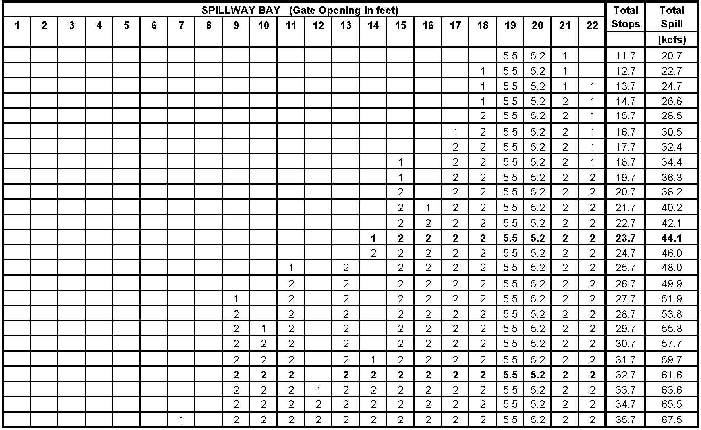
* TSWs in bays 19 and 20 have flows equivalent to 5.5 and 5.2 stops, respectively, at forebay elevation of 339 feet.
* Raise gates for TSWs approximately 3-5 feet above water surface to ensure free surface and debris passage.

Table MCN-7 (pg 2 of 5). McNary Dam Spill Pattern for Fish Passage (discharge at forebay elevation 339 ft). *
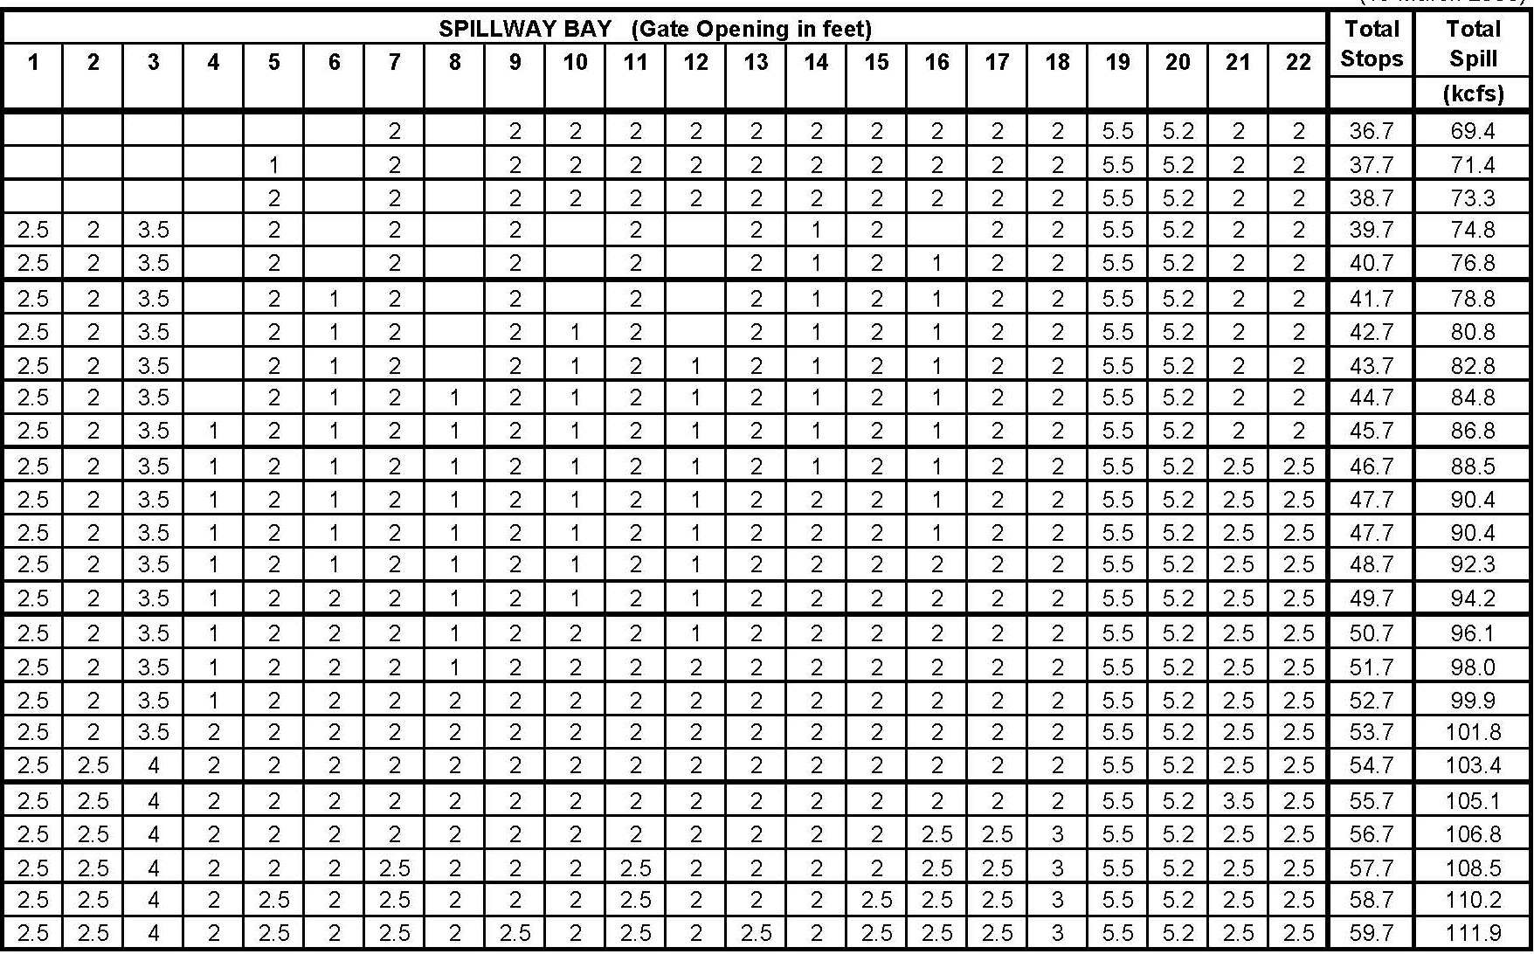
* TSWs in bays 19 and 20 have flows equivalent to 5.5 and 5.2 stops, respectively, at forebay elevation of 339 feet.
* Raise gates for TSWs approximately 3-5 feet above water surface to ensure free surface and debris passage.

Table MCN-7 (pg 3 of 5). McNary Dam Spill Pattern for Fish Passage (discharge at forebay elevation 339 ft). *
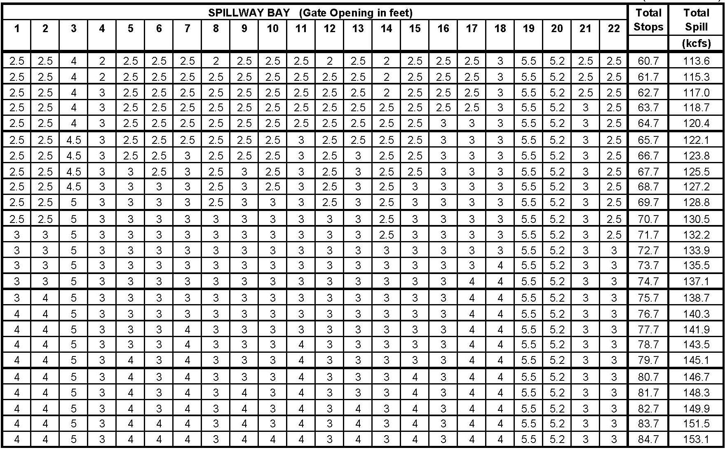
* TSWs in bays 19 and 20 have flows equivalent to 5.5 and 5.2 stops, respectively, at forebay elevation of 339 feet.
* Raise gates for TSWs approximately 3-5 feet above water surface to ensure free surface and debris passage.

Table MCN-7 (pg 4 of 5). McNary Dam Spill Pattern for Fish Passage (discharge at forebay elevation 339 ft). *
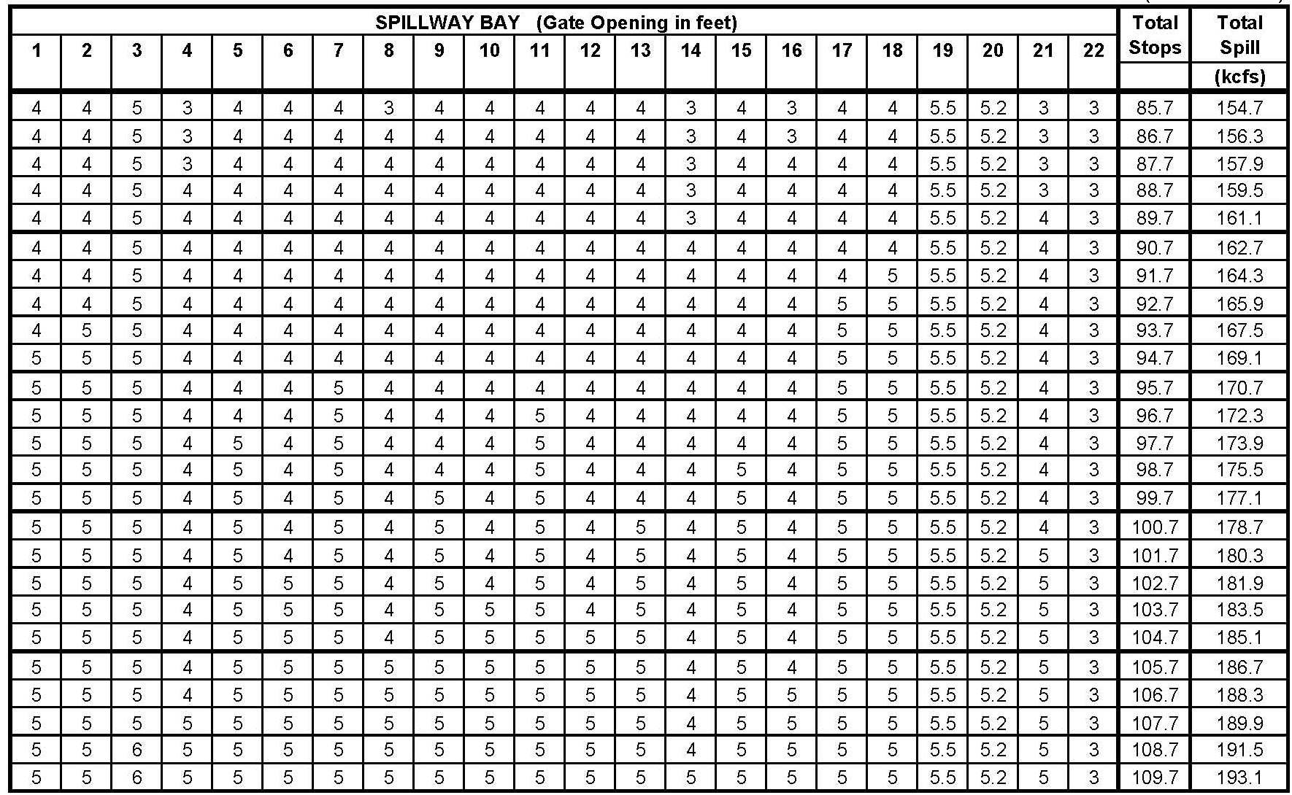
* TSWs in bays 19 and 20 have flows equivalent to 5.5 and 5.2 stops, respectively, at forebay elevation of 339 feet.
* Raise gates for TSWs approximately 3-5 feet above water surface to ensure free surface and debris passage.
Table MCN-7 (pg 5 of 5). McNary Dam Spill Pattern for Fish Passage (discharge at forebay elevation 339 ft). *
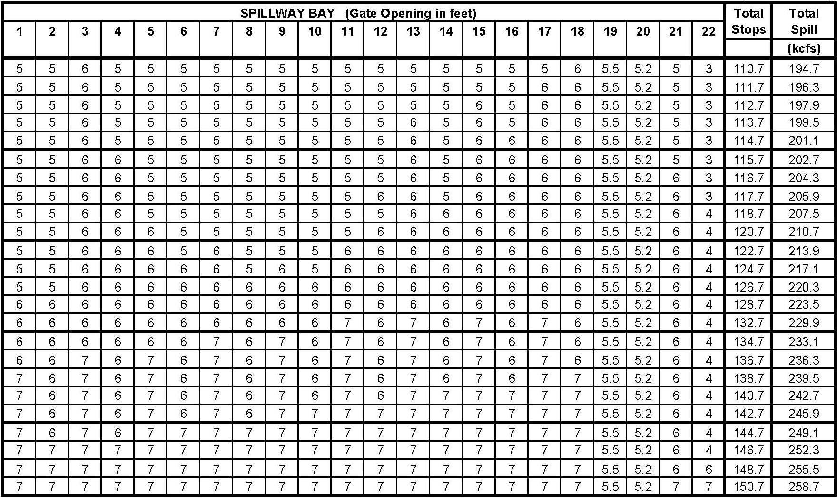
* TSWs in bays 19 and 20 have flows equivalent to 5.5 and 5.2 stops, respectively, at forebay elevation of 339 feet.
* Raise gates for TSWs approximately 3-5 feet above water surface to ensure free surface and debris passage.
Table MCN-. McNary Dam Spill Pattern for Navigation (discharge at forebay elevation 339 ft). *
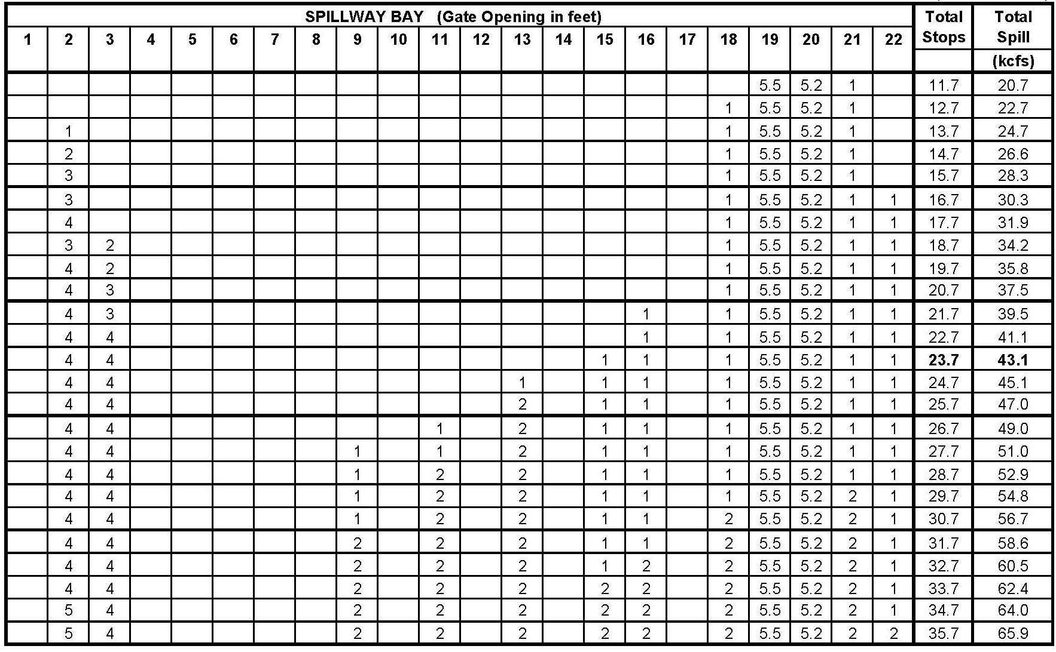
* TSWs in bays 19 and 20 have flows equivalent to 5.5 and 5.2 stops, respectively, at forebay elevation of 339 feet.
* Raise gates for TSWs approximately 3-5 feet above water surface to ensure free surface and debris passage.

Table MCN- (pg 1 of 5). McNary Dam Spill Pattern After Both TSWs Removed (discharge in kcfs at Forebay Elevation 339 ft). *
Spill  (kcfs) | Spillbay – No TSWs Installed |  |  |  |  |  |  |  |  |  |  |  |  |  |  |  |  |  |  |  |  |  | Total  Stops
Spill  (kcfs) | 1 | 2 | 3 | 4 | 5 | 6 | 7 | 8 | 9 | 10 | 11 | 12 | 13 | 14 | 15 | 16 | 17 | 18 | 19 | 20 | 21 | 22 | Total  Stops
3.9 |  |  |  |  |  |  |  |  |  |  |  |  |  |  |  |  |  |  | 2 |  |  |  | 2
7.8 |  |  |  |  |  |  |  |  |  |  |  |  |  |  |  |  |  |  | 2 | 2 |  |  | 4
9.5 |  |  |  |  |  |  |  |  |  |  |  |  |  |  |  |  |  |  | 2.5 | 2.5 |  |  | 5
11.7 |  |  |  |  |  |  |  |  |  |  |  |  |  |  |  |  |  | 2 | 2 | 2 |  |  | 6
13.4 |  |  |  |  |  |  |  |  |  |  |  |  |  |  |  |  |  | 2 | 2.5 | 2.5 |  |  | 7
15.6 |  |  |  |  |  |  |  |  |  |  |  |  |  |  |  |  | 2 | 2 | 2 | 2 |  |  | 8
17.3 |  |  |  |  |  |  |  |  |  |  |  |  |  |  |  |  | 2 | 2.5 | 2.5 | 2 |  |  | 9
19.5 |  |  |  |  |  |  |  |  |  |  |  |  |  |  | 2 |  | 2 | 2 | 2 | 2 |  |  | 10
21.2 |  |  |  |  |  |  |  |  |  |  |  |  |  |  | 2 |  | 2 | 2.5 | 2.5 | 2 |  |  | 11
23.4 |  |  |  |  |  |  |  |  |  |  |  |  | 2 |  | 2 |  | 2 | 2 | 2 | 2 |  |  | 12
25.1 |  |  |  |  |  |  |  |  |  |  |  |  | 2 |  | 2 |  | 2 | 2.5 | 2.5 | 2 |  |  | 13
27.3 |  |  |  |  |  |  |  |  |  |  | 2 |  | 2 |  | 2 |  | 2 | 2 | 2 | 2 |  |  | 14
29.0 |  |  |  |  |  |  |  |  |  |  | 2 |  | 2 |  | 2 |  | 2 | 2.5 | 2.5 | 2 |  |  | 15
31.2 |  |  |  |  |  |  |  |  | 2 |  | 2 |  | 2 |  | 2 |  | 2 | 2 | 2 | 2 |  |  | 16
32.9 |  |  |  |  |  |  |  |  | 2 |  | 2 |  | 2 |  | 2 |  | 2 | 2.5 | 2.5 | 2 |  |  | 17
35.1 |  |  |  |  |  |  |  |  | 2 |  | 2 |  | 2 |  | 2 | 2 | 2 | 2 | 2 | 2 |  |  | 18
36.8 |  |  |  |  |  |  |  |  | 2 |  | 2 |  | 2 |  | 2 | 2 | 2.5 | 2 | 2.5 | 2 |  |  | 19
39.0 |  |  |  |  |  |  | 2 |  | 2 |  | 2 |  | 2 |  | 2 | 2 | 2 | 2 | 2 | 2 |  |  | 20
40.7 |  |  |  |  |  |  | 2 |  | 2 |  | 2 |  | 2 |  | 2 | 2 | 2.5 | 2 | 2.5 | 2 |  |  | 21
42.9 |  |  |  |  | 2 |  | 2 |  | 2 |  | 2 |  | 2 |  | 2 | 2 | 2 | 2 | 2 | 2 |  |  | 22
44.6 |  |  |  |  | 2 |  | 2 |  | 2 |  | 2 |  | 2 |  | 2 | 2 | 2.5 | 2 | 2.5 | 2 |  |  | 23
46.8 |  |  |  |  | 2 |  | 2 |  | 2 |  | 2 |  | 2 | 2 | 2 | 2 | 2 | 2 | 2 | 2 |  |  | 24
48.5 |  |  |  |  | 2 |  | 2 |  | 2 |  | 2 |  | 2 | 2 | 2 | 2.5 | 2 | 2.5 | 2 | 2 |  |  | 25
50.7 |  |  |  |  | 2 |  | 2 |  | 2 |  | 2 |  | 2 | 2 | 2 | 2 | 2 | 2 | 2 | 2 | 2 |  | 26
52.4 |  |  |  |  | 2 |  | 2 |  | 2 |  | 2 |  | 2 | 2 | 2 | 2.5 | 2 | 2.5 | 2 | 2 | 2 |  | 27
54.6 |  |  |  |  | 2 |  | 2 |  | 2 |  | 2 |  | 2 | 2 | 2 | 2 | 2 | 2 | 2 | 2 | 2 | 2 | 28
56.3 |  |  |  |  | 2 |  | 2 |  | 2 |  | 2 |  | 2 | 2 | 2 | 2.5 | 2 | 2.5 | 2 | 2 | 2 | 2 | 29
58.5 |  |  |  |  | 2 |  | 2 |  | 2 |  | 2 | 2 | 2 | 2 | 2 | 2 | 2 | 2 | 2 | 2 | 2 | 2 | 30
60.2 |  |  |  |  | 2 |  | 2 |  | 2 |  | 2 | 2 | 2 | 2 | 2 | 2.5 | 2 | 2.5 | 2 | 2 | 2 | 2 | 31
61.9 |  |  |  |  | 2 |  | 2 |  | 2 |  | 2 | 2 | 2 | 2.5 | 2 | 2.5 | 2 | 2.5 | 2 | 2.5 | 2 | 2 | 32
63.6 |  |  |  |  | 2 |  | 2 |  | 2 |  | 2 | 2 | 2 | 2.5 | 2 | 2.5 | 2.5 | 2.5 | 2 | 2.5 | 2.5 | 2 | 33
65.3 |  |  |  |  | 2 |  | 2 |  | 2 |  | 2 | 2 | 2 | 2.5 | 2.5 | 2.5 | 2.5 | 2.5 | 2.5 | 2.5 | 2.5 | 2 | 34
67.0 |  |  |  |  | 2 |  | 2 |  | 2 |  | 2 | 2 | 2.5 | 2.5 | 2.5 | 2.5 | 2.5 | 2.5 | 2.5 | 2.5 | 2.5 | 2.5 | 35
68.7 |  |  |  |  | 2 |  | 2 |  | 2 |  | 2.5 | 2.5 | 2.5 | 2.5 | 2.5 | 2.5 | 2.5 | 2.5 | 2.5 | 2.5 | 2.5 | 2.5 | 36
70.4 |  |  |  |  | 2 |  | 2 |  | 2 |  | 2.5 | 2.5 | 2.5 | 2.5 | 2.5 | 3 | 2.5 | 3 | 2.5 | 2.5 | 2.5 | 2.5 | 37
71.3 | 2 | 3.5 | 3.5 | 2 | 2 | 2 | 2 | 2 | 2 | 2 | 2 | 2 | 2 | 2 | 2 | 2 | 2 |  |  |  |  |  | 37
73.0 | 2 | 3.5 | 3.5 | 2.5 | 2.5 | 2 | 2 | 2 | 2 | 2 | 2 | 2 | 2 | 2 | 2 | 2 | 2 |  |  |  |  |  | 38
74.7 | 2.5 | 3.5 | 3.5 | 2.5 | 2.5 | 2.5 | 2 | 2 | 2 | 2 | 2 | 2 | 2 | 2 | 2 | 2 | 2 |  |  |  |  |  | 39
76.3 | 2.5 | 4 | 4 | 2.5 | 2.5 | 2.5 | 2 | 2 | 2 | 2 | 2 | 2 | 2 | 2 | 2 | 2 | 2 |  |  |  |  |  | 40
78.0 | 2.5 | 4 | 4 | 2.5 | 2.5 | 2.5 | 2.5 | 2.5 | 2 | 2 | 2 | 2 | 2 | 2 | 2 | 2 | 2 |  |  |  |  |  | 41
79.6 | 2.5 | 4.5 | 4.5 | 2.5 | 2.5 | 2.5 | 2.5 | 2.5 | 2 | 2 | 2 | 2 | 2 | 2 | 2 | 2 | 2 |  |  |  |  |  | 42
81.3 | 2.5 | 4.5 | 4.5 | 2.5 | 2.5 | 2.5 | 2.5 | 2.5 | 2.5 | 2.5 | 2 | 2 | 2 | 2 | 2 | 2 | 2 |  |  |  |  |  | 43
82.9 | 2.5 | 5 | 5 | 2.5 | 2.5 | 2.5 | 2.5 | 2.5 | 2.5 | 2.5 | 2 | 2 | 2 | 2 | 2 | 2 | 2 |  |  |  |  |  | 44
85.1 | 2.5 | 5 | 5 | 2.5 | 2.5 | 2.5 | 2.5 | 2.5 | 2 | 2 | 2 | 2 | 2 | 2 | 2 | 2 | 2 | 2 |  |  |  |  | 45
86.8 | 2.5 | 5 | 5 | 2.5 | 2.5 | 2.5 | 2.5 | 2.5 | 2.5 | 2.5 | 2 | 2 | 2 | 2 | 2 | 2 | 2 | 2 |  |  |  |  | 46
88.5 | 2.5 | 5 | 5 | 2.5 | 2.5 | 2.5 | 2.5 | 2.5 | 2.5 | 2.5 | 2.5 | 2.5 | 2 | 2 | 2 | 2 | 2 | 2 |  |  |  |  | 47
90.2 | 2.5 | 5 | 5 | 2.5 | 2.5 | 2.5 | 2.5 | 2.5 | 2.5 | 2.5 | 2.5 | 2.5 | 2.5 | 2 | 2.5 | 2 | 2 | 2 |  |  |  |  | 48
92.4 | 2.5 | 5 | 5 | 2.5 | 2.5 | 2.5 | 2.5 | 2.5 | 2.5 | 2.5 | 2.5 | 2.5 | 2 | 2 | 2 | 2 | 2 | 2 | 2 |  |  |  | 49
94.1 | 2.5 | 5 | 5 | 2.5 | 2.5 | 2.5 | 2.5 | 2.5 | 2.5 | 2.5 | 2.5 | 2.5 | 2.5 | 2 | 2.5 | 2 | 2 | 2 | 2 |  |  |  | 50
95.8 | 2.5 | 5 | 5 | 2.5 | 2.5 | 2.5 | 2.5 | 2.5 | 2.5 | 2.5 | 2.5 | 2.5 | 2.5 | 2.5 | 2.5 | 2 | 2.5 | 2 | 2 |  |  |  | 51
98.0 | 2.5 | 5 | 5 | 2.5 | 2.5 | 2.5 | 2.5 | 2.5 | 2.5 | 2.5 | 2.5 | 2.5 | 2.5 | 2 | 2.5 | 2 | 2 | 2 | 2 | 2 |  |  | 52
99.7 | 2.5 | 5 | 5 | 2.5 | 2.5 | 2.5 | 2.5 | 2.5 | 2.5 | 2.5 | 2.5 | 2.5 | 2.5 | 2 | 2.5 | 2 | 2.5 | 2 | 2.5 | 2 |  |  | 53
101.4 | 3 | 5 | 5 | 2.5 | 2.5 | 2.5 | 2.5 | 2.5 | 2.5 | 2.5 | 2.5 | 2.5 | 2.5 | 2.5 | 2.5 | 2 | 2.5 | 2 | 2.5 | 2 |  |  | 54
103.1 | 3 | 5 | 5 | 2.5 | 2.5 | 2.5 | 2.5 | 2.5 | 2.5 | 2.5 | 2.5 | 2.5 | 2.5 | 2.5 | 2.5 | 2.5 | 2.5 | 2.5 | 2.5 | 2 |  |  | 55
105.3 | 3 | 5 | 5 | 2.5 | 2.5 | 2.5 | 2.5 | 2.5 | 2.5 | 2.5 | 2.5 | 2.5 | 2.5 | 2.5 | 2.5 | 2 | 2.5 | 2 | 2.5 | 2 | 2 |  | 56
107.0 | 3 | 5 | 5 | 2.5 | 2.5 | 2.5 | 2.5 | 2.5 | 2.5 | 2.5 | 2.5 | 2.5 | 2.5 | 2.5 | 2.5 | 2.5 | 2.5 | 2.5 | 2.5 | 2 | 2 |  | 57
108.7 | 3 | 5 | 5 | 3 | 3 | 2.5 | 2.5 | 2.5 | 2.5 | 2.5 | 2.5 | 2.5 | 2.5 | 2.5 | 2.5 | 2.5 | 2.5 | 2.5 | 2.5 | 2 | 2 |  | 58
110.4 | 3 | 5 | 5 | 3 | 3 | 3 | 3 | 2.5 | 2.5 | 2.5 | 2.5 | 2.5 | 2.5 | 2.5 | 2.5 | 2.5 | 2.5 | 2.5 | 2.5 | 2 | 2 |  | 59
112.1 | 3 | 5 | 5 | 3 | 3 | 3 | 3 | 2.5 | 2.5 | 2.5 | 2.5 | 2.5 | 2.5 | 2.5 | 2.5 | 2.5 | 2.5 | 2.5 | 2.5 | 2.5 | 2.5 |  | 60
114.3 | 3 | 5 | 5 | 3 | 3 | 3 | 3 | 2.5 | 2.5 | 2.5 | 2.5 | 2.5 | 2.5 | 2.5 | 2.5 | 2.5 | 2.5 | 2.5 | 2.5 | 2 | 2 | 2 | 61
116.0 | 3.5 | 5 | 5 | 3 | 3 | 3 | 3 | 2.5 | 2.5 | 2.5 | 2.5 | 2.5 | 2.5 | 2.5 | 2.5 | 2.5 | 2.5 | 2.5 | 2.5 | 2.5 | 2 | 2 | 62
117.7 | 3.5 | 5 | 5 | 3 | 3 | 3 | 3 | 2.5 | 2.5 | 2.5 | 2.5 | 2.5 | 2.5 | 2.5 | 2.5 | 2.5 | 2.5 | 2.5 | 2.5 | 2.5 | 2.5 | 2.5 | 63
119.4 | 3.5 | 5 | 5 | 3 | 3 | 3 | 3 | 3 | 3 | 2.5 | 2.5 | 2.5 | 2.5 | 2.5 | 2.5 | 2.5 | 2.5 | 2.5 | 2.5 | 2.5 | 2.5 | 2.5 | 64
121.1 | 3.5 | 5 | 5 | 3 | 3 | 3 | 3 | 3 | 3 | 3 | 3 | 2.5 | 2.5 | 2.5 | 2.5 | 2.5 | 2.5 | 2.5 | 2.5 | 2.5 | 2.5 | 2.5 | 65
122.8 | 3.5 | 5 | 5 | 3 | 3 | 3 | 3 | 3 | 3 | 3 | 3 | 2.5 | 3 | 2.5 | 3 | 2.5 | 2.5 | 2.5 | 2.5 | 2.5 | 2.5 | 2.5 | 66
124.5 | 3.5 | 5 | 5 | 3 | 3 | 3 | 3 | 3 | 3 | 3 | 3 | 2.5 | 3 | 2.5 | 3 | 2.5 | 3 | 2.5 | 3 | 2.5 | 2.5 | 2.5 | 67
126.0 | 3.5 | 6 | 6 | 3 | 3 | 3 | 3 | 3 | 3 | 3 | 3 | 2.5 | 3 | 2.5 | 3 | 2.5 | 2.5 | 2.5 | 2.5 | 2.5 | 2.5 | 2.5 | 68
127.6 | 4 | 6 | 6 | 3 | 3 | 3 | 3 | 3 | 3 | 3 | 3 | 2.5 | 3 | 2.5 | 3 | 2.5 | 3 | 2.5 | 2.5 | 2.5 | 2.5 | 2.5 | 69
129.3 | 4 | 6 | 6 | 3 | 3 | 3 | 3 | 3 | 3 | 3 | 3 | 3 | 3 | 2.5 | 3 | 2.5 | 3 | 2.5 | 3 | 2.5 | 2.5 | 2.5 | 70
131.0 | 4 | 6 | 6 | 3 | 3 | 3 | 3 | 3 | 3 | 3 | 3 | 3 | 3 | 3 | 3 | 3 | 3 | 2.5 | 3 | 2.5 | 2.5 | 2.5 | 71
132.7 | 4 | 6 | 6 | 3 | 3 | 3 | 3 | 3 | 3 | 3 | 3 | 3 | 3 | 3 | 3 | 3 | 3 | 3 | 3 | 3 | 2.5 | 2.5 | 72
134.4 | 4 | 6 | 6 | 3 | 3 | 3 | 3 | 3 | 3 | 3 | 3 | 3 | 3 | 3 | 3 | 3 | 3 | 3 | 3 | 3 | 3 | 3 | 73
136.0 | 4 | 6 | 6 | 3.5 | 3 | 3.5 | 3 | 3 | 3 | 3 | 3 | 3 | 3 | 3 | 3 | 3 | 3 | 3 | 3 | 3 | 3 | 3 | 74
137.6 | 4 | 6 | 6 | 3.5 | 3 | 3.5 | 3 | 3.5 | 3 | 3.5 | 3 | 3 | 3 | 3 | 3 | 3 | 3 | 3 | 3 | 3 | 3 | 3 | 75
139.2 | 4 | 6 | 6 | 3.5 | 3 | 3.5 | 3 | 3.5 | 3 | 3.5 | 3 | 3.5 | 3 | 3.5 | 3 | 3 | 3 | 3 | 3 | 3 | 3 | 3 | 76
140.8 | 4.5 | 7 | 7 | 3.5 | 3 | 3.5 | 3 | 3.5 | 3 | 3 | 3 | 3 | 3 | 3 | 3 | 3 | 3 | 3 | 3 | 3 | 3 | 3 | 77
142.4 | 4.5 | 7 | 7 | 3.5 | 3 | 3.5 | 3 | 3.5 | 3 | 3.5 | 3 | 3.5 | 3 | 3 | 3 | 3 | 3 | 3 | 3 | 3 | 3 | 3 | 78
144.0 | 4.5 | 7 | 7 | 3.5 | 3.5 | 3.5 | 3 | 3.5 | 3 | 3.5 | 3 | 3.5 | 3 | 3.5 | 3 | 3 | 3 | 3 | 3 | 3 | 3 | 3 | 79
145.6 | 4.5 | 7 | 7 | 3.5 | 3.5 | 3.5 | 3.5 | 3.5 | 3.5 | 3.5 | 3 | 3.5 | 3 | 3.5 | 3 | 3 | 3 | 3 | 3 | 3 | 3 | 3 | 80
147.2 | 4.5 | 7 | 7 | 4 | 3.5 | 4 | 3.5 | 3.5 | 3.5 | 3.5 | 3 | 3.5 | 3 | 3.5 | 3 | 3 | 3 | 3 | 3 | 3 | 3 | 3 | 81
148.8 | 4.5 | 7 | 7 | 4 | 3.5 | 4 | 3.5 | 3.5 | 3.5 | 3.5 | 3.5 | 3.5 | 3.5 | 3.5 | 3 | 3 | 3 | 3 | 3 | 3 | 3 | 3 | 82
150.4 | 4.5 | 7 | 7 | 4 | 3.5 | 4 | 3.5 | 3.5 | 3.5 | 3.5 | 3.5 | 3.5 | 3.5 | 3.5 | 3 | 3.5 | 3 | 3.5 | 3 | 3 | 3 | 3 | 83
152.0 | 4.5 | 7 | 7 | 4 | 3.5 | 4 | 3.5 | 3.5 | 3.5 | 3.5 | 3.5 | 3.5 | 3.5 | 3.5 | 3.5 | 3.5 | 3 | 3.5 | 3 | 3.5 | 3 | 3 | 84
153.6 | 4.5 | 7 | 7 | 4 | 3.5 | 4 | 3.5 | 3.5 | 3.5 | 3.5 | 3.5 | 3.5 | 3.5 | 3.5 | 3.5 | 3.5 | 3.5 | 3.5 | 3.5 | 3.5 | 3 | 3 | 85
155.2 | 4.5 | 7 | 7 | 4 | 3.5 | 4 | 3.5 | 3.5 | 3.5 | 3.5 | 3.5 | 3.5 | 3.5 | 3.5 | 3.5 | 3.5 | 3.5 | 3.5 | 3.5 | 3.5 | 3.5 | 3.5 | 86
157.0 | 4.5 | 8 | 8 | 4 | 3.5 | 4 | 3.5 | 3.5 | 3.5 | 3.5 | 3.5 | 3.5 | 3.5 | 3.5 | 3.5 | 3.5 | 3.5 | 3.5 | 3.5 | 3.5 | 3 | 3 | 87
158.6 | 4.5 | 8 | 8 | 4 | 3.5 | 4 | 3.5 | 3.5 | 3.5 | 3.5 | 3.5 | 3.5 | 3.5 | 3.5 | 3.5 | 3.5 | 3.5 | 3.5 | 3.5 | 3.5 | 3.5 | 3.5 | 88
160.2 | 4.5 | 8 | 8 | 4 | 3.5 | 4 | 3.5 | 3.5 | 3.5 | 3.5 | 3.5 | 3.5 | 3.5 | 3.5 | 3.5 | 4 | 3.5 | 4 | 3.5 | 3.5 | 3.5 | 3.5 | 89
161.8 | 4.5 | 8 | 8 | 4 | 3.5 | 4 | 3.5 | 3.5 | 3.5 | 3.5 | 3.5 | 3.5 | 3.5 | 4 | 3.5 | 4 | 3.5 | 4 | 3.5 | 4 | 3.5 | 3.5 | 90
163.4 | 4.5 | 8 | 8 | 4 | 3.5 | 4 | 3.5 | 3.5 | 3.5 | 4 | 3.5 | 4 | 3.5 | 4 | 3.5 | 4 | 3.5 | 4 | 3.5 | 4 | 3.5 | 3.5 | 91
165.0 | 4.5 | 8 | 8 | 4 | 3.5 | 4 | 3.5 | 4 | 3.5 | 4 | 3.5 | 4 | 3.5 | 4 | 3.5 | 4 | 3.5 | 4 | 3.5 | 4 | 3.5 | 4 | 92
166.6 | 4.5 | 8 | 8 | 4 | 3.5 | 4 | 3.5 | 4 | 3.5 | 4 | 3.5 | 4 | 3.5 | 4 | 3.5 | 4 | 4 | 4 | 4 | 4 | 3.5 | 4 | 93
168.2 | 4.5 | 8 | 8 | 4 | 3.5 | 4 | 3.5 | 4 | 3.5 | 4 | 3.5 | 4 | 4 | 4 | 4 | 4 | 4 | 4 | 4 | 4 | 3.5 | 4 | 94
169.8 | 4.5 | 8 | 8 | 4 | 3.5 | 4 | 3.5 | 4 | 3.5 | 4 | 4 | 4 | 4 | 4 | 4 | 4 | 4 | 4 | 4 | 4 | 4 | 4 | 95
171.4 | 4.5 | 8 | 8 | 4 | 3.5 | 4 | 3.5 | 4 | 3.5 | 4 | 4 | 4 | 4 | 4 | 4 | 4.5 | 4 | 4.5 | 4 | 4 | 4 | 4 | 96
173.0 | 4.5 | 8 | 8 | 4 | 3.5 | 4 | 3.5 | 4 | 3.5 | 4 | 4 | 4 | 4 | 4 | 4 | 4.5 | 4.5 | 4.5 | 4.5 | 4 | 4 | 4 | 97
174.6 | 4.5 | 8 | 8 | 4 | 3.5 | 4 | 3.5 | 4 | 3.5 | 4 | 4 | 4 | 4 | 4.5 | 4 | 4.5 | 4.5 | 4.5 | 4.5 | 4.5 | 4 | 4 | 98
176.2 | 5 | 8 | 8 | 4 | 3.5 | 4 | 3.5 | 4 | 4 | 4 | 4 | 4 | 4 | 4.5 | 4 | 4.5 | 4.5 | 4.5 | 4.5 | 4.5 | 4 | 4 | 99
177.8 | 5 | 8 | 8 | 4 | 3.5 | 4 | 3.5 | 4 | 4 | 4.5 | 4 | 4.5 | 4 | 4.5 | 4 | 4.5 | 4.5 | 4.5 | 4.5 | 4.5 | 4 | 4 | 100
179.4 | 5 | 8 | 8 | 4 | 3.5 | 4 | 3.5 | 4 | 4 | 4.5 | 4 | 4.5 | 4 | 4.5 | 4.5 | 4.5 | 4.5 | 4.5 | 4.5 | 4.5 | 4.5 | 4 | 101
181.0 | 5 | 8 | 8 | 4 | 3.5 | 4 | 3.5 | 4 | 4 | 4.5 | 4 | 4.5 | 4.5 | 4.5 | 4.5 | 4.5 | 4.5 | 4.5 | 4.5 | 4.5 | 4.5 | 4.5 | 102
182.6 | 5 | 8 | 8 | 4 | 3.5 | 4 | 3.5 | 4 | 4 | 4.5 | 4 | 4.5 | 4.5 | 4.5 | 4.5 | 5 | 4.5 | 5 | 4.5 | 4.5 | 4.5 | 4.5 | 103
184.2 | 5 | 8 | 8 | 4 | 3.5 | 4 | 3.5 | 4 | 4 | 4.5 | 4 | 4.5 | 4.5 | 5 | 4.5 | 5 | 4.5 | 5 | 4.5 | 5 | 4.5 | 4.5 | 104
185.8 | 5 | 8 | 8 | 4 | 4 | 4 | 4 | 4 | 4 | 4.5 | 4 | 4.5 | 4.5 | 5 | 4.5 | 5 | 4.5 | 5 | 4.5 | 5 | 4.5 | 4.5 | 105
187.4 | 5 | 8 | 8 | 4 | 4 | 4 | 4 | 4.5 | 4 | 4.5 | 4 | 4.5 | 4.5 | 5 | 4.5 | 5 | 5 | 5 | 4.5 | 5 | 4.5 | 4.5 | 106
189.0 | 6 | 8 | 8 | 4 | 4 | 4 | 4 | 4.5 | 4 | 4.5 | 4 | 4.5 | 4.5 | 5 | 4.5 | 5 | 5 | 5 | 4.5 | 5 | 4.5 | 4.5 | 107
190.6 | 6 | 8 | 8 | 4 | 4 | 4 | 4 | 4.5 | 4 | 4.5 | 4 | 4.5 | 4.5 | 5 | 5 | 5 | 5 | 5 | 5 | 5 | 4.5 | 4.5 | 108
192.2 | 6 | 8 | 8 | 4 | 4 | 4 | 4 | 4.5 | 4 | 4.5 | 4.5 | 4.5 | 4.5 | 5 | 5 | 5 | 5 | 5 | 5 | 5 | 5 | 4.5 | 109
193.8 | 6 | 8 | 8 | 4.5 | 4 | 4.5 | 4 | 4.5 | 4 | 4.5 | 4.5 | 4.5 | 4.5 | 5 | 5 | 5 | 5 | 5 | 5 | 5 | 5 | 4.5 | 110
195.4 | 6 | 8 | 8 | 4.5 | 4 | 4.5 | 4 | 4.5 | 4.5 | 4.5 | 4.5 | 5 | 4.5 | 5 | 5 | 5 | 5 | 5 | 5 | 5 | 5 | 4.5 | 111
197.0 | 6 | 8 | 8 | 4.5 | 4 | 4.5 | 4.5 | 4.5 | 4.5 | 5 | 4.5 | 5 | 4.5 | 5 | 5 | 5 | 5 | 5 | 5 | 5 | 5 | 4.5 | 112
198.6 | 6 | 8 | 8 | 4.5 | 4.5 | 4.5 | 4.5 | 5 | 4.5 | 5 | 4.5 | 5 | 4.5 | 5 | 5 | 5 | 5 | 5 | 5 | 5 | 5 | 4.5 | 113
200.2 | 6 | 8 | 8 | 5 | 4.5 | 5 | 4.5 | 5 | 4.5 | 5 | 4.5 | 5 | 4.5 | 5 | 5 | 5 | 5 | 5 | 5 | 5 | 5 | 4.5 | 114
201.8 | 6 | 8 | 8 | 5 | 4.5 | 5 | 4.5 | 5 | 4.5 | 5 | 4.5 | 5 | 5 | 5 | 5 | 5 | 5 | 5 | 5 | 5 | 5 | 5 | 115
203.4 | 6 | 8 | 8 | 5 | 4.5 | 5 | 4.5 | 5 | 4.5 | 5 | 4.5 | 5 | 5 | 5 | 5 | 5 | 6 | 5 | 5 | 5 | 5 | 5 | 116
206.6 | 6 | 8 | 8 | 5 | 4.5 | 5 | 4.5 | 5 | 4.5 | 5 | 4.5 | 5 | 5 | 5 | 6 | 5 | 6 | 5 | 6 | 5 | 5 | 5 | 118
209.8 | 6 | 8 | 8 | 5 | 4.5 | 5 | 4.5 | 5 | 4.5 | 5 | 4.5 | 5 | 6 | 5 | 6 | 5 | 6 | 5 | 6 | 5 | 6 | 5 | 120
213.0 | 6 | 8 | 8 | 5 | 4.5 | 5 | 4.5 | 5 | 4.5 | 5 | 4.5 | 5 | 6 | 5 | 6 | 6 | 6 | 6 | 6 | 5 | 6 | 5 | 122
216.2 | 6 | 8 | 8 | 5 | 5 | 5 | 5 | 5 | 5 | 5 | 5 | 5 | 6 | 5 | 6 | 6 | 6 | 6 | 6 | 5 | 6 | 5 | 124
219.4 | 7 | 9 | 8 | 5 | 5 | 5 | 5 | 5 | 5 | 5 | 5 | 5 | 6 | 5 | 6 | 6 | 6 | 6 | 6 | 5 | 6 | 5 | 126
222.6 | 7 | 9 | 8 | 5 | 5 | 5 | 5 | 5 | 5 | 5 | 5 | 5 | 6 | 6 | 6 | 6 | 6 | 6 | 6 | 6 | 6 | 5 | 128
225.8 | 7 | 9 | 8 | 5 | 5 | 5 | 5 | 5 | 5 | 5 | 5 | 6 | 6 | 6 | 6 | 6 | 6 | 6 | 6 | 6 | 6 | 6 | 130
229.0 | 7 | 9 | 8 | 5 | 5 | 5 | 5 | 5 | 5 | 6 | 6 | 6 | 6 | 6 | 6 | 6 | 6 | 6 | 6 | 6 | 6 | 6 | 132
232.2 | 7 | 9 | 8 | 5 | 5 | 5 | 5 | 5 | 5 | 6 | 6 | 6 | 6 | 6 | 7 | 6 | 6 | 7 | 6 | 6 | 6 | 6 | 134
235.4 | 7 | 9 | 8 | 5 | 5 | 5 | 5 | 5 | 5 | 6 | 6 | 6 | 6 | 6 | 7 | 7 | 6 | 7 | 7 | 6 | 6 | 6 | 136
238.6 | 7 | 9 | 8 | 5 | 5 | 5 | 5 | 5 | 5 | 6 | 6 | 6 | 6 | 7 | 7 | 7 | 7 | 7 | 7 | 6 | 6 | 6 | 138
241.8 | 7 | 9 | 8 | 5 | 5 | 5 | 5 | 6 | 6 | 6 | 6 | 6 | 6 | 7 | 7 | 7 | 7 | 7 | 7 | 6 | 6 | 6 | 140
245.1 | 7 | 9 | 8 | 5 | 5 | 5 | 5 | 6 | 6 | 6 | 6 | 6 | 6 | 7 | 7 | 7 | 8 | 7 | 7 | 7 | 6 | 6 | 142
248.5 | 7 | 9 | 8 | 5 | 5 | 5 | 5 | 6 | 6 | 6 | 6 | 6 | 6 | 7 | 8 | 7 | 8 | 7 | 8 | 7 | 6 | 6 | 144
251.7 | 7 | 9 | 8 | 5 | 5 | 5 | 5 | 6 | 6 | 7 | 6 | 7 | 6 | 7 | 8 | 7 | 8 | 7 | 8 | 7 | 6 | 6 | 146
254.9 | 7 | 9 | 8 | 6 | 5 | 6 | 5 | 6 | 6 | 7 | 6 | 7 | 6 | 7 | 8 | 7 | 8 | 7 | 8 | 7 | 6 | 6 | 148
258.1 | 7 | 9 | 8 | 6 | 5 | 6 | 5 | 6 | 6 | 7 | 6 | 7 | 7 | 7 | 8 | 7 | 8 | 7 | 8 | 7 | 7 | 6 | 150
261.4 | 7 | 9 | 8 | 6 | 5 | 6 | 5 | 6 | 6 | 7 | 6 | 7 | 8 | 7 | 8 | 7 | 8 | 7 | 8 | 7 | 7 | 7 | 152
264.6 | 7 | 9 | 8 | 6 | 6 | 6 | 6 | 6 | 6 | 7 | 6 | 7 | 8 | 7 | 8 | 7 | 8 | 7 | 8 | 7 | 7 | 7 | 154
267.9 | 7 | 9 | 8 | 6 | 6 | 6 | 6 | 6 | 6 | 7 | 7 | 7 | 8 | 7 | 8 | 8 | 8 | 7 | 8 | 7 | 7 | 7 | 156
271.3 | 7 | 9 | 8 | 6 | 6 | 6 | 6 | 6 | 6 | 7 | 7 | 7 | 8 | 8 | 8 | 8 | 8 | 8 | 8 | 7 | 7 | 7 | 158
274.7 | 7 | 9 | 8 | 6 | 6 | 6 | 6 | 6 | 6 | 7 | 7 | 8 | 8 | 8 | 8 | 8 | 8 | 8 | 8 | 8 | 7 | 7 | 160
277.9 | 7 | 9 | 8 | 6 | 6 | 7 | 6 | 6 | 7 | 7 | 7 | 8 | 8 | 8 | 8 | 8 | 8 | 8 | 8 | 8 | 7 | 7 | 162
281.3 | 7 | 9 | 8 | 6 | 6 | 7 | 6 | 6 | 7 | 7 | 8 | 8 | 8 | 8 | 8 | 8 | 8 | 8 | 8 | 8 | 8 | 7 | 164
284.5 | 7 | 9 | 8 | 7 | 6 | 7 | 6 | 7 | 7 | 7 | 8 | 8 | 8 | 8 | 8 | 8 | 8 | 8 | 8 | 8 | 8 | 7 | 166
287.9 | 7 | 9 | 8 | 7 | 6 | 7 | 6 | 7 | 7 | 8 | 8 | 8 | 8 | 8 | 8 | 8 | 8 | 8 | 8 | 8 | 8 | 8 | 168
291.1 | 7 | 9 | 8 | 7 | 7 | 7 | 7 | 7 | 7 | 8 | 8 | 8 | 8 | 8 | 8 | 8 | 8 | 8 | 8 | 8 | 8 | 8 | 170
294.5 | 8 | 9 | 8 | 7 | 7 | 7 | 7 | 7 | 8 | 8 | 8 | 8 | 8 | 8 | 8 | 8 | 8 | 8 | 8 | 8 | 8 | 8 | 172
297.9 | 8 | 9 | 8 | 7 | 8 | 7 | 8 | 7 | 8 | 8 | 8 | 8 | 8 | 8 | 8 | 8 | 8 | 8 | 8 | 8 | 8 | 8 | 174
301.3 | 8 | 9 | 8 | 7 | 8 | 8 | 8 | 8 | 8 | 8 | 8 | 8 | 8 | 8 | 8 | 8 | 8 | 8 | 8 | 8 | 8 | 8 | 176
* Special care MAY be required to open and close Bays 1 & 22. (This will need to be verified by field testing.)
Opening sequence:
a) Open Bays 2 – 21 first, as specified in the spill pattern table.
b) After Bays 2 - 21 have been set and operating for at least 10 minutes, open Bays 1 & 22 to their desired settings.
Closing Sequence:
a) Close Bays 1 & 22 prior to closing Bays 2-21.
Table MCN- (pg 1 of 3). McNary Dam Spill Pattern During TSW Removal (discharge in kcfs at Forebay Elevation 339 ft).*
Spill (kcfs) | Spillbay – During TSW Removal |  |  |  |  |  |  |  |  |  |  |  |  |  |  |  |  |  |  |  |  |  | Total  Stops
Spill (kcfs) | 1 | 2 | 3 | 4 | 5 | 6 | 7 | 8 | 9 | 10 | 11 | 12 | 13 | 14 | 15 | 16 | 17 | 18 | 19 | 20 | 21 | 22 | Total  Stops
73.5 | 2 | 3 | 4 | 3 | 2 | 2 | 2 | 2 | 2 | 2 | 2 | 2 | 2 | 2 | 2 | 2 | 2 |  |  |  |  |  | 38
75.1 | 2 | 4 | 4 | 3 | 2 | 2 | 2 | 2 | 2 | 2 | 2 | 2 | 2 | 2 | 2 | 2 | 2 |  |  |  |  |  | 39
76.8 | 3 | 4 | 4 | 3 | 2 | 2 | 2 | 2 | 2 | 2 | 2 | 2 | 2 | 2 | 2 | 2 | 2 |  |  |  |  |  | 40
78.4 | 3 | 4 | 4 | 3 | 3 | 2 | 2 | 2 | 2 | 2 | 2 | 2 | 2 | 2 | 2 | 2 | 2 |  |  |  |  |  | 41
80.1 | 3 | 4 | 4 | 3 | 3 | 3 | 2 | 2 | 2 | 2 | 2 | 2 | 2 | 2 | 2 | 2 | 2 |  |  |  |  |  | 42
81.6 | 3 | 4 | 5 | 3 | 3 | 3 | 2 | 2 | 2 | 2 | 2 | 2 | 2 | 2 | 2 | 2 | 2 |  |  |  |  |  | 43
83.2 | 3 | 5 | 5 | 3 | 3 | 3 | 2 | 2 | 2 | 2 | 2 | 2 | 2 | 2 | 2 | 2 | 2 |  |  |  |  |  | 44
84.9 | 3 | 5 | 5 | 3 | 3 | 3 | 3 | 2 | 2 | 2 | 2 | 2 | 2 | 2 | 2 | 2 | 2 |  |  |  |  |  | 45
86.5 | 3 | 5 | 5 | 3 | 3 | 3 | 3 | 3 | 2 | 2 | 2 | 2 | 2 | 2 | 2 | 2 | 2 |  |  |  |  |  | 46
88.2 | 3 | 5 | 5 | 3 | 3 | 3 | 3 | 3 | 3 | 2 | 2 | 2 | 2 | 2 | 2 | 2 | 2 |  |  |  |  |  | 47
89.8 | 3 | 5 | 5 | 3 | 3 | 3 | 3 | 3 | 3 | 3 | 2 | 2 | 2 | 2 | 2 | 2 | 2 |  |  |  |  |  | 48
91.5 | 3 | 5 | 5 | 3 | 3 | 3 | 3 | 3 | 3 | 3 | 3 | 2 | 2 | 2 | 2 | 2 | 2 |  |  |  |  |  | 49
93.1 | 3 | 5 | 5 | 3 | 3 | 3 | 3 | 3 | 3 | 3 | 3 | 3 | 2 | 2 | 2 | 2 | 2 |  |  |  |  |  | 50
94.8 | 3 | 5 | 5 | 3 | 3 | 3 | 3 | 3 | 3 | 3 | 3 | 3 | 3 | 2 | 2 | 2 | 2 |  |  |  |  |  | 51
96.4 | 4 | 5 | 5 | 3 | 3 | 3 | 3 | 3 | 3 | 3 | 3 | 3 | 3 | 2 | 2 | 2 | 2 |  |  |  |  |  | 52
98.1 | 4 | 5 | 5 | 4 | 3 | 3 | 3 | 3 | 3 | 3 | 3 | 3 | 3 | 2 | 2 | 2 | 2 |  |  |  |  |  | 53
99.7 | 4 | 5 | 5 | 4 | 4 | 3 | 3 | 3 | 3 | 3 | 3 | 3 | 3 | 2 | 2 | 2 | 2 |  |  |  |  |  | 54
101.3 | 4 | 5 | 6 | 4 | 4 | 3 | 3 | 3 | 3 | 3 | 3 | 3 | 3 | 2 | 2 | 2 | 2 |  |  |  |  |  | 55
102.9 | 4 | 6 | 6 | 4 | 4 | 3 | 3 | 3 | 3 | 3 | 3 | 3 | 3 | 2 | 2 | 2 | 2 |  |  |  |  |  | 56
104.6 | 4 | 6 | 6 | 4 | 4 | 4 | 3 | 3 | 3 | 3 | 3 | 3 | 3 | 2 | 2 | 2 | 2 |  |  |  |  |  | 57
106.2 | 4 | 6 | 6 | 4 | 4 | 4 | 4 | 3 | 3 | 3 | 3 | 3 | 3 | 2 | 2 | 2 | 2 |  |  |  |  |  | 58
107.9 | 4 | 6 | 6 | 4 | 4 | 4 | 4 | 4 | 3 | 3 | 3 | 3 | 3 | 2 | 2 | 2 | 2 |  |  |  |  |  | 59
109.5 | 4 | 6 | 6 | 4 | 4 | 4 | 4 | 4 | 4 | 3 | 3 | 3 | 3 | 2 | 2 | 2 | 2 |  |  |  |  |  | 60
111.2 | 4 | 6 | 6 | 4 | 4 | 4 | 4 | 4 | 4 | 4 | 3 | 3 | 3 | 2 | 2 | 2 | 2 |  |  |  |  |  | 61
112.8 | 4 | 6 | 6 | 4 | 4 | 4 | 4 | 4 | 4 | 4 | 4 | 3 | 3 | 2 | 2 | 2 | 2 |  |  |  |  |  | 62
114.5 | 4 | 6 | 6 | 4 | 4 | 4 | 4 | 4 | 4 | 4 | 4 | 4 | 3 | 2 | 2 | 2 | 2 |  |  |  |  |  | 63
116.1 | 4 | 6 | 6 | 4 | 4 | 4 | 4 | 4 | 4 | 4 | 4 | 4 | 4 | 2 | 2 | 2 | 2 |  |  |  |  |  | 64
117.8 | 4 | 6 | 6 | 4 | 4 | 4 | 4 | 4 | 4 | 4 | 4 | 4 | 4 | 3 | 2 | 2 | 2 |  |  |  |  |  | 65
119.4 | 4 | 6 | 6 | 4 | 4 | 4 | 4 | 4 | 4 | 4 | 4 | 4 | 4 | 3 | 3 | 2 | 2 |  |  |  |  |  | 66
121.1 | 4 | 6 | 6 | 4 | 4 | 4 | 4 | 4 | 4 | 4 | 4 | 4 | 4 | 3 | 3 | 3 | 2 |  |  |  |  |  | 67
122.7 | 4 | 6 | 6 | 4 | 4 | 4 | 4 | 4 | 4 | 4 | 4 | 4 | 4 | 3 | 3 | 3 | 3 |  |  |  |  |  | 68
124.3 | 5 | 6 | 6 | 4 | 4 | 4 | 4 | 4 | 4 | 4 | 4 | 4 | 4 | 3 | 3 | 3 | 3 |  |  |  |  |  | 69
125.8 | 5 | 6 | 6 | 5 | 4 | 4 | 4 | 4 | 4 | 4 | 4 | 4 | 4 | 3 | 3 | 3 | 3 |  |  |  |  |  | 70
127.4 | 5 | 6 | 6 | 5 | 5 | 4 | 4 | 4 | 4 | 4 | 4 | 4 | 4 | 3 | 3 | 3 | 3 |  |  |  |  |  | 71
129.1 | 5 | 6 | 7 | 5 | 5 | 4 | 4 | 4 | 4 | 4 | 4 | 4 | 4 | 3 | 3 | 3 | 3 |  |  |  |  |  | 72
130.7 | 5 | 7 | 7 | 5 | 5 | 4 | 4 | 4 | 4 | 4 | 4 | 4 | 4 | 3 | 3 | 3 | 3 |  |  |  |  |  | 73
132.3 | 5 | 7 | 7 | 5 | 5 | 5 | 4 | 4 | 4 | 4 | 4 | 4 | 4 | 3 | 3 | 3 | 3 |  |  |  |  |  | 74
133.8 | 5 | 7 | 7 | 5 | 5 | 5 | 5 | 4 | 4 | 4 | 4 | 4 | 4 | 3 | 3 | 3 | 3 |  |  |  |  |  | 75
135.4 | 5 | 7 | 7 | 5 | 5 | 5 | 5 | 5 | 4 | 4 | 4 | 4 | 4 | 3 | 3 | 3 | 3 |  |  |  |  |  | 76
136.9 | 5 | 7 | 7 | 5 | 5 | 5 | 5 | 5 | 5 | 4 | 4 | 4 | 4 | 3 | 3 | 3 | 3 |  |  |  |  |  | 77
138.5 | 5 | 7 | 7 | 5 | 5 | 5 | 5 | 5 | 5 | 5 | 4 | 4 | 4 | 3 | 3 | 3 | 3 |  |  |  |  |  | 78
140.1 | 5 | 7 | 7 | 5 | 5 | 5 | 5 | 5 | 5 | 5 | 5 | 4 | 4 | 3 | 3 | 3 | 3 |  |  |  |  |  | 79
141.6 | 5 | 7 | 7 | 5 | 5 | 5 | 5 | 5 | 5 | 5 | 5 | 5 | 4 | 3 | 3 | 3 | 3 |  |  |  |  |  | 80
143.2 | 5 | 7 | 7 | 5 | 5 | 5 | 5 | 5 | 5 | 5 | 5 | 5 | 5 | 3 | 3 | 3 | 3 |  |  |  |  |  | 81
144.8 | 5 | 7 | 7 | 5 | 5 | 5 | 5 | 5 | 5 | 5 | 5 | 5 | 5 | 4 | 3 | 3 | 3 |  |  |  |  |  | 82
146.5 | 5 | 7 | 7 | 5 | 5 | 5 | 5 | 5 | 5 | 5 | 5 | 5 | 5 | 4 | 4 | 3 | 3 |  |  |  |  |  | 83
148.1 | 5 | 7 | 7 | 5 | 5 | 5 | 5 | 5 | 5 | 5 | 5 | 5 | 5 | 4 | 4 | 4 | 3 |  |  |  |  |  | 84
149.8 | 5 | 7 | 7 | 5 | 5 | 5 | 5 | 5 | 5 | 5 | 5 | 5 | 5 | 4 | 4 | 4 | 4 |  |  |  |  |  | 85
151.3 | 6 | 7 | 7 | 5 | 5 | 5 | 5 | 5 | 5 | 5 | 5 | 5 | 5 | 4 | 4 | 4 | 4 |  |  |  |  |  | 86
152.9 | 6 | 7 | 7 | 6 | 5 | 5 | 5 | 5 | 5 | 5 | 5 | 5 | 5 | 4 | 4 | 4 | 4 |  |  |  |  |  | 87
154.5 | 6 | 7 | 7 | 6 | 6 | 5 | 5 | 5 | 5 | 5 | 5 | 5 | 5 | 4 | 4 | 4 | 4 |  |  |  |  |  | 88
156.1 | 6 | 7 | 8 | 6 | 6 | 5 | 5 | 5 | 5 | 5 | 5 | 5 | 5 | 4 | 4 | 4 | 4 |  |  |  |  |  | 89
157.7 | 6 | 8 | 8 | 6 | 6 | 5 | 5 | 5 | 5 | 5 | 5 | 5 | 5 | 4 | 4 | 4 | 4 |  |  |  |  |  | 90
159.3 | 6 | 8 | 8 | 6 | 6 | 6 | 5 | 5 | 5 | 5 | 5 | 5 | 5 | 4 | 4 | 4 | 4 |  |  |  |  |  | 91
160.9 | 6 | 8 | 8 | 6 | 6 | 6 | 6 | 5 | 5 | 5 | 5 | 5 | 5 | 4 | 4 | 4 | 4 |  |  |  |  |  | 92
162.5 | 6 | 8 | 8 | 6 | 6 | 6 | 6 | 6 | 5 | 5 | 5 | 5 | 5 | 4 | 4 | 4 | 4 |  |  |  |  |  | 93
164.1 | 6 | 8 | 8 | 6 | 6 | 6 | 6 | 6 | 6 | 5 | 5 | 5 | 5 | 4 | 4 | 4 | 4 |  |  |  |  |  | 94
165.7 | 6 | 8 | 8 | 6 | 6 | 6 | 6 | 6 | 6 | 6 | 5 | 5 | 5 | 4 | 4 | 4 | 4 |  |  |  |  |  | 95
167.3 | 6 | 8 | 8 | 6 | 6 | 6 | 6 | 6 | 6 | 6 | 6 | 5 | 5 | 4 | 4 | 4 | 4 |  |  |  |  |  | 96
168.9 | 6 | 8 | 8 | 6 | 6 | 6 | 6 | 6 | 6 | 6 | 6 | 6 | 5 | 4 | 4 | 4 | 4 |  |  |  |  |  | 97
170.5 | 6 | 8 | 8 | 6 | 6 | 6 | 6 | 6 | 6 | 6 | 6 | 6 | 6 | 4 | 4 | 4 | 4 |  |  |  |  |  | 98
172.1 | 6 | 8 | 8 | 6 | 6 | 6 | 6 | 6 | 6 | 6 | 6 | 6 | 6 | 5 | 4 | 4 | 4 |  |  |  |  |  | 99
173.6 | 6 | 8 | 8 | 6 | 6 | 6 | 6 | 6 | 6 | 6 | 6 | 6 | 6 | 5 | 5 | 4 | 4 |  |  |  |  |  | 100
175.2 | 6 | 8 | 8 | 6 | 6 | 6 | 6 | 6 | 6 | 6 | 6 | 6 | 6 | 5 | 5 | 5 | 4 |  |  |  |  |  | 101
176.7 | 6 | 8 | 8 | 6 | 6 | 6 | 6 | 6 | 6 | 6 | 6 | 6 | 6 | 5 | 5 | 5 | 5 |  |  |  |  |  | 102
178.4 | 7 | 8 | 8 | 6 | 6 | 6 | 6 | 6 | 6 | 6 | 6 | 6 | 6 | 5 | 5 | 5 | 5 |  |  |  |  |  | 103
180.1 | 7 | 8 | 8 | 7 | 6 | 6 | 6 | 6 | 6 | 6 | 6 | 6 | 6 | 5 | 5 | 5 | 5 |  |  |  |  |  | 104
181.7 | 7 | 8 | 8 | 7 | 7 | 6 | 6 | 6 | 6 | 6 | 6 | 6 | 6 | 5 | 5 | 5 | 5 |  |  |  |  |  | 105
183.3 | 7 | 8 | 9 | 7 | 7 | 6 | 6 | 6 | 6 | 6 | 6 | 6 | 6 | 5 | 5 | 5 | 5 |  |  |  |  |  | 106
184.9 | 7 | 9 | 9 | 7 | 7 | 6 | 6 | 6 | 6 | 6 | 6 | 6 | 6 | 5 | 5 | 5 | 5 |  |  |  |  |  | 107
186.6 | 7 | 9 | 9 | 7 | 7 | 7 | 6 | 6 | 6 | 6 | 6 | 6 | 6 | 5 | 5 | 5 | 5 |  |  |  |  |  | 108
188.2 | 7 | 9 | 9 | 7 | 7 | 7 | 7 | 6 | 6 | 6 | 6 | 6 | 6 | 5 | 5 | 5 | 5 |  |  |  |  |  | 109
189.9 | 7 | 9 | 9 | 7 | 7 | 7 | 7 | 7 | 6 | 6 | 6 | 6 | 6 | 5 | 5 | 5 | 5 |  |  |  |  |  | 110
191.5 | 7 | 9 | 9 | 7 | 7 | 7 | 7 | 7 | 7 | 6 | 6 | 6 | 6 | 5 | 5 | 5 | 5 |  |  |  |  |  | 111
193.2 | 7 | 9 | 9 | 7 | 7 | 7 | 7 | 7 | 7 | 7 | 6 | 6 | 6 | 5 | 5 | 5 | 5 |  |  |  |  |  | 112
194.9 | 7 | 9 | 9 | 7 | 7 | 7 | 7 | 7 | 7 | 7 | 7 | 6 | 6 | 5 | 5 | 5 | 5 |  |  |  |  |  | 113
196.5 | 7 | 9 | 9 | 7 | 7 | 7 | 7 | 7 | 7 | 7 | 7 | 7 | 6 | 5 | 5 | 5 | 5 |  |  |  |  |  | 114
198.2 | 7 | 9 | 9 | 7 | 7 | 7 | 7 | 7 | 7 | 7 | 7 | 7 | 7 | 5 | 5 | 5 | 5 |  |  |  |  |  | 115
199.8 | 7 | 9 | 9 | 7 | 7 | 7 | 7 | 7 | 7 | 7 | 7 | 7 | 7 | 6 | 5 | 5 | 5 |  |  |  |  |  | 116
201.4 | 7 | 9 | 9 | 7 | 7 | 7 | 7 | 7 | 7 | 7 | 7 | 7 | 7 | 6 | 6 | 5 | 5 |  |  |  |  |  | 117
203.0 | 7 | 9 | 9 | 7 | 7 | 7 | 7 | 7 | 7 | 7 | 7 | 7 | 7 | 6 | 6 | 6 | 5 |  |  |  |  |  | 118
204.6 | 7 | 9 | 9 | 7 | 7 | 7 | 7 | 7 | 7 | 7 | 7 | 7 | 7 | 6 | 6 | 6 | 6 |  |  |  |  |  | 119
206.2 | 8 | 9 | 9 | 7 | 7 | 7 | 7 | 7 | 7 | 7 | 7 | 7 | 7 | 6 | 6 | 6 | 6 |  |  |  |  |  | 120
207.8 | 8 | 9 | 9 | 8 | 7 | 7 | 7 | 7 | 7 | 7 | 7 | 7 | 7 | 6 | 6 | 6 | 6 |  |  |  |  |  | 121.0
209.3 | 8 | 9 | 9 | 8 | 8 | 7 | 7 | 7 | 7 | 7 | 7 | 7 | 7 | 6 | 6 | 6 | 6 |  |  |  |  |  | 122.0
210.9 | 8 | 9 | 10 | 8 | 8 | 7 | 7 | 7 | 7 | 7 | 7 | 7 | 7 | 6 | 6 | 6 | 6 |  |  |  |  |  | 123.0
212.5 | 8 | 10 | 10 | 8 | 8 | 7 | 7 | 7 | 7 | 7 | 7 | 7 | 7 | 6 | 6 | 6 | 6 |  |  |  |  |  | 124.0
214.1 | 8 | 10 | 10 | 8 | 8 | 8 | 7 | 7 | 7 | 7 | 7 | 7 | 7 | 6 | 6 | 6 | 6 |  |  |  |  |  | 125.0
215.7 | 8 | 10 | 10 | 8 | 8 | 8 | 8 | 7 | 7 | 7 | 7 | 7 | 7 | 6 | 6 | 6 | 6 |  |  |  |  |  | 126.0
217.3 | 8 | 10 | 10 | 8 | 8 | 8 | 8 | 8 | 7 | 7 | 7 | 7 | 7 | 6 | 6 | 6 | 6 |  |  |  |  |  | 127.0
218.9 | 8 | 10 | 10 | 8 | 8 | 8 | 8 | 8 | 8 | 7 | 7 | 7 | 7 | 6 | 6 | 6 | 6 |  |  |  |  |  | 128.0
220.5 | 8 | 10 | 10 | 8 | 8 | 8 | 8 | 8 | 8 | 8 | 7 | 7 | 7 | 6 | 6 | 6 | 6 |  |  |  |  |  | 129.0
222.1 | 8 | 10 | 10 | 8 | 8 | 8 | 8 | 8 | 8 | 8 | 8 | 7 | 7 | 6 | 6 | 6 | 6 |  |  |  |  |  | 130.0
* Special care MAY be required to open and close Bays 1 & 22. (This will need to be verified by field testing.)
Opening sequence:
a) Open Bays 2 – 21 first, as specified in the spill pattern table.
b) After Bays 2 - 21 have been set and operating for at least 10 minutes, open Bays 1 & 22 to their desired settings.
Closing Sequence:
a) Close Bays 1 & 22 prior to closing Bays 2-21.

Temporary spillway weirs (TSWs) are installed at McNary, John Day and Little Goose dams. TSWs are differentiated from Removable Spillway Weirs (RSWs, installed at Lower Granite, Lower Monumental and Ice Harbor dams) by the ability to install, uninstall and move TSWs between spillbays using the project’s gantry crane.

