Section 4 – John Day Dam
Table of Contents

1. Fish Passage Information ............ ...........JDA-01
1.1. Juvenile Fish Passage ................ ..........JDA-01
1.2. Adult Fish Passage ................... ..........JDA-06
2. Project Operation. JDA-07
2.1. General JDA-07
2.2. Spill Management JDA-07
2.3. Dissolved Gas Management and Control JDA-07
2.4. Juvenile Fish Passage Facilities JDA-07
2.5. Adult Fish Passage Facilities JDA-12
3. Facilities Monitoring and Reporting....... .............JDA-14
3.1. Inspections .JDA-14
3.2. Zebra Mussel Monitoring JDA-15
3.3. Reporting JDA-15
4. Fish Facilities Maintenance JDA-16
4.1. General JDA-16
4.2. Juvenile Fish Passage Facilities JDA-16
4.3. Adult Passage Facilities JDA-18
5. Turbine Unit Operation and Maintenance JDA-21
5.1. Guidelines........................ ......JDA-21
5.2. Juvenile Fish Passage... ............JDA-21
6. Dewatering Plans JDA-24
6.1. Adult Fish Ladders JDA-24
6.2. Non-Routine Maintenance JDA-25
6.3. Powerhouse Fish Collection System JDA-25
6.4. Juvenile Bypass System JDA-25
6.5. Turbines JDA-25
7. Forebay Debris Removal JDA-26
8. Response to Hazardous Materials Spills............................ ...........JDA-26
9. Endnotes JDA-26

Section 4 John Day Dam

1. Fish Passage Information. The locations of fish passage facilities at John Day Lock and Dam are shown on Figures JDA-1 and JDA-2. Dates for project operations for fish purposes and special operations are listed in Table JDA-1.

1.1. Juvenile Fish Passage

1.1.1. Juvenile Bypass Facilities Description. Juvenile fish bypass facilities at John Day Dam, completed in 1987, with the new Smolt Monitoring Facility (SMF) completed in 1998, include one vertical barrier screen (VBS), submersible traveling screen (STS) and one 14" diameter orifice per gatewell in each of the project’s 16 turbine units for a total of 48 orifices. The bypass collection conduit leads to a transport channel which carries collected juvenile fish to the river below the dam when the smolt monitoring facility is not in operation (bypass mode). Differential between the forebay and bypass conduit is controlled by the tainter gate.

1.1.2 Smolt Monitoring Facilities Description. During the juvenile sampling season, flow with collected fish from the JBS is sent over the crest gate and down an elevated chute to the dewatering structure. Most of the flow is dewatered and the remaining water, 30 cfs, is directed to the transport flume and past a switch gate. This gate directs fish to either the sampling building or directly to the outfall (emergency bypass only). Fish diverted for sampling pass a fish and debris separator, where debris and adult fish are directed into a separate discharge flume, leading to the outfall. Juvenile fish are interrogated by PIT-tag detectors and are diverted either to the outfall or to the laboratory building for sampling (shown in Figure JDA-1).

1.1.3. Juvenile Migration Timing. Juvenile passage timing has been determined by past gatewell and SMF sampling at John Day Dam (Table JDA-2.) Ongoing research shows that daytime operation shows significant daytime passage (results to date). Bull trout, lamprey, juvenile sturgeon, and other listed salmonids shall be recorded in the by-catch of the smolt monitoring facilities. The juvenile bypass system will operate through December 15. Sample collection in lab will operate through September 15. PIT interrogation will continue through November 30, weather permitting. Maintenance of juvenile fish facilities is scheduled from approximately December 16 through March 31 to minimize impact on downstream migrants and reduce the possibility of adult fallbacks through turbine units. During this time the juvenile bypass system will be dewatered.

1.1.3.1. Peak passage occurs between 2300 and 2400 hours with a long period of elevated passage until dawn, when passage decreases. Passage increases dramatically at dusk (about 2,000 hours). Gatewell sampling data indicate that roughly 80% of the juvenile migrants pass John Day Dam between 2100 and 0600 hours. During the peak spring juvenile migration period at John Day Dam, 40% of the spring Chinook and steelhead daily passage occurred between 0700 and 2200 hours. Note the above information is for powerhouse passage only. Recent radio-tracking and hydroacoustic information indicates different passage patterns for the spillway and project when spill is occurring 24 hours a day.
Figure JDA-1. John Day Dam South Fish Ladder, Powerhouse Collection System, and Juvenile Fish Bypass System.

See .pdf version of 2012 FPP for figures – available online at:
http://www.nwd-wc.usace.army.mil/tmt/documents/fpp/2012/
Figure JDA-2. John Day Dam Spillway and North Fish Ladder.

See .pdf version of 2012 FPP for figures – available online at:
http://www.nwd-wc.usace.army.mil/tmt/documents/fpp/2012/
Table JDA- . Dates of Fish-Related Operations at John Day Dam during the 2012 Fish Passage Season and 2012-13 Winter Maintenance Period.
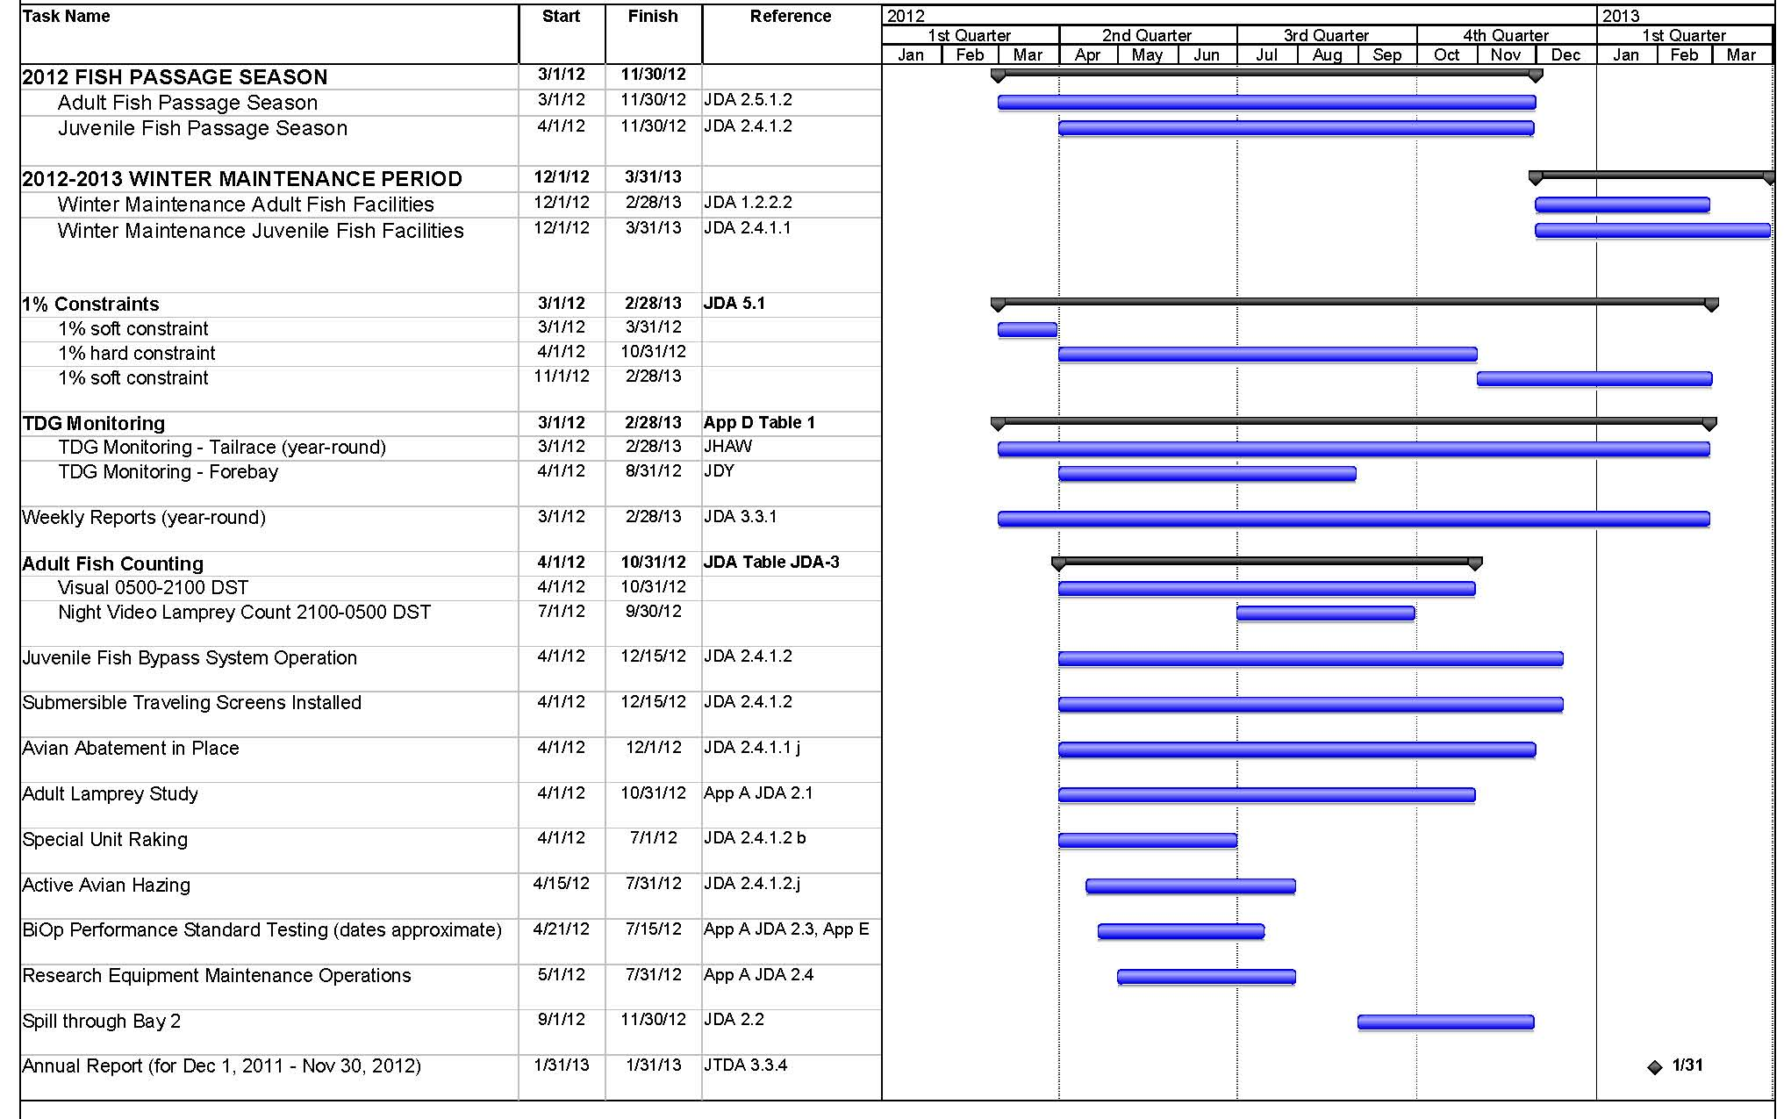
Table JDA- . John Day Dam 10-Year Juvenile Salmonid Passage Data (2002-2011).
Yearling Chinook |  |  |  |  |  | Subyearling Chinook*
 | 10 % | 50% | 90 % | # of Days |  |  | 10 % | 50% | 90 % | # of Days
2002 | May 01 | May 17 | Jun 01 | 32 |  | 2002 | Jun 20 | Jun 30 | Jul 20 | 31
2003 | May 03 | May 19 | Jun 02 | 31 |  | 2003 | Jun 06 | Jun 27 | Jul 30 | 55
2004 | Apr 28 | May 16 | May 30 | 33 |  | 2004 | Jun 14 | Jun 28 | Jul 23 | 40
2005 | Apr 25 | May 12 | May 22 | 28 |  | 2005 | Jun 19 | Jul 05 | Jul 27 | 39
2006 | Apr 25 | May 11 | May 24 | 30 |  | 2006 | Jun 14 | Jul 03 | Jul 18 | 35
2007 | May 02 | May 13 | May 25 | 24 |  | 2007 | Jun 25 | Jul 08 | Jul 17 | 23
2008 | May 04 | May 22 | Jun 01 | 29 |  | 2008 | Jun 24 | Jul 09 | Aug 05 | 43
2009 | Apr 27 | May 17 | Jun 01 | 36 |  | 2009 | Jun 17 | Jul 01 | Jul 17 | 31
2010 | May 01 | May 18 | Jun 06 | 37 |  | 2010 | Jun 14 | Jul 01 | Jul 20 | 37
2011 | May 02 | May 17 | May 28 | 27 |  | 2011 | Jun 16 | Jul 14 | Aug 3 | 49
MEDIAN | Apr 29 | May 16 | May 31 | 33 |  | MEDIAN* | Jun 16 | Jun 29 | Jul 28 | 43
MIN | Apr 20 | May 09 | May 22 | 24 |  | MIN* | Jun 06 | Jun 27 | Jul 20 | 23
MAX | May 06 | May 27 | Jun 20 | 46 |  | MAX* | Jun 27 | Jul 30 | Aug 22 | 59
Unclipped Steelhead |  |  |  |  |  | Clipped Steelhead
 | 10 % | 50% | 90 % | # of Days |  |  | 10 % | 50% | 90 % | # of Days
2002 | Apr 19 | May 19 | Jun 08 | 51 |  | 2002 | Apr 24 | May 14 | Jun 06 | 44
2003 | Apr 30 | May 28 | Jun 04 | 36 |  | 2003 | May 02 | May 29 | Jun 04 | 34
2004 | Apr 30 | May 23 | Jun 02 | 34 |  | 2004 | May 07 | May 20 | May 29 | 23
2005 | May 01 | May 14 | May 24 | 24 |  | 2005 | May 04 | May 19 | May 26 | 23
2006 | Apr 24 | May 13 | May 29 | 36 |  | 2006 | Apr 28 | May 10 | May 29 | 32
2007 | Apr 29 | May 13 | May 28 | 30 |  | 2007 | May 04 | May 12 | May 26 | 23
2008 | May 06 | May 21 | Jun 01 | 27 |  | 2008 | May 07 | May 16 | May 30 | 24
2009 | Apr 26 | May 11 | May 28 | 33 |  | 2009 | Apr 29 | May 10 | May 27 | 29
2010 | Apr 27 | May 12 | Jun 08 | 43 |  | 2010 | May 03 | May 11 | Jun 09 | 38
2011 | Apr 25 | May 19 | May 31 | 37 |  | 2011 | Apr 19 | May 19 | May 30 | 42
MEDIAN | Apr 28 | May 16 | May 31 | 35 |  | MEDIAN | May 02 | May 15 | May 29 | 28
MIN | Apr 19 | May 11 | May 24 | 24 |  | MIN | Apr 19 | May 10 | May 26 | 23
MAX | May 06 | May 28 | Jun 08 | 51 |  | MAX | May 07 | May 29 | Jun 9 | 44
Coho |  |  |  |  |  | Sockeye (Wild + Hatchery)
 | 10 % | 50% | 90 % | # of Days |  |  | 10 % | 50% | 90 % | # of Days
2002 | May 07 | Jun 01 | Jun 12 | 37 |  | 2002 | May 09 | May 21 | Jun 02 | 25
2003 | May 09 | May 30 | Jun 08 | 31 |  | 2003 | May 10 | May 19 | Jun 02 | 24
2004 | May 12 | May 27 | Jun 12 | 32 |  | 2004 | May 20 | Jun 01 | Jun 12 | 24
2005 | May 05 | May 16 | Jun 03 | 30 |  | 2005 | May 16 | May 21 | May 31 | 16
2006 | May 10 | May 26 | Jun 12 | 27 |  | 2006 | May 07 | May 20 | May 30 | 24
2007 | May 05 | May 16 | Jun 04 | 31 |  | 2007 | May 09 | May 25 | Jun 07 | 30
2008 | May 11 | May 25 | Jun 06 | 27 |  | 2008 | May 22 | May 29 | Jun 06 | 16
2009 | May 16 | May 29 | Jun 13 | 29 |  | 2009 | May 10 | May 25 | Jun 07 | 29
2010 | May 09 | Jun 03 | Jun 16 | 39 |  | 2010 | May 11 | May 29 | Jun 09 | 30
2011 | May 10 | May 23 | Jun 06 | 28 |  | 2011 | May 10 | May 22 | Jun 02 | 24
MEDIAN | May 09 | May 26 | Jun 07 | 30 |  | MEDIAN | May 10 | May 23 | Jun 04 | 26
MIN | May 05 | May 16 | Jun 03 | 24 |  | MIN | May 07 | May 19 | May 30 | 16
MAX | May 16 | Jun 03 | Jun 16 | 90 |  | MAX | May 22 | Jun 01 | Jun 12 | 41

* Subyearling Chinook median, min and max values based on data from 1998-2005. Data from 2006-2011 were not included due to potential bias from missed sample days resulting from the implementation of sampling protocols during periods of high water temperature (Appendix K).
1.2. Adult Fish Passage.

1.2.1. Facilities Description. The adult fish passage facilities at John Day Dam include a north shore fish ladder that passes fish from entrances at the north end of the spillway, and a south shore fish ladder that passes fish from entrances along a collection channel which extends the full length of the powerhouse. Auxiliary water is provided to all collection systems by pumping from the tailrace. South auxiliary water also includes forebay water from the fish turbines. Counting stations are provided in both fishways.

1.2.2. Adult Migration Timing and Counting. Upstream migrants are present at John Day Dam throughout the year and adult passage facilities are operated year-round. Adult fish (salmon, steelhead, shad, lamprey) are typically counted from April 1 through October 31 (Table JDA-3), and count data appear daily on the Corps adult count website. Migration timing data for these species, except shad, appear in Table JDA-4. Sturgeon and bull trout are also counted and recorded on the WDFW fish counters’ daily summary sheet comments section, but do not appear on the Corps daily website total due to relative infrequency of passage. These data are posted in the Miscellaneous Fish Counts report during the passage season (updated periodically during the season) found on the Corps’ web site and summarized in the Annual Fish Passage Report.

Table JDA- . Adult Fish Counting Schedule at John Day Dam.
Count Period | Counting Method and Hours
April 1 through October 31 | Visual 0500–2100 hours (DST)
July 1 through September 30 | Night Video Lamprey count 2100–0500 hours (DST)

1.2.2.2. Annual winter maintenance of adult fish facilities is scheduled from December 1 through February (in-water work period) to minimize impacts on upstream migrants.

1.2.2.3. Adult fish migration timing has been calculated for John Day Dam from count data collected by the Corps since 1968. Table JDA-4 summarizes adult fish count periods and peak passage timing through 2011. The primary passage period and the earliest and latest peaks of migration recorded are listed for each species (except shad). Peak lamprey migration timing for only the years 2000-2011 appears in this table.

Table JDA- . Adult Count Periods and Peak Migration Timing at John Day Dam (based on fish count data from years 1968-2011).
Species | Count Period | Earliest Peak | Latest Peak
Spring Chinook | 2/20 – 6/5 | 4/14 | 5/22
Summer Chinook | 6/6 – 8/5 | 6/7 | 8/2
Fall Chinook | 8/6 – 12/7 | 9/2 | 9/25
Steelhead | 2/20 – 12/7 | 8/25 | 10/6
Sockeye | 2/20 – 12/7 | 6/21 | 7/10
Coho | 2/20 – 12/7 | 9/4 | 10/26
Lamprey* | 2/20 – 12/7 | 7/16 | 8/12
*Peak lamprey migration timing based on lamprey count data for years 2000-2011.
2. Project Operation.

2.1. General.

2.1.1. Research, non-routine maintenance, other fish related activities, and construction activities will not be conducted within 100' of any fishway entrance or exit, within 50' of any other part of the adult fishway, or directly in, above, or adjacent to any fishway, unless coordinated by the project, Portland District Operations and/or Planning, or CENWP Construction office through FPOM or FFDRWG. Currently coordinated special operations related to research are described in Appendix A. Alternate actions will be considered by district and project biologists in conjunction with the Regional fish agencies on a case by case basis. Emergency situations should be dealt with immediately by the project in coordination with the project or district biologist. If unavailable, the biologists will be informed of steps taken to correct the situation immediately following the incident. All activities within boat restricted zone (BRZ) will be coordinated at least two weeks in advance with the project, unless it is deemed an emergency (see also Overview for coordination guidance).

2.2. Spill Management. See the Fish Operations Plan (Appendix E) for more information. Spill patterns formulated with spillway deflectors in place are provided in Table JDA-9. These will be used for both adult and juvenile patterns. Minimum spill of 25% is to provide adequate tailrace egress for juvenile salmonids. Spill from Bay 2 (1 stop or 1.6K) is provided for adult attraction during daylight hours between September 1 through November 30. Provisions are in place for deviations from normal spill patterns for barge traffic entering the navigation lock and have been coordinated with the fish agencies and tribes through the proper fish regulatory forums (e.g., TMT, FPOM, FFDRWG). Minimum spill level is 30% from April 10 through August 31.

2.3. Total Dissolved Gas (TDG) Management and Control. Total dissolved gas (TDG) levels at JDA are monitored in accordance with the Dissolved Gas Monitoring Program, Appendix D

2.3.1. Excessive total TDG levels, which may harm fish, will be controlled to the extent possible, subject to river flow conditions. Control measures will include system spill allocations through the spill priority list issued by Reservoir Control Center (RCC), nighttime or daytime spill limits, and shaping of spill discharge.

2.4. Juvenile Fish Passage Facilities.

2.4.1. Operating Criteria.

2.4.1.1. December 1 through March 31 (Winter Maintenance Period).

a. Remove debris from the forebay, all trash racks, and gatewell slots, so that these areas are debris-free on April 1.

b. Inspect all VBSs for damage, holes, debris accumulations, or protrusions (video inspection acceptable). Clean and repair when necessary.

c. Inspect and operate each STS.

d. By April 1, place STSs in each intake slot of all operational units unless otherwise coordinated with the fish agencies and tribes.

e. Inspect and, where necessary, clean and/or repair all gatewell orifices and orifice lighting systems, such that these systems are debris-free and operable on April 1.

f. Check automatic control calibration/operation for the DSM tainter gate and other necessary sensors weekly and recalibrate as necessary. Report summaries of equipment recalibration in the weekly SMF operation monitoring reports.

g. Inspect, maintain and, where necessary, repair the DSM conduit tainter gate.

h. Inspect and, where necessary, correct any deficiencies of walls and floor of DSM conduit, raceway, and outfall.

i. Inspect and, where necessary, repair spill gates and the associated control system. Spillways, except for coordinated exceptions, must be able to achieve standard spill patterns on April 1.

j. Avian Abatement Measures. Avian abatement measures shall be in place by April 1. Repair avian predator control lines as soon as possible following damage or removal. Install and maintain new avian predator control lines in locations determined to be significantly impacted by avian predators. Avian hazing will occur mid-April – July 31. However, there will be no avian abatement measures, other than avian lines, performed from August through mid-April each year.

k. Smolt Monitoring Facility: Insure all of the following items are fully operational:

1. Dewatering facilities, including weir gates, clean perforated plates, the screens (free of holes or gaps), and the screen cleaner brush system.

2. All valves and auxiliary water systems.

3. Flushing water valves and their perforated plates.

4. All gates, including the crest, tainter, switch, and rotating gates.

5. Fish and debris separator, including perforated plates and adult passage chamber.

6. PIT-tag detectors.

7. All sampling building systems, including holding tanks, valves, and conduits. (Note: A more specific list can be found in the SMF Operation and Maintenance Manual.)

2.4.1.2. April 1 through November 30 (Juvenile Fish Passage Season). Juvenile fish protection devices (submersible traveling screens (STS)); will be in place prior to the beginning of the juvenile fish passage season. Screens will remain in operation through December 15 to prevent adult salmonids from falling back through turbine units, even though the juvenile passage season officially ends November 30.

a. Measure gatewell drawdown across the trashrack a minimum of once per week. Remove debris from forebay and trash racks as required to maintain less than 1.5' of drawdown in gatewell. If VBS drawdown reaches 1.2’, the Project will inspect the screen and prepare to clean it.

b. Units 1 through 5 will be raked, if necessary as determined by ROV inspection, monthly between April 1 and July 1. Units 6 through 10 or units 11 through 16 will be alternately raked with units 1 through 5 from April 1 through July 1. After July 1, units will be raked as necessary as determined by ROV inspection, or as needed to avoid exceeding gatewell drawdown criterion.

c. Debris accumulations in the forebay of 300' or more in any direction from the face of the dam will be removed within 48 hours. Debris removal efforts should continue until the debris load has been removed.

d. If debris loads are obvious in the forebay, trash will be raked in front of the affected units weekly until the debris load has been removed.

e. Additional raking will occur whenever trash accumulations are suspected because of increased differential (1.5') across the trash racks, or as determined by the project biologist in reference to indicators such as increased juvenile fish descaling at the dam, deteriorating fish condition as noted by SMF personnel, or increased accumulations of tumbleweeds in the forebay. Gatewell orifices of the unit being raked must be closed during the raking operation.

f. Inspect each STS, VBS, and orifices once per month (or 720 hours run time). Video inspections are acceptable. More frequent inspections may be required under the following conditions: deterioration of fish condition, increased debris load in bypass system, and other indications of STS or VBS malfunction or failure. If STS or VBS damage or plugging is detected, follow procedures in Section 3. Fish Facilities Maintenance. Records of inspections will be reported in weekly fishway status reports and provided to FPOM. Unit 2 will operate when unit 1 is out of service for STS inspections.

g. Open all gatewell orifices April 1 – December 15. Inspect orifice lights daily to assure that the orifice lights are operating. Replace all burned out orifice lights within 24 hours. Close and open each orifice three times daily, or more frequently, to be determined by the project biologist, as necessary due to heavy debris accumulations in gatewells. If a unit goes out of service, orifices are to remain open in associated gatewells for a 24-hour period afterward to allow fish to escape the gatewells into the DSM.

h. Observe each STS amp and/or watt meter readings at least once per shift. If an STS failure occurs, then follow procedures in Section 3. Fish Facilities Maintenance.

i. Inspect all STS gatewells daily. The project will clean gatewells before the gatewell water surface becomes 50% covered with debris. If, due to the volume of debris, it is not possible to keep the gatewell surfaces at least 50% clear, they will be cleaned at least once daily. Turbines with a gatewell fully covered with debris will not be operated except to be in compliance with other coordinated fish measures, and then only on a last-on/first-off basis. The powerhouse gatewell orifices will be closed during the cleaning operation. After de-barking a gatewell, cycle the orifice in that gatewell. Check gatewell drawdown.

j. Efforts should be made to keep all petroleum out of gatewells. Project environmental section will determine cleanup efforts if needed. Regardless of unit operating status, oil accumulations will be dealt with promptly.

k. Coordinate gatewell cleaning when using a dip basket with personnel operating the SMF.

l. Reinstall or repair avian predator control lines as soon as possible following damage or removal. Install and maintain new avian predator control lines in locations determined to be significantly impacted by avian predators. Implement other avian abatement (hazing) as necessary from April through August only.

m. Turbine units without a full complement of rotating STSs will not operate, except to be in compliance with other coordinated fish measures.

n. Maintain water level in the bypass conduit between 4.0’ – 5.0’, as measured at Unit 16.

o. Smolt Monitoring Facility. Ensure the proper function of sampling systems. Particular attention is directed toward the following:

1. Dewatering facilities, including the screens being free of holes or gaps, and the screen cleaner brush system.

2. All valves and auxiliary water systems.

3. Flushing water valves and their perforated plates.

4. All gates, including the crest, tainter, switch, and rotating gates.

5. Fish and debris separator, including perforated plates and the adult passage chamber.

6. PIT-tag detectors.

7. All sampling building systems, including holding tanks, valves, and conduits.

8. April 1 – September 15: the SMF will be monitored 24-hours per day, 7 days per week by the project fish personnel to ensure its proper functioning and provide quick response to an emergency. Inspect every 2 hours. Therefore, the system will be fully staffed while the SMF is in operation (i.e., crest gate is deployed and the secondary dewatering structure is receiving fish-laden flow).

9. Cycle Primary Dewatering Screen (PDS) sweepers twice per shift (6 per day) during low to normal debris loads. If debris loads increase, increase frequency of screen sweeper cycling as determined by the project biologist through inspections.

10. A person on duty will perform a walking inspection of the entire SMF system every two hours to ensure safe passage conditions.

11. Particular attention will be paid to the fish/debris separator (FDS) that needs to be visually inspected every 30 minutes to prevent injury and/or mortality to passing fish.

12. During any high debris loading periods (likely during spring runoff) additional personnel may be required to keep the FDS free of any obstruction to fish passage. The project biologist will decide to assign a person to remove debris from the FDS on a shift basis (possible constant, 24 hours/day presence) for as long as it is necessary to assure the safety of passing fish.

13. For adult fish removal from the PDS area when river temperatures reach 70°F or greater, all fish handling will be coordinated through FPOM.

2.4.1.3. December 1 through March 31 (Winter Maintenance Period).

a. Screens (STS, ESBS) will remain in place through December 15 to prevent adult salmonids from falling back through turbine units, thereby shortening some aspects of the winter maintenance period by two weeks. To reduce adult fallback mortality, the juvenile bypass system, or JBS channel will operate from November 30 through December 15. Priority units will be left screened during this period to the extent practicable (barring operational failure), and screens from non-priority units will only be removed when necessary to begin maintenance. If units are required for operation during this period, and are unscreened, they will be operated on a last-on/first-off basis. After December 15, all STSs may be removed.

b. Dewater DSM channel only when required for inspection, maintenance, or structural modifications (see section 5. Dewatering Plans; also, paragraph 3.2.1.2. Juvenile Bypass System). The outage period will be minimized to the extent practicable.

c. All units are available to meet power demands.

2.5. Adult Fish Passage Facilities.

2.5.1. Operating Criteria.

2.5.1.1. December 1 through February (Winter Maintenance Period).

a. Inspect and calibrate all staff gages, water level sensors, and indicators. Repair and/or clean where necessary.

b. Dewater and inspect repair as needed all ladders and all other dewatered sections of fish facilities for projections, debris, or plugged orifices which could injure fish, or slow their progress up the ladder.

c. Inspect for and, when necessary, clear debris in ladder exits.

d. Reinstall picket leads at counting stations prior to watering up ladders during maintenance.

e. Repair or, when necessary, upgrade netting and padding at top of north fish ladders to address the fish jumping problem in this area.

f. Outage periods will be minimized to the extent practicable. Only one ladder may be out of service or operating out of standard operating criteria at any one time, unless specifically coordinated.

2.5.1.2. March 1 through November 30 (Adult Fish Passage Season).

a. All Adult Facilities.

1. Water depth over fish ladder weirs: 1' +/-0.1'. When shad numbers exceed 5000 fish per day per count station at Bonneville Dam, water depth should be increased to 1.3' +/- 0.1'.

2. Measure water temperatures at the count stations of each ladder and include the weekly means in the status report. When water temperature reaches 70°F all fish handling activities will be coordinated with the Regional fish agencies through FPOM prior to any action to verify protocols that will be followed.

3. Head on all entrances: 1' to 2' (1.5' optimum). Refer to paragraph 3.3.1 when unable to achieve head criteria.
4. A water velocity of 1.5' to 4 fps per second (2 fps optimum) shall be maintained in all channels and the lower ends of the fish ladders that are below the tailwater. Floating orifice gates 1, 2, 18, and 19 open and operate three fish pumps to maintain fishway criteria. The entrance gate should remain at 8’ depth submergence or greater to be in criteria. Fishway channel water velocities will be measured thrice weekly, daily preferred, during adult fish passage (Mar 1 – Dec 1) part of the fishway inspection program. Floats will be timed through all fishway channels that are supplemented by auxiliary water. Results will be provided in the project weekly fishway status report.

5. Maximum of 0.5' head on attraction water intakes and trash racks at all the ladder exits, with a 0.3' maximum head on all picket leads. Debris shall be removed when significant amounts accumulate.

6. Staff gages and water level indicators will be readable at all water levels encountered during the fish passage period, and calibration checked weekly. Instruments will be cleaned and/or recalibrated when necessary as soon as practicable.

7. Main entrance weir depths: 8' or greater below tailwater. Maintain tailwater elevation greater than 158’msl to stay within criteria operation range for the entrance weirs.

8. Count station crowders shall be at maximum width that allows count or video tape accuracy. The minimum count slot width shall be no less than 18 inches. If passage is impaired by narrow count slot conditions, the count slot will be widened until proper passage conditions are achieved, despite count accuracy. Project biologists, FFU, and WDFW fish counters shall coordinate to achieve optimum count slot passage and/or count accuracy conditions. If counting is temporarily discontinued due to unscheduled events, the crowder shall be fully opened. The crowder shall remain in operating position during the counters’ hourly ten minute break periods.

b. North Fishway.

1. Operate one entrance weir (EW-1) at 8’ or greater weir depth. Entrance head: 1’ to 2’ (1.5’ optimum).

2. Starting September 1, spill from Bay 2 (1 stop or 1.5K) for adult attraction during daylight hours through November.

3. Maintain netting and padding for the North fishway to address the adult salmonid jumping problem. All holes in the netting large enough to catch or allow escapement of an adult salmonid must be closed.

c. South Fishway. Operate entrance weir SE-1.
d. Powerhouse.

1. Operate entrances NE-1 and NE-2.

2. Operate four powerhouse floating orifices (1, 2, 18, 19) and open associated auxiliary water diffusers (see also 2.5.1.2.a.4.). During the fish turbine #3 overhaul, planned for 2011-2012, floating orifice gates 18 and 19 will be closed.

3. From 0400 to 2000 hours, operate unit 1 near 100 megawatts (+/- 10 MW) to facilitate best entrance conditions. If additional load is required by BPA, unit 1 may be operated at above 100MW, but it should be the last to be brought up to full load when demand increases and the first to drop off when demand decreases. (See also Load Shaping Guidelines, Appendix C).

2.5.1.3. December 16 through February (Winter Maintenance Period).

a. Operate according to fish passage season standards, except facilities may be dewatered or operated out of criteria for maintenance or repair. Outage periods will be minimized to the extent practicable.

b. Only one of the two adult fish passage facilities may be out of service at a time. The other facility must be operated at full passage season criteria unless specially coordinated with the Regional fish agencies through FPOM. However, operation of unit 2 may be substituted for unit 1 without special coordination when the south fishway is in service.

c. Pull picket leads at counting stations and have crowders adjusted such that the counting slots are fully opened at the end of the counting season (this will be done shortly after adult fish counting ends).

d. Maximum of 0.5' head on attraction water intakes and trash racks at all ladder exits. Debris shall be removed when significant amounts accumulate.

3. Facility Monitoring and Reporting.

3.1. Inspections.

3.1.1. The results of all inspections and the readiness of the facilities for operation will be reported to the FPOM at the meeting immediately prior to the fish passage season.

3.1.2. During fish passage season, fish passage facilities will be inspected at least twice per day/seven days a week to assure operation according to established criteria.

3.1.3. During winter maintenance season, fish passage facilities will be inspected once per day/at seven days a week.
3.1.4. More frequent inspections of some facility components will occur as noted throughout the text.

3.1.5 Additional fishway inspections may be performed by FFU and fish agencies.

3.2. Zebra Mussel Monitoring. A zebra mussel monitoring program will continue. These organisms have become a serious problem elsewhere in the country and may become introduced into the Columbia River basin. Inspections should also be made when dewatering all project facilities.

3.3. Reporting.

3.3.1. Project biologists shall prepare weekly reports throughout the year summarizing project operations. The weekly reports will provide an overview of how the project and the fish passage facilities operated during the week and an evaluation of resulting fish passage conditions. The reports shall include:

a. Any out-of-criteria situations observed and subsequent corrective actions taken;
b. Any equipment malfunctions, breakdowns, or damage along with a summary of resulting repair activities;
c. Adult fishway control calibrations;
d. STS and VBS inspections;
e. AWS closures (i.e. cleaning times);
f. Any unusual activities which occurred at the project which may affect fish passage.

3.3.2. The weekly reports shall cover a Sunday through Saturday period and they shall be e-mailed to CENWP-OD and other interested parties as soon as possible the following week, with a copy to CENWD-PDW-R RCC.

3.3.3. The project biologists shall prepare a memo for the record for any negative impact to fish or fishways. This memo will be sent to FPOM by the next working day. Items that shall be included in the memo are:

a. Time and date.
b. Nature of activity that lead to fish impact.
c. Agency responsible for the impact, or the reporter if no responsible party can be identified.
d. Fish numbers, species, origin, discernible external injuries, tags, etc.
e. Future actions to avoid a similar impact.
f. Any relevant photos.

3.3.4. The project biologists shall prepare an annual report by January 31, summarizing the operation of the project fish passage facilities for the previous year.

3.3.4.1. The report will cover from the beginning of one adult fish facility winter maintenance period to the beginning of the next.
3.3.4.2. The annual report also will include a description of all actions taken to discourage avian predation at the project, with an overview of the effectiveness of the activities in discouraging avian predation.

3.3.4.3. The annual report will be provided to CENWP-OD in time for distribution to FPOM members at the February meeting.

4. Fish Facilities Maintenance.

4.1. General.

4.1.1. Routine Maintenance. Scheduled fishway maintenance, to the extent practicable, will be conducted during periods when passage has been documented to be at its lowest to minimize impacts to migrating salmonids. Maintenance activities that occur during the fish passage period, and that may affect fish passage, will be reported in the weekly reports (section 3.3).

4.1.1.1. Staff gages will be installed, cleaned, and/or repaired as required.

4.2. Juvenile Fish Passage Facilities.

4.2.1. Routine Maintenance.

4.2.1.1. Submersible Traveling Screens. The STS system may receive preventive maintenance or repair at any time during the year as necessary. Most maintenance will occur during the winter maintenance period when all STSs may be removed from the intakes. During the designated juvenile passage season, a turbine unit cannot operate without a full compliment of functioning STSs.

4.2.1.2. Juvenile Bypass System. The juvenile bypass facilities may receive preventive maintenance at any time of the year as deemed necessary in coordination with FPOM. During the juvenile fish passage season, this will normally be above water work, such as maintenance of automatic systems, air lines, electrical systems, and monitoring equipment. During the winter maintenance period, the system is dewatered. The system is visually inspected in all accessible areas for damaged equipment and areas that may cause potential problems to juvenile fish. Identified problems will be repaired by project maintenance or the contractor as soon as possible. Extended repair projects will be coordinated through FPOM.

4.2.1.3. Turbines and Spillway. Maintenance and routine repair of project turbines and spillways is a regular and recurring process which requires that units be shut down for extended periods of time (see section 5. Dewatering Plans). Maintenance schedules for these turbines and spillways will be coordinated through FPOM. Certain turbine and spillway discharges at the projects are secondarily used to attract adult fish near fishway entrances to keep predator fish from accumulating in the area of juvenile release sites and to move juveniles downstream away from the project. The maintenance schedules for these turbines and spillways will reflect equal weight given to fish, power, and water management and will be coordinated with the appropriate fish agencies. Units that should not be scheduled for maintenance during the fish passage season are 1, 2, and 5. Some types of turbine maintenance will require testing turbine operation throughout the full operating range before returning it to normal service.

4.2.2. Non-Routine Maintenance. Non-routine maintenance of facilities will be carried out as described below. Activities that will have a significant impact on juvenile fish passage shall be coordinated through FPOM on a case-by-case basis by project and CENWP-OD biologists. The CENWP-OD biologists will be notified as soon as possible after it becomes apparent that maintenance repairs are required. The Project Operations Manager has the authority to initiate work prior to notifying CENWP-OD when delay of the work will result in an unsafe situation for people, property, or fish. Information required by CENWP-OD includes (see also Overview for the coordination form):

a. Description of the problem.
b. Type of outage required.
c. Impact on facility operation.
d. Length of time for repairs.
e. Expected impacts on fish passage.

4.2.2.1. Submersible Traveling Screens (STS). If an STS or VBS is damaged or inoperative in an operating unit, the unit will be regarded as an unscreened unit. The screen will be repaired or replaced before returning the unit to service.

4.2.2.2. Juvenile Bypass System.

a. The juvenile bypass system is automatically controlled. If the automatic system fails, it will be operated manually until automation repairs are made. If the orifices become plugged with debris, the turbine will not be operated until it has been cleaned.

b. Inspect all STS gatewells daily. The project will clean gatewells before the water surface becomes 50% covered with debris. If due to the volume of debris it is not possible to keep the gatewell surfaces at least 50% clear, they will be cleaned at least daily. Turbines with a gatewell fully covered with debris will not be operated except on a last-on/first-off basis if required to be in compliance with other coordinated fish measures. The gatewell orifices must be closed during the cleaning process. Juvenile mortality numbers will be monitored in all gatewells, as potential indicators of gatewell environment problems. Mortality estimates will be recorded and reported in the weekly status reports.

c. If the bypass system fails in the powerhouse conduit, tainter gate, or transportation outfall making the system unsafe for fish, an action decision will be made in coordination with the FPOM. During this emergency operating mode, power generation will be minimized to the extent practicable. If this operating mode is expected to last longer than four days, then all units required for generation will be sequentially shut down, fish salvaged from the gatewells, the STSs removed, and the unit restarted. The orifice gates will be closed during this process.

d. During fishway inspection activities, VBSs may be found plugged with debris, damaged or not properly seated. In these cases, the associated unit will be regarded as if unscreened and repairs will be made before returning the unit to operation.

4.2.2.3. Turbines and Spillways.

a. If a spill gate becomes inoperable, the operators will make the changes necessary to accommodate the spill and then immediately notify the operations supervisor and project biologist to determine the best pattern to follow until repairs can be made. This interim operation shall be coordinated with the FPOM through the district biologist who will provide additional guidance to the project.

b. Unit 2 will replace unit 1 for adult attraction whenever unit 1 is not operating.

c. From September 15 through the end of February, spillbay gate 2 may be closed for up to one work day for maintenance activities. During the outage, spill gate 3 will be opened to provide attraction flow.

4.3. Adult Passage Facilities.

4.3.1. Routine Maintenance. Maintenance activities that occur during the fish passage period and that may affect fish passage will be reported in the weekly reports (section 3.0).

4.3.1.1. Fishway Auxiliary Water Systems. John Day Dam has tailwater pump auxiliary water systems. Preventive maintenance and normal repair are carried out throughout the year. Trash racks for the AWS intakes will be raked when drawdown exceeds criteria. When practicable, rake trash racks during the time of day when fish passage is least affected.

During the annual navigation lock maintenance outage, the north fish ladder auxiliary water is shut off for about half a day. This is required to allow divers to clean off the navigation lock discharge sill so that a bulkhead can be placed.

4.3.1.2. Powerhouse and Spillway Fish Collection Systems. Preventive maintenance and repair occurs throughout the year as needed. During the adult fish passage season, this maintenance will not involve operation that will cause failure to comply with the adult fishway criteria, unless coordinated through FPOM. During the winter maintenance period, an inspection will occur through dewatering or divers per discretion of the project biologists. One additional underwater diver/ROV will occur during August 1 - 15. Timing of this inspection will be coordinated through FPOM. The project biologist or alternate Corps fish personnel will attend all dewatering and inspection activities potentially involving fish (section 5. Dewatering Plans).

4.3.1.3. Adult Fish Ladders and Counting Stations. Adult fish ladders will be dewatered once per year during the winter maintenance period. Unless specially coordinated, only one ladder will be dewatered at a time, with the other ladder operating within criteria. During this time, the ladders are inspected for necessary maintenance needs and potential fish passage problems. These include blocked orifices, projections into the fishway that may injure fish, unstable weirs, damaged picket leads, exit gate problems, loose diffuser gratings, unreadable or damaged staff gauges, defective diffuser valves, and malfunctioning equipment at the counting stations. Potential problems identified throughout the passage year that do not impact fish passage, as well as those identified during the dewatered period, are then repaired. Trash racks at the ladder exits will be raked when criteria are exceeded. When practicable, rake trash racks during the time of day when fish passage would be least affected. Fish count station windows, light panels, and crowder panels will be cleaned, as needed, to achieve accurate counts and, when practicable, during the time of day when fish passage is least affected. North netting installed on the ladders to prevent fish leaping will be inspected daily and maintained when necessary. Summaries of inspections will be included in the weekly activity report.

4.3.2. Non-Routine Maintenance. Maintenance activities that occur during the fish passage period and that may affect fish passage will be reported in the weekly reports (section 3.3.1.). Non-routine maintenance that will significantly affect the operation of a facility, such as repair of displaced diffuser gratings, will be coordinated through FPOM. Coordination procedures for non-routine maintenance of adult facilities are the same as for juvenile facilities (section 4.2.2).

4.3.2.1. Fishway Auxiliary Water Systems. The fishway auxiliary water systems are mostly automated. If the automatic system fails, the system will be operated manually by project personnel. This will allow the fish facility to operate according to criteria while the automatic system is repaired. When this operation becomes necessary, project personnel will increase the surveillance of the adult system to ensure that criteria are being met. The FPOM will work with the project to determine the best operation in the event of an AWS failure during the adult passage season.

a. South Ladder. If one of the three auxiliary water turbines fails, assuming all three turbines are being used to meet criteria, the output of the two remaining turbines will be increased to meet adult fishway criteria. If a second turbine unit fails, the adult fish facility will be operated as follows until a fishway head of 1' is achieved.

1. Increase discharge of the remaining unit to maximum capacity.

2. Close NE-1.

3. Leave NE-2 at a depth of 8’.

4. Close the remaining floating submerged orifice gate entrances starting at the north end.

5. Leave the south powerhouse entrance weir (SE-1) at 8' depth below the tailwater surface.

6. If the above criteria are still not achieved, then reduce entrance weirs in depth to 6’, or then to 4’ if necessary, until more auxiliary water becomes available. Then reverse the above procedure.

7. If all three turbine units fail, operate as follows until repairs can be made:
- SE-1 will be open with the weir crest 6' below the tailwater surface.
- Close NE1 and NE2.
- Cross channel bulkheads will be placed in the powerhouse collection channel between units 2 and 3.
- The floating orifice gate in front of unit 2 will be closed, leaving the floating orifice gate in front of unit 1 open. (See also 2.5.1.2.a.4.)

b. North Ladder. This system cannot operate according to the adult fishway criteria under any conditions due to design limitations. Three of the six available pumps can be operated simultaneously. If one pump fails, one of the standby pumps will be started. This routine will be followed until the available pumps can no longer meet the adult fishway criteria. If this occurs, EW1 will be set at the maximum weir depth needed to maintain fishway criteria. Present design capability: 2 pumps with tailwater <160 msl; 3 pumps with tailwater >160 msl.

4.3.2.2. Powerhouse and Spillway Fish Collection Systems. John Day Dam contains several types of fishway entrances. In most cases, if failures occur, the entrance can be operated manually by project personnel until repairs are made. When this operation becomes necessary, project personnel will increase the surveillance of the adult system to ensure criteria are being met. In those cases in which the failure will not allow the entrance to be operated manually, the gate will be maintained, to the extent possible, in an operational position. If this is not possible, the entrance will be repaired expediently and the entrance will be returned to manual or automatic control at the earliest possible date.

4.3.2.3. Adult Fish Ladders and Counting Stations. Pickets with excessive spacing (greater than 1"), erosion of concrete around the picket leads, or missing pickets can allow fish into areas where escape is not possible. The north count station upstream picket leads have an exit hatch that can be opened to allow fish to escape. Repair will be required for picket lead failure at the south count station. In the instances of picket lead failure or concrete erosion, the timing and method of repair will depend upon the severity of the problem. The decision of whether or not to dewater the fishway and repair any problem will be made in coordination with the FPOM.

4.3.2.4. Diffuser Gratings. Diffuser chambers for adding auxiliary water to fish ladders and collection channels are covered by gratings attached by several different methods. Diffuser gratings are normally inspected during the winter maintenance period to assure integrity. These inspections are done by either dewatering the fishway and/or collection channel, or by using video cameras and divers or other methods to inspect the gratings underwater. Diffuser gratings may come loose during the fish passage season due to a variety of reasons. Daily inspections of the fish ladders and collection systems should include looking for any flow changes that may indicate problems with diffuser gratings. If a diffuser grating is known to or suspected of having moved, creating an opening into a diffuser chamber, efforts must immediately be taken to correct the situation and minimize impacts on adult fish in the fishway. If possible, a video inspection should be made as soon as possible to determine the extent of the problem. If diffusers gratings are found to be missing or displaced, close associated diffuser, a method of repair shall be developed and coordinated with FPOM. Repairs shall be made as quickly as possible unless coordinated differently.

5. Turbine Unit Operation and Maintenance.

Unit operating priority is shown in Table JDA-5, including that time when synchronous condensing occurs. Unit maintenance schedules will be reviewed by project and district biologists for fish impacts.

Table JDA- . Turbine Unit Operating Priorities at John Day Dam.
Season | Time of Day | Unit Operating Priority*
Fish Passage Season  without TSWs | 24 hours / day | 1-4 in any order, then 5-16 in any order.
Fish Passage Season  with TSWs¹ | 24 hours / day | 5,1,3,16,14,12,10,8,15,2,11,7,4,13,9,6
Winter Maintenance Season | 24 hours / day | any unit
*When a main unit is not available, the paired “sister unit” will be used to comply with the requested priority.

5.1. Guidelines for operating units within the 1% turbine efficiency range at various heads are shown in Tables JDA-6 to JDA-7. To the extent technically feasible, turbines will be operated within +/- 1% of best turbine efficiency, unless operation outside of that range is necessary to meet load requirements of the BPA administrator, consistent with the BPA System Load Shaping Guidelines (Appendix C), or to comply with other coordinated fish measures. The System Load Shaping Guidelines apply between April 1 and October 31. However, during the rest of the year, the project will continue to operate units within the 1% turbine efficiency range, except as specifically requested by BPA for power production.

5.2. Juvenile fish passage decreases through units from south to north, making inefficient operation of unit 16 least likely to impact fish. Based on this, if it is necessary to select turbines to operate outside the 1% efficiency range, they will be selected in sequence from north to south. However, allowance will also be given to special project requirements for stable voltage control which require load distribution between transformer banks.
Table JDA- . Turbine Operating Ranges Within 1% of Best Efficiency at John Day Dam.
Head (feet) | With STSs Installed * |  |  |  | With ESBSs Installed **
Head (feet) | Lower Limit |  | Upper Limit |  | Lower Limit |  | Upper Limit
Head (feet) | (MW) | (cfs) | (MW) | (cfs) | (MW) | (cfs) | (MW) | (cfs)
80 | 65.4 | 11,338 | 118.0 | 20,472
81 | 66.7 | 11,416 | 120.8 | 20,671
82 | 68.1 | 11,492 | 123.6 | 20,864
83 | 69.4 | 11,566 | 126.4 | 21,052
84 | 70.8 | 11,638 | 129.1 | 21,234
85 | 72.1 | 11,707 | 131.9 | 21,411 | 69.6 | 11,396 | 111.5 | 18,269
86 | 72.9 | 11,692 | 134.7 | 21,593 | 70.3 | 11,381 | 113.7 | 18,402
87 | 73.7 | 11,676 | 137.5 | 21,770 | 71.1 | 11,366 | 115.9 | 18,531
88 | 74.5 | 11,661 | 140.2 | 21,942 | 71.9 | 11,351 | 118.1 | 18,657
89 | 75.3 | 11,646 | 143.0 | 22,110 | 72.6 | 11,336 | 120.3 | 18,779
90 | 76.1 | 11,632 | 145.8 | 22,274 | 73.4 | 11,322 | 122.5 | 18,898
91 | 77.0 | 11,622 | 146.9 | 22,164 | 74.3 | 11,313 | 122.9 | 18,717
92 | 77.9 | 11,613 | 148.0 | 22,057 | 75.1 | 11,304 | 123.2 | 18,540
93 | 78.8 | 11,604 | 149.1 | 21,951 | 76.0 | 11,295 | 123.6 | 18,367
94 | 79.7 | 11,595 | 150.2 | 21,848 | 76.9 | 11,285 | 123.9 | 18,197
95 | 80.6 | 11,585 | 151.3 | 21,746 | 77.7 | 11,276 | 124.3 | 18,031
96 | 81.7 | 11,604 | 151.6 | 21,532 | 78.8 | 11,294 | 124.4 | 17,841
97 | 82.8 | 11,623 | 151.8 | 21,323 | 79.8 | 11,312 | 124.6 | 17,654
98 | 83.8 | 11,640 | 152.1 | 21,118 | 80.9 | 11,329 | 124.7 | 17,472
99 | 84.9 | 11,657 | 152.4 | 20,917 | 81.9 | 11,346 | 124.8 | 17,293
100 | 86.0 | 11,674 | 152.7 | 20,720 | 82.9 | 11,361 | 125.0 | 17,117
101 | 86.9 | 11,675 | 154.9 | 20,800 | 83.8 | 11,363 | 126.6 | 17,163
102 | 87.9 | 11,677 | 155.2 | 20,613 | 84.7 | 11,364 | 128.3 | 17,207
103 | 88.8 | 11,678 | 155.2 | 20,378 | 85.6 | 11,365 | 129.9 | 17,250
104 | 89.7 | 11,679 | 155.2 | 20,149 | 86.5 | 11,367 | 131.6 | 17,293
105 | 90.6 | 11,680 | 155.2 | 19,923 | 87.4 | 11,367 | 133.2 | 17,334
106 | 91.4 | 11,658 | 155.2 | 19,711
107 | 92.1 | 11,637 | 155.2 | 19,503
108 | 92.8 | 11,615 | 155.2 | 19,299
109 | 93.6 | 11,594 | 155.2 | 19,098
110 | 94.3 | 11,574 | 155.2 | 18,901
* The turbine efficiency table was revised to reflect information using a 2001 Unit 9 NS index test and a 1962 model test with STS adjustment Factor (Table JDA- 6 revised 2005). Table prepared by HDC dated November 2002.
** The turbine efficiency tables are being revised to reflect new information for John Day Dam. This table is based on data from Little Goose Dam (LGS-5).
Table JDA- . Turbine Operating Ranges Within 1% of Best Efficiency with No Screens Installed at John Day Dam.
Head  (Feet) | Lower Generator Limits (No Screens) |  | Upper Generator Limits (No Screens)
Head  (Feet) | (MW) | (cfs) | (MW) | (cfs)
80 | 71.7 | 12,305 | 122.8 | 21,074
81 | 73.2 | 12,391 | 125.7 | 21,290
82 | 74.7 | 12,473 | 128.7 | 21,500
83 | 76.1 | 12,554 | 131.6 | 21,703
84 | 77.6 | 12,631 | 134.6 | 21,901
85 | 79.1 | 12,707 | 137.5 | 22,093
86 | 80.0 | 12,690 | 140.1 | 22,223
87 | 80.9 | 12,674 | 142.6 | 22,349
88 | 81.7 | 12,657 | 145.1 | 22,471
89 | 82.6 | 12,641 | 147.6 | 22,591
90 | 83.5 | 12,625 | 150.2 | 22,707
91 | 84.5 | 12,616 | 151.7 | 22,656
92 | 85.5 | 12,606 | 153.2 | 22,606
93 | 86.4 | 12,596 | 154.8 | 22,556
94 | 87.4 | 12,586 | 155.1 | 22,321
95 | 88.4 | 12,576 | 155.2 | 22,062
96 | 89.6 | 12,597 | 155.2 | 21,797
97 | 90.8 | 12,617 | 155.2 | 21,538
98 | 92.0 | 12,636 | 155.2 | 21,284
99 | 93.1 | 12,655 | 155.2 | 21,035
100 | 94.3 | 12,673 | 155.2 | 20,792
101 | 95.3 | 12,675 | 155.2 | 20,554
102 | 96.4 | 12,676 | 155.2 | 20,321
103 | 97.4 | 12,678 | 155.2 | 20,092
104 | 98.4 | 12,679 | 155.2 | 19,868
105 | 99.4 | 12,680 | 155.2 | 19,649
106 | 100.2 | 12,656 | 155.2 | 19,442
107 | 101.0 | 12,633 | 155.2 | 19,239
108 | 101.8 | 12,610 | 155.2 | 19,040
109 | 102.6 | 12,587 | 155.2 | 18,845
110 | 103.5 | 12,565 | 155.2 | 18,653
NOTE: The turbine efficiency table was revised to reflect information using a 2001 Unit 9 NS index test and a 1962 model test (Table JDA- 8 revised, 2006). Table prepared by HDC dated November 2002.

5.3. Units may be operationally tested for up to 30 minutes before going into maintenance status by running the unit at speed no load and various loads within the 1% criteria to allow pre-maintenance measurements and testing AND TO ALLOW ALL FISH TO MOVE THROUGH THE UNIT. Units may be operationally tested after maintenance or repair while remaining in maintenance or forced outage status. Operational testing may consist of running the unit for up to a cumulative time of 30 minutes (within 1% criteria) before it is returned to operational status. Operational testing OF UNIT UNDER MAINTENANCE is in addition to a unit in run status (E.G. MINIMUM GENERATION) required for power plant reliability. Operational testing may deviate from fish priority units and may require water that would otherwise be used for spill if the running unit for reliability is at its 1% minimum load. Water will be used from the powerhouse allocation if possible, and water diverted from spill for operational testing will be minimized to that necessary to maintain and assure generation system reliability.

6. Dewatering Plans. Guidelines for dewatering and fish handling plans (Appendix F) have been developed and are followed for dewatering project facilities. These plans include consideration for fish safety and are consistent with the following general guidance. The appropriate plans are reviewed by participants before each salvage operation. The project fish biologist and/or alternate Corps fish personnel will attend all project activities involving fish handling. The fish agencies and tribes will be encouraged to participate in all ladder dewaterings. During the pumping or draining operation to dewater a portion or all, the water level will not be allowed to drop so low it strands fish. Personnel shall remain present onsite during pumping operations to ensure stranding does not occur or a water level sensor that deactivates the dewatering process will be used.

6.1. Adult Fish Ladders.

6.1.1. Routine Maintenance.

6.1.1.1. When possible, operate ladders to be dewatered at orifice flow, with the AWS off, for at least 24 hours, but not more than 96 hours prior to dewatering.

6.1.1.2. The project biologist will assure that fish rescue equipment is available, and will coordinate to ensure adequate numbers of personnel will be available to move fish out of the dewatered ladder.

6.1.1.3. Project personnel will install head gates to shut down ladder flow. Where possible, a flushing flow of 1-2" will be maintained in the ladder until fish are rescued.

6.1.1.4. The project biologist or alternate Corps fish personnel will oversee fish rescue when the ladders are dewatered. The project biologist will invite fish agency and/or tribal biologists to participate in the dewatering activities. Captured fish will then be transported to the forebay or tailwater, depending on the fish life stage (adults to forebay, juveniles to tailrace), for release. If a ladder is dewatered in the spring or summer, steelhead kelts should be released into the tailrace.

6.1.1.5. Orifice blocking devices, which are placed in the lower-most weirs to prevent fish from re-ascending the dewatered portion of the adult fishway, shall have ropes attached to them by project operations and be tied off to fishway railings. The blocking devices shall be removed just before the fishway is returned to service. These devices will be noted on the pre-water-up checklist maintained by project fish biologists. This will prevent the orifice blocks from being unintentionally left in place following fishway water-up.

6.2. Non-Routine Maintenance.

6.2.1. When possible, discontinue auxiliary water and operate ladder at reduced flow as long as possible up to 72 hours prior to dewatering.

6.2.2. Follow guidance in paragraphs 6.4.1.3. through 6.4.1.6.

6.3. Powerhouse Fish Collection System.

6.3.1. Routine Maintenance. During the pumping or draining operation to dewater a portion or the entire collection channel, the water will not be allowed to drop to a level which strands fish. Personnel shall remain present onsite during pumping operations to ensure that stranding does not occur. The project biologist will assure that all necessary rescue equipment is available. The project biologist or alternate Corps fish personnel will provide technical guidance on fish safety and will assist directly in rescue operations.

6.4. Juvenile Bypass System.

6.4.1. Routine Maintenance. When draining the juvenile bypass channel, it is typical to flush the channel with only bay 16 bypass orifices open. Bay 16 gatewells will be dipped in advance to minimize the number of fish contained in this flushing water during fish passage season.

6.5. Turbines.

6.5.1. Remove juvenile fish from the gatewell(s) that will be drained. This is done by use of a special dipping basket. Dipping is not required when fish screens have been removed. Immediately before setting the headgates, spin the unit to move fish out of the draft tube.

6.5.2. If the turbine unit draft tube is dewatered, operate unit with full load for a minimum 15 minutes prior to immediately installing tail logs. If not possible to load, run unit at speed-no-load for minimum 15 minutes. Install bottom two tail logs side-by-side first before stacking the remainder to minimize sturgeon from entering the draft tube before dewatering. This is necessary for both scheduled and unscheduled outages.

6.5.3. If a turbine unit is idle and partially dewatered, and tail logs are to be put into place, an adequate safety pool may be maintained for up to 4 days to accommodate fish trapped in the draft tube. If longer timeframes are needed for the safety pool, project fisheries will coordinate with FPOM on a case-by-case basis. Adequate inspections will need to be conducted to ensure that the safety pool is maintained and fish are in good condition. Water levels in the draft tube will not be allowed to drop to a level that strands fish.

6.5.4. Fish rescue personnel will inspect dewatered turbine draft tubes, scroll cases, and intakes as soon as they can gain access and the water levels reach a depth permitting visual inspection. The project biologist or alternative fish personnel will provide technical guidance on fish safety and will directly participate in fish salvage.

6.5.5. The project biologist will assure that all necessary rescue equipment is available.

7. Forebay Debris Removal.

7.1. Debris at projects can impact fish passage conditions. It can plug or block trash racks, VBSs, gatewell orifices, dewatering screens, separators, and facility piping resulting in impingement, injuries, and descaling of fish. Removing debris at its source in the forebay is sometimes necessary to maintain safe and efficient fish passage conditions, navigation, and other project activities. In this case, the only viable alternative is to spill to pass the debris.

7.2. Special spill operations that don’t follow the normal spill schedule or volume limits will be coordinated prior to their execution. Normally, the project shall contact CENWP-OD at least two workdays prior to the day the special operation is required. Using information provided by the project, CENWP-OD will coordinate with FPOM and with RCC, as necessary. Once the coordination is complete, RCC will issue a teletype detailing the special operations.

8. Response to Hazardous Materials Spills. John Day Project’s guidance for responding to hazardous substance spills is contained in its Emergency Spill Response Plan. This guidance will be followed in case of a spill.

8.1. Project Fisheries will be contacted as soon as possible after a hazardous material release and prior to any modification to fishway operations. The project biologist will in turn contact the CENWP-OD biologist and FPOM. Attempts should be made to first contact the project biologist on duty. During fish passage season there is a project biologist on duty seven days a week. If a project biologist cannot be reached by radio or in the office, attempts to contact Project Fisheries will occur in the following order:

1. Miro Zyndol - (541) 506-7860 or (541) 980-9958. Home # available in Control Room.

2. Bern Klatte (503) 808-4318 or Tammy Mackey (503) 961-5733.

9. Endnotes.

9.1. Hydroacoustic Monitoring of Downstream Migrant Juvenile Salmonids at John Day Dam in 1983. R. Magne et. al., US COE research Report. 35 pp. plus appendices.
9.2. Hydroacoustic Monitoring of Downstream Migrant Juvenile Salmonids at John Day Dam 1984-85. R. Magne et. al., US COE Research Report. 29 pp. plus appendices.
9.3. Hydroacoustic Evaluation of Juvenile Salmonid Fish Passage at John Day Dam in Summer 1986. Sue Kuehl, BioSonics, Inc. Final Report. Prepared for US COE under Contract No. DACW57-86-C-0088. 61 pp. plus appendices.
9.4. Hydroacoustic Evaluation of the Spill Program for Fish Passage at John Day Dam in 1987. L. Johnson et. al. Associated Fish Biologists, Inc. Final Report prepared for US COE under Contract No. DACW57-87-C-0077. 71 pp. plus appendices.
Table JDA- . John Day Dam Spill Pattern with Temporary Spillway Weirs (TSWs).
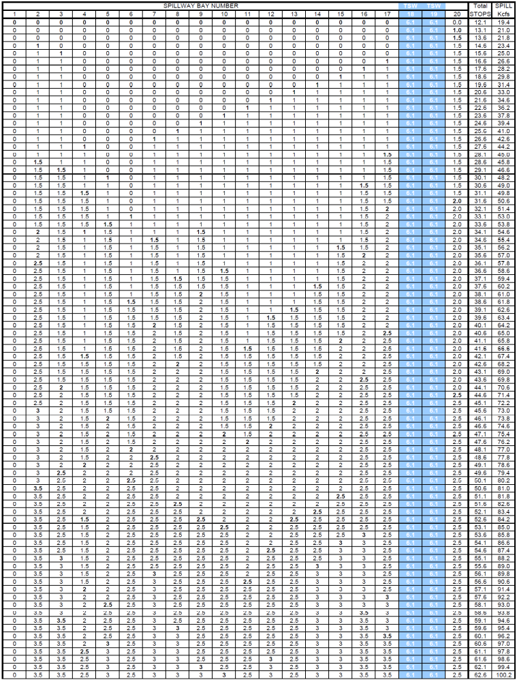
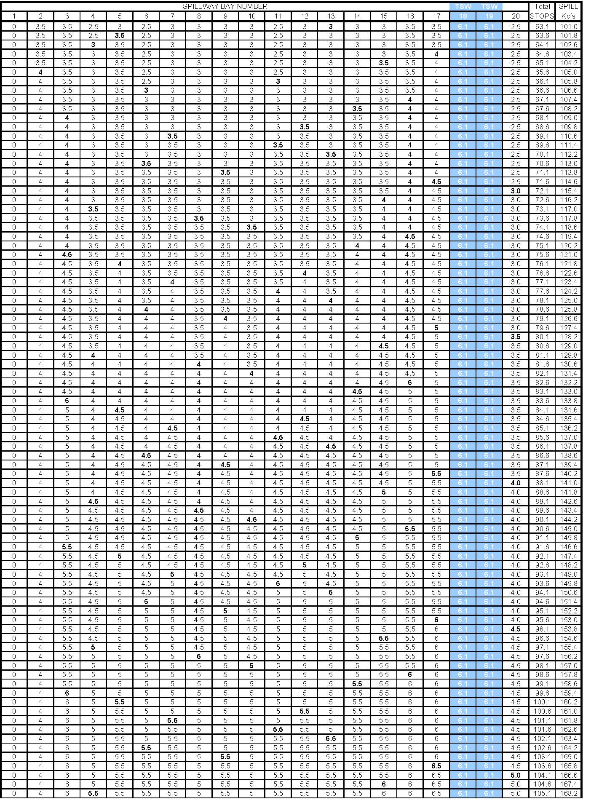
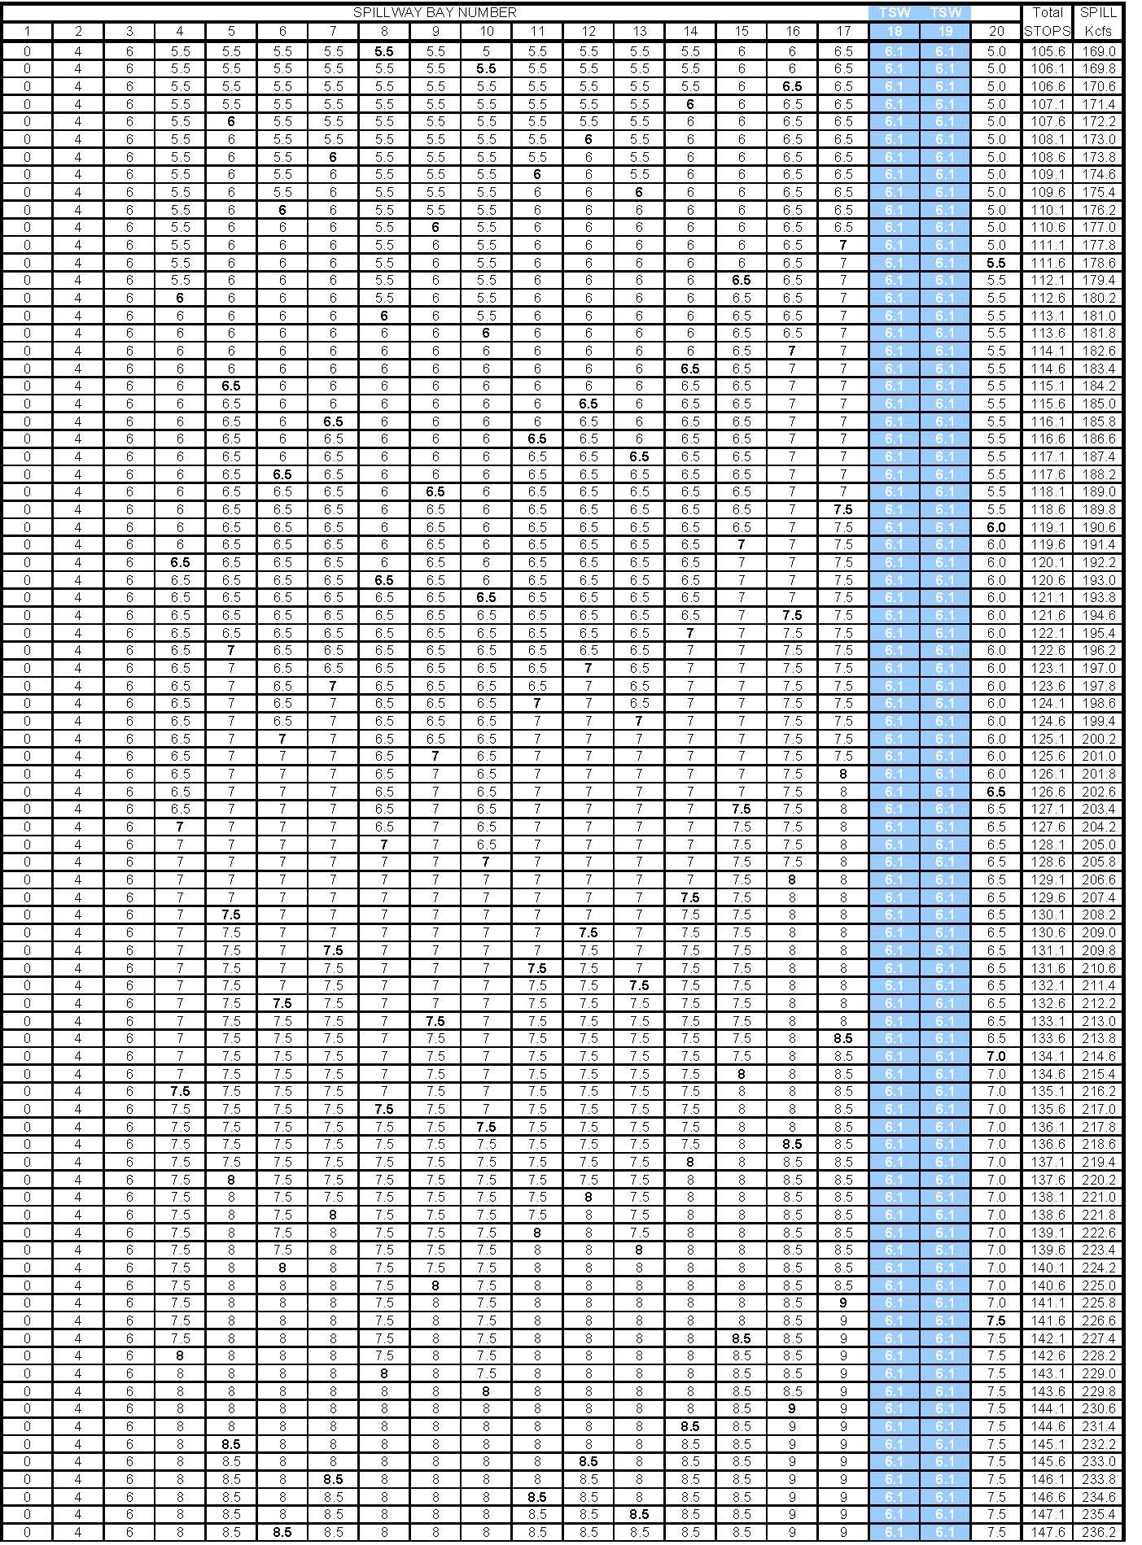
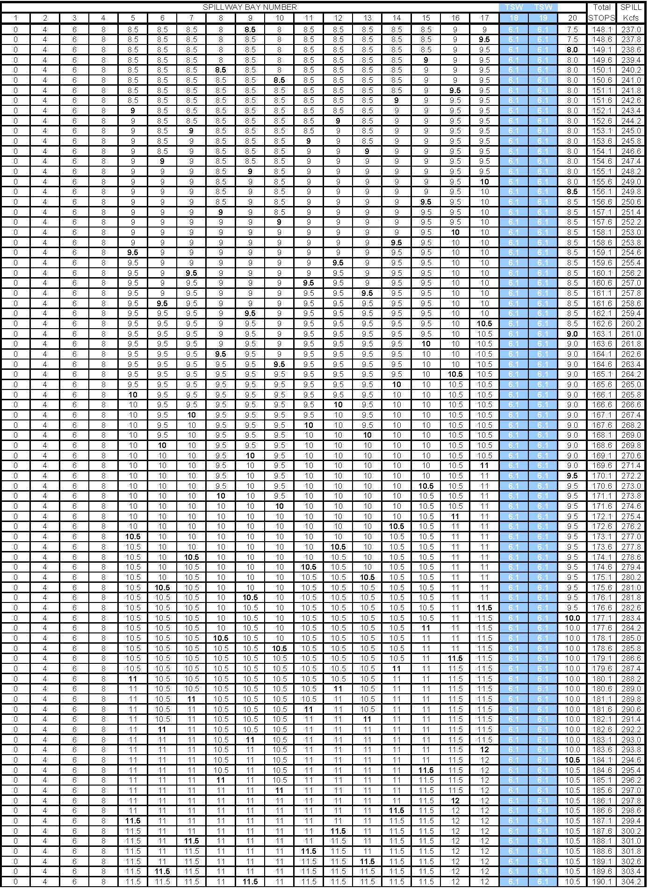
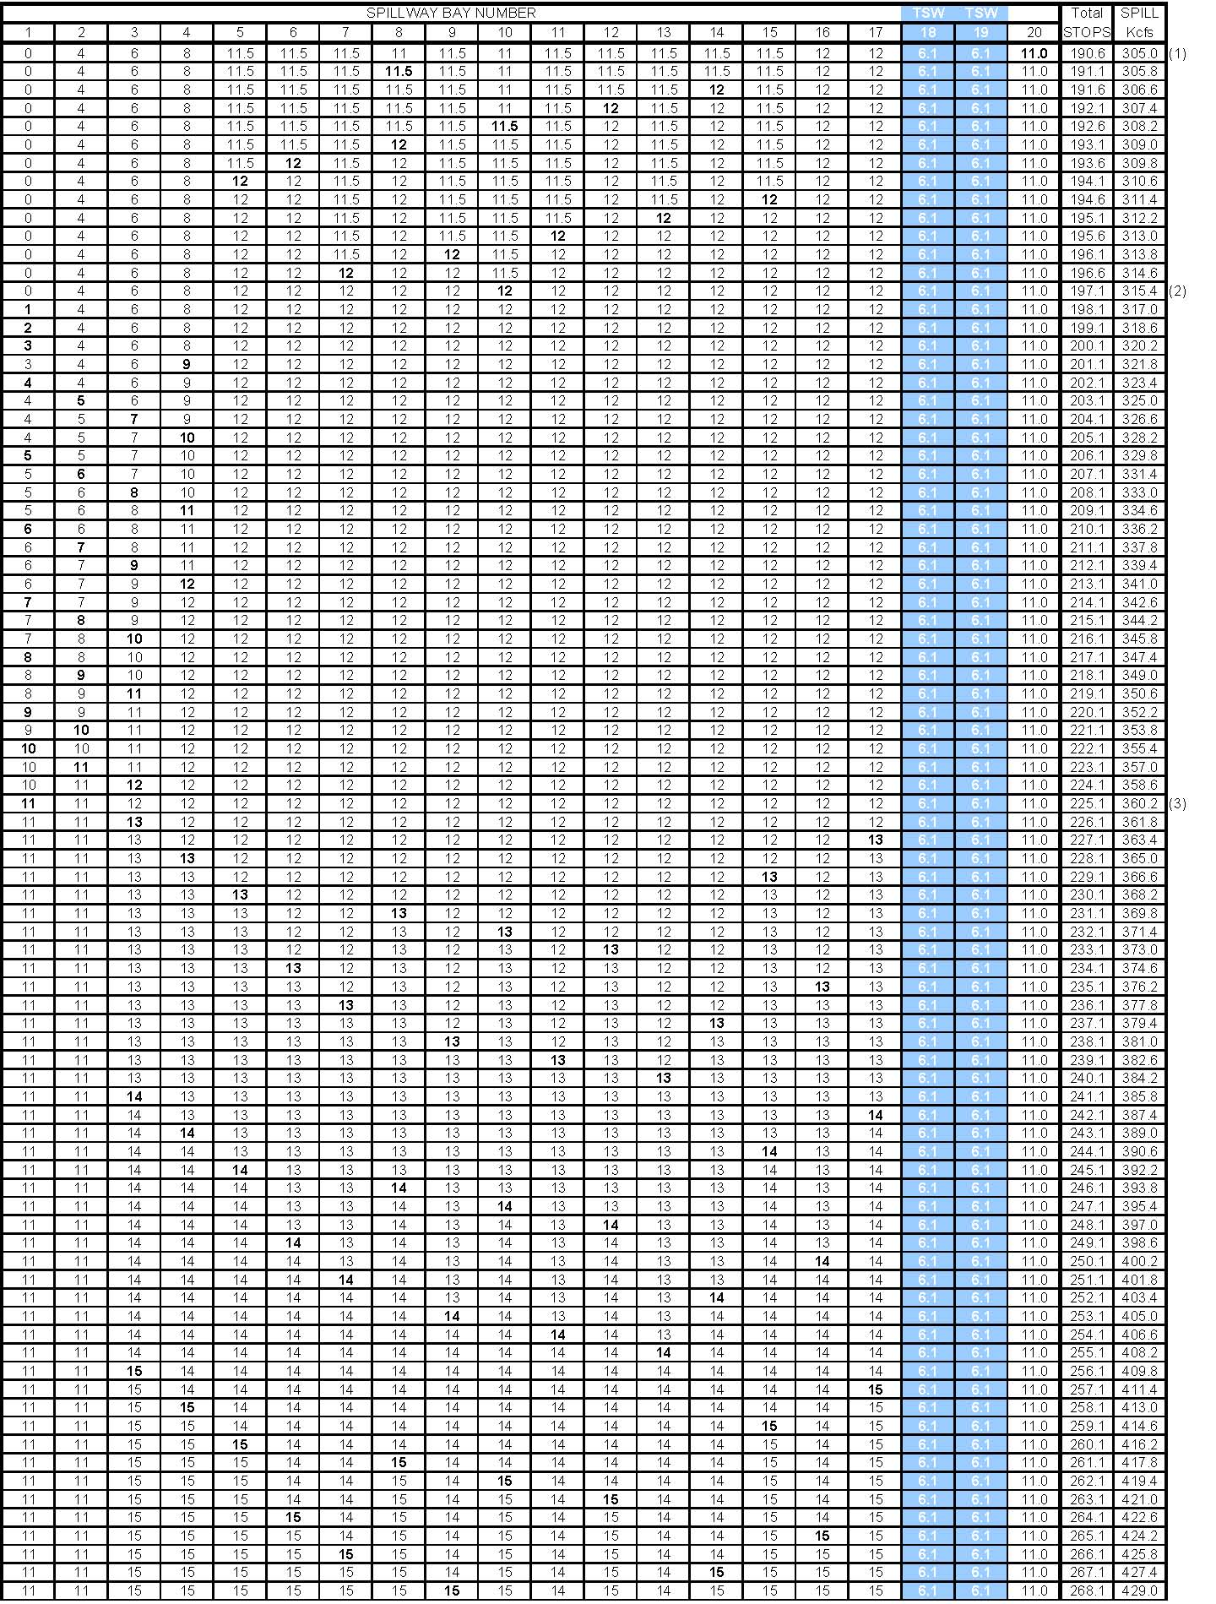
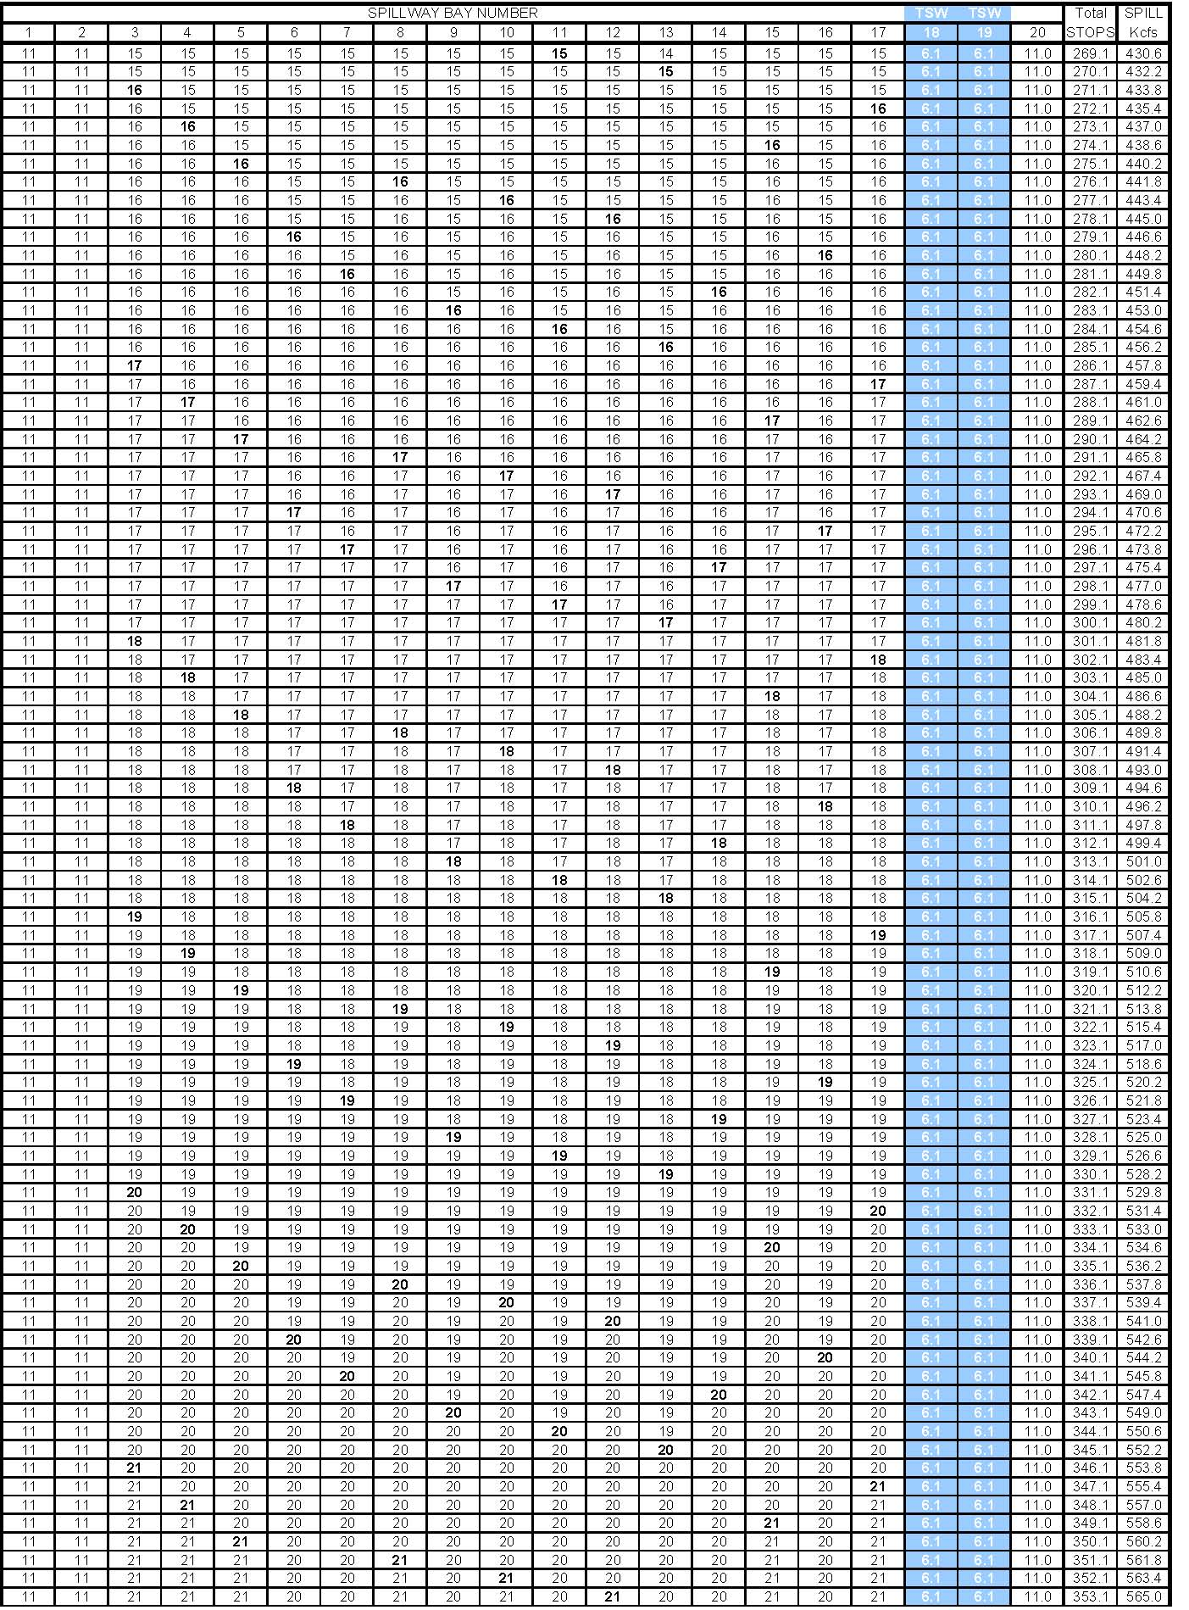
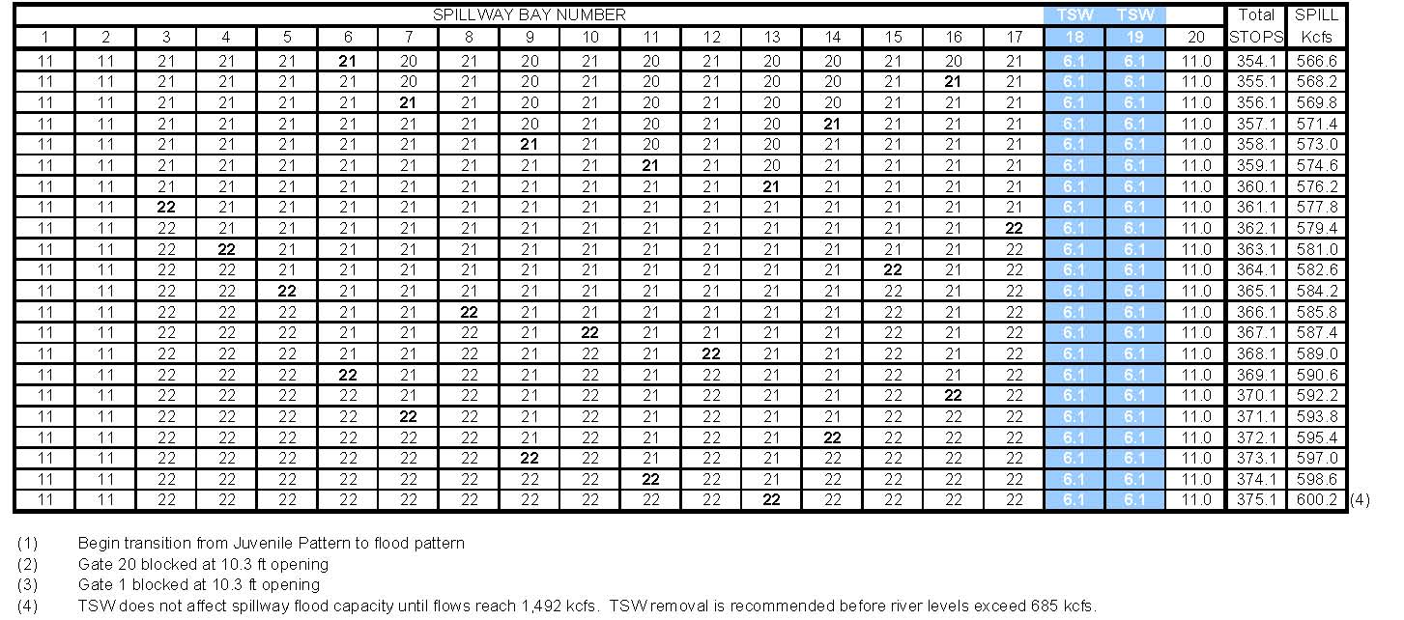
Table JDA- . John Day Dam Spill Pattern with No Temporary Spillway Weirs (TSWs).
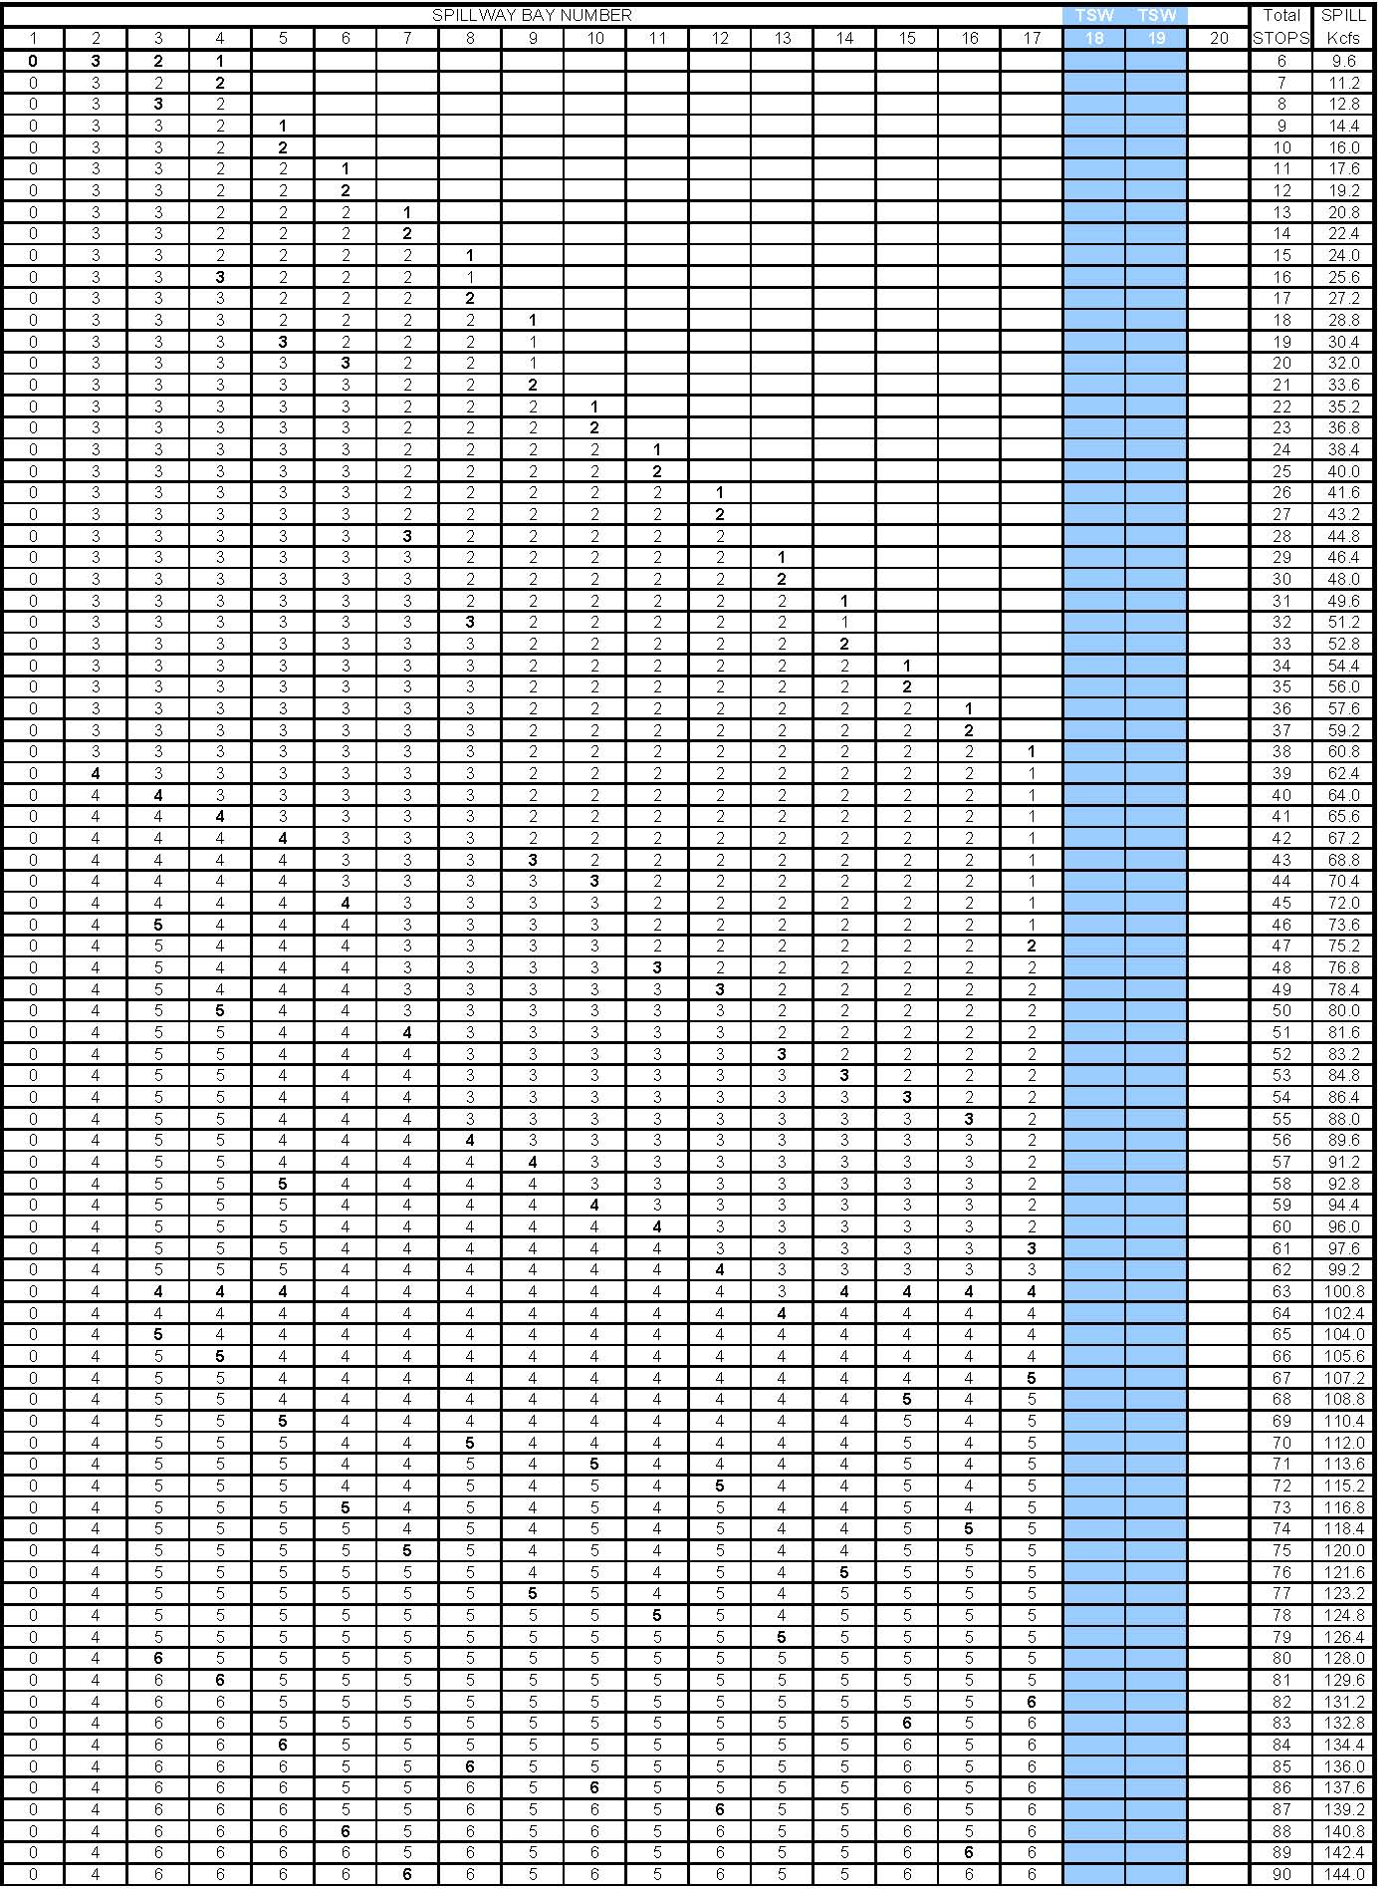
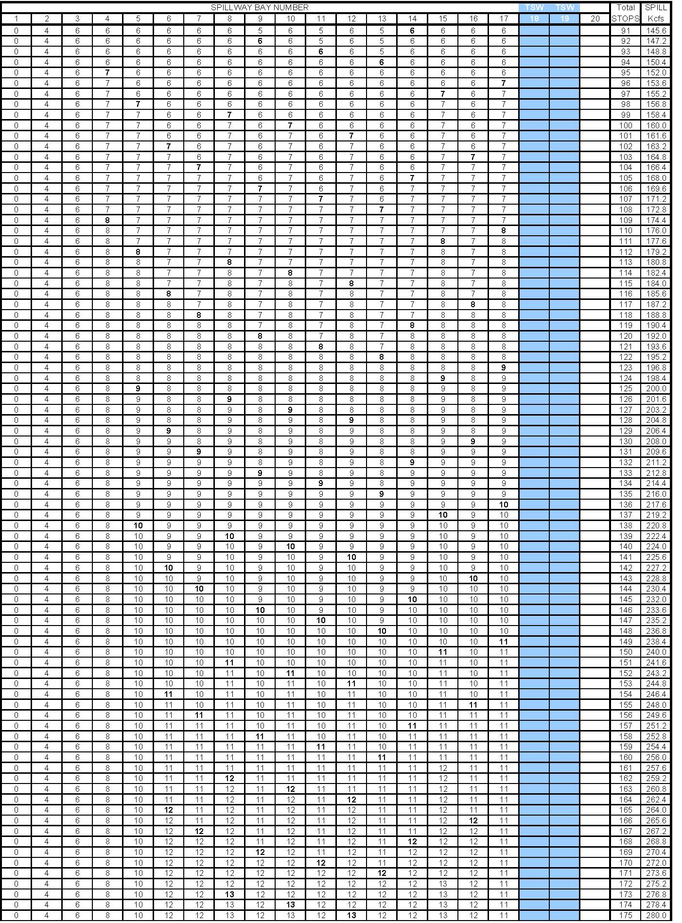
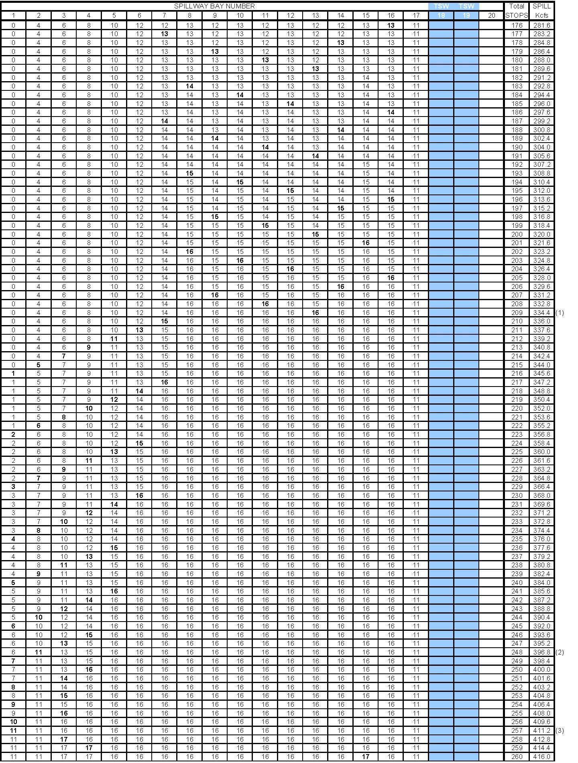
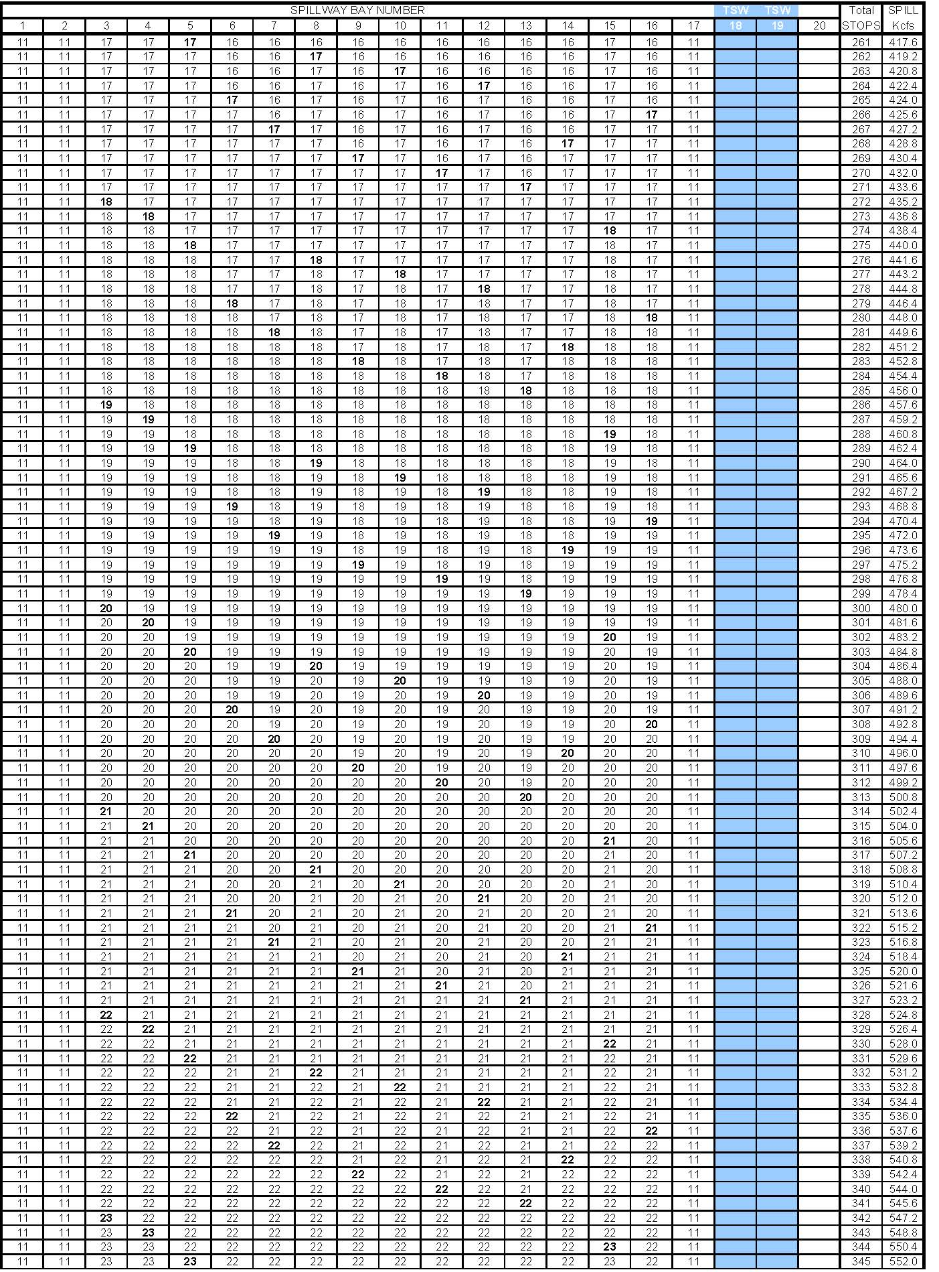
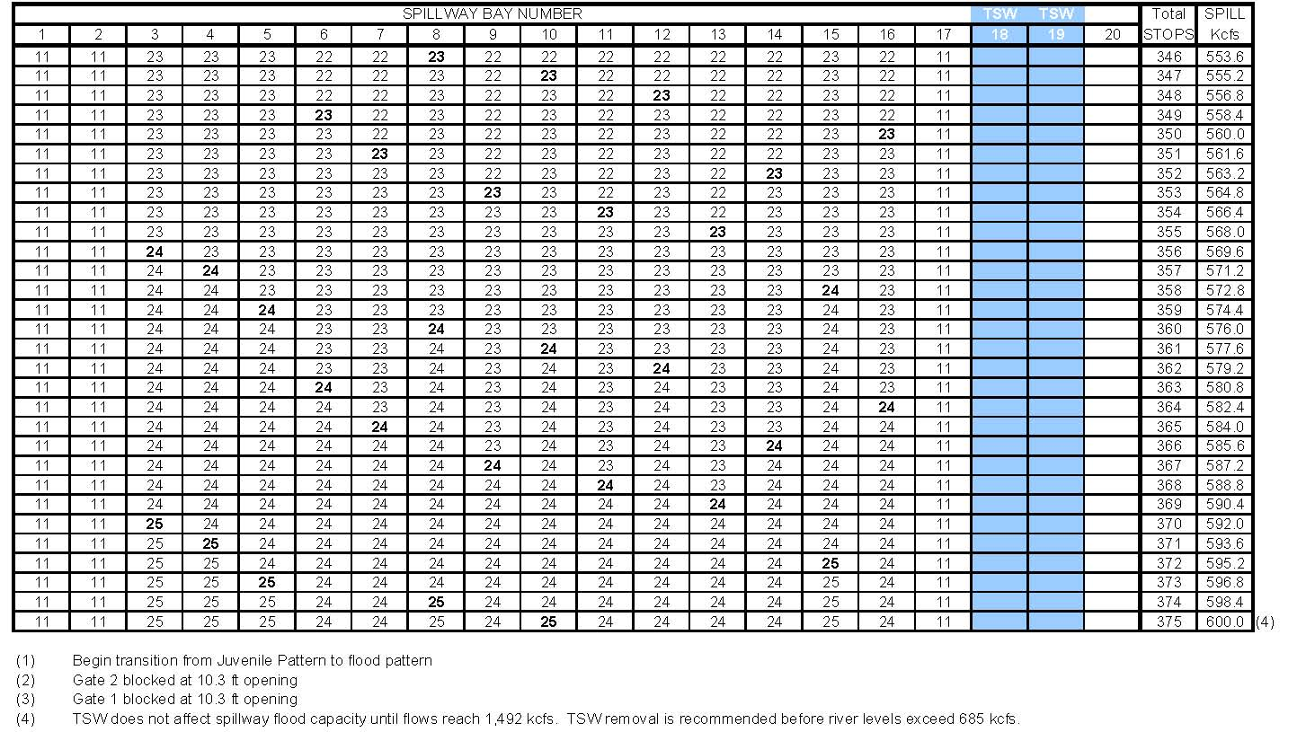

Temporary spillway weirs (TSWs) are installed at John Day, McNary and Little Goose dams. TSWs are differentiated from Removable Spillway Weirs (RSWs, installed at Lower Granite, Lower Monumental and Ice Harbor dams) by the ability to install, uninstall and move TSWs between spillbays using the project’s gantry crane.

