Evaluation of proposed temperature target at Detroit Dam.

Dan Turner 3/30/2016

I was asked to use the Detroit temperature model to evaluate the impacts of using the proposed temperature by ODFW (Table 1). The temperature model was developed by USGS (2015, <http://pubs.usgs.gov/of/2015/1012/>). The temperature model will use available outlets with head constraints and maximum flow ratios (40% power and 60% spill) to attempt to meet a temperature target. The existing and proposed targets are a range but the model needs a single value, so I chose the maximum value of the range for the scenarios. There are three years with different hydrology and meteorology to test the impact under different year types: ‘hot dry’, ‘cool wet’ and ‘normal’. Note that the ‘hot dry’ is less extreme than 2015.

Table 1. Existing and proposed targets.

|  |  |  |  |  |
| --- | --- | --- | --- | --- |
| **Month** | **Existing Temperature Targets** | | **ODFW proposed Temperature Targets** | |
| **Maximum, °F** | **Minimum, °F** | **Maximum, °F** | **Minimum, °F** |
| January | 40.1 | 40.1 | 42 | 38 |
| February | 42.1 | 41.0 | 42 | 38 |
| March | 42.1 | 41.0 | 44 | 42 |
| April | 45.1 | 43.2 | 46 | 42 |
| May | 49.1 | 46.0 | 50 | 46 |
| June | 56.1 | 51.1 | 54 | 48 |
| July | 61.2 | 54.1 | 54 | 48 |
| August | 60.3 | 54.1 | 54 | 48 |
| September | 56.1 | 52.3 | 54 | 48 |
| October | <50.0 | <50.0 | 52 | 46 |
| November | <50.0 | <50.0 | 46 | 42 |
| December | 41.0 | 41.0 | 46 | 41 |

In 2015, a set of evaluation criteria for water temperature in the Middle Fork WillametteRiver was developed to assess biological effectiveness based on spring Chinook salmon life stages. The criteria are used here for comparison however may need to be altered to reflect differences in the North Santiam basin (colored boxes in Figures 1-3 and Table 2). Criteria were developed for various life stages to capture sub-optimal conditions and more extreme conditions throughout the year. Observations were compared as the percent of days not achieving the criteria. However, deviation from the criteria may not have a biological impact because temperatures realized by individual fish is not the same as temperatures measured at specific locations. Water temperatures in streams vary over space and time. The evaluation criteria based on the gage sites should be used as an indicator of potential impact.

The model predicts that outflow temperature would be less during the summer when using the ODFW proposed targets (Figures 1, 2 and 3). However, the model predicts that the ODFW target would result in warmer temperature in the fall, especially during the ‘cool wet’ and ‘normal’ year. The warmer predicted temperatures in the fall result in a 2 to 9 day earlier emergence when using the proposed target (Table 1).

Figure 1. Outlet temperature predictions for a ‘cool wet’ year. The target is dashed and the resulting prediction is a thin, solid line.

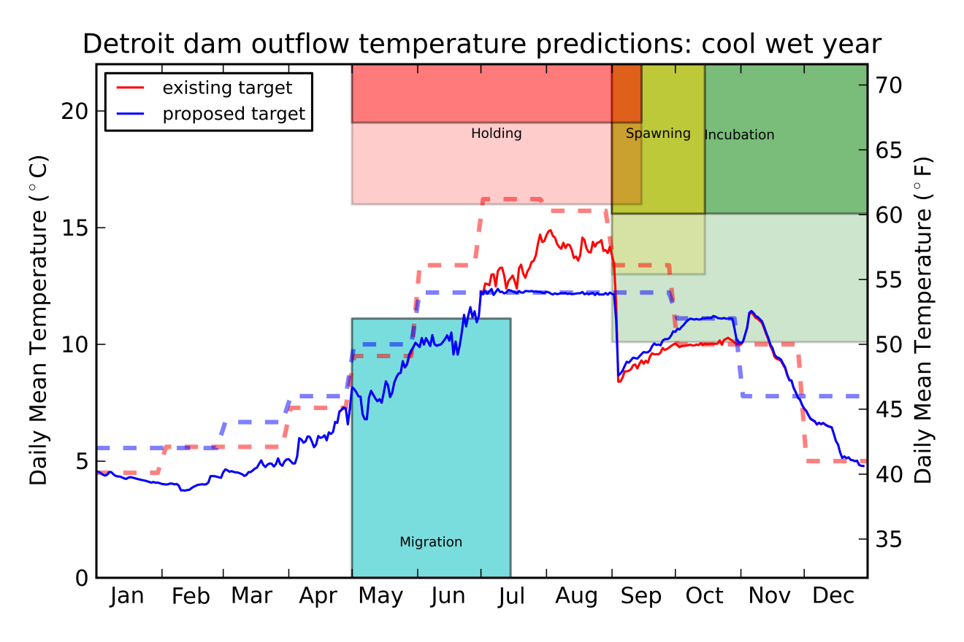

Figure 2. Outlet temperature predictions for a ‘hot dry’ year. The target is dashed and the resulting prediction is a thin, solid line.

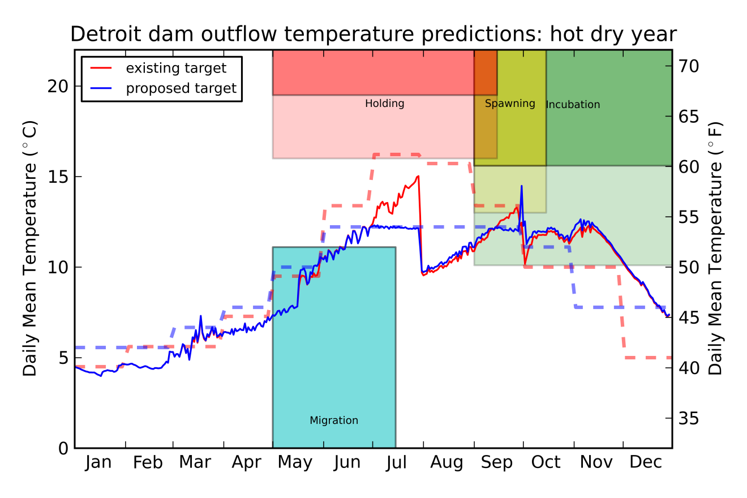

Figure 3. Outlet temperature predictions for a ‘normal’ year. The target is dashed and the resulting prediction is a thin, solid line.

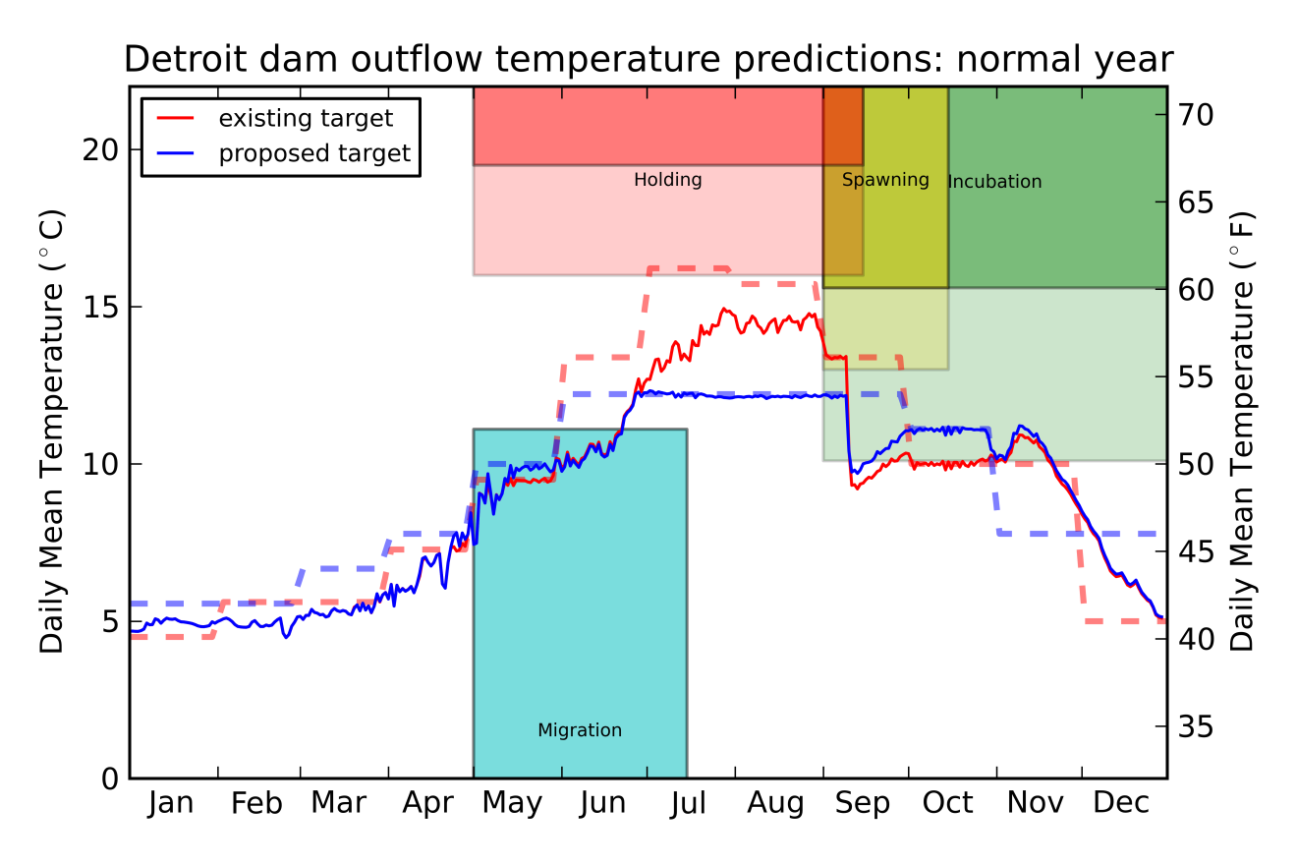

Table 2. Evaluation of different targets.

