Piscivorous Bird Take at McNary Dam as of June 30, 2021

Piscivorous bird take from the tailrace of McNary Dam were performed by USDA personnel, brought to the McNary Juvenile Fish Facility and frozen for later evaluation. For necropsies, the birds were lightly thawed before the esophagus and crop were dissected. Necropsies were performed by McNary SMP staff Thomas VanNice and Kathleen Carter of Pacific States Marine Fisheries Commission.

To date, fifteen birds have been examined from four take dates (Table 1). Juvenile salmon have been observed in 5 of the 15 birds examined. The other birds did not contain any contents. The primary species observed were subyearling Chinook salmon based on the size and appearance of the fish in the bird contents. One Gull (Gull 2, Figure 2) contained 1 steelhead. Some contents were massed together into a bolus making it difficult to determine the identity of everything in the mass (Figure 3). In those cases, the number of juvenile salmon reported were based on the number easily observed but could have contained more.

Table 1. Take Dates, Species and Content of Birds Taken, and Juvenile Salmon Collection Numbers

|  |  |  |  |  |
| --- | --- | --- | --- | --- |
| Take Date | Species | Content | SMP Juvenile Collection Numbers on Take Date | Primary Juvenile Salmon Species on Take Date (No. Collected)* |
| 6/9/2021 | Gull 1 | 1 salmon tail (subyearlingǂ) | 5,200 | Subyearling (3,900) |
|  | Gull 2 | 1 Steelhead |
|  | Gull 3 | ~ 3 subyearlings |
|  | Gull 4 | None |
|  | Gull 5 | 1 salmon tail (subyearling) |
| ~ 6/20/2021 | Cormorant 1 | None | 16,400 | Subyearling (16,250) |
| 6/25/2021 | Cormorant 2 | None | 37,100 | Subyearling (36,900) |
|  | Gull 6 | None |
|  | Cormorant 3 | ~ 5 subyearlings |
|  | Cormorant 4 | None |
|  | Cormorant 5 | None |
|  | Cormorant 6 | None |
| 6/30/2021 | Cormorant 7  Cormorant 8  Cormorant 9 | None | 25,803 | Subyearling (25,703) |
| None |
| None |

* Note: Collection data are only available every other day on even days in June. If the take date fell on an odd day, the collection data from the next day was used.

ǂSubyearling refer to subyearling Chinook salmon

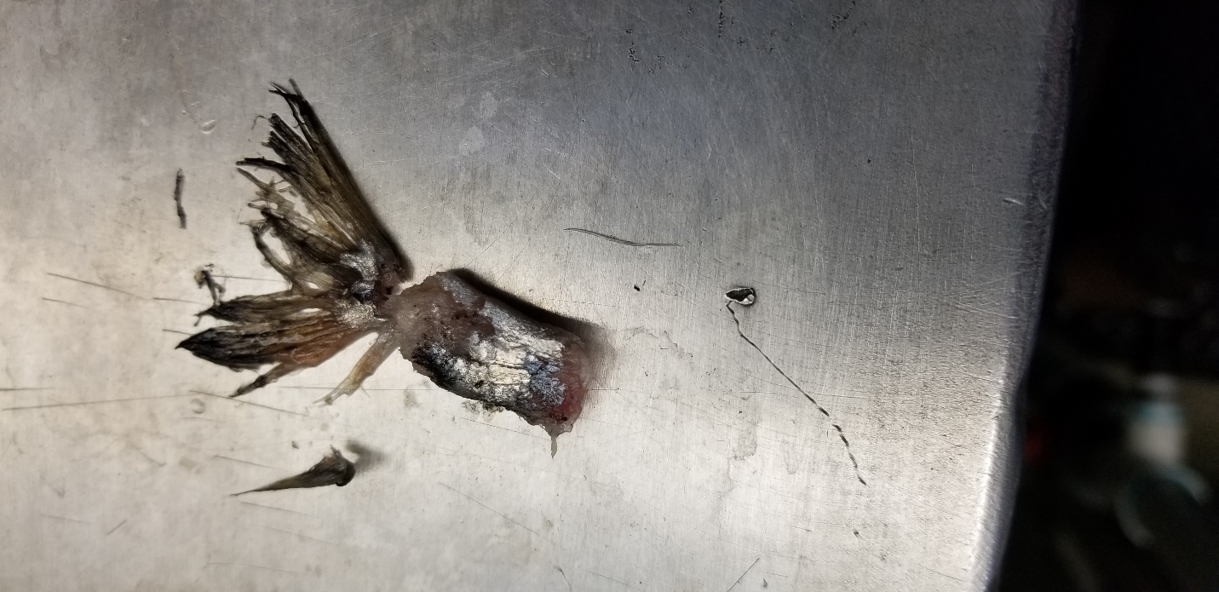

Figure 1. The content of Gull 1 consisted of a subyearling Chinook salmon tail.

Figure 2 A. Gull 2 contained 1 steelhead. B. A closer view of the steelhead. The steelhead was clipped.

A

B

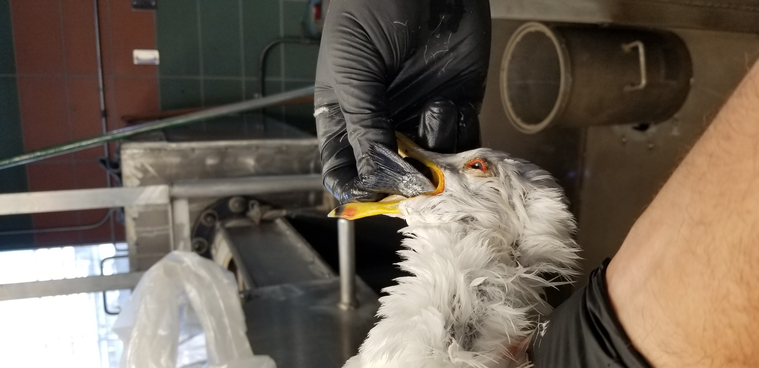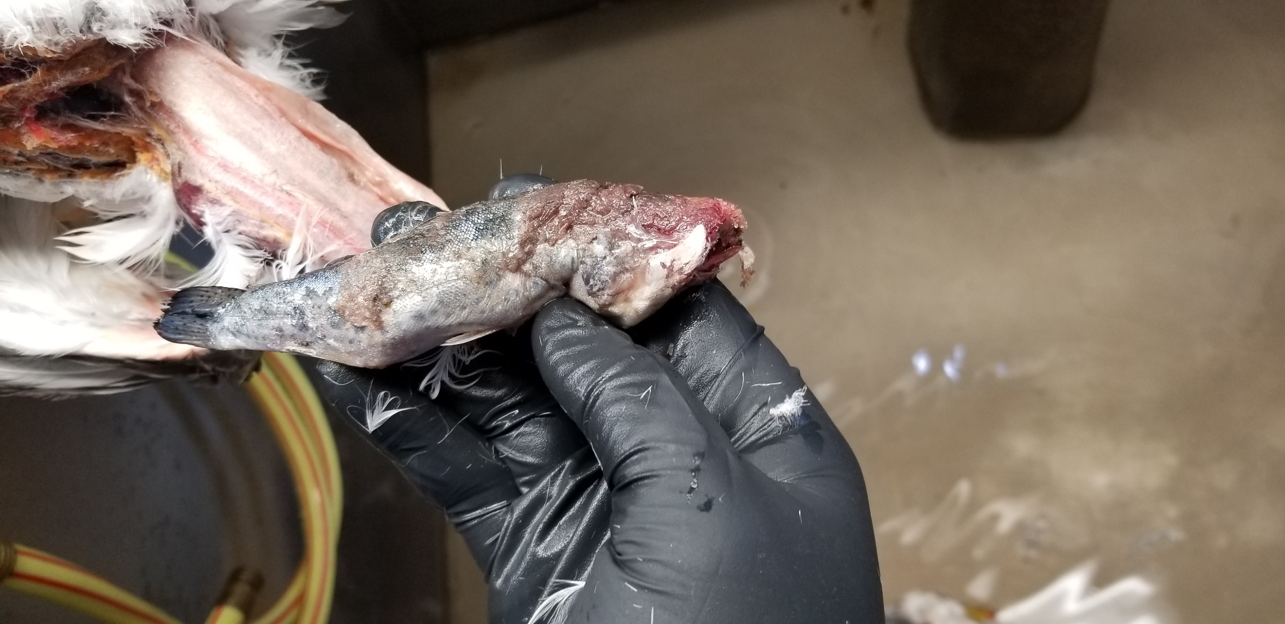

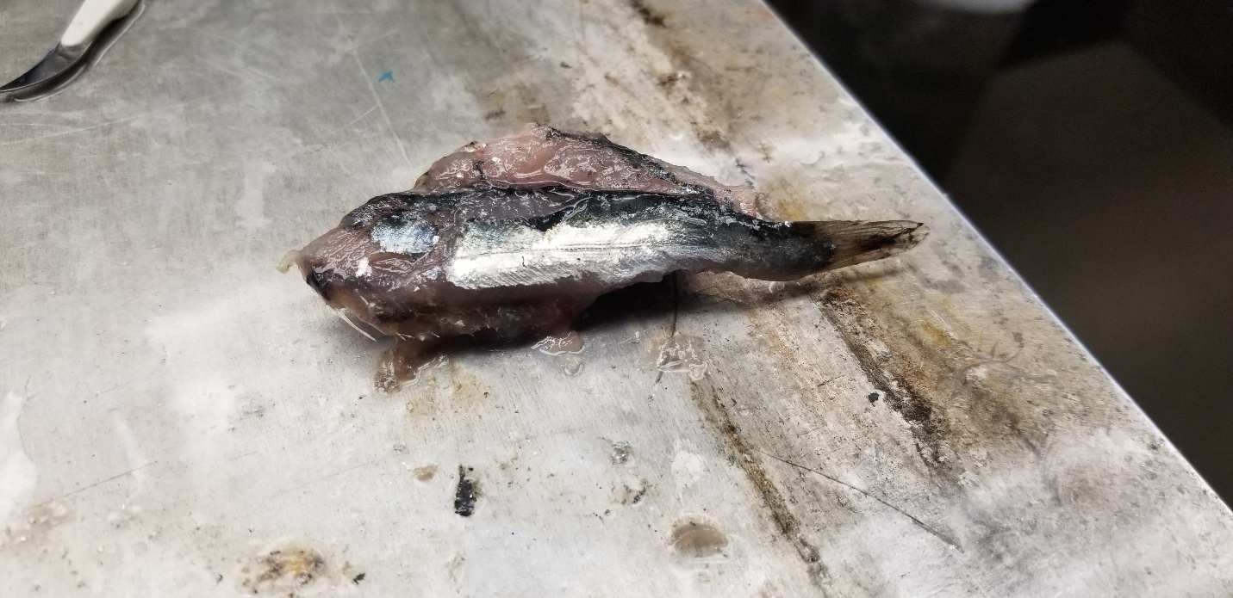

Figure 3. Gull 3 contained a bolus of fish containing at least three subyearling Chinook salmon that were discernable from the rest of the contents in the mass.