Turbine Survival Program
- PROJECT INFORMATION
P2 Identifier | 463071
Project Manager (PM) | George Medina (NWP, 503-808-4753)
Technical Lead (TL) | Martin Ahmann (NWP, 509-827-7538)
Biologist/Coordination | John Rerecich (NWP, 503-808-4779)

- PURPOSE
The purpose of this project management plan is to document scope, schedule, budget, and management practices in support of the Turbine Survival Program (TSP).

- BACKGROUND

Turbine-passage is one of the downstream migratory fish passage routes though a dam. Fish passing through turbines is unavoidable. Improving fish passage through turbines both by operational improvements and design improvements supports Regional requirements for improving fish passage through the hydropower system. The TSP was formed under the Columbia River Fish Mitigation Program (CRFMP) to evaluate the effects of turbine passage on fish and to investigate and recommend potential turbine improvements for safer fish passage.
Phase I of the Turbine Survival Program began in 1995 with the TSP workshop held in Portland, Oregon. The TSP was initially developed to quantitatively evaluate juvenile fish passage through turbines with an emphasis on identifying turbine structures and operations responsible for injury to fish. The TSP is supported by a regional cross-functional, multidiscipline team with representatives from the Walla Walla District (NWW), Portland District (NWP), Hydroelectric Design Center (HDC), Engineering Research and Development Center (ERDC) at Waterways Experimental Station, the Bonneville Power Administration (BPA), and the National Marine Fisheries Service (NMFS/NOAA). Phase I concluded in 2004 with the publication of the Phase I Report. The recommendations contained in that report are presently being implemented through Phase II.
.

- STATUS & ISSUES
- ERDC modeling in FY17 focused on a bead analysis study of The Dalles model to help identify the best operating point. The data acquired from this effort will fill data gaps for The Dalles Project in the BIT Report/Study. Testing done this year and reporting next year
- ERDC is looking to complete a B1 and B2 report this FY with Final edited and ERDC approved report in FY18
- FY17 scope of work for TSP also entailed a monthly forum meeting to discuss TSP related issues for powerhouse plants up for FCRPS
- TSP will not be funded beyond FY18. Therefore The Dalles Model testing needs to be completed and a summary report provided; the model needs to be stood down and stored, and provisions made to indefinitely fund storage and maintenance of all turbine models

- SCHEDULE & COST

YEAR | COST | MAJOR ACTIVITIES
FY17 Actual Obligation | $416,035 | FY17 focus is on a bead analysis study of The Dalles model to help identify the best operating point. The data acquired from this effort will fill data gaps for The Dalles Project in the BIT Report/Study. Testing done this year and reporting in FY18.
FY18  PBUD | $250,000 | Complete testing and summary report for The Dalles Bead analysis; complete B1/B2 reports; update BIT report; continue monthly PDT meetings with a focus on closing out the project under CRFM.

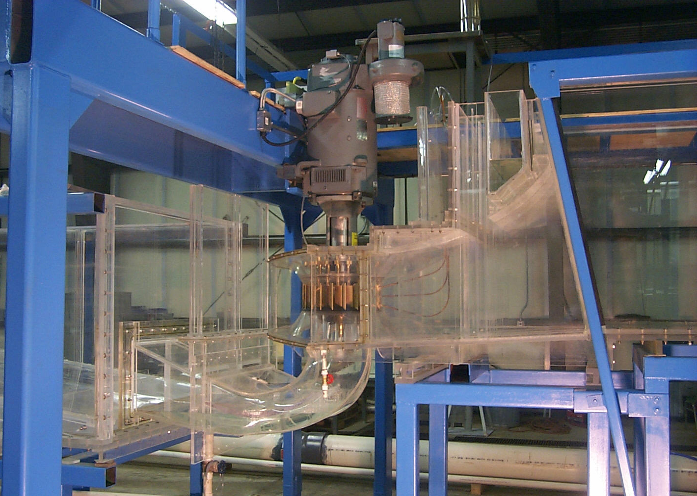
- PHOTOS & DRAWINGS

