To: Randy Absolon

From: Benjamin Sandford

Date: 13 August, 2015

Subject: Preliminary analyses for project: B2 FGE Improvements, Post Construction Gatewell Improvement Testing (update from 23 and 30 July and 3 August due to travel time update, adding mortality proportion of observed sample, and some name changes

Data

Subyearling Chinook salmon were PIT-tagged and released between 1 April and 29 May 2015 into gatewell slots 14A , 15A, and 15C. A portion of the tagged fish were detected at the Second Powerhouse Juvenile Fish Monitoring Facility (JFMF) and a portion were diverted into sample tanks using the Sort-by-Code system. Diverted fish were examined for injury (rare) and mortality. Date and time of first detection at the JFMF was noted for detected fish. Useful metrics were defined and calculated as follows:

ObsProp = Observed proportion of each release that were subsequently detected somewhere in the PIT-tag system of the JFMF

RecapProp = Observed proportion of JFMF-detections that were recaptured in sample tanks and examined for injury/mortality

ObsMortProp = Proportion of ObsMort to Total in recapture sample

MaxMortProp = Estimated mortality proportion of released fish =

ObsMort + NonRecapObs*ObsMortProp + NonObs,

Where ObsMort = Observed mortalities in recapture sample,

NonRecapObs = Observed JFMF detections that were not in recapture sample

And NonObs = Fish released but not observed anywhere in the JFMF

Gatewell Residence Time (GRT) = Median time from release to first detection in the JFMJ for each cohort of daily-released PIT-tagged fish into each gatewell

Consider the following possible assumptions:

A1 – Mortality was related only to gatewell treatment or passage to the JFMF, and not as a result of being sampled by the Sort-by-Code system. Therefore, all mortality was expressed fairly quickly after the mechanism that caused it, and fish not sampled by the Sort-by-Code system had the same mortality probability as those sampled.

A2a – Fish not detected by the JFMF were mortalities that prevented the PIT tag from reaching the facility. This means the JFMF detection probability was assumed to be 100% and tagged fish did not have an opportunity to exit the dam without passing through the JFMF.

A2b – Fish not detected by the JFMF passed another route that prevented the PIT tag from being detected. This means the JFMF detection probability was assumed to be 0% and these fish would have had the same mortality probability as the JFMF-detected fish if they had used the same passage route.

ObsMortProp is an appropriate estimate of the true treatment mortality under A1 and A2b. MaxMortProp is an appropriate estimate of the true treatment mortality under A1 and A2a. We made assumption A1 for this study. We also assumed that neither assumptions A2a or A2b were probably completely correct, but rather an unknown proportion of fish “fit” under each of them. Unfortunately we have no way of estimating that proportion. Therefore, accurate estimates of treatment mortality in this study lie between these two estimates. When the proportion of undetected fish was small, ObsMortProp was assumed to be a reasonably accurate estimate of the particular treatment mortality.

Summary data results are as follows:

Table 1a. Series 1, Unit 14A. Metrics for PIT-tag released subyearling Chinook salmon at Bonneville Dam 2nd Powerhouse in 2015.

|  |  |  |  |  |  |  |
| --- | --- | --- | --- | --- | --- | --- |
| Release | Release |  |  |  |  | Median Gatewell |
| Date | Number | ObsProp | RecapProp | ObsMortProp | MaxMortProp | Residence Time (d) |
| 4/1 | 100 | 0.930 | 0.978 | 0.187 | 0.244 | 0.106 |
| 4/2 | 94 | 0.872 | 1.000 | 0.122 | 0.234 | 0.057 |
| 4/3 | 101 | 0.960 | 0.990 | 0.292 | 0.320 | 0.263 |
| 4/4 | 100 | 0.920 | 0.978 | 0.256 | 0.315 | 0.038 |
| 4/5 | 100 | 0.920 | 0.957 | 0.443 | 0.488 | 0.347 |
| 4/6 | 102 | 0.951 | 0.969 | 0.340 | 0.373 | 0.463 |
| 4/7 | 100 | 0.930 | 0.968 | 0.322 | 0.370 | 0.251 |
| 4/8 | 99 | 0.960 | 0.916 | 0.184 | 0.217 | 0.044 |
| 4/9 | 101 | 0.970 | 0.949 | 0.323 | 0.343 | 0.289 |
| 4/21 | 116 | 0.879 | 0.961 | 0.122 | 0.228 | 0.506 |
| 4/23 | 250 | 0.912 | 0.890 | 0.059 | 0.142 | 0.487 |
| 5/5 | 125 | 0.992 | 0.952 | 0.034 | 0.042 | 0.544 |
| 5/7 | 233 | 0.966 | 0.942 | 0.038 | 0.071 | 0.495 |
|  | Mean | 0.936 | 0.958 | 0.209 | 0.260 | 0.299 |
|  | SE | 0.010 | 0.008 | 0.036 | 0.035 | 0.053 |

Table 1b. Series 1, Unit 15A. Metrics for PIT-tag released subyearling Chinook salmon at Bonneville Dam 2nd Powerhouse in 2015.

|  |  |  |  |  |  |  |
| --- | --- | --- | --- | --- | --- | --- |
| Release | Release |  |  |  |  | Median Gatewell |
| Date | Number | ObsProp | RecapProp | ObsMortProp | MaxMortProp | Residence Time (d) |
| 4/1 | 100 | 0.950 | 1.000 | 0.000 | 0.050 | 0.095 |
| 4/2 | 99 | 0.914 | 0.975 | 0.026 | 0.105 | 0.035 |
| 4/3 | 102 | 0.882 | 1.000 | 0.000 | 0.118 | 0.054 |
| 4/4 | 100 | 0.910 | 1.000 | 0.044 | 0.130 | 0.040 |
| 4/5 | 100 | 0.890 | 0.989 | 0.000 | 0.110 | 0.057 |
| 4/6 | 100 | 0.840 | 1.000 | 0.000 | 0.160 | 0.175 |
| 4/7 | 101 | 0.634 | 0.984 | 0.032 | 0.386 | 0.106 |
| 4/8 | 100 | 0.620 | 0.952 | 0.051 | 0.412 | 0.076 |
| 4/9 | 100 | 0.580 | 0.983 | 0.018 | 0.430 | 0.068 |
| 4/21 | 115 | 0.443 | 0.922 | 0.085 | 0.594 | 0.075 |
| 4/23 | 240 | 0.783 | 0.963 | 0.006 | 0.221 | 0.522 |
| 5/5 | 125 | 0.800 | 0.980 | 0.010 | 0.208 | 0.537 |
| 5/7 | 247 | 0.834 | 0.971 | 0.000 | 0.166 | 0.543 |
|  | Mean | 0.775 | 0.978 | 0.021 | 0.238 | 0.183 |
|  | SE | 0.043 | 0.006 | 0.007 | 0.046 | 0.056 |

Table 2a. Series 2, Unit 14A. Metrics for PIT-tag released subyearling Chinook salmon at Bonneville Dam 2nd Powerhouse in 2015.

|  |  |  |  |  |  |  |
| --- | --- | --- | --- | --- | --- | --- |
| Release | Release |  |  |  |  | Median Gatewell |
| Date | Number | ObsProp | RecapProp | ObsMortProp | MaxMortProp | Residence Time (d) |
| 5/12 | 131 | 0.985 | 0.938 | 0.017 | 0.032 | 0.532 |
| 5/13 | 129 | 0.984 | 0.937 | 0.000 | 0.016 | 0.044 |
| 5/14 | 123 | 0.984 | 0.942 | 0.018 | 0.034 | 0.392 |
| 5/15 | 130 | 0.954 | 0.976 | 0.025 | 0.070 | 0.548 |
| 5/18 | 130 | 0.977 | 0.969 | 0.016 | 0.039 | 0.545 |
| 5/19 | 130 | 0.985 | 0.953 | 0.041 | 0.056 | 0.527 |
| 5/20 | 129 | 0.984 | 0.984 | 0.016 | 0.031 | 0.393 |
| 5/21 | 130 | 0.954 | 0.960 | 0.076 | 0.118 | 0.288 |
| 5/22 | 140 | 0.986 |  |  |  | 0.407 |
| 5/27 | 130 | 0.992 | 0.953 | 0.000 | 0.008 | 0.369 |
| 5/28 | 130 | 0.946 | 0.935 | 0.017 | 0.070 | 0.548 |
| 5/29 | 135 | 0.993 | 0.978 | 0.008 | 0.015 | 0.568 |
|  | Mean | 0.977 | 0.957 | 0.021 | 0.044 | 0.430 |
|  | SE | 0.005 | 0.005 | 0.006 | 0.010 | 0.044 |

Table 2b. Series 2, Unit 15C. Metrics for PIT-tag released subyearling Chinook salmon at Bonneville Dam 2nd Powerhouse in 2015.

|  |  |  |  |  |  |  |
| --- | --- | --- | --- | --- | --- | --- |
| Release | Release |  |  |  |  | Median Gatewell |
| Date | Number | ObsProp | RecapProp | ObsMortProp | MaxMortProp | Residence Time (d) |
| 5/12 | 131 | 0.954 | 0.984 | 0.000 | 0.046 | 0.345 |
| 5/13 | 131 | 0.962 | 1.000 | 0.008 | 0.046 | 0.368 |
| 5/14 | 118 | 0.983 | 0.948 | 0.000 | 0.017 | 0.337 |
| 5/15 | 134 | 0.985 | 0.962 | 0.016 | 0.030 | 0.511 |
| 5/18 | 130 | 0.969 | 0.968 | 0.016 | 0.047 | 0.497 |
| 5/19 | 130 | 0.915 | 0.958 | 0.018 | 0.101 | 0.633 |
| 5/20 | 130 | 0.815 | 0.962 | 0.000 | 0.185 | 0.296 |
| 5/21 | 130 | 0.962 | 0.992 | 0.008 | 0.046 | 0.545 |
| 5/22 | 142 | 0.944 |  |  |  | 0.567 |
| 5/27 | 130 | 0.954 | 0.847 | 0.000 | 0.046 | 0.518 |
| 5/28 | 130 | 0.962 | 0.920 | 0.000 | 0.038 | 0.545 |
| 5/29 | 134 | 0.993 | 0.955 | 0.000 | 0.007 | 0.475 |
|  | Mean | 0.950 | 0.954 | 0.006 | 0.055 | 0.470 |
|  | SE | 0.014 | 0.013 | 0.002 | 0.015 | 0.031 |

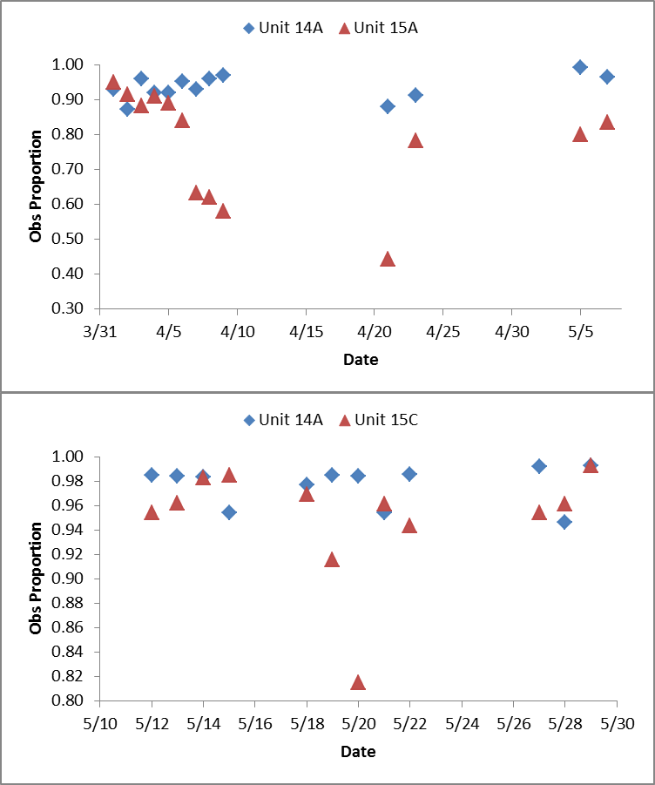

Figure 1. Observed proportion of fish detected on the JFMF in 2015.

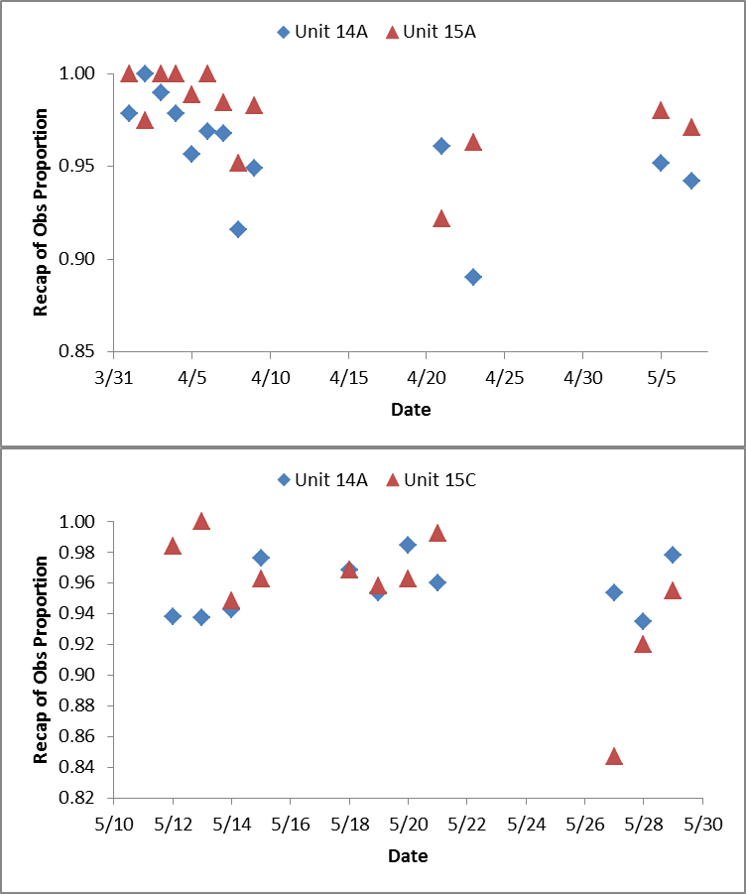

Figure 2. Recapture proportion of JFMF-detected fish in 2015.

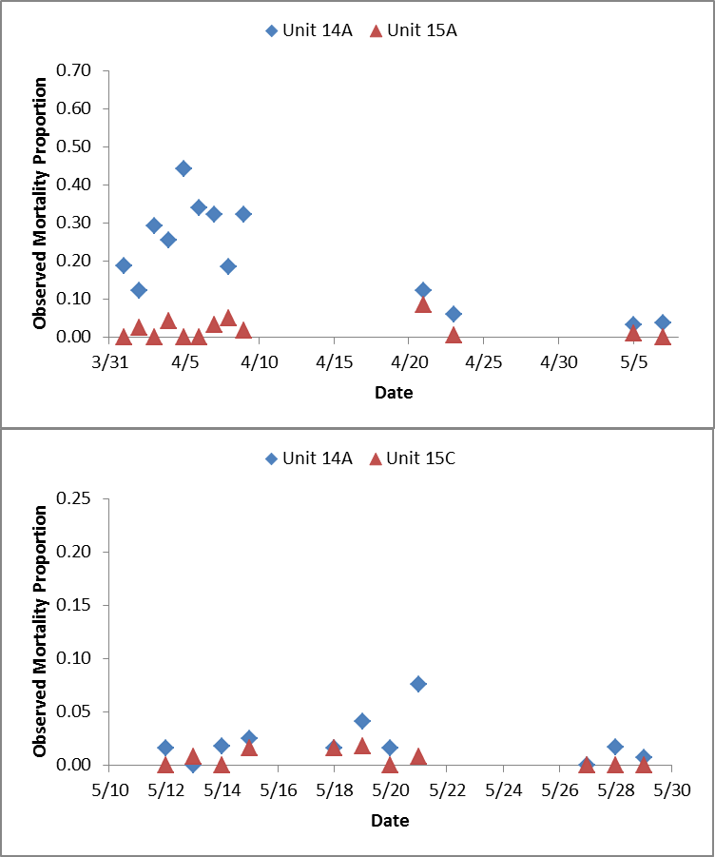

Figure 3. Observed mortality for fish observed in the recapture sample in 2015.

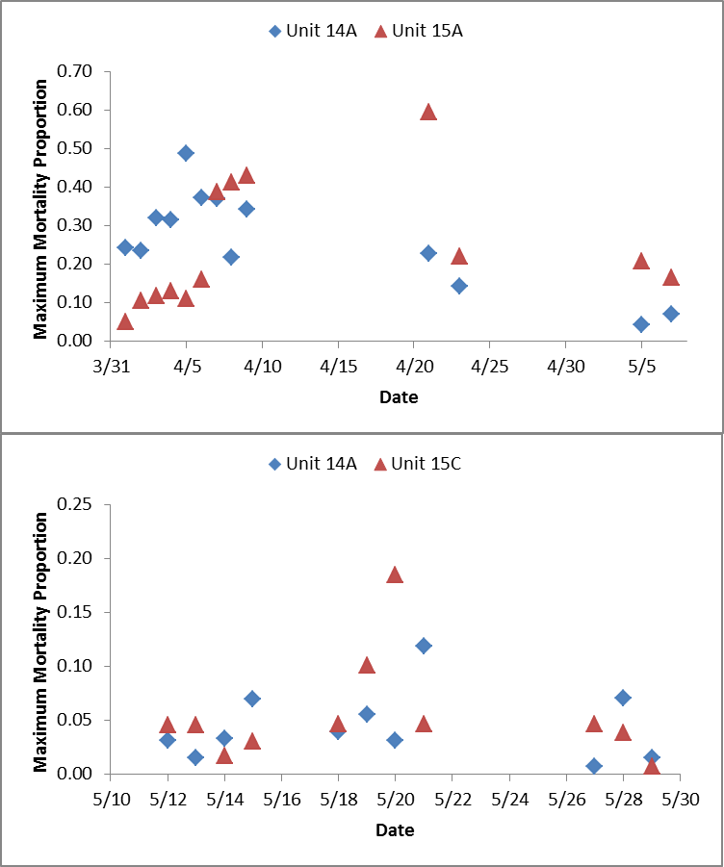

Figure 4. Maximum estimated mortality for fish observed in the recapture sample, estimated for fish in the JFMF but not recaptured, and assumed for non-detected fish in 2015

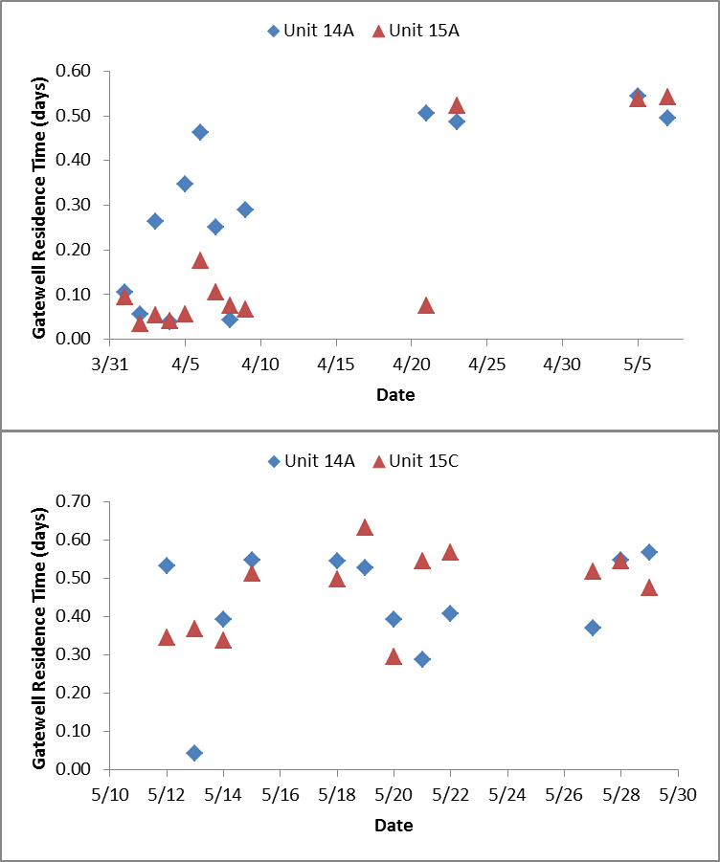

Figure 5. Median Gatewell Residence time from Gatewells 14A, 15A, or 15C to first detection in the JFMF in 2015.

Comparisons

From the proposal for this study, the objectives were:

1 & 2. Hydraulic testing (not included).

1. Estimate Spring Creek NFH juvenile subyearling Chinook salmon mortality and gatewell residence time at the upper and middle 1% peak efficiency range under the following gatewell configurations in 15A and 14A.
   1. Modified Gatewell 15A at upper 1% operation.
   2. Unmodified Gatewell 14A at middle 1% operation.

4. Estimate Spring Creek NFH juvenile subyearling Chinook salmon mortality and

gatewell residence time at the upper and middle 1% peak efficiency range of Gatewell Slots 14A and 15C.

A. Unmodified Gatewell Slot 15C at upper 1% operation.

B. Unmodified Gatewell Slot 14A at middle 1% operation.

1. Compare treatment A against treatment B for Objective 3 and 4 releases (sample

sizes shall be calculated to detect a difference in fish condition of 3% at α = 0.05).

* + 1. Fish Condition (FC): H0 = FCupper15A = FCmid14A;

HA = FCupper15A≠FCmid14A

* + 1. Gatewell Residence Time (GRT): H0 = GRTupper15A = GRTmid14A;

HA = GRTupper15A≠GRTmid14A

* + 1. Fish Condition (FC): H0 = FCupper15C = FCmid14A;

HA = FCupper15C≠FCmid14A

* + 1. Gatewell Residence Time (GRT): H0 = GRTupper15C = GRTmid14A;

HA = GRTupper15C≠GRTmid14A

The above metrics were used to provide estimates for objectives 3 and 4 (Note means and se’s in Tables 1a, 1b, 2a, and 2b) and to make comparisons for objective 5 using paired t-tests. Results are in Tables 2a and 2b and visually represented in Figures 6-8. These preliminary results suggest that mortality for comparison “i.” above was significantly higher in Unit 14A than in Unit 15A using the observed sample mortality (*P* < 0.001) but using the maximum estimated mortality it was undetermined since the first 6 groups had higher mortality in Unit 14A but the last 6 groups had lower for a non-significant difference overall (*P*=0.705). For the latter metric, dividing the data into the “obvious” groupings, the early part (releases on 1-6 April showed significantly higher mortality in Unit 14A (*P* = 0.003) and for 7 April-7 May showed significantly lower mortality in Unit 14A (*P* =0.021) For comparison “iii.” above, there was a significant difference in mortality using either the observed metric (Unit 14A > Unit 15C by 1.5%, *P* = 0.029) but not significant using the maximum estimated mortality metric (Unit 14A < Unit 15C by 1.1%, *P* = 0.549). For comparison “ii.” above, Gatewell Residence Time was around three hours significantly longer than for Unit 15A (*P* = 0.021) but not different at all for Unit 15C (*P* = 0.402). Further, perhaps more complex, analysis will be explored to examine these patterns.

Boxplots of Gatewell Residence Time distributions are in the Appendix. Fish that were observed as mortalities at the JFMF Sort-by-Code sample had somewhat longer times than live fish (Figure A1). This difference needs to be discussed. There were not generally large differences in median Gatewell Residence Time as noted in Table 3a and 3b, but there were some observed differences in the shape of the distributions (Figures A2 and A3).

Table 3a. Paired differences for metrics comparing conditions in Unit 14A and 15A gatewells in 2015 at Bonneville Dam 2nd Powerhouse.

|  |  |  |  |  |  |  |  |
| --- | --- | --- | --- | --- | --- | --- | --- |
|  |  |  |  |  | Median Gatewell |  |  |
| Release | ObsProp | RecapProp | ObsMortProp | MaxMortProp | Residence Time (d) | MaxMortProp Difference | |
| Date | Difference | Difference | Difference | Difference | Difference | 4/1 - 4/6 | 4/7 - 5/7 |
| 4/1 | -0.020 | -0.022 | 0.187 | 0.194 | 0.011 | 0.194 |  |
| 4/2 | -0.042 | 0.025 | 0.096 | 0.129 | 0.022 | 0.129 |  |
| 4/3 | 0.078 | -0.010 | 0.292 | 0.202 | 0.209 | 0.202 |  |
| 4/4 | 0.010 | -0.022 | 0.212 | 0.185 | -0.002 | 0.185 |  |
| 4/5 | 0.030 | -0.032 | 0.443 | 0.378 | 0.290 | 0.378 |  |
| 4/6 | 0.111 | -0.031 | 0.340 | 0.213 | 0.288 | 0.213 |  |
| 4/7 | 0.296 | -0.017 | 0.290 | -0.017 | 0.146 |  | -0.017 |
| 4/8 | 0.340 | -0.036 | 0.133 | -0.195 | -0.032 |  | -0.195 |
| 4/9 | 0.390 | -0.034 | 0.305 | -0.087 | 0.222 |  | -0.087 |
| 4/21 | 0.436 | 0.039 | 0.037 | -0.366 | 0.431 |  | -0.366 |
| 4/23 | 0.129 | -0.072 | 0.054 | -0.079 | -0.035 |  | -0.079 |
| 5/5 | 0.192 | -0.028 | 0.024 | -0.167 | 0.007 |  | -0.167 |
| 5/7 | 0.132 | -0.029 | 0.038 | -0.095 | -0.048 |  | -0.095 |
|  | 0.160 | -0.021 | 0.189 | 0.023 | 0.116 | 0.217 | -0.144 |
|  | 0.044 | 0.008 | 0.038 | 0.058 | 0.044 | 0.034 | 0.043 |
| t | 3.625 | -2.681 | 4.958 | 0.388 | 2.664 | 6.320 | -3.328 |
| df | 12 | 12 | 12 | 11 | 12 | 4 | 5 |
| P-value | 0.003 | 0.020 | 0.000 | 0.705 | 0.021 | 0.003 | 0.021 |
| 95% CI Lower | 0.064 | -0.037 | 0.106 | -0.106 | 0.021 | 0.122 | -0.255 |
| 95% CI Upper | 0.256 | -0.004 | 0.271 | 0.151 | 0.211 | 0.312 | -0.033 |

Table 3b. Paired differences for metrics comparing conditions in Unit 14A and 15C gatewells in 2015 at Bonneville Dam 2nd Powerhouse.

|  |  |  |  |  |  |
| --- | --- | --- | --- | --- | --- |
|  |  |  |  |  | Median Gatewell |
| Release | ObsProp | RecapProp | ObsMortProp | MaxMortProp | Residence Time (d) |
| Date | Difference | Difference | Difference | Difference | Difference |
| 5/12 | 0.031 | -0.046 | 0.017 | -0.014 | 0.187 |
| 5/13 | 0.023 | -0.063 | -0.008 | -0.030 | -0.324 |
| 5/14 | 0.001 | -0.006 | 0.018 | 0.017 | 0.056 |
| 5/15 | -0.031 | 0.014 | 0.009 | 0.039 | 0.037 |
| 5/18 | 0.008 | 0.000 | 0.000 | -0.008 | 0.049 |
| 5/19 | 0.069 | -0.005 | 0.023 | -0.045 | -0.106 |
| 5/20 | 0.169 | 0.022 | 0.016 | -0.153 | 0.098 |
| 5/21 | -0.008 | -0.032 | 0.068 | 0.072 | -0.258 |
| 5/22 | 0.042 |  |  |  | -0.160 |
| 5/27 | 0.038 | 0.107 | 0.000 | -0.038 | -0.149 |
| 5/28 | -0.015 | 0.015 | 0.017 | 0.032 | 0.003 |
| 5/29 | 0.000 | 0.023 | 0.008 | 0.008 | 0.093 |
|  | 0.027 | 0.003 | 0.015 | -0.011 | -0.040 |
|  | 0.015 | 0.013 | 0.006 | 0.018 | 0.045 |
| t | 1.787 | 0.189 | 2.545 | -0.620 | -0.872 |
| df | 11 | 10 | 10 | 10 | 11 |
| P-value | 0.102 | 0.854 | 0.029 | 0.549 | 0.402 |
| 95% CI Lower | -0.006 | -0.027 | 0.002 | -0.051 | -0.139 |
| 95% CI Upper | 0.061 | 0.033 | 0.028 | 0.029 | 0.060 |

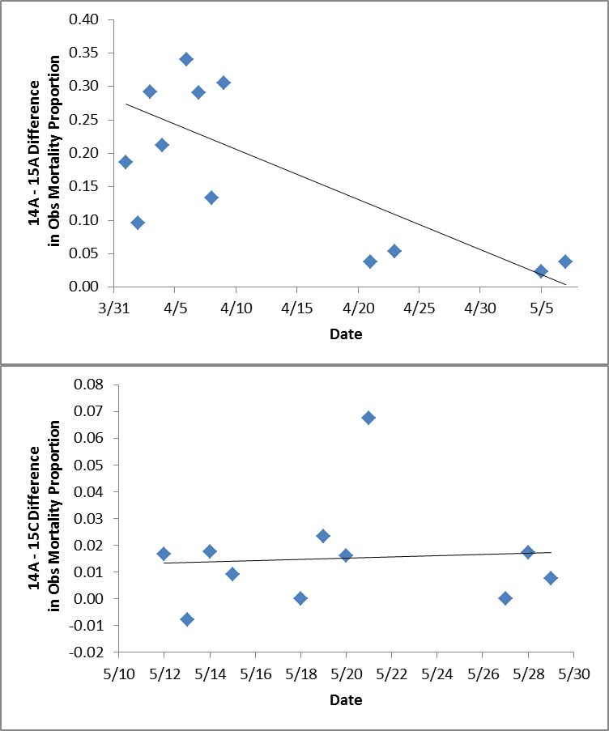

Figure 6. Paired comparison of observed mortality for different gatewell treatments in 2015. The line represents a standard linear regression curve.

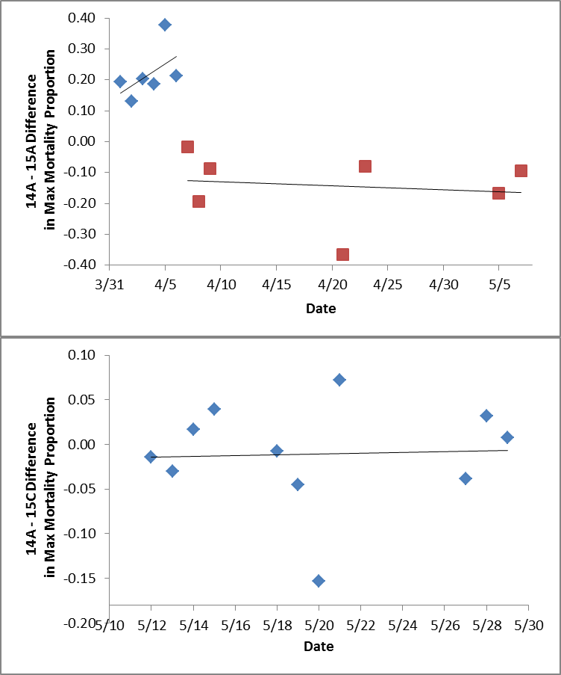

Figure 7. Paired comparison of maximum estimated mortality for different gatewell treatments in 2015. The line represents a standard linear regression curve. The dataset for the first series was, for visual purposes, split into early and late periods that indicated opposite results.

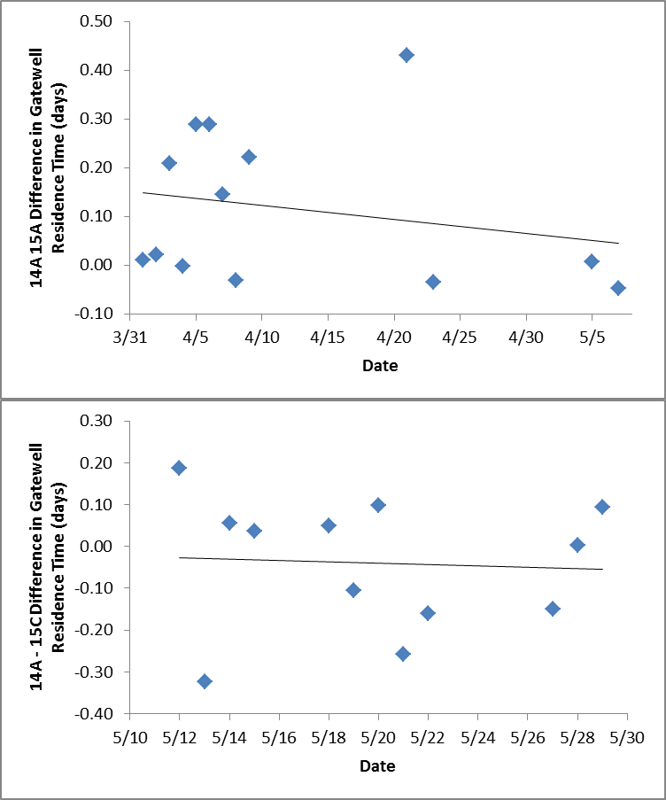

Figure 8. Paired comparison of Gatewell Residence Time for different gatewell treatments in 2015. The line represents a standard linear regression curve.

Appendix



Figure A1. Gatewell Residence Time Distributions for various release day groupings for Series 1 (Unit 14A vs Unit 15A) and Series 2 (Unit 14A vs Unit 15C) further divided into fish observed at JFMF as Live vs Mortalities for Bonneville Dam 2nd Powerhouse in 2015.



Figure A2. Gatewell Residence Time Distributions by Release Day Replicate for Series 1 comparing Unit 14A and Unit 15A at Bonneville Dam 2nd Powerhouse in 2015.



Figure A3. Gatewell Residence Time Distributions by Release Day Replicate for Series 2 comparing Unit 14A and Unit 15C at Bonneville Dam 2nd Powerhouse in 2015.