**CENWP-ODT5/2/24**

**MEMORANDUM FOR THE RECORD**

**SUBJECT: *24TDA06 MFR Sewage spill in East Fishway South collection channel***

On the morning of 2 May @ 0930 maintenance team members were working in the vicinity of the ice and trash sluiceway outfall and noticed a sewage smell in the air. Upon further investigation by the team a sewage leak was discovered, Maintenance Manager and plant operations was notified, and the team began the process of isolating the leaking section of pipe (figure 1) with the leak being isolated at 0952. The estimated leak rate was 3 gallons per minute and took approximately 22 minutes to isolate. It is estimated 66 gallons of untreated sewage water was leaked into the east fishway south collection channel.

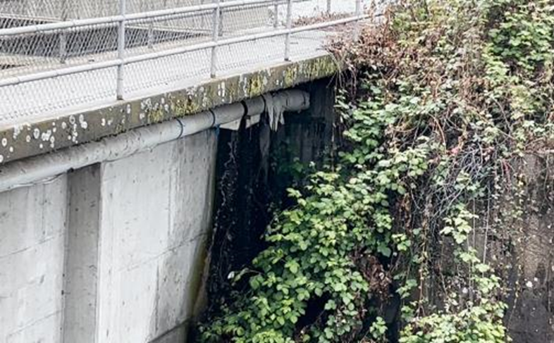

Figure 1. Pipe above South collection channel of East fishway

1. Species – NA
2. Origin – NA
3. Length – NA
4. Marks and tags – NA
5. Marks and Injuries found on carcass –NA
6. Cause and Time of Death – NA
7. Future and Preventative Measures - The leak was isolated and will be investigated next week and a repair plan started.

Sincerely,

Project Fisheries