**OFFICIAL COORDINATION REQUEST FOR**

**NON-ROUTINE OPERATIONS AND MAINTENANCE**

**COORDINATION TITLE-** 24JDA05 – Installing the Lamprey Modified SE-1 Weir in JDA SFL During the Adult Fish Passage Season

**COORDINATION DATE-** 4/8/24

**PROJECT-** John Day Dam

**RESPONSE DATE- 4/22/2024**

**Description of the problem –** The current John Day South Fish Ladder (SFL) entrance weir (SE-1) has a flat upper surface (Figure 1). This makes it difficult for lamprey to enter the SFL (on average about 60% of the lamprey pass JDA through the North Fish Ladder). Modifications are being made to a spare weir to allow for easier lamprey passage. These modifications include a rounded top (Figure 2), and a section of steel plating on the downstream face (Figure 3) for lamprey attachment. Additional modifications include painting, installing new guide wheels, new bushings, and replacing worn portions of the gasket.

Completion was originally expected during the winter maintenance season (by 3/1/24). Unfortunately, due to several unforeseen delays (long lead times for parts, holiday vacations, etc.), the window was missed. The weir is still being modified as of this memo’s coordination date and is expected to be completed by 4/26/24. Since these modifications are expected to improve lamprey passage, JDA would like to install the weir once the modifications are complete.

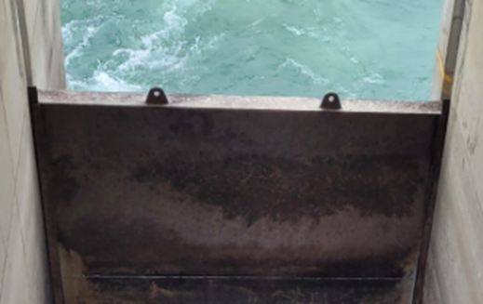

Figure 1: The currently deployed SE-1 top. The flat surface makes it difficult for lamprey to enter the system.

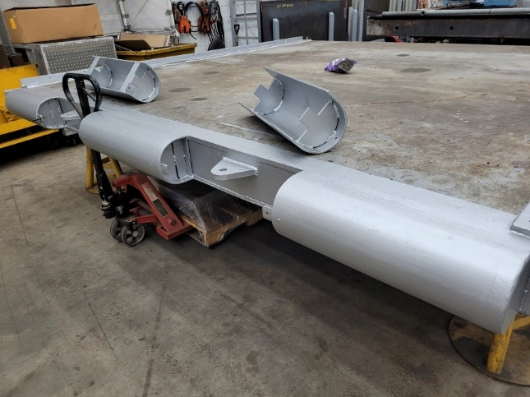

Figure 2: Picture of the rounded top on the newly modified SE-1 weir. The rounded top will make it easier for lamprey to enter the ladder. Once deployed the detached rounded sections (shown sitting on top of the weir) will mount over the lifting brackets.

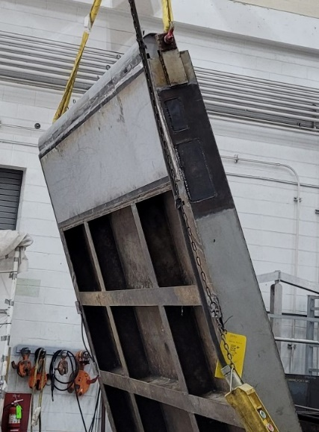

Figure 3: Picture of the steel plating installed on the downstream face of the newly modified SE-1 weir. The flat surface will provide an attachment point for lamprey before entering the SFL.

**Type of outage required – A**ttraction water will be shutoff to the SFL for approximately 2-hours while the weir is replaced. During this time the North Fish Ladder will remain in service. Both SFL entrances on the northside of the powerhouse will remain open (NE-1 & NE-2) without attraction flows.

**Impact on facility operation –** The SFL AWS pumps will be turned off resulting in a loss of attraction water to the SFL.

**Dates of impacts/repairs –** Estimated outage date 4/26/24

**Length of time for repairs** – The estimated installation time is approximately 2-hours.

**Analysis of potential impacts to fish-**

The 10-year average for daily fish passage (April 21st – April 27th) at the SFL is as follows: 0-Coho, 0-sockeye, <1-lamprey, 3-steelhead, and 387-Chinook. The NFL has similar numbers except 520-Chinook passed on average (57% of the average daily passage). With attraction off at the SFL, and only the NFL in service, there would likely be delays for any fish drawn to the southside of the tailrace.

**Summary statement – expected impacts on:**

**Downstream migrants:** There is no expected impact to downstream migrants.

**Upstream migrants (including Bull Trout):** Potential delayed migration due to a lack of attraction water at the SFL. They will still have the NFL available for passage.

**Lamprey:** With <1 lamprey (on average) passing the dam during this time of year, and installing a weir better suited for their passage, the outage is likely to result in better passage efficiency while having very minimal impacts.

**Comments from agencies**

**Final coordination results**

Please email or call with questions or concerns.

Thank you,

Michael Lotspeich

Fish Biologist

John Day Dam

[Michael.D.Lotspeich@usace.army.mil](mailto:Michael.D.Lotspeich@usace.army.mil)

541-739-1064

Laura Ricketts

Fish Biologist

John Day Dam

[Laura.a.ricketts@usace.army.mil](mailto:Laura.a.ricketts@usace.army.mil)

541-739-1065

Patricia Madson

Fish Biologist

Columbia River Coordinator (acting)

[Patricia.l.madson@usace.army.mil](mailto:Patricia.l.madson@usace.army.mil)

541-374-3655