**CENWP-ODJ3/28/24**

**MEMORANDUM FOR THE RECORD**

**SUBJECT: *24JDA04 Oil Sheen and Chinook Mort in Gatewell 1A***

On 19 March 2024, at approximately 1630, JDF personnel observed a 2' x 4' oil sheen in gatewell 1A during inspections. JDF personnel called the Control Desk, and EHS personnel investigated the sheen. EHS concluded the sheen was residual from previous maintenance (an elbow in the piping and lubricant at the dogging mechanism). It was estimated that 1 teaspoon of oil spilled. EHS promptly deployed an absorbent pad in the gatewell to collect the oil.

On 28 March 2024, at approximately 0930 JDF personnel noticed a clipped Chinook smolt mort on the absorbent pad in gatewell 1A (9-days after initial deployment). The mort was retrieved from the gatewell, scanned for PIT tags, and returned to the river. There were no noticeable injuries on the smolt, and it’s presumed the smolt jumped onto the pad and became stranded.

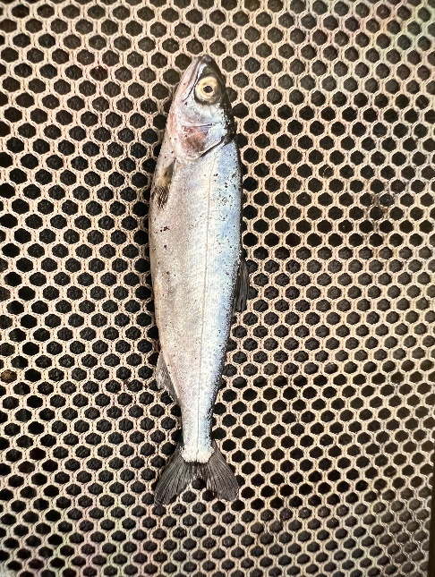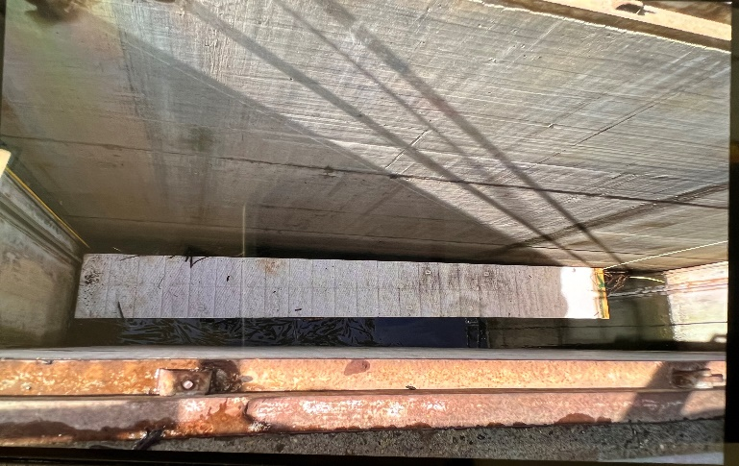

1. Species – Chinook
2. Origin – NA
3. Length – NA
4. Marks and tags – clipped, no PIT tag
5. Marks and Injuries found on carcass – none
6. Cause and Time of Death – unknown
7. Future and Preventative Measures- Continue to monitor gatewells daily and keep a close eye on gatewells with oil absorbents deployed. JDA personnel will work to determine how long oil absorbent pads need to be deployed in order to reduce exposure times for smolts. This method of absorbency has been used numerous times, and this is the first known occurrence of smolt stranding.

Sincerely,

Project Fisheries