# Fish Passage Plan (FPP) Change Request Form

**Change Form # & Title**: 20LGS003 – Surface Velocity

**Date Submitted**: 20 December 2019

**Project**: Little Goose Dam

**Requester Name, Agency**: Scott St. John, USACE LGS

**Final Action:**

**FPP Section**: Little Goose 2.4.2.8 Adult Facilities / Fish Passage Season (Mar 1-Dec 31)

**Justification for Change**: Subsurface water velocity measurements are taken monthly using a rickly velocity meter that was permanently mounted near the north powerhouse fishway entrance a number of years ago. Little Goose is requesting that the surface velocity be measured in the same location in order to more easily compare the two measurements.

Historically the surface velocity was measured near the junction pool at the SSE. Annual reports indicate that an electronic water velocity meter was installed in 2010 near the SSE. The velocity meter failed in 2011 and it was not repaired or replaced because that particular location is near diffuser 2, the largest diffuser in the adult channel. The close proximity to the diffuser as well as other physical attributes produce non-laminar flows and unreliable surface velocity readings near the SSE. Currently, Little Goose is unable to adjust the diffuser near the SSE due to mechanical failures. These problems have been documented and are being tracked to receive funding in years forthcoming. The SSE typically produces much lower surface velocity readings than other locations within the adult channel. The NPE and NSE seem to produce similar surface velocity measurements to those seen with the subsurface measurements.

|  |  |  |  |
| --- | --- | --- | --- |
| Location/Year | Minimum (fps) | Maximum (fps) | Average (fps) |
| SSE 2019 | 0.4 | 2.7 | 1.6 |
| NPE 2019 | 1.1 | 4.6 | 2.3 |
| NSE 2019 | 1.3 | 4.2 | 3.1 |
| Subsurface 2019 | 2.3 | 4.2 | 3.1 |
| SSE 2018 | 0.6 | 2.3 | 1.7 |
| NPE 2018 | 1.4 | 3.5 | 2.1 |
| NSE 2018 | 1.7 | 3.4 | 2.5 |

**Proposed Change**: *[see below with edits to existing FPP in track changes]*

**2.4.2.8. Channel Velocity.** 1.5' – 4' per second.

Adult collection channel water velocities must be between 1.5 and 4 feet per second. This is the optimum velocity for returning adult salmon and steelhead to migrate upstream through the fishway. Velocity readings will be included in required fishway inspections and reported in weekly and annual reports.

Surface water velocities will be measured in the open access area near the north powerhouse weir / fish entrance. The surface velocity will be measured using a piece of woody debris (stick, bark) or water bubble timed over a marked fixed distance. The measurement of the water velocity at this location typifies the velocity conditions throughout the length of the channel.

Subsurface water velocity will be measured and reported once per month using an underwater flowmeter. The average velocity will be calculated using several measurements taken at various depths across the width of the channel that best represents the average subsurface flow. The measurements will be taken at a location in the channel that represents the overall flow characteristic.

**Comments**: *[Listed oldest to newest]*

1/23/2020 FPOM FPP Meeting:

FPOM wanted more information on the location and the influence of spill. Conder is in support as long the project can confirm that the location is not influenced by the spill operation. Setter will work with St. John to provide additional information.

1/24/2020 email from Ann Setter and Scott St. John:

FPOM: Below is additional information [from Scott St. John] to help better understand the location for taking velocity measurements in the LGS fish ladder as referenced in FPP change form 20 LGS 003. Please respond in writing to let me know if after further review we now have agency concurrence for approval of this language change.

Ann Setter

--------------------------------------------------------------------------

Ann,

Attached are images of the area where we proposed the FPP language change for taking velocity measurements near NPE. The proposed location for surface velocity is in the adult channel between the NPE entrance and the spillway. This is the location we currently take the subsurface velocity and have for many years. It is downstream from all of the diffusers or any water input within the adult channel.

There are really only a few locations that are accessible to take these measurements. The NPE and NSE provide the most laminar flow, but NSE is not accessible at times of high spill. SSE location is upstream of the largest diffuser, downstream of the junction pool and also just downstream of a large concrete pillar that splits the channel and the SSE. All of these things are creating inaccurate velocity readings that are not seen anywhere else within the adult channel.

Once we are able to operate the sluice gate for all of the diffusers in the adult channel, this location’s hydraulics may change. At this point, there is nothing we can physically do to change the surface velocity characteristics. Again, this is the only portion in the channel that we see these weird dynamics.

Let me know if you have any other questions.

Scott St. John

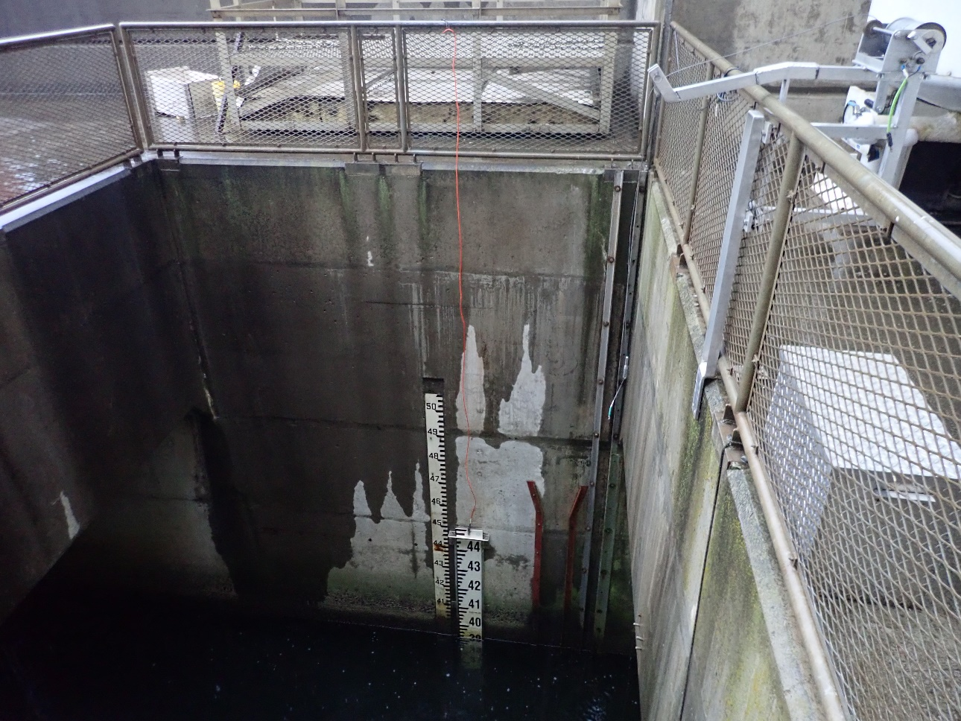

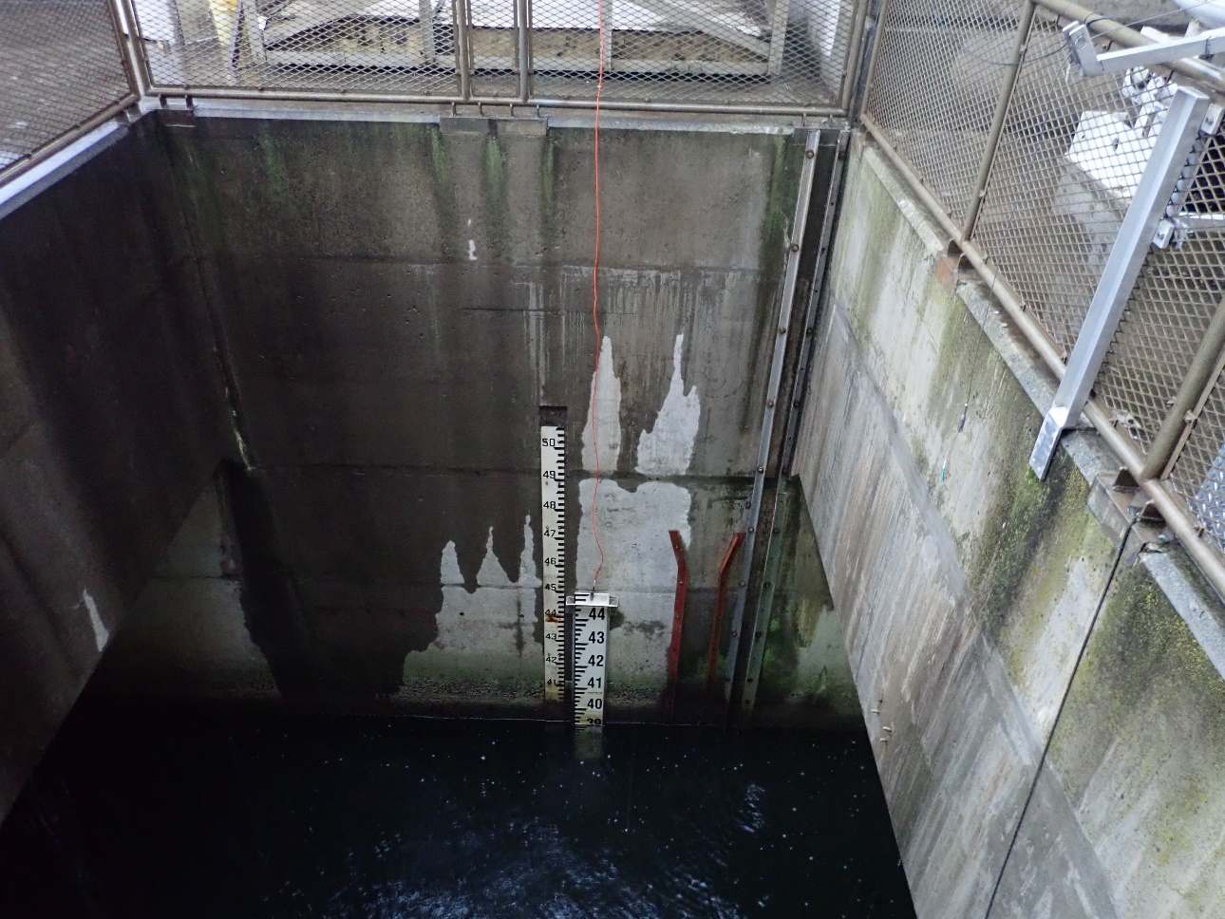

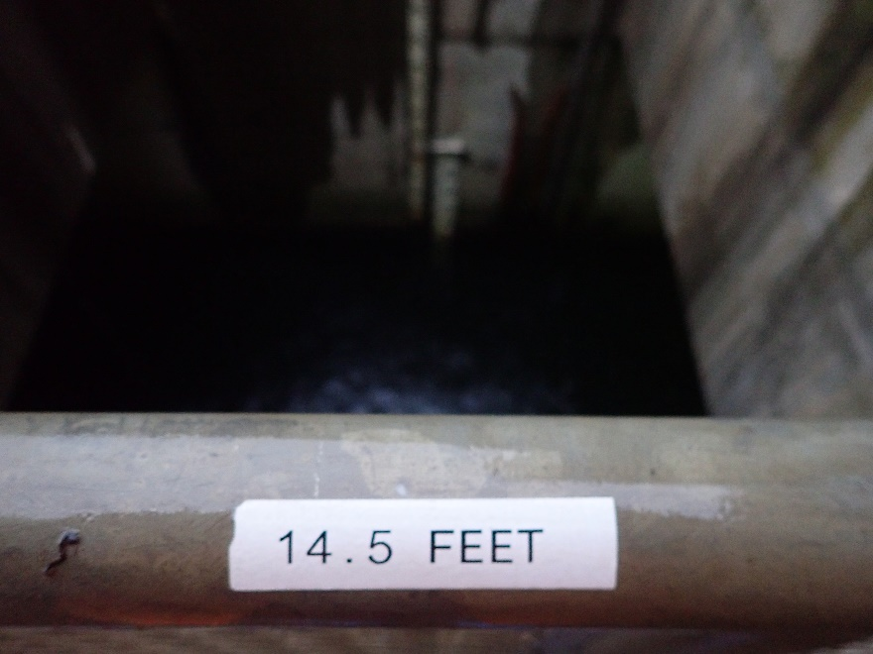

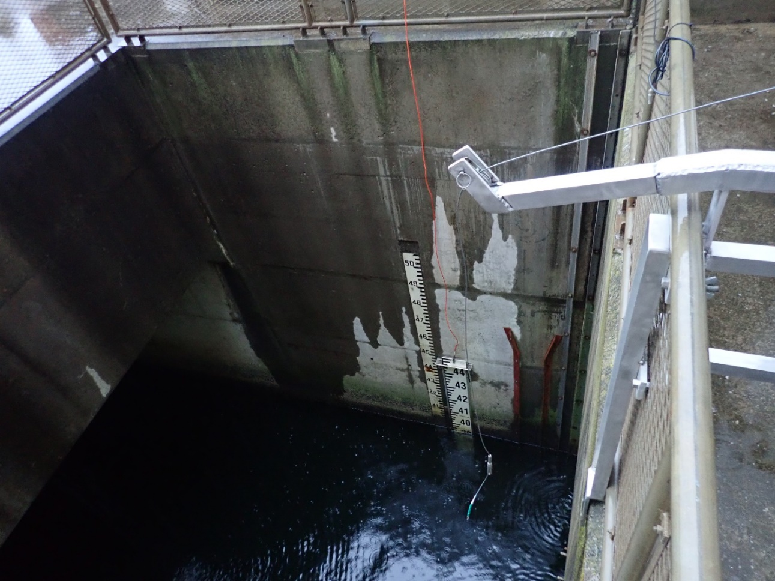

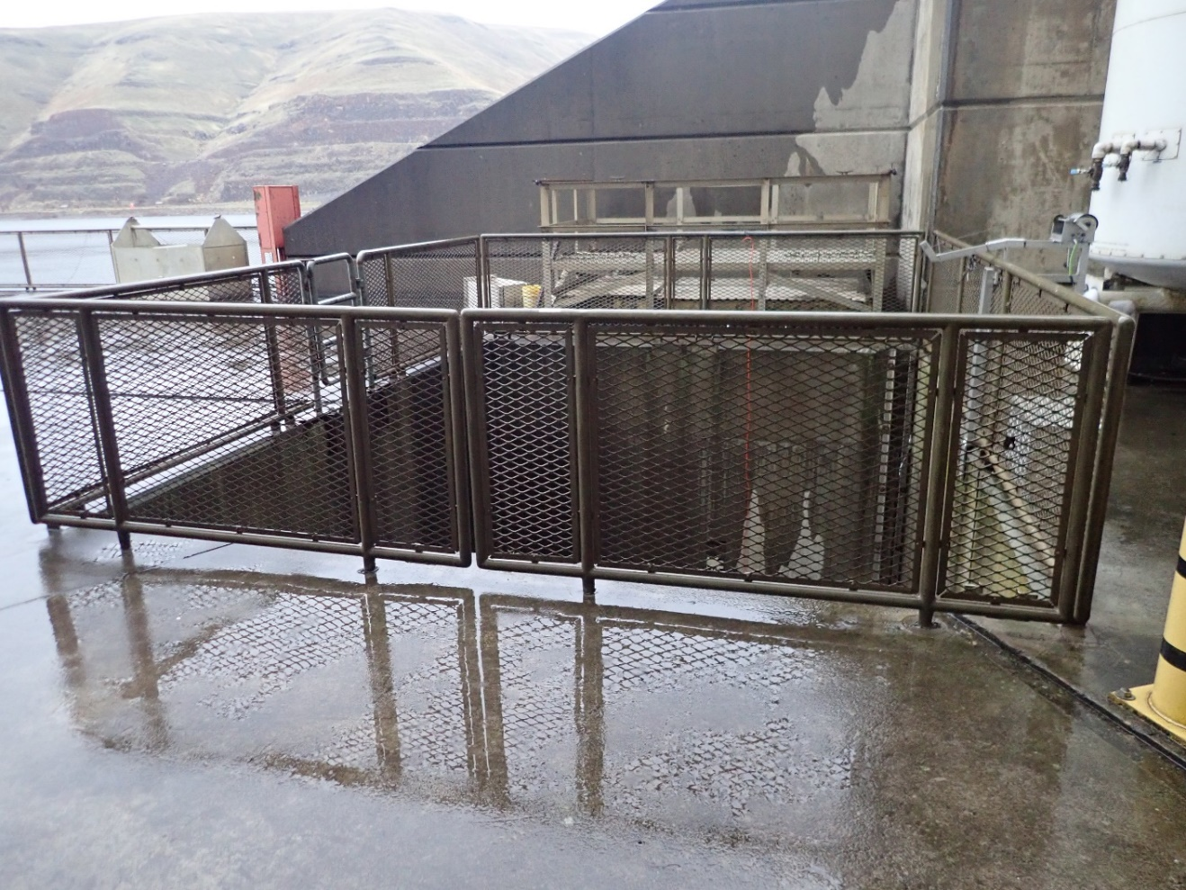

1/24/2020 email from Erick Van Dyke:

Just a few additional question that may help me come to a recommendation.

* "This is the location we currently take the subsurface velocity and have for many years" It appeared that this location bookended a range of conditions found in the ladder currently (specifically at higher flow), how will replacement location assure continuity in range of conditions in the ladder if it is changed or remove?

* "NSE is not accessible at times of high spill" Is there a more specific threshold for high (kcfs reference, number of bays...)?

* "Once we are able to operate the sluice gate for all of the diffusers in the adult channel, this locations hydraulics may change" Why shouldn't we wait to verify this before making the change?

1/27/2020 email from Ann Setter and Scott St. John:

Erick: The attached PDF has replies from Scott St John to your questions and some supplemental information to assist with better understanding the layout at the project. The picture with broken fencing in the fishway occurred during 2011 and has been repaired, but the physical conditions outside the NSE entrance have not yet been repaired since washout/undercut occurred when entire powerhouse went down for days during a spring period of high river flow.

BLUF: The historic and present conditions upstream from NPE where readings have been occurring are in an area not influenced by the configuration of project operations. Please let me know if you have further questions.

Ann Setter

-------------------------------------------------------------------------------

Ann,

Hopefully I'm able to answer these questions. I've attached a pdf of the Little Goose Fishway. I placed a small yellow box at each location that we take velocity measurements. You can hover/click the box to see the location title. I hope that helps.

1.) From Erick: "This is the location we currently take the subsurface velocity and have for many years" It appeared that this location bookended a range of conditions found in the ladder currently (specifically at higher flow), how will replacement location assure continuity in range of conditions in the ladder if it is changed or remove?

St. John: I'm struggling understand what the question is here, but the overall answer for moving the location is for a few reasons. First, SSE velocity location is upstream of the diffusers that we currently cannot control. This location is the most challenging location to get a surface velocity reading due to the non-laminar flow. Due to the physical factors of this location (ie- downstream of junction pool, downstream from concrete pillar, upstream of diffusers, upstream of bend in channel), I do not believe it is a good indicator of the true channel conditions. Additionally, I do not think it would matter how sluice gates were set, you'd still see some non-laminar hydraulics due to the physical attributes of the location.

* "NSE is not accessible at times of high spill" Is there a more specific threshold for high (kcfs reference, number of bays...)?

St. John: Typically we do not access the NSE area from Apr 3-June 20. This area can be very dangerous during high spill, see attached pictures.

* "Once we are able to operate the sluice gate for all of the diffusers in the adult channel, this locations hydraulics may change" Why shouldn't we wait to verify this before making the change?

St. John: I do not plan on discontinuing velocity measurements at all locations, but would prefer the verbiage in the FPP was for the NPE. It could be years before we see any funding to repair the sluice gates. Currently, the only factors we have been able to control in the adult fishway is the weir heights and RPM's of the fish pumps. For the most part, we are unable to control channel velocity by changing fish pump RPM's, except at very low RPM's which decreases velocity. See above comments. I do not think we will ever get rid of the non-laminar flow at this location because of the physical characteristics (bend in channel, concrete pillar, etc.)

Scott St. John

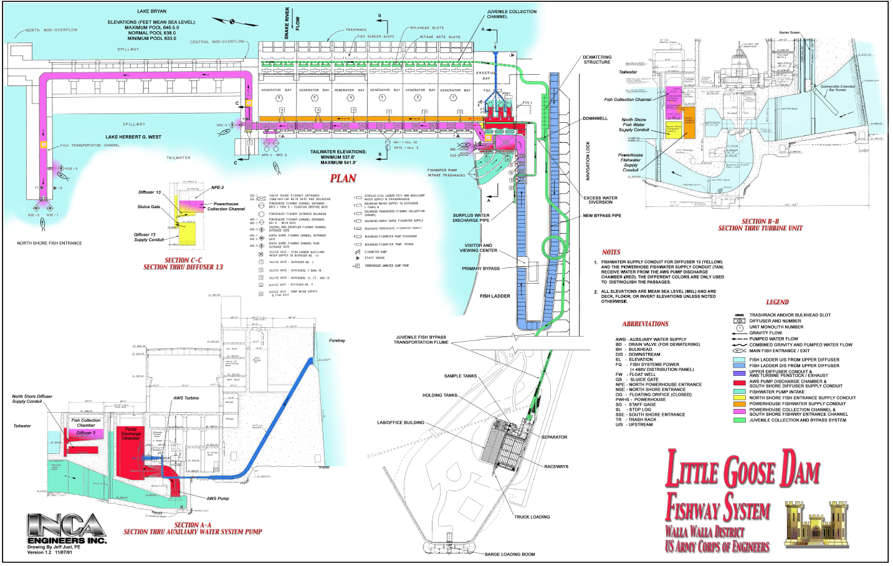

**SSE Surface Velocity**

**NPE Surface Velocity**

**NSE Surface Velocity**

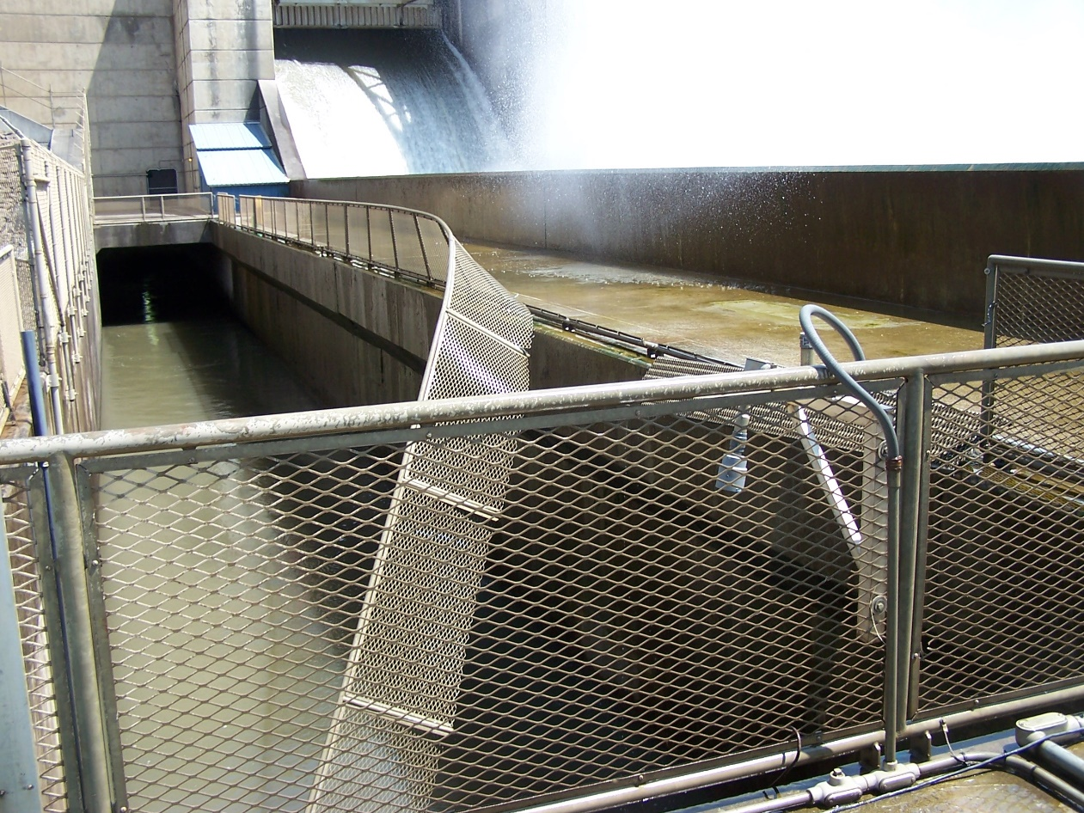

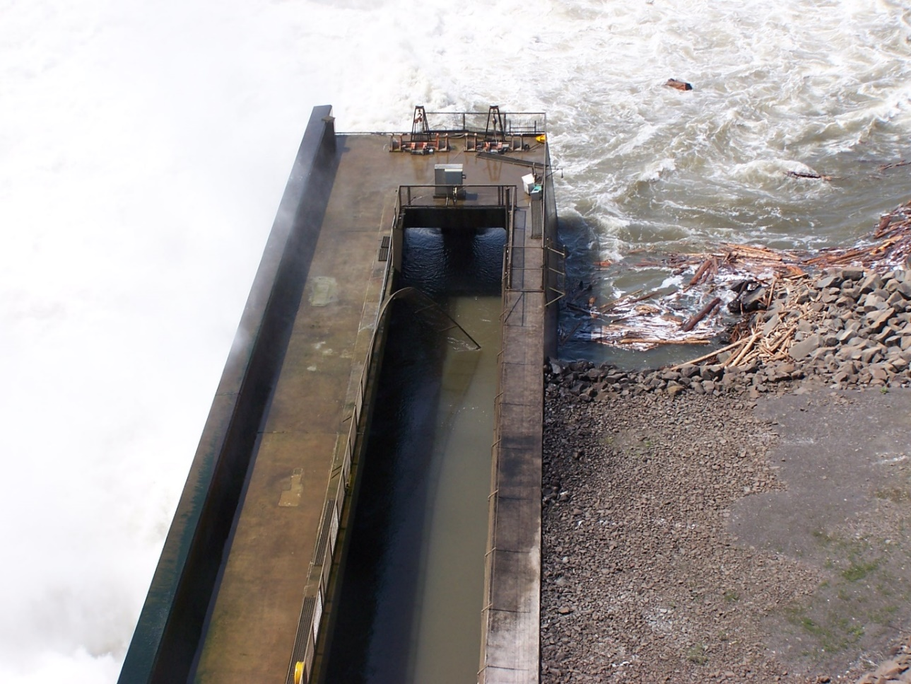

1/27/2020 email from Charles Morrill:

Makes sense to me plus having had the opportunity to walk the length when it was dewatered … really a valuable experience.

**Record of Final Action**: