**2019 Fish Transportation Total Dissolved Gas (TDG) Monitoring**

**By Eric Hockersmith and Darren Pecora**

**Abstract**

We monitored total dissolved gas (TDG) levels in the transport collection raceways and fish transportation barges during the spring 2019 under the Flex Spill Agreement operations to assess TDG exposure. High TDG exposure can lead to gas bubble disease (GBD) that can lead to physical injury or mortality. The effects of GBD can be reduced or delayed with increased depth such as when fish sound however transported smolts have a limited opportunity for depth compensation because holding and transport depths are relatively shallow. TDG in the Snake and Columbia rivers when the fish barges were passing through the dam forebays and tailraces (April 25-May 16) averaged 118.0% and ranged from 1110.6 to 125.1%. The maximum TDG reading in the fish transport barge sea chest was 124.6%, whereas, the maximum reading in the fish hold was 103.8% in the 8000 series barge and 106.8% in the 2000 series barge. TDG in the transport collection raceways was much higher than in the transport fish holds with Little Goose Dam (LGS) raceways ≥ 110% TDG approximately 82% of the time and Lower Monumental Dam (LMN) raceways ≥ 110% TDG 6% of the time. The average TDG levels while direct loading 2000 series barges was much lower than in the raceway at Little Goose Dam (LGS) (104.4% versus 111.0%). Based on results in 2019, the proposed increase in the gascap spill limit to 125% TDG during spring 2020 is likely to result in TDG levels between 114% and 118% in the raceways at LGS and may result in acute GBD mortality for fish collected in the raceways. LMN raceway TDG levels are not anticipated to exceed 111% for the proposed 2020 spring spill operation. The proposed increase in the gascap spill limit to 125% TDG is not anticipated to result in TDG levels greater than 107% in the fish transport barge fish holds because the aeration systems appear to provide adequate degassing.

**Introduction**

The goal of this investigation was to determine TDG exposure levels for fish that are collected and transported from the lower Snake River dams during the spring April24 to June 20). The current U.S. Army Corps of Engineers (USACE) program transports approximately 50% of the smolts passing through the juvenile bypass systems (JBS) at Lower Granite (LWG), Little Goose (LGS) and Lower Monumental (LMN) dams. Fish are collected and either held in raceways or direct loaded into a transport barge. Holding times before being transported to below Bonneville Dam in either direct loading fish transport barges or in the raceways is limited to 48-hours.

The number of raceways and capacity vary by project and are described in Table 1. Fish and water pass from the forebay into a gatewell and then exit the gatewell into a collection channel. The supply water for the raceways is excess water removed from the JBS by a dewatering facility between the collection channel and bypass flume. Neither the supply system nor the raceways have degassing systems.

The USACE has three types of fish transportation barges (2000, 4000, and 8000 series) with differing capacities and aeration systems (Table 2). Water enters a sea chest on the fish barge and pumps transfer it to the fish holds. The water supply on the 2000 series barges is delivered via a spray bar above the fish holds. On both the 4000 and 8000 series barges water is pumped into 2 meter tall aeration towers where it cascades down via gravity through a packed column of bio-balls before entering the top of the fish holds. TDG is likely reduced by both spray bar and packed column aeration systems, however, the effectiveness of the different systems across a range of in-river TDG is unknown. The 8000 series barges typically travel from LWG with a temporary stop at LGS to pick up either a 2000 or 4000 series barge. The 8000 series barge then travels to LMN to load additional fish before continuing to the release sites below Bonneville Dam. The 4000 and 2000 series barges are used for direct loading at LGS and therefore travel from LGS to the release sites below Bonneville Dam. The fish barges normally operate as a flow through system but can be changed to a recirculating system by closing the intake valve to the sea chest. McGrath et al. (2006) reported that short-term exposure up to 120% TDG does not produce significant effects on migratory juvenile or adult salmonids when compensating water depths are available. Transported smolts have limited opportunity for depth compensation because raceways and transport barge are relatively shallow (Table 1 and 2).

Project operations during the 2019 spring Fish Operation Plan (FOP) are outlined in the Flex Spill Agreement (2018) and consisted of spill to a gas cap of 120% TDG daily average in the tailrace at each dam for a minimum of 16-hours per day. Spill continued during the remaining 8-hours, but at a reduced volume. The timing and duration of the reduced spill varied by day and project throughout the season.

**Methods**

Hydrolab MS5 Mini Sondes (sondes) were used to monitor water quality associated with the fish transportation operations in 2019. The sondes were outfitted with membrane diffusion method TDG sensors, thermometers (thermistor), luminescent dissolved oxygen, conductivity and depth sensors. Sondes were calibrated in the USACE Walla Walla District water quality lab prior to deployment following standard operating procedures (Eaton et al. 1998, HACH 2006). Sondes were deployed at approximately mid-depth in monitoring locations. After the sondes were retrieved from the field, a post-deployment calibration verification was performed on all sensors. Parameters were recorded every 15 minutes throughout the evaluation. Data was collected from late April through the end of July.

**Raceway TDG Monitoring**

One sonde was deployed in the raceway water supplies at each fish transport collection dam (LWG, LGS, and LMN) to assess TDG conditions in fish holding raceways. This TDG sonde was deployed in the head tank raceway water supply at LWG, downstream of the raceway 10 tail screen at LGS, and downstream of the raceway 3 tail screen at LMN. Raceway monitoring locations differed slightly by project due to accessibility, with monitoring at LWG in the supply water immediately upstream of the raceways, whereas, at LGS and LMN the monitoring was in the discharge immediately downstream of the raceways. Raceway TDG data was compared to TDG in the project forebay which collected via the water quality (WQ) monitor at a depth of approximately 52 feet. At LGS the raceway monitor included a barometer for calculating TDG. At LWG and LMN the monitoring system did not include a barometer so TDG calculations used the barometric pressure from the tailrace WQ station. TDG in the raceways was analyzed for the period from late April through approximately June 20, 2019 at LWG and LGS. At LMN the comparison between the raceway and forebay included additional data collected through the end of July to improve the resolution of the correlation analysis.

**Barge TDG Monitoring**

One sonde was installed in the sea chest and one in the fish hold in both 2000 series barges and two of the four 8000 series barges. The two 8000 series barges were paired with the 2000 series barges so that comparisons of TDG between the barges incorporated the same temporal and spatial resolution. The 4000 series barges were not evaluated in 2019 because their configuration is very similar to the 8000 series barges and fish hold TDG levels in 2018 were also found to be similar. Each barge monitoring system also included a barometer, Sutron Satlink data logger/satellite transmitter, global positioning system (GPS), solar panel and battery to supply power for an extended durations. The satellite communications and GPS systems provided the capability to remotely check proper operation during data collection as well as the location of the barge during data collection. Monitors were installed in the rear hold on the 2000 series barges and the left rear hold on the 8000 series barges. During all barge trips, the TDG monitors were deployed in holds containing fish. Depth and conductivity were used to determine when the fish hold was watered up and when fish were released. Analysis was restricted to barge trips when every day barging was occurring (April 24 through May 16) with paired 8000/2000 series barges operating. Only complete trips where data was continuously collected from both the 2000 and 8000 series barges was included in the analysis. TDG levels in the fish holds were compared to the sea chest as well as between the 8000 and 2000 series barges. From April 24 through May 16 there were 22 barge trips of which 11 incorporated TDG monitoring. Three of these trips were omitted from analysis because one or both barges stopped collecting data during a trip. Thus analysis was limited to 8 barge trips. On May 17, 2019 the transport operation changed from daily to every other day and the 2000 series barges were removed from operations for the season.

**Direct Loading versus Raceway Collection TDG**

Raceway TDG conditions versus TDG levels in the sea chest and fish hold on the 2000 series barge were compared when direct loading at LGS. LGS is the only project where direct loading currently occurs. Data was available during two periods (April 26-27 and April 28-29) to compare. After April 29 direct loading at LGS ended due to debris issues related to the fish barge loading lines. During times when debris loads are high fish are collected into the raceway rather than direct loading in order to effectively manage debris in barge loading lines.

**Results**

**Raceway TDG**

A summary of monitored depth and %TDG in the raceways at LWG, LGS, and LMN is presented in Table 3. TDG levels in the forebay and raceways at LWG, LGS, and LMN are presented in Figures 1, 2 and 3. Dams above LWG are located sufficiently upstream so that their spill operations are unlikely to influence TDG levels in the forebay or raceways at LWG, whereas, spill at LWG influences TDG levels in the forebay of LGS and spill LGS influences the TDG levels in the forebay at LMN. TDG in the raceways at LWG ranged from 103.7% to 106.6% (Table 3). TDG in the raceway at LGS ranged from 105.3% to 115.1% and TDG was ≥ 110% more than 80% of the time (Table 3). TDG in the raceways at LMN ranged from 103.3% to 110.6% and was ≥ 110% approximately 6% of the time (Table 3). Forebay and raceway TDG levels were well correlated (Figures 4, 5, and 6) providing the ability to predict raceway TDG levels for various forebay TDG levels. The estimated raceway TDG levels for various forebay TDG levels at LGS and LMN based on the regression equations in Figures 5 and 6 is presented in Table 4.

**Barge TDG**

The eight monitored barge trips for this evaluation occurred from April 24 through May 16, 2019. During this time average daily Snake River flows ranged from 103 kcfs to 163 kcfs at LWG and average daily Columbia River flows ranged from 210 kcfs to 331 kcfs at The Dalles Dam. Daily average Snake River spill ranged from 27% to 75% and averaged 45% overall. Daily average Columbia River spill ranged from 35% to 67% and averaged 50% overall.

TDG in the forebay and tailrace at the Snake and Columbia dams at the time closest to when the fish transport barges were passing WQ monitoring sites, ranged from 110.6% to 125.1% (Table 5). TDG was typically higher in the tailrace than the forebay at most dams. The number and pounds of fish loaded in the fish barges as well as % capacity by trip and within the TDG monitored fish hold are presented in Table 6. The maximum depth of the fish holds for the 8000 series barges are 1 foot deeper than the fish holds in the 2000 series barges (Table 2) and the TDG sensor in the 8000 series fish holds was on average 0.9 ft. deeper than in the 2000 series fish holds (Table 7). Overall, the barge aerators maintained fish hold TDG below 105% in the 8000 series barges and below 107% in the 2000 series barges even though the supply water in the seachest ranged from 104.6% to 124.6% TDG (Tables 8; Figures 7-14). The aerators in the 2000 series barge were slightly less effective than those in the 8000 series barges at degassing but the differences were small and averaged 1.3%.

**Direct Loading versus Raceway Collection TDG**

TDG in the LGS raceway and fish barge during direct loading is presented in Table 9 and Figure 15. TDG in the raceway at LGS during direct loading was ≥ 105% TDG the entire the time and ≥ 110% TDG 82% of the time, whereas, in the 2000 series barge fish hold TDG was ≥ 105% TDG 24.0% of the time and never above 106.1% (Table 9).

**Discussion**

TDG supersaturation can cause GBD that can lead to physical injury or mortality. GBD severity is a function of TDG exposure level and duration with higher concentrations and increased duration of exposure causing higher severity (Weitkamp and Katz 1980). GBD signs and effects can be reduced or delayed with increased depth such as when fish sound. McGrath et al. (2006) reported that when compensating water depth is available, TDG levels up to 120% for short-term periods do not produce significant effects on juvenile or adult salmonids. In general, 10% TDG compensation occurs with each 1 meter in depth (Maynard 2008). Thus for 120% TDG at the surface, TDG would be 110% at 1 m deep and 100% at 2 m, etc.

The fish transport collection raceways are 1.5 m (5 feet deep) and the fish transport barge holds have a maximum depth of 1.5 m in the 2000 series barges and 1.8 m in the 8000 series barges, providing little opportunity for depth compensation. Tiffan el al. (2009) hypothesized that added stressors such as collection and handling combined with exposure to relatively low TDG levels (cyclic daily TDG swings from 102% to 109%) resulted in acute mortality for subyearling Chinook salmon held for less than 48 h at depths < 1m.

Mesa et al. (2000) found that yearling Chinook salmon held in 120% TDG water had 20% mortality within 40 to 120 h and juvenile steelhead within 20 to 35 h. At 130% TDG, 20% mortality occurred in 3 to 6 h for yearling Chinook salmon and 5 to 7 h for juvenile steelhead. They did not observe any mortality for fish held 22 days when TDG was 110%. During 2019, TDG was below 110% in the barge fish holds and raceways, except at LGS where TDG exceeded 110% approximately 82% of the time.

The USACE has not directly observed increased mortality related to GBD for fish collected and held in raceways or during fish transportation, however, delayed effects may be occurring particularly for fish held in the raceways and transported from LGS. Indirect mortality related to GBD can result in increased vulnerability to predation (Mesa and Warren 1997) and susceptibility to disease (Weiland et al. 1999). The relationships between indirect effects of long term chronic exposure to elevated TDG such as increased stress, susceptibility to disease, reduced growth, vulnerability to predation, or delayed mortality are poorly understood (McGrath et al.,2006).

An increased spill cap in 2020 (gas cap limit of 125% for 16 hours minimum) is proposed in the Flex Spill Agreement for six of the eight fish passage projects. Based on the 2019 findings, the raceways at LMN and fish transport barges appear to provide degassing sufficient to keep TDG below 110% at forebay levels at or below 125%. The degasing capacity of the raceway water supply at LGS does not provide a similar capability. Differences in raceway water supply systems that provides degassing in the raceways at LMN but not LGS are being examined. When LGS forebay TDG exceeds 114% the raceway TDG exceeds 110% and at forebay TDG of 125% the raceways would reach 117.9%. Based on the research by Mesa et al. (2000), the 2020 proposed spill levels may result in acute GBD mortality for fish held in the raceways at LGS for durations of less than 1 day with juvenile steelhead being more susceptible than yearling Chinook salmon. Direct barge loading rather than raceway collection for transported fish at LGS provides an alternative to avoid the high TDG exposure in the raceways. However, direct loading operations are dependent on debris amounts due to constriction in direct loading hoses and flumes.

Options to reduce LGS raceway TDG levels could include operational changes or structural modifications. Since GBD severity is a combination of TDG exposure level and duration, operational changes that decrease exposure duration during periods of high raceway TDG would likely be the least costly and easiest to implement for 2020. Transferring smolts more frequently from the LGS raceways to a fish transport barge could be used to reduce exposure times to the high TDG in the raceways because the transport barge fish holds TDG levels are lower.

**References**

Eaton, A. D., Clesceri, L. S., Greenberg, A. E., & Franson, M. A. H. 1998. Standard methods for the examination of water and wastewater. 20th ed. 1998. Washington, DC: American Public Health Association.

Flexible Spill Agreement. 2018. available at: <https://www.bpa.gov/efw/FishWildlife/SpillOperationAgreement/doc/ECF-2298_Spill-Notice-and-Agreement.pdf>

HACH. 2006. Hydrolab DS5X, DS5, and MS5Water Quality Multiprobes User Manual: February 2006, Edition 3. Available at: <https://s.campbellsci.com/documents/ca/manuals/series_5_man.pdf>

Maynard, C. 2008. Evaluation of Total Dissolved Gas Criteria (TDG) Biological Effects Research: A literature review. WA State Department of Ecology Publication 08-10-059.

McGrath, K. E., E.M. Dawley, and D. R. Geist. 2006. Total Dissolved Gas Effects on Fishes of the Lower Columbia River. PNNL-15525. Report to U.S. Army Corps of Engineers Portland District, Portland, Oregon Contract DE-AC05-76RL01830. 40 p.

Mesa M. G., L. K. Weiland, and A. G. Maule. (2000). Progression and Severity of Gas Bubble Trauma in Juvenile Salmonids. Transactions of the American Fisheries Society, 129:174-185.

Mesa, M. G., and J. J. Warren. 1997. Predator avoidance ability of juvenile Chinook Salmon subjected to sublethal exposures of gas supersaturated water. Canadian Journal of Fisheries and Aquatic Science 54:757–764.

Tiffan, K. F., W. P. Connor, B. J. Bellegraph, and R. A. Buchanan. 2009. Snake River fall Chinook salmon life history investigations annual report 2008. Report to Bonneville Power Administration, Portland, OR. Project number 200203200.

Weiland, L. K., M. G. Mesa, and A. G. Maule. 1999. Influence of infection with Renibacterium salmoninarum on susceptibility of juvenile spring Chinook Salmon to gas bubble trauma. Journal of Aquatic Animal Health 11:123–129.

Weitkamp D.E. and Katz M. (1980). A review of dissolved gas supersaturation literature. Transactions of the American Fisheries Society109, 659-702.

Table 1. Volume and capacity of fish transport collection raceways by project.

|  |  |  |  |
| --- | --- | --- | --- |
|  | **Lower Granite** | **Little Goose** | **Lower Monumental** |
| **Number of Raceways** | 10 | 10 | 4 |
| **Maximum depth (ft.)** | 5 | 5 | 5 |
| **Inflow (gal./min)** | 1,200 | 1,200 | 2,400 |
| **Volume (gal.)** | 12,000 | 12,000 | 24,000 |
| **Raceway Capacity (0.5 pound/gal.)** | 6,000 | 6,000 | 12,000 |
| **Facility Capacity (lbs. of fish)** | 60,000 | 60,000 | 48,000 |

Table 2. Fish transport barge configuration, volume and capacity. Barges used for TDG monitoring in 2019 are in bold.

|  |  |  |  |  |  |  |  |
| --- | --- | --- | --- | --- | --- | --- | --- |
| **Barge** | **Volume**  **(gallons)** | **Aeration** | **Fish Holds** | **Pumps** | **Inflow (gpm)** | **Total Fish Capacity**  **(5 lbs. of fish/gpm)** | **Max Depth (ft.)** |
| **2127** | **85,000** | **Spray bar** | **3** | **2** | **4,600** | **23,000** | **5** |
| **2817** | **85,000** | **Spray bar** | **3** | **2** | **4,600** | **23,000** | **5** |
| 4382 | 100,000 | Packed column | 4 | 3 | 10,000 | 50,000 | 6 |
| 4394 | 100,000 | Packed column | 4 | 3 | 10,000 | 50,000 | 6 |
| **8105** | **150,000** | **Packed column** | **6** | **4** | **15,000** | **75,000** | **6** |
| **8106** | **150,000** | **Packed column** | **6** | **4** | **15,000** | **75,000** | **6** |
| 8107 | 150,000 | Packed column | 6 | 4 | 15,000 | 75,000 | 6 |
| 8108 | 150,000 | Packed column | 6 | 4 | 15,000 | 75,000 | 6 |

Table 3. Summary of the monitored depth and % TDG in the raceways at Lower Granite, Little Goose and Lower Monumental dams, 2019. The % of the time the TDG was ≥ 105% and ≥ 110% is also shown.

|  |  |  |  |  |  |  |
| --- | --- | --- | --- | --- | --- | --- |
|  | **Lower Granite Raceway** | | **Little Goose Raceway** | | **Lower Monumental Raceway** | |
|  | **Depth (ft.)** | **TDG** | **Depth (ft.)** | **TDG** | **Depth (ft.)** | **TDG** |
| **Min** | 1.0 | 103.7% | 1.0 | 105.3% | 2.0 | 103.3% |
| **Max** | 2.9 | 106.6% | 3.3 | 115.1% | 3.4 | 110.6% |
| **Average** | 1.7 | 105.1% | 2.7 | 111.1% | 2.9 | 108.1% |
| **Median** | 1.7 | 105.1% | 2.7 | 111.2% | 3.0 | 108.0% |
| **≥ 105%** |  | 50.9% |  | 100.0% |  | 99.7% |
| **≥ 110%** |  | 0.0% |  | 81.7% |  | 6.0% |

Table 4. Estimated raceway TDG at Lower Monumental and Little Goose dams for a given TDG in the forebay based on regression equations generated in Figures 5 and 6.

|  |  |  |
| --- | --- | --- |
| **Forebay TDG (%)** | **Lower Monumental Dam**  **Raceway TDG (%)** | **Little Goose Dam**  **Raceway TDG (%)** |
| 110 | 104.3 | 107.9 |
| 111 | 104.7 | 108.6 |
| 112 | 105.0 | 109.2 |
| 113 | 105.4 | 109.9 |
| 114 | 105.8 | 110.6 |
| 115 | 106.1 | 111.2 |
| 116 | 106.5 | 111.9 |
| 117 | 106.9 | 112.5 |
| 118 | 107.2 | 113.2 |
| 119 | 107.6 | 113.9 |
| 120 | 107.9 | 114.5 |
| 121 | 108.3 | 115.2 |
| 122 | 108.7 | 115.9 |
| 123 | 109.0 | 116.5 |
| 124 | 109.4 | 117.2 |
| 125 | 109.7 | 117.9 |
| 126 | 110.1 | 118.5 |
| 127 | 110.5 | 119.2 |
| 128 | 110.8 | 119.9 |
| 129 | 111.2 | 120.5 |
| 130 | 111.5 | 121.2 |

Table 5. Approximate %TDG in the forebay and tailrace at the Snake and Columbia dams at the time closest to when the fish transport barges were passing the WQ monitoring sites, 2019.

|  |  |  |  |  |  |  |  |  |
| --- | --- | --- | --- | --- | --- | --- | --- | --- |
| **Trip** | **2** | **4** | **6** | **8** | **10** | **14** | **18** | **22** |
| **Dates** | **April 25-26** | **April 27-28** | **April 29-30** | **May 1-2** | **May 3-4** | **May 7-8** | **May 11-12** | **May 15-16** |
| **Lower Granite Dam** | | | | | | | | |
| **Tailwater TDG** | 123.9 | 119.6 | 119.0 | 110.6 | 111.0 | 111.3 | 120.5 | 117.3 |
| **Little Goose Dam** | | | | | | | | |
| **Forebay TDG** | 118.2 | 115.7 | 112.3 | 115.1 | 113.0 | 116.3 | 116.9 | 114.1 |
| **Tailwater TDG** | 123.9 | 122.0 | 120.3 | 120.1 | 121.2 | 120.1 | 121.1 | 122.2 |
| **Lower Monumental Dam** | | | | | | | | |
| **Forebay TDG** | 125.1 | 120.9 | 121.2 | 120.7 | 119.8 | 121.3 | 121.8 | 122.1 |
| **Tailwater TDG** | 121.7 | 120.5 | 120.0 | 119.0 | 118.7 | 119.6 | 119.5 | 119.7 |
| **Ice Harbor Dam** | | | | | | | | |
| **Forebay TDG** | 121.4 | 118.5 | 117.8 | 118.0 | 117.8 | 118.7 | 119.7 | 118.2 |
| **Tailwater TDG** | 123.0 | 122.2 | 119.5 | 117.8 | 117.1 | 118.2 | 118.9 | 121.7 |
| **McNary Dam** | | | | | | | | |
| **Forebay TDG** | 116.1 | 110.7 | 113.8 | 112.2 | 112.4 | 115.0 | 117.0 | 112.5 |
| **Tailwater TDG** | 118.3 | 119.2 | 118.5 | 119.2 | 118.1 | 119.0 | 119.3 | 119.7 |
| **John Day Dam** | | | | | | | | |
| **Forebay TDG** | 113.2 | 110.6 | 110.6 | 111.5 | 113.4 | 117.0 | 118.1 | 114.4 |
| **Tailwater TDG** | 119.1 | 119.5 | 119.6 | 119.0 | 119.5 | 119.2 | 116.3 | 118.2 |
| **The Dalles Dam** | | | | | | | | |
| **Forebay TDG** | 114.9 | 115.5 | 113.6 | 112.5 | 115.3 | 116.4 | 116.4 | 117.3 |
| **Tailwater TDG** | 119.0 | 120.0 | 121.1 | 119.6 | 123.4 | 120.9 | 120.1 | 121.0 |
| **Bonneville Dam** | | | | | | | | |
| **Forebay TDG** | 116.2 | 116.0 | 121.4 | 114.6 | 115.8 | 117.1 | 116.9 | 120.1 |
| **Tailwater TDG** | 118.8 | 118.7 | 119.1 | 117.8 | 120.5 | 117.9 | 119.0 | 119.4 |
| **Overall Forebay TDG** | **113.2-125.1** | **110.6-120.9** | **110.6-121.4** | **111.5-120.7** | **112.4-119.8** | **115.0-121.3** | **116.4-121.8** | **112.5-122.1** |
| **Overall Tailrace TDG** | **118.3-123.9** | **118.7-122.2** | **118.5-121.1** | **110.6-120.1** | **111.0-123.4** | **111.3-120.9** | **116.3-121.1** | **117.3-122.2** |

Table 6. Number and pounds of smolts, and % of the loading capacity for the barge and in the monitored fish hold, 2019. Paired barges are designated by similar shading of adjacent rows.

|  |  |  |  |  |  |  |  |
| --- | --- | --- | --- | --- | --- | --- | --- |
|  |  | **Barge** | | | **Monitored Fish Hold** | | |
| **Trip** | **Barge** | **# of smolts** | **Pounds of smolts** | **% of capacity** | **# of smolts** | **Pounds of smolts** | **% of capacity** |
| 2 | 2817 | 98,534 | 12,153 | 53% | 29,433 | 5,605 | 73% |
| 2 | 8106 | 328,672 | 47,179 | 63% | 48,381 | 7,012 | 56% |
| 4 | 2127 | 112,702 | 13,976 | 61% | 30,178 | 5,072 | 66% |
| 4 | 8105 | 361,794 | 56,619 | 75% | 64,628 | 10,098 | 81% |
| 6 | 2817 | 106,347 | 12,278 | 53% | 24,725 | 4,087 | 53% |
| 6 | 8106 | 220,684 | 29,601 | 39% | 52,233 | 6,784 | 54% |
| 8 | 2127 | 78,809 | 7,286 | 32% | 11,676 | 1,653 | 22% |
| 8 | 8105 | 192,059 | 26,727 | 36% | 44,977 | 7,767 | 62% |
| 10 | 2817 | 53,204 | 6,388 | 28% | 11,981 | 1,976 | 26% |
| 10 | 8106 | 124,565 | 16,638 | 22% | 38,921 | 4,633 | 37% |
| 14 | 2817 | 46,577 | 4,430 | 19% | 12,762 | 4,430 | 58% |
| 14 | 8106 | 112,518 | 12,363 | 16% | 20,099 | 2,030 | 16% |
| 18 | 2817 | 25,991 | 3,055 | 13% | 13,658 | 2,197 | 29% |
| 18 | 8106 | 100,909 | 10,529 | 14% | 49,594 | 4,769 | 38% |
| 22 | 2817 | 36,117 | 3,478 | 15% | 12,606 | 1,664 | 22% |
| 22 | 8106 | 116,283 | 11,840 | 16% | 47,737 | 4,340 | 35% |

Table 7. Depth readings of TDG probes in the barge fish holds, 2019. Paired barges are designated by similar shading of adjacent rows.

|  |  |  |  |  |  |
| --- | --- | --- | --- | --- | --- |
| **Trip** | **Dates** | **Barge** | **Fish Hold Sensor Depth** | | |
| **Min** | **Max** | **Ave** |
| 2 | April 25-26 | 2817 | 2.2 | 3.2 | 2.6 |
| 2 | April 25-26 | 8106 | 3.1 | 4.4 | 3.8 |
| 4 | April 27-28 | 2127 | 3.0 | 3.9 | 3.5 |
| 4 | April 27-28 | 8105 | 4.1 | 5.1 | 4.6 |
| 6 | April 29-30 | 2817 | 2.8 | 3.4 | 3.1 |
| 6 | April 29-30 | 8106 | 3.5 | 4.1 | 3.8 |
| 8 | May 1-2 | 2127 | 3.4 | 4.3 | 3.9 |
| 8 | May 1-2 | 8105 | 4.0 | 5.0 | 4.5 |
| 10 | May 3-4 | 2817 | 2.3 | 3.2 | 2.7 |
| 10 | May 3-4 | 8106 | 3.5 | 4.4 | 3.8 |
| 14 | May 7-8 | 2817 | 2.8 | 3.3 | 3.1 |
| 14 | May 7-8 | 8106 | 3.4 | 4.2 | 3.8 |
| 18 | May 11-12 | 2817 | 2.2 | 2.9 | 2.5 |
| 18 | May 11-12 | 8106 | 3.1 | 3.9 | 3.5 |
| 22 | May 15-16 | 2817 | 2.7 | 3.2 | 2.8 |
| 22 | May 15-16 | 8106 | 3.1 | 3.9 | 3.5 |
| **Overall 2000 series** |  |  | 2.2 | 4.3 | 3.0 |
| **Overall 8000 series** |  |  | 3.1 | 5.1 | 3.9 |

Table 8. Minimum, maximum, average % TDG and % of the time TDG was ≥ 105% in the sea chest and fish hold of the paired 8000 and 2000 series fish barges, 2019. Paired barges are designated by similar shading of adjacent rows.

|  |  |  |  |  |  |  |  |  |  |  |
| --- | --- | --- | --- | --- | --- | --- | --- | --- | --- | --- |
| **Trip** | **Dates** | **Barge** | **Sea chest TDG** | | | | **Fish hold TDG** | | | |
| **Min** | **Max** | **Ave** | **% ≥ 105%** | **Min** | **Max** | **Ave** | **% ≥ 105%** |
| 2 | April 25-26 | 2817 | 112.6% | 123.5% | 117.2% | 100.0% | 90.6% | 105.9% | 95.7% | 3.1% |
| 2 | April 25-26 | 8106 | 113.2% | 123.4% | 117.5% | 100.0% | 95.1% | 102.9% | 97.5% | 0.0% |
| 4 | April 27-28 | 2127 | 109.6% | 121.0% | 115.3% | 100.0% | 88.9% | 103.3% | 93.7% | 0.0% |
| 4 | April 27-28 | 8105 | 106.6% | 121.3% | 114.5% | 100.0% | 97.4% | 103.8% | 99.4% | 0.0% |
| 6 | April 29-30 | 2817 | 110.3% | 122.8% | 116.5% | 100.0% | 99.3% | 104.7% | 101.7% | 0.0% |
| 6 | April 29-30 | 8106 | 104.8% | 122.7% | 116.2% | 98.6% | 96.9% | 102.4% | 98.4% | 0.0% |
| 8 | May 1-2 | 2127 | 110.8% | 121.4% | 115.6% | 100.0% | 101.0% | 106.8% | 103.1% | 5.8% |
| 8 | May 1-2 | 8105 | 106.0% | 122.5% | 114.8% | 100.0% | 98.5% | 103.3% | 99.7% | 0.0% |
| 10 | May 3-4 | 2817 | 111.5% | 122.1% | 116.7% | 100.0% | 96.9% | 105.8% | 101.4% | 5.6% |
| 10 | May 3-4 | 8106 | 105.0% | 122.4% | 115.6% | 100.0% | 98.6% | 103.0% | 99.7% | 0.0% |
| 14 | May 7-8 | 2817 | 111.3% | 122.6% | 117.6% | 100.0% | 100.1% | 105.7% | 102.5% | 4.8% |
| 14 | May 7-8 | 8106 | 104.6% | 122.4% | 116.1% | 95.3% | 99.4% | 102.7% | 100.3% | 0.0% |
| 18 | May 11-12 | 2817 | 112.7% | 123.0% | 118.0% | 100.0% | 97.8% | 103.7% | 99.8% | 0.0% |
| 18 | May 11-12 | 8106 | 113.2% | 123.5% | 118.4% | 100.0% | 94.7% | 103.6% | 97.1% | 0.0% |
| 22 | May 15-16 | 2817 | 112.2% | 123.6% | 117.9% | 100.0% | 102.4% | 105.7% | 103.7% | 10.1% |
| 22 | May 15-16 | 8106 | 104.8% | 124.1% | 116.8% | 95.9% | 98.3% | 103.1% | 99.3% | 0.0% |
| **Overall 2000 series** | | | **109.6%** | **123.6%** | **116.8%** | **100.0%** | **88.9%** | **106.8%** | **100.2%** | **3.6%** |
| **Overall 8000 series** | | | **104.6%** | **124.6%** | **116.2%** | **98.2%** | **94.7%** | **103.8%** | **98.9%** | **0.0%** |

Table 9. Summary % TDG in the Little Goose raceway and the 2000 series barge (sea chest and fish hold) during direct loading at Little Goose Dam on April 26-27 and April 28-29, 2019.

|  |  |  |  |  |
| --- | --- | --- | --- | --- |
|  | **Raceway** | **Sea chest** | **Fish Hold** | **Tailrace** |
| **Min** | 108.8% | 113.1% | 103.3% | 115.9% |
| **Max** | 114.9% | 120.0% | 106.1% | 122.3% |
| **Average** | 111.0% | 118.1% | 104.4% | 120.4% |
| **Median** | 109.8% | 119.0% | 104.2% | 121.1% |
| **≥ 105%** | 100.0% | 100.0% | 24.0% | 100.0% |
| **≥ 110%** | 51.5% | 100.0% | 0.0% | 100.0% |

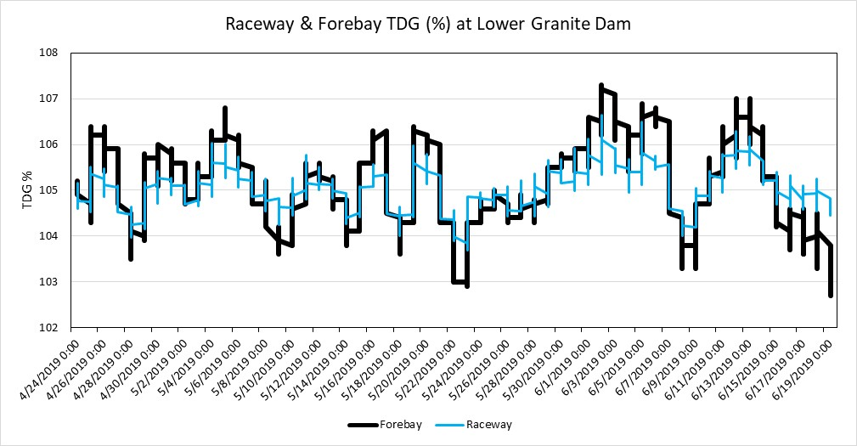Figure 1. TDG in the raceway and forebay at Lower Granite Dam from April 24, 2019 through June 19, 2019.

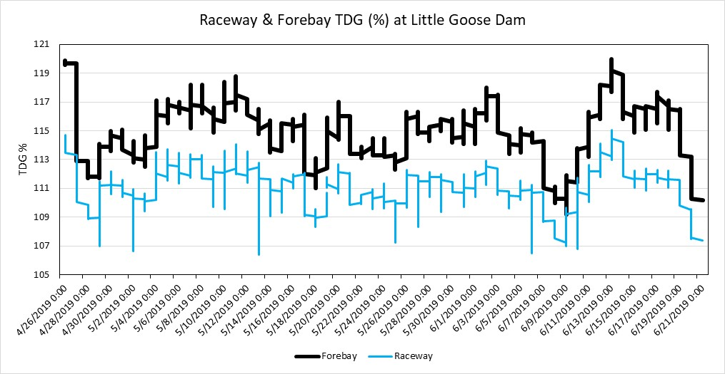

Figure 2. TDG in the raceway and forebay at Little Goose Dam from April 26, 2019 through June 20, 2019.

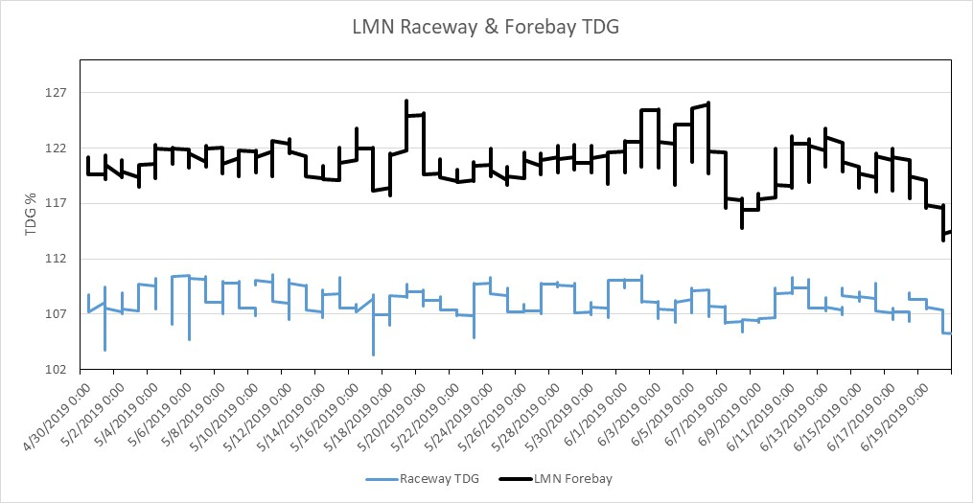

Figure 3. TDG in the raceway and forebay at Lower Monumental Dam from April 26, 2019 through June 20, 2019.

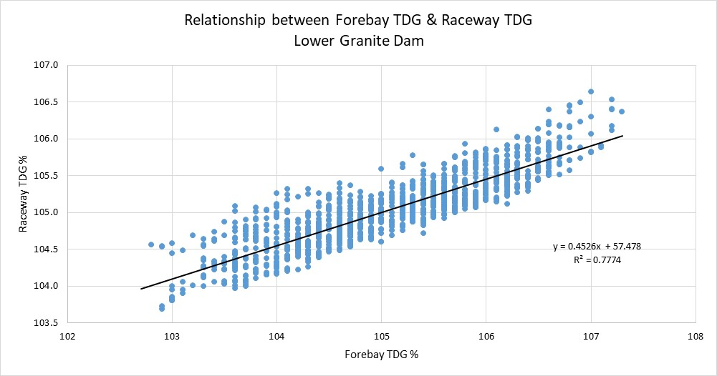

Figure 4. Relationship between forebay and raceway TDG levels at Lower Granite Dam from April 24 through June 19.

.

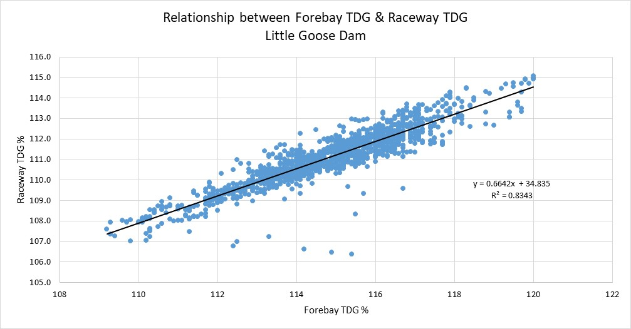

Figure 5. Relationship between forebay and raceway TDG levels at Little Goose Dam from April 26 through June 20.

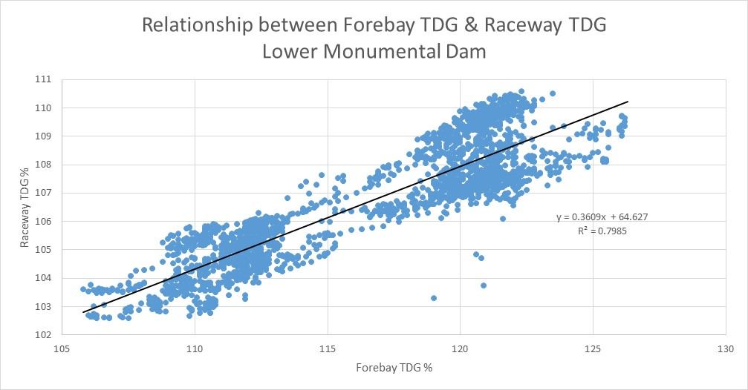

Figure 6. Relationship between forebay and raceway TDG levels at Lower Monumental Dam from April 30 through July 30. At Lower Monumental Dam a longer time series was compared, providing additional data to improve the correlation between the forebay and raceway TDG.

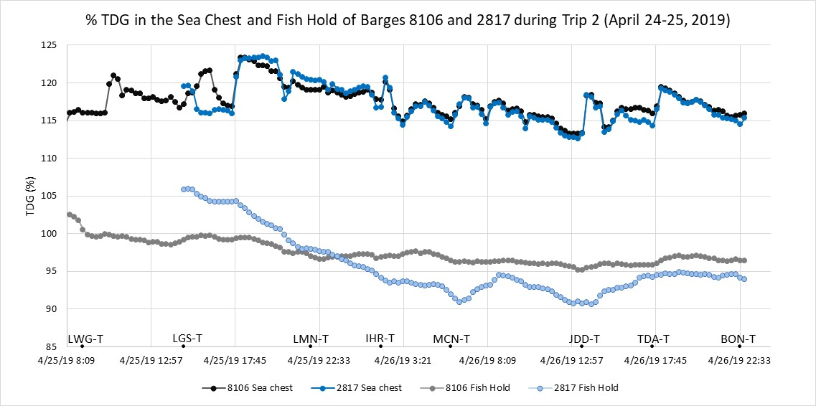

Figure 7. Sea chest and fish hold TDG (%) during the paired (8106 and 2817) barge trip 2 (April 24-25, 2019). The 8106 trip began in the Lower Granite Dam tailrace and the 2817 trip began in the Little Goose Dam tailrace. Approximate locations of the barges during the trip are also shown. Abbreviations: LWG-T = Lower Granite Dam tailrace, LGS-T = Little Goose Dam tailrace, LMN-T = Lower Monumental Dam tailrace, IHR-T = Ice Harbor Dam tailrace, MCN-T = McNary Dam tailrace, JDD-T = John Day Dam tailrace, TDA-T = The Dalles Dam tailrace, BON-T = Bonneville Dam tailrace.

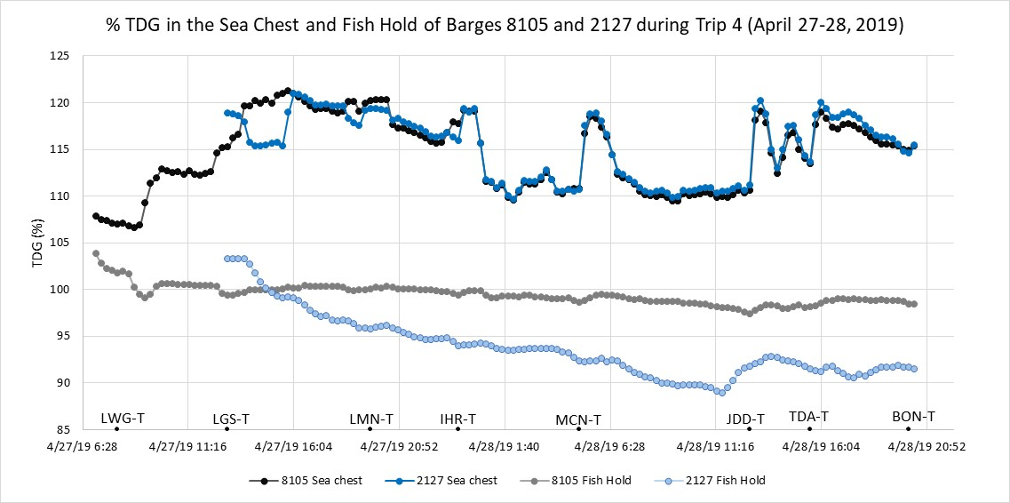

Figure 8. Sea chest and fish hold TDG (%) during the paired (8105 and 2127) barge trip 4 (April 27-28, 2019). The 8105 trip began in the Lower Granite Dam tailrace and the 2127 trip began in the Little Goose Dam tailrace. Approximate locations of the barges during the trip are also shown. Abbreviations: LWG-T = Lower Granite Dam tailrace, LGS-T = Little Goose Dam tailrace, LMN-T = Lower Monumental Dam tailrace, IHR-T = Ice Harbor Dam tailrace, MCN-T = McNary Dam tailrace, JDD-T = John Day Dam tailrace, TDA-T = The Dalles Dam tailrace, BON-T = Bonneville Dam tailrace.

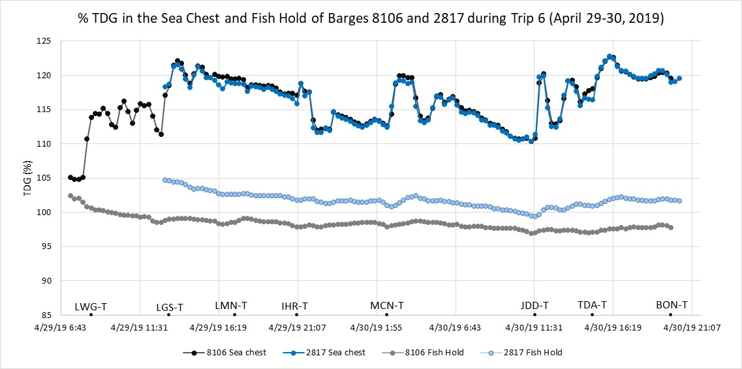

Figure 9. Sea chest and fish hold TDG (%) during the paired (8106 and 2817) barge trip 6 (April 29-30, 2019). The 8106 trip began in the Lower Granite Dam tailrace and the 2817 trip began in the Little Goose Dam tailrace. Approximate locations of the barges during the trip are also shown. Abbreviations: LWG-T = Lower Granite Dam tailrace, LGS-T = Little Goose Dam tailrace, LMN-T = Lower Monumental Dam tailrace, IHR-T = Ice Harbor Dam tailrace, MCN-T = McNary Dam tailrace, JDD-T = John Day Dam tailrace, TDA-T = The Dalles Dam tailrace, BON-T = Bonneville Dam tailrace.

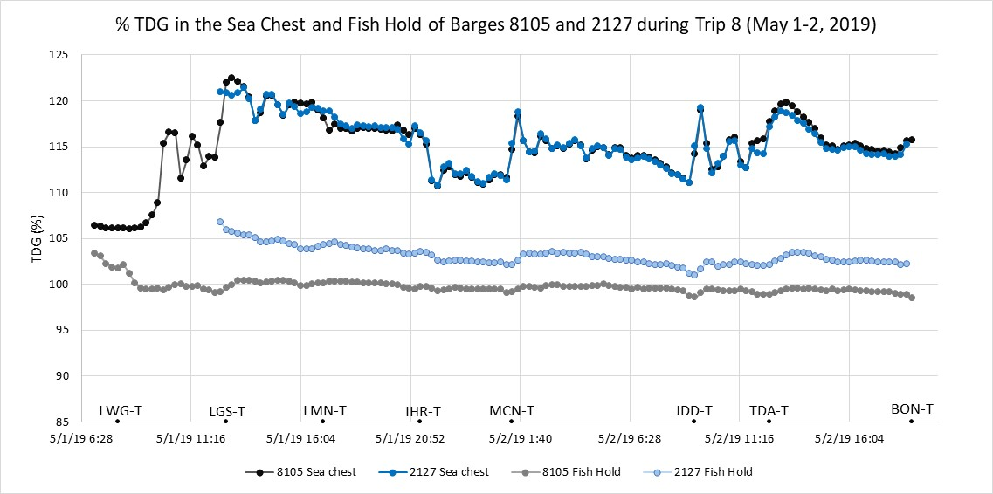

Figure 10. Sea chest and fish hold TDG (%) during the paired (8105 and 2127) barge trip 8 (May 1-2, 2019). The 8105 trip began in the Lower Granite Dam tailrace and the 2127 trip began in the Little Goose Dam tailrace. Approximate locations of the barges during the trip are also shown. Abbreviations: LWG-T = Lower Granite Dam tailrace, LGS-T = Little Goose Dam tailrace, LMN-T = Lower Monumental Dam tailrace, IHR-T = Ice Harbor Dam tailrace, MCN-T = McNary Dam tailrace, JDD-T = John Day Dam tailrace, TDA-T = The Dalles Dam tailrace, BON-T = Bonneville Dam tailrace.

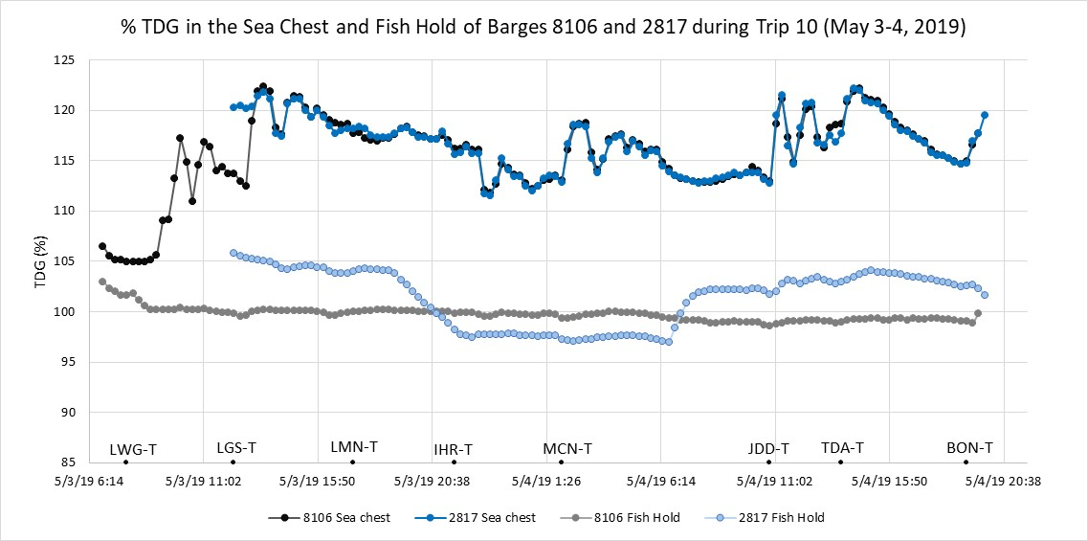

Figure 11. Sea chest and fish hold TDG (%) during the paired (8106 and 2817) barge trip 10 (May 3-4, 2019). The 8106 trip began in the Lower Granite Dam tailrace and the 2817 trip began in the Little Goose Dam tailrace. Approximate locations of the barges during the trip are also shown. Abbreviations: LWG-T = Lower Granite Dam tailrace, LGS-T = Little Goose Dam tailrace, LMN-T = Lower Monumental Dam tailrace, IHR-T = Ice Harbor Dam tailrace, MCN-T = McNary Dam tailrace, JDD-T = John Day Dam tailrace, TDA-T = The Dalles Dam tailrace, BON-T = Bonneville Dam tailrace.

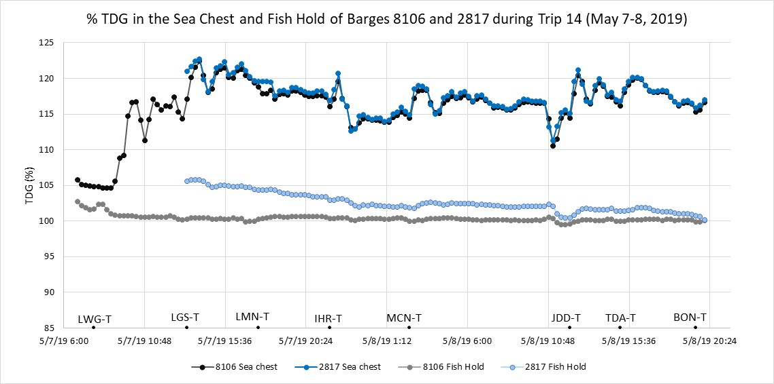

Figure 12. Sea chest and fish hold TDG (%) during the paired (8106 and 2817) barge trip 14 (May 7-8, 2019). The 8106 trip began in the Lower Granite Dam tailrace and the 2817 trip began in the Little Goose Dam tailrace. Approximate locations of the barges during the trip are also shown. Abbreviations: LWG-T = Lower Granite Dam tailrace, LGS-T = Little Goose Dam tailrace, LMN-T = Lower Monumental Dam tailrace, IHR-T = Ice Harbor Dam tailrace, MCN-T = McNary Dam tailrace, JDD-T = John Day Dam tailrace, TDA-T = The Dalles Dam tailrace, BON-T = Bonneville Dam tailrace.

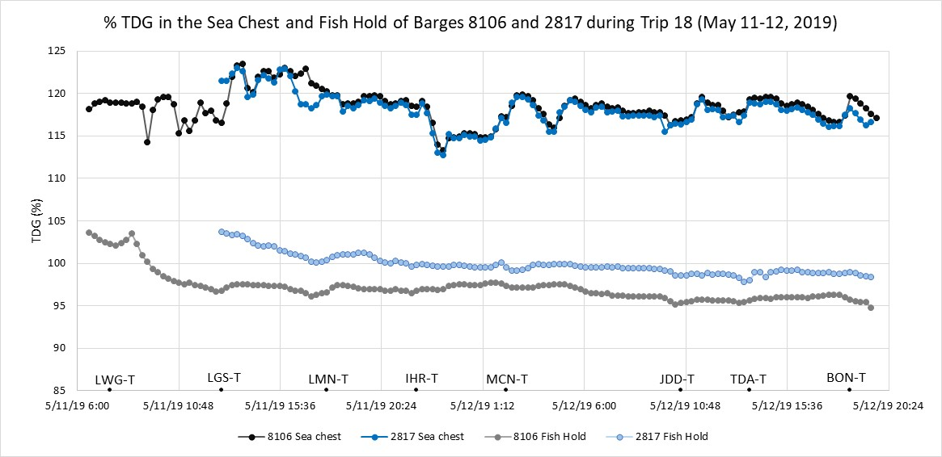

Figure 13. Sea chest and fish hold TDG (%) during the paired (8106 and 2817) barge trip 18 (May 11-12, 2019). The 8106 trip began in the Lower Granite Dam tailrace and the 2817 trip began in the Little Goose Dam tailrace. Approximate locations of the barges during the trip are also shown. Abbreviations: LWG-T = Lower Granite Dam tailrace, LGS-T = Little Goose Dam tailrace, LMN-T = Lower Monumental Dam tailrace, IHR-T = Ice Harbor Dam tailrace, MCN-T = McNary Dam tailrace, JDD-T = John Day Dam tailrace, TDA-T = The Dalles Dam tailrace, BON-T = Bonneville Dam tailrace.

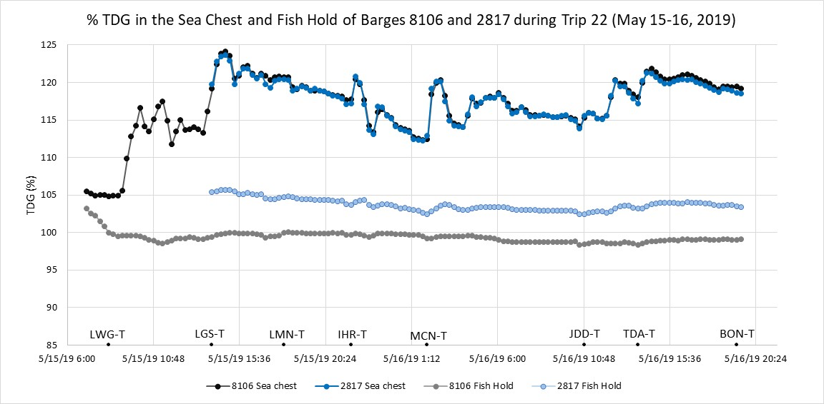

Figure 14. Sea chest and fish hold TDG (%) during the paired (8106 and 2817) barge trip 22 (May 15-16, 2019). The 8106 trip began in the Lower Granite Dam tailrace and the 2817 trip began in the Little Goose Dam tailrace. Approximate locations of the barges during the trip are also shown. Abbreviations: LWG-T = Lower Granite Dam tailrace, LGS-T = Little Goose Dam tailrace, LMN-T = Lower Monumental Dam tailrace, IHR-T = Ice Harbor Dam tailrace, MCN-T = McNary Dam tailrace, JDD-T = John Day Dam tailrace, TDA-T = The Dalles Dam tailrace, BON-T = Bonneville Dam tailrace.

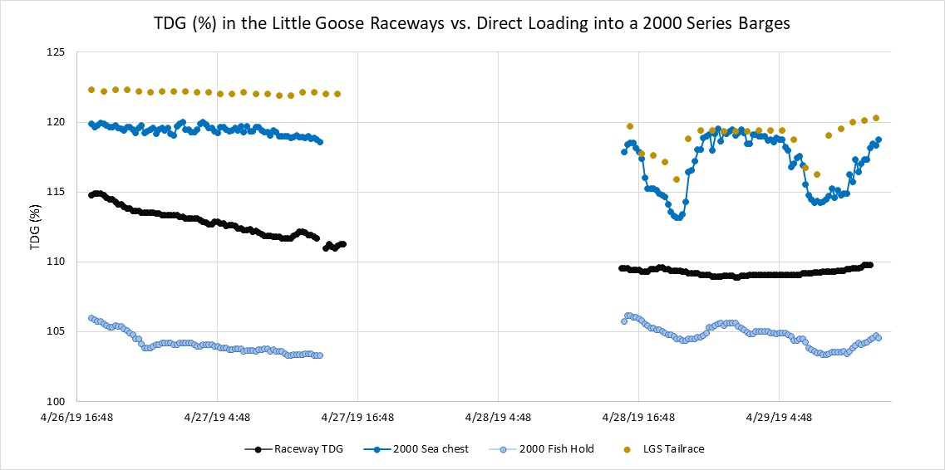

Figure 15. Comparison between TDG in the raceways, tailrace, and in the 2000 series barges (sea chest and fish hold) during direct loading at Little Goose Dam.