YAKAMA NATION
YAKAMA NATION
EXPERIMENTAL FISHERY PERMIT
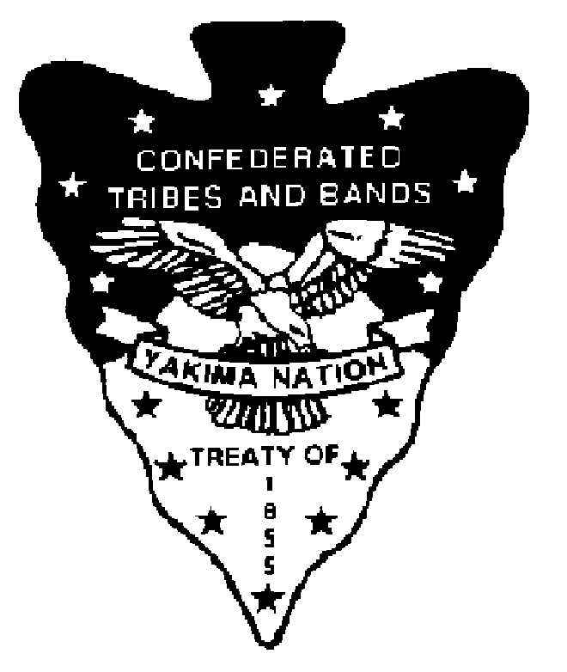

1. This Experimental Fishery Permit is issued by authority of the Yakama Nation pursuant to its status as a self-regulatory manager of fish and wildlife resources for the purpose of developing new fishery opportunities for enrolled members of the Yakama Nation.

2. The undersigned agencies, entities, or persons are authorized to take fish and wildlife species listed below for commercial or subsistence purposes subject to the conditions of this permit.

3. This permit is non-transferable. Agencies, entities, or persons not listed on this permit may not harvest fish and wildlife species under authority of this permit.

4. A report of the harvest, including species released alive, must be completed and returned to the tribal Fisheries Resource Management Program at termination of the experimental fishery.

CONDITIONS:

Location, species and number to be taken: Shad, walleye, yellow perch, bass, and carp from Zone 6 of the Columbia River, exclusive of Boat Restricted Zones. Salmonids and Sturgeon must be released alive and unharmed. There is no limit on the number of shad, walleye, yellow perch, bass and carp that can be harvested, but this permit may be revoked or modified if the incidental catch or mortality of non-target species becomes excessive.

Disposition of catch: Salmon, including steelhead, and sturgeon may be sampled for scientific data collection, but must be released unharmed. Shad, walleye, yellow perch, bass, and carp may be retained and sold commercially by Yakama Nation Members listed on this Permit.

Agency, entity, or persons authorized to take fish and wildlife under this permit: Randy Settler, Joe Stensgar (Non-Yakama Nation), and Crew(?)

Dates or duration of sampling activities (not to exceed current year): May 16 to July 31, 2011, Not to Occur During Commercial Gillnet Seasons or Sundays.

Other specific conditions: Permitted gears include beach seines, purse seines, and fish wheels. Catch including numbers and species of released fish must be reported to the Yakama Nation at least weekly and Yakama Nation Fisheries Staff must be allowed to sample fish whenever present. Non-Yakama persons may participate as advisors in the operation of fishing gear but may not operate fishing gears. Only Yakama Nation Fishers listed on this Permit may sell fish caught pursuant to this permit.

Signature of Authorizing Official:

Date:
Virgil Lewis, Sr., Chairman
Fish and Wildlife, Law and Order Committee
Yakama Tribal Council

