Contingency Actions list (Red highlighted new as the T rating)
The following is a list of contingency actions that may be taken to provide reserves, voltage, energy or inertia. The order and extent of the actual implementation of the actions in this list will be dictated by each specific condition but if possible the order at each individual dam will be followed. The actions on the list may be updated as necessary through coordination with TMT. The actions are ranked by project and by a Tier rating (eg T1 = Tier 1). Tier 1 actions taken first, then Tier 2 through Tier 7 (updated by TMT March xx, 2018)
April – August period
Tier 1
Power emergency increase generation to outside 1% up to full load
Order: Reduce, BON PH1, JDA, TDA, MCN up to 14.4 kcfs range, Snake River Dams

Tier 2
Power emergency reduce spill to 2014 BiOp levles

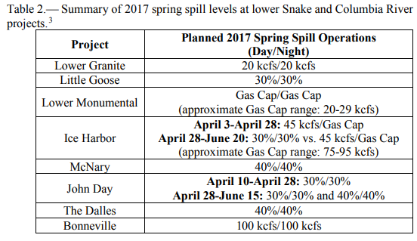
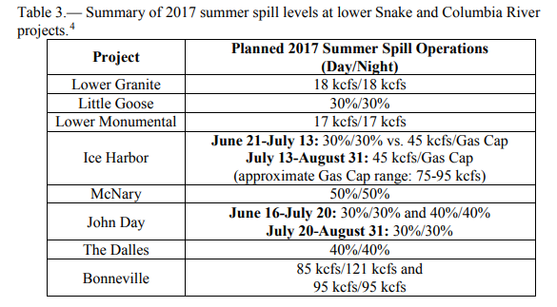

Order: LGR, LGO, LMN, IHR, MCN, JDA, TDA, BON
Increase generation outside of 1% Bon PH2, Use full 1% range at MCN

Allow MOP excursion up to: 1-2 feet

Tier 3
Power emergency intermediate spill
Order: 18k LGR, 17k LMN, 30% LGS, 30% IHR, 30% MCN, 30% JDA, 30% TDA, 95K BON

Allow MOP excursion up to: 2-3 feet

Tier 4
Power emergency low spill
Spillway weir(s) only at LGR, LGS, LMN, IHR, MCN, JDA, and surface passage with 20% TDA and 75Kcfs BON

Tier 5
Power emergency surface only spill
Surface Spillway Wiers only - LGR, LGS, LMN, IHR, MCN, JDA, 50 kcfs at BON

Tier 6
Power emergency No spill
Order: LGR, LGS, LMN, IHR, MCN, JDA, TDA, BON

Tier 7
Shut off sluiceways at TDA, Bonn PH1 first then Bonn CC

_{Sept-March period}
JDA increase generation outside 1% up to full load
JDA shutoff adult attraction flow
MCN increase generation outside 1% up to full load.
TDA increase generation outside 1% up to full load
TDA shut off sluiceway
BON increase generation outside 1% up to full load
BON shutoff adult attraction flow
BON shut off sluiceway
HGH & LIB modify ramping rates
HGH, LIB, DWR, ALF, GCL: increase project drafts which might impact spring refill

