Fish Passage Plan (FPP) Change Request Form
Change Form # & Title: 17BON004 – Ladder Temperature Monitoring & Locations
Date Submitted: 9/8/16; REVISED 12/31/16 (added locations to FPP figures)
Project: BON
Requester Name, Agency: Tom Lorz, CRITFC; Trevor Conder and Gary Fredricks, NOAA
Final Action: APPROVED as Revised 1/26/17 and 3/9/17
FPP Section: BON 2.4.2. Adult Facilities – Fish Passage Season; Figures BON-2, BON-4

Justification for Change: Adds language to standardize temperature monitoring at the mainstem ladders to record entrance and exit temperatures and differentials. Adds monitor locations to the FPP figures.

Proposed Change: (see following pages)

Comments: (listed oldest to newest)
9/12/2016 email from Trevor Conder, NOAA Fisheries: We are only really concerned with ladder temps from around June 1 until September 30. We can use TDG or strings during the other periods to see how things are tracking. Bill had a good thought to have them start in May so that if things get screwed up, we can get it fixed by June.
1/26/2017 FPOM FPP Meeting: FPOM revised the language to clarify where the monitors should be located.
Hausmann clarified that the figures show the current locations. Fredricks, Conder, and Lorz noted these need to be reviewed and moved if necessary to meet the objectives. Fredricks asked whether the monitors were above or below diffusers. Hausmann replied that the current monitor at the UMT is right at the diffusers – is this ok for an exit temperature? FPOM discussed where to put the monitors this year and requested spot checks to QA/QC throughout the year. PENDING – Hausmann will revise figures and resubmit for Feb FPOM.

Record of Final Action:
APPROVED Section 2.4.2.2 at FPOM 10/13/16, then revised at FPP meeting 1/26/17.
APPROVED figures w/ monitor locations as revised by Hausmann 3/9/16.

Proposed Change:
2.4.2.2. Temperature Monitoring.
- Water temperature will be measured in an adult fishway at each powerhouse. When water temperature reaches 70°F, all fish handling activities will be coordinated through FPOM prior to any action to verify protocols that will be followed. Fish handling activities in the Adult Fish Facility (AFF) will implement protocols in Appendix G.
- From June 1 through September 30, water temperature will be monitored at adult fishway entrances and exits.
  - Temperature monitors shall be placed within 10 meters of all shore-oriented entrances and exits.
  - If possible, the entrance monitor shall be within 1 meter above the ladder floor and at least 10 meters downstream of ladder diffusers to allow for sufficient mixing with surface water.
  - The exit monitor shall be within 1 meter above the ladder floor and above all diffusers to allow for sufficient mixing with surface water.
  - If an existing temperature monitoring location is proposed for either the exit or entrance, it shall be verified that the site accurately reflects water temperature within 10 meters of the entrance or exit.
  - Project Fisheries will submit temperature data to the Fish Passage Center (FPC) on a weekly basis for posting online at: http://www.fpc.org/river/Q_ladderwatertempgraph.php.

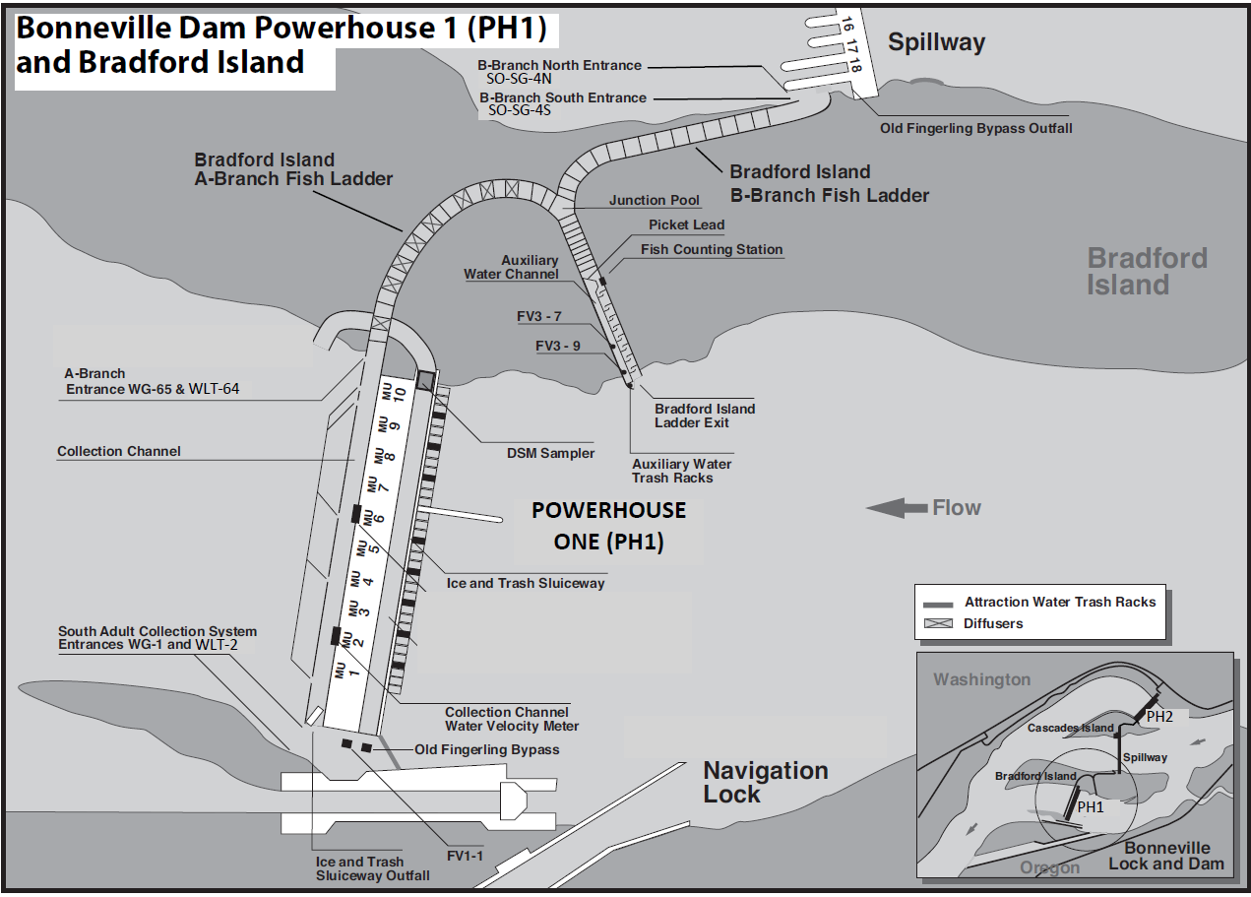
Figure BON-2. Bonneville Dam Powerhouse 1 (PH1) and Bradford Island Adult Fish Ladder A-Branch and B-Branch.
= Ladder Temperature Monitors (3)

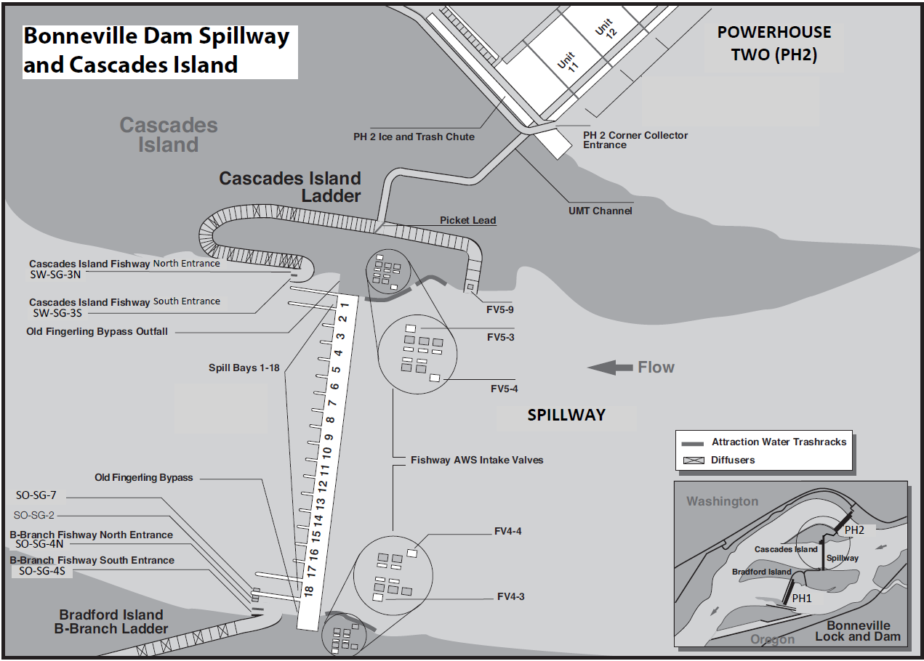
= Ladder Temperature Monitors (2)

Figure BON-3. Bonneville Dam Spillway, Cascades Island Fish Ladder and Upstream Migrant Transportation (UMT) Channel.
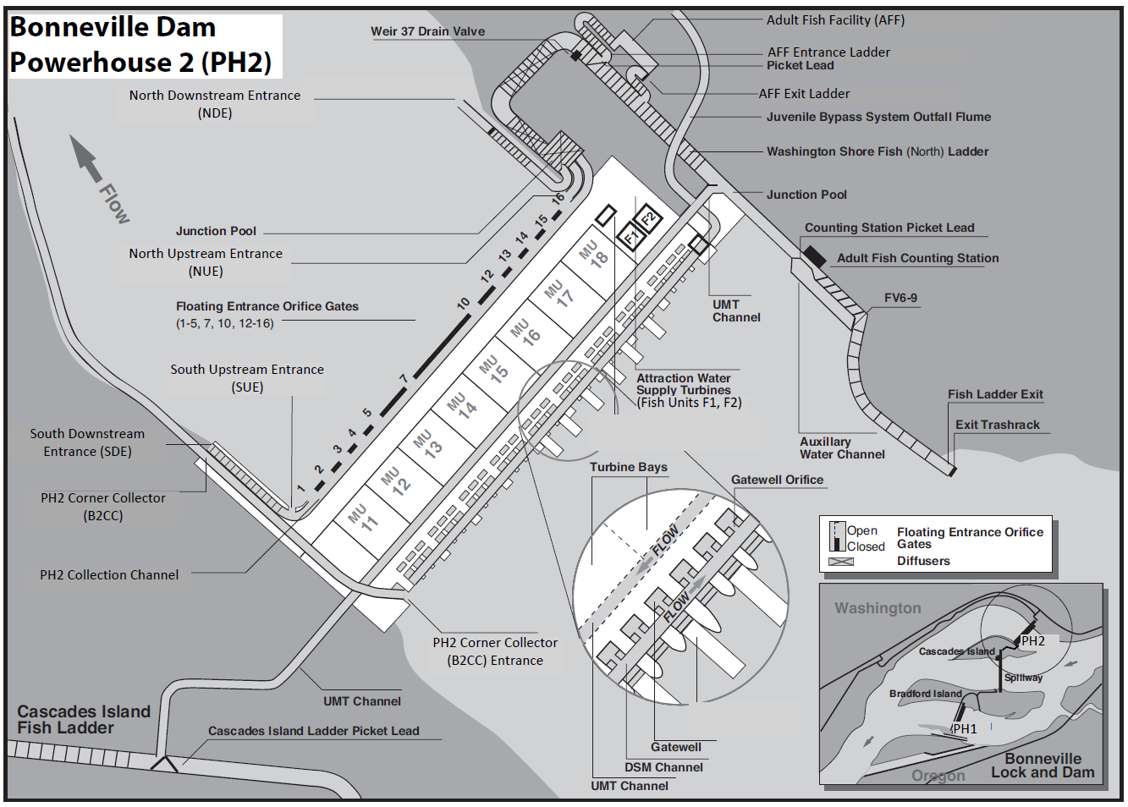
= Ladder Temperature Monitors (4)

Figure BON-4. Bonneville Dam Powerhouse 2 (PH2) and Washington Shore (WS) North Fish Ladder.

